***Radio Waves***

***The Great Lakes Division***

***Monthly Journal***

***October 2024***

***What’s inside…***

|  |  |
| --- | --- |
| 🡪 Silent Key  🡪 Estate Planning  🡪 Volunteers | 🡪 Student Membership  🡪 Youth Licensing Grant Program  🡪 Survey |
| 🡪 2024 Division Hamfests | 🡪 Club Links |

***Scott’s Stuff***

Hi Gang,

Are you ready for FALL???… Like it or not the leaves have started their traditional turning of colors and dropping off the trees for me to clean up, yuck! Although this year they don’t seem to be as bright and beautiful as they have been in the past. I guess that’s due to the drought that we’ve been experiencing. They also seem more crunchier than in years past. This is a good thing since I mulch up my leaves and use them for winter cover over our garden. The worms just love it. And since I use those worms for fishing, this makes the entire recycle process complete!

It’s been a busy month for me with club meetings and hamfests. I’ve also been busy around the house with things breaking and needing replaced. It’s been a zoo around here just trying to keep up with it all. As some of you know, I had a few trees cut down and quite a few trimmed up this past month too. This caused me to take down every antenna that I have and now after all the trees have been taken care of, it is now time for the re-assembly of my dipoles and vertical so that I can get back on the air.

Since the trees that I had cut down were also my center mounting points for a couple of dipoles, I’ve quickly come to the realization that I will need some sort of support structure to replace the trees that I had them mounted in. I really want to thank a really good friend K8IV for the generous donation of 3 sections of tower. I’ve got it home and now just waiting for some clear weather to get it up and get the dipoles mounted again.

**Hurricane Helene…** Do any of you have family or friends that live in the path of Helene? Many of us do and I hope you have been in contact with them. I’ve been on a number of Zoom meetings with the various support groups and as they have described it… “it’s apocalyptic.” The news media is reporting that there are now well over 100 people that have died in this hurricane. My good friends in North and South Carolina as well as Tennessee have really sustained some horrible damage due to Helene as well. Please keep them in your thoughts as we go through our daily routine.

Did you participate in the latest survey? I was really pleased to see so many of you that did, we had over 540 responses. It’s really great hearing back from you just how you feel about things. I really appreciate your responses, and I’m actually surprised by some of the results. The final results are posted in this newsletter.

](https://arrl-greatlakes.org/links.html)

I’ve received a number of new requests from clubs to be listed on the “Links” club page.

Is your club listed? If not, send the URL of your club website to me [n8sy@n8sy.com](mailto:n8sy@n8sy.com) and I’ll get it listed.

That’s going to do it from me this time around. Hope to catch ya’ on the air, at a club meeting or a hamfest soon!!

73,

Scott Yonally, N8SY

Director - Great Lakes Division

[n8sy@arrl.org](mailto:n8sy@arrl.org)

***Who is going to be the next Silent Key?***

The Future of Amateur Radio - What is your vision? By Roy Hook, W8REH

In searching out our mission, we must not lose sight of how we realistically fit into and are perceived by the political and financially competitive, capitalistic society we live in. What we see as our value to the public as amateur radio operators may not be seen as a value by that very same public. That in mind, we need to accept some hard facts that may define our opportunities to provide thoughtful influence. We may not be as big of fish as we see ourselves in the ocean we live in.

The fact that the US population is made up of 0.2% licensed Amateur Radio operators (ARRL members 0.04%) should not intimidate us, but guide us on how we must present our needs and perspectives to the world. The fact that only about 16% US Amateur Radio licensees are ARRL members should not necessarily alarm us until we understand in more clear detail what it is about the pool of licensees that contributes to the perceived disparity. Are new licensees being recruited with inadequate education as to what Amateur Radio will mean to them?

Are we too intent just on increasing our ham population numbers or even membership numbers? Are our efforts to mentor and retain failing? Are family members strong arming children and spouses with the vision of creating a legacy? Are we focused primarily on the things about the hobby that give us personal enjoyment without adequate concern about how the rest of the world perceives our value? Other things we haven’t identified? Remember this is a capitalist society we live in.

All of this points out that Amateur Radio’s value will be measured in terms different than our own. The perceived value and the justification for our privilege to occupy spectrum will be defined by the terms of the other 99.9% of the population and the politicians’ representing them. The recent assault on the 900 MHz band evidenced by the FCC requesting comments on a petition from NextNav or the French based assault by Thales, a Paris multinational defense contractor proposing to relegate the amateur radio 2 meter band to secondary status several months ago, doesn’t appear to be top of mind to many of us. It was recently pointed out to me that the top Political Action Committee (PAC) donations were from telecommunications and media companies only to be surpassed by Defense companies.

Although all of this may not be top of mind to us, none of this should be a surprise. It seems there is never a shortage of controversy anywhere. As the tendency is for all of us to focus on the things that impact us personally the closest, we sometimes don’t step back far enough to see the big picture, (forest for the trees syndrome). Realities we are likely to be dealt make it necessary we consider preserving our existence. Maintaining positive, productive thinking while we understand the things that are possible is critical. Learning from and accepting the things we can’t change is not easy, especially for those fixated on making things the way they use to be.

Understanding our stature in the world as pointed out above is an important piece as we work through a SWOT analysis of our situation. SWOT, an often used business technique, identifies core **S**trengths, **W**eaknesses, **O**pportunities and **T**hreats. Don’t allow yourself to jump to your assumptions because none of this is completely clear without a lot of collaborative work and thought yet to be completed. Although assumed to be potentially fatal, loss of spectrum is only one “Threat” we face.

When we have a collaborative SWOT analysis in hand, strategically we must identify our mission: Preserving Amateur Radio - “Capturing the passion of Amateur Radio for all Generations.” are possible beginning suggestions.

We are so very fortunate that Scott Yonally, our own Great Lakes Division Director along with Jeff Ryan, Rocky Mountain Division Director, understand that the world has evolved and our organization was originally created based on technology, population distribution, span of control, and other factors that may no longer exist. At the last ARRL Board meeting they successfully presented and got unanimous approval for an extremely thoughtful motion. Their motion is forward looking, resulting in the ARRL President appointing a “Study Group” to review the current structure of the ARRL governance and field organization.

Its task is to determine what, if any, changes may be necessary to more effectively manage the organization and support the membership. In view of our over 100 year old history and its incremental changes, it is time to insure that the organization has kept in sync with the world changes around us. Although most clubs are probably not 100 years old, maybe you and your club should do the same.

Many of the challenges the ARRL organization faces are similar for all of us individually and for our grass roots club organizations. Our national organization’s board is made up of all volunteers just like Amateur Radio clubs and other field support efforts. An appreciation for and willingness to do hard work is required at all levels. Just as we should encourage the youth we attempt to mentor, we each should work to develop our talents in things we are good at in support of our mission, not just the things we are passionate about. We should depend upon our national organization, which has the best visibility to big picture strategic things (the forest), to provide support for the hard work tactical efforts of our clubs.

You and our clubs are capable of creating opportunities and tactics in that strategic support. There are some excellent examples of clubs around the country doing amazing things. Congratulations! If you have read to this point you are proving the hypotheses of my February GLD Newsletter article wrong, *“Real Hams Don’t Read or Do they?*” (02-Newsletters - GLD webpage <https://arrl-greatlakes.org/> ). With better strategic thinking, communication and encouragement we can do much more. Tell me what this all means to you and if my premise is on target. Without waiting for someone else to do the work, we as individuals and clubs should keep using our talents to engage in efforts addressing more than just what we need for personal enjoyment. How can clubs in our Division work together to support the direction we collectively need to go? Many of our clubs are providing VE sessions and working hard to attract new supporters to our hobby. How can you do more to keep and develop the new people? Your big picture forward thinking feedback is important so we can all work to drown out the unproductive criticism we, the FCC and the public hears! Let me know.

Thanks for supporting the League since that it is one of the most practical tools we have to succeed.

73,

Roy Hook, W8REH

Vice Director

Great Lakes Division

[w8reh@arrl.org](mailto:w8reh@arrl.org)

***Estate Planning for Hams (What happens to all your stuff?)***

August is National Make-a-Will month. Some estimates show that nearly two-thirds of Americans don't have a plan. For some, it's procrastination. Others don't know where to start. “So many times we hear from the family of a Silent Key who are overwhelmed with what to do with a lifetime worth of amateur radio gear,” said ARRL Director of Development Kevin Beal, K8EAL. “Simply thinking through what needs to be done ahead of time can prevent the stress on our loved ones after we are gone.”

ARRL this week [held a webinar](https://www.youtube.com/watch?v=tQF31INyo-w), hosted by Beal and Dino Papas, KLØS, to discuss the first steps of planning. “It is something that, unfortunately, doesn’t get a lot of attention. The bottom-line up front is, ‘what happens to all our beloved ham gear when that inevitable day comes along that we become a Silent Key?’... Unfortunately, that day may arrive unexpectedly – so we need to prepare ahead of time to make it as simple as possible for our families,” said Papas.

On the ARRLHQ YouTube channel, you can see a [replay of the 52-minute presentation](https://www.youtube.com/watch?v=tQF31INyo-w), along with the question-and-answer section at the end.

“Your station is an asset, just like anything else you’ve built and put resources into. Deciding now what happens when you become a Silent Key can help solidify your legacy to ham radio,” said Beal. [The ARRL Legacy Circle](https://www.arrl.org/arrl-legacy-circle) recognizes the generosity of individuals who have planned support for ARRL through wills, trusts, life insurance gifts, and other ways. The ARRL Legacy Circle ensures that ARRL and amateur radio will continue to thrive for generations to come.

***Youth Licensing Grant Program***

Here’s one of those little talked about programs to help our youth. I’ll be that many of you didn’t even know about the **ARRL**Youth Licensing Grant Program. It started in 2022 and covers the one-time FCC $35 application fee for new license candidates younger than 18-years old for tests administered under the **ARRL**Volunteer Examiner Coordinator ([ARRL VEC](mailto:vec@arrl.org)) program.

Yes, the ARRL will cover the $35 FCC fee for youth who are getting into Amateur Radio.

**Additionally, candidates younger than 18-years old would pay a reduced exam session fee of $5** to the [ARRL VEC](mailto:vec@arrl.org) VE team at the time of the exam. The $5 fee is for all candidates under the age of 18 regardless of the exam level taken. Proof of under 18 status is required at the session ([what to bring to an exam session](http://www.arrl.org/what-to-bring-to-an-exam-session)).

***Both of these programs are sponsored by YOUR ARRL.***

Candidates younger than 18-years old will pay a reduced exam session fee of $5 to the ARRL VEC VE team when taking an exam. Proper identification must be presented to and verified by the team, per the procedures for all exam candidates ([what to bring to an exam session](http://www.arrl.org/what-to-bring-to-an-exam-session)).  The $5 fee is for all candidates under the age of 18 regardless of the exam level taken.  Want more information about these programs? [**Licensing Grant Program**](https://www.arrl.org/news/arrl-youth-licensing-grant-program)

**Volunteers – The Heart and Soul of ARRL Headquarters**

ARRL is quite privileged to have the service of many member-volunteers. Your national association could not function without the tens of thousands of dedicated hams who give freely of their time and talents to serve the greater amateur radio community.

The ARRL Field Organization is comprised entirely of volunteers – Section Managers, Affiliated Club Coordinators, Emergency Coordinators, and all other positions are all filled by those who have stepped up for the task. In central Connecticut, where ARRL is based, we enjoy a dedicated group of volunteers who come to ARRL Headquarters to serve.

“The volunteers really keep this place functioning,” said ARRL Member Services Representative Chanel Holley. Holley coordinates the volunteers in her role as ARRL’s receptionist. “They’re always happy to be here and bring so much dedication to their service,” she said.

ARRL is sincerely grateful to the HQ volunteer team. If you come to visit ARRL Headquarters, and the Hiram Percy Maxim Memorial Station, W1AW, join us in thanking this great crew who serve in many different functions including W1AW, ARRL Library, QSL Bureau, and the ARRL Lab.

***Results from GLD-7 Survey:***

I want to thank each and every one of you for taking the time to complete the survey this past month. It’s really important to me to know just how you feel about things. We had a total of 542 responses.

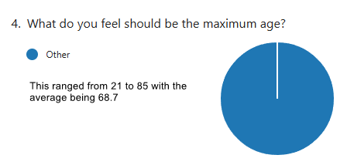

***2024 Great Lakes Division Hamfests***

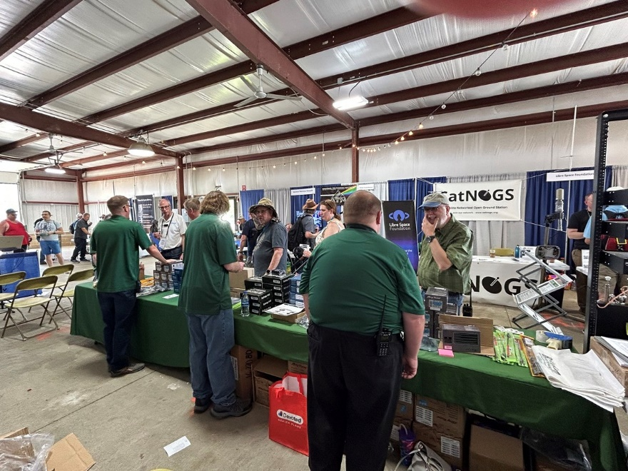

Here in the Great Lakes Division, we have over 50 hamfests a year, including the largest one in the country, Hamvention. This year Hamvention will also be the ARRL’s National Convention as well, which means that there will be some very special things happening there.

So, if you haven’t started planning your hamfest schedule yet, you really need to start now.

Please post this listing in your club's newsletter and announce the swaps on your local nets. Talk them up. Let's fully support all of our hamfests in every way possible. It means success for everyone. Be sure to invite your ARRL Officials as soon as your date is set.

If your ARRL Affiliated club plans to request Hamfest Sanctioning, you should make that request well in advance of the scheduled Hamfest date, as this allows adequate time for QST Listings. QST announcements require a 3-month lead time. To be fair to our division’s clubs, the Great Lakes Division policy **now has 2 requirements** for any ARRL Sanctioning.

**Any club requesting ARRL sanctioning within the Great Lakes Division must now be an ARRL Affiliated Club with a maximum of two hamfests/swaps in any given calendar year, and they must be at least four months apart.**

NOTE:… Since the cyber-attack at headquarters, they have been unable to process new requests for hamfests. If you have completed the on-line form for an upcoming hamfest and have yet to see it listed, please contact Steve Ewald, WV1X at 860-594-0265 and let him know. He will manually enter it into the system.

|  |  |
| --- | --- |
| **10/05/2024 -**[**Central Kentucky Hamfest**](https://www.arrl.org/hamfests/central-kentucky-hamfest-9)  **Location:**Lexington, KY **Type:** ARRL Hamfest **Sponsor:** Bluegrass Amateur Radio Society **Website:** [http://www.bluegrassars.org](http://www.bluegrassars.org/) [**Learn More**](https://www.arrl.org/hamfests/central-kentucky-hamfest-9)  Cancelled  **Due to issues beyond our control, we lost our venue for the 2024 BARS (Bluegrass Amateur Radio Society) hamfest too late for us to secure a new location.** | **10/05/2024 -**[**Kalamazoo Hamfest**](https://www.arrl.org/hamfests/kalamazoo-hamfest-4)  **Location:**Kalamazoo, MI **Type:** ARRL Hamfest **Sponsor:** Kalamazoo Amateur Radio Club (KARC), Southwest Michigan Amateur Radio Team (SMART) **Website:** <http://www.kalamazoohamfest.org/> [**Learn More**](https://www.arrl.org/hamfests/kalamazoo-hamfest-4) |
| **10/05/2024 -**[**Northwest Ohio ARC Hamfest**](https://www.arrl.org/hamfests/northwest-ohio-amateur-radio-club-nwoarc-hamfest)  **Location:**Lima, OH **Type:** ARRL Hamfest **Sponsor:** Northwest Ohio Amateur Radio Club **Website:** [http://www.nwoarc.com](http://www.nwoarc.com/) [**Learn More**](https://www.arrl.org/hamfests/northwest-ohio-amateur-radio-club-nwoarc-hamfest) | **10/05/2024 -**[**Scioto Valley ARC Hamfest**](https://www.arrl.org/hamfests/scioto-valley-amateur-radio-club-hamfest-2)  **Location:**Piketon, OH **Type:** ARRL Hamfest **Sponsor:** Scioto Valley Amateur Radio Club [**Learn More**](https://www.arrl.org/hamfests/scioto-valley-amateur-radio-club-hamfest-2) |
| **10/06/2024 -**[**U.S.E.C.A. Hamfest**](https://www.arrl.org/hamfests/u-s-e-c-a-utica-shelby-emergency-communication-association-hamfest)  **Location:**St. Clair Shores, MI **Type:** ARRL Hamfest **Sponsor:** U.S.E.C.A. **Website:** [http://USECAARC.ORG](http://usecaarc.org/) [**Learn More**](https://www.arrl.org/hamfests/u-s-e-c-a-utica-shelby-emergency-communication-association-hamfest) | **10/12/2024 -**[**Muskegon Color Tour Hamfest**](https://www.arrl.org/hamfests/muskegon-color-tour-hamfest-11)  **Location:**Muskegon, MI **Type:** ARRL Hamfest **Sponsor:** Muskegon County Emergency Communication Services, Inc. **Website:** <http://mcecs.net/Download/Hamfest2024.pdf>  [**Learn More**](https://www.arrl.org/hamfests/muskegon-color-tour-hamfest-11) |
| **10/26/2024 -**[**Hazard Hamfest**](https://www.arrl.org/hamfests/hazard-hamfest-7)  **Location:**Hazard, KY **Type:** ARRL Hamfest **Sponsor:** Kentucky Mountains Amateur Radio Club [**Learn More**](https://www.arrl.org/hamfests/hazard-hamfest-7) | **10/27/2024 -**[**2024 MARC Hamfest at MAPS**](https://www.arrl.org/hamfests/2024-marc-hamfest-at-maps)  **Location:**N. Canton, OH **Type:** ARRL Hamfest **Sponsor:** Massillon Amateur Radio Club **Website:** [https://www.w8np.net](https://www.w8np.net/) [**Learn More**](https://www.arrl.org/hamfests/2024-marc-hamfest-at-maps) |
| **12/01/2024 -**[**LCARC Amateur Radio Swap/Hamfest**](https://www.arrl.org/hamfests/lcarc-amateur-radio-swap-hamfest-10)  **Location:**Troy, MI **Type:** ARRL Hamfest **Sponsor:** L'Anse Creuse Amateur Radio Club **Website:** [http://www.n8lc.org](http://www.n8lc.org/) [**Learn More**](https://www.arrl.org/hamfests/lcarc-amateur-radio-swap-hamfest-10) | **12/07/2024 -**[**Winter Hamfest**](https://www.arrl.org/hamfests/winter-hamfest-11)  **Location:**Archbold, OH **Type:** ARRL Hamfest **Sponsor:** FCARC **Website:** <https://k8bxq.org/hamfest> [**Learn More**](https://www.arrl.org/hamfests/winter-hamfest-11) |

You can always find the latest updates for upcoming hamfests on the Great Lakes Division website.

](https://www.arrl.org/hamfests/search/Location.division_id:gl)

Just click to get to the latest hamfest updates.

***Wanted… Your Photo’s***

Have you seen the Photo Gallery on the Great Lakes Division website? If you haven’t you really need to, your face may be among the many already posted there.

[](https://arrl-greatlakes.org/gallery/index.php)

I’m always looking for more pictures to use in the Gallery, newsletter, banner and video display. Please, send me your pictures!!! Send them to: [n8sy@n8sy.com](mailto:n8sy@n8sy.com)

***Is your club website listed?***

](https://arrl-greatlakes.org/links.html)