***Radio Waves***

***The Great Lakes Division***

***Monthly Journal***

***January 2025***

***What’s inside…***

|  |  |
| --- | --- |
| 🡪 ARRL Kids Day  🡪 A Year Of..  🡪 2024 Division Hamfests | 🡪 Proposed Changes to ARRL By-Laws  🡪 Club Links    🡪 Scott’s Stuff |

***ARRL Straight Key Night: January 1, 2025***

[ARRL Straight Key Night](http://www.arrl.org/straight-key-night) will be January 1, 2025, from 0000 UTC through 2359 UTC. This 24-hour event is not a contest but rather a day dedicated to celebrating our CW heritage.

articipants are encouraged to get on the air and simply make enjoyable, conversational CW QSOs. The use of straight keys or bugs to send CW is preferred. There are no points scored and all who participate are winners. All authorized amateur frequencies may be used but activity has traditionally been centered on the HF bands.

“Most Interesting QSO” will be tabulated and included in the results. Send your information to [straightkey@arrl.org](https://arrl.informz.net/z/cjUucD9taT0zMjE4NTk3JnA9MSZ1PTU1MTI0MTMzNSZsaT0zNjMyNTQ4Ng/index.html) or by mail to ARRL Straight Key Night, 225 Main Street, Newington, Connecticut 06111. For more information, contact [contests@arrl.org](https://arrl.informz.net/z/cjUucD9taT0zMjE4NTk3JnA9MSZ1PTU1MTI0MTMzNSZsaT0zNjMyNTQ4OA/index.html) or (860) 594-0232.

***ARRL Kids Day - January 4, 2025***

[ARRL The National Association for Amateur Radio®](http://www.arrl.org/) Kids Day runs January 4, 2025 from 1800 UTC - 2359 UTC. Operate as much or as little as you like.

The event is designed to give on-the-air experience to young people, to foster interest in getting a license of their own, and give older hams a chance to share their stations and love for amateur radio with their children. You can share the excitement with your own kids, grandkids, a Scout troop, a church, or the general public!

All participants are encouraged to post their story and thumbnail photos to the [Kids Day Soapbox page](https://www.arrl.org/soapbox?utm_source=Informz&utm_medium=Email&utm_campaign=ARRL&_zs=pk0xl&_zl=5HAC3). Tell the world about your operations, the fun you had, and the contacts you made! Remember, ARRL must have a completed [release form](https://www.arrl.org/files/file/Model20/ModelReleaseForm.pdf) in order to include youth photos (younger than 18 years of age) in ARRL publications.

***There will be a second ARRL Kids Day on June 21, 2025.***

More information, including frequencies, suggested exchanges, and how to download a certificate, can be found on the Kids Day web page at <https://www.arrl.org/Kids-Day>

***ARRL Youth Licensing Grant Program***

Here’s one of those little talked about programs to help our youth. I’ll be that many of you didn’t even know about the **ARRL**Youth Licensing Grant Program. It started in 2022 and covers the one-time FCC $35 application fee for new license candidates younger than 18-years old for tests administered under the **ARRL**Volunteer Examiner Coordinator ([ARRL VEC](mailto:vec@arrl.org)) program. Yes, the ARRL will cover the $35 FCC fee for youth who are getting into Amateur Radio

**Additionally, candidates younger than 18-years old would pay a reduced exam session fee of $5** to the [ARRL VEC](mailto:vec@arrl.org) VE team at the time of the exam. The $5 fee is for all candidates under the age of 18 regardless of the exam level taken. Proof of under 18 status is required at the session ([what to bring to an exam session](http://www.arrl.org/what-to-bring-to-an-exam-session)). 

***Both of these programs are sponsored by YOUR ARRL.***

Candidates younger than 18-years old will pay a reduced exam session fee of $5 to the ARRL VEC VE team when taking an exam. Proper identification must be presented to and verified by the team, per the procedures for all exam candidates ([what to bring to an exam session](http://www.arrl.org/what-to-bring-to-an-exam-session)).  The $5 fee is for all candidates under the age of 18 regardless of the exam level taken.  Want more information about these programs? [**Licensing Grant Program**](https://www.arrl.org/news/arrl-youth-licensing-grant-program)

***Learn Even More with On the Air Live!***

In early 2025, the ARRL Education & Learning Department will launch an interactive livestreamed video podcast, On the Air Live. The monthly episodes will be aimed toward educating new and intermediate-level hams, inspiring them to explore the nearly endless aspects of amateur radio and develop their skills.

ARRL Education Specialist Wayne Greene, KB4DSF, who will host each episode, joins the On the Air podcast to share more details, including upcoming topics and how to participate in real time.

🎧: LISTEN: [**tinyurl.com/yc7b7jwd**](https://tinyurl.com/yc7b7jwd?fbclid=IwZXh0bgNhZW0CMTAAAR3A4ncRjHu-dzk362arBUy65wGQc8WMRwKbqXjgFRjuiWUKcFVxT-HK2G8_aem_ACReZuKK9212Yil8hqze5g)

🎥: WATCH: [**tinyurl.com/mpuf6yyc**](https://l.facebook.com/l.php?u=https%3A%2F%2Ftinyurl.com%2Fmpuf6yyc%3Ffbclid%3DIwZXh0bgNhZW0CMTAAAR1aZboWTvV05IOHUl0qqCQSey4LD6zNXscX6hihmqy4NYS_2wsXpEJFQ00_aem_N5wsZuyQKZEXVvwvUZ926w&h=AT2DxpDfGcGPFyiS50spUDU8ONG12SpxwwEQo4p4fY0gPzRywKwAetdF3_9LxUt2R6EcIxiIn7y8CI7_TdCp9pbdCp-SEINe5KgftacROjv3RSIyQoZ8OHAEprOcCa7_TBqPrboLHR0xVv7CjKm5&__tn__=-UK-R&c%5b0%5d=AT2Egq0YQe2efJhuDenI3S6LgRHGABKmcVaLE44x0uy2yV6BB4x-PS9Xl5DzDIZw9GSV_YNOW-Xzg5tJTJYqBXLsfdfh18JuqXN6kY9gTQZQCXm3BtgzmH8OJs241ksrwVff7qCXCM9mN7brbZnuQ9SOMCJst8_fpxpoOaFw9E-uie1WCERz8jT3T6nWMxfRG47SEwTv4ZmURVyBHDtp8K9l9zmLgIehfxy-2Xu97ztAEEtePmbkXfDv)

***Scott’s Stuff***

Hi Gang,

Happpppy New Year!!! Wow, I can’t believe that a whole year has gone by already.

Every year at this time we all go through that phase where we reflect back on the year past and think about all the things that we wanted to do but didn’t. It’s something that keeps us on track and gives us the ability to look forward to the new year with a positive attitude and willingness to improve and make things in your life better. Have you thought about this new year and what you’re going to change?

Have you thought about "volunteering" this year? As we sit and ponder what your New Year’s Resolutions should be, I want you to consider adding "volunteering" to that resolution as well. Even if you are already volunteering now, can you give just a little more?

There are many different ways that you can volunteer. Have you ever thought about running for one of those positions that never seems to have a person available to fill it in your local club? I know many clubs that would just love to have that position filled by someone that could give of themselves just a little.

How about volunteering to become a weather spotter, or a member of your local ARES team? Yes, these are commitments of time, some more than others. The one and only item in life that none of us knows exactly just how much time we have left.

But can you imagine what life would be like if none of us volunteered? I mean really… think about how everything around you would be… No hamfest, because we couldn’t find enough volunteers. No club meeting because no one wanted to run the meetings. No contests because no one was willing to spend the time adding up all the scores. No repeater because no one wanted to do the maintenance on it. I’d really hate to think of what life would be like without the help from volunteers. So, how about it? Are you going to let someone else carry the load for you or are you going to “STEP UP” and volunteer.

Things are really super busy for Roy and me right now getting all those details ready for the upcoming Board of Directors meeting in January. It seems like there’s a Zoom meeting every night to go over something before the meeting, but as the Board meeting is coming up in mid-January, finalizing all those plans and making sure that everything is precisely worded as we want, takes a lot of meetings.

2025 Will Be an Amazing Time for ARRL. As I reflect on the trajectory of the American Radio Relay League (ARRL), I can’t help but feel a sense of anticipation for what 2025 has in store. While we continue to recover from the significant cyber-attack that impacted our systems, I am optimistic about the resilience that lies ahead. The process of bringing our essential systems back online has been ongoing, and with each step, I can see the foundations for a stronger future being laid.

One of the most exciting developments for ARRL in 2025 is the commitment to undertake a comprehensive examination of how our organization functions. This initiative is poised to be a game-changer, as it will allow us to assess our current practices and determine whether any significant changes are necessary. The engagement of an outside independent company to conduct this assessment signals our dedication to transparency and improvement. It’s essential for any organization, especially one with as much history as the ARRL, to continuously evaluate its operations to ensure we are not only meeting the needs of our members but also adhering to best practices in today's rapidly evolving landscape.

I do believe that the focus on recovery from the cyber-attack will also serve as a catalyst for enhancing our security protocols. As we reintegrate our systems, we are not merely restoring what was lost; we are implementing more robust defenses to safeguard against future threats. This proactive approach enhances the overall trust we have in our capabilities.

Looking ahead, I am also excited about the potential for new projects and initiatives to emerge from this evaluation. With the insights garnered from the assessment, we may find opportunities to introduce cutting-edge technologies, foster greater community engagement, or even enhance our educational programs. The possibilities are truly limitless, and I am eager to see how we can harness our collective expertise to create a vibrant future for ARRL.

Hey! I want to say that if your student hasn’t applied for a college scholarship by now, they’d better get busy, they only have until this coming Wednesday, January 6th at 12 noon to get their application in.

There is a link on the ARRL homepage in addition to the link on the scholarship page. More than 100 scholarships ranging from $500 to $25,000 will be awarded in 2025. This is FREE money for your kids to go to college on! How many kids do you know that couldn’t use a helping hand with their college tuition? All applicants must be active, FCC-licensed amateur radio operators. Go to: [http://www.arrl.org/scholarship-program](https://www.arrl.org/scholarship-program)

Okay, that is going to do it from here this month. Stay safe and "Catch Me On The Air, at a meeting or hamfest!!!" But most of all... Have FUN and…. Get On The Air!!!!

73,

Scott Yonally, N8SY

Director - Great Lakes Division

[n8sy@arrl.org](mailto:n8sy@arrl.org)

***ARRL Systems Service Disruption - Update on DXCC® application processing***

In October, we reported that the ARRL DXCC® System had been returned to service. Since then, over 3,000 DXCC applications have been logged into the DXCC System for processing. It is important to understand that the queue of submitted applications is very large, and has included nearly 6 months of applications for processing. ARRL Awards staff and additional staff and volunteers have been working extended hours and weekends to process applications.  
  
DXCC is ARRL’s most popular award. Even while previously submitted applications are being processed, new applications are being submitted and received every day. We continue to appreciate everyone’s patience as we process the large queue of submitted applications.

***Application Processing Queue***  
  
DXCC applications enter the DXCC System from one of three sources: from DXCC applications created by users in Logbook of The World® (LoTW®), from traditional paper applications, and from the Online DXCC Application.  
  
The DXCC System has logged applications received via Logbook of The World from May through October 23, and paper applications received through mid-December. On December 13, the Online DXCC Application was returned to service.  
We are currently processing paper applications received in November and December, and applications from LoTW submitted in November.  
  
We have resumed mailing orders for paper DXCC Certificates and endorsement stickers. Over 350 certificates were mailed on December 26.  
  
The easiest way to determine if your DXCC application has been processed is to review your [**LoTW account**](https://lotw.arrl.org/). From the Award Account Menu, select Account Status. The “Awarded” column will reflect those QSOs that have been awarded to you after your application(s) has been fully processed.  
  
We appreciate your continued patience as we work to return to normal processing times. Our team is committed to ensuring that all applications are handled as quickly and efficiently as possible. Thank you once again for your understanding and support during this time.

[](https://ohsimplex.org/?fbclid=IwY2xjawHb8nVleHRuA2FlbQIxMAABHaynKKnQ5Tfzb10nfOaxy67EGLx5jLYnchjQ3mPyKXXy83k4u3CdaKn-JA_aem_GC3J8CpZCBNbRBRcKC5x9g)

](https://ohsimplex.org/?fbclid=IwY2xjawHb8nVleHRuA2FlbQIxMAABHaynKKnQ5Tfzb10nfOaxy67EGLx5jLYnchjQ3mPyKXXy83k4u3CdaKn-JA_aem_GC3J8CpZCBNbRBRcKC5x9g)

***A Year of Frustration And Optimism***

Roy Hook, W8REH

**Frustration** because we never make as much progress as

we hope for.

**Optimism** because we have so much good to build on and an occasional bright spot of success. It’s not too late. Look at the great band conditions we have been experiencing and the opportunity for Technicians to maximize their existing 10-meter privileges to talk all around the world.

Optimism can be found by just looking for it past any negativity we come across. Most all of us have experienced great and wonderful things from our hobby. Not the same things for everyone, but igniting passions often different than our own. Wishing for things to be the way we remember will not stop change.

We have a lot of very hard thinking people in our hobby. Einstein said it best “Thinking is hard work. If it weren’t more people would do it”.

Inclusion or Exclusion. This may hold the answer on how we perpetuate our hobby. We may not always realize it but inclusionary and exclusionary are mutually exclusive. One does not exist in the presents of the other. Keeping an open mind can certainly be difficult at times. Expanding our hobby requires including more people.

Our CEO’s editorial in the November QST (Second Century, The Future of DXCC) prods all of us to THINK about the future of our hobby. It is clear that the passion for DXing is strong within our hobby. The strength of such passions may cause some to lose sight of the hundreds of other aspects of the hobby just as important in attracting others. Recently I was made aware of efforts of one DXpedition enthusiast who for unknown reasons blocked access of previously available communication channels to some individuals who he presumably did not agree with. Exclusionary thinking may be difficult to recognize. Including the unknown into our thinking can be difficult.

Last month I resurrected a 1970 Pogo comic strip by Walt Kelly, summarizing mankind’s tendency to create our own problems, where we have only ourselves to blame.

I have lengthy travel over the next couple of months leaving me little time to write the February article. I have decided to include you by giving you the opportunity to present your thoughts in the Division newsletter for me. I’ll use the best submission for our February newsletter and any runner-ups later. My articles in the Great Lakes newsletters from all 12 months are all available at [https//:arrl-greatlakes.org/](https://arrl-greatlakes.org/)

In preparing to write your thoughts, review of some of my previous writing should help you understand what we are looking for. Keep in mind change is constant and a lot has evolved over the last months. We all should be lifetime learners considering our evolved thoughts and positions. My suggested articles for review include:

* Have we met the Enemy?
* Are we Out of Balance?
* The Future of Amateur Radio – What is your Vision?

I keep some simple guidelines in mind as I write each month. Just simply engage our readers with positive, big picture, forward thinking (no slash and burn editorializing).

* Be interesting to the broad amateur radio community
* 500 to 1000 words
* I need to receive your article by Monday January 20, 2025

Thanks for supporting the League since that it is one of the most practical tools we have to succeed.

73,

Roy Hook, W8REH

Vice Director

Great Lakes Division

[w8reh@arrl.org](mailto:w8reh@arrl.org)

# # # #

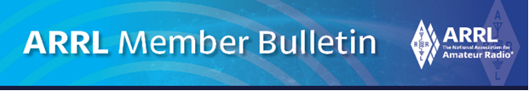

***Committee Proposes Changes to ARRL By-Laws 18 and 20***

Dear Member,

A previous bulletin to ARRL members addressed the report of the By-Law 46 Committee’s proposed changes to By-Laws 42 and 46. In response to comments from Board members, the Committee has made several minor wording changes to the documents. For example, where appropriate, the term “ARRL” was substituted for “the corporation”. There were two relatively major changes. Proposed By-Law 42, Section 1(e) now has a better description of a neutral independent third party. A proposal to modify Article 7 of the ARRL Articles of Association was added to better describe ineligibility.

Two other proposed changes to By-Laws have been submitted.

1. It is proposed to modify By-Law 18 to clarify election procedures and candidate qualification. Important elements describing elections will be moved into the By-Laws from less formally controlled documents. The proposal also better defines candidate eligibility requirements to minimize misunderstanding and reduce the need for interpretation by the Ethics and Elections Committee (E&E) in matters of eligibility.

2. The current By-Law 20 requires that a representative of E&E observe ballot processing at a selected qualified and disinterested third party. Because the process used by such entities is automated, little is learned by watching the lights blinking on a computer or the ballot scanner.

Sending a Committee member to observe is, in most circumstances, an unnecessary expense. The proposed new By-Law says that an E&E member may observe ballot processing at the discretion of the E&E Committee.

Copies of these motions and related documents [are posted on the ARRL Website](https://arrl.informz.net/z/cjUucD9taT0zMjE2OTI3JnA9MSZ1PTUyMDM2NDI5NiZsaT0zNjMwMzYzNQ/index.html).

Do you have any questions about these proposals? You can always contact me at: [n8sy@n8sy.com](mailto:n8sy@n8sy.com)

***Final Weeks to Apply***

The ARRL Foundation Scholarship Program continues to accept applications for the 2025 scholarship cycle. The application period is open until 12:00 PM Eastern Standard Time on January 6, 2025. The scholarships are available to eligible amateur radio operators pursuing higher education. There are more than 100 scholarships ranging from $500 to $25,000.

The scholarships have been established by generous donors and can help fund a portion of a ham’s education. Descriptions of the scholarships may be found at <https://www.arrl.org/scholarship-descriptions>

In 2024, 135 scholarships totaling more than $715,000 were awarded.  Young Hams throughout the country benefitted from scholarships ranging from $500 to $25,000 to assist them with college or university expenses. Funded entirely through the generous contributions of individuals, Clubs, and friends, the Scholarship Program is one of two areas of focus (the other being grants) for the Foundation, which is a separate organization that works closely in partnership with ARRL.

ARRL Director of Development Kevin Beal, K8EAL, is encouraged by the program. “Hams are always learning, and being able to honor that dedication to education through generously funded scholarship programs helps relieve some of the financial burden that students can experience,” he said.

All applicants must submit a completed online application. Transcripts and any additional required documents must be submitted with the application and not emailed separately. A number of scholarships require additional documents, such as a letter of recommendation from a sitting Officer of an ARRL-affiliated club. Applications without accompanying transcripts and additional required documents (if applicable) will not be considered. Scholarship recipients will be notified by early June 2025. Awards are mailed directly to recipients' schools and will be awarded in July 2025.

ARRL’s mission is to promote and protect the art, science, and enjoyment of amateur radio, and to develop the next generation of radio amateurs. Through programs like the free youth membership and the ARRL Teachers Institute on Wireless Technology, ARRL is enabling futures in STEM-field careers through amateur radio.

***2024 Great Lakes Division Hamfests***

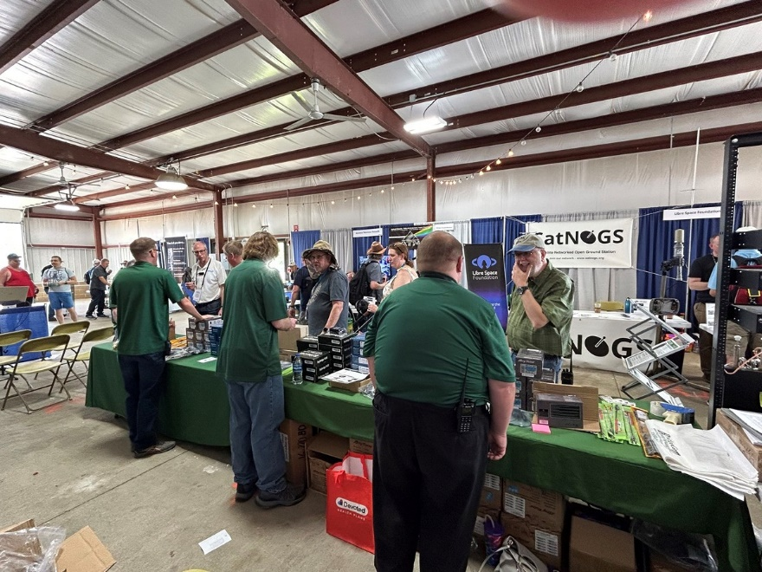

Here in the Great Lakes Division, we have over 50 hamfests a year, including the largest one in the country, Hamvention. This year Hamvention will also be the ARRL’s National Convention as well, which means that there will be some very special things happening there.

So, if you haven’t started planning your hamfest schedule yet, you really need to start now.

Please post this listing in your club's newsletter and announce the swaps on your local nets. Talk them up. Let's fully support all of our hamfests in every way possible. It means success for everyone. Be sure to invite your ARRL Officials as soon as your date is set.

If your ARRL Affiliated club plans to request Hamfest Sanctioning, you should make that request well in advance of the scheduled Hamfest date, as this allows adequate time for QST Listings. QST announcements require a 3-month lead time. To be fair to our division’s clubs, the Great Lakes Division policy **now has 2 requirements** for any ARRL Sanctioning.

**Any club requesting ARRL sanctioning within the Great Lakes Division must now be an ARRL Affiliated Club with a maximum of two hamfests/swaps in any given calendar year, and they must be at least four months apart.**

|  |  |
| --- | --- |
| **01/19/2025 -**[**Sunday Creek Amateur Radio Federation Hamfest**](https://www.arrl.org/hamfests/sunday-creek-amateur-radio-federation-hamfest-4)  **Location:**Shade, OH **Sponsor:** Sunday Creek Amateur Radio Federation [**Learn More**](https://www.arrl.org/hamfests/sunday-creek-amateur-radio-federation-hamfest-4) | **02/08/2025 -**[**Cherryland ARC Ham Swap**](https://www.arrl.org/hamfests/cherryland-arc-ham-swap)  **Location:**Traverse City, MI **Sponsor:** Cherryland Amateur Radio Club **Website:** [http://cherrylandarc.com](http://cherrylandarc.com/) [**Learn More**](https://www.arrl.org/hamfests/cherryland-arc-ham-swap) |
| **02/22/2025 -**[**Livonia Amateur Radio Club Annual Swap & Shop**](https://www.arrl.org/hamfests/livonia-amateur-radio-club-annual-swap-shop-1)  **Location:**Northville , MI **Sponsor:** Livonia Amateur Radio Club [**Learn More**](https://www.arrl.org/hamfests/livonia-amateur-radio-club-annual-swap-shop-1) | **03/16/2025 -**[**Toledo Mobile Radio Association Hamfest and Computer Fair**](https://www.arrl.org/hamfests/toledo-mobile-radio-association-hamfest-and-computer-fair-3)  **Location:**Perrysburg, OH **Sponsor:** Toledo Mobile Radio Association **Website:** [http://www.w8hhf.org](http://www.w8hhf.org/) [**Learn More**](https://www.arrl.org/hamfests/toledo-mobile-radio-association-hamfest-and-computer-fair-3) |
| **03/22/2025 -**[**Cave City Hamfest**](https://www.arrl.org/hamfests/cave-city-hamfest-14)  **Location:**Cave City, Kentucky, KY **Sponsor:** MCARC **Website:** [http://ky4x.org](http://ky4x.org/) [**Learn More**](https://www.arrl.org/hamfests/cave-city-hamfest-14) | **03/23/2025 -**[**Lowell Amateur Radio Youth Club Hamfest**](https://www.arrl.org/hamfests/lowell-amateur-radio-youth-club-hamfest-1)  **Location:**Lowell, MI **Sponsor:** Lowell Amateur Radio Youth Club **Website:** [http://amateurradioyouth.club](http://amateurradioyouth.club/) [**Learn More**](https://www.arrl.org/hamfests/lowell-amateur-radio-youth-club-hamfest-1) |
| **04/05/2025 -**[**Cuyahoga Falls Amateur Radio Club 69th Hamfest**](https://www.arrl.org/hamfests/cuyahoga-falls-amateur-radio-club-69th-hamfest)  **Location:**Cuyahoga Falls , OH **Sponsor:** Cuyahoga Falls Amateur Radio Club, Inc. **Website:** [https://www.cfarc-hamfest.org](https://www.cfarc-hamfest.org/) [**Learn More**](https://www.arrl.org/hamfests/cuyahoga-falls-amateur-radio-club-69th-hamfest) | **04/05/2025 -**[**E-town Hamfest (The Lincoln Trail Amateur Radio Club's 47th Annual Hamfest)**](https://www.arrl.org/hamfests/e-town-hamfest-the-lincoln-trail-amateur-radio-club-s-47th-annual-hamfest)  **Location:**Elizabethtown , KY **Sponsor:** Lincoln Trail Club [**Learn More**](https://www.arrl.org/hamfests/e-town-hamfest-the-lincoln-trail-amateur-radio-club-s-47th-annual-hamfest) |

You can always find the latest updates to all of the approved ARRL upcoming hamfests on the Great Lakes Division website.

](https://www.arrl.org/hamfests/search/Location.division_id:gl)

Just click to get the latest hamfest updates.

](https://kyqsoparty.org/)

](https://kyqsoparty.org/)

***Do you know someone who is not getting this newsletter***

Hi Gang,

If you know someone who isn’t already getting Radio Waves, have them sign up to receive it!! They don’t have to be ARRL members to sign up, just click on the button below and in no time, they will start receiving it.

[](https://arrl-greatlakes.org/glnews/index.html)

***Club Links***

](https://arrl-greatlakes.org/links.html)I’ve received a number of new requests from clubs to be listed on the “Links” club page.

Is your club listed? If not, send the URL of your club website to me [n8sy@n8sy.com](mailto:n8sy@n8sy.com) and I’ll get it listed.

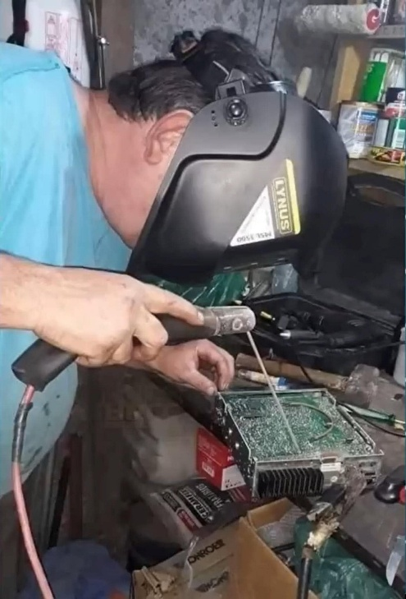***Wanted… Your Photo’s***

Have you seen the Photo Gallery on the Great Lakes Division website? If you haven’t you really need to, your face may be among the many already posted there.

[](https://arrl-greatlakes.org/gallery/index.php)

I’m always looking for more pictures to use in the Gallery, newsletter, banner and video display. Please, send me your pictures!!! Send them to: [n8sy@n8sy.com](mailto:n8sy@n8sy.com)

***New Survey – GLD-9***

](https://forms.office.com/r/5dvKARNvpe)

There is a new survey posted GLD-9 and it is on the website and waiting for input from you. I really would like to hear your feedback.

Please take just a couple of minutes of your time and take the survey.

Got a question that you think should be asked? Let me know… [n8sy@n8sy.com](mailto:n8sy@n8sy.com)

***Free - Extra License Class Course Being Offered***

A free, weekly, live, Amateur Radio Extra Class Licensing course on Zoom will begin on **Thursday, January 16, 2025**, and run through Thursday, March 27.

There will be 11 three-hour sessions starting at 6:30 PM Eastern Time. They will be recorded. Those who attend should hold (or be studying for) the General Class Amateur Radio License.

Those wishing to sign up should email [roland.anders@comcast.net](mailto:roland.anders@comcast.net).

***Winner of the “Handbook Give Away”***

And the winner of the 2025 ARRL Softcover Handbook is none other than….

(Drum Roll Please……..)

Larry Knapp, KC8JX

Saint Joseph, Michigan