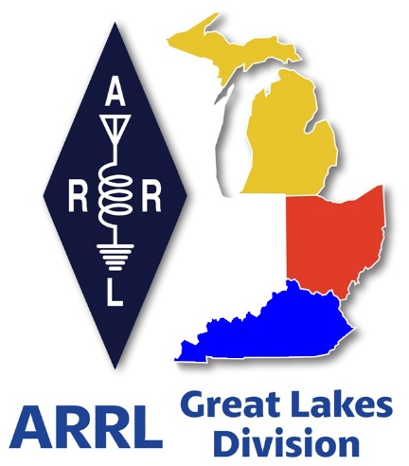 ***Radio Waves***

***The Great Lakes Division***

***Monthly Journal***

***February 2025***

***What’s inside…***

|  |  |
| --- | --- |
| 🡪 Scott’s Stuff  🡪 How Young Can We Go  🡪 2024 Division Hamfests  🡪 Handbook Give Away | 🡪 Member Bulletin    🡪 Survey Results  🡪 Winter Field Day |

***ARRL Youth Licensing Grant Program***

Here’s one of those little talked about programs to help our youth. I’ll be that many of you didn’t even know about the **ARRL**Youth Licensing Grant Program. It started in 2022 and covers the one-time FCC $35 application fee for new license candidates younger than 18-years old for tests administered under the **ARRL**Volunteer Examiner Coordinator ([ARRL VEC](mailto:vec@arrl.org)) program. Yes, the ARRL will cover the $35 FCC fee for youth who are getting into Amateur Radio

**Additionally, candidates younger than 18-years old would pay a reduced exam session fee of $5** to the [ARRL VEC](mailto:vec@arrl.org) VE team at the time of the exam. The $5 fee is for all candidates under the age of 18 regardless of the exam level taken. Proof of under 18 status is required at the session ([what to bring to an exam session](http://www.arrl.org/what-to-bring-to-an-exam-session)). 

***Both of these programs are sponsored by YOUR ARRL.***

Candidates younger than 18-years old will pay a reduced exam session fee of $5 to the ARRL VEC VE team when taking an exam. Proper identification must be presented to and verified by the team, per the procedures for all exam candidates ([what to bring to an exam session](http://www.arrl.org/what-to-bring-to-an-exam-session)).  The $5 fee is for all candidates under the age of 18 regardless of the exam level taken.  Want more information about these programs? [**Licensing Grant Program**](https://www.arrl.org/news/arrl-youth-licensing-grant-program)

***Scott’s Stuff***

Hi Gang,

Happpppy Groundhog Day!!! Can you believe it, it’s just a mere 48 days until spring arrives!

What a wild week that Roy and I had in Newington at the annual Board of Directors meeting recently! We were both locked in on numerous meetings that lasted into the wee hours of Thursday evening.

The Board meeting started bright and early on Friday morning and it came to an end around 4pm on Saturday.

We got a lot accomplished, and you can read about many of those items in the Member Bulletin posted further down this newsletter.

I’m assuming that you are reading this column on Saturday, February 1st, and as such, I just want to say that tomorrow is Groundhog Day... Yes, Groundhog Day! You know, the day we all get up before the crack of dawn and grab a little worthless varmint that does nothing but make a mess out of our garbage cans, yet we celebrate whether he can see his shadow when the sun rises. Here in Ohio, we have Buckeye Chuck doing the forecasting. He’s been right only slightly more than wrong, but what the heck, it’s fun just to see if that little critter really does predict it accurately or not. Personally, I think he’s no better than a coin toss but it’s something fun to do in the middle of winter.

February is also known as the month for lovers, as it’s Valentine’s Day on Friday, February 14th. Now, I don’t know about you, but I’ve found the best way to keep my YL happy is to take her out for that special dinner, if not on Valentine’s Day, somewhere close to it, especially if you want to drop the news that you’ve just purchased a very expensive, but absolutely necessary piece of ham equipment that you just couldn’t live without. So, do yourself a favor, make dinner plans now for that special day!

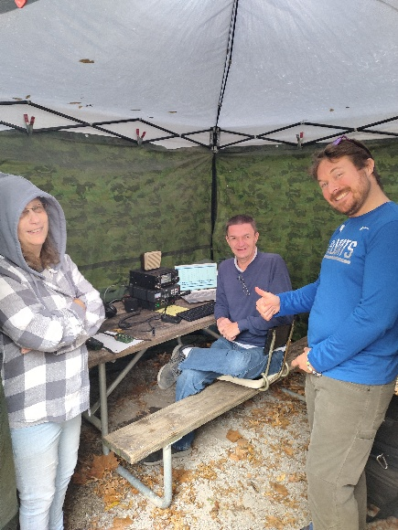Here’s a little piece of trivia for ya’… Today is February 1 and it’s the 32nd day of the year in the Gregorian calendar. There are 333 days remaining until the end of the year (334 in leap years). This day marks the approximate midpoint of winter in the Northern Hemisphere and of summer in the Southern Hemisphere. So, with that said, we are now starting on the upward swing of getting winter behind us. Yippie!!! Shorts and T-shirts will soon be out in blossom once again! Also, let’s not forget that in just 46 days we will once again lose an hour of sleep. Yes, Daylight Saving Time will start on March 9th this year.

We have a couple of great ARRL contests coming up this month, School Roundup on February 10th - 14th, and International DX / CW contest on February 15th - 16th. Hey, if you’re not into contesting I get it, but you still can have some fun and make a kids’ eyes light up if you do decide to participate in at least the School Roundup.

Did you participate in Winter Field Day? I got out and visited 6 different sites and it was a blast for sure. Everyone was having fun and the food… Oh my, hams travel on their stomachs for sure as the food was so inviting everywhere I went. Want to see some of the pictures I acquired? Here’s the link..

<https://youtu.be/L-ZaKQrgF8o>

Did you take pictures of your Winter Field Day operations? In addition to what I took, I captured a few that were posted on Facebook, but I just know that there are so many more pictures out there. Please, send them to me and I can add them to what we have already. [n8sy@n8sy.com](mailto:n8sy@n8sy.com)

Okay, that is going to do it from here this month. Stay safe and "Catch Me On The Air, at a meeting or hamfest!!!" But most of all... Have FUN and…. Get On The Air!!!!

73,

Scott Yonally, N8SY

Director - Great Lakes Division

[n8sy@arrl.org](mailto:n8sy@arrl.org)

***Learn Even More with On the Air Live!***

In early 2025, the ARRL Education & Learning Department will launch an interactive livestreamed video podcast, On the Air Live. The monthly episodes will be aimed toward educating new and intermediate-level hams, inspiring them to explore the nearly endless aspects of amateur radio and develop their skills.

ARRL Education Specialist Wayne Greene, KB4DSF, who will host each episode, joins the On the Air podcast to share more details, including upcoming topics and how to participate in real time.

🎧: LISTEN: [**tinyurl.com/yc7b7jwd**](https://tinyurl.com/yc7b7jwd?fbclid=IwZXh0bgNhZW0CMTAAAR3A4ncRjHu-dzk362arBUy65wGQc8WMRwKbqXjgFRjuiWUKcFVxT-HK2G8_aem_ACReZuKK9212Yil8hqze5g)

🎥: WATCH: [**tinyurl.com/mpuf6yyc**](https://l.facebook.com/l.php?u=https%3A%2F%2Ftinyurl.com%2Fmpuf6yyc%3Ffbclid%3DIwZXh0bgNhZW0CMTAAAR1aZboWTvV05IOHUl0qqCQSey4LD6zNXscX6hihmqy4NYS_2wsXpEJFQ00_aem_N5wsZuyQKZEXVvwvUZ926w&h=AT2DxpDfGcGPFyiS50spUDU8ONG12SpxwwEQo4p4fY0gPzRywKwAetdF3_9LxUt2R6EcIxiIn7y8CI7_TdCp9pbdCp-SEINe5KgftacROjv3RSIyQoZ8OHAEprOcCa7_TBqPrboLHR0xVv7CjKm5&__tn__=-UK-R&c%5b0%5d=AT2Egq0YQe2efJhuDenI3S6LgRHGABKmcVaLE44x0uy2yV6BB4x-PS9Xl5DzDIZw9GSV_YNOW-Xzg5tJTJYqBXLsfdfh18JuqXN6kY9gTQZQCXm3BtgzmH8OJs241ksrwVff7qCXCM9mN7brbZnuQ9SOMCJst8_fpxpoOaFw9E-uie1WCERz8jT3T6nWMxfRG47SEwTv4ZmURVyBHDtp8K9l9zmLgIehfxy-2Xu97ztAEEtePmbkXfDv)

***How Young Can We Go…***

Roy Hook, W8REH

Last month I challenged one of you to write my monthly newsletter article for February. I want to make this a standing offer so get busy and shoot me something for March. You can review all the 2024/25 Great Lakes newsletters at https:arrl-greatlakes.org/. As you present me your article keep in mind my simple guidelines; strive to be interesting to the broad amateur radio community and engage our readers with positive, big picture, forward thinking. Target 500 to 1000 words. No slash and burn editorializing please.

This month I am excited and extremely pleased to present the following great article by Jeff Meyer, K4DKW. I encourage you to contact Jeff directly from his QRZ page contact information, but copy me on your thoughts as well. You will find more of Jeff’s activities on his page including current activity on a Community based Amateur Radio station designed specifically for the visually challenged.

**How young is too young to introduce Kids to Amateur Radio?**

You might have guessed the correct answer. It’s not age dependent. It’s interest dependent. Developing interest in Amateur Radio comes down to visibility and exposure. The changing world we live in makes it a necessity to constantly adapt and find new appropriate exposure opportunities for our hobby. The typical school provided Industrial Arts, science or electronics clubs of the past are generally no longer available as introduction mechanisms. This topic arises frequently within Amateur Radio groups and clubs as people perceive or observe the aging of many of our most passionate and dedicated participants. I want to dispel the misconception that age is the primary cause of diminished interest or reduced hobby participation. We should not expect anyone to knock on our door and say “I want to be interested in ham radio”. Our challenge is to present opportunities to expose the public to Amateur Radio technologies so that they might choose something they find of interest.

As a volunteer educator in Northeast Ohio of 3rd to 7th grade students I am equipped to offer you encouragement that there is great opportunity to provide exposure to pre-teen students who are hungry for and excited to explore the science of Amateur Radio. Although the elementary school Amateur Radio Club I created may be looked upon as unique, repeated winning of the ARRL School Roundup, participating in non-youth targeted activities like Foxhunting and SKYWARN, demonstrates we are not doing anything that cannot be replicated in other schools.

As individual hams become more seasoned, a common theme expressed is how the hobby has positively influenced their lives and how they want to see it propagated and preserved for all generations. The opportunity to help identify the hundreds of activities and technologies, both underdeveloped and traditional, thought of as our avocation Amateur radio, is available to all. It has been said that Amateur Radio is a thousand hobbies within a hobby. We can exploit that at any age, but I think I have demonstrated the viability of Amateur Radio Club activity at ages earlier than many are intuitively aware of. I have received requests to replicate what I am doing with our Elementary School Amateur Radio Club in places around the Great Lakes Division like Columbus and Cincinnati. It can be anywhere. I need other passionate and enthusiastic Hams to step up if we want that to happen.

There are certainly many opportunities inside and outside our schools for organizations to create exposure to Amateur Radio, young, old and in between. The ARRL Teachers Institute is another opportunity for professional teachers to proliferate Amateur Radio among our youthful generations. This donor funded program is designed to provide training and help classroom teachers elevate their STEM programs through the use of wireless technology.

Regardless of your talent or expertise, if these thoughts possibly give you or someone you know the desire to help provide exposure to Amateur radio, please reach out to me. More information and my contact details can be found on my K4DKW QRZ page.

Jeff Meyer, K4DKW

/ / / / / / / / / / / /

Thanks for supporting the League since that it is one of the most practical tools we have to succeed.

73,

Roy Hook, W8REH

Vice Director

Great Lakes Division

[w8reh@arrl.org](mailto:w8reh@arrl.org)

***Handbook Give Away***

How’s about I give away an ARRL softcover Handbook absolutely FREE !!!

Yes, I’m holding a little contest to "GIVE AWAY" a 2025 ARRL softcover Handbook

It’s just as simple as filling out a couple of quick questions and you’re entered

**>>** [**Click Here To Enter**](https://forms.office.com/Pages/ResponsePage.aspx?id=Dx2iugFz_kC91gPUQ6jCGEYWzQfXysZHvDC8hUJ9GuFUQlgyT0c4NzhYWEs0SFhJUFo4REw1TTU3OS4u) **<<**

Drawing ends Friday, February 14th - Valentines Day

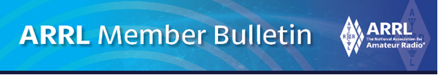

Many of you have told me that you either missed or just didn’t get the really important update on what happened at the Board meeting. Here’s a copy of what was sent for you

January 22, 2025

ARRL Board Reviews and Approves By-Law Changes. Establishes Technical Standards Committee.

The ARRL Board of Directors met in Windsor, Connecticut, for its Annual Meeting, January 17 - 18, 2025. ARRL First Vice President Kristen McIntyre, K6WX, presided over the meeting in place of President Rick Roderick, K5UR, who could not attend.

Vice President McIntyre welcomed new Board members including New England Division Director Tom Frenaye, K1KI, and Division Vice Directors David Galletly, KM2O (Hudson), Andrew Milluzzi, KK4LWR (Southeastern), and Joshua Long, W9HT (Central). She also recognized Central Division Director Brent Walls, N9BA, who previously served as Vice Director.

Prior to the Board meeting, Board committees met on January 16th with the following actions highlighted below:

The Programs & Services Committee and headquarters staff from the Radiosport Department are moving ahead with the creation of a new DXCC award -- DXCC Trident -- which will recognize those who achieve DXCC using CW, phone, and digital modes. Higher achievement endorsements can be earned at the 200, 300, and Honor Roll levels. The DXCC Trident award is intended to spur greater on-air operating and to inspire those using digital modes to also develop their skills in, and practice, CW and SSB.

The Administration & Finance Committee discussed and approved the 2025 operating plan, amending it with an additional $200,000 for Washington advocacy. This includes continuing work to reintroduce bills H.R.4006 and S.3690 – the Amateur Radio Emergency Preparedness Act -- for passage. The committee also agreed that an additional year will be granted to those Incoming QSL Bureaus who still require financial support from all ARRL members to operate.

The Emergency Communications and Field Services Committee established an initiative to track and report on the activities of clubs nationwide. This initiative will help ARRL better understand the scope of these activities and improve club leadership tools. The committee also adopted a rewrite of the ARRL Active Club Primer, a tool for radio club leaders, and a rewrite of the rules and regulations for ARRL Hamfests and Conventions.

The Historical Committee is expanding the ARRL Heritage Museum's online collection by adding a new virtual component, which currently features more than 3,000 images and documents. This virtual museum will continue to grow, showcasing both ARRL's historical collection and other significant items from the history of amateur radio.

**Here are the highlights of actions taken at the Board meeting:**

* Board members discussed motions proposed by a committee that was established by unanimous approval during the January 2024 Annual Meeting. This committee was tasked with evaluating proposed changes to By-Law 46, the Board's Conflict of Interest Policy, and By-Law 42, the charter for the Ethics & Elections Committee. The committee returned with a lengthy motion that certain Directors believed they had not had sufficient time to review and comment on. Despite broad support for passing the committee’s motion, the Board approved delaying the vote until the July 2025 Second Meeting of the Board of Directors. Directors have until April 21, 2025, to file their comments with the committee for consideration in the final motion.

**The Board approved two motions involving elections:**

* By-Law 18. ARRL has had a confusing set of documents defining the elections process. The rules set out in By-Law 18 require at least a two-thirds vote for approval, whereas the rules and regulations found in less formally controlled documents published on the ARRL website only require a simple majority. This motion moved most of the language from the rules and regulations into By-Law 18. The Board also approved changes driven by shortcomings that came to light during the 2024 election cycle. These changes are primarily intended to ensure that elections are conducted at a Division level where the members are voting, and not at a national level.
* By-Law 20. The Board approved a change to By-Law 20, providing greater discretion regarding the previous requirement for a member of the Ethics & Elections committee to observe ballot processing at the third-party election processing company -- an expense now considered unnecessary.

**Government Relations:**

* The Board approved a motion to sunset the Governmental Affairs Committee and authorized the CEO to take on the responsibility of partnering with Director John Robert Stratton, N5AUS (West Gulf), who is currently working with ARRL’s lobbyists in Washington DC. It also requires the CEO to take on the responsibility of reporting the progress being made on certain legislation with quarterly reports to the Administration & Finance Committee.

The Board briefly discussed fund raising for the Legislative Issues Advocacy Fund. This included an appeal by Director Stratton for every Director and Officer to donate towards our legislative efforts. Less than a week after the Board meeting, nearly every Director and Officer has donated to the fund.

**New Technical Standards Committee:**

* The Board approved the formation of a Technical Standards Committee to oversee the successful Clean Signal Initiative (CSI) and to develop future initiatives including amateur radio receiver standards.

**ARRL Foundation.:**

* The Board heard a report from ARRL Foundation President David Norris, K5UZ (Delta Division Director). The Foundation provides philanthropic support for amateur radio by way of the ARRL Foundation Scholarship Program, Club Grant Program, Division Convention Grant Program, and other grants and funds. In 2024, the Foundation awarded 126 scholarships totaling $709,500, through the generosity of ARDC, individuals, and radio clubs.

The Foundation also saw a return of the Club Grant Program and awarded 37 Club Grants totaling $500,502.04. A total of 110 applications were received requesting $1,593,580.24 for 2024. Norris also reported that the Foundation awarded 25 grants valued at $47,434, and 2 Division Convention grants for $12,250.

**Elections:**

* Executive Committee (EC). Directors re-elected to the EC include Bill Lippert, AC0W (Dakota), Art Zygielbaum, K0AIZ (Midwest), Jim Boehner, N2ZZ (Roanoke), and Jeff Ryan, K0RM (Rocky Mountain). Newly elected to the EC is Scott Yonally, N8SY (Great Lakes).

**ARRL Foundation Board:**

* ARRL Director Mark Tharp, KB7HDX (Northwestern), was re-elected, and Director Tom Frenaye, K1KI (New England), was elected to fill the seat vacated by former Central Division Director Carl Luetzelschwab, K9LA. Past Central Division Director Kermit Carlson, W9XA, and CEO David A. Minster, NA2AA, were re-elected for 3-year terms.

The complete minutes of the 2025 Annual Meeting of the ARRL Board of Directors will be available soon on the ARRL website.

The Second Meeting of the ARRL Board of Directors is scheduled for July 18 - 19, 2025.

***2025 Great Lakes Division Hamfests***

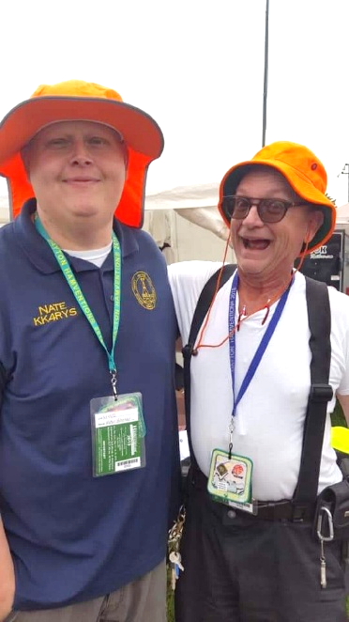

Here in the Great Lakes Division, we have over 50 hamfests a year.

So, if you haven’t started planning your hamfest schedule yet, you really need to start now.

Please post this listing in your club's newsletter and announce the swaps on your local nets. Talk them up.

Let's fully support all of our hamfests in every way possible. It means success for everyone. Be sure to invite your ARRL Officials as soon as your date is set.

If you are planning on having your hamfest listed in QST please be sure to start your planning well in advance of your Hamfest date, as this allows adequate time for QST Listings. QST announcements require a 3-month lead time.

To be fair to our division’s clubs, the Great Lakes Division policy **now has 2 requirements**.

**Any club requesting ARRL sanctioning within the Great Lakes Division must now be an ARRL Affiliated Club with a maximum of two hamfests/swaps in any given calendar year, and they must be at least four months apart.**

|  |  |
| --- | --- |
| **02/08/2025 -**[**Cherryland ARC Ham Swap**](https://www.arrl.org/hamfests/cherryland-arc-ham-swap)  **Location:**Traverse City, MI **Sponsor:** Cherryland Amateur Radio Club **Website:** [http://cherrylandarc.com](http://cherrylandarc.com/) [**Learn More**](https://www.arrl.org/hamfests/cherryland-arc-ham-swap) | **02/22/2025 -**[**Livonia Amateur Radio Club Annual Swap & Shop**](https://www.arrl.org/hamfests/livonia-amateur-radio-club-annual-swap-shop-1)  **Location:**Northville , MI **Sponsor:** Livonia Amateur Radio Club [**Learn More**](https://www.arrl.org/hamfests/livonia-amateur-radio-club-annual-swap-shop-1) |
| **03/09/2025 -**[**Northern Ohio Amateur Radio Society Winter Hamfest**](https://www.arrl.org/hamfests/northern-ohio-amateur-radio-society-winter-hamfest)  **Location:**Elyria, OH **Sponsor:** Northern Ohio Amateur Radio Society **Website:** <https://www.noars.net/hamfests/winter-hamfest/> [**Learn More**](https://www.arrl.org/hamfests/northern-ohio-amateur-radio-society-winter-hamfest) | **03/16/2025 -**[**Toledo Mobile Radio Association Hamfest and Computer Fair**](https://www.arrl.org/hamfests/toledo-mobile-radio-association-hamfest-and-computer-fair-3)  **Location:**Perrysburg, OH **Sponsor:** Toledo Mobile Radio Association **Website:** [http://www.w8hhf.org](http://www.w8hhf.org/) [**Learn More**](https://www.arrl.org/hamfests/toledo-mobile-radio-association-hamfest-and-computer-fair-3) |
| **03/22/2025 -**[**Cave City Hamfest**](https://www.arrl.org/hamfests/cave-city-hamfest-14)  **Location:**Cave City, Kentucky, KY **Sponsor:** MCARC **Website:** [http://ky4x.org](http://ky4x.org/) [**Learn More**](https://www.arrl.org/hamfests/cave-city-hamfest-14) | **~~03/23/2025 -~~**[**~~Lowell Amateur Radio Youth Club Hamfest~~**](https://www.arrl.org/hamfests/lowell-amateur-radio-youth-club-hamfest-1)  **~~Location:~~**~~Lowell, MI~~  **Cancelled** |
| **04/05/2025 -**[**Cuyahoga Falls Amateur Radio Club 69th Hamfest**](https://www.arrl.org/hamfests/cuyahoga-falls-amateur-radio-club-69th-hamfest)  **Location:**Cuyahoga Falls , OH **Sponsor:**Cuyahoga Falls Amateur Radio Club **Website:**[**https://www.cfarc-hamfest.org**](https://www.cfarc-hamfest.org/)[**Learn More**](https://www.arrl.org/hamfests/cuyahoga-falls-amateur-radio-club-69th-hamfest) | **04/05/2025 -**[**E-town Hamfest (The Lincoln Trail Amateur Radio Club's 47th Annual Hamfest)**](https://www.arrl.org/hamfests/e-town-hamfest-the-lincoln-trail-amateur-radio-club-s-47th-annual-hamfest)  **Location:**Elizabethtown , KY **Sponsor:**Lincoln Trail Club[**Learn More**](https://www.arrl.org/hamfests/e-town-hamfest-the-lincoln-trail-amateur-radio-club-s-47th-annual-hamfest) |

You can always find the latest information to upcoming hamfests on the Great Lakes Division website.

](https://www.arrl.org/hamfests/search/Location.division_id:gl)

Just click to get the latest hamfest updates.

](https://kyqsoparty.org/)

](https://kyqsoparty.org/)

***Club Links***

](https://arrl-greatlakes.org/links.html)I’ve received a number of new requests from clubs to be listed on the “Links” club page.

Is your club listed? If not, send the URL of your club website to me [n8sy@n8sy.com](mailto:n8sy@n8sy.com) and I’ll get it listed.

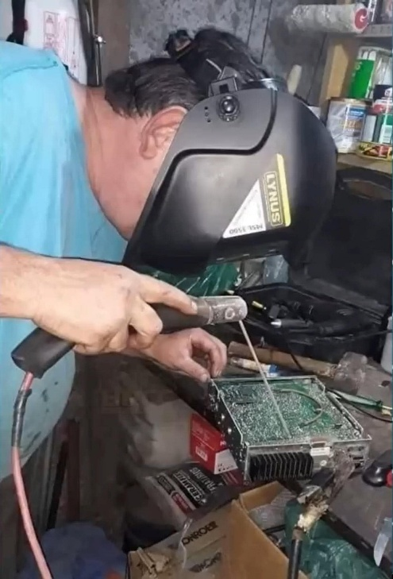***Wanted… Your Photo’s***

Have you seen the Photo Gallery on the Great Lakes Division website? If you haven’t you really need to, your face may be among the many already posted there.

[](https://arrl-greatlakes.org/gallery/index.php)

I’m always looking for more pictures to use in the Gallery, newsletter, banner and video display. Please, send me your pictures!!! Send them to: [n8sy@n8sy.com](mailto:n8sy@n8sy.com)

***Results of Survey – GLD-9***

There are the results of our latest survey. It’s great to see your responses.

Got a question that you think should be asked? Let me know… [n8sy@n8sy.com](mailto:n8sy@n8sy.com)

***Winter Field Day…***

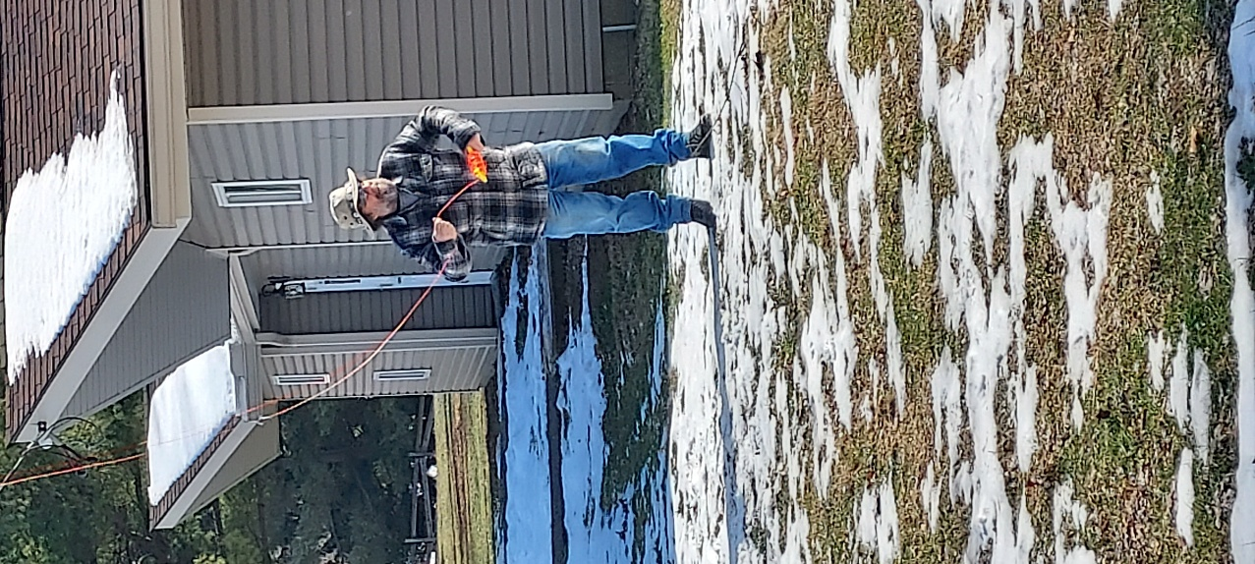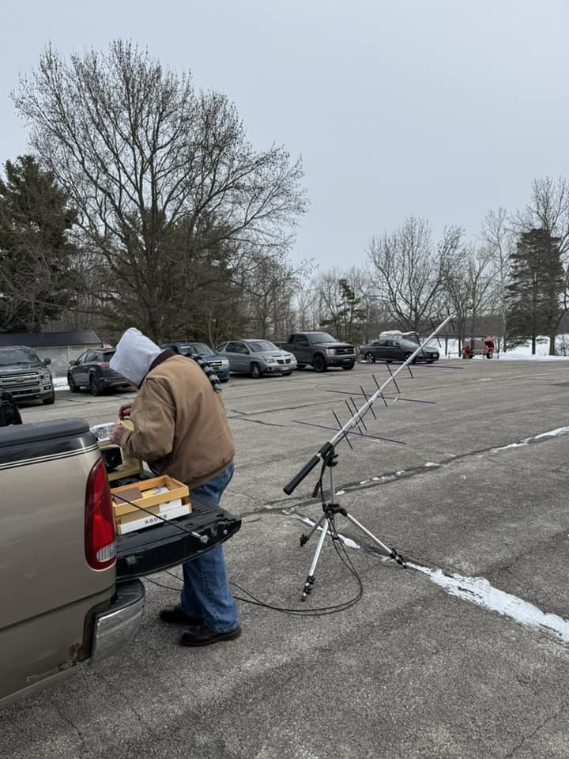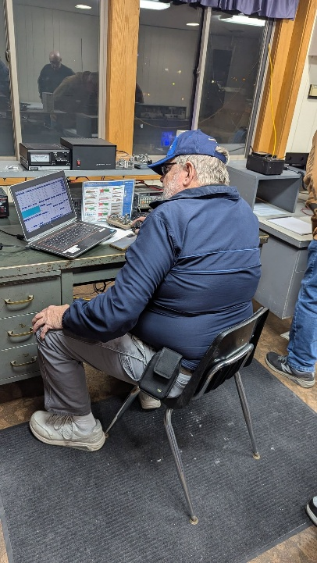

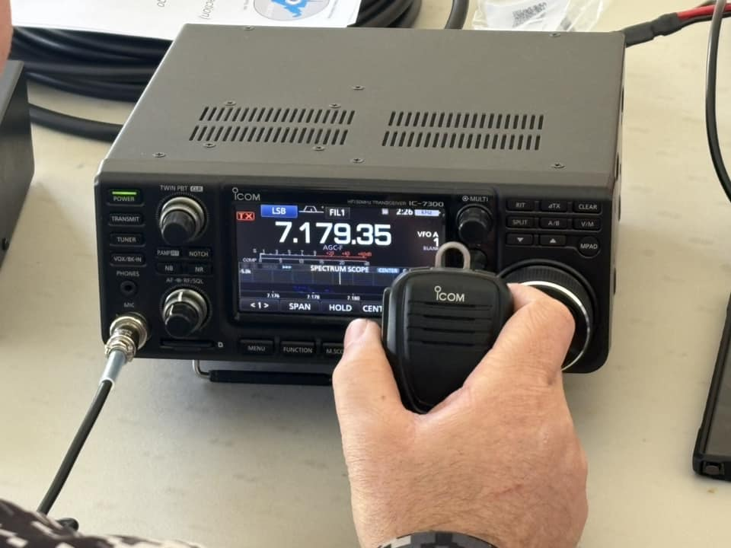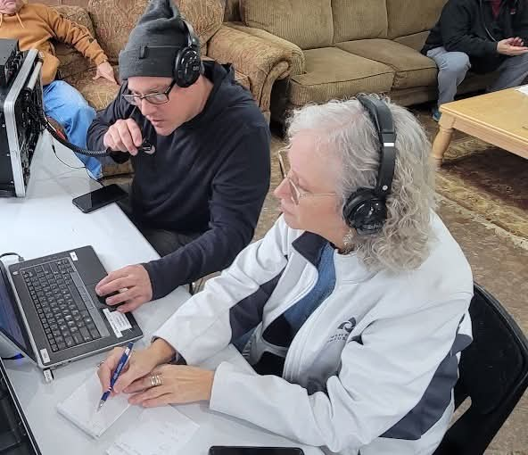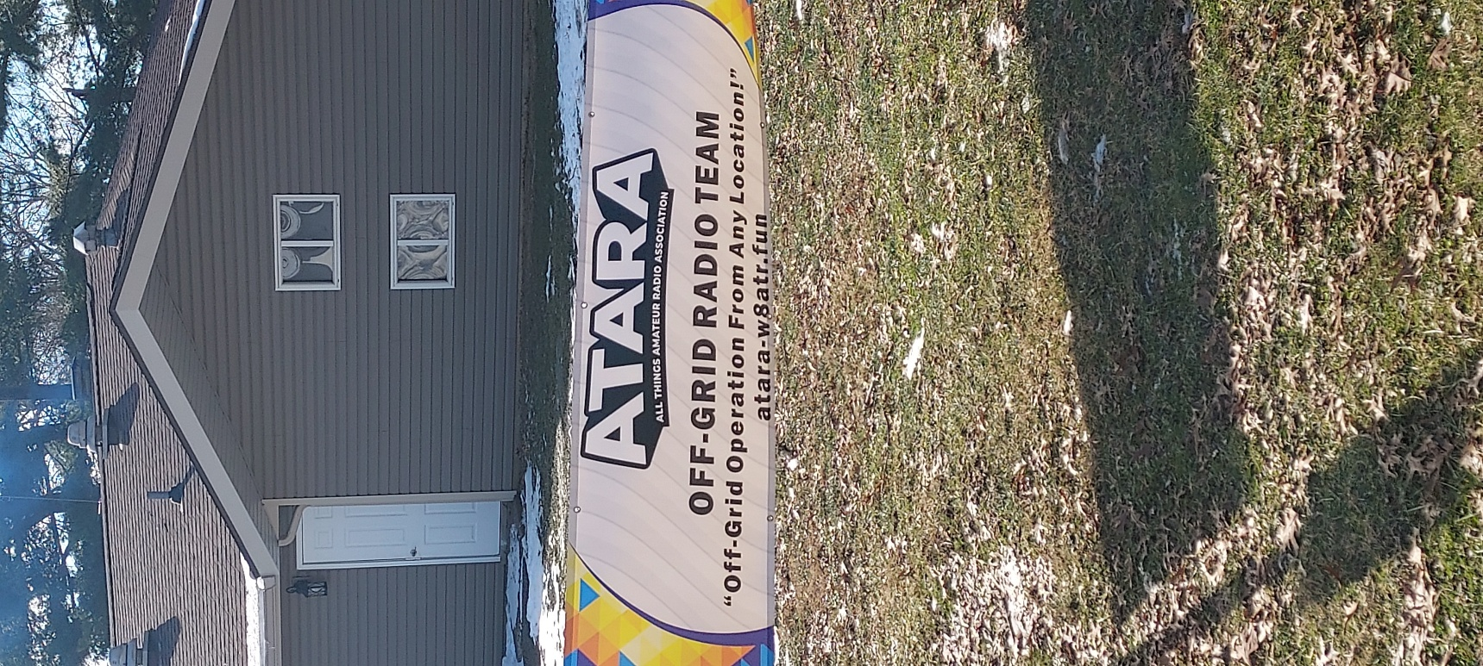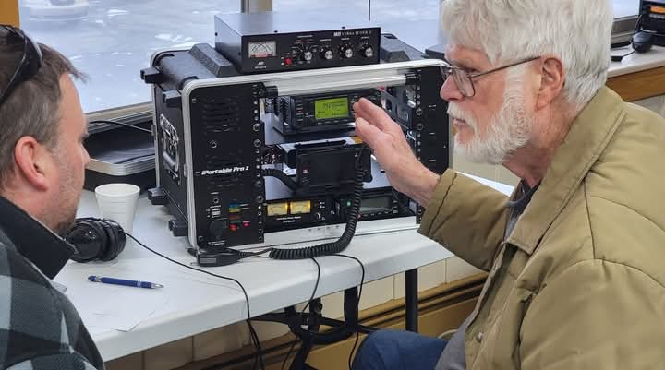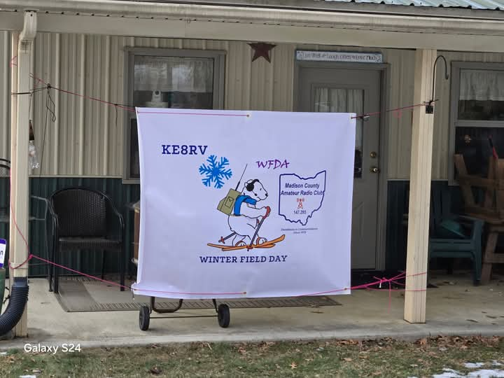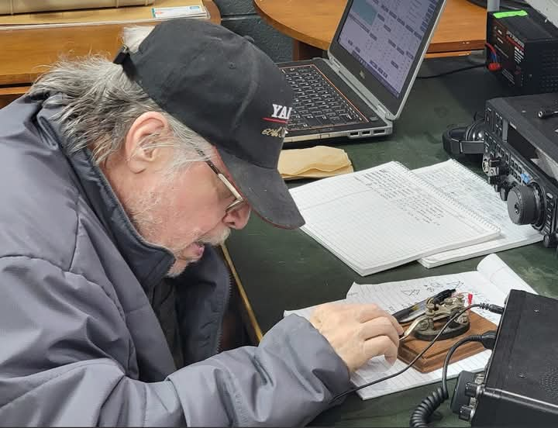

See Ya’ Next Month!!!!