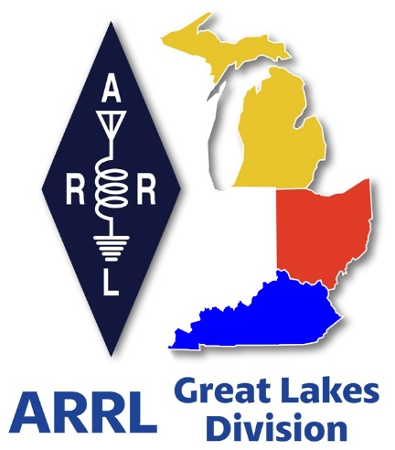 ***Radio Waves***

***The Great Lakes Division***

***Mid- Month Report***

***From the Michigan Section Manager***

Larry Camp, WB8R

**Michigan ARRL Section News March 2025**

Greetings to the Amateurs of Michigan and all others who read this.

Spring is here for sure as yesterday (March 14) here in Coldwater (13 miles from Indiana) the thermometer made it to 75 degrees. What a beautiful spring day! I hope that all you were able to enjoy similar beautiful weather wherever you are.

**Michigan Section Youth Coordinator Appointed**

Here in the Michigan Section of the ARRL, I have the pleasure of acknowledging volunteerism at its finest. To manage the various areas of importance, we typically appoint willing individuals to manage certain activities to support the hams of our section. This includes positions such as Section Emergency Coordinator, Section Traffic Manager, Affiliated Club Coordinator, Technical Coordinator, State Government Liaison and now we have a new Section Youth Coordinator.

It is my pleasure to announce that Kanushi Desai, KE8RNA from Midland, MI has accepted an appointment as the new Michigan Section Youth Coordinator. We are delighted to welcome her to the Michigan ARRL Section Staff. She brings a fresh approach to the tasks at hand and will be working with students, schools and youth radio clubs to bring amateur radio to more young people in the Michigan school systems. She will be working closely with Sean Fleming, K8KHZ, our Affiliated Club Coordinator.

When you have an opportunity to meet Kanushi, be sure to congratulate her on her appointment and ask if there is anything that you can do to be of assistance to her in her new endeavor.

**2025 Michigan ARRL Sanctioned Hamfests and Other Events**

Note: Callsigns in parentheses indicate ARRL officials planning to attend

Apr 12, AC8RC Allegan Mini-Swap, Burnips, MI (K8TB)

Apr 19, SJCARC Hamfest, Centreville, MI (WB8R)

May 3, Wexaukee ARC Hamfest, Cadillac, MI (WB8R & AC8W – QSL Card Checker)

May 10, GMARC Trunk Swap, Shelby Twp, MI

Jun 7, IRA Hudsonville Swap, Hudsonville, MI (K8TB)

Jun 7, LARS Yooper Hamfest, Newberry, MI (WB8R)

Jun 8, Crossroads Hamfest, Marshall, MI (WB8R)

Jun 14, Midland Hamfest, Midland, MI (WB8R)

Jun 15, Monroe Hamfest, Monroe, MI (WB8R)

Sep 6, Grand Rapids Area hamfest, Wyoming, MI (WB8R)

Sep 13, GMARC Trunk Swap, Shelby Twp, MI

Sep 14, Adrian Hamfest, Adrian, MI (WB8R)

Sep 20, Top of Michigan ARC Hamfest, Gaylord, MI (WB8R)

Oct 11, Muskegon Color Tour Hamfest, Muskegon, MI (WB8R)

Oct 19, USECA Hamfest, St. Clair Shores, MI (TBD)

**ARES/NTS Activity for February, 2025**

Contributed value of ARES Activity: $68,320

Contributed value of NTS hours: $71,980

Total value contributed to the State of Michigan: $140,300

**Public Service Honor Roll:**

K8ED 372, KB9PGW 116, KD8ZCM 67, ND8W 59, K8RDN 48, WB8TQZ 37, WD8USA 32, N8RWF 25, KE8HKA 23, KE8CEH 19, WB8R 13, KE8CYC 10, KC8YVF 6.

**Brass Pounder’s League: None**

I try to attend as many swaps as possible during the course of the year and our Asst SM Tom, K8TB will be substituting for me on at least a couple of our ‘double up days’ where there may be simultaneous swaps.

We are less than a month away from the year’s first hamfest and I am on a fast idle, ready to hit the road. Please stop by the ARRL table and say hello.

Travel Safely, and best 73,

Larry

***From the Ohio Section Manager***

Tom Sly, WB8LCD

The latest edition of PostScript is now online and ready for you to read! Grab your favorite refreshment, sit back and relax in your comfy chair, and just enjoy the great reading found in this latest edition!

<https://arrl-ohio.org/wp-content/uploads/2025/03/PS_03-10-2025.pdf>

There’s an awful lot of Ham Radio activities going on in the Ohio Section, so get off the chair or couch you’re sitting on and get out there, get involved, and get on the air!

Tom…

|  |
| --- |
| ***Just Ahead in Radiosport*** |

|  |
| --- |
| * March 13 -- BCC QSO Party (CW, phone, digital) * March 15 -- PODXS 070 Club St. Patrick’s Day Contest (digital) * March 15 - 17 -- BARTG HF RTTY Contest (digital) * March 15 - 16 -- Russian DX Contest (CW, phone) * March 15 - 16 -- F9AA Cup, SSB (phone) * March 15 -- AGCW VHF/UHF Contest (CW) * March 15 - 16 -- Virginia QSO Party (CW, phone, digital) * March 15 - 24 -- AWA John Rollins Memorial DX Contest (CW, phone) * March 16 -- UBA Spring Contest, SSB (phone) * March 16 - 17 -- Run for the Bacon QRP Contest (CW) * March 17 -- Bucharest Digital Contest (FT4) * March 17 -- RSGB FT4 Contest (FT4) * March 19 -- IRTS 80m Counties Contest (CW, phone) * March 20 - 21 -- Walk for the Bacon QRP Contest (CW)   Remember to visit the [ARRL Contest Calendar](https://arrl.informz.net/z/cjUucD9taT0zMjgwNTY2JnA9MSZ1PTUyMDM2NDI5NiZsaT0zNzI2NzI0OA/index.html) for more events and information. |

|  |
| --- |
| ***ARRL Ham Radio Open House — Site Locator Live*** |

|  |
| --- |
| ARRL Ham Radio Open House is a national event being hosted by local amateur radio clubs in April to coincide with World Amateur Radio Day on April 18. The event is designed to highlight technical innovations in ham radio, and show off the current state of the art. It will serve as a tool to tell the story of amateur radio being a pathway to tomorrow's technical careers.    A site locator is now live on the ARRL Ham Radio Open House page at [**www.arrl.org/open-house**](https://arrl.informz.net/z/cjUucD9taT0zMjgwNTY2JnA9MSZ1PTUyMDM2NDI5NiZsaT0zNzI2NzIyMA/index.html). Participating clubs may enter their information so that local hams and members of the public may find the event.  [A screenshot of a map  AI-generated content may be incorrect.](https://arrl.informz.net/z/cjUucD9taT0zMjgwNTY2JnA9MSZ1PTUyMDM2NDI5NiZsaT0zNzI2NzIyMA/index.html) |

|  |
| --- |
|  |
|  |

|  |
| --- |
| A public relations workshop for those organizing an event is being held via Zoom on Wednesday, March 19. It is open to any amateur radio public information volunteer, but will be especially valuable to ARRL Public Information Coordinators, Public Information Officers, Section Managers, Affiliated Club Coordinators, club presidents, and other leaders. [Registration](https://arrl.informz.net/z/cjUucD9taT0zMjgwNTY2JnA9MSZ1PTUyMDM2NDI5NiZsaT0zNzI2NzIyMQ/index.html) is required.    If you’re unable to make the live interactive event, a recording will be available afterward. For more information on how to create a Ham Radio Open House at your club’s station, visit [**www.arrl.org/world-amateur-radio-day**](https://arrl.informz.net/z/cjUucD9taT0zMjgwNTY2JnA9MSZ1PTUyMDM2NDI5NiZsaT0zNzI2NzIyMg/index.html). |

|  |
| --- |
| ***Just Ahead in Radiosport*** |

|  |
| --- |
| * March 13 -- BCC QSO Party (CW, phone, digital) * March 15 -- PODXS 070 Club St. Patrick’s Day Contest (digital) * March 15 - 17 -- BARTG HF RTTY Contest (digital) * March 15 - 16 -- Russian DX Contest (CW, phone) * March 15 - 16 -- F9AA Cup, SSB (phone) * March 15 -- AGCW VHF/UHF Contest (CW) * March 15 - 16 -- Virginia QSO Party (CW, phone, digital) * March 15 - 24 -- AWA John Rollins Memorial DX Contest (CW, phone) * March 16 -- UBA Spring Contest, SSB (phone) * March 16 - 17 -- Run for the Bacon QRP Contest (CW) * March 17 -- Bucharest Digital Contest (FT4) * March 17 -- RSGB FT4 Contest (FT4) * March 19 -- IRTS 80m Counties Contest (CW, phone) * March 20 - 21 -- Walk for the Bacon QRP Contest (CW)   Remember to visit the [ARRL Contest Calendar](https://arrl.informz.net/z/cjUucD9taT0zMjgwNTY2JnA9MSZ1PTUyMDM2NDI5NiZsaT0zNzI2NzI0OA/index.html) for more events and information. |

***Spring Arrives!!***

The spring equinox (also called the March equinox or vernal equinox) falls on **Thursday, March 20**, which is earlier than it's been in over a century!

This event marks the astronomical first day of spring in the Northern Hemisphere.

***Scott’s Stuff***

Hi Gang,

I’ve had a blast these past several weeks visiting with many of you at your meetings and Hamfests!

March always brings a whole bunch of celebrations and fun-filled contests that will keep even the most housebound ham busier than a long tailed cat in a room full of rocking chairs!!

OK… before you even ask…. YES… I will be having my usual ***GREEN*** beer or two… to celebrate St Patty’s Day this coming Monday!

I know it’s probably hard to believe, but I am 5% Irish and that’s according to Ancestry.com and I’m taking full advantage of their analysis.

Hey, I also need to mention that this March is when we observe Tornado Safety Week. In Kentucky (it has come and went already) the week begins March 1 – 7. In Michigan it is March 16 – 22 and in Ohio is the same, March 16 – 22.

Ok… that’s going to do it from here this time around.

Catch you on the air, in a meeting or at a hamfest!!!

Be Radio Acitve!!!!!

73,

Scott, N8SY

Great Lakes Division Director

[n8sy@arrl.org](mailto:n8sy@arrl.org)

***Handbook Give Away***

Ok… now, can I have a drum roll please?

The winner of the Handbook Give Away is none other than…

*Thomas Currie, N4AOF*

from Louisville, Kentucky

Did you enter? You can’t win if you don’t enter, so keep your eyes peeled for the next time the Give Away comes up on the website, click on that link and get yourself entered.

***2025 Great Lakes Division Hamfests***

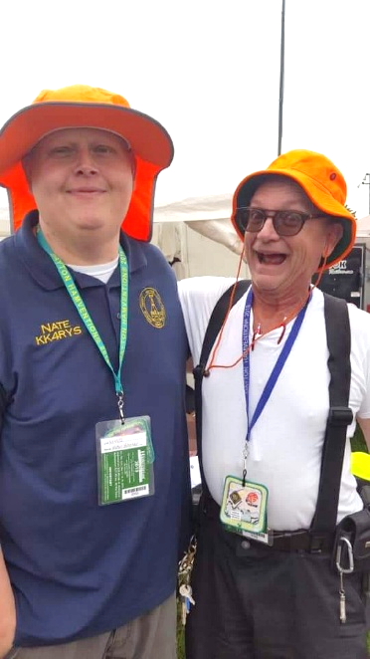

Here in the Great Lakes Division, we have over 50 hamfests a year.

So, if you haven’t started planning your hamfest schedule yet, you really need to start now.

Please post this listing in your club's newsletter and announce the swaps on your local nets. Talk them up.

Let's fully support all of our hamfests in every way possible. It means success for everyone. Be sure to invite your ARRL Officials as soon as your date is set.

If you are planning on having your hamfest listed in QST please be sure to start your planning well in advance of your Hamfest date, as this allows adequate time for QST Listings. QST announcements require a 3-month lead time.

To be fair to our division’s clubs, the Great Lakes Division policy **now has 2 requirements**.

**Any club requesting ARRL sanctioning within the Great Lakes Division must now be an ARRL Affiliated Club with a maximum of two hamfests/swaps in any given calendar year, and they must be at least four months apart.**

|  |  |
| --- | --- |
| **03/16/2025 -**[**Toledo Mobile Radio Association Hamfest and Computer Fair**](https://www.arrl.org/hamfests/toledo-mobile-radio-association-hamfest-and-computer-fair-3)  **Location:**Perrysburg, OH **Type:** ARRL Hamfest **Sponsor:** Toledo Mobile Radio Association **Website:** [http://www.w8hhf.org](http://www.w8hhf.org/) [**Learn More**](https://www.arrl.org/hamfests/toledo-mobile-radio-association-hamfest-and-computer-fair-3) | **03/22/2025 -**[**Cave City Hamfest**](https://www.arrl.org/hamfests/cave-city-hamfest-14)  **Location:**Cave City, Kentucky, KY **Type:** ARRL Hamfest **Sponsor:** MCARC **Website:** [http://ky4x.org](http://ky4x.org/) [**Learn More**](https://www.arrl.org/hamfests/cave-city-hamfest-14) |
| **04/05/2025 -**[**Cuyahoga Falls Amateur Radio Club 69th Hamfest**](https://www.arrl.org/hamfests/cuyahoga-falls-amateur-radio-club-69th-hamfest)  **Location:**Cuyahoga Falls , OH **Type:** ARRL Hamfest **Sponsor:** Cuyahoga Falls Amateur Radio Club, Inc. **Website:** [https://www.cfarc-hamfest.org](https://www.cfarc-hamfest.org/) [**Learn More**](https://www.arrl.org/hamfests/cuyahoga-falls-amateur-radio-club-69th-hamfest) | **04/05/2025 -**[**E-town Hamfest (The Lincoln Trail Amateur Radio Club's 47th Annual Hamfest)**](https://www.arrl.org/hamfests/e-town-hamfest-the-lincoln-trail-amateur-radio-club-s-47th-annual-hamfest)  **Location:**Elizabethtown , KY **Type:** ARRL Hamfest **Sponsor:** Lincoln Trail Club [**Learn More**](https://www.arrl.org/hamfests/e-town-hamfest-the-lincoln-trail-amateur-radio-club-s-47th-annual-hamfest) |
| **04/12/2025 -**[**AC8RC Allegan Mini-Swap**](https://www.arrl.org/hamfests/ac8rc-allegan-mini-swap-1)  **Location:**Burnips, MI **Type:** ARRL Hamfest **Sponsor:** AC8RC Allegan County Amateur Radio Club [**Learn More**](https://www.arrl.org/hamfests/ac8rc-allegan-mini-swap-1) | **04/19/2025 -**[**SJCARC Hamfest**](https://www.arrl.org/hamfests/sjcarc-hamfest)  **Location:**Centreville, MI **Type:** ARRL Hamfest **Sponsor:** St. Joseph County Amateur Radio Club [**Learn More**](https://www.arrl.org/hamfests/sjcarc-hamfest) |
| **04/26/2025 - [Tusco Amateur Radio Club's 2025 Hamfest, Computer & Electronics Show](https://www.arrl.org/hamfests/tusco-amateur-radio-club-s-2025-hamfest-computer-electronics-show" \o "Tusco Amateur Radio Club's 2025 Hamfest, Computer & Electronics Show)**  **Location:**Dover, OH **Type:** ARRL Hamfest **Sponsor:** Tusco Amateur Radio Club **Website:** <http://www.w8zx.net/hamfest> [**Learn More**](https://www.arrl.org/hamfests/tusco-amateur-radio-club-s-2025-hamfest-computer-electronics-show) | **04/27/2025 -**[**Athens Hamfest**](https://www.arrl.org/hamfests/athens-hamfest-12)  **Location:**Athens, OH **Type:** ARRL Hamfest **Sponsor:** Athens County Amateur Radio Association **Website:** <https://www.ac-ara.org/> [**Learn More**](https://www.arrl.org/hamfests/athens-hamfest-12) |
| **05/03/2025 - [Wexaukee ARC Swap & Shop](https://www.arrl.org/hamfests/wexaukee-arc-swap-shop-1" \o "Wexaukee ARC Swap & Shop)**  **Location:**Cadillac, MI **Type:** ARRL Hamfest **Sponsor:** Wexaukee Amateur Radio Club **Website:** [http://wexaukeearc.org](http://wexaukeearc.org/) [**Learn More**](https://www.arrl.org/hamfests/wexaukee-arc-swap-shop-1) | **05/10/2025 -**[**GMARC Trunk Swap**](https://www.arrl.org/hamfests/gmarc-trunk-swap-10)  **Location:**Shelby Township, MI **Type:** ARRL Hamfest **Sponsor:** General Motors Amateur Radio Club **Website:** [http://gmarc.org](http://gmarc.org/) [**Learn More**](https://www.arrl.org/hamfests/gmarc-trunk-swap-10) |
| **05/10/2025 - 05/15/2025** [**RV Radio Network Rally**](https://www.arrl.org/hamfests/rv-radio-network-rally-1)  **Location:**Navarre, OH **Type:** ARRL Convention **Sponsor:** RV Radio Network [**Learn More**](https://www.arrl.org/hamfests/rv-radio-network-rally-1) | **05/15/2025 - 05/18/2025** [**Four Days In May**](https://www.arrl.org/hamfests/four-days-in-may-2)  **Location:**Fairborn , OH **Type:** ARRL Convention **Sponsor:** QRP Amateur Radio Club International **Website:** <http://qrparci.org/fdim> [**Learn More**](https://www.arrl.org/hamfests/four-days-in-may-2) |
| **05/16/2025 - 05/18/2025** [**Dayton Hamvention**](https://www.arrl.org/hamfests/dayton-hamvention-8)  **Location:**Xenia, OH **Type:** **Sponsor:** Dayton Amateur Radio Association **Website:** [http://Hamvention.org](http://hamvention.org/) [**Learn More**](https://www.arrl.org/hamfests/dayton-hamvention-8) | |

You can always find the latest information to upcoming hamfests on the Great Lakes Division website.

](https://www.arrl.org/hamfests/search/Location.division_id:gl)

Just click to get the latest hamfest updates.

***Amateur Television Friday Night Dinner.***

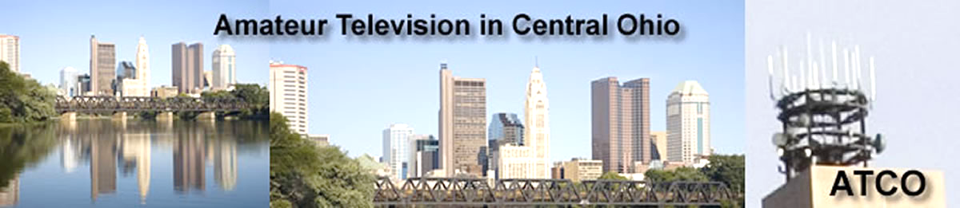

The ATV Friday Night Dinner will be on Hamvention weekend --- **May 16** at 6:30 PM at the China Garden Buffet Restaurant (937-781-9999), 112 Woodman Drive in Dayton, Ohio 45431 (Airway Shopping Center).

The all you can eat Buffet Dinner is $11.99. We will have dinner and then ATV presentations with it concluding at 9 PM.

All are invited. Door prizes will be awarded.

[***Dayton Bus Trip – May 17, 2025***](https://w8rp.org/daytonbus2025/)

The ARROW Communications Association and the [Toledo Mobile Radio Association (TMRA)](https://w8hhf.org/) are proud to sponsor a motor coach trip to the [Hamvention](http://www.hamvention.org/)2025 in Dayton, Ohio. This one-day trip leaves early in the morning on May 17, 2025 and returns the same day after Hamvention closes for the day at 5:00 p.m.

The bus has two pickup spots, in Ann Arbor and in Toledo (Rossford). Please join us! Tickets are $70 per person. Please note that this does not include the Hamvention ticket, which you need to [purchase separately](https://hamvention.org/purchase-tickets/).

ARROW started a bus in 2002, this annual club activity has grown in size and reputation with Hams across Michigan. We have hosted to over 700 Hams for this event.

](https://i0.wp.com/w8rp.org/wp-content/uploads/activities/dayton-bus-trip/dayton2004groupshot.jpg)

**Register before the bus fills up**  
ARROW and TMRA reserves the right to cancel the bus if not enough people sign up. If the bus is cancelled for unforeseen reasons, refunds will be issued.

**There are two pickup/drop off locations on May 17th, 2025**  
Ann Arbor – 601 W Stadium Blvd, Ann Arbor, MI – Departing 4:30 am

Toledo – 727 Lime City Rd. Rossford, OH – Departing 5:30 am

The plan is to arrive at the Hamvention around 8:30 am. On board, you can stretch out, relax, chat with other Hams and enjoy a continental breakfast with coffee as the coach takes you directly to the door of the country’s largest amateur radio event!

We arrive at Dayton early enough so that you can enjoy a full day!

* Visit exhibits
* See what’s new from major manufacturers
* Attend seminars
* Take license tests
* Shop one of the largest outdoor swap meets in the United States

***Send a Radiogram***

**What’s a *Radiogram*?**

You’ve probably heard of amateur radio (“ham”) operators, and you might know a friend, family member, or neighbor who loves to build radio equipment and talk to thousands of other ham operators around the world!

But, you might **not** know that amateur radio operators are primed and ready to step in and provide valuable communications to the general public, when all else fails. Even if Internet service, power lines, and phone lines are all down, amateur radio still can get the message through.

To be ready for this, many amateurs have joined a network called the National Traffic System (NTS), which is like a telegraph office over radio. NTS volunteers spend their free time relaying messages, called **Radiograms**, entirely by amateur radio, completely free of charge. This is great practice to be sure they can serve the public during a true emergency!

**Send a Radiogram Now — It’s Free!**

Now, there’s a way that YOU can try Amateur Radio messaging! Think of a friend or family member you’d like to contact by Radiogram. You can send any short message, as long as it’s not business-related, urgent or critical, or too private or personal. Your message will be picked up by an Amateur Radio volunteer operator and relayed across the country to near its destination; finally, the recipient will get a local phone call from a nearby ham, or the message might even be delivered in person. Along the way, ham operators will be relaying your message by voice, digital, or even Morse code, and getting valuable practice in emergency public service.

**Your Message**

To make it easy, please choose one of the standard message texts below. (Note: Both the sender and the recipient must be in the United States or Canada).

***Club Links***

](https://arrl-greatlakes.org/links.html)I’ve received a number of new requests from clubs to be listed on the “Links” club page.

Is your club listed? If not, send the URL of your club website to me [n8sy@n8sy.com](mailto:n8sy@n8sy.com) and I’ll get it listed.

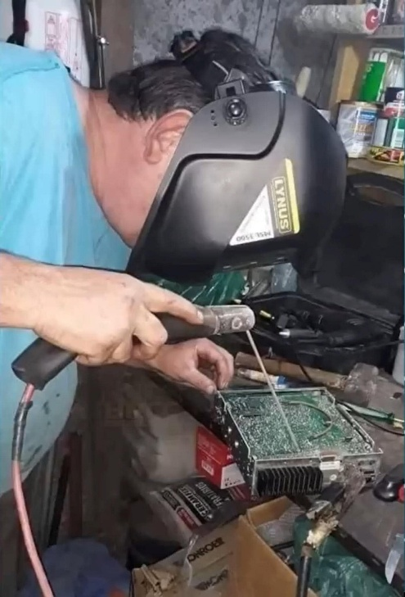***Wanted… Your Photo’s***

Have you seen the Photo Gallery on the Great Lakes Division website? If you haven’t you really need to, your face may be among the many already posted there.

[](https://arrl-greatlakes.org/gallery/index.php)

I’m always looking for more pictures to use in the Gallery, newsletter, banner and video display. Please, send me your pictures!!! Send them to: [n8sy@n8sy.com](mailto:n8sy@n8sy.com)

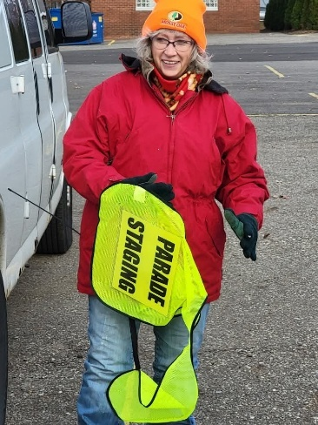

***The Not-So-Secret Sauce to a Thriving Club***

The question echoes in ham radio circles as regularly as a CQ call: "What's the magic bullet for a successful amateur radio club?" Some clubs seem to be beacons of activity, membership rosters overflowing, while others struggle to muster a quorum. The truth is, there's no mystical, frequency-hopping secret. The key ingredient, surprisingly, boils down to this: make your club active and, dare we say, ***FUN.***

Yes, fun. It sounds almost too simple, doesn't it? But let's be honest, no one willingly sacrifices their precious free time to attend what feels like a mandatory lecture on advanced modulation techniques delivered at breakneck speed. Members need to leave each meeting or event feeling enriched, as though their time was well-spent. Whether it's gaining new knowledge, fostering camaraderie, or simply sharing a good laugh, the experience must be worthwhile.

***"People rarely succeed unless they have fun in what they are doing." - Dale Carnegie***

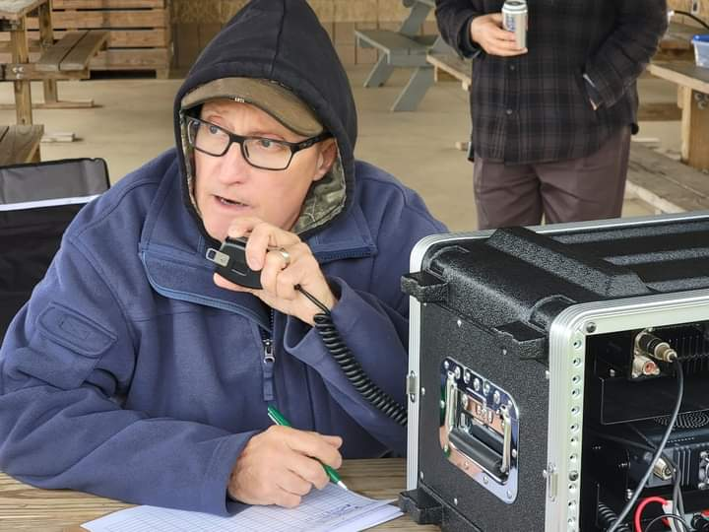

Think of your club as a radio signal. A weak, predictable signal fades into the background noise. A vibrant, engaging signal, however, cuts through the static and attracts attention. The challenge, then, is to boost your club's signal strength. How do you amplify the wattage and make it truly resonate with current and potential members?

First, inject some vitality into your meetings. Cut down on the lengthy recitations of bylaws and committee reports. Instead, invigorate the agenda with dynamic presentations, practical workshops, interactive demonstrations, or even a lively question-and-answer session. Tap into the wealth of knowledge within your membership. Invite experienced hams to share their expertise on topics ranging from antenna construction to the nuances of digital modes. The possibilities are as vast as the radio spectrum itself.

***“The vibrancy of a thriving club extends far beyond the confines of formal meetings.”***

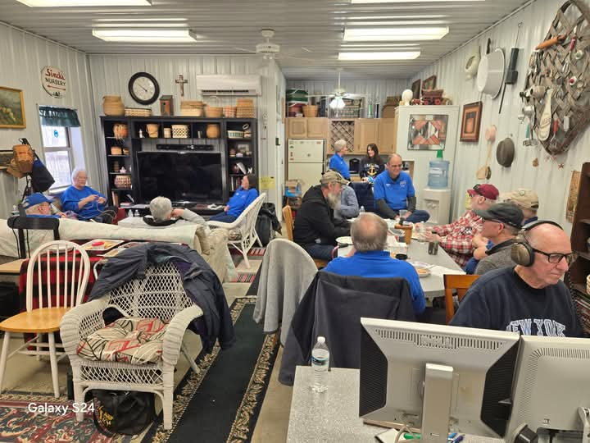Organize activities that ignite excitement and foster a sense of adventure. While mainstays like Field Day are essential, consider incorporating more frequent, smaller-scale outings. SOTA (Summits On The Air) or POTA (Parks On The Air) activations provide opportunities for outdoor operating and exploration. Fox hunts offer a thrilling blend of radio direction finding and problem-solving. Even a simple, casual coffee meet-up can foster valuable connections and facilitate informal knowledge sharing. One group of club members meets every Friday for breakfast, where the discussions range from the intricacies of dipole antenna assembly to the latest breaking news – a testament to the power of camaraderie and shared interests.

Furthermore, actively seek opportunities to partner with community organizations for outreach events. Sharing the wonders of amateur radio with a new generation is crucial for the hobby's continued growth.

Consider giving presentations to local service organizations like the Lions Club, Rotary, or even your Local Emergency Planning Committee. These are excellent platforms to showcase the vital role amateur radio plays in emergency communications and community service.

Ultimately, the success of an amateur radio club hinges on cultivating a strong sense of community and belonging. It needs to be a place where members feel appreciated, where they can learn and share their knowledge freely, and where they can forge lasting friendships, and maybe even share a few jokes along the way. A club should be a supportive environment where newcomers feel welcome and experienced operators are eager to mentor.

Let's be brutally honest, a radio club devoid of laughter, engagement, and genuine connection is simply... static. So, break free from the humdrum routine, inject some fun, and watch your club's signal soar to new heights. The world of amateur radio is a world of innovation, exploration, and camaraderie. Make sure your club reflects that.

***Amateur Radio License Map***

Created by: Ross, KT1F

Welcome to my little spare time project. I've been working on this on and off for about a year as time and motivation allows.

[Amateur Radio License Map | Ham Info (tetranz.com)](https://haminfo.tetranz.com/map)

This is more of an excuse to have some fun with Maps and Geocoding than anything else, but it hopefully provides something interesting to play with. "Geocoding" means to convert physical addresses into longitude and latitude coordinates. Behind the scenes, this site has been slowly geocoding all active amateur radio addresses in the FCC license data. The FCC data includes all licenses which have a status of "active".

I've found it an interesting project with lots of little challenges. Some of this is because of the wide variation of population and therefore "ham density" throughout the country. I've had to balance that with performance issues both at the database query level and practical limitations of Google Maps.

The data is also kind of messy with multiple licensees at one address and multiple addresses at the same location. This last issue is mostly due to spelling variations. In general, one marker appears on the map for each unique latitude / longitude point.

The performance / data quantity compromise I've come up with is that it searches within a 20-mile radius of the map center and has a limit of 200 location markers.

The results are sorted by distance which means that the circle is complete until it hits the 200 markers. I haven't found a grid square that has more than 200 so if you center on a grid square, I think we always get all in that square.

The initial geocoding was done in bulk using [Nominatim](http://www.nominatim.org/) / [OpenStreetMap.](https://www.openstreetmap.org/) This succeeded in finding about half of all addresses. Then over a long period of time the rest were processed using [Geocodio](https://www.geocod.io/).

Geocoding continues using Geocodio at a rate of 125 per hour or a total of 2500 per day which keeps it within the free limit.  Every hour it selects 125 addresses from the database to geocode. These are chosen with the following priorities.

1. New addresses that have not been geocoded before.
2. Those that previously succeeded on OpenStreetMap. Reprocessing these with Geocodio seems to be improving the results.
3. Those that previously failed. Some now succeed because of better data.

A weekly import from the FCC usually happens early Wednesday morning eastern time. Only those stations with a status of "active" are retained. About 1000 addresses are added and deleted each week. Geocoding the new addresses is usually completed by late Wednesday.

Of course, some addresses are PO Boxes and other mailing services. Addresses starting with "PO Box" are simply excluded. Also, many licensees are not active in the hobby. Be that as it may, it can be fun to play with the Street View feature of the maps to look for antennas.

Although I've only considered data from the USA, it's written in a generalized way so it can handle data from other countries but I'm not aware of any other countries who make their data publicly available.

Feedback is welcome. The easiest way is by email to tetranz (at) gmail.com

Use this map to find amateur radio license holders in the USA.

[Amateur Radio License Map | Ham Info (tetranz.com)](https://haminfo.tetranz.com/map)

* Select the type of input (callsign, grid square, zip code or street address) on the left.
* Enter an appropriate search value on the right.
* Hit the button.
* Scroll down to see the map.

The selection determines the center of the map.

When the map appears, you can adjust the zoom level and drag the map around. If you're looking at a sparsely populated area, you'll probably need to zoom out.

After two seconds of not moving, it will reload with stations for the new area. You can also click on the grid square labels to center the map on that square. Use the "Show grid labels" checkbox to temporarily remove the grid square lines and labels if they get in the way.

Give it a try, I know that you’ll find it very fascinating for sure. Thanks so much Rick for creating this little app that we can have fun with.

The Young Ladies Radio League (YLRL) has announced the Memorial Scholarship pro-gram for 2025. The scholarship program is aimed at women Amateur Radio Operators studying radio, communications, electronics or Amateur Radio related arts and sciences.

The Young Ladies Radio League (YLRL) is an international non-profit organization of women Amateur Radio enthusiasts. It was founded in 1939 and is the longest running YL club in the world. The YLRL is sponsoring three memorial scholarships for 2025:

The Ethel Smith K4LMB Memorial Scholarship—$2,500 award

The Mary Lou Brown NM7N Memorial Scholarship—$2,500 award

The Martha “Marte” Wessel K0EPE Memorial Scholarship—$1,500 award

The YLRL believes that education in the fields or radio, communications, electronics and Amateur Related arts and sciences will play an important role in shaping the world’s future. Through these Memorial Scholarship, YLRL hopes to encourage female students to learn more about Amateur Radio.

“YLRL is committed to investing in women in Amateur Radio, and we believe that every act of volunteerism through Amateur Radio — even a small one — helps turn the world into a better place,” said Vicki Zumwalt, President of YLRL. “We hope that our scholarships will not only encourage students to learn more about science, technology, engineering but also inspire them to take pride in being an Amateur Radio operator and to encourage others to do so as well.”

To qualify, students must be female, have an Amateur Radio License, meet the requirements listed on the YLRL.net website and apply using the online application. Applications are due by April 30, 2025. Winners will be announced in July 2025.

Application link: <https://YLRL.net/Scholarships>

***Murphy’s Law***

* A falling object will always land where it can do the most damage.
* A shatterproof object will always fall on the only surface hard enough to crack or break it.
* A picture containing clipart

  Description automatically generatedA paint drip will always find the hole in the newspaper and land on the carpet underneath (and will not be discovered until it has dried).
* A dropped power tool will always land on the concrete instead of the soft ground (if outdoors) or the carpet (if indoors) - unless it is running, in which case it will fall on something it can damage (like your foot).
* If a dish is dropped while removing it from the cupboard, it will hit the sink, breaking the dish and chipping or denting the sink in the process.
* A valuable dropped item will always fall into an inaccessible place (a diamond ring down the drain, for example) - or into the garbage disposal while it is running.

***STOP – Right there!!!***

***We’ve come to the end…***



Be Radio-Active --- See Ya’ Soon!

Radio Waves is produced as a look inside of the Great Lakes Division and all that it has to offer. It is our sincerest hope that you have enjoyed this edition and will encourage your friends to be a part of the ARRL and receive the latest news and information about the ARRL and the Great Lakes Division!