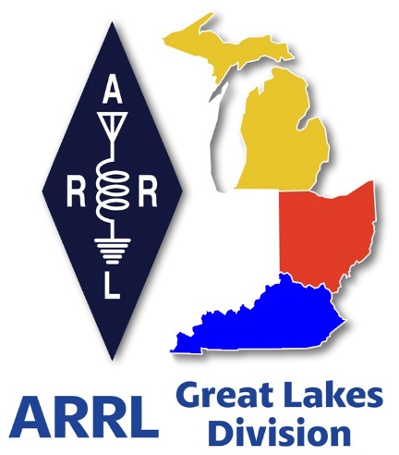 ***Radio Waves***

 ***The Great Lakes***

***Division***

***Monthly Journal***

***March 2025***

***What’s inside…***

|  |  |
| --- | --- |
| 🡪 Scott’s Stuff  🡪 Handbook Give Away  🡪 Club Links | 🡪 On The Air - Live    🡪 2025 Division Hamfests  🡪 Not So Secret Sauce |

***Special Service Clubs***

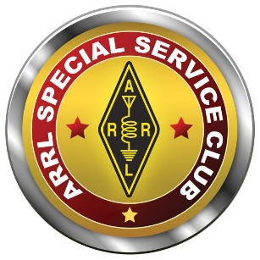

The Special Service Club Program is a special program that exists within the ARRL to recognize those clubs who do more than usual for their communities and for Amateur Radio. These well-rounded groups are the Special Service Clubs (SSCs).

SSCs are the leaders in their Amateur Radio communities. They're the ones with the active training classes, the publicity program and the members who actively pursue technical projects and operating activities.

Participation in the SSC program means a more ambitious program for your club. By taking an active role in coordination with the ARRL Field Organization, you will create a stronger, more effective Amateur Radio presence in your area.

The SSC program was designed to be flexible--there's room for a host of creative ideas, and regardless of your club's size, if the members are willing, there's a place for your club.

SSCs have gone through a process above and beyond the requirements for other affiliated clubs. These clubs have demonstrated proficiency in the following areas:

* Training and supporting local Amateur Radio efforts in licensing, upgrading and continuing education or mentoring.
* Public Relations and improving the visibility of Amateur Radio, promoting it as a positive force within the community.
* A willingness to become involved in any local emergency or drill.
* Technical Advancement and encouraging members to become more familiar and knowledgeable in technical Amateur Radio aspects in the community.
* Operating Activities in which a substantial program is conducted in an area of particular interest of the club; and,
* Miscellaneous Activities in which ongoing programs or activities are in additional established areas (or suitable substitutes).

Here’s a list of Active SSCs in the Great Lakes Division. Is your club listed? If not, why not? Contact your club officers and ask why your club isn’t an SSC!

|  |  |
| --- | --- |
| Arrow Communication Association  Monroe County Radio Comm Assn  Motor City Radio Club Inc  Alliance Amateur Radio Club  Central Ohio Radio Club Inc  Cuyahoga Amateur Radio Society  Cuyahoga Falls Amateur Radio Club  Delaware Amateur Radio Association  Germantown Amateur Radio Society  Highland Amateur Radio Association  Western Reserve Amateur Radio Club | InterCity Amateur Radio Club  Mahoning Valley Amateur Radio Association  Massillon Amateur Radio Club  Medina County Amateur Radio Club / Medina 2 Meter Group  Mount Vernon Amateur Radio Club  Northern Ohio Amateur Radio Society  OH-KY-IN Amateur Radio Society  Sandusky Valley Amateur Radio Club  Seneca Radio Club  Toledo Mobile Radio Association |

Did you know that you have to renew your SSC every year? That’s right, your anniversary date has been changed to coordinate with your anniversary date for your annual Affiliated Club report – December 31st of each year now.

***Scott’s Stuff***

Hi Gang,

Happy Mardi Gras, Daylight Saving Time Day, Ides of March Day, Saint Patrick’s Day and a whole bunch of other special days in March!!! Can you believe it, the time is changing back to Daylight Saving Time on March 9th. Don’t forget to set your clocks AHEAD 1 hour. Yes, you lose an hour of sleep from that point until November when we change it all back. Sorta’ like a yoyo. Wow.. and I was just getting used this “normal” time!!

Of course, the Ides of March are always on March 15th and that’s the day that we all need to watch each other’s backs for those surprise knives… and for those of us that are Irish (I have 5% Irish in me according to Ancestry.com) it is always celebrated on March 17th when everything turns green for this auspicious day. For the contesters out there, March 1 – 2 is the International DX– Phone Contest which is always a blast to participate in as well. There are a bunch more contests in March, too many to post all of them here, but if you are interested in just having some fun, here is a link to a schedule of all the contests for the month of March <https://www.contestcalendar.com/fivewkcal.html> As you can see, March is a very busy month for sure.

Hey, it was really great to see so many of you at the Livonia Hamfest last weekend. I couldn’t believe the turnout. It was a packed house. At one point, the folks were stacked up 4 and 5 deep at most of the tables. I haven’t seen that in several years. Let’s hope that this trend continues throughout the rest of the hamfest season!

Now, speaking of hamfests, have you gotten your tickets and rooms reserved for the Dayton Hamvention yet? You know it’s only 76 days away, so you’d better get on the stick quickly, as room reservations are going fast! And, while we are on the subject of hamfests, please take a look at the list of all of the hamfests we have on the schedule so far below.

Okay, I also need to mention that this March is when we observe Tornado Safety Week. In Kentucky the week begins March 1 – 7. In Michigan it is March 16 – 22 and in Ohio is the same, March 16 – 22.

As the severe weather season approaches, take some time during Severe Weather Safety Awareness Week to make a safety plan for your family, friends, neighbors and co-workers. Planning ahead will lower the chance of injury or death in the event severe weather strikes.

Tornadoes develop from severe thunderstorms. They are usually preceded by very heavy rain and/or large hail. A thunderstorm accompanied by hail indicates that the storm has large amounts of energy and may be severe. In general, the larger the hailstones, the more potential there is for damaging winds and/or tornadoes.

The most violent tornadoes are capable of tremendous destruction with wind speeds of 250 mph or more. Damage paths have exceeded the width of one mile and 50 miles long. Tornadoes generally move from southwest to northeast but have also been recorded traveling in any direction. The forward speed of a tornado varies from 30 mph to 70 mph.

Peak tornado season in the Great Lakes area is generally April through July, and they usually occur between 2 p.m. and 10 p.m. One year, though, an EF1 tornado occurred in Fairfield County at 6 in the morning - which proves that tornadoes can happen at any time, during any season.

>>Fujita Tornado Damage Scale - By Category

The Enhanced Fujita Scale is a set of wind estimates (not measurements) based on damage. It uses three-second gusts estimated at the point of damage based on a judgment of eight levels of damage.

NOTE: Prior to February 1st, 2007, tornadoes were rated according to the “F” (Fujita) scale rather than the newer “EF” (Enhanced Fujita Scale). Click on the Storm Prediction website <http://www.spc.noaa.gov/efscale/> for additional information regarding the “F” and “EF” scales.

Have you taken a Skywarn class lately? If not, you really should get enrolled in one as soon as you can. Also, now is a great time to get yourself involved with ARES if you haven’t already.

Okay, that is going to do it from here this month. Stay safe and "Catch Me On The Air, at a meeting or hamfest!!!" But most of all... Have FUN and…. Get On The Air!!!!

73,

Scott Yonally, N8SY

Director - Great Lakes Division

[n8sy@arrl.org](mailto:n8sy@arrl.org)

***Learn Even More with On the Air Live!***

In early 2025, the ARRL Education & Learning Department will launch an interactive livestreamed video podcast, On the Air Live. The monthly episodes will be aimed toward educating new and intermediate-level hams, inspiring them to explore the nearly endless aspects of amateur radio and develop their skills.

ARRL Education Specialist Wayne Greene, KB4DSF, who will host each episode, joins the On the Air podcast to share more details, including upcoming topics and how to participate in real time.

🎧: LISTEN: [**tinyurl.com/yc7b7jwd**](https://tinyurl.com/yc7b7jwd?fbclid=IwZXh0bgNhZW0CMTAAAR3A4ncRjHu-dzk362arBUy65wGQc8WMRwKbqXjgFRjuiWUKcFVxT-HK2G8_aem_ACReZuKK9212Yil8hqze5g)

🎥: WATCH: [**tinyurl.com/mpuf6yyc**](https://l.facebook.com/l.php?u=https%3A%2F%2Ftinyurl.com%2Fmpuf6yyc%3Ffbclid%3DIwZXh0bgNhZW0CMTAAAR1aZboWTvV05IOHUl0qqCQSey4LD6zNXscX6hihmqy4NYS_2wsXpEJFQ00_aem_N5wsZuyQKZEXVvwvUZ926w&h=AT2DxpDfGcGPFyiS50spUDU8ONG12SpxwwEQo4p4fY0gPzRywKwAetdF3_9LxUt2R6EcIxiIn7y8CI7_TdCp9pbdCp-SEINe5KgftacROjv3RSIyQoZ8OHAEprOcCa7_TBqPrboLHR0xVv7CjKm5&__tn__=-UK-R&c%5b0%5d=AT2Egq0YQe2efJhuDenI3S6LgRHGABKmcVaLE44x0uy2yV6BB4x-PS9Xl5DzDIZw9GSV_YNOW-Xzg5tJTJYqBXLsfdfh18JuqXN6kY9gTQZQCXm3BtgzmH8OJs241ksrwVff7qCXCM9mN7brbZnuQ9SOMCJst8_fpxpoOaFw9E-uie1WCERz8jT3T6nWMxfRG47SEwTv4ZmURVyBHDtp8K9l9zmLgIehfxy-2Xu97ztAEEtePmbkXfDv)

***Handbook Give Away***

How’s about I give away an ARRL softcover Handbook absolutely FREE !!!

Yes, I’m holding a little contest to "GIVE AWAY" a 2025 ARRL softcover Handbook. Why you ask? It’s to get you to check-in to the Great Lakes Division website and take a look around.

Getting signed up is just as simple as filling out a couple of quick questions and you’re entered!!

**>>** [**Click Here To Enter**](https://forms.office.com/Pages/ResponsePage.aspx?id=Dx2iugFz_kC91gPUQ6jCGEYWzQfXysZHvDC8hUJ9GuFUQlgyT0c4NzhYWEs0SFhJUFo4REw1TTU3OS4u) **<<**

The drawing ends Friday, March 14th

***2025 Great Lakes Division Hamfests***

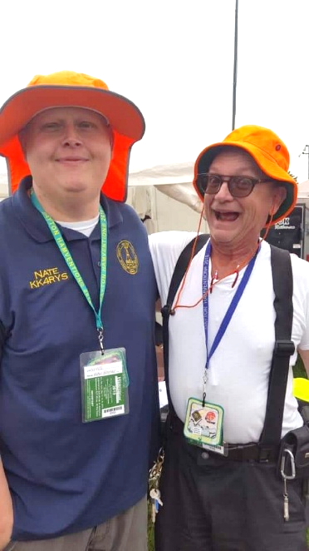

Here in the Great Lakes Division, we have over 50 hamfests a year.

So, if you haven’t started planning your hamfest schedule yet, you really need to start now.

Please post this listing in your club's newsletter and announce the swaps on your local nets. Talk them up.

Let's fully support all of our hamfests in every way possible. It means success for everyone. Be sure to invite your ARRL Officials as soon as your date is set.

If you are planning on having your hamfest listed in QST please be sure to start your planning well in advance of your Hamfest date, as this allows adequate time for QST Listings. QST announcements require a 3-month lead time.

To be fair to our division’s clubs, the Great Lakes Division policy **now has 2 requirements**.

**Any club requesting ARRL sanctioning within the Great Lakes Division must now be an ARRL Affiliated Club with a maximum of two hamfests/swaps in any given calendar year, and they must be at least four months apart.**

|  |  |
| --- | --- |
| **03/09/2025 -**[**Northern Ohio Amateur Radio Society Winter Hamfest**](https://www.arrl.org/hamfests/northern-ohio-amateur-radio-society-winter-hamfest)  **Location:**Elyria, OH **Type:** ARRL Hamfest **Sponsor:** Northern Ohio Amateur Radio Society **Website:** <https://www.noars.net/hamfests/winter-hamfest/> [**Learn More**](https://www.arrl.org/hamfests/northern-ohio-amateur-radio-society-winter-hamfest) | **03/16/2025 -**[**Toledo Mobile Radio Association Hamfest and Computer Fair**](https://www.arrl.org/hamfests/toledo-mobile-radio-association-hamfest-and-computer-fair-3)  **Location:**Perrysburg, OH **Type:** ARRL Hamfest **Sponsor:** Toledo Mobile Radio Association **Website:** [http://www.w8hhf.org](http://www.w8hhf.org/) [**Learn More**](https://www.arrl.org/hamfests/toledo-mobile-radio-association-hamfest-and-computer-fair-3) |
| **03/22/2025 -**[**Cave City Hamfest**](https://www.arrl.org/hamfests/cave-city-hamfest-14)  **Location:**Cave City, Kentucky, KY **Type:** ARRL Hamfest **Sponsor:** MCARC **Website:** [http://ky4x.org](http://ky4x.org/) [**Learn More**](https://www.arrl.org/hamfests/cave-city-hamfest-14) | **~~03/23/2025 -~~**[**~~CANCELED - Lowell Amateur Radio Youth Club Hamfest~~**](https://www.arrl.org/hamfests/canceled-lowell-amateur-radio-youth-club-hamfest)  **~~Location:~~**~~Lowell, MI~~ **~~Type:~~**~~ARRL Hamfest~~ **~~Sponsor:~~**~~Lowell Amateur Radio Youth Club~~ **~~Website:~~**[~~http://amateurradioyouth.club~~](http://amateurradioyouth.club/)[**~~Learn More~~**](https://www.arrl.org/hamfests/canceled-lowell-amateur-radio-youth-club-hamfest) |

|  |  |
| --- | --- |
| **04/05/2025 -**[**Cuyahoga Falls Amateur Radio Club 69th Hamfest**](https://www.arrl.org/hamfests/cuyahoga-falls-amateur-radio-club-69th-hamfest)  **Location:**Cuyahoga Falls , OH **Type:** ARRL Hamfest **Sponsor:** Cuyahoga Falls Amateur Radio Club, Inc. **Website:** [https://www.cfarc-hamfest.org](https://www.cfarc-hamfest.org/) [**Learn More**](https://www.arrl.org/hamfests/cuyahoga-falls-amateur-radio-club-69th-hamfest) | **04/05/2025 -**[**E-town Hamfest (The Lincoln Trail Amateur Radio Club's 47th Annual Hamfest)**](https://www.arrl.org/hamfests/e-town-hamfest-the-lincoln-trail-amateur-radio-club-s-47th-annual-hamfest)  **Location:**Elizabethtown , KY **Type:** ARRL Hamfest **Sponsor:** Lincoln Trail Club [**Learn More**](https://www.arrl.org/hamfests/e-town-hamfest-the-lincoln-trail-amateur-radio-club-s-47th-annual-hamfest) |
| **04/12/2025 -**[**AC8RC Allegan Mini-Swap**](https://www.arrl.org/hamfests/ac8rc-allegan-mini-swap-1)  **Location:**Burnips, MI **Type:** ARRL Hamfest **Sponsor:** AC8RC Allegan County Amateur Radio Club [**Learn More**](https://www.arrl.org/hamfests/ac8rc-allegan-mini-swap-1) | **~~04/12/2025 -~~**[**~~CANCELED - Rio Grande Ohio Hamfest~~**](https://www.arrl.org/hamfests/canceled-rio-grande-ohio-hamfest)  **~~Location:~~**~~Bidwell, OH~~ **~~Type:~~**~~ARRL Hamfest~~ **~~Sponsor:~~**~~Mid-Ohio Valley Amateur Radio Club~~ **~~Website:~~**[~~https://www.facebook.com/KC8ZAB~~](https://www.facebook.com/KC8ZAB)[**~~Learn More~~**](https://www.arrl.org/hamfests/canceled-rio-grande-ohio-hamfest) |
| **04/19/2025 -**[**SJCARC Hamfest**](https://www.arrl.org/hamfests/sjcarc-hamfest)  **Location:**Centreville, MI **Type:** ARRL Hamfest **Sponsor:** St. Joseph County Amateur Radio Club [**Learn More**](https://www.arrl.org/hamfests/sjcarc-hamfest) | **04/26/2025 - [Tusco Amateur Radio Club's 2025 Hamfest, Computer & Electronics Show](https://www.arrl.org/hamfests/tusco-amateur-radio-club-s-2025-hamfest-computer-electronics-show" \o "Tusco Amateur Radio Club's 2025 Hamfest, Computer & Electronics Show)**  **Location:**Dover, OH **Type:** ARRL Hamfest **Sponsor:** Tusco Amateur Radio Club **Website:** <http://www.w8zx.net/hamfest> [**Learn More**](https://www.arrl.org/hamfests/tusco-amateur-radio-club-s-2025-hamfest-computer-electronics-show) |
| **04/27/2025 -**[**Athens Hamfest**](https://www.arrl.org/hamfests/athens-hamfest-12)  **Location:**Athens, OH **Type:** ARRL Hamfest **Sponsor:** Athens County Amateur Radio Association **Website:** <https://www.ac-ara.org/> [**Learn More**](https://www.arrl.org/hamfests/athens-hamfest-12) | **05/03/2025 - [Wexaukee ARC Swap & Shop](https://www.arrl.org/hamfests/wexaukee-arc-swap-shop-1" \o "Wexaukee ARC Swap & Shop)**  **Location:**Cadillac, MI **Type:** ARRL Hamfest **Sponsor:** Wexaukee Amateur Radio Club **Website:** [http://wexaukeearc.org](http://wexaukeearc.org/) [**Learn More**](https://www.arrl.org/hamfests/wexaukee-arc-swap-shop-1) |
| **05/10/2025 -**[**GMARC Trunk Swap**](https://www.arrl.org/hamfests/gmarc-trunk-swap-10)  **Location:**Shelby Township, MI **Type:** ARRL Hamfest **Sponsor:** General Motors Amateur Radio Club **Website:** [http://gmarc.org](http://gmarc.org/) [**Learn More**](https://www.arrl.org/hamfests/gmarc-trunk-swap-10) | **05/10/2025 - 05/15/2025** [**RV Radio Network Rally**](https://www.arrl.org/hamfests/rv-radio-network-rally-1)  **Location:**Navarre, OH **Type:** ARRL Convention **Sponsor:** RV Radio Network [**Learn More**](https://www.arrl.org/hamfests/rv-radio-network-rally-1) |
| **05/15/2025 - 05/18/2025** [**Four Days In May**](https://www.arrl.org/hamfests/four-days-in-may-2)  **Location:**Fairborn , OH **Type:** ARRL Convention **Sponsor:** QRP Amateur Radio Club International **Website:** <http://qrparci.org/fdim> [**Learn More**](https://www.arrl.org/hamfests/four-days-in-may-2) | **05/16/2025 - 05/18/2025** [**Dayton Hamvention**](https://www.arrl.org/hamfests/dayton-hamvention-8)  **Location:**Xenia, OH **Type:** **Sponsor:** Dayton Amateur Radio Association **Website:** [http://Hamvention.org](http://hamvention.org/) [**Learn More**](https://www.arrl.org/hamfests/dayton-hamvention-8) |

You can always find the latest information to upcoming hamfests on the Great Lakes Division website.

](https://www.arrl.org/hamfests/search/Location.division_id:gl)

Just click to get the latest hamfest updates.

***Amateur Television Friday Night Dinner.***

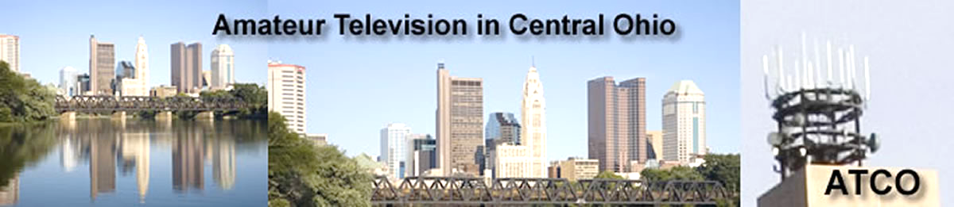

The ATV Friday Night Dinner will be on Hamvention weekend --- **May 16** at 6:30 PM at the China Garden Buffet Restaurant (937-781-9999), 112 Woodman Drive in Dayton, Ohio 45431 (Airway Shopping Center).

The all you can eat Buffet Dinner is $11.99. We will have dinner and then ATV presentations with it concluding at 9 PM.

All are invited. Door prizes will be awarded.

[**Dayton Bus Trip – May 17, 2025**](https://w8rp.org/daytonbus2025/)

The ARROW Communications Association and the [Toledo Mobile Radio Association (TMRA)](https://w8hhf.org/) are proud to sponsor a motor coach trip to the [Hamvention](http://www.hamvention.org/)2025 in Dayton, Ohio. This one-day trip leaves early in the morning on May 17, 2025 and returns the same day after Hamvention closes for the day at 5:00 p.m.

The bus has two pickup spots, in Ann Arbor and in Toledo (Rossford). Please join us! Tickets are $70 per person. Please note that this does not include the Hamvention ticket, which you need to [purchase separately](https://hamvention.org/purchase-tickets/).

ARROW started a bus in 2002, this annual club activity has grown in size and reputation with Hams across Michigan. We have hosted to over 700 Hams for this event.

](https://i0.wp.com/w8rp.org/wp-content/uploads/activities/dayton-bus-trip/dayton2004groupshot.jpg)

**Register before the bus fills up**  
ARROW and TMRA reserves the right to cancel the bus if not enough people sign up. If the bus is cancelled for unforeseen reasons, refunds will be issued.

**There are two pickup/drop off locations on May 17th, 2025**  
Ann Arbor – 601 W Stadium Blvd, Ann Arbor, MI – Departing 4:30 am

Toledo – 727 Lime City Rd. Rossford, OH – Departing 5:30 am

The plan is to arrive at the Hamvention around 8:30 am. On board, you can stretch out, relax, chat with other Hams and enjoy a continental breakfast with coffee as the coach takes you directly to the door of the country’s largest amateur radio event!

We arrive at Dayton early enough so that you can enjoy a full day!

* Visit exhibits
* See what’s new from major manufacturers
* Attend seminars
* Take license tests
* Shop one of the largest outdoor swap meets in the United States

***Club Links***

](https://arrl-greatlakes.org/links.html)I’ve received a number of new requests from clubs to be listed on the “Links” club page.

Is your club listed? If not, send the URL of your club website to me [n8sy@n8sy.com](mailto:n8sy@n8sy.com) and I’ll get it listed.

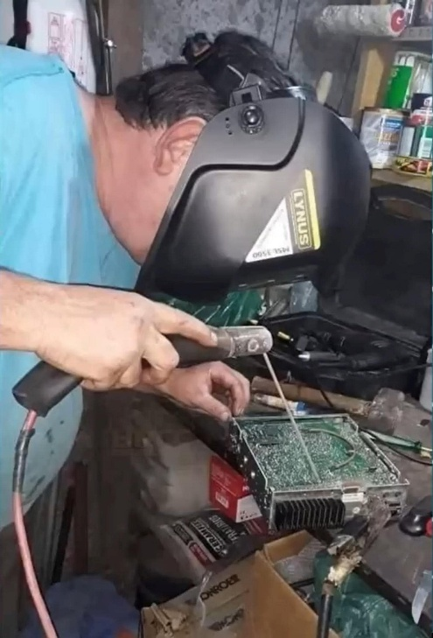***Wanted… Your Photo’s***

Have you seen the Photo Gallery on the Great Lakes Division website? If you haven’t you really need to, your face may be among the many already posted there.

[](https://arrl-greatlakes.org/gallery/index.php)

I’m always looking for more pictures to use in the Gallery, newsletter, banner and video display. Please, send me your pictures!!! Send them to: [n8sy@n8sy.com](mailto:n8sy@n8sy.com)

***Freeze Your Acorns Off…***

Each year, Several Portage County Amateur Radio Service (PCARS) members gather on some cold, rainy, snowy Saturday morning to thumb their noses at mother nature. That’s what happened the past February 15.

The purpose for this insanity? To have FUN!!! And, to prove that we are all just a bit nuts. We’ve had as much as a foot of snow on the ground during this event over the years, but even that isn’t enough to detour these intrepid souls from their task of making as many QRP QSOs as possible while trying not to freeze their extremities off.

Oh, and there’s always enough food to feed an army. No one, and I mean NO ONE has any excuse for going away hungry.

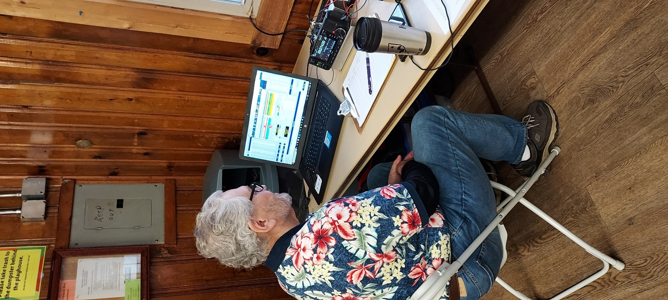

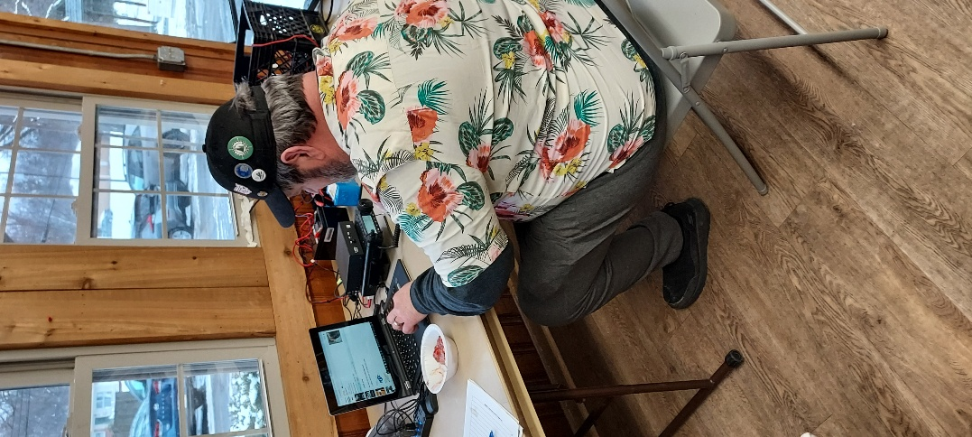

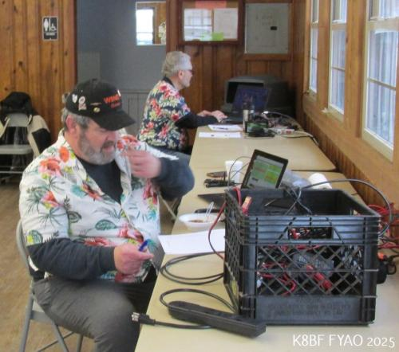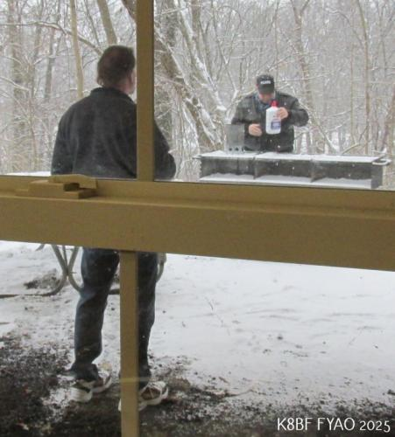

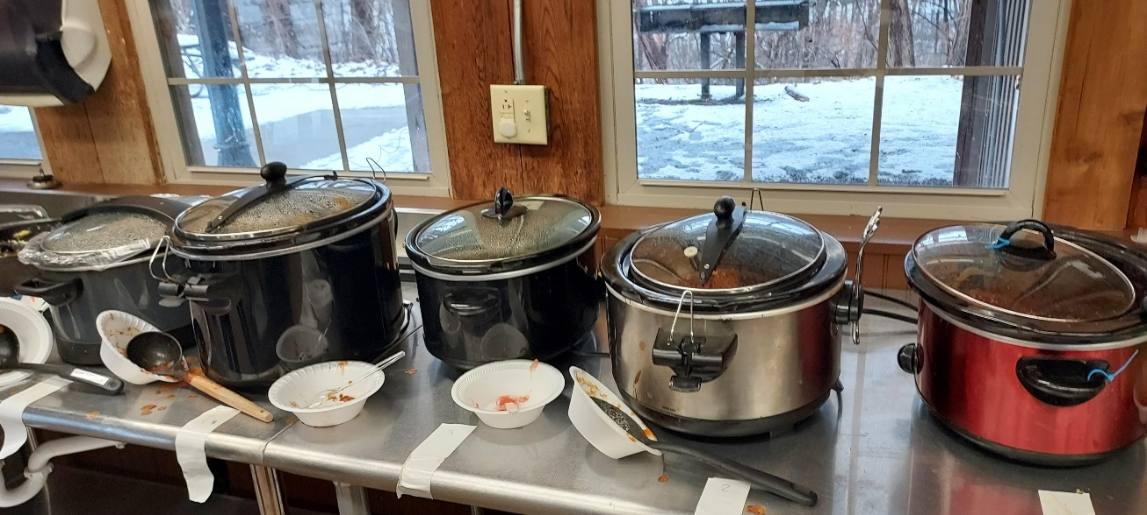

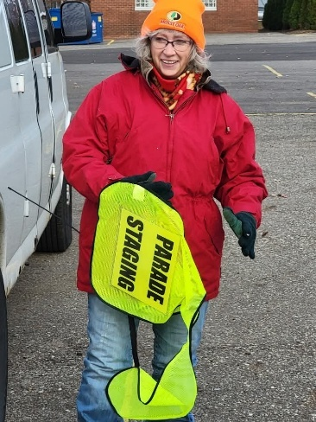

***The Not-So-Secret Sauce to a Thriving Club***

The question echoes in ham radio circles as regularly as a CQ call: "What's the magic bullet for a successful amateur radio club?" Some clubs seem to be beacons of activity, membership rosters overflowing, while others struggle to muster a quorum. The truth is, there's no mystical, frequency-hopping secret. The key ingredient, surprisingly, boils down to this: make your club active and, dare we say, ***FUN.***

Yes, fun. It sounds almost too simple, doesn't it? But let's be honest, no one willingly sacrifices their precious free time to attend what feels like a mandatory lecture on advanced modulation techniques delivered at breakneck speed. Members need to leave each meeting or event feeling enriched, as though their time was well-spent. Whether it's gaining new knowledge, fostering camaraderie, or simply sharing a good laugh, the experience must be worthwhile.

***"People rarely succeed unless they have fun in what they are doing." - Dale Carnegie***

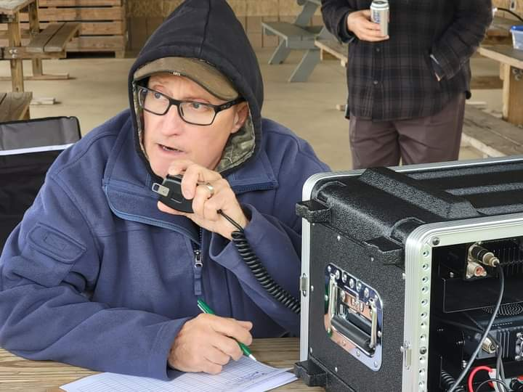

Think of your club as a radio signal. A weak, predictable signal fades into the background noise. A vibrant, engaging signal, however, cuts through the static and attracts attention. The challenge, then, is to boost your club's signal strength. How do you amplify the wattage and make it truly resonate with current and potential members?

First, inject some vitality into your meetings. Cut down on the lengthy recitations of bylaws and committee reports. Instead, invigorate the agenda with dynamic presentations, practical workshops, interactive demonstrations, or even a lively question-and-answer session. Tap into the wealth of knowledge within your membership. Invite experienced hams to share their expertise on topics ranging from antenna construction to the nuances of digital modes. The possibilities are as vast as the radio spectrum itself.

***“The vibrancy of a thriving club extends far beyond the confines of formal meetings.”***

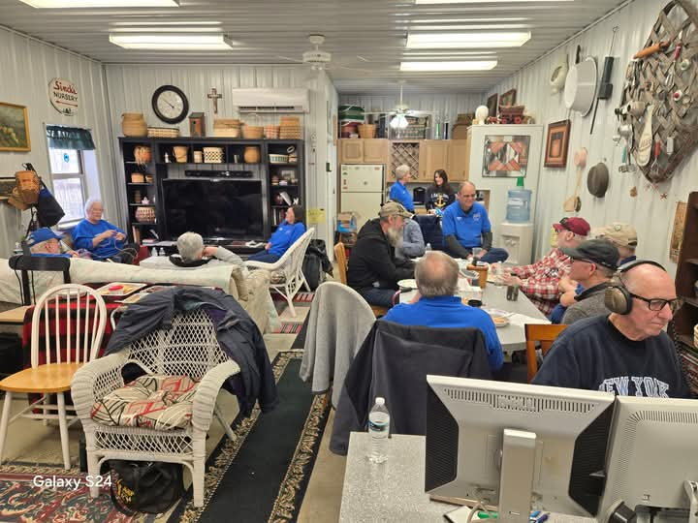Organize activities that ignite excitement and foster a sense of adventure. While mainstays like Field Day are essential, consider incorporating more frequent, smaller-scale outings. SOTA (Summits On The Air) or POTA (Parks On The Air) activations provide opportunities for outdoor operating and exploration. Fox hunts offer a thrilling blend of radio direction finding and problem-solving. Even a simple, casual coffee meet-up can foster valuable connections and facilitate informal knowledge sharing. One group of club members meets every Friday for breakfast, where the discussions range from the intricacies of dipole antenna assembly to the latest breaking news – a testament to the power of camaraderie and shared interests.

Furthermore, actively seek opportunities to partner with community organizations for outreach events. Sharing the wonders of amateur radio with a new generation is crucial for the hobby's continued growth. Consider giving presentations to local service organizations like the Lions Club, Rotary, or even your Local Emergency Planning Committee. These are excellent platforms to showcase the vital role amateur radio plays in emergency communications and community service.

Ultimately, the success of an amateur radio club hinges on cultivating a strong sense of community and belonging. It needs to be a place where members feel appreciated, where they can learn and share their knowledge freely, and where they can forge lasting friendships, and maybe even share a few jokes along the way. A club should be a supportive environment where newcomers feel welcome and experienced operators are eager to mentor.

Let's be brutally honest, a radio club devoid of laughter, engagement, and genuine connection is simply... static. So, break free from the humdrum routine, inject some fun, and watch your club's signal soar to new heights. The world of amateur radio is a world of innovation, exploration, and camaraderie. Make sure your club reflects that.

***Amateur Radio License Map***

Created by: Ross, KT1F

Welcome to my little spare time project. I've been working on this on and off for about a year as time and motivation allows.

[Amateur Radio License Map | Ham Info (tetranz.com)](https://haminfo.tetranz.com/map)

This is more of an excuse to have some fun with Maps and Geocoding than anything else, but it hopefully provides something interesting to play with. "Geocoding" means to convert physical addresses into longitude and latitude coordinates. Behind the scenes, this site has been slowly geocoding all active amateur radio addresses in the FCC license data. The FCC data includes all licenses which have a status of "active".

I've found it an interesting project with lots of little challenges. Some of this is because of the wide variation of population and therefore "ham density" throughout the country. I've had to balance that with performance issues both at the database query level and practical limitations of Google Maps.

The data is also kind of messy with multiple licensees at one address and multiple addresses at the same location. This last issue is mostly due to spelling variations. In general, one marker appears on the map for each unique latitude / longitude point.

The performance / data quantity compromise I've come up with is that it searches within a 20-mile radius of the map center and has a limit of 200 location markers.

The results are sorted by distance which means that the circle is complete until it hits the 200 markers. I haven't found a grid square that has more than 200 so if you center on a grid square, I think we always get all in that square.

The initial geocoding was done in bulk using [Nominatim](http://www.nominatim.org/) / [OpenStreetMap.](https://www.openstreetmap.org/) This succeeded in finding about half of all addresses. Then over a long period of time the rest were processed using [Geocodio](https://www.geocod.io/).

Geocoding continues using Geocodio at a rate of 125 per hour or a total of 2500 per day which keeps it within the free limit.  Every hour it selects 125 addresses from the database to geocode. These are chosen with the following priorities.

1. New addresses that have not been geocoded before.
2. Those that previously succeeded on OpenStreetMap. Reprocessing these with Geocodio seems to be improving the results.
3. Those that previously failed. Some now succeed because of better data.

A weekly import from the FCC usually happens early Wednesday morning eastern time. Only those stations with a status of "active" are retained. About 1000 addresses are added and deleted each week. Geocoding the new addresses is usually completed by late Wednesday.

Of course, some addresses are PO Boxes and other mailing services. Addresses starting with "PO Box" are simply excluded. Also, many licensees are not active in the hobby. Be that as it may, it can be fun to play with the Street View feature of the maps to look for antennas.

Although I've only considered data from the USA, it's written in a generalized way so it can handle data from other countries but I'm not aware of any other countries who make their data publicly available.

Feedback is welcome. The easiest way is by email to tetranz (at) gmail.com

Use this map to find amateur radio license holders in the USA.

[Amateur Radio License Map | Ham Info (tetranz.com)](https://haminfo.tetranz.com/map)

* Select the type of input (callsign, grid square, zip code or street address) on the left.
* Enter an appropriate search value on the right.
* Hit the button.
* Scroll down to see the map.

The selection determines the center of the map.

When the map appears, you can adjust the zoom level and drag the map around. If you're looking at a sparsely populated area, you'll probably need to zoom out.

After two seconds of not moving, it will reload with stations for the new area. You can also click on the grid square labels to center the map on that square. Use the "Show grid labels" checkbox to temporarily remove the grid square lines and labels if they get in the way.

Give it a try, I know that you’ll find it very fascinating for sure. Thanks so much Rick for creating this little app that we can have fun with.

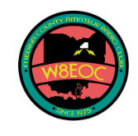

***Upgrade to Amateur Radio General Class License:***

PREREQUISITE: FCC TECHNICIAN LICENSE

Amateur Radio FCC General Class Licensing Instruction offered by the Medina County Amateur Radio Club.:

Will prepare you for the FCC Element 3, General Class License exam, 35 multiple choice questions to get your upgrade!

March 5, 2025 begins *nine*Wednesday classes, 7:00-9:00 pm

No charge for classes. Last class is exam session – walk away with an FCC General Class License.

Required purchase of current *ARRL General Class License Manual,*Tenth Edition, available on Amazon…

MUST READ CHAPTERS 1-3 BEFORE FIRST CLASS

[Jane@K8JGR.radio](mailto:Jane@K8JGR.radio) for more info, or [*https://www.W8EOC.org*](https://w8eoc.us18.list-manage.com/track/click?u=97b7b54d1419974010a5ce49e&id=558f4f5a3d&e=0443f5e61f)

Location:  
Medina County Career Center (JVS),  
Room 246,  
1101 West Liberty St, Medina, Ohio  44256

February 13, 2025 — The Young Ladies Radio League (YLRL) has announced the Memorial Scholarship pro-gram for 2025. The scholarship program is aimed at women Amateur Radio Operators studying radio, communications, electronics or Amateur Radio related arts and sciences.

The Young Ladies Radio League (YLRL) is an international non-profit organization of women Amateur Radio enthusiasts. It was founded in 1939 and is the longest running YL club in the world. The YLRL is sponsoring three memorial scholarships for 2025:

The Ethel Smith K4LMB Memorial Scholarship—$2,500 award

The Mary Lou Brown NM7N Memorial Scholarship—$2,500 award

The Martha “Marte” Wessel K0EPE Memorial Scholarship—$1,500 award

The YLRL believes that education in the fields or radio, communications, electronics and Amateur Related arts and sciences will play an important role in shaping the world’s future. Through these Memorial Scholarship, YLRL hopes to encourage female students to learn more about Amateur Radio.

“YLRL is committed to investing in women in Amateur Radio, and we believe that every act of volunteerism through Amateur Radio — even a small one — helps turn the world into a better place,” said Vicki Zumwalt, President of YLRL. “We hope that our scholarships will not only encourage students to learn more about science, technology, engineering but also inspire them to take pride in being an Amateur Radio operator and to encourage others to do so as well.”

To qualify, students must be female, have an Amateur Radio License, meet the requirements listed on the YLRL.net website and apply using the online application. Applications are due by April 30, 2025. Winners will be announced in July 2025.

Application link: <https://YLRL.net/Scholarships>

***STOP!!!***

***We’ve come to the end…***



Be Radio-Active --- See Ya’ Soon!