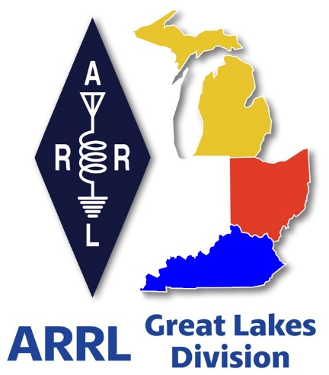 ***Radio Waves***

***The Great Lakes Division***

***Mid- Month Report***

***From the Michigan Section Manager***

Larry Camp, WB8R

***Michigan Section News***

***April 2025***

Greetings and welcome to April. The weather is alternating between snow and sunshine, but one thing for sure is that warmer weather is on the way. And of course, warmer weather means hamfests and other outside activities. (Hooray!)

***New Michigan Section Youth Coordinator***

I am extremely pleased to announce that the Michigan Section of the ARRL has a new Section Youth Coordinator. Kanushi Desai, KE8RNA from Midland, MI has been appointed to serve as Section Youth Coordinator, Kanushi is already hard at work on getting organized and ready to go to work. You will be hearing a lot from this dynamic young lady. If you should come in contact with her, be sure to congratulate her on her appointment.

***A few words from Kanushi:***

Hi everyone! My name is Kanushi Desai, KE8RNA, and I’m excited to serve as the Michigan Section Youth Coordinator. I’m a high school student from Midland. I’ve been licensed since 2021 and enjoy helping out at local events and being a part of the high school electronics club in Midland.

One of my goals in this role is to connect young hams across the state and help build a stronger youth presence in our section. If you or your club know of any youth-focused clubs, younger operators, or students who might be interested in radio/ electronics, I’d love to hear from you! Even just a quick introduction helps paint a clearer picture of where our youth involvement is strongest- and where we can grow.

You can reach me at [ke8rna@arrl.net](mailto:ke8rna@arrl.net), and I’ll also be at the Dayton Hamvention and most likely the Midland Swap, so feel free to say hello!

73,  
Kanushi Desai, KE8RNA  
Michigan Section Youth Coordinator

***Michigan POTA Meet-Up (F***rom the organizers)

Join us at the beautiful Fort Custer State Recreation Area in Agusta, MI for the Michigan POTA Meetup 2025. This scenic location is the perfect backdrop for a day of radio activities and connection with fellow enthusiasts.

Date: June 7, 2025 Time: 11:00 AM – 3:00 PM

***2025 Michigan Section Hamfests and other Activities***

Apr 19, 2025 SJCARC Hamfest, Centreville, MI (WB8R)

May 3, 2025 Wexaukee ARC Hamfest, Cadillac, MI (WB8R)

May 10, 2025 GMARC Trunk Swap, Shelby Twp (TBD)

May 16, 17, 18 2025 Dayton Hamvention, Xenia, OH (WB8R)

Jun 7, 2025 IRA Hudsonville Swap, Hudsonville, MI (K8TB)

Jun 7, 2025 POTA Meetup Fort Custer State Recreation Area in Agusta, MI

Jun 7, 2025 LARS Yooper Hamfest, Newberry, MI (WB8R)

Jun 8, 2025 Crossroads Hamfest, Marshall, MI (WB8R)

Jun 14, 2025 Midland ARC Swap, Midland, MI (WB8R, KE8RNA)

Jun 15, 2025 Monroe Hamfest, Monroe, MI (WB8R)

Jul 26, 2025 Blossomland Hamfest, Berrien Center. MI (TBD)

Sep 6, 2025 Grand Rapids Area Hamfest, Wyoming, MI (WB8R, K8TB)

Sep 13, 2025 GMARC Trunk Swap, Shelby Twp, MI (TBD)

Sep 14, 2025 Adrian Hamfest, Adrian, MI (WB8R)

Sep 20, 2025 Top of Michigan ARC Hamfest, Gaylord, MI (WB8R)

Oct 11, 2025 Muskegon Color Tour Hamfest, Muskegon, MI (WB8R)

Oct 19, 2025, USECA Hamfest, St. Clair Shores, MI (TBD)

Dec 7, 2025 LCARC ARC Hamfest, Troy, MI (WB8R)

I look forward to seeing many of you at some of these swaps. Please stop by the ARRL Table and say hello!

ARES/NTS Reporting:

Calls of DECs/ECs reporting:

N8HEE, KC8OUF, KC8RYF, KC8QWH, WD8PMD, W8JMB, AC8FW, KE8YNU, KE8BYC, AB8JR, KE8JNF, K8JBD, KD8ZSK, N8AVX, AB8SY, KF8F, KD8BMB, W8JDE, W8PVP, KB8TAR, KD0RMK, W8COP, N9KOP, KC8YVF, KF8ZO, WJ8V, KD8QNX, KC8SFQ, KC8MGD, KD8RHB, KD8GTX, N8MRC, N8JSN, K8OE, K8COP, W8WJB, N8UKH, N8RR,L K8QBZ, W8VPC, KJ4KFJ, W8NWO, K8ABY, N8CN, WZ8N, N8JTQ, WB8TQZ, KD8ZY, KB0BS, N8XAH, K8PDC, KE8UFF, N8NAV, KD8FUE, AA8GH, N8WAV, AB8ZJ, KD8OOS, KC8OCK, N8NXP, W8NSA, KE8DON, N8NIF, W8SDK, N8UKF, N8VPZ, W8VRD, KD8REH.

Individual Station Activity Reports:

K8ED 438, KB8PGW 116, WB8TQZ 107, ND8W 60, KD8ZCM 58, K8RDN 41,

KE8HKA 41, KE8CEH 20, N8RWF 18, WD8USA 17, KE8CYC 15, KC8YVF 7,

KE8DON 1.

Public Service Honor Roll (callsigns and total points):KE8BYC 382, KE8DON 255, KC8YVF 212, ND8W 195, WD8USA 177, KD8ZCM 145, KE8HKA 140, WB8TQZ 110, K8RDN 103, K8ED 100, KB8PGW 95, KE8CYC 94, N8RWF 53, KE8CEH 41.

The combined value of ARPSC hours: $188,615. Contributed value of NTS hours: $47,830

Total combined value of our services to the citizens of Michigan: $236, 445.

I look forward to seeing many of you at the various swaps and other activities. As you certainly understand, it is virtually impossible to attend every listed event. I try my best to attend as many events as possible, and I look forward to chatting with you when the opportunity presents itself. In the interim, you can reach me using the contact information below.

Travel Safely, and best 73,

Larry

***From the Ohio Section Manager***

Tom Sly, WB8LCD

The latest edition of PostScript is now online and ready for you to read! Grab your favorite refreshment, sit back and relax in your comfy chair, and just enjoy the great reading found in this latest edition!

<https://arrl-ohio.org/wp-content/uploads/2025/04/OSJ-April-2025.pdf>

There’s an awful lot of Ham Radio activities going on in the Ohio Section, so get off the chair or couch you’re sitting on and get out there, get involved, and get on the air!

Tom…

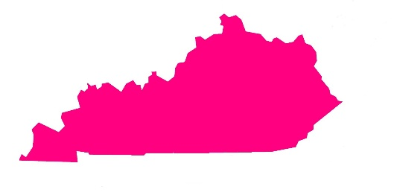***From the Kentucky Section Manager***

Alan Morgan, KY1O

Hi ARRL Members here in KY:   
  
Just a quick note to let you know that I have been busy trying to get caught up on Section Manager duties and making some field appointments such as Emergency Coordinators, District ECs, Assistant SMs, and etc, since my appointment as SM on 1/1/25. I officially became SM on April 1, 2025 for a 2-year term.

One I'm very happy to appoint is Glenn Foley, KO4OL in Richmond as Section Traffic Manager/Assistant Section Manager, so send your net reports, traffic handling, PSHR information to him by the 5th of each month for the proceeding months activities. I will be   
accepting ARES related reports until I can find a good Section Emergency Coordinator to take over those duties of ARES reporting to ARRL HQ. You can look up the various field appointment positions and duties of each at: <https://www.arrl.org/field-organization> I have many other appointments that ne ed to be filled/made very soon as well, so if interested in serving please let me know ASAP!   
  
I attended the Cave City Hamfest and had planned on attending Elizabethtown as well as Greater Louisville (Shepherdsville) and Richmond both in September as the 4 ARRL sponsored hamfests in 2025 here in Kentucky. I hope to attend some of the other hamfests as well.   
  
I have been trying to attend various club/society meetings when possible to get to know more of you, especially many newly licensed hams.   
  
You can learn more about me by reading my bio at: <https://www.qrz.com/db/ky1o>   
  
I have been a Life Member of ARRL for about 46+ years now. I have been a SM previously 4/1/2015-3/31/2017 in Kentucky.   
  
If you have any comments, concerns, or questions, then do not hesitate to contact me. I would also appreciate clubs sending me activities information and photographs of events via email, please. Copy me on your club newsletters too.   
  
73, Alan KY10 - WRBM701 - PG196081

|  |
| --- |
| ***ARRL Ham Radio Open House — Site Locator Live*** |

|  |
| --- |
| ARRL Ham Radio Open House is a national event being hosted by local amateur radio clubs in April to coincide with World Amateur Radio Day on April 18. The event is designed to highlight technical innovations in ham radio, and show off the current state of the art. It will serve as a tool to tell the story of amateur radio being a pathway to tomorrow's technical careers.    A site locator is now live on the ARRL Ham Radio Open House page at [**www.arrl.org/open-house**](https://arrl.informz.net/z/cjUucD9taT0zMjgwNTY2JnA9MSZ1PTUyMDM2NDI5NiZsaT0zNzI2NzIyMA/index.html). Participating clubs may enter their information so that local hams and members of the public may find the event.  [A screenshot of a map  AI-generated content may be incorrect.](https://arrl.informz.net/z/cjUucD9taT0zMjgwNTY2JnA9MSZ1PTUyMDM2NDI5NiZsaT0zNzI2NzIyMA/index.html) |

|  |
| --- |
|  |
|  |

|  |
| --- |
| A public relations workshop for those organizing an event is being held via Zoom on Wednesday, March 19. It is open to any amateur radio public information volunteer, but will be especially valuable to ARRL Public Information Coordinators, Public Information Officers, Section Managers, Affiliated Club Coordinators, club presidents, and other leaders. [Registration](https://arrl.informz.net/z/cjUucD9taT0zMjgwNTY2JnA9MSZ1PTUyMDM2NDI5NiZsaT0zNzI2NzIyMQ/index.html) is required.    If you’re unable to make the live interactive event, a recording will be available afterward. For more information on how to create a Ham Radio Open House at your club’s station, visit [**www.arrl.org/world-amateur-radio-day**](https://arrl.informz.net/z/cjUucD9taT0zMjgwNTY2JnA9MSZ1PTUyMDM2NDI5NiZsaT0zNzI2NzIyMg/index.html). |

***Scott’s Stuff***

Hi Gang,

April showers bring May flowers, and the Mayflower brought the pilgrims to the Dayton Hamvention! It’s now just 31 days away. Are you ready for the **FUN to begin**?

***Ok, let’s get down to business.***

Over the past several weeks, I have thoroughly enjoyed attending hamfests and club meetings. It has been a pleasure to engage with many of you and discuss various topics of interest.

Recently, I had the honor of participating in the 60th anniversary banquet of The Auto State Young Ladies (TASYL) group. I presented them with a proclamation designating April 12, 2025, as TASYL Day in the Great Lakes Division. These exceptional women have made significant contributions to our esteemed hobby, and I extend my sincere gratitude for their efforts.

The Dayton Hamvention will feature numerous forums catering to all aspects of ham radio. Additionally, there will be an ARRL Leadership Presentation on Saturday at 11:25 am in Room 3, where I will serve as the moderator. This session is highly recommended for anyone interested.

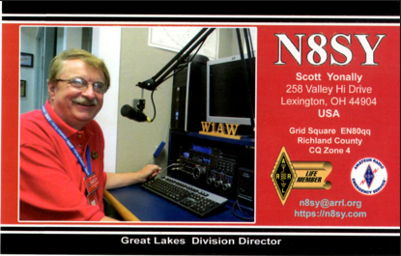**We warmly invite all attendees to bring a QSL card for display on the Division’s Brag Board.**

Last year, we were pleased with the impressive number of QSL cards received. This year, we are providing advance notice to encourage even greater participation. A larger Brag Board will be available to accommodate the outstanding cards we anticipate receiving.

Please visit our booth and remember to bring your QSL card for display.

**Field Day -** Consider meeting with local government officials to request a proclamation for Amateur Radio during that weekend. Most local governments will gladly support this initiative. Remember to invite the news media, as it provides excellent public relations and earns extra points.

Share copies of proclamations with ARRL via [pr@arrl.org](mailto:pr@arrl.org) and don’t forget to register your Field Day site on the Locator… <http://www.arrl.org/field-day-locator>

ARRL uses these proclamations to advance legislative efforts, promoting amateur radio awareness among lawmakers.

Additionally, it is crucial to assign someone to take photos during events. In today's age, nearly everyone has a phone with a built-in camera, so there is no excuse for not capturing these moments. Please send your photos to me at: [n8sy@n8sy.com](mailto:n8sy@n8sy.com)

Regarding Field Day, I am undecided whether I will be attending or choosing a site to work some stations this year.

**Photographs** - Your club members likely possess thousands of pictures that could be compiled into a video or photo book, which can be shared at meetings or special gatherings.

This is an excellent tool for gaining new members and showcasing the club's achievements over the years. While organizing these photos requires effort, the results are undoubtedly worthwhile, especially with collective participation. Enjoy these memorable moments together and consider sending me those pictures at: [n8sy@n8sy.com](mailto:n8sy@n8sy.com)

That’s going to do it from me this time around. Catch you on the air, in a meeting or at a hamfest!!! Be Radio Acitve!!!!!

73,

Scott, N8SY

Great Lakes Division Director

[n8sy@arrl.org](mailto:n8sy@arrl.org)

***Handbook Give Away***

Have you entered the Give Away Yet? You only have a few days left… April 17th is the last day to enter…

>> [Click Here To Enter](https://forms.office.com/Pages/ResponsePage.aspx?id=Dx2iugFz_kC91gPUQ6jCGEYWzQfXysZHvDC8hUJ9GuFUQlgyT0c4NzhYWEs0SFhJUFo4REw1TTU3OS4u) <<

Yes, I’m holding a little contest to "GIVE AWAY" a 2025 ARRL softcover Handbook. Why you ask? It’s to get you to check-in to the Great Lakes Division website and take a look around.

Getting signed up is just as simple as filling out a couple of quick questions and you’re entered!!

Did you enter? You can’t win if you don’t enter, so keep your eyes peeled for the next time the Give Away comes up on the website, click on that link and get yourself entered.

***Survey***

There’s another new survey on the website GLD-10. I really would like to hear your feedback to the questions asked. Please take just a couple of minutes of your time and take the survey.

](https://forms.office.com/r/vzqfmBjSVp)

Here’s a link to it…

Got a question that you think should be asked? Let me know… [n8sy@n8sy.com](mailto:n8sy@n8sy.com)

***2025 Great Lakes Division Hamfests***

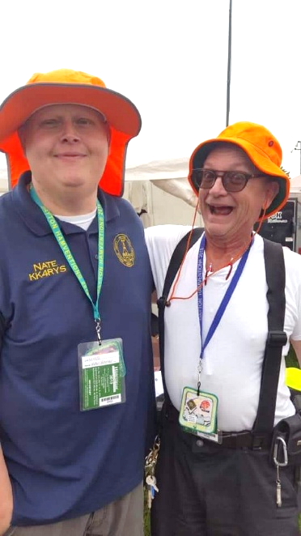

Here in the Great Lakes Division, we have over 50 hamfests a year.

So, if you haven’t started planning your hamfest schedule yet, you really need to start now.

Please post this listing in your club's newsletter and announce the swaps on your local nets. Talk them up.

Let's fully support all of our hamfests in every way possible. It means success for everyone. Be sure to invite your ARRL Officials as soon as your date is set.

If you are planning on having your hamfest listed in QST please be sure to start your planning well in advance of your Hamfest date, as this allows adequate time for QST Listings. QST announcements require a 3-month lead time.

To be fair to our division’s clubs, the Great Lakes Division policy **now has 2 requirements**.

**Any club requesting ARRL sanctioning within the Great Lakes Division must now be an ARRL Affiliated Club with a maximum of two hamfests/swaps in any given calendar year, and they must be at least four months apart.**

|  |  |
| --- | --- |
| **04/19/2025 -**[**SJCARC Hamfest**](https://www.arrl.org/hamfests/sjcarc-hamfest)  **Location:**Centreville, MI **Sponsor:** St. Joseph County Amateur Radio Club [**Learn More**](https://www.arrl.org/hamfests/sjcarc-hamfest) | **04/26/2025 - [Tusco Amateur Radio Club's 2025 Hamfest](https://www.arrl.org/hamfests/tusco-amateur-radio-club-s-2025-hamfest-computer-electronics-show" \o "Tusco Amateur Radio Club's 2025 Hamfest, Computer & Electronics Show)**  **Location:**Dover, OH **Sponsor:** Tusco Amateur Radio Club **Website:** <http://www.w8zx.net/hamfest> [**Learn More**](https://www.arrl.org/hamfests/tusco-amateur-radio-club-s-2025-hamfest-computer-electronics-show) |
| **04/27/2025 -**[**Athens Hamfest**](https://www.arrl.org/hamfests/athens-hamfest-12)  **Location:**Athens, OH **Sponsor:** Athens County Amateur Radio Association **Website:** <https://www.ac-ara.org/> [**Learn More**](https://www.arrl.org/hamfests/athens-hamfest-12) | **05/03/2025 - [Wexaukee ARC Swap & Shop](https://www.arrl.org/hamfests/wexaukee-arc-swap-shop-1" \o "Wexaukee ARC Swap & Shop)**  **Location:**Cadillac, MI **Sponsor:** Wexaukee Amateur Radio Club **Website:** [http://wexaukeearc.org](http://wexaukeearc.org/) [**Learn More**](https://www.arrl.org/hamfests/wexaukee-arc-swap-shop-1) |
| **05/10/2025 -**[**GMARC Trunk Swap**](https://www.arrl.org/hamfests/gmarc-trunk-swap-10)  **Location:**Shelby Township, MI **Sponsor:** General Motors Amateur Radio Club **Website:** [http://gmarc.org](http://gmarc.org/) [**Learn More**](https://www.arrl.org/hamfests/gmarc-trunk-swap-10) | **05/10/2025 - 05/15/2025** [**RV Radio Network Rally**](https://www.arrl.org/hamfests/rv-radio-network-rally-1)  **Location:**Navarre, OH **Sponsor:** RV Radio Network [**Learn More**](https://www.arrl.org/hamfests/rv-radio-network-rally-1) |
| **05/15/2025 - 05/18/2025** [**Four Days In May**](https://www.arrl.org/hamfests/four-days-in-may-2)  **Location:**Fairborn , OH **Sponsor:** QRP Amateur Radio Club International **Website:** <http://qrparci.org/fdim> [**Learn More**](https://www.arrl.org/hamfests/four-days-in-may-2) | **05/16/2025 - 05/18/2025** [**Dayton Hamvention**](https://www.arrl.org/hamfests/dayton-hamvention-8)  **Location:**Xenia, OH **Sponsor:** Dayton Amateur Radio Association **Website:** [http://Hamvention.org](http://hamvention.org/) [**Learn More**](https://www.arrl.org/hamfests/dayton-hamvention-8) |
| **06/07/2025 -**[**FCARC Summer Hamfest**](https://www.arrl.org/hamfests/fcarc-summer-hamfest-5)  **Location:**Delta, OH **Sponsor:** Fulton County Amateur Radio Club **Website:** <https://k8bxq.org/hamfest> [**Learn More**](https://www.arrl.org/hamfests/fcarc-summer-hamfest-5) | **06/07/2025 -**[**IRA Hudsonville Hamfest**](https://www.arrl.org/hamfests/ira-hudsonville-hamfest-5)  **Location:**Hudsonville, MI **Sponsor:** Independent Repeater Association **Website:** [http://www.w8ira.org](http://www.w8ira.org/) [**Learn More**](https://www.arrl.org/hamfests/ira-hudsonville-hamfest-5) |
| **06/07/2025 -**[**LARS Yooper Hamfest**](https://www.arrl.org/hamfests/lars-yooper-hamfest-1)  **Location:**Newberry, MI **Sponsor:** Luce Amateur Radio Services **Website:** [http://www.w8nby.org](http://www.w8nby.org/) [**Learn More**](https://www.arrl.org/hamfests/lars-yooper-hamfest-1) | **06/08/2025 -**[**Crossroads Hamfest**](https://www.arrl.org/hamfests/crossroads-hamfest-4)  **Location:**Marshall, MI **Sponsor:** Southern Michigan Amateur Radio Society **Website:** [http://www.w8df.com](http://www.w8df.com/) [**Learn More**](https://www.arrl.org/hamfests/crossroads-hamfest-4) |
| **06/14/2025 -**[**Midland Amateur Radio Club Swap**](https://www.arrl.org/hamfests/midland-amateur-radio-club-swap)  **Location:**Midland, MI **Sponsor:** Midland Amateur Radio Club **Website:** [http://www.w8kea.org](http://www.w8kea.org/) [**Learn More**](https://www.arrl.org/hamfests/midland-amateur-radio-club-swap) | **06/15/2025 -**[**Monroe Hamfest**](https://www.arrl.org/hamfests/monroe-hamfest-14)  **Location:**Monroe , MI **Sponsor:** Monroe County Radio Communications Association **Website:** [http://mcrca.org](http://mcrca.org/) [**Learn More**](https://www.arrl.org/hamfests/monroe-hamfest-14) |

You can always find the latest information to upcoming hamfests on the Great Lakes Division website.

](https://www.arrl.org/hamfests/search/Location.division_id:gl)

Just click to get the latest hamfest updates.

***Amateur Television Friday Night Dinner.***

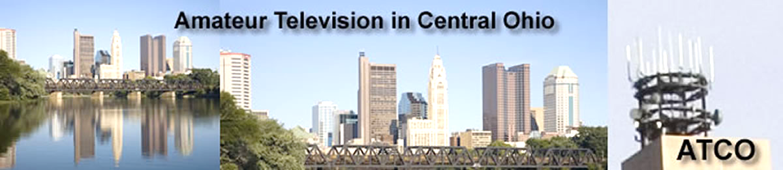

The ATV Friday Night Dinner will be on Hamvention weekend --- **May 16** at 6:30 PM at the China Garden Buffet Restaurant (937-781-9999), 112 Woodman Drive in Dayton, Ohio 45431 (Airway Shopping Center).

The all you can eat Buffet Dinner is $11.99. We will have dinner and then ATV presentations with it concluding at 9 PM.

All are invited. Door prizes will be awarded.

[***Dayton Bus Trip – May 17, 2025***](https://w8rp.org/daytonbus2025/)

The ARROW Communications Association and the [Toledo Mobile Radio Association (TMRA)](https://w8hhf.org/) are proud to sponsor a motor coach trip to the [Hamvention](http://www.hamvention.org/)2025 in Dayton, Ohio. This one-day trip leaves early in the morning on May 17, 2025 and returns the same day after Hamvention closes for the day at 5:00 p.m.

The bus has two pickup spots, in Ann Arbor and in Toledo (Rossford). Please join us! Tickets are $70 per person. Please note that this does not include the Hamvention ticket, which you need to [purchase separately](https://hamvention.org/purchase-tickets/).

ARROW started a bus in 2002, this annual club activity has grown in size and reputation with Hams across Michigan. We have hosted to over 700 Hams for this event.

](https://i0.wp.com/w8rp.org/wp-content/uploads/activities/dayton-bus-trip/dayton2004groupshot.jpg)

**Register before the bus fills up**  
ARROW and TMRA reserves the right to cancel the bus if not enough people sign up. If the bus is cancelled for unforeseen reasons, refunds will be issued.

**There are two pickup/drop off locations on May 17th, 2025**  
Ann Arbor – 601 W Stadium Blvd, Ann Arbor, MI – Departing 4:30 am

Toledo – 727 Lime City Rd. Rossford, OH – Departing 5:30 am

The plan is to arrive at the Hamvention around 8:30 am. On board, you can stretch out, relax, chat with other Hams and enjoy a continental breakfast with coffee as the coach takes you directly to the door of the country’s largest amateur radio event!

We arrive at Dayton early enough so that you can enjoy a full day!

* Visit exhibits
* See what’s new from major manufacturers
* Attend seminars
* Take license tests
* Shop one of the largest outdoor swap meets in the United States

***Club Links***

](https://arrl-greatlakes.org/links.html)I’ve received a number of new requests from clubs to be listed on the “Links” club page.

Is your club listed? If not, send the URL of your club website to me [n8sy@n8sy.com](mailto:n8sy@n8sy.com) and I’ll get it listed.

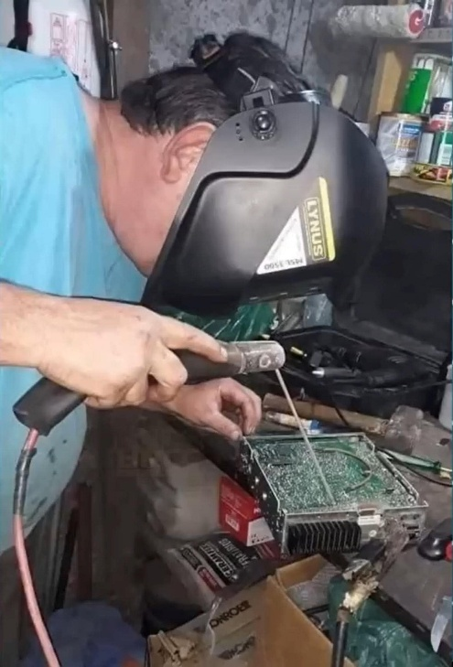***Wanted… Your Photo’s***

Have you seen the Photo Gallery on the Great Lakes Division website? If you haven’t you really need to, your face may be among the many already posted there.

[](https://arrl-greatlakes.org/gallery/index.php)

I’m always looking for more pictures to use in the Gallery, newsletter, banner and video display. Please, send me your pictures!!! Send them to: [n8sy@n8sy.com](mailto:n8sy@n8sy.com)

***The “Secret Sauce” for a Thriving Amateur Radio Club***

Over these past several issues of Radio Waves, I've been diving deep into what I consider the "Secret Sauce" that makes some ham radio clubs thrive while others struggle to maintain even a minimal membership for meetings. It's a concern that resonates with many of the club officers and members throughout the Great Lakes Division who want to see our local club’s flourish.

For years, I’ve chased the elusive “Secret Sauce” – but the truth, as it often does, turned out to be far simpler, yet significantly more challenging. There isn’t a universal, one-size-fits-all solution. The revitalization of any club hinges not on a secret sauce, but on something far more intrinsic: fostering a culture of genuine involvement.

And here's the kicker: this seemingly straightforward task is profoundly demanding, and uniquely local to each individual club. What works for one group might completely flop for another. The key is understanding *your* club's unique DNA, its members' needs and aspirations, and tailoring your approach accordingly.

Over the past year, I have had the opportunity to engage in many insightful discussions with you—our committed club leaders and members—regarding the ongoing challenges we face in boosting club participation and reigniting enthusiasm. These conversations have proven invaluable in clarifying the current situation and pinpointing the obstacles we encounter. It's about identifying a gap and exploring how we can reignite the spirit of collaboration that has always been at the heart of amateur radio. We all recognize the ARRL's vital role in spectrum defense, regulatory advocacy, and education. But on the ground level, in our local clubs and communities, many of us feel a disconnect, a sense that our efforts to invigorate the hobby aren’t always met with the resources and encouragement we hope for.

Many of you have stated to me that you feel strongly that the ARRL should take a more proactive approach, offering concrete resources and guidance to empower our clubs to succeed and thrive. You believe that the ARRL has the potential to be a more effective driver of positive change.

While I sincerely understand and appreciate this viewpoint, I believe that the root of the issue may be closer to us than we realize. The challenge, as I perceive it, is more local, entrenched, and perhaps more complex than merely expecting the ARRL to fix all the problems.

The underlying concept itself is deceptively simple: happy, engaged, and invested members are, without question, the lifeblood of any successful club, the very engine that drives its progress. However, translating this seemingly straightforward concept into practical reality demands unwavering dedication, persistent effort, and, most importantly, a genuine, collective commitment from **everyone** involved – from leadership to the newest recruit. And that, my friends, is precisely where I believe we need to focus our attention, where we must instigate the most significant and transformative change. It is simply not sufficient to merely hold occasional events or schedule perfunctory meetings. We must actively and deliberately cultivate an inclusive and welcoming atmosphere, a vibrant ecosystem where every single member feels genuinely valued, truly heard, respected for their unique contributions, and actively participating not only in the club's activities but also in the crucial process of shaping its future direction and strategic vision.

Too many of you have confided in me, often in moments of quiet frustration, that the overwhelming burden of responsibility consistently falls on the shoulders of the same small, albeit exceptionally dedicated, group of individuals – the usual five or six who consistently step up to volunteer their time, meticulously organize events, and tirelessly lead the charge. The pervasive feeling that others "just don't care," that there's a widespread apathy within the ranks, should serve as a clear and unmistakable warning sign that things are heading in a decidedly unsustainable direction. It's a stark symptom of a deeper, more systemic problem: a pervasive lack of widespread engagement, a growing disconnect between the club's activities and the needs and interests of its members, and a dwindling sense of shared ownership and collective purpose.

***"The best way to predict the future is to create it." - Peter Drucker***

Revitalizing a club is not a sprint; it's a marathon. It requires patience, persistence, and a genuine desire to create a welcoming and engaging environment for all members. It’s about shifting the focus from simply running a club to cultivating a community. I can recall countless instances in my own experiences of attempting to share innovative ideas with club officers only to be met with disheartening resistance. The classic dismissals, such as "this is the way we've always done it," or the even more discouraging, "this is (you-name-it)'s committee, and they decide what goes," have echoed through the halls of many organizations, effectively silencing potential contributions and stifling the very lifeblood of progress.

In fact, I've found that these phrases, while seemingly innocuous, speak volumes about the underlying dynamics within the club. They create an immediate barrier, communicating that new perspectives are not welcome and that the existing power structure is firmly entrenched. This kind of environment can quickly lead to disengagement, as members begin to feel that their voices don't matter, and their ideas are not valued. Consequently, enthusiasm wanes, participation dwindles, and the club slowly begins to stagnate. I have observed that when members are afraid to speak freely, creativity is stifled, and the organization misses out on opportunities for growth and innovation that might otherwise have been seized.

I've definitely noticed that breaking through this cycle requires a deliberate commitment to creating a space where everyone feels safe to share their thoughts and ideas without fear of judgment or reprisal. Therefore, it's about establishing clear channels for open communication, actively soliciting input from all members, and demonstrating a genuine willingness to consider new approaches. Moreover, it's about empowering members to take ownership of the club's activities and initiatives, fostering a sense of collective responsibility and shared purpose. I believe that by prioritizing involvement, we can unlock the full potential of our clubs, creating vibrant and engaging communities where everyone feels valued, respected, and inspired to contribute their best.

**From Passive to Active: It's All About Getting Involved**

Think about it. Are your club meetings filled with the same old routine? A quick update on club business, maybe a dry technical presentation, and then everyone scatters? While there's a place for structure, we need to inject some excitement and hands-on learning. Here are a few ideas to get those creative juices flowing:

* **Hands-On Workshops:** Instead of just talking about antennas, build one! Instead of discussing digital modes, set up a station and get everyone on the air.
* **Skill-Building Challenges:** Organize contests or mini-competitions focused on specific skills like soldering, Morse code, or antenna design.
* **Embrace New Technologies:** Don't be afraid to explore new digital modes, software-defined radios (SDRs), and other advancements in the hobby.
* **Themed Meetings:** Host meetings centered around specific topics or interests, like vintage radios, satellite communications, or emergency preparedness.
* **Contests and Games:** Introduce friendly competitions, like fox hunts or on-air challenges, to add some excitement to club activities.
* **Celebrate Successes:** Recognize and celebrate the achievements of club members, whether it's earning a new license, making a DX contact, or completing a challenging project.
* **Mentorship Programs:** Pair experienced hams with newer members to provide personalized guidance and support. This fosters a sense of community and allows new hams to learn from the wisdom of seasoned operators.
* **Field Days and On-Air Events:** Organize regular field days and on-air events that give members the opportunity to put their skills into practice and connect with other hams around the world. These events can be competitive or collaborative, but they should always be fun and engaging. Make Field Day more than just a weekend of operating. Incorporate educational activities, demonstrations, and opportunities for members to learn new skills
* **Community Service Projects:** Get involved in community service projects that utilize your radio skills. This could include providing communications support for local events, participating in emergency drills, or assisting with disaster relief efforts. This not only helps the community but also raises the profile of your club and attracts new members.
* **Tech Nights and Project Builds:** Dedicate specific nights to troubleshooting technical issues, building projects, or experimenting with new technologies. This provides a platform for members to share their expertise and learn from each other. Encourage members to share their projects, experiences, and interesting finds with the group.
* **Social Events:** Don't forget the importance of social interaction. Organize potlucks, picnics, and other social events that allow members to connect on a personal level. This builds camaraderie and strengthens the bonds within the club.

**Effective Time Management:** **Time management** is crucial for both club leaders and members. Carefully plan events and meetings to maximize engagement and minimize wasted time. Utilize online tools and communication platforms to streamline communication and coordinate activities.

**The Importance of "Why"**

I've always believed that a clear sense of purpose is essential for any successful organization. Ham radio clubs are no exception. Take some time as a club to discuss, define, and articulate your club's mission. Why do you exist? What do you hope to achieve? When things get tough, and engagement wanes, this will act as your North Star.

**It Starts With Us**

Ultimately, the responsibility for revitalizing our clubs’ rests with each and every one of us. We can't just sit back and wait for the ARRL or someone else to fix things. We (clubs) need to take ownership, get back involved, and actively contribute to resurrecting a club, making it both impactful and fun!

It requires a shift in mindset, a willingness to try new things, and a genuine commitment to serving the needs of our members. But the rewards are well worth the effort: a thriving club, a vibrant community, and a renewed passion for the hobby we all love.

Yes, "fun" can seem almost too simplistic, even frivolous, when discussing a hobby steeped in technical expertise and emergency preparedness. But consider this: in a world saturated with demands on our **time**, no one willingly dedicates their precious free hours to attending what feels like a monotonous, overly technical lecture or a series of dry, predictable meetings. We are all bombarded with information and commitments; the draw of an amateur radio club must be greater than the convenience of staying home.

Members need to leave each meeting or event feeling enriched, as if their **time** has been invested wisely. Whether it's acquiring new knowledge, nurturing camaraderie, sharing their expertise, or simply sharing a laugh, the experience must be intrinsically worthwhile.

**The Power to Transform Your Club Lies Within You**

We've all been there, sitting in a club meeting, feeling a sense of *meh*. Maybe attendance is dwindling, the projects feel stale, or the energy is just…off. It's easy to point fingers, to blame the leadership, the lack of resources, or even the collective apathy of the members. But I'm here to tell you, after years of being involved in clubs and organizations, that the real power to ignite change, to transform a lackluster club into something vibrant and thriving, lies within **you**.

**Yes, you.** The reader, the member, the maybe-even-an-officer who might be feeling a little discouraged right now. I'm not suggesting you single-handedly shoulder the entire burden. What I am saying is that your individual choices, your dedication, and your willingness to step up can collectively make a monumental difference.

Think about it. Clubs are, at their core, a collection of individuals with shared interests. And just like any ecosystem, the health and vitality of the group relies on the contributions of each member.

Complaining about the problem is easy. Identifying the source of the stagnation is a good start. But true progress starts with taking ownership and becoming part of the solution.

So, how do you become that catalyst for change? Here are a few things I've learned that have worked for some of the more active clubs in the Division:

* **Find Your Passion and Champion It:** What initially drew you to the club? Rekindle that spark. If you're passionate about a specific project, a particular cause, or even just improving the overall atmosphere, share that enthusiasm! Propose new initiatives, volunteer to lead a workshop, or simply inject your energy into existing activities. Passion is infectious, and your drive will inspire others to get involved.
* **Be the Engagement You Wish to See:** Are meetings feeling monotonous? Step up and liven them up! Suggest icebreaker activities, propose engaging discussion topics, or offer to present a short, informative segment on a topic related to the club's purpose. Even small changes can significantly impact the overall experience and encourage more active participation.
* **Embrace Collaboration and Listen Actively:** Transformation isn't a solo mission. It requires collaboration and a genuine understanding of what others want from the club. Before pushing your own agenda, take the time to listen to your fellow members. What are their concerns? What are their ideas? By actively listening and incorporating their feedback, you create a sense of shared ownership and build a stronger, more unified team.
* **Show Appreciation and Recognition:** A little recognition goes a long way. Acknowledge the contributions of your fellow members, both big and small. A simple "thank you" or a public acknowledgment of someone's hard work can boost morale and foster a more positive and supportive environment.
* **Don't Be Afraid to Challenge the Status Quo:** Sometimes, the best way to improve a situation is to question the way things have always been done. If you see an area where the club could be more effective or inclusive, don't be afraid to voice your concerns respectfully and propose alternative solutions.
* **Become a Mentor and Lead by Example:** Guide new members, share your knowledge, and demonstrate the values you want to see reflected in the club. By mentoring others, you not only contribute to their growth but also create a culture of mentorship that will benefit the club for years to come.

I know it can be daunting to feel like you're the only one trying to make a difference. But remember, even the smallest actions can have a ripple effect. Your enthusiasm, your willingness to contribute, and your commitment to creating a positive change can inspire others to join your cause.

Ultimately, the success of any club hinges on the collective effort of its members. It's not just the responsibility of the president or the board; it's the responsibility of each and every one of us. So, I challenge you to look within, identify your passions, and take the initiative to make the change you want to see in your club.

Believe me, when you take ownership and actively contribute to the betterment of your club, you'll not only transform the organization, but you'll also find a renewed sense of purpose and fulfillment within yourself. And that, my friends, is a reward worth striving for. The power is in your hands. Now go out there and make a difference.

Want help with understanding what your job as Secretary or Treasurer are? Go to: <https://learn.arrl.org/courses/52440> The ARRL Learning Center is crammed full of videos on a number of different topics that you and your club can use. Take advantage of these ARRL resources. This is part of what your dues pays for.

The Young Ladies Radio League (YLRL) has announced the Memorial Scholarship pro-gram for 2025. The scholarship program is aimed at women Amateur Radio Operators studying radio, communications, electronics or Amateur Radio related arts and sciences.

The Young Ladies Radio League (YLRL) is an international non-profit organization of women Amateur Radio enthusiasts. It was founded in 1939 and is the longest running YL club in the world. The YLRL is sponsoring three memorial scholarships for 2025:

The Ethel Smith K4LMB Memorial Scholarship—$2,500 award

The Mary Lou Brown NM7N Memorial Scholarship—$2,500 award

The Martha “Marte” Wessel K0EPE Memorial Scholarship—$1,500 award

The YLRL believes that education in the fields or radio, communications, electronics and Amateur Related arts and sciences will play an important role in shaping the world’s future. Through these Memorial Scholarship, YLRL hopes to encourage female students to learn more about Amateur Radio.

“YLRL is committed to investing in women in Amateur Radio, and we believe that every act of volunteerism through Amateur Radio — even a small one — helps turn the world into a better place,” said Vicki Zumwalt, President of YLRL. “We hope that our scholarships will not only encourage students to learn more about science, technology, engineering but also inspire them to take pride in being an Amateur Radio operator and to encourage others to do so as well.”

To qualify, students must be female, have an Amateur Radio License, meet the requirements listed on the YLRL.net website and apply using the online application. Applications are due by April 30, 2025. Winners will be announced in July 2025.

Application link: <https://YLRL.net/Scholarships>

***Delete.. Delete.. Delete..***

Many members have asked whether Amateur Radio will be affected by the recent government actions aimed at reducing waste, as mentioned in the article about "Delete.. Delete.. Delete" from the FCC chairman.

As I have stated to those who inquired, I view this as a potential positive development for Amateur Radio. It might lead to the removal of outdated regulations and consideration of proposals submitted by the ARRL over the years.

For those who may not have received the bulletin, I wanted to inform you about the ARRL's proposals to the FCC in light of the "Delete.. Delete.. Delete" approach from the FCC Chairman.

April 14, 2025

Dear ARRL Member,

ARRL The National Association for Amateur Radio® filed comments [PDF] with the Federal Communications Commission in response to its request for public input on alleviating unnecessary regulatory burdens by deleting or modifying rules, In the Matter of Delete, Delete, Delete. Implementing ARRL’s suggestions would promote and protect the art, science, and enjoyment of amateur radio, and enhance the development of the next generation of radio amateurs.

In response to ARRL’s request, over 200 members submitted suggestions that were reviewed when considering what rules should be deleted or modified. ARRL will continue to engage with members and advocate for the Amateur Radio Service.

In its filing, ARRL asked the FCC to delete or amend the following rules:

**Delete** the LF and VHF/UHF Symbol (Baud) Rate and Bandwidth Limitations

ARRL supports the deletion of these restrictions as proposed by the Commission in late 2023. Doing so would enhance Amateur experimentation with digital technologies.

**Update** and Modernize Entry Level Technician Class License Privileges

ARRL reiterated its earlier proposal for extending additional limited privileges for Technician class operators. Adopting its proposal would provide new licensees an introductory window to HF data and phone communications that are at the core of the Amateur Radio experience and serve to incentivize the next generation of technical leaders just as Novice CW HF privileges did for earlier generations of operators.

**Modernize** 80/75 Meter Subband Divisions

ARRL requested action on an earlier proposal that would make more efficient and intense use of the 80/75 meter band. Changes in technology and modes since band usage was last addressed have resulted in overcrowding in one band segment that would be alleviated by adoption of ARRL’s proposal.

**Delete** and Replace Obsolete Digital Code Limitations

ARRL also asked the FCC remove provisions that refer to digital codes that today are obsolete and permit Radio Amateurs to experiment freely with new digital codes, so long as such codes are publicly documented and decodable over the air.

**Implement** Changes to Third Party Rules Adopted Internationally at WRC-03

Although the United States fully supported changes to the ITU Radio Regulations in 2003 that removed a treaty requirement for third-party messages, there is no record of this change having been considered and the FCC’s rules were never conformed to the new provision. Being the only nation known to continue to require a formal treaty for such purposes has resulted in no new such treaties since the treaty changed more than two decades ago. Thus ARRL asked the FCC to Implement rules that are consistent with those internationally agreed to align with the rest of the world.

**Delete** Amplifier Drive Limitation

ARRL requested that the Commission act favorably on a pending proposal to remove limits HF amplifier gain that add to Amateur equipment cost and impede use of new efficient amplifier technology.

**Remove** Non-current Personal Information in Amateur ULS records

ARRL requested that the FCC complete a rule making in which it proposed that only current licensee information to be visible in the public (ULS) database. Right now, if an amateur changes their address to a Post Office Box to shield their home address, the previous address remains visible. ARRL advocates for protecting the privacy of radio amateurs.

**Delete** Obsolete Identification Requirement for Special Call Signs

Users of special event call signs are required to identify with the FCC-issued responsible call sign at least once each hour. This can be confusing, especially on data and CW modes. ARRL proposed reliance on the web-based database that clearly identifies each special event call sign and authorized period of use.

**Delete** Obsolete Paper License Replacement Provision

The FCC no longer mails physical copies of amateur radio licenses, so ARRL suggested deleting the rule that provides for sending paper replacements as obsolete.

The FCC notice [PDF] generated a lot of interest among radio amateurs, with hundreds of Amateurs submitting comments directly to the FCC as well as responding to ARRL’s request for suggestions.

The FCC deadline for filing reply comments is April 28, 2025.

It is hoped that the Commission will incorporate worthy suggestions in a future Notice of Proposed Rulemaking (NPRM) later this year. At that time there will be a new opportunity for public comment on the specific rules that the Commission proposes to delete or modify.

***STOP – Right there!!!***

***We’ve come to the end…***

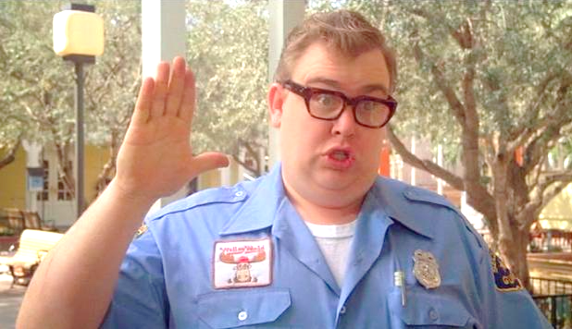

Be Radio-Active --- See Ya’ Soon!

Radio Waves is produced as a look inside of the Great Lakes Division and all that it has to offer. It is our sincerest hope that you have enjoyed this edition and will encourage your friends to be a part of the ARRL and receive the latest news and information about the ARRL and the Great Lakes Division!