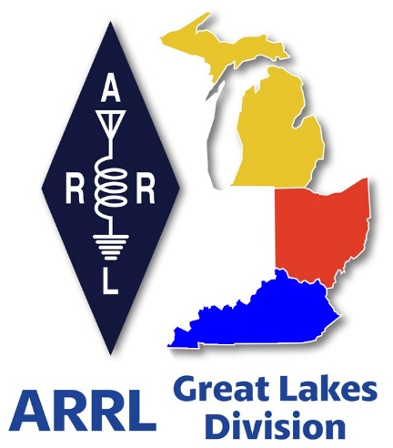 ***Radio Waves***

***The Great Lakes Division***

***Mid- Month Report***

***May***

***From the Michigan Section Manager***

Larry Camp, WB8R

Michigan Section News May, 2025

Greetings to all who read this. This month’s column will be a bit shorter than most because the amateur radio world is going to (almost literally) come to a halt because the Dayton Hamvention is happening on the 16th-18th of this month. First up is the preparation for going to Dayton/Xenia, followed by 3 or so days of total insanity at Hamvention, followed by 10 days of recovery and lots of conversation about what took place at Dayton/Xenia.

I find it very interesting how a single event can absolutely capture and dominate the total attention of many thousands of amateur radio operators from around the world. We are so fortunate to have this event reasonably close to us. BTW, I will be at Hamvention and plan to spend most of my time at the ARRL area in the Great Lakes Booth meeting and greeting everyone who passes through the area. This will be in Building 2 (the Tesla building). I will be there with the Section Managers from Ohio and Kentucky, along with our Division Director and Vice Director.

The hamfest season is in full swing in Michigan with a strong number of swaps organized and on the docket for 2025. Hamfests are a good barometer for determining several things: economic conditions, general attitude of the amateur population, and of course, the weather conditions always play a role in hamfest travels.

Here is the Michigan hamfest schedule as of this writing (w/callsign of ARRL Official planning to attend):

Jun 7, 2025 IRA Hudsonville Swap, Hudsonville, MI (K8TB)

Jun 7, 2025 LARS Yooper Hamfest, Newberry, MI (WB8R)

Jun 8, 2025 Crossroads Hamfest, Marshall, MI (WB8R)

Jun 14, 2025 Midland ARC Swap, Midland, MI (WB8R)

Jun 15, 2025 Monroe Hamfest, Monroe, MI (WB8R)

Jul 26, 2025 Blossomland Hamfest, Berrien Center. MI (TBD)

Sep 6, 2025 Grand Rapids Area Hamfest, Wyoming, MI (WB8R, K8TB)

Sep 13, 2025 OAARS Hamfest, West Branch MI (TBD)

Sep 13, 2025 GMARC Trunk Swap, Shelby Twp, MI (TBD)

Sep 14, 2025 Adrian Hamfest, Adrian, MI (WB8R)

Sep 20, 2025 Top of Michigan ARC Hamfest, Gaylord, MI (WB8R)

Oct 2, 2025 MAARC Meeting, Muskegon, MI (WB8R)

Oct 4, 2025 Keweenaw County Repeater Assn, Baraga, MI (TBD)

Oct 11, 2025 Muskegon Color Tour Hamfest, Muskegon, MI (WB8R)

Oct 19, 2025, USECA Hamfest, St. Clair Shores, MI (TBD)

Dec 7, 2025 LCARC ARC Hamfest, Troy, MI (WB8R)

Field Day 2025 The ARRL Field Day is held annually on the last full weekend in June. FD is always a favorite activity and is a great way to introduce new hams to the event and to welcome them to the world of amateur radio contesting. Operating skills for all will improve after an hour or two in the ‘hot seat’ on FD. Remember, the staples for a successful FD are:

Fun, Comradery, Radio, Public Awareness, Learning, and Fun. Did I mention Fun? Gotta have fun… Make sure that you and your club are radioactive. Be sure to get out and have fun and bring your friends.

Attend your local club meetings and make time to attend the meetings of other clubs near you. Be active within your club. Volunteer to be on a committee…. Run for office in your club. Offer to assist. Suggest or even organize a new activity. Invite club members to have a meal together. Be sure to include families. Find a reason to get together. Organize and participate on the air activities. Organize a fund raiser for your club. Does your club have a V/UHF net on the air? If so, participate as often as possible. If your club doesn’t have an on-air gathering, start said gathering. Don’t have a repeater close? Start a simplex net. Or use HF… Or use both repeaters and HF.

Activity is the key to a healthy club. That’s it for now. Travel safely and I hope to see you at an event sometime this year. If you are attending any of the hamfest that are scheduled, be sure to stop by and say hello. Best 73, Larry WB8R

Travel Safely, and best 73,

Larry

***From the Ohio Section Manager***

Tom Sly, WB8LCD

The latest edition of PostScript is now online and ready for you to read! Grab your favorite refreshment, sit back and relax in your comfy chair, and just enjoy the great reading found in this latest edition!

<https://arrl-ohio.org/wp-content/uploads/2025/05/OSJ_May-2025.pdf>

There’s an awful lot of Ham Radio activities going on in the Ohio Section, so get off the chair or couch you’re sitting on and get out there, get involved, and get on the air!

Tom…

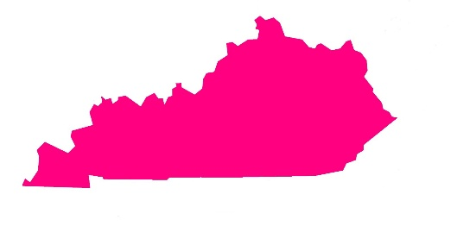***From the Kentucky Section Manager***

Alan Morgan, KY1O

Hi ARRL Members here in KY:   
  
First off I want to inform everyone that if you call me and don’t leave me a voicemail and I don’t recognize the number, then I will block the number and delete the call! I get around 12+ calls a day that   
are spam or sales calls I don’t want to receive and I get very tired of getting them! I got 3 calls while typing this message. Thanks for your understanding on this matter.   
  
I’m still in need to make many field appointments for various positions. One urgent need is for a Section Emergency Coordinator soon. I need more Emergency Coordinator and District Emergency Coordinator positions filled across the Commonwealth. Net Managers, Technical   
Coordinators, Youth Coordinators, Assistant Section Managers, and others as well.   
  
Field Day is coming up the end of June, so hopefully your club or other groups have plans well underway already. Plan for other activities also to keep members interested.   
  
I want to cover an important situation that occurs regularly to individuals. When new hams or other potential future club members attend their first meeting at one club or another and are ignored or not treated very welcome at all. How do clubs expect to expand club membership if the current members don’t act friendly and inviting.   
Many clubs just cover the same type of business meetings consistently and rarely do fun activities to keep and get new members in the club.

I’ve been treated less than nicely at several club meetings through my 46+ years as a ham. I’ve been a Life Member of ARRL for over 40+ years and have experienced a few good clubs with some being the exception. We all need to learn to be more friendly and welcoming to others. Let us all become better stewards in this hobby and as ARRL members too!   
  
As usual please do not hesitate to contact me with your, comments, questions, concerns, input, suggestions, club assistance, or other matters.   
  
Yous in service,   
   
73, Alan KY10 - WRBM701 - PG196081   
(859) 753-5092 cell   
[Ky1o@arrl.org](mailto:Ky1o@arrl.org) email

***Scott’s Stuff***

Hi Gang,

**Hamvention…** There’s a ton of forums scheduled for just about any interest within ham radio you could have. There’s also an ARRL Forum scheduled and I’m going to be the moderator. You’ll definitely want to sit in on that one for sure. It’s scheduled for 11:25am on Saturday in Room 3.

Have you downloaded the ARRL Events App yet? If you haven’t, you really should. It’s your guide for Hamvention. You can download it from the Google or Apple Apps store. Just search on ARRL Events App.

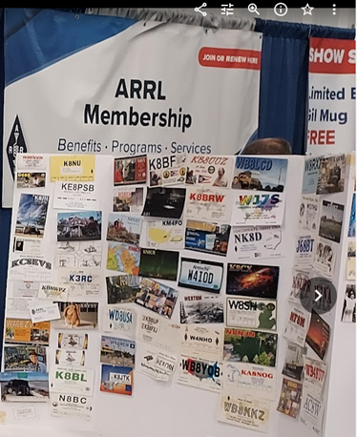Keeping with the Convention theme just a bit more... The Great Lakes Division will once again have a booth at Hamvention inside the ARRL area, just like last year. We are asking everyone to bring a QSL Card with them to post on the Division’s Brag Board. We were overwhelmed last year with the number of great QSL Cards that we got. This year we are making sure that you know well in advance so that we can have even more cards on display. And, we WILL have a much larger Brag Board to display all the great cards we get! Be sure to stop by the booth and say “Hey”… Want to talk? This is a great time to have that one-on-one conversation with us. Oh, and don’t forget to bring your QSL card with you to post as well!

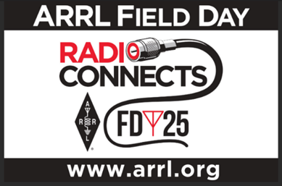

**Field Day** is fast approaching as well (June 22/23). Is your club making plans to have Field Day this year? If they are, don’t let them forget to get signed up on the Field Day locator <http://www.arrl.org/field-day-locator>

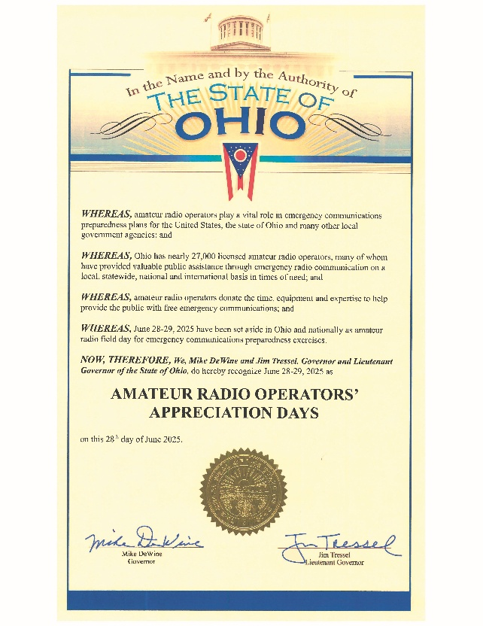Proclaim Your Passion: Get a Proclamation for Amateur Radio!

Here's a fantastic opportunity to raise awareness of amateur radio in your community: reach out to your local government officials and request a Proclamation for Amateur Radio for Field Day weekend. Most local governments are happy to support initiatives like this, and it's a great way to highlight the value of amateur radio to the public.

Don't forget to invite the local news media to the proclamation signing – this is excellent PR for your club and amateur radio in general, and you'll receive bonus points for your Field Day efforts! Amateur radio groups are encouraged to share a copy of their proclamations with the ARRL via [pr@arrl.org](mailto:pr@arrl.org). The ARRL often shares these proclamations to advance legislative efforts, creating additional support and awareness for amateur radio among lawmakers. It's a small effort that can have a big impact!

Oh, and one more thing... This isn’t mentioned much but it is so very important to make sure you do. Have someone assigned to take pictures!! Lots of them. Just about everyone nowadays has a phone with a camera built into it, so there’s really no excuse anymore for not taking pictures, and.... send them to me at: [n8sy@n8sy.com](mailto:n8sy@n8sy.com)

Regarding Field Day, I am undecided whether I will be attending or choosing a site to work some stations this year.

***Survey…*** I found the responses to the Survey last month once again very fascinating to say the least. The results are posted in this newsletter.

Is there a question that you’d like to see posted that hasn’t been so far? Let me know.

That’s going to do it from me this time around. Catch you on the air, in a meeting or at a hamfest!!! Be Radio Acitve!!!!!

73,

Scott, N8SY

Great Lakes Division Director

[n8sy@arrl.org](mailto:n8sy@arrl.org)

***Handbook Give Away***

Have you entered the Give Away Yet? Yes, I’m holding a little contest to "GIVE AWAY" a 2025 ARRL softcover Handbook. Why you ask? It’s to get you to check-in to the Great Lakes Division website and take a look around.

>> [Click Here To Enter](https://forms.office.com/Pages/ResponsePage.aspx?id=Dx2iugFz_kC91gPUQ6jCGEYWzQfXysZHvDC8hUJ9GuFUQlgyT0c4NzhYWEs0SFhJUFo4REw1TTU3OS4u) <<

Getting signed up is just as simple as filling out a couple of quick questions and you’re entered!!

Did you enter? You can’t win if you don’t enter, so keep your eyes peeled for the next time the Give Away comes up on the website, click on that link and get yourself entered.

***End of Life Announcement***

**From: rtl-sdr.com**

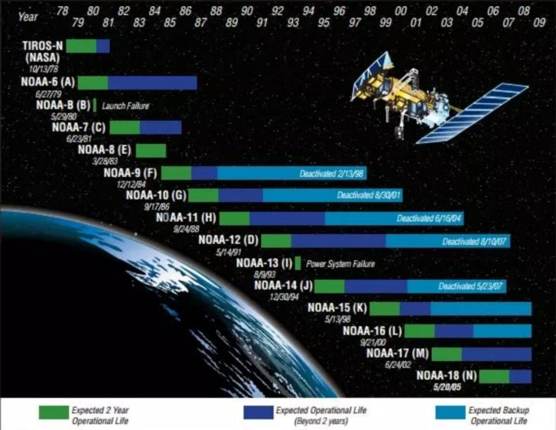The [www.USradioguy.com](http://www.USradioguy.com) blog recently highlighted information from Carl Reinmann regarding the future of several NOAA weather satellites popular with the RTL-SDR hobbyist community. According to Reinmann's report, NOAA 15, 18, and 19 are slated to be designated as "end-of-life" on June 16, 2025. These satellites are frequently used by enthusiasts to capture weather satellite images using inexpensive RTL-SDR dongles and readily available antennas. Two primary methods are employed: APT (Automatic Picture Transmission) on 137 MHz, typically using a simple V-dipole antenna, and HRPT (High Resolution Picture Transmission) on 1.7 GHz, which necessitates a more sophisticated tracking dish antenna for optimal reception.

Initially, the "end-of-life" classification sparked concerns within the community, with many fearing that this meant the cessation of APT and HRPT transmissions altogether. However, Carl Reinmann has since provided a crucial clarification obtained directly from NOAA. The good news is that the APT and HRPT signal transmissions will continue as usual, even after the June 2025 designation.

Despite the continued broadcasts, NOAA emphasizes that these transmissions will be considered "data of opportunity" going forward. This means that the data should no longer be relied upon for operational purposes, especially in any applications where safety is critical. Simply put, while the signals will remain available and perfectly suitable for casual hobbyist use, professional weather forecasting and safety-related applications should no longer depend on data from these specific satellites.

The "end-of-life" designation carries significant implications for the long-term viability of these satellites. Critically, if the sensors on board begin to malfunction, NOAA will not undertake any efforts to repair them remotely. Furthermore, in the event of a critical failure affecting the satellite's functionality, the satellite will be permanently decommissioned. This contrasts with past experiences, such as NOAA 15's recurring scan motor issues. The scan motor has failed on multiple occasions, only to seemingly recover on its own.

The exact cause of these recoveries remains unclear; it's unknown whether commands from ground control played a role in restoring functionality or whether the motor spontaneously resolved the issue. Moving forward, such failures will likely result in permanent decommissioning.

***Survey***

Here are the results from this last survey GLD-10. Thanks so much to all of you who took a few minutes of your busy schedules and completed it.

Got a question that you think should be asked? Let me know… [n8sy@n8sy.com](mailto:n8sy@n8sy.com)

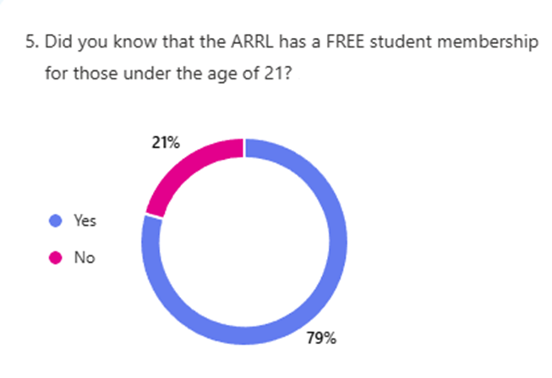

***2025 Great Lakes Division Hamfests***

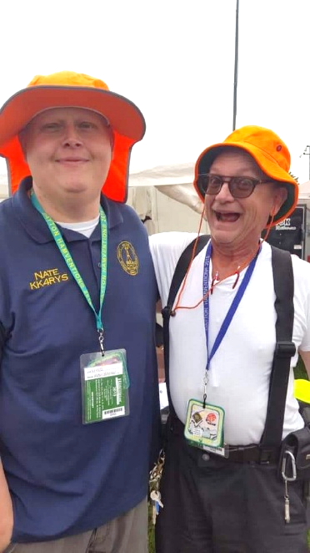

Here in the Great Lakes Division, we have over 50 hamfests a year.

So, if you haven’t started planning your hamfest schedule yet, you really need to start now.

Please post this listing in your club's newsletter and announce the swaps on your local nets. Talk them up.

Let's fully support all of our hamfests in every way possible. It means success for everyone. Be sure to invite your ARRL Officials as soon as your date is set.

If you are planning on having your hamfest listed in QST please be sure to start your planning well in advance of your Hamfest date, as this allows adequate time for QST Listings. QST announcements require a 3-month lead time.

To be fair to our division’s clubs, the Great Lakes Division policy **now has 2 requirements**.

**Any club requesting ARRL sanctioning within the Great Lakes Division must now be an ARRL Affiliated Club with a maximum of two hamfests/swaps in any given calendar year, and they must be at least four months apart.**

|  |  |
| --- | --- |
| **05/15/2025 - 05/18/2025** [**Four Days In May**](https://www.arrl.org/hamfests/four-days-in-may-2)  **Location:**Fairborn , OH **Type:** ARRL Convention **Sponsor:** QRP Amateur Radio Club International **Website:** <http://qrparci.org/fdim> [**Learn More**](https://www.arrl.org/hamfests/four-days-in-may-2) | **05/16/2025 - 05/18/2025** [**Dayton Hamvention**](https://www.arrl.org/hamfests/dayton-hamvention-8)  **Location:**Xenia, OH **Type:** **Sponsor:** Dayton Amateur Radio Association **Website:** [http://Hamvention.org](http://hamvention.org/) [**Learn More**](https://www.arrl.org/hamfests/dayton-hamvention-8) |
| **05/24/2025 -**[**Scioto Valley ARC Hamfest**](https://www.arrl.org/hamfests/scioto-valley-amateur-radio-club-hamfest-3)  **Location:**Piketon, OH **Type:** ARRL Hamfest **Sponsor:** Scioto Valley Amateur Radio Club [**Learn More**](https://www.arrl.org/hamfests/scioto-valley-amateur-radio-club-hamfest-3) | **06/07/2025 -**[**FCARC Summer Hamfest**](https://www.arrl.org/hamfests/fcarc-summer-hamfest-5)  **Location:**Delta, OH **Type:** ARRL Hamfest **Sponsor:** Fulton County Amateur Radio Club **Website:** <https://k8bxq.org/hamfest> [**Learn More**](https://www.arrl.org/hamfests/fcarc-summer-hamfest-5) |

|  |  |
| --- | --- |
| **06/07/2025 -**[**IRA Hudsonville Hamfest**](https://www.arrl.org/hamfests/ira-hudsonville-hamfest-5)  **Location:**Hudsonville, MI **Type:** ARRL Hamfest **Sponsor:** Independent Repeater Association **Website:** [http://www.w8ira.org](http://www.w8ira.org/) [**Learn More**](https://www.arrl.org/hamfests/ira-hudsonville-hamfest-5) | **06/07/2025 -**[**LARS Yooper Hamfest**](https://www.arrl.org/hamfests/lars-yooper-hamfest-1)  **Location:**Newberry, MI **Type:** ARRL Hamfest **Sponsor:** Luce Amateur Radio Services **Website:** [http://www.w8nby.org](http://www.w8nby.org/) [**Learn More**](https://www.arrl.org/hamfests/lars-yooper-hamfest-1) |
| **06/08/2025 -**[**Crossroads Hamfest**](https://www.arrl.org/hamfests/crossroads-hamfest-4)  **Location:**Marshall, MI **Type:** ARRL Hamfest **Sponsor:** Southern Michigan Amateur Radio Society **Website:** [http://www.w8df.com](http://www.w8df.com/) [**Learn More**](https://www.arrl.org/hamfests/crossroads-hamfest-4) | **06/14/2025 -**[**Midland ARClub Swap**](https://www.arrl.org/hamfests/midland-amateur-radio-club-swap)  **Location:**Midland, MI **Type:** ARRL Hamfest **Sponsor:** Midland Amateur Radio Club **Website:** [http://www.w8kea.org](http://www.w8kea.org/) [**Learn More**](https://www.arrl.org/hamfests/midland-amateur-radio-club-swap) |
| **06/15/2025 -**[**Monroe Hamfest**](https://www.arrl.org/hamfests/monroe-hamfest-14)  **Location:**Monroe , MI **Type:** ARRL Hamfest **Sponsor:** Monroe County Radio Communications Association **Website:** [http://mcrca.org](http://mcrca.org/) [**Learn More**](https://www.arrl.org/hamfests/monroe-hamfest-14) | **07/19/2025 - [NOARSfest](https://www.arrl.org/hamfests/noarsfest-12" \o "NOARSfest)**  **Location:**Elyria, OH **Type:** ARRL Hamfest **Sponsor:** Northern Ohio Amateur Radio Society **Website:** <https://www.noars.net/hamfests/noarsfest/> [**Learn More**](https://www.arrl.org/hamfests/noarsfest-12) |
| **07/19/2025 -**[**Williams County ARA Hamfest**](https://www.arrl.org/hamfests/williams-county-ara-hamfest-1)  **Location:**Montpelier, OH **Type:** ARRL Hamfest **Sponsor:** Williams County ARA [**Learn More**](https://www.arrl.org/hamfests/williams-county-ara-hamfest-1) | **07/20/2025 -**[**Van Wert Hamfest**](https://www.arrl.org/hamfests/van-wert-hamfest-9)  **Location:**Van Wert, OH **Type:** ARRL Hamfest **Sponsor:** Van Wert Amateur Radio Club **Website:** [http://w8fy.org](http://w8fy.org/) [**Learn More**](https://www.arrl.org/hamfests/van-wert-hamfest-9) |

You can always find the latest information about upcoming hamfests on the Great Lakes Division website.

](https://www.arrl.org/hamfests/search/Location.division_id:gl)

Just click to get the latest hamfest updates.

***Club Links***

](https://arrl-greatlakes.org/links.html)I’ve received a number of new requests from clubs to be listed on the “Links” club page.

Is your club listed? If not, send the URL of your club website to me [n8sy@n8sy.com](mailto:n8sy@n8sy.com) and I’ll get it listed.

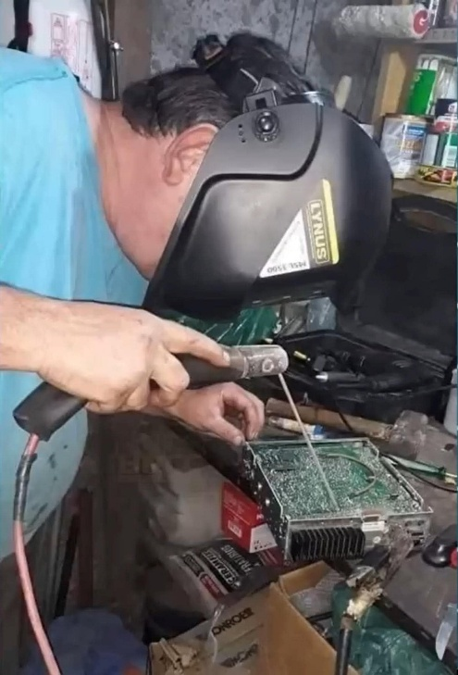***Wanted… Your Photo’s***

Have you seen the Photo Gallery on the Great Lakes Division website? If you haven’t you really need to, your face may be among the many already posted there.

[](https://arrl-greatlakes.org/gallery/index.php)

I’m always looking for more pictures to use in the Gallery, newsletter, banner and video display. Please, send me your pictures!!! Send them to: [n8sy@n8sy.com](mailto:n8sy@n8sy.com)

**Who's on First… and Trained?**

**The Evolving Role of Amateur Radio in Emergency Communications**

Remember the timeless "Who's on First?" skit by Abbott and Costello? The sheer comedic brilliance lies in the escalating chaos born from miscommunication and a lack of clarity. Now, consider this: have you ever heard this frustrating question, ***"Why do I need all this training to volunteer for ARES?"*** It's a sentiment that, while perhaps understandable on the surface, reveals a critical tension within the amateur radio community, particularly concerning emergency communications.

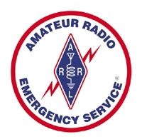The landscape of emergency response is changing, and with it, the demands placed on amateur radio operators. The eagerness of new and younger amateur radio operators to participate in ARES (Amateur Radio Emergency Service) and emergency communications is certainly commendable. Their passion and willingness to serve are valuable assets. However, it's crucial to recognize that raw enthusiasm, while a great starting point, is not sufficient preparation for the realities of emergency response. Consider this: imagine being thrust into a chaotic and rapidly changing situation – a devastating natural disaster, a widespread power outage crippling essential services, or a critical public health crisis. You arrive, equipped only with a handheld radio and the best of intentions. Without the necessary training and experience, your presence, while well-meaning, could inadvertently obstruct more experienced responders, create confusion, or even endanger yourself and others. You might lack the understanding of established protocols, the ability to efficiently communicate vital information, or the skills to troubleshoot technical issues under pressure. Effective emergency communication requires a solid foundation of knowledge, practiced skills, and the ability to remain calm and collected under duress.

Similarly, the desire to instantly become a skilled meteorologist, often observed in new hams drawn to the excitement of scanner activity during severe weather events, requires a more grounded approach. While listening to weather reports can be captivating, true understanding of atmospheric phenomena and the ability to accurately interpret weather patterns is a complex undertaking.

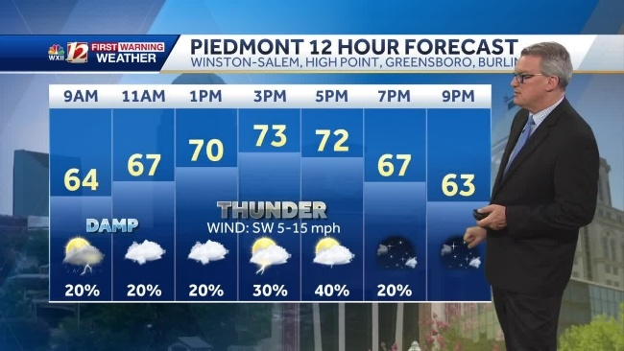It takes years of dedicated schooling, rigorous study of meteorological principles, and extensive on-the-job training to develop the expertise needed to accurately recognize various cloud formations, understand their intricate relationships to severe weather development, and effectively forecast potential hazards. Simply hearing the alerts on a scanner doesn't equate to the ability to provide reliable and informed weather information during a critical situation. Developing genuine competency in either emergency communications or meteorology demands a commitment to continuous learning, practical experience, and a willingness to receive guidance from seasoned professionals.

Let's be frank: volunteering in emergency communications isn't simply about knowing how to operate a radio. It's about understanding protocols, adhering to established communication structures, and seamlessly integrating with professional responders. It's about being a reliable asset, not a liability.

Think about the professional responders you'll be supporting. They've dedicated countless hours to training, often coupled with extensive field experience. They operate under immense pressure, making critical decisions that can have life-or-death consequences. Can you honestly say you're as prepared as they are? The reality is, likely not. And that's okay – it's why training is so crucial.

The core challenge lies in bridging the gap between the romanticized image of the ham radio operator as a lone wolf and the reality of modern emergency response, which demands coordinated teamwork and adherence to established procedures. Here's why comprehensive training is no longer optional, but absolutely essential:

* **Interoperability is Key:** Emergency situations necessitate seamless communication between various agencies – law enforcement, fire departments, medical personnel, and emergency management organizations. Training ensures you understand the terminology, protocols, and communication systems used by these professionals, allowing you to integrate effectively into the response effort.
* **Standardized Procedures for Efficiency:** Imagine the chaos if every amateur radio operator used a different method for relaying critical information. Training instills standardized procedures for message handling, net control operations, and emergency traffic management, ensuring clarity and efficiency when time is of the essence.
* **Situational Awareness and Decision-Making:** It's not enough to just transmit information. Training equips you with the skills to assess the situation, prioritize messages, and make informed decisions under pressure. You'll learn how to filter through extraneous noise and focus on the critical data needed by responders on the ground.
* **Personal Safety and Risk Mitigation:** Emergency situations are inherently dangerous. Training provides you with the knowledge to assess potential risks, protect yourself from harm, and operate safely in challenging environments. This includes understanding basic first aid, situational awareness, and communication protocols specific to hazardous conditions.
* **Legal and Ethical Considerations:** As an ARES volunteer, you’re representing the organization and, in some cases, a served agency. Training covers the legal and ethical considerations of emergency communications, ensuring you operate within the bounds of the law and with the highest level of integrity.

***So, what does this mean for you, the aspiring ARES volunteer?***

Embrace the training opportunities available. ARES groups and other organizations offer a wide range of courses, from basic emergency communication protocols to advanced net control techniques. Look for certifications like FEMA's Incident Command System (ICS) training, which are highly valued by emergency management agencies.

View training not as an obstacle, but as an investment. It's an investment in your skills, your knowledge, and your ability to make a meaningful contribution during times of crisis. It's an investment in the safety and well-being of yourself and the community you're serving.

Ultimately, the goal isn't to become a clone of a professional responder, but to be a well-trained, reliable, and valuable asset to the emergency response team. By embracing training, you transform yourself from a well-intentioned amateur into a vital link in the chain of communication, ensuring that when the call for help goes out, you're not just "on first," but you're also ready to play your position with skill and confidence. Let's ensure that in the face of an emergency, the only thing clear is the communication, not the confusion.

In some counties, Emergency Management Agencies (EMAs) are shifting away from solely relying on ARES (Amateur Radio Emergency Service) for communications support. They are increasingly embracing the AUXCOMM (Auxiliary Communications) model. This shift signifies a recognition that effective emergency communications require a broader skillset and a standardized approach, emphasizing the importance of comprehensive training and interoperability.

***I'm a Communicator, Not a Paper Shuffler***

Over the years, some ARES groups have grown complacent regarding training, relying on the assumption that technical expertise alone is sufficient. The image of a volunteer arriving at an incident with multiple radios, declaring themselves ready to take charge solely based on their ham radio license, has become a cautionary tale. These individuals, often lacking formal training beyond a basic ARES taskbook – and sometimes not even that – are often unprepared for the realities of modern emergency response.

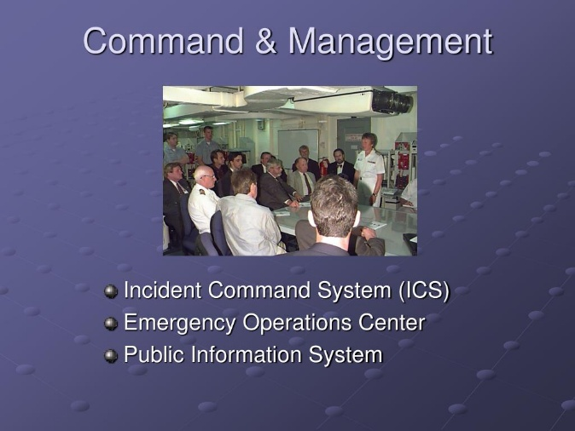They lack familiarity with essential protocols like ICS (Incident Command System) 100, 200, 700, and 800. Their understanding of NIMS (National Incident Management System) is often limited, and they may be unfamiliar with current methodologies for operating within an ICS structure. In today's emergency response landscape, such a lack of preparation is no longer acceptable, and unfortunately, these individuals are often turned away. Their common response, "I'm a Ham Radio Operator, and all I do is communications!" underscores the disconnect between their perceived value and the actual requirements of modern emergency communication.

The reality is that the communication systems available today are far more sophisticated and robust than in the past. With multiple layers of redundancy and advanced technologies, it would require a truly catastrophic event to necessitate relying solely on "10 watts and a wire" as a primary backup. This doesn't negate the value of amateur radio, but it necessitates a shift in how Hams prepare and contribute.

***Ham Radio: An Anachronism or a Vital Resource?***

So, is amateur radio becoming obsolete? The answer is nuanced. Ham radio operators can still play a vital role in supporting existing communication infrastructure, but only if they are willing to commit to comprehensive training and adapt to the evolving demands of emergency response. They might get deployed for other tasks besides communication specific tasks

During an actual crisis, the Logistics Branch (which oversees communications) will be overwhelmed and unable to provide on-the-spot training. Therefore, providing a small, well-trained group, encompassing individuals from various amateur radio organizations, who are adaptable and capable of thinking outside the box, will be invaluable. Such a team will be welcomed and encouraged to participate.

AUXCOMM, unlike focusing solely on ARES, embraces a broader approach. It prioritizes trained and licensed amateur radio operators from any organization, as long as they possess the requisite knowledge of ICS and are capable of contributing effectively to the served agencies in times of need.

To be a valuable asset in emergency communications, volunteers must be proficient in:

* **ICS and NIMS:** Understanding and applying the principles of the Incident Command System and the National Incident Management System is paramount.
* **Interoperability:** The ability to communicate effectively with various agencies and organizations using different communication systems is crucial. This includes familiarity with technologies such as:
  + - MotoTRBO (DMR)
    - Trunked P25 Systems
    - Data Transmissions
* **NiFOG (National Interoperability Field Operations Guide):** Familiarity with the guidelines and best practices outlined in the NiFOG for ensuring interoperable communications.
* **Served Agency Protocols:** Understanding the specific communication needs and protocols of the agencies you are supporting, such as:
  + - FEMA (Federal Emergency Management Agency)
    - EMA (Emergency Management Agency)
    - NGO's (Non-Governmental Organizations) such as the Red Cross, Salvation Army, and other relief organizations.
    - National Weather Service during SKYWARN operations.
* **ARRL Resources:** Leveraging the training and resources provided by the ARRL (American Radio Relay League) to enhance skills and knowledge.
* **Stepping Up to the Plate: Training for Success**

To truly contribute effectively to emergency communications, volunteers need to embrace a commitment to continuous learning and professional development. This includes:

* **Formal ICS and NIMS Training:** Completing courses like ICS 100, 200, 700, and 800 is essential for understanding the framework of emergency response.
* **Participation in Drills and Exercises:** Actively participating in drills and exercises with served agencies allows volunteers to practice their skills and integrate into the overall response plan.
* **Staying Current with Technology:** Keeping abreast of the latest advancements in communication technology, including digital modes and interoperability solutions.
* **Building Relationships:** Establishing strong working relationships with served agencies and other volunteer organizations fosters trust and collaboration.
* **Embracing AUXCOMM:** Recognizing the value of a standardized, multi-faceted approach to emergency communications and actively participating in AUXCOMM initiatives.

***Being Ready When Called Upon:***

***Amateur Radio's Evolving Role in Emergency Communications***

For decades, amateur radio has stood as a stalwart backup communication system, ready to spring into action "When All Else Fails." Your technical prowess, your ability to coax signals across vast distances without relying on conventional infrastructure, has been invaluable during emergencies. However, the landscape of emergency communications is changing, and with it, the demands placed upon amateur radio operators. While your technical skills remain essential, they are no longer sufficient on their own. To truly be ready when called upon, you must embrace a more comprehensive approach, one that emphasizes training, adaptability, and interoperability.

The days of simply knowing how to operate a radio are fading. Today's emergency response environment is complex, involving a diverse array of agencies, technologies, and protocols. To effectively contribute, you need a deeper understanding of how these elements interact and how amateur radio fits into the overall picture.

Think of it like this: knowing how to swing a bat isn't enough to win a baseball game. You need to understand the rules, know the positions, and work effectively as part of a team. Similarly, simply knowing how to tune a radio dial isn't enough to be an effective emergency communicator. You need to know the protocols, understand the roles of different agencies, and be prepared to integrate seamlessly into their communication networks.

One of the best frameworks for achieving this readiness is embracing the AUXCOMM model. Auxiliary Communications (AUXCOMM) emphasizes the importance of standardized training and operational procedures for amateur radio operators who support public safety agencies. By aligning your training and practices with those of the agencies you serve, you become a 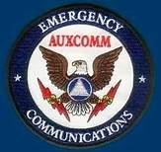more valuable and reliable resource. This includes understanding the National Incident Management System (NIMS) and the Incident Command System (ICS), which are the standardized frameworks used by most emergency response organizations in the United States and beyond.

Beyond embracing the AUXCOMM model, investing in formal training is paramount. This goes beyond the basic license requirements. Seek out opportunities to participate in courses offered by FEMA, state emergency management agencies, and amateur radio organizations. These courses can provide you with vital knowledge in areas such as:

* **Emergency Communications Protocols:** Understanding how to relay messages accurately and efficiently, using standard operating procedures.
* **Incident Command System (ICS):** Learning how communications are structured within an incident and your role within that structure.
* **Interoperability:** Familiarizing yourself with the equipment and protocols used by various agencies and how to seamlessly integrate with their systems.
* **Situational Awareness:** Developing the skills to gather, analyze, and disseminate critical information effectively.

This formal training is not merely about accumulating certifications; it's about cultivating a mindset of preparedness and professionalism. It's about understanding the nuances of emergency communication and developing the skills necessary to perform effectively under pressure.

However, training alone is not enough. Building strong relationships with the agencies you intend to serve is equally crucial. This means actively engaging with local emergency management agencies, law enforcement, fire departments, and other relevant organizations. Attend their meetings, participate in their exercises, and seek opportunities to learn about their communication needs and challenges. By fostering these relationships, you can gain a deeper understanding of their operational environment and tailor your skills and services to meet their specific requirements. You also build trust, which is essential when seconds count. When an emergency strikes, agencies will be far more likely to rely on amateur radio operators they know and trust, who have demonstrated a commitment to professionalism and preparedness.

The role of amateur radio in emergency communications is evolving, moving beyond a purely technical focus towards a more integrated and collaborative approach. By embracing the A person sitting at a picnic table
AUXCOMM model, participating in formal training, and building strong relationships with served agencies, you can ensure that you are not just a ham radio operator, but a vital member of the emergency response team. Just like knowing who's on first base, understanding the protocols and procedures of modern emergency response is critical for success.

Let's make sure we're all trained and ready to step up to the plate when needed, so that "When All Else Fails," we are prepared to provide reliable and effective communication support to our communities.

***STOP – Right there!!!***

***We’ve come to the end…***



Be Radio-Active --- See Ya’ Soon!

Radio Waves is produced as a look inside of the Great Lakes Division and all that it has to offer. It is our sincerest hope that you have enjoyed this edition and will encourage your friends to be a part of the ARRL and receive the latest news and information about the ARRL and the Great Lakes Division!