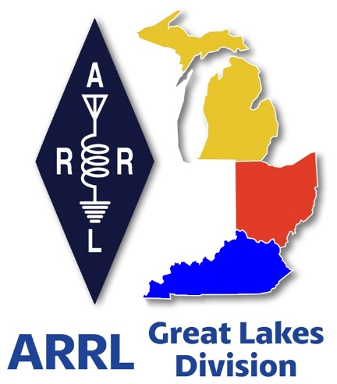 ***Radio Waves***

***The Great Lakes Division***

***Monthly Journal***

***May 2025***

***What’s inside…***

|  |  |
| --- | --- |
| 🡪 Handbook Give Away  🡪 Kentucky opens hamfest season  🡪 Club Links | 🡪 2025 Division Hamfests  🡪 Club Leadership |

***Scott’s Stuff***

Hi Everyone,

Happy May 1st! Mayday!

The air is buzzing with excitement, and for good reason. As the saying goes, "April showers bring May flowers," and just like the Mayflower brought the Pilgrims, May brings us closer to the legendary Dayton Hamvention! We're just 15 days away from diving headfirst into a weekend of all things amateur radio. Are you as ready as I am for the fun to begin?

Let's get right down to business – there's a lot to cover!

**Hamvention – The Mecca of Ham Radio!**

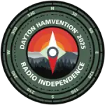Hamvention is renowned for its incredible array of forums, covering virtually every aspect of our hobby imaginable. Whether you're into contesting, digital modes, emergency communications, or the history of radio – there's a forum for you.

And speaking of forums, I'm excited to announce that I will be the moderator for the ARRL Leadership Presentation! This is a fantastic opportunity to hear directly from ARRL leaders and learn about the organization's initiatives and vision for the future of amateur radio. You definitely won't want to miss it! Mark your calendars for **Saturday at 11:25 AM in Room 3.** I hope to see you there!

**Great Lakes Division Brag Board at Hamvention!**

Building on the Hamvention theme, the Great Lakes Division will be hosting our popular booth inside the ARRL area, just like last year. We're bringing back the "Brag Board," and we need YOUR help to make it even better!

We're asking everyone attending Hamvention from the Great Lakes Division (and beyond!) to bring a QSL card to post on the board. Last year, we were amazed by the variety and quality of cards we received. This year, we're giving you plenty of advance notice so we can create an even more impressive display! We've even secured a larger Brag Board to accommodate all the fantastic cards we expect.

Stop by the booth to say "Hey!" This is also a wonderful opportunity to have a one-on-one conversation with division leadership, ask questions, share your ideas, and connect with fellow hams. And remember, don't forget to bring your QSL card to contribute to the Brag Board!

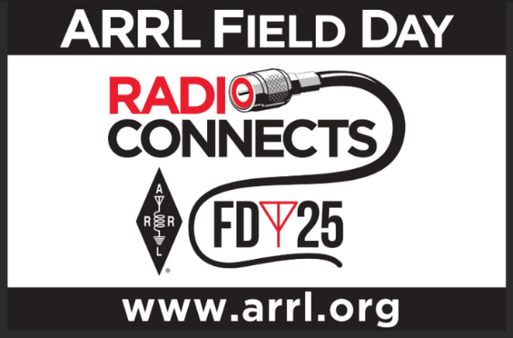**Field Day is Coming – Time to Plan!**

Field Day is rapidly approaching (June 28th and 29th)! This is amateur radio's largest on-the-air event, and a prime opportunity to showcase our capabilities to the public. Is your club making plans to participate this year?

If so, please ensure your club is registered on the official ARRL Field Day Locator: <http://www.arrl.org/field-day-locator>. This allows others to find your site and join in the fun!

**Proclaim Your Passion: Get a Proclamation for Amateur Radio!**

Here's a fantastic opportunity to raise awareness of amateur radio in your community: reach out to your local government officials and request a Proclamation for Amateur Radio for Field Day weekend. Most local governments are happy to support initiatives like this, and it's a great way to highlight the value of amateur radio to the public.

Don't forget to invite the local news media to the proclamation signing – this is excellent PR for your club and amateur radio in general, and you'll receive bonus points for your Field Day efforts! Amateur radio groups are encouraged to share a copy of their proclamations with the ARRL via [pr@arrl.org](mailto:pr@arrl.org). The ARRL often shares these proclamations to advance legislative efforts, creating additional support and awareness for amateur radio among lawmakers. It's a small effort that can have a big impact!

**Capture the Memories: Don't Forget the Photos!**

This is a critical point that often gets overlooked: assign someone (or several people!) to take pictures during Field Day! With nearly everyone carrying a smartphone with a built-in camera, there's no excuse for not capturing the fun and excitement.

Please send your best Field Day photos to me at [n8sy@n8sy.com](mailto:n8sy@n8sy.com). I'd love to see them and potentially feature them in future communications!

**Field Day – Where Will I Be?**

I haven't yet finalized my plans for Field Day this year. I'm debating whether to travel around and visit multiple Field Day sites or simply set up camp with a group and enjoy the weekend. I always wish I could visit more sites than I'm able to, but we'll see what the final decision is.

There's still plenty of time to decide, and my dartboard is ready for action! The most important thing is that there are many fantastic Field Day sites to visit and support.

I look forward to seeing many of you at Hamvention and hearing about your successful Field Day operations!

That's all for this month. Stay safe, everyone, and I hope to "Catch You On The Air, at a meeting, or at a hamfest!" Most importantly... Have FUN and... Get On The Air!

73,

Scott Yonally, N8SY

Director - Great Lakes Division

[n8sy@arrl.org](mailto:n8sy@arrl.org)

***Handbook Give Away Winner!!***

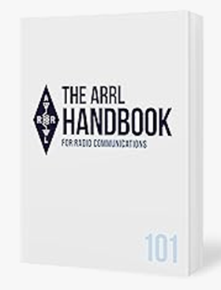Ok… now, can I have a drum roll please?

The winner of the Handbook Give Away is none other than…

*Jack Prindle, AB4AWS*

from Union, Kentucky

Did you enter? You can’t win if you don’t enter, so keep your eyes peeled for the next time the Give Away comes up on the website, click on that link and get yourself entered.

***Amateur Television Friday Night Dinner.***

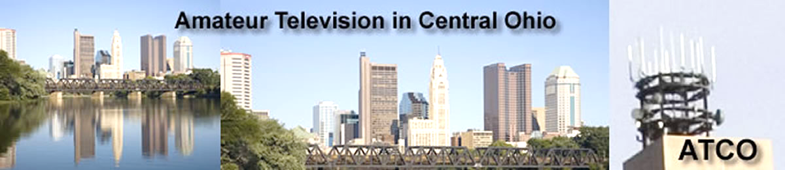

The ATV Friday Night Dinner will be on Hamvention weekend --- **May 16** at 6:30 PM at the China Garden Buffet Restaurant (937-781-9999), 112 Woodman Drive in Dayton, Ohio 45431 (Airway Shopping Center).

The all you can eat Buffet Dinner is $11.99. We will have dinner and then ATV presentations with it concluding at 9 PM.

All are invited. Door prizes will be awarded.

***2025 Great Lakes Division Hamfests***

Here in the Great Lakes Division, we have over 50 hamfests a year.

So, if you haven’t started planning your hamfest schedule yet, you really need to start now.

Please post this listing in your club's newsletter and announce the swaps on your local nets. Talk them up.

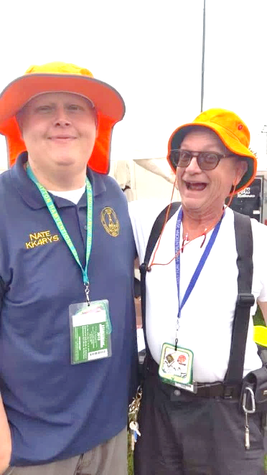

Let's fully support all of our hamfests in every way possible. It means success for everyone. Be sure to invite your ARRL Officials as soon as your date is set.

If you are planning on having your hamfest listed in QST please be sure to start your planning well in advance of your Hamfest date, as this allows adequate time for QST Listings. QST announcements require a 3-month lead time.

To be fair to our division’s clubs, the Great Lakes Division policy **now has 2 requirements**. **Any club requesting ARRL sanctioning within the Great Lakes Division must now be an ARRL Affiliated Club with a maximum of two hamfests/swaps in any given calendar year, and they must be at least four months apart.**

You can always find the latest information to upcoming hamfests on the Great Lakes Division website.

](https://www.arrl.org/hamfests/search/Location.division_id:gl)

Just click to get the latest hamfest updates.

|  |  |
| --- | --- |
| **05/03/2025 - [Wexaukee ARC Swap & Shop](https://www.arrl.org/hamfests/wexaukee-arc-swap-shop-1" \o "Wexaukee ARC Swap & Shop)**  **Location:**Cadillac, MI **Type:** ARRL Hamfest **Sponsor:** Wexaukee Amateur Radio Club **Website:** [http://wexaukeearc.org](http://wexaukeearc.org/) [**Learn More**](https://www.arrl.org/hamfests/wexaukee-arc-swap-shop-1) | **05/10/2025 -**[**GMARC Trunk Swap**](https://www.arrl.org/hamfests/gmarc-trunk-swap-10)  **Location:**Shelby Township, MI **Type:** ARRL Hamfest **Sponsor:** General Motors Amateur Radio Club **Website:** [http://gmarc.org](http://gmarc.org/) [**Learn More**](https://www.arrl.org/hamfests/gmarc-trunk-swap-10) |
| **05/10/2025 - 05/15/2025** [**RV Radio Network Rally**](https://www.arrl.org/hamfests/rv-radio-network-rally-1)  **Location:**Navarre, OH **Type:** ARRL Convention **Sponsor:** RV Radio Network [**Learn More**](https://www.arrl.org/hamfests/rv-radio-network-rally-1) | **05/15/2025 - 05/18/2025** [**Four Days In May**](https://www.arrl.org/hamfests/four-days-in-may-2)  **Location:**Fairborn , OH **Type:** ARRL Convention **Sponsor:** QRP Amateur Radio Club International **Website:** <http://qrparci.org/fdim> [**Learn More**](https://www.arrl.org/hamfests/four-days-in-may-2) |
| **05/16/2025 - 05/18/2025** [**Dayton Hamvention**](https://www.arrl.org/hamfests/dayton-hamvention-8)  **Location:**Xenia, OH **Type:** **Sponsor:** Dayton Amateur Radio Association **Website:** [http://Hamvention.org](http://hamvention.org/) [**Learn More**](https://www.arrl.org/hamfests/dayton-hamvention-8) | **05/24/2025 -**[**Scioto Valley Amateur Radio Club Hamfest**](https://www.arrl.org/hamfests/scioto-valley-amateur-radio-club-hamfest-3)  **Location:**Piketon, OH **Type:** ARRL Hamfest **Sponsor:** Scioto Valley Amateur Radio Club [**Learn More**](https://www.arrl.org/hamfests/scioto-valley-amateur-radio-club-hamfest-3) |
| **06/07/2025 -**[**FCARC Summer Hamfest**](https://www.arrl.org/hamfests/fcarc-summer-hamfest-5)  **Location:**Delta, OH **Type:** ARRL Hamfest **Sponsor:** Fulton County Amateur Radio Club **Website:** <https://k8bxq.org/hamfest> [**Learn More**](https://www.arrl.org/hamfests/fcarc-summer-hamfest-5) | **06/07/2025 -**[**IRA Hudsonville Hamfest**](https://www.arrl.org/hamfests/ira-hudsonville-hamfest-5)  **Location:**Hudsonville, MI **Type:** ARRL Hamfest **Sponsor:** Independent Repeater Association **Website:** [http://www.w8ira.org](http://www.w8ira.org/) [**Learn More**](https://www.arrl.org/hamfests/ira-hudsonville-hamfest-5) |
| **06/07/2025 -**[**LARS Yooper Hamfest**](https://www.arrl.org/hamfests/lars-yooper-hamfest-1)  **Location:**Newberry, MI **Type:** ARRL Hamfest **Sponsor:** Luce Amateur Radio Services **Website:** [http://www.w8nby.org](http://www.w8nby.org/) [**Learn More**](https://www.arrl.org/hamfests/lars-yooper-hamfest-1) | **06/08/2025 -**[**Crossroads Hamfest**](https://www.arrl.org/hamfests/crossroads-hamfest-4)  **Location:**Marshall, MI **Type:** ARRL Hamfest **Sponsor:** Southern Michigan Amateur Radio Society **Website:** [http://www.w8df.com](http://www.w8df.com/) [**Learn More**](https://www.arrl.org/hamfests/crossroads-hamfest-4) |
| **06/14/2025 -**[**Midland Amateur Radio Club Swap**](https://www.arrl.org/hamfests/midland-amateur-radio-club-swap)  **Location:**Midland, MI **Type:** ARRL Hamfest **Sponsor:** Midland Amateur Radio Club **Website:** [http://www.w8kea.org](http://www.w8kea.org/) [**Learn More**](https://www.arrl.org/hamfests/midland-amateur-radio-club-swap) | **06/15/2025 -**[**Monroe Hamfest**](https://www.arrl.org/hamfests/monroe-hamfest-14)  **Location:**Monroe , MI **Type:** ARRL Hamfest **Sponsor:** Monroe County Radio Communications Association **Website:** [http://mcrca.org](http://mcrca.org/) [**Learn More**](https://www.arrl.org/hamfests/monroe-hamfest-14) |

***Kentucky opens hamfest season with a bang.***

Roy Hook, [W8REH@arrl.org](mailto:W8REH@arrl.org)

ARRL Great Lakes Division

Vice Director

*I was so proud of myself for getting this article for May written and ready to go shortly after returning from Cave City weekend in advance of its deadline. It quickly points out we don’t know what tomorrow brings. The first week of April mother nature showed who was boss. We all know the devastation in Kentucky from the floods that likely impacted many who provided the hospitality and comradery we so enjoyed at Cave City. Because I want that event to be remembered as such a good time, I am leaving the following original article intact.*

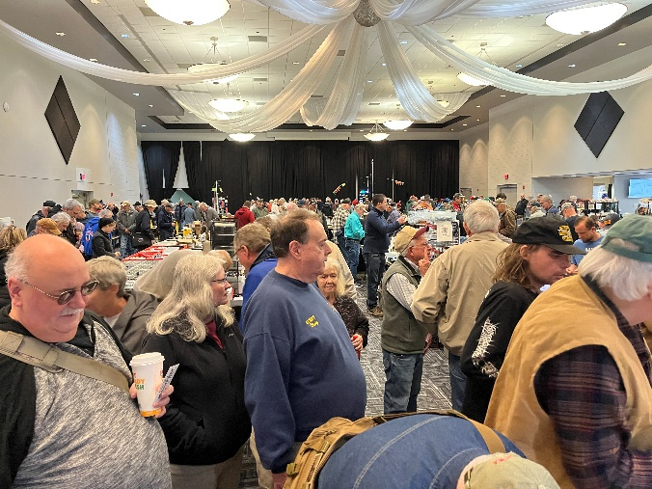Kentucky kicked off the Great Lakes Division hamfest season on March 22 at Cave City’s convention center with a large, extremely passionate ham crowd. Only a little over an hour north of the home of WSM, the world’s most famed country music RADIO station at Nashville’s Grand Old Opry, Cave City Kentucky is at the southern tip of the Great Lakes Division. The Upper Peninsula of Michigan represents our northern extreme.

This was the 49th annual consecutive Cave City event. Although I have never attended before, it has a reputation as a well-established event for the area. I was pleasantly surprised at about everything I encountered. Director Scott Yonally from northern Ohio and I residing in more central Ohio met the evening before setting up. Allen, KY1O our new Kentucky Section Manager, joined us Saturday morning where we all enjoyed a warm welcome and friendly, informative discussions all morning. I often visit Kentucky Bourbon Country enjoying the passion of its history and people. As you study the historical details of the rich Kentucky bourbon culture and ham radio you find interesting parallels of the passion, friendship and comradery of each.

We have visited Mammoth Cave in the past. We took Friday afternoon to explore a 1960’s contemporary private cave discovery, Crystal Onyx. Digging into the history of this cave you discover passion similar to what we experienced in the building of our ham radio hobby.

After this cave’s initial discovery, it was opened for tours for a few years. Without resources to maintain it, it was sold to Cumberland Cellular for its antenna location benefits.

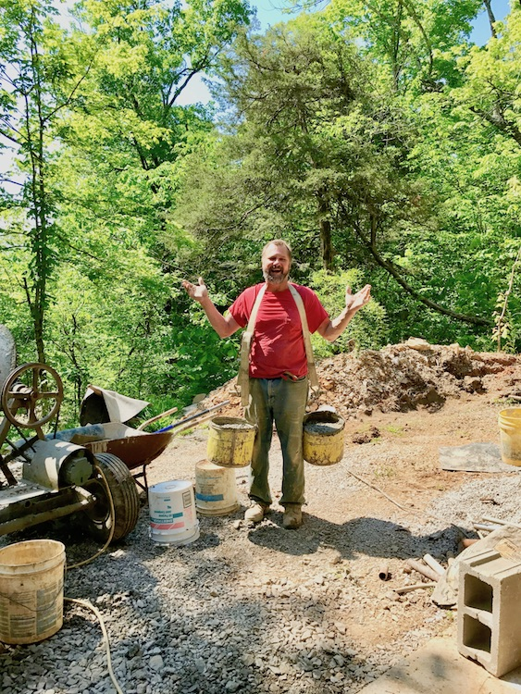

It would not reopen until 2018 after a husband/wife team with the necessary passion and strong backs brought it back as a spectacular area attraction. If excavating by hand with a pair of 5-gallon buckets isn’t ham radio style passion, what is?

Studying Amateur Radio history quickly reveals the many passionate people who have led us to where we are today. I have often heard it said the only things definite in life are death and taxes. I have concluded it really is death and change. We may not like change since we don’t have control over much of it, but we must learn to accept what we cannot control.

Many are pointing out that our hobby has become a thousand hobbies with a hobby.

Some of the most passionate supporters of Amateur radio have strong interest in the traditional aspects of our hobby like Contesting, DX-ing, supporting community and emergency preparedness activities which are all extremely important to the health of our hobby and brought us to where we are today.

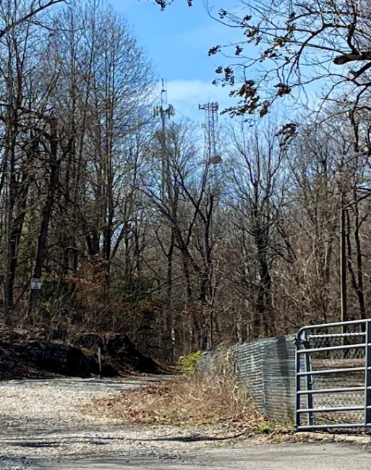Cultivating the other 900 or so less understood aspects that will bring the new generation of hams to the table remains a challenge. The passion yet to be developed for each of the new things we may not understand or even care about is part of the future. All of us can do better at providing encouragement and support for a new generation who will ultimately define our hobby. We must stop trying to educate people on the way it was or is and give support in finding the passion to drive the future. Our hobby started with spark gap technology, later evolving into continuous wave technology we now simply call RF. RF is the backbone of almost everything we know and love about ham radio. As our hobby and world moves forward, RF is likely to be a major part of it, but maybe not exclusively. Keep an open mind and be willing to learn and explore science and technology. Be a lifetime learner.

The month of May always brings Hamvention, May 16-18, 2025. I encourage everyone to visit Hamvention to learn and explore, not just to shop the world’s largest candy store. You will find no better place in the world to learn from the forums and knowledge everywhere. Look beyond your traditional interest and search for the passions that just might drive the future. No one knows where we will go or what tomorrow brings. Scott and I plan to be there in the Great Lakes team booth so bring a QSL card for the board and stop by and tell us what’s on your mind.

The future definition of our hobby is still to be found. Understanding our history is extremely important in understanding how our predecessors looked past the “what’s in it for me” today and created the future we now enjoy. Understand some of this historic passion may help you create the spark you need to create the future.

***Club Leadership:***

**Turning Meetings from Drudgery to Delight**

How's the atmosphere at your amateur radio club? Are your meetings lively hubs of camaraderie and learning, or do they feel more like obligatory gatherings to discuss finances and membership dues? If your club meetings are starting to feel stale, it might be time to examine your club leadership and explore ways to inject some **fun** and engagement.

In previous articles, we touched upon the importance of making meetings **interesting** – of providing that "magic bullet" and "secret sauce" that keeps members coming back for more. But creating a dynamic and thriving club requires more than just one or two individuals. It truly takes a "village" – a collective effort from leadership and members alike – to transform your club into something truly special.

**Recognizing the Newcomer: A Crucial First Step**

Imagine being a new, prospective member walking into a club meeting for the first time. You're eager to learn, connect, and potentially join a community of like-minded individuals. But what if you're met with a room full of people already engaged in discussions, presentations, and club business? Do you feel welcomed and encouraged to participate, or do you find yourself lost in the shuffle, trying to figure things out on your own?

This scenario plays out far too often. Many clubs, caught up in their established routines, inadvertently overlook the importance of actively welcoming and integrating **new members**. We get so focused on delivering pre-planned information that we neglect the human element – the need to make newcomers feel recognized, valued, and comfortable enough to ask questions.

Does your club have a designated "greeter" or a structured process for introducing **new members** and ensuring their questions are answered? Does the club leadership actively encourage members to reach out to newcomers, share their experiences, and offer guidance? These small gestures can make a world of difference in creating a welcoming and inclusive environment.

**Injecting Excitement: Beyond the Business Agenda in Amateur Radio Clubs**

Let’s be honest, attending club meetings can sometimes feel like a chore. Deliberations on club expenditures, lengthy discussions about membership dues, and the minutiae of organizational matters, while undoubtedly important, can often overshadow the very essence of amateur radio – the excitement of discovery, experimentation, and community. To truly thrive, amateur radio clubs need to move beyond the purely procedural and cultivate an environment of engaging content, interactive activities, and opportunities for growth. It's time to inject some excitement.

One potent way to revitalize club meetings is by offering enriching presentations. Have you ever considered inviting a truly special guest speaker, perhaps someone whose expertise lies in a niche area of amateur radio, but whose geographical location makes a physical appearance impossible? This is where technology steps in to bridge the gap. Services like Zoom, or other virtual meeting platforms, make it remarkably simple to host remote presentations that are both informative and engaging. With a little pre-planning and technical setup, your club can host a world-renowned expert on antenna design, a seasoned DX-peditioner, or even an ARRL representative, all from the comfort of your regular meeting space.

Speaking of ARRL, have you and your club explored the wealth of resources available through the ARRL Learning Center? This online platform provides a treasure-trove of educational material, covering everything from basic licensing to advanced technical topics. Beyond the Learning Center, many ARRL staff members are willing to present to clubs virtually, sharing their expertise and insights on a variety of topics. Don't hesitate to reach out and explore the possibilities, as this can be a fantastic way to bring authoritative and up-to-date information to your members.

Another effective strategy for fostering engagement is the creation of Special Interest Groups (SIGs). SIGs provide a focused platform for members to delve deeper into specific areas of amateur radio that resonate with them. Whether it's digital modes like FT8 and Vara, the intricacies of contesting, the art and science of antenna design, or the vital role of emergency communications, SIGs allow members with shared passions to connect, collaborate, and learn from one another.

These smaller, more intimate groups can foster a stronger sense of community and provide opportunities for hands-on learning that may not be possible in a larger, more general meeting setting.

Of course, nothing beats the thrill of hands-on activities. Ditch the PowerPoint presentations occasionally and get your members involved in something tangible. Consider organizing a balloon launch to explore the ionosphere, a classic fox hunt to test direction-finding skills, or a collaborative construction project, like building a simple receiver or antenna.

These activities not only provide opportunities for members to apply their knowledge and learn new skills, but they also foster camaraderie and create lasting memories. Imagine the sense of accomplishment and shared experience that comes from launching a weather balloon together or successfully tracking down a hidden transmitter. These memorable experiences are what keep members coming back for more.

Ultimately, the goal is to transform club meetings from perceived obligations into anticipated opportunities for learning, connection, and fun. By prioritizing engaging content, interactive activities, and opportunities for growth, clubs can cultivate a vibrant and thriving community of amateur radio enthusiasts. Think outside the box, embrace technology, leverage the resources available through the ARRL, and, most importantly, listen to your members. What are they interested in learning? What activities would they enjoy? By tailoring your meeting agendas to meet the needs and interests of your members, you can inject a new level of excitement into your club and ensure its continued success for years to come. Let's move beyond the business agenda and rediscover the joy of amateur radio together.

**Addressing Dissatisfaction: It Starts with You**

It's not uncommon to hear complaints about the ARRL (American Radio Relay League) and its perceived lack of support for local clubs. However, as we've discussed in previous articles, placing blame solely on the **ARRL** is often misplaced. While the **ARRL** provides valuable resources and support, the ultimate responsibility for a club's success lies with its leadership and members.

The most successful clubs are those that take ownership of their own destinies. They don't rely on external organizations to dictate their direction or solve their problems. Instead, they focus on creating a vibrant and engaging environment that attracts and retains members.

These clubs understand that the key to success is not just about conducting business efficiently, but about fostering a sense of community, providing opportunities for learning and growth, and making amateur radio **fun** and accessible to all.

They keep the treasurer's report concise and focused and devote the majority of the meeting to what truly matters: **interesting** presentations, engaging activities, and building camaraderie.

**The Road to Success: A Collaborative Effort**

Transforming a club from a mundane business meeting into a thriving community requires a collaborative effort from both the leadership and the members. Here are some key steps to consider:

* **Assess the Current Situation:** Take an honest look at your club's strengths and weaknesses. Gather feedback from members about their experiences and suggestions for improvement.
* **Prioritize Engagement:** Make member engagement a top priority. Focus on creating a welcoming and inclusive environment where everyone feels valued and has the opportunity to participate.
* **Develop Engaging Content:** Plan presentations and activities that are **interesting**, informative, and relevant to the diverse interests of your members.
* **Foster a Sense of Community:** Organize social events, mentoring programs, and other activities that promote camaraderie and build relationships among members.
* **Empower Members:** Encourage members to take on leadership roles, share their expertise, and contribute to the club's success.

By embracing these principles and working together, your amateur radio club can transform itself into a vibrant and engaging community that attracts **new members**, fosters learning and growth, and makes amateur radio an **interesting** and **fun** experience for all.

***R – U - A Member?***

**Be Radio-Active. Join ARRL Today!**

Join ARRL today and get access to benefits, services, and programs to help you get (and stay) active and on the air. Your membership supports ARRL’s work to promote and protect amateur radio, and to develop the next generation of radio amateurs.

**Did You Know?**

You can give the gift of ARRL Membership. By purchasing a gift membership, you’ll be helping a ham become more active and involved in amateur radio. Gift memberships are available for both U.S. and International individuals and for our Associate (non-licensed) and Full membership types.

By gifting a membership to ARRL you are opening up a world of information, education and fun for that special radio enthusiast in your life! Please call our Member Services team at 860-594-0200 and they will be happy to assist you.

|  |
| --- |
|  |

**Join -** [**Register**](https://login.personifygo.com/prodarrl/Registration/RegisterEmail?returnurl=https://home.arrl.org/action/My-Account) for a web account and then [**Join**](https://home.arrl.org/action/Membership/Join-ARRL).Already a member? [**Renew**](https://home.arrl.org/action/Membership/Renew-Membership) your ARRL membership or simply call ARRL Member Services at **860-594-0200** during normal business hours.

***Armed Forces Day (AFD) Crossband Test - Saturday May 10, 2025.***

The event will test two-way communications between military stations and amateur radio operators as authorized by the Federal Communications Commission in Title 47 of the Code of Federal Regulations [47 CFR 97.111](https://arrl.informz.net/z/cjUucD9taT0zMzE2OTMyJnA9MSZ1PTUyMDM2NDI5NiZsaT0zNzc5Mjc1MA/index.html).

The test provides opportunities — and challenges — for operators to test their individual technical skills in a controlled scenario that will not impact public or private communications. The annual DOD message will be transmitted via RTTY on 14.667 kHz at 1400 and 2000 UTC. Military stations will transmit on selected military frequencies and announce the specific amateur radio service frequencies that will be monitored. All scheduled times will be in UTC, and all scheduled transmissions will be upper sideband (USB), unless otherwise noted.

Frequencies, times, and other technical information can be found at [DoD MARS - Armed Forces Day](https://arrl.informz.net/z/cjUucD9taT0zMzE2OTMyJnA9MSZ1PTUyMDM2NDI5NiZsaT0zNzc5Mjc1Mg/index.html). Those who wish to document their contacts with a QSL card should visit [**www.usarmymars.org**](https://arrl.informz.net/z/cjUucD9taT0zMzE2OTMyJnA9MSZ1PTUyMDM2NDI5NiZsaT0zNzc5Mjc1NA/index.html) and complete the request form. For more than 50 years, military and amateur stations have taken part in this event.

***Solar Flares, Auras, and Ham Radio: How Space Weather Impacts GPS Users***

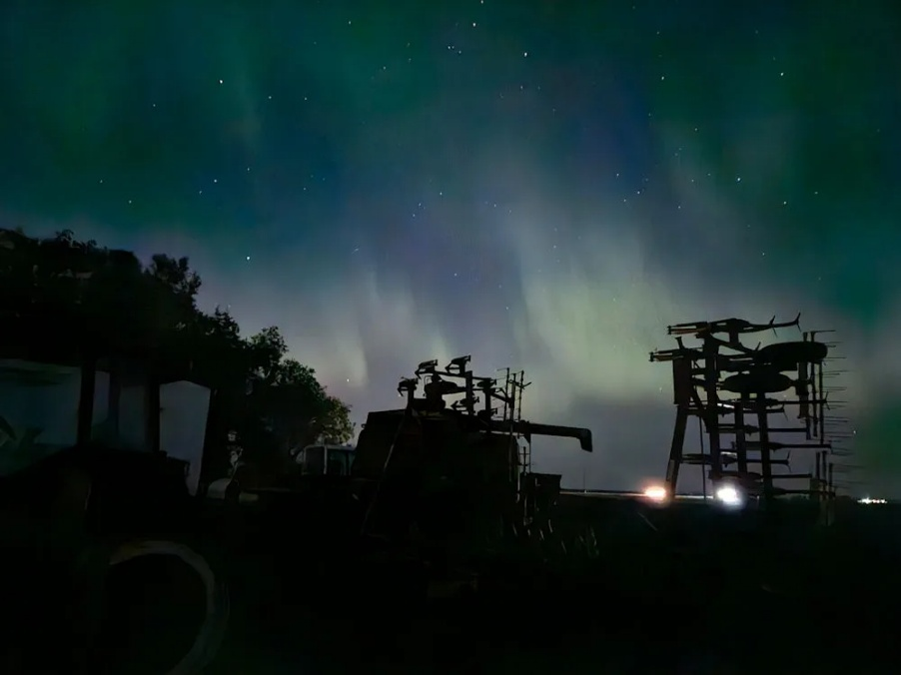

Solar flares, spectacular eruptions on the sun's surface, are more than just a beautiful astronomical phenomenon. They release immense amounts of energy in the form of electromagnetic radiation, including radio waves, that can significantly impact the Earth's atmosphere and, consequently, technologies we rely on daily. While stunning auroras are a visible effect of solar activity, the less visible but equally significant impact on radio propagation affects GPS users across various sectors, not just farmers.

The sun constantly emits a stream of charged particles known as the solar wind. When a solar flare erupts, it intensifies this solar wind, sometimes dramatically. These intensified streams interact with the Earth's magnetosphere, the protective bubble around our planet. This interaction can disrupt the ionosphere, a layer of the atmosphere crucial for radio wave propagation.

For amateur radio (ham radio) operators, understanding radio wave propagation is fundamental. Hams use the ionosphere to bounce radio signals over long distances, sometimes across continents. Solar flares can cause sudden ionospheric disturbances (SIDs), disrupting these carefully planned communications. Signals can fade, become distorted, or even disappear entirely.

But the impact extends far beyond ham radio enthusiasts. Modern technology heavily relies on GPS signals. Land transportation depends on GPS for navigation, logistics, and fleet management. Aviation safety systems rely on accurate GPS positioning. Even critical infrastructure, such as power grids and financial networks, often depends on GPS signals for precise timing.

Therefore, the impact of solar flares on GPS accuracy is a widespread concern. Disruptions to the ionosphere can cause GPS errors, leading to inaccurate positioning data. This can have serious consequences across the board, from navigational mishaps to financial transaction errors. Even those using GPS for accurate time signals, as in some amateur radio applications, can experience discrepancies.

As radio waves are critical to amateur radio, any increased frequency in the aurora can cause disruptions for those using HAM radios.

The increasing reliance on GPS technology underscores the importance of monitoring space weather and understanding its potential effects.

“The amateur radio community provides a valuable service to the public and the nation in times of need. When other forms of communication fail, amateur radio operators are often able to provide vital communications links.” - *Michael D. Griffin, former NASA Administrator*

This is why understanding the impact of solar flares and disruptions to radio propagation is crucial for all stakeholders, particularly those who rely on GPS for critical functions. Continuous monitoring of solar activity and development of mitigation strategies are essential to minimize potential disruptions and ensure the continued reliability of GPS technology across all sectors.

Want more information on this topic?

<https://spaceweatherarchive.com/2025/04/23/solar-storms-are-driving-farmers-crazy/>

***Club Links***

](https://arrl-greatlakes.org/links.html)I’ve received a number of new requests from clubs to be listed on the “Links” club page.

Is your club listed? If not, send the URL of your club website to me [n8sy@n8sy.com](mailto:n8sy@n8sy.com) and I’ll get it listed.

***STOP!!!***

***We’ve come to the end…***

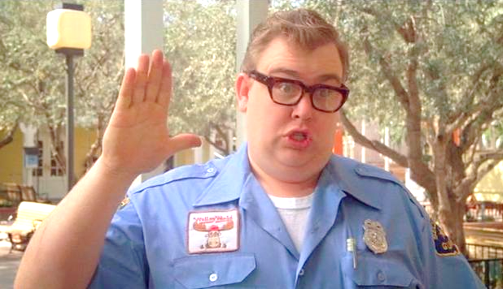

Be Radio-Active --- See Ya’ Soon!