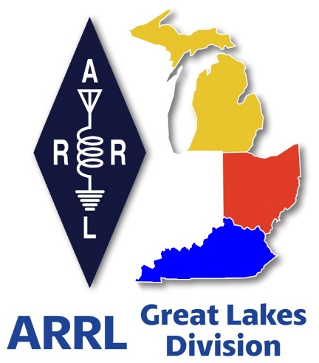 ***Radio Waves***

***The Great Lakes Division***

***Mid- Month Report***

***June***

***From the Michigan Section Manager***

Larry Camp, WB8R

***Michigan Section News*** - ***June, 2025***

Greetings to all who read this,

I wish all readers the best and I hope that you are enjoying the pre-summer. We have had a few days of summer-like conditions that hint of warmer weather to come. As time moves on, I find that I enjoy the moderate weather of spring and fall as opposed to the deep freeze and the blazing heat. However, we get what we get.

***Dayton Recap***

The 2025 Dayton experience was absolutely outstanding, with great weather, huge crowds, and lots of excitement and fun. The attendees were smiling, chatting, and obviously enjoying themselves. I was particularly pleased to have been present when my old friend of around 45 years, Dale Williams, WA8EFK was presented with the ARRL Lifetime Achievement Award. I cannot think of a single person who would be more deserving of said award. Thank you, Dale,  for your hard work on behalf of Amateur Radio and for being a great friend for all these years. You have earned your retirement, my friend…..

***ARRL Michigan Events***

On June 7, the Parks On The Air (Pota) held a meet-up at Custer State Park near Agusta, MI and while I was at a hamfest in the Upper Peninsula (Newberry). I understand that a large crowd attended this event.

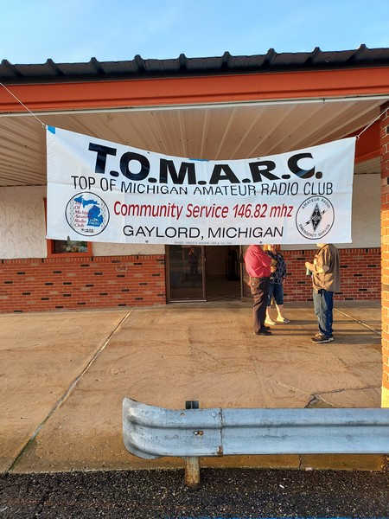The hamfest season is in full swing in Michigan with a strong number of swaps organized and on the docket for 2025. Hamfests are a good barometer for determining several things: economic conditions, general attitude of the amateur population, and of course, the weather conditions always play a role in hamfest travels.

Here is the Michigan hamfest schedule as of this writing (w/callsign of ARRL Official planning to attend):

Jun 14, 2025 Midland Hamfest, Midland, MI (WB8R)

Jun 15, 2025 Monroe Hamfest, Monroe, MI (WB8R)

Jul 26, 2025 Blossomland Hamfest, Berrien Center. MI (TBD)

Sep 6, 2025 Grand Rapids Area Hamfest, Wyoming, MI (WB8R, K8TB)

Sep 13, 2025 OAARS Hamfest, West Branch MI (TBD)

Sep 13, 2025 GMARC Trunk Swap, Shelby Twp, MI (TBD)

Sep 14, 2025 Adrian Hamfest, Adrian, MI (WB8R)

Sep 20, 2025 Top of Michigan ARC Hamfest, Gaylord, MI (WB8R)

Oct 2, 2025 MAARC Meeting, Muskegon, MI (WB8R)

Oct 4, 2025 Kalamazoo ARC/SMART Vintage Electronics Expo (WB8R)

Oct 4, 2025 Copper Country Hamfest, Baraga, MI (TBD)

Oct 11, 2025 Muskegon Color Tour Hamfest, Muskegon, MI (WB8R)

Oct 19, 2025, USECA Hamfest, St. Clair Shores, MI (TBD)

Dec 7, 2025 LCARC ARC Hamfest, Troy, MI (WB8R)

***Field Day 2025***

The ARRL Field Day is held annually on the last full weekend in June. FD is always a favorite activity and is a great way to introduce new hams to the event and to welcome them to the world of amateur radio contesting. Operating skills for all will improve after an hour or two in the ‘hot seat’ on FD. Remember, the staples for a successful FD are: Fun, Comradery, Radio, Public Awareness, Learning, and Fun. Did I mention Fun? Gotta have fun…

Make sure that you and your club are radioactive. Be sure to get out and have fun and bring your friends. Attend your local club meetings and make time to attend the meetings of other clubs near you. Be active within your club. Volunteer to be on a committee…. Run for office in your club. Offer to assist. Suggest or even organize a new activity. Invite club members to have a meal together. Be sure to include families. Find a reason to get together. Organize and participate in  on air activities. Organize a fund raiser for your club. Does your club have a V/UHF net on the air? If so, participate as often as possible.

If your club doesn’t have an on-air gathering, start said gathering. Don’t have a repeater close? Start a simplex net. Or use HF… Or use both repeaters and HF. Activity is the key to a healthy club.

***ARPSC/Net Activity May 2025***

ARPSC Total Person Hours: 4792   Dollar Value: $166,713

Net Activity Total Person Hours: 1195   Dollar Value: $20,175

Total Person Hours: 5987

Total Dollar Value; $186,888

Station Activity:

K8ED 470. KB8PGW 115, WB8TQZ 97, ND8W 61, K8RDN 60, KD8ZCM 56, KE8HKA 35, KE8SMN 27, WD8USA 23, KE8CEH 19. N8RWF 9 K8WU 7. KC8YVF 6

You can find complete MI Amateur Radio Public Service Corps information at [www.mi-arpsc.org](http://www.mi-arpsc.org/)

That’s it for now. Travel safely and I hope to see you at an event sometime this year. If you are attending any of the hamfests that are scheduled, be sure to stop by and say hello.

Best 73,

Larry WB8R

[wb8r@arrl.org](mailto:wb8r@arrl.org)

517-617-4883

***From the Ohio Section Manager***

Tom Sly, WB8LCD

The latest edition of the Ohio Section Journal is now online and ready  
for you to read! There’s an awful lot of Ham Radio activities going on  
in the Ohio Section, so get off the chair or couch you’re sitting on  
and get out there, get involved, and get on the air!  
  
The links below will take you directly to the newsletter. Both are also  
available directly from the Ohio Section Web-site ( [www.arrl-ohio.org](http://www.arrl-ohio.org) )  
where you will also find the downloadable PDF of the Ohio Governor’s  
proclamation for Field Day. You’ll want to print it out and display  
it at your Field Day site.  
  
Since the ARRL email reflector is not yet working, please forward this  
announcement everywhere!  
  
<https://arrl-ohio.org/wp-content/uploads/2025/06/OSJ_June_2025.pdf>

Tom…

***Scott’s Stuff***

Hi Gang,

Wow, These Past few Weeks Have Flown By!

Now on to Field Day, Fireworks, and Firing Up the 13 Colonies!

Raise your hand if you feel like someone hit the fast-forward button on life! Seriously, it feels like I *just* recovered from the tax season, and suddenly, BAM! We're staring down the barrel of Field Day, fireworks are already going off in my neighborhood (much to my neighbor’s dog’s dismay), and the 13 Colonies special event is looming large. Where does the time go?

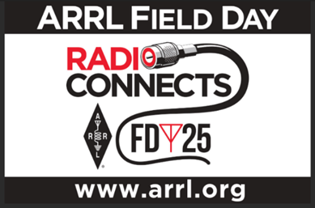First things first: **Field Day!** Are you ready? More importantly, is your club ready? I've been debating on where to go this year and still haven’t quite figured it out yet, but I will.

Now, you know the drill: coax cables are tangled like a bad hair day, antennas are suspiciously droopy, and the soldering iron is plotting its revenge for years of neglect.

Before you get too deep into the pre-Field Day chaos, do me a favor. Head over to the ARRL website and make sure your club's Field Day site is listed on their locator. Nothing's worse than setting up a killer station in a remote location only to have people fail to find you! Think of it as your ham radio Bat-Signal, guiding fellow enthusiasts to the promised land of RF signals and questionable coffee. <http://www.arrl.org/field-day-locator>

Oh, and don't forget to invite the local news media to the proclamation signing – this is excellent PR for your club and amateur radio in general, and you'll receive bonus points for your Field Day efforts! Amateur radio groups are encouraged to share a copy of their proclamations with the ARRL via [pr@arrl.org](mailto:pr@arrl.org). The ARRL often shares these proclamations to advance legislative efforts, creating additional support and awareness for amateur radio among lawmakers. It's a small effort that can have a big impact!

This isn’t mentioned much but it is so very important to make sure you do. Have someone assigned to take pictures!! Lots of them. Just about everyone nowadays has a phone with a camera built into it, so there’s really no excuse anymore for not taking pictures, and.... send them to me at: [n8sy@n8sy.com](mailto:n8sy@n8sy.com)

Speaking of signals, let’s not forget what comes shortly after Field Day, that glorious celebration of freedom, barbecues, and explosions in the sky: the **4th of July!** It's almost the nation's 249th birthday – old enough to rent a car without extra fees, but still young enough to party!

Is your club doing anything special to commemorate this auspicious occasion? Maybe a little "Happy Birthday, America" net? A contest to see who can build the most patriotic antenna? Or perhaps a strategically placed repeater message with a rousing rendition of "Yankee Doodle?" Just throwing ideas out there! I might just try and work some DX while dodging rogue bottle rockets.

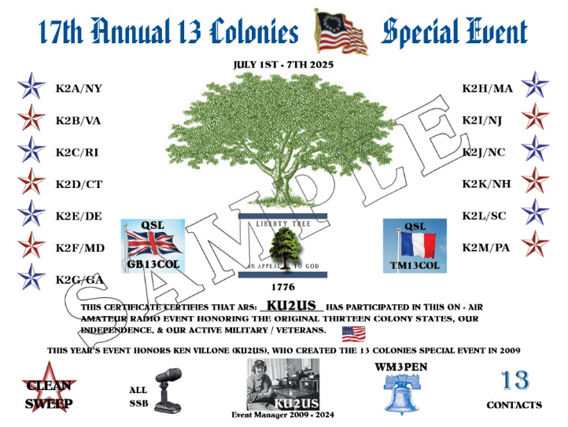

But wait, there's more! (Imagine me doing my best infomercial voice). Right on the heels of the fireworks comes the annual **13 Colonies** special event!

This year the event will honor founder Ken Villone, KU2US, who is passing the torch to Tony Jones, N4ATJ. Villone has led the event for 16 years by working with state and bonus station coordinators and has grown from making approximately 12,000 contacts in 2009 to making 292,496 contacts around the world in 2024.

This year, one station will be operating in each of the 13 original British colonies, K2A – K2M, along with three bonus stations — WM3PEN, Philadelphia; GB13COL, England, and TM13COL, France — each representing their city, state, or country’s role in America’s colonial period.

Villone said event actually started 2008, right after he finished participating in the ARRL Sweepstakes.

“I remembered how fun it was, but I could not figure out why there were not more of these types of special events on the air,” said Villone. “So, I decided to try my luck and create one, for one year only, to see what happens and to have some fun. I knew we had to offer a special QSL card and/or certificate plus have on hand a printer and supplies. The hard part was deciding what the event would commemorate and when to do this. I needed a theme that all could relate to, and the event would have to be the type with multiple event stations involved, like the ARRL Sweeps.”

“Then it hit me...13 colony states, during the 4th of July week and offer a certificate with the theme for the year. I made sure the theme was different each year with a different certificate design, to make it interesting and to also make the cert collectable. The theme would highlight some event or thing connected to the American Revolution.”

“The inaugural event was held July 1st to the 4th, 2009, 4 days, with no advertising except on QRZ. I had a hard time getting 13 different ops, one from each colony state, but it worked out. All in all it was a success!”

Amateur radio operators and SWLs can participate in the event. Complete information about the call for each colony station and the bonus stations can be found on the [event website](https://arrl.informz.net/z/cjUucD9taT0zMzU0MzkxJnA9MSZ1PTUyNTgxODI4NCZsaT0zODMyMTIyOQ/index.html) or on Facebook at [13 Colonies Special Event Community](https://arrl.informz.net/z/cjUucD9taT0zMzU0MzkxJnA9MSZ1PTUyNTgxODI4NCZsaT0zODMyMTIzMA/index.html).

The contest starts on July 1st (9 AM Eastern) to July 7th (Midnight Eastern) – that’s July 1, 2025-1300 UTC to July 8, 2025-0400 UTC for you UTC aficionados – ham radio operators across the country will be activating stations representing the original **13 colonies**. It's a fantastic opportunity to brush up on your history, polish your CW skills, and snag some cool awards.

I, for one, am already strategizing. Last year, I was convinced I had a handle on it… until I realized I was calling "Delaware" when the operator was *clearly* from Georgia. Communication is key, people!

Now, for those of you new to this event (or those of us who tend to overthink things), let's clear up a couple of misconceptions. First, you *do not* need to contact all **13 colonies** to get the basic certificate. Think of it as a choose-your-own adventure of historical proportions.

Hit a few colonies, rack up some points, and bask in the glory of your ham radio prowess.

And second, don't sweat it if you miss the bonus stations. These bonus stations are always fun to get, but they're *not* required for a "Clean Sweep." You have a good chance of getting them as they are on the air a lot.

So, there you have it, my friends. A whirlwind of ham radio activities on the horizon. Get your gear ready, charge your radios, and prepare for a few weeks of intense operating fun. This summer just keeps getting better and better!

That’s going to do it from me this time around. Catch you on the air, in a meeting or at a hamfest!!! Be Radio Acitve!!!!!

73,

Scott, N8SY

Great Lakes Division Director

[n8sy@arrl.org](mailto:n8sy@arrl.org)

***ARRL Foundation Accepting Grant Applications in June***

The ARRL Foundation is accepting grant applications from amateur radio organizations for eligible amateur radio-related projects and initiatives, particularly those focused on educating, licensing, and supporting amateur radio activities. To grow amateur radio's future, youth-based projects and initiatives are especially encouraged.

The ARRL Foundation grants program accepts proposals on a cyclical model three times a year: in February, June, and October. Proposals for the June grant period are accepted through June 30. Awardees will be notified approximately 1 month after the closing of each cycle.

The ARRL Foundation carefully manages a portfolio of endowments where donors have provided specific goals for their gifts, and that portfolio is invested and managed in a way that it can continue to support those goals for many years to come. Additional information and a link to the grant application can be found at <http://www.arrl.org/amateur-radio-grants>

***2025 Great Lakes Division Hamfests***

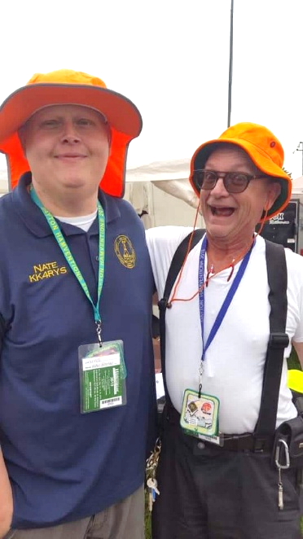

Here in the Great Lakes Division, we have over 50 hamfests a year.

So, if you haven’t started planning your hamfest schedule yet, you really need to start now.

Please post this listing in your club's newsletter and announce the swaps on your local nets. Talk them up.

Let's fully support all of our hamfests in every way possible. It means success for everyone. Be sure to invite your ARRL Officials as soon as your date is set.

If you are planning on having your hamfest listed in QST please be sure to start your planning well in advance of your Hamfest date, as this allows adequate time for QST Listings. QST announcements require a 3-month lead time.

To be fair to our division’s clubs, the Great Lakes Division policy **now has 2 requirements**.

**Any club requesting ARRL sanctioning within the Great Lakes Division must now be an ARRL Affiliated Club with a maximum of two hamfests/swaps in any given calendar year, and they must be at least four months apart.**

|  |  |
| --- | --- |
| 07/19/2025 - [NOARSfest](https://www.arrl.org/hamfests/noarsfest-12)  **Location:**Elyria, OH **Type:** ARRL Hamfest **Sponsor:** Northern Ohio Amateur Radio Society **Website:** <https://www.noars.net/hamfests/noarsfest/> [**Learn More**](https://www.arrl.org/hamfests/noarsfest-12) | 07/20/2025 - [Van Wert Hamfest](https://www.arrl.org/hamfests/van-wert-hamfest-9)  **Location:**Van Wert, OH **Type:** ARRL Hamfest **Sponsor:** Van Wert Amateur Radio Club **Website:** [http://w8fy.org](http://w8fy.org/) [**Learn More**](https://www.arrl.org/hamfests/van-wert-hamfest-9) |
| 07/26/2025 - [BARA / MCRN Trunk Swap](https://www.arrl.org/hamfests/bara-mcrn-trunk-swap)  **Location:**Berrien Center, MI **Type:** ARRL Hamfest **Sponsor:** Blossomland Amateur Radio Association and the Midwest Classic Radio Net **Website:** <https://www.w8mai.org/index.php/club-information/bara-trunk-swap> [**Learn More**](https://www.arrl.org/hamfests/bara-mcrn-trunk-swap) | 08/02/2025 - [Columbus Hamfest](https://www.arrl.org/hamfests/columbus-hamfest-6)  **Location:**Grove City, OH **Type:** ARRL Hamfest **Sponsor:** Aladdin Shrine Audio Unit **Website:** [http://columbushamfest.com](http://columbushamfest.com/) [**Learn More**](https://www.arrl.org/hamfests/columbus-hamfest-6) |

|  |  |
| --- | --- |
| 08/02/2025 - [U.P. Hamfest 2025](https://www.arrl.org/hamfests/u-p-hamfest-2025) **Location:**Rapid River, MI **Type:** ARRL Hamfest **Sponsor:** Delta County Amateur Radio Society [**Learn More**](https://www.arrl.org/hamfests/u-p-hamfest-2025) | 08/09/2025 - [Cincinnati Hamfest℠](https://www.arrl.org/hamfests/cincinnati-hamfest-4) **Location:**Owensville, OH **Type:** ARRL Hamfest **Sponsor:** Milford Amateur Radio Club **Website:** [https://CincinnatiHamfest.org](https://cincinnatihamfest.org/) [**Learn More**](https://www.arrl.org/hamfests/cincinnati-hamfest-4) |
| 08/09/2025 - [Letcher County Hamfest](https://www.arrl.org/hamfests/letcher-county-hamfest-3) **Location:**Whitesburg, KY **Type:** ARRL Hamfest **Sponsor:** Letcher County Amateur Radio Club **Website:** [http://www.lcarcky.com](http://www.lcarcky.com/) [**Learn More**](https://www.arrl.org/hamfests/letcher-county-hamfest-3) | 08/16/2025 - [Portsmouth Radio Club 2025 Hamfest](https://www.arrl.org/hamfests/portsmouth-radio-club-2025-hamfest-1) **Location:**New Boston, OH **Type:** ARRL Hamfest **Sponsor:** ARRL, Jett Fire Equipment, Shawnee Computer and More **Website:** [http://www.portsmouthradioclub.com](http://www.portsmouthradioclub.com/) [**Learn More**](https://www.arrl.org/hamfests/portsmouth-radio-club-2025-hamfest-1) |
| 08/17/2025 - [Warren Hamfest](https://www.arrl.org/hamfests/warren-hamfest-2) **Location:**Cortland, OH **Type:** ARRL Hamfest **Sponsor:** Warren Amateur Radio Association **Website:** <http://w8vtd.com/hamfest> [**Learn More**](https://www.arrl.org/hamfests/warren-hamfest-2) | 08/30/2025 - [Athens Trunkfest](https://www.arrl.org/hamfests/athens-trunkfest-1) **Location:**Athens, OH **Type:** ARRL Hamfest **Sponsor:** Athens County Amateur Radio Association **Website:** <https://www.ac-ara.org/> [**Learn More**](https://www.arrl.org/hamfests/athens-trunkfest-1) |

You can always find the latest information about upcoming hamfests on the Great Lakes Division website.

](https://www.arrl.org/hamfests/search/Location.division_id:gl)

Just click to get the latest hamfest updates.

***Are You Wired for Emergencies?***

**Powering Your Home and Ham Shack Safely**

When the power grid fails, are you prepared to keep essential systems running in your home and, importantly, your amateur radio (ham) shack? Going "off-grid" requires careful planning and a solid understanding of electrical safety. I’ve written this article as a guide for you on the many serious items that you need to consider in helping you make better informed decisions about backup power solutions and ensuring a safe and reliable setup.

**Assessing Your Power Needs: More Than Just the Shack**



Before you even start looking at generators or battery backups, take a hard look at your power requirements. This isn’t just about how many amps your transceiver draws – although that’s crucial – it’s about everything you want to keep running during an outage. Every appliance, light, and device adds to the load. Create a detailed list:

* **Ham Shack:** Transceiver, amplifier, computer, tuner, lighting, soldering iron.
* **Essential Home Appliances:** Refrigerator, freezer, well pump (if applicable), furnace fan (for heat), medical equipment.
* **Basic Comforts:** Lighting, phone chargers, a TV or radio for information. Notice that I haven’t listed air conditioning. Many of us have basements that are cool in the summer. Utilizing your basement to keep cool during your outage will save you a fortune in generating emergency power.

Your air conditioner uses huge amounts of electricity and if you have a temporary way of keeping cool, why rob your wallet for a minor inconvenience. If you don’t have a basement, fans are a lot cheaper. They may not keep you as cool, but they will save a bundle in the end.

Once you have your list, determine the wattage (or amperage at your voltage) for each item. Many appliances have labels indicating their power consumption. If not, you can use a hand-held volt/amp meter with a plugin current adapter to measure the actual draw. Add up all the wattages to determine your total power needs. Be realistic – do you really need to power the entire house, or just the essentials? Remember, every item you want to run increases the size and cost of your generator (or battery system) and the amount of fuel it consumes.

**Fueling Your Backup: Options and Considerations**

The type of fuel your generator uses is another critical factor. You have several options:

* **Gasoline:** Gasoline generators are readily available and relatively inexpensive. However, gasoline degrades over time, requiring stabilizers for long-term storage. You also need to store gasoline safely, complying with local regulations.
* **Propane (LP Gas):** Propane has a longer shelf life than gasoline and is relatively easy to store in tanks. Portable generators can run on propane.
* **Natural Gas:** If you have natural gas service to your home, a natural gas generator can be a convenient option. You won't have to worry about storing fuel. However, natural gas has a lower BTU content than gasoline or propane, meaning you'll consume more fuel to generate the same amount of power.
* **Battery Backup with Solar/Wind Charging**: This is becoming increasingly popular, but it can take time and money to build a system that powers your equipment.

**Generator Types: Portable vs. Permanently Installed**

Now, let's consider the two main types of generators:

* **Portable Generators:** These are a cost-effective solution for many homeowners. They can be easily moved and stored when not in use. However, they require manual starting and connecting, and you must run extension cords to power your appliances.
* **Permanently Installed Generators:** These generators are connected directly to your home's electrical system and start automatically when the power goes out. They offer convenience and seamless power transfer but are more expensive to purchase and install.

Before making a decision ask yourself these questions:

* Have you costed out the difference in a permanently installed generator and a portable one?
* Do you know what the national electric code specifies for a proper installation of a transfer switch?

**The Importance of Transfer Switches and Lockout Switches**

**Transfer switches** are absolutely essential for safely connecting a generator to your home's electrical system. They prevent backfeeding electricity into the power grid, which can endanger utility workers and damage equipment.

**How does a transfer switch work?** A transfer switch isolates your home's wiring from the utility grid. When the power goes out, you switch the transfer switch to the "generator" position, allowing the generator to power selected circuits in your home.

**What is a lockout switch?** A lockout switch is installed at your main breaker panel. It allows you to safely switch between main power and generator power without risking backfeed.

The National Electrical Code (NEC) mandates the use of transfer switches for permanently installed generators. Local and state electrical codes may also have specific requirements. It is *crucial* to consult with a qualified electrician to ensure proper installation and compliance with all applicable codes.

**Safe Installation: NEC and Local Codes**

Installing a generator requires a thorough understanding of electrical codes and safety practices. Here are some key considerations:

**Wire Sizes:** Using the correct wire sizes is critical to prevent overheating and fire hazards. The wire size must be adequate for the amperage it will carry. Consult the NEC and local codes for guidance on wire size selection.

**Electrical Connections:** All electrical connections must be secure and properly insulated. Loose connections can cause arcing and overheating, leading to fires.

**Grounding:** Proper grounding is essential for safety. The generator must be properly grounded to prevent electric shock.

**Mitigating Radio Frequency Interference (RFI) and Noise**

Generators, especially those with inverters, can generate significant RFI that can interfere with your ham radio operations. Inverter noise from solar charging and battery backups inverters can also be problematic. Here are some tips for minimizing RFI:

* **Placement:** Position the generator as far away from your ham shack as possible.
* **Grounding:** Ensure the generator and your shack are properly grounded to a common ground point.
* **Shielding:** Use shielded cables and connect them to ground.
* **Filters:** Install power line filters and RFI chokes on the generator's output and your equipment's power cords.
* **Ferrite Beads:** Snap ferrite beads onto cables to absorb RFI.

Similarly, motor noise from the generator can be a nuisance. Using rubber isolation mounts can help reduce vibration and noise transmission.

**FAQs: Backup Power for Your Home and Ham Shack**

* **Q: Do I need a permit to install a generator?**
  + **A:** Yes, in most jurisdictions, you will need a permit to install either a portable or a permanently installed generator. Check with your local building department for specific requirements.
* **Q: Can I install a generator myself?**
  + **A:** While you may be able to connect a portable generator with extension cords, installing a permanently installed generator requires electrical expertise and should be done by a qualified electrician to ensure compliance with codes and safety regulations.
* **Q: How do I choose the right size generator?**
  + **A:** Calculate your total power needs, as described earlier, and then choose a generator with a slightly higher capacity to account for starting surges and future needs.
* **Q: What is the difference between a traditional generator and an inverter generator?**
  + **A:** Traditional generators produce AC power directly, while inverter generators produce DC power first, then convert it to AC. Inverter generators provide cleaner, more stable power, making them suitable for sensitive electronics. They are also typically quieter and more fuel-efficient.
* **Q: How often should I service my generator?**
  + **A:** Follow the manufacturer's recommendations for servicing. Generally, you should check the oil level, air filter, and spark plug regularly. Also, run the generator periodically to ensure it's in good working order.

**Be Prepared, Be Safe**

Being prepared for power outages is essential, both for your home and your ham radio operations. By carefully assessing your power needs, choosing the right type of generator or backup system, understanding the importance of transfer switches, and complying with all applicable electrical codes, you can ensure a safe and reliable backup power solution.

Don't take shortcuts when it comes to electricity. Consult with qualified professionals and prioritize safety above all else. With proper planning and execution, you can stay powered up and connected, even when the grid goes down.

**ARRL Repeater Etiquette: A Ham's Guide to Not Being "That Guy" (or Gal)**

Alright, fellow hams let's talk repeater etiquette. We all love hopping on the airwaves, sharing stories, and maybe even coordinating a potluck or two. But let's be honest, sometimes things can get a little...uncomfortable. We've all heard "that guy" (or gal) who seems to think the repeater is their personal soapbox, dominating the airwaves with lengthy monologues and potentially driving others away.

So, let's dive into some of those famously inspired guidelines to ensure we're all sharing the airwaves like responsible, radio-wielding citizens. These guidelines are designed to promote a positive and productive experience for everyone using the repeater. Think of it as a survival guide for the modern ham! By adhering to these principles, we can maintain a welcoming and enjoyable environment for both seasoned operators and newcomers alike. We'll cover topics ranging from proper identification and break procedures to respectful conversation and avoiding unnecessary interference. Let's work together to keep our repeaters a valuable

**The Golden Rules of Repeater Usage (in no particular order of importance, because they're all pretty darn important):**

1. **Short Transmissions:** Pretend you're paying by the word. Brevity is the soul of wit, and also the key to not hogging the repeater. Get your point across and let someone else have a turn.
2. **Think Before Transmitting:** Is what you're about to say actually interesting or relevant? Or are you just rambling about your cat's unusual hairball? Consider whether the world *really* needs to know, and if not, spare the airwaves.
3. **Pause Between Conversation Handovers:** This one's crucial. Give other users a chance to jump in. It's not a race to see who can talk the most; it's a conversation. Imagine everyone sitting at a round table and be polite.
4. **Identify Properly:** This isn't hide-and-seek. Follow FCC regulations and identify your station clearly. It's not just the law; it's also good practice.
5. **Be Courteous:** Treat others as you would like to be treated. Common courtesy goes a long way in maintaining a friendly and enjoyable on-air environment. If someone asks a question, help them out if you can!
6. **Use Simplex When Possible:** If you can talk directly to the other person without the repeater, do it! Save the repeater for those who need it. Simplex is your friend!
7. **Use Low Power When Possible:** No need to blast your signal across the state if you're just chatting with someone a mile away. Conserve power and reduce interference to other users.
8. **Support Your Local Repeater Club:** Repeaters don't run on fairy dust and good intentions. They require maintenance, electricity, and the dedication of volunteers. Chip in!
9. **Butting In Is Not Nice:** Unless it's an emergency, don't interrupt an ongoing conversation. Wait for a pause and politely indicate your desire to join.
10. **Blessed are Those Who Listen:** Sometimes the best thing you can do is listen. You might learn something, or you might just give someone else a chance to talk.
11. **Watch What You Say:** Okay, let's get serious for a moment. As licensed amateur radio operators, we are held to a higher standard. The FCC takes a dim view of certain types of transmissions. Which leads us to...
12. **One Thought Per Transmission:** Avoid rambling. Keep your transmissions focused and easy to follow.
13. **State Your Purpose:** When you first access the repeater, let people know what you're trying to do. "This is [Your Call Sign], looking for a signal report" is much more helpful than just keying the mic and saying nothing.
14. **When Testing, Say So, and Be Brief:** Nobody wants to hear you whistling into your microphone for five minutes. Identify, state you're testing, and keep it short.
15. **ID Your Station:** We mentioned this before, but it bears repeating (pun intended!). Regularly identify your station per FCC regulations.
16. **Certain Words... OH NO YOU DON'T!!:** This one is crucial, folks. Consider yourself warned. We're talking about **improper language** and **foul language**. Remember those **7 forbidden words on the air**? Yeah, those. Just don't. The FCC doesn't appreciate it, the **repeater trustee** and **repeater control operator** certainly don't appreciate it, and frankly, neither do we. Keep it clean, people. Think PG-13, at most.

The ARRL provides guidance and suggestions for amateur radio operation. This information is meant to help hams safely and courteously communicate with each other. With common sense and careful attention, everyone will enjoy their time on the airwaves!

**FAQs: Repeater Edition**

* **Q: What happens if I accidentally swear on the repeater?**
  + A: Uh oh. Apologize immediately, learn from your mistake (maybe wash your mouth out with soap?), and try not to do it again. The FCC can issue fines, and you might earn yourself some unwanted attention from the repeater community.
* **Q: What if someone else is being a jerk on the repeater?**
  + A: This is a tricky one. Engaging might just escalate the situation. Your best bet is usually to ignore them or, if it's a serious issue, contact the repeater trustee or control operator.
* **Q: How often do I need to identify my station?**
  + A: FCC regulations require you to identify at the end of your transmission and at least every 10 minutes during a series of transmissions.
* **Q: Is it okay to talk about politics on the repeater?**
  + A: While not strictly prohibited, it's generally considered bad form. Politics can be divisive, and it's best to keep the conversations focused on ham radio-related topics.

Let's work together to keep our repeaters a friendly and enjoyable place for everyone. Happy hamming!

***Club Links***

](https://arrl-greatlakes.org/links.html)I’ve received a number of new requests from clubs to be listed on the “Links” club page.

Is your club listed? If not, send the URL of your club website to me [n8sy@n8sy.com](mailto:n8sy@n8sy.com) and I’ll get it listed.

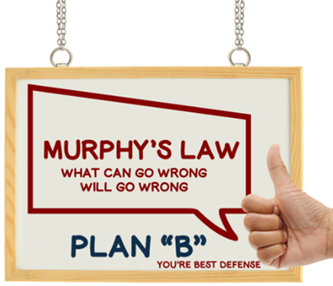

***The microwave oven will always stop with the turntable turned so that the food in located in the back of the oven.***

***It always starts raining right when you leave the house.***

***The fallen toast always lands on the smeared side.***

***Clothes are never found in the store in the right size.***

***Wanted… Your Photo’s***

Have you seen the Photo Gallery on the Great Lakes Division website? If you haven’t you really need to, your face may be among the many already posted there.

[](https://arrl-greatlakes.org/gallery/index.php)

I’m always looking for more pictures to use in the Gallery, newsletter, banner and video display. Please, send me your pictures!!!

Send them to: [n8sy@n8sy.com](mailto:n8sy@n8sy.com)

***STOP – Right there!!!***

***We’ve come to the end…***

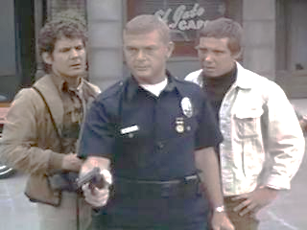

Be Radio-Active --- See Ya’ Soon!

Radio Waves is produced as a look inside of the Great Lakes Division and all that it has to offer. It is our sincerest hope that you have enjoyed this edition and will encourage your friends to be a part of the ARRL and receive the latest news and information about the ARRL and the Great Lakes Division!