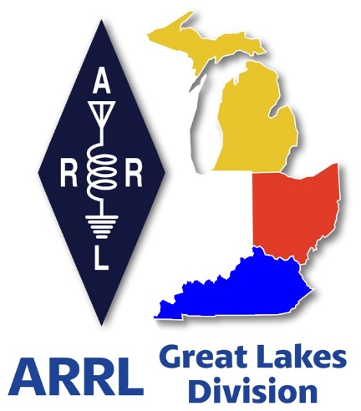 ***Radio Waves***

***The Great Lakes Division***

***Mid- Month Report***

***July***

***From the Michigan Section Manager***

Larry Camp, WB8R

Greetings to all who read this,

Summer is here and the first burst of hamfests in the Spring have been completed and the mid-summer swaps are few and far between. Obviously, the summer heat is a factor, plus it is prime family vacation time, Things pick up again in September and we will be busy up through mid- October and onto the season finale in early December.

***ARRL Michigan Events***

On June 7, the Parks On The Air (POTA) held a very successful meet-up at Custer State Park near Agusta, MI and while I was at a hamfest in the Upper Peninsula (Newberry). I understand that a large crowd attended this event. The 3rd Annual Michigan POTA Meetup is scheduled for Saturday, June 6th, 2026 at Hartwick Pines State Park. We will have more information available as the date approaches. Mark your calendars now!

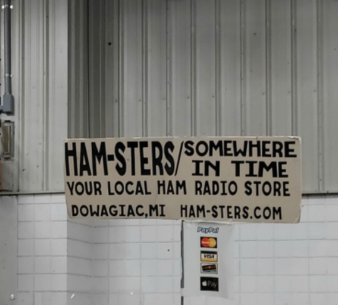

The hamfest season is in full swing in Michigan with a strong number of swaps organized and on the docket for 2025. Hamfests are a good barometer for determining several things: economic conditions, general attitude of the amateur population, and of course, the weather conditions always play a role in hamfest travels.

Here is the Michigan hamfest schedule as of this writing (w/callsign of ARRL Official planning to attend):

Jul 26, 2025 Blossomland Hamfest, Berrien Center. MI (TBD)

Aug 2, 2025 U.P. Hamfest, Rapid River, MI (TBD)

Sep 6, 2025 Grand Rapids Area Hamfest, Wyoming, MI (WB8R, K8TB)

Sep 13, 2025 OAARS Hamfest, West Branch MI (TBD)

Sep 13, 2025 GMARC Trunk Swap, Shelby Twp, MI (TBD)

Sep 14, 2025 Adrian Hamfest, Adrian, MI (WB8R)

Sep 20, 2025 Top of Michigan ARC Hamfest, Gaylord, MI (WB8R)

Oct 2, 2025 MAARC Meeting, Muskegon, MI (WB8R)

Oct 4, 2025 Kalamazoo ARC/SMART Vintage Electronics Expo (WB8R)

Oct 4, 2025 Copper Country Hamfest, Baraga, MI (TBD)

Oct 11, 2025 Muskegon Color Tour Hamfest, Muskegon, MI (WB8R)

Oct 19, 2025, USECA Hamfest, St. Clair Shores, MI (TBD)

Dec 7, 2025 LCARC ARC Hamfest, Troy, MI (WB8R)

***ARPSC/Net Activity June 2025***

ARPSC Total Person Hours: 5956 Dollar Value: $207,209

Net Activity Total Person Hours: 1158 Dollar Value: $40,301

Total Person Hours: 7114

Total Dollar Value; $247,510

**Station Activity:**

K8ED 467. WD8TQZ 91, KB8PGW 80, ND8W 56, KD8CEH 53, KD8ZCM 53, KE8HKA 49, K8RDN 47, K8WU 42, KE8SMN 22, W8ROY 18, WD8USA 16, . N8RWF 9 KC8YVF 8

You can find complete MI Amateur Radio Public Service Corps information at [www.mi-arpsc.org](http://www.mi-arpsc.org)

That’s it for now. Travel safely and I hope to see you at an event sometime this year. If you are attending any of the hamfests that I am scheduled to attend, be sure to stop by and say hello.

And, as always, Stay Radioacitive!

Best 73,

Larry WB8R

[wb8r@arrl.org](mailto:wb8r@arrl.org)

517-617-4883

***From the Ohio Section Manager***

Tom Sly, WB8LCD

The latest edition of the Ohio Section Journal is now online and ready  
for you to read! There’s an awful lot of Ham Radio activities going on  
in the Ohio Section, so get off the chair or couch you’re sitting on  
and get out there, get involved, and get on the air!  
  
The links below will take you directly to the newsletter. Both are also  
available directly from the Ohio Section Web-site ( [www.arrl-ohio.org](http://www.arrl-ohio.org) )  
where you will also find the downloadable PDF of the Ohio Governor’s  
proclamation for Field Day. You’ll want to print it out and display  
it at your Field Day site.  
  
Since the ARRL email reflector is not yet working, please forward this  
announcement everywhere!  
  
<https://arrl-ohio.org/wp-content/uploads/2025/07/OSJ_July_2025.pdf>

Tom…

[wb8lcd@arrl.org](mailto:wb8lcd@arrl.org)

***Scott’s Stuff***

Hi Gang,

Well, hello there, fellow radio fanatics! It’s mid-July, and if you’re anything like me, you’re currently melting into your desk chair, contemplating if operating a radio in this humidity counts as a new form of extreme sport. Hot, humid, and downright miserable? Yep, that’s July for ya’… But hey, at least we have plenty of opportunities for heatstroke-inducing outdoor radio fun to look forward to!

Speaking of outdoor fun, did your club brave the elements for Field Day? I’ve been on a mission, hunting down photos like a digital detective with a serious caffeine habit.

I took a bunch myself, then dove headfirst into the internet rabbit hole of websites and social media posts, emerging victoriously with a respectable haul. My Field Day Gallery is officially open for business over on the ARRL Great Lakes Division website – feel free to swing by and relive the glory (and sweat) at <https://arrl-greatlakes.org/fd-25/index.php>.

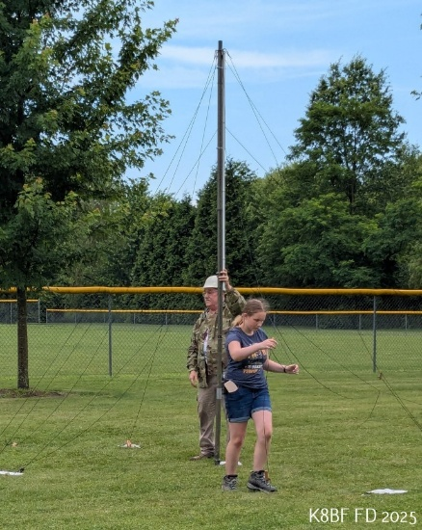

But my friends, the gallery is like a ham radio without an antenna – it needs more input! If you’ve got snaps of your club’s Field Day antics, please, for the love of all that is RF, send them my way at [n8sy@n8sy.com](mailto:n8sy@n8sy.com). Yes, sometimes I also use these highly coveted visual treasures for other things, like our division banner or even right here in this very newsletter. Think of it as your fifteen minutes of blurry, sun-drenched fame!

Now, on a slightly less sweaty note, I’ve been living the dream (or perhaps, the delusion) of a road warrior lately, bouncing around attending various hamfests and club meetings across the Kentucky, Michigan, and Ohio landscapes. And let me tell you, the ARRL members of our ARRL Great Lakes Division are truly the "Greatest" with a capital G! I want to extend a massive, heartfelt thank you to all of you wonderful folks for your sheer kindness and generosity.

Everywhere that I rolled up to I was greeted with smiles, robust handshakes, a few enthusiastic hugs and an open invitation to as much food as anyone could ever want to eat. A veritable smorgasbord of everything eatable. Seriously, folks, I think I’ve gained 15 pounds just from the sheer proximity to your potluck spreads. It’s been an absolute blast getting out there and chatting (and breaking bread) with so many of you!

As I’m sure you’re vaguely aware, July isn’t just about battling humidity and eating copious amounts of covered-dish casseroles; it’s also the month of the ARRL Board of Directors meeting. It’s been busier than a repeater on contest weekend around here, getting things squared away for my committee meetings as well as the main Board meeting itself. I can’t exactly spill the beans just yet – my lips are sealed tighter than a freshly soldered connection – but I’m pretty sure that once you hear about some of the motions coming out of the Board meeting, you’ll all be both happy and delightfully surprised. Stay tuned, because good things are brewing!

Speaking of important things, has your ARES group started getting its ducks in a row for the Simulated Emergency Test (S.E.T.) yet? Mark your calendars, because October 4-5 are the dates, and next to Field Day, it’s arguably one of the busiest times for ham radio operators.

This isn't just a drill, folks; it’s our chance to really shine. Is your ARES group or club already in the planning stage? If not, consider this your friendly (and slightly panicked) nudge! Like Field Day, S.E.T. demonstrates to our served agencies what amateur radio is truly all about, reliable, resilient, and utterly indispensable communications. It’s where all those late-night net check-ins and antenna tinkering sessions pay off. So, get planning, practice your message passing, and maybe even stock up on some emergency snacks. You know, for preparedness.

***"According to the map, we've only gone 4 inches." — Jeff Daniels***

Now, for those of you who’ve been wrestling with your devices trying to navigate the digital realms of our ARRL magazines, fear not! You are not alone in your tech-induced frustration. I’ve heard the cries, the gnashing of teeth, the desperate pleas for "just a simple PDF!" Well, good news! There’s a fantastic ARRL video that’s been helping countless members finally conquer the digital magazine frontier. This video has proven to be a lifesaver, helping many membership holders get more out of their digital magazine experience.



Remember, as ARRL members, we all have digital access to four high-quality magazines: QST, On The Air, QEX, and NCJ. If you’ve had questions or concerns about how to get the most out of these digital editions (like why your finger always seems to zoom instead of scroll), this video on the ARRLHQ YouTube channel will gracefully walk you through it.

The video, hosted by the ever-patient Jherica Goodgame, KI5HTA, explores a treasure trove of features, including switching between magazines, saving it to PDF, searching for content, placing bookmarks, and zooming in to content without accidentally calling your aunt.

It covers both the web browser version (for us desktop dinosaurs) and the Android and iOS applications (for the cool kids). And here’s a neat trick: if you download the ARRL Magazines app for Android or iOS, ARRL will even send a helpful notification to your device when a new edition is hot off the presses (or, you know, digitally uploaded). You can view this technological salvation at the following link: <https://youtu.be/vmZflC2IUIs>. Go forth and digitally consume!

Wow, what a summer it's shaping up to be for us hams! Just when you think things might quiet down, the airwaves buzz with even more activity, and I'm feeling incredibly optimistic about the weeks ahead. It truly feels like this season just keeps getting better and better, packed with opportunities to connect, learn, and give back.

I'm still recovering from a wonderfully "sweltering" Field Day – perhaps it's those fond memories (or the lingering heat) that are making me eye a personal cooling unit right now!

But seriously, though the sun was intense, the spirit of camaraderie was even stronger. It's moments like those, organized and championed by our local clubs, that truly remind me why I love this hobby so much. We might sweat a bit, but the friendships forged, and the skills honed are more than worth it.

Looking forward, one of the most critical events on my radar is the Simulated Emergency Test, or SET. This isn't just another contest; it's essential preparation, especially for those of us involved with ARES. We're talking about honing our communication skills to serve our communities when it truly matters, ensuring we're ready to assist during any unforeseen crisis. It's a testament to the dedication of our members across the entire Great Lakes Division.

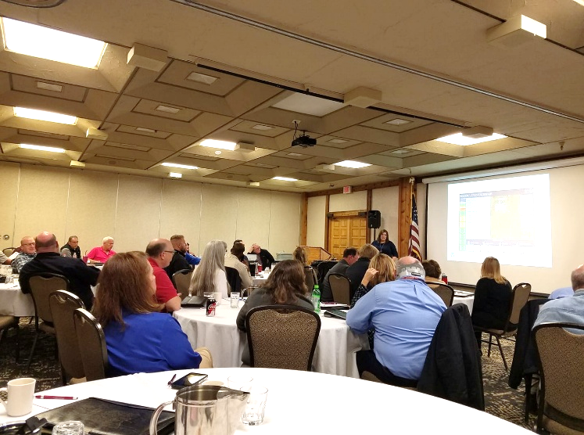Beyond the serious stuff, I'm also thrilled about the continued opportunities for fun and fellowship. The hamfests are always a blast, a treasure trove of gear to discover and a fantastic chance to swap stories with fellow hams. And our local club meetings? They’re the heart of our community. There's always incredible food, an abundance of generosity, and a welcoming atmosphere that makes visiting your club feel like a homecoming. It's fantastic to see existing members mentoring newcomers, embodying the true spirit of ham radio.

So, there you have it, my friends. A whirlwind of ham radio activities on the horizon, from sweltering Field Day memories to essential Simulated Emergency Test preparations and mastering the mystical art of digital magazines. Get your gear ready and prepare for some intense operating fun. This summer just keeps getting better and better.

That’s going to do it from here this time around. Catch you on the air, in a club meeting, or at a hamfest! Until then, **Be Radio Active!!!!!**

73,

Scott, N8SY

Great Lakes Division Director

[n8sy@arrl.org](mailto:n8sy@arrl.org)

***New H.F. Software Radio***

Hey Gang,

Have You Seen the Latest Radio Station? It’s a VoIP Transceiver!! This may be your Answer to those HOA restrictions and high costs!

Are you a passionate radio enthusiast, yearning to get on the air, but constantly hitting roadblocks? Maybe you dream of reaching distant lands with your signals, but the thought of battling with your homeowner’s association (HOA) over an antenna installation gives you nightmares. Or perhaps, like many of us, the eye-watering cost of a new HF transceiver setup – often running into thousands of dollars – feels like an insurmountable barrier. Well, what if I told you there’s a game-changing alternative emerging in the world of amateur radio that directly addresses these very concerns?

Imagine a radio station that operates on the most popular bands, accessible from virtually anywhere, without the need for a massive antenna farm or a dedicated shack full of expensive gear. This isn't science fiction; it's the reality of the VoIP transceiver. This innovative approach allows you to operate an HF transceiver remotely over the internet, using your everyday devices. Think of it as a virtual radio station at your fingertips, bringing the world of distant signals right to you.

For anyone living under the watchful eye of a homeowner’s association, the mere mention of installing an outdoor antenna can start world war III with the HOA’s. The covenants, conditions, and restrictions (CC&Rs) enforced by many HOA’s can make traditional amateur radio an impossible hobby. You're faced with rules that restrict antenna size, height, visibility, or even outright ban any external structures. This often leaves eager operators feeling frustrated and sidelined, unable to pursue their passion because of bureaucratic red tape.

This is where this new VoIP transceiver truly becomes a possible real answer for you. Since you’re not installing any outdoor equipment, there are no antennas for your HOA to complain about, no towers to get permits for, and no visible wires to spark a neighborhood dispute. Your radio operations become discreet, confined to your computer, tablet, or even your cell phone, making HOA restrictions on R.F. transmitters irrelevant to your setup.

You can finally enjoy the airwaves without the constant worry of a notice showing up in your mailbox.

Beyond the HOA headache, let's talk about the significant financial hurdle that often detours new entrants and seasoned ops alike. A brand-new, high-quality HF transceiver can easily set you back $3,000, $6,000, or even more, before you even consider the cost of an antenna, tuner, linear amplifier, and all the other necessary peripherals. It's a substantial investment that for many, is simply out of reach, forcing them to put their radio dreams on hold indefinitely.

But what if you could get on the air, experience those same popular bands, and make contacts for a fraction of that cost? With this new VoIP transceiver platform ([CQPlace](https://cqplace.com/#features)), you can have access to the wide world of amateur radio for as little as $39 per year! Yes, you read that right – thirty-nine dollars for an entire year of operating time. No, I’m not a sponsor, salesperson, or have any connection to this company.

Then why this story? Simple, I know that within the Great Lakes Division we have hundreds, if not thousands of hams that want to get on the air but can’t, due to housing restrictions. No, it doesn’t have to necessarily be HOA’s, it can also be folks who rent apartments as well. So, when I saw this on the internet, I felt that this just might be an answer for some to now get on the air and enjoy ham radio.

One of the standout features of this approach is its incredible convenience. Forget about bulky radios and complex wiring. There's no software to download and wrestle with; these platforms run directly in your web browser. Whether you're on a desktop computer, a laptop, a tablet, or even your smartphone, you can connect and start operating. This means your radio station is as mobile as you are.

Now, let’s be real. This isn’t Utopia, and it’s important to manage expectations. This VoIP transceiver won't replicate the exact experience of having your own full-blown contest station with a massive beam antenna in your backyard. You won't be able to physically tweak every knob or build custom circuits with your hands on the RF. There might be slight latency depending on your internet connection as well.

So, if your goal is to be a top-tier contester requiring milliseconds of response time and ultimate control, this probably isn’t going to be your primary solution. However, for someone that just wants to simply get on the air and enjoy the thrill of making contacts, it’s remarkably effective and profoundly satisfying.

So, who exactly can benefit from this revolutionary approach?

* If you're battling HOA restrictions this might be your knight in shining armor, offering a way around those prohibitive rules without conflict.
* If you're on a budget you can get on the air without breaking the bank, and you can even try it for FREE on Sundays.
* If you're new to amateur radio it’s an excellent, low-commitment way to learn the ropes, understand band conditions, and practice operating procedures before investing heavily.
* If you lack space there is no need for a dedicated room or large antenna – your shack fits wherever your computer does.
* And finally, if you travel a lot you can take your 'shack' with you wherever you have internet access.

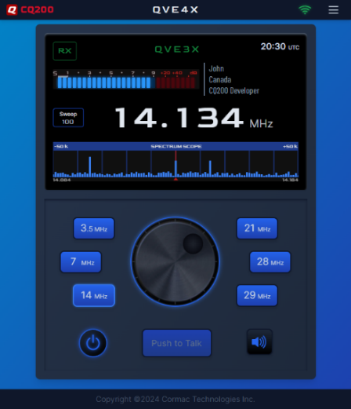

Ultimately, if the dream of operating an HF transceiver has been just out of reach due to the high cost of equipment, the complexities of installation, or the restrictive rules of your homeowner’s association, then this VoIP transceiver might just be the option you absolutely need to explore. It’s cost-effective, incredibly convenient, requires no fussy software downloads, and runs effortlessly on the most popular web browsers. What’s not to like about an option that bridges the gap between aspiration and reality? Take advantage of the FREE Sunday access and experience the future of radio today!

**CQ200 Highlights**

* CQ200 is the transceiver application that operates within the CQplace virtual ionosphere. This app can be run from any modern web browser on a phone, desktop, laptop or tablet. No downloads and no installation needed.
* The Dynamic S meter monitors signal strength for both transmit and receive.
* The Spectrum Scope has an adjustable sweep that shows transmissions within 50KHz to 500KHz of your current tuning.
* The transmitter automatically broadcasts the operator's Callsign during a transmission - along with a custom and optional Handle, QTH, and Description.
* The Audio Settings panel lets you set your microphone and speaker gain to the best levels for your equipment. The S meter will help get this set up correctly.
* Landscape mode switches automatically when the device is rotated or when the desktop window is resized.
* The frequency can be tuned using either the tuning knob, the frequency digits or the Spectrum Scope. They can all be operated by mouse, by scroll wheel, by keyboard or by touch, if available.

**Rules**

The use of **CQplace** and the **CQ200** transceiver are restricted to licensed amateur radio stations.

Operators are expected to use normal radio procedure - for example:

* Identify your callsign frequently
* Always be courteous. Do not use a frequency that is already in use.
* Do not use voice on the CW portions of the bands.
* Do not engage in commercial activity. No advertising.
* Do not transmit music or other copyrighted content.

Want to know more about this program or want to sign up? Here’s the link: <https://cqplace.com/>

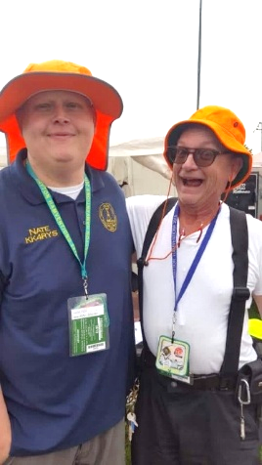

***2025 Great Lakes Division Hamfests***

Here in the Great Lakes Division, we have over 50 hamfests a year.

So, if you haven’t started planning your hamfest schedule yet, you really need to start now.

Please post this listing in your club's newsletter and announce the swaps on your local nets. Talk them up.

Let's fully support all of our hamfests in every way possible. It means success for everyone. Be sure to invite your ARRL Officials as soon as your date is set.

If you are planning on having your hamfest listed in QST please be sure to start your planning well in advance of your Hamfest date, as this allows adequate time for QST Listings. QST announcements require a 3-month lead time.

To be fair to our division’s clubs, the Great Lakes Division policy **now has 2 requirements**.

**Any club requesting ARRL sanctioning within the Great Lakes Division must now be an ARRL Affiliated Club with a maximum of two hamfests/swaps in any given calendar year, and they must be at least four months apart.**

|  |  |
| --- | --- |
| 07/19/2025 - [NOARSfest](https://www.arrl.org/hamfests/noarsfest-12)  **Location:**Elyria, OH **Type:** ARRL Hamfest **Sponsor:** Northern Ohio Amateur Radio Society **Website:** <https://www.noars.net/hamfests/noarsfest/> [**Learn More**](https://www.arrl.org/hamfests/noarsfest-12) | 07/20/2025 - [Van Wert Hamfest](https://www.arrl.org/hamfests/van-wert-hamfest-9)  **Location:**Van Wert, OH **Type:** ARRL Hamfest **Sponsor:** Van Wert Amateur Radio Club **Website:** [http://w8fy.org](http://w8fy.org/) [**Learn More**](https://www.arrl.org/hamfests/van-wert-hamfest-9) |
| 07/26/2025 - [BARA / MCRN Trunk Swap](https://www.arrl.org/hamfests/bara-mcrn-trunk-swap)  **Location:**Berrien Center, MI **Type:** ARRL Hamfest **Sponsor:** Blossomland Amateur Radio Association and the Midwest Classic Radio Net **Website:** <https://www.w8mai.org/index.php/club-information/bara-trunk-swap> [**Learn More**](https://www.arrl.org/hamfests/bara-mcrn-trunk-swap) | 08/02/2025 - [Columbus Hamfest](https://www.arrl.org/hamfests/columbus-hamfest-6)  **Location:**Grove City, OH **Type:** ARRL Hamfest **Sponsor:** Aladdin Shrine Audio Unit **Website:** [http://columbushamfest.com](http://columbushamfest.com/) [**Learn More**](https://www.arrl.org/hamfests/columbus-hamfest-6) |
| 08/02/2025 - [U.P. Hamfest 2025](https://www.arrl.org/hamfests/u-p-hamfest-2025) **Location:**Rapid River, MI **Type:** ARRL Hamfest **Sponsor:** Delta County Amateur Radio Society [**Learn More**](https://www.arrl.org/hamfests/u-p-hamfest-2025) | 08/09/2025 - [Cincinnati Hamfest℠](https://www.arrl.org/hamfests/cincinnati-hamfest-4) **Location:**Owensville, OH **Type:** ARRL Hamfest **Sponsor:** Milford Amateur Radio Club **Website:** [https://CincinnatiHamfest.org](https://cincinnatihamfest.org/) [**Learn More**](https://www.arrl.org/hamfests/cincinnati-hamfest-4) |
| 08/09/2025 - [Letcher County Hamfest](https://www.arrl.org/hamfests/letcher-county-hamfest-3) **Location:**Whitesburg, KY **Type:** ARRL Hamfest **Sponsor:** Letcher County Amateur Radio Club **Website:** [http://www.lcarcky.com](http://www.lcarcky.com/) [**Learn More**](https://www.arrl.org/hamfests/letcher-county-hamfest-3) | 08/16/2025 - [Portsmouth Radio Club 2025 Hamfest](https://www.arrl.org/hamfests/portsmouth-radio-club-2025-hamfest-1) **Location:**New Boston, OH **Type:** ARRL Hamfest **Sponsor:** ARRL, Jett Fire Equipment, Shawnee Computer and More **Website:** [http://www.portsmouthradioclub.com](http://www.portsmouthradioclub.com/) [**Learn More**](https://www.arrl.org/hamfests/portsmouth-radio-club-2025-hamfest-1) |
| 08/17/2025 - [Warren Hamfest](https://www.arrl.org/hamfests/warren-hamfest-2) **Location:**Cortland, OH **Type:** ARRL Hamfest **Sponsor:** Warren Amateur Radio Association **Website:** <http://w8vtd.com/hamfest> [**Learn More**](https://www.arrl.org/hamfests/warren-hamfest-2) | 08/30/2025 - [Athens Trunkfest](https://www.arrl.org/hamfests/athens-trunkfest-1) **Location:**Athens, OH **Type:** ARRL Hamfest **Sponsor:** Athens County Amateur Radio Association **Website:** <https://www.ac-ara.org/> [**Learn More**](https://www.arrl.org/hamfests/athens-trunkfest-1) |

You can always find the latest information about upcoming hamfests on the Great Lakes Division website.

](https://www.arrl.org/hamfests/search/Location.division_id:gl)

Just click to get the latest hamfest updates.

***The Shocking Truth:***

Here in the big metropolis of Lexington, we are at the very end of not one. Not two, but three different power companies. Each has a slice of our town. So, depending on just which neighborhood, street, and even which side of the street, including upper or lower ends will depend if you have power or not after a storm. It’s very frustrating for sure. Here where I’m at I am able to see if power is on at any of the three electrical providers. Yes, it can get very ugly at council meetings when one side of a street is without power for days while the other side relaxes in air-conditioned comfort. Anyway, as you can imagine every time we have even a blip in the power, out comes the generators full blast.

The other day I was visiting my local hardware store when I overheard a conversation that one of the folks in the electrical department was having with a customer. He was showing him how to make up a cord to plug into his dryer outlet box from his generator for the next time the power goes off.

Wow, I thought, what a way to get electrocuted!!! I went over to where this conversation was happening and just listened intently to the guy explain just how to cut the female end off of the cord and wire in a male so that it would end up being male to male. As he showed the guy how to do this, I just shook my head and turned away. The customer saw me and asked what’s wrong with doing this? I didn’t say anything, I just grabbed the male terminals on the cord and shook it hard. I said that this is what will happen if you follow that direction.

**The "Dead-Man's Cord”**

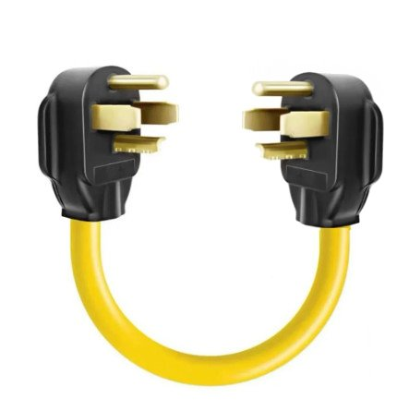

In the annals of human ingenuity, there exists a curious subset of inventions born not of meticulous engineering, but of desperate times and a distinct lack of proper electrical training. We're talking about those "hold my beer and watch this" moments that lead to... well, let's just say a potential for fireworks of the most electrifying kind.

Chief among these dubious innovations is the infamous "dead-man's cord," a Frankensteinian creation often starring a dryer plug and a whole lot of unspoken peril.

Picture this… The power's out, the fridge is whimpering, and a generator hums heroically in the driveway. "Aha!" thinks our intrepid (and soon-to-be-enlightened) homeowner. "My dryer plug! It's big! It's beefy! Surely, it can handle the mighty electrons from my portable power plant!" And thus, the dead-man’s cord is born – a custom-made umbilical cord with a male plug on both ends. One end nestles into the generator, while the other, often a unsuspecting dryer plug, is destined for a wall receptacle. What could possibly go wrong, right?

**The Exposed Terminal Tango of Terror**

The first act of this electrifying drama begins with the very nature of the dead-man’s cord itself. Imagine our homeowner, having successfully plugged one end into the running generator. The other end, typically a dryer plug, is now just... dangling. And here's where the plot thickens faster than cold molasses: those glorious, bare metal prongs on the dryer plug? They're no longer just inert pieces of metal. Oh no, dear reader, they are now exposed terminals, fully energized with lethal voltage, ready to deliver a potentially fatal jolt to anything (or anyone) that crosses their path.

Think of it as having a hungry, invisible electrical dragon attached to the end of your cord, and its fiery breath is just waiting for an innocent touch. Unlike your everyday, garden-variety extension cord with its safely recessed female slots, the male prongs of a dryer plug are practically begging for accidental contact. A curious toddler, a sniffing pet, or even a clumsy adult fumbling in the dark could inadvertently become an unwilling conductor. One innocent brush, and suddenly, that "clever" solution transforms into a shocking, life-altering or life-ending mistake. It's a ticking time bomb disguised as a power cord, and its fuse is startlingly short.

**The Backfeed Boogeyman**

But wait, there's more! Should you actually succeed in plugging this potentially lethal contraption into your dryer receptacle without becoming a Frankenstein’s monster, there’s another, even more insidious monster to the party… Backfeed, this isn't just about shocking yourself; this is about shocking, well, everyone else connected to the grid.

When you plug a generator directly into your home's electrical system without proper isolation, you're essentially sending power *back* out onto the utility lines. For the unsung heroes of the power company, diligently working to restore electricity, this creates an incredibly dangerous situation. Yes, most of the linesmen today wear a device that will alarm when they get near energized lines, but do you really want your generator to try to power the entire neighborhood? Now, Imagine that lineman that may not have put on this lifesaving device. He’s thinking a line is "dead" and safe to work on, only for your rogue generator to suddenly energize it, turning their routine repair into a potentially fatal incident. It's like rigging a booby trap for someone else, entirely by accident.

This is precisely why the national electrical code (NEC) and countless local electrical codes explicitly forbid such connections and mandate safeguards like transfer switches or interlock kits. They're not just being party poopers; they're trying to prevent utility workers from becoming human pretzels.

So, the next time the lights go out, and that ingenious sparkle flickers in your eye, remember the dead-man’s cord and its perilous exposed terminals. Remember the phantom menace of backfeed and the unsung heroes of the national electrical code. Instead of becoming a cautionary tale, invest in a proper transfer switch or interlock kit. Your life, your pet's life, that curious child's life, and even the utility worker's life, are all worth far more than a "clever" shortcut. Leave the electrifying entertainment to the professionals – in a controlled environment, perhaps with a stage and some pyrotechnics, but definitely not in your living room via a dryer plug.

**Frequently Asked Questions (FAQs)**

**Q1: What exactly is "backfeeding" in the context of generators?**

A1: Backfeeding refers to the dangerous practice of connecting a portable generator directly into a home's electrical system, typically through an appliance outlet (like a dryer or range receptacle), in a way that allows the generator to send power back onto the utility grid. This is extremely hazardous as it can energize power lines that utility workers believe to be "dead."

**Q2: Why is using a "dead-man's cord" with exposed prongs so dangerous?**

A2: A "dead-man's cord" is an improvised cord with male plugs on both ends. When one end is plugged into a running generator, the exposed prongs on the other end become energized with lethal voltage. Anyone, including children or pets, who accidentally touches these bare, live prongs can suffer severe electrical shock, burns, or even electrocution.

**Q3: What does the National Electrical Code (NEC) say about backfeeding?**

A3: The NEC, specifically Section 406.6(B), prohibits installing any receptacle in a way that requires an energized attachment plug as its source of supply. This directly outlaws the use of a standard wall receptacle (like a dryer outlet) to feed power into the home from a generator, as it poses a significant hazard of exposed live terminals and potential backfeed onto the grid.

**Q4: What is the safest and legal way to connect a portable generator to my home?**

A4: The safest and legal method is to install a generator-rated power inlet box outside your home. This inlet connects to a dedicated circuit breaker in your main electrical panel through an interlock kit. The interlock kit mechanically prevents the main utility breaker and the generator breaker from being on simultaneously, ensuring complete isolation and preventing backfeed. An automatic transfer switch is another, more advanced and convenient, safe option.

**Q5: Can I get fined or have insurance issues if I backfeed my house illegally?**

A5: Yes, absolutely. Local electrical codes, which adopt and enforce the NEC, prohibit this practice. If discovered, you could face fines, be required to have the installation professionally corrected, and your homeowner's insurance policy may deny claims related to fire, damage, or injury caused by an unapproved and unsafe electrical connection.

***Survey***

](https://forms.office.com/pages/responsepage.aspx?id=Dx2iugFz_kC91gPUQ6jCGEYWzQfXysZHvDC8hUJ9GuFUQkFOQTFURDJQTklJQk5GTzFMWU1XWEs1RC4u&route=shorturl)It’s been a little while since we’ve done a survey and I want to hear from you… always. So, if you could take a few minutes (around 2) to complete this on-line survey for me. Remember, we have a 2-way communications street here in the Great Lakes Division. My email and/or phone is always open to hear from you.

***Club Links***

](https://arrl-greatlakes.org/links.html)Hey… Does your club have a link to your club’s website listed here??? Has your club’s URL changed recently?? If your clubs website isn’t listed or your club has changed its URL lately, you’ll need to send me your new information for the “Club Links” page.

Is your club listed? If not, send the URL of your club website to me [n8sy@n8sy.com](mailto:n8sy@n8sy.com) and I’ll get it listed.

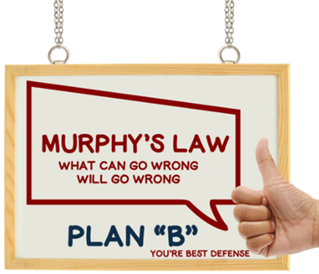

**Scott's First Law**

No matter what goes wrong, it will probably look right.

**Scott's Second Law**

When an error has been detected and corrected, it will be found to have been correct in the first place.

**Scott's Second Law Corollary**

After the correction has been found in error, it will be impossible to fit the original quantity back into the equation.

***STOP – Right there!!!***

***We’ve come to the end…***

Be Radio-Active --- See Ya’ Soon!

Radio Waves is produced as a look inside of the Great Lakes Division and all that it has to offer. It is our sincerest hope that you have enjoyed this edition and will encourage your friends to be a part of the ARRL and receive the latest news and information about the ARRL and the Great Lakes Division!