***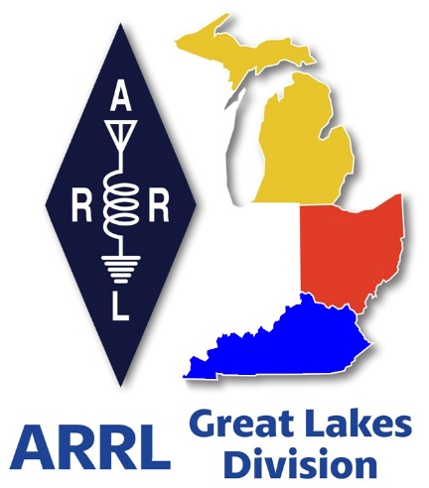 Radio Waves***

***The Great Lakes Division***

***Monthly Journal***

***July 2025***

***Scott’s Stuff***

**Hi Gang, Let's Talk About All Things Ham Radio!**

Well, July is officially here, and I still can't quite shake the memory of that incredibly hot and humid last week of June. Seriously, I'm so thankful the rain we got wasn't snow! Can you imagine trying to shovel snow in this kind of heat? Hi… Hi…!!!

I'm really hoping most of you are catching this before the 4th of July holiday kicks off, and that you're planning to spend it just as it should be – with family and friends. Our nation is celebrating its 249th birthday, so it’s definitely time to par - tay!

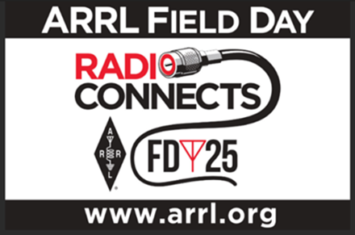

And as we toast to freedom and celebrate, please, let’s all take a moment to remember and appreciate those who have served and are currently serving our great nation. It's because of their dedication and sacrifice that we get to enjoy days like these.

Now, about Field Day! It’s officially in the books for another year, and soon enough, the results will be published, letting us know how all the amazing groups performed.

I managed to visit a whopping 11 clubs this year. If I somehow missed yours, I am truly sorry. It’s a real challenge to navigate between locations and still manage to spend some quality time with everyone. The road conditions certainly didn't help, it felt like every few miles I was greeted by those cheerful orange construction barrels. But even with the detours, I had an absolute blast! All in all, I put 554 miles on the car over those two days.

I sincerely hope that all of you had as much fun as I did. A massive thank you to everyone at the clubs I visited for the genuinely fantastic great time. Each stop felt like a new adventure, and all of you were so incredibly gracious and generous, not just with your time, but with the delicious food and refreshing drinks too. Yes, it was a stinky hot weekend, in more ways than one, but it was an absolute blast getting out there, seeing so many of you having fun, and witnessing the passion and energy you all bring to this incredible hobby of ours. It’s truly inspiring to see everyone being so passionately **RADIO ACTIVE**!

Oh, and one more thing, and this is important! Did you capture any photos of your Field Day setups, your teams, or the general fun and excitement? I've got a Field Day Gallery up and running on the website

<https://arrl-greatlakes.org/fd-25/index.php>

It showcases all the pictures that I managed to snap myself, as well as any others I can find floating around on websites and social media posts. If you have any pictures you’d like to share, please send them to me!

You can email them directly to me at: [n8sy@n8sy.com](mailto:n8sy@n8sy.com) and I’ll get them added to the gallery for everyone to enjoy. And just a heads-up, I do sometimes feature these pictures in other places, like our website banner or even within this newsletter, so your contributions will definitely be seen!

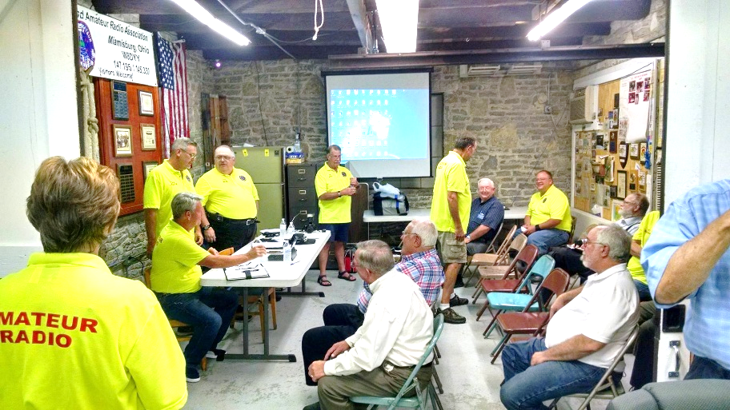Beyond Field Day, I’ve also been hitting the road attending various club meetings and hamfests. I want to extend a huge thank you to the organizers and volunteers for putting on such outstanding events. It’s always a pleasure to get out, wander around, and connect with so many of you. The weather doesn’t always cooperate, but as we all know, that never stops us from having FUN!

July also marks the second Board of Directors meeting. Roy and I are both working diligently to get everything organized and in order for our respective duties to the Board, as well as to our committee responsibilities. These next few weeks are really busy but it’s an important time for both of us.

Speaking of keeping up with things, have you had a chance to visit the ARRL Great Lakes Division website lately? If you haven’t, I’m guessing you might have missed out on registering for our special Handbook Giveaway. Time is running short on this, as it was a special "Happy Birthday" giveaway to celebrate the nation’s birthday. You can find it here: <https://arrl-greatlakes.org/hb.html>. It’s definitely worth checking out!

**Got a Story to Share? Let's Get It in the Newsletter!**

You know, the other night, someone asked me how they could get their club's awesome activities featured in our division newsletter. It’s a question I love to get because it tells me people are engaged and have cool stuff to share. And honestly, the answer is super simple: just send me the story! [n8sy@n8sy.com](mailto:n8sy@n8sy.com)

Seriously, that’s it. If your club has been up to something fantastic, something that deserves a little spotlight, then grab your keyboard and tell me all about it. I’ve got a pretty good track record of fitting most submissions in, especially since our newsletter is designed to be a two-way street, not just a one-way broadcast.

Think about it. This isn’t some stuffy, corporate publication. It's ***our*** newsletter, a space for ***us*** to connect, share, and celebrate what we’re all doing. If your club has achieved something noteworthy, or embarked on an exciting new activity, I genuinely want to hear about it. This is your chance to let the rest of the Division know what you’ve been up to.

Now, before you start typing, let’s get a little clearer on what kind of stories really shine in these pages. While I appreciate enthusiasm for everything, this isn't the place for a constant stream of hamfest advertisements or for-sale listings. Those kinds of announcements are best handled by your local club newsletter editors, who do a fantastic job of keeping your immediate community informed.

What I’m really looking for are those stories that highlight accomplishments. Did your club organize a successful community outreach event? Did you tackle a challenging technical project with impressive results? Maybe you mentored some new members who are now leading fantastic initiatives? These are the kinds of triumphs that inspire others. When I receive a story about a club’s success, it’s not just a report; it’s a blueprint.

It’s an opportunity for other clubs and individuals within our division to learn from your experiences, to see what’s possible, and perhaps even to emulate your success. We’re a community, after all, and what better way to strengthen that community than by sharing our wins and lessons learned?

And don’t feel like you need to be Shakespeare to submit. Just write it up in your own words, as clearly as possible. Tell me what happened, who was involved, and what made it special. The goal is to paint a picture for the reader, to make them feel like they were there or at least understanding the significance of the event.

And hey, don't forget the visuals! If you’ve got great photos or graphics that go along with your story, absolutely send those to me as well. A good picture can often tell a story all on its own and really help your submission grab attention. It adds so much more life to the newsletter and makes it a more engaging read for everyone.

It’s also important to remember that this isn’t *exclusively* about organized club activities. Have you personally undertaken a project that you believe would be of interest to the wider Division?

Perhaps you’ve built something amazing in your shack, experimented with a new technology, or even had a particularly insightful experience related to our shared interests? If you think it’s something that could spark curiosity, inform, or even amuse your fellow members, write it up and send it my way. Your personal projects can be just as valuable and inspiring as a large-scale club effort.

So, the next time your club wraps up a fantastic event, or you complete a project you’re particularly proud of, don’t let that story fade away. Think of our division newsletter as your stage. Send me the narrative, pepper it with some great photos if you have them, and let’s get your amazing club news out there for everyone to see and learn from. I'm eagerly awaiting your submissions!

So, that’s a quick rundown of what’s been happening from my end. I’m looking forward to connecting with more of you throughout the rest of the summer. Until next time, keep those radios on and that enthusiasm high!

73… Stay safe… and I hope to "Catch You On The Air, at a meeting, or at a hamfest!" Most importantly... Have FUN and... Get On The Air!

Scott…

Scott Yonally, N8SY

Director - Great Lakes Division

[n8sy@arrl.org](mailto:n8sy@arrl.org)

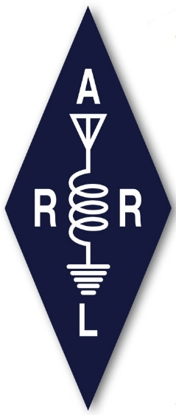***R – U - A Member?***

**Be Radio-Active. Join ARRL Today!**

Join ARRL today and get access to benefits, services, and programs to help you get (and stay) active and on the air. Your membership supports ARRL’s work to promote and protect amateur radio, and to develop the next generation of radio amateurs.

**Did You Know?**

You can give the gift of ARRL Membership. By purchasing a gift membership, you’ll be helping a ham become more active and involved in amateur radio. Gift memberships are available for both U.S. and International individuals and for our Associate (non-licensed) and Full membership types.

By gifting a membership to ARRL you are opening up a world of information, education and fun for that special radio enthusiast in your life! Please call our Member Services team at 860-594-0200 and they will be happy to assist you.

|  |
| --- |
|  |

**Join -** [**Register**](https://login.personifygo.com/prodarrl/Registration/RegisterEmail?returnurl=https://home.arrl.org/action/My-Account) for a web account and then [**Join**](https://home.arrl.org/action/Membership/Join-ARRL).Already a member? [**Renew**](https://home.arrl.org/action/Membership/Renew-Membership) your ARRL membership or simply call ARRL Member Services at **860-594-0200** during normal business hours.

**Life Memberships**

Yes, you still can obtain a Life Membership. Contrary to some social media posts, Life Memberships are still being offered. If you are interested contact Member Services at: **860-594-0200** during normal business hours.

***2025 Great Lakes Division Hamfests***

Here in the Great Lakes Division, we have over 50 hamfests a year.

So, if you haven’t started planning your hamfest schedule yet, you really need to start now.

Please post this listing in your club's newsletter and announce the swaps on your local nets. Talk them up.

Let's fully support all of our hamfests in every way possible. It means success for everyone. Be sure to invite your ARRL Officials as soon as your date is set.

If you are planning on having your hamfest listed in QST please be sure to start your planning well in advance of your Hamfest date, as this allows adequate time for QST Listings. QST announcements require a 3-month lead time.

To be fair to our division’s clubs, the Great Lakes Division policy **now has 2 requirements**. **Any club requesting ARRL sanctioning within the Great Lakes Division must now be an ARRL Affiliated Club with a maximum of two hamfests/swaps in any given calendar year, and they must be at least four months apart.**

You can always find the latest information about upcoming hamfests on the Great Lakes Division website.

](https://www.arrl.org/hamfests/search/Location.division_id:gl)

Just click to get the latest hamfest updates.

|  |  |
| --- | --- |
| **07/19/2025 - [NOARSfest](https://www.arrl.org/hamfests/noarsfest-12" \o "NOARSfest)**  **Location:**Elyria, OH **Sponsor:** Northern Ohio Amateur Radio Society **Website:** <https://www.noars.net/hamfests/noarsfest/> [**Learn More**](https://www.arrl.org/hamfests/noarsfest-12) | **07/20/2025 -**[**Van Wert Hamfest**](https://www.arrl.org/hamfests/van-wert-hamfest-9)  **Location:**Van Wert, OH **Sponsor:** Van Wert Amateur Radio Club **Website:** [http://w8fy.org](http://w8fy.org/) [**Learn More**](https://www.arrl.org/hamfests/van-wert-hamfest-9) |
| **07/26/2025 -**[**BARA / MCRN Trunk Swap**](https://www.arrl.org/hamfests/bara-mcrn-trunk-swap)  **Location:**Berrien Center, MI **Sponsor:** Blossomland ARA **Website:** <https://www.w8mai.org/index.php/club-information/bara-trunk-swap> [**Learn More**](https://www.arrl.org/hamfests/bara-mcrn-trunk-swap) | **08/02/2025 -**[**Columbus Hamfest**](https://www.arrl.org/hamfests/columbus-hamfest-6)  **Location:**Grove City, OH **Sponsor:** Aladdin Shrine Audio Unit **Website:** [http://columbushamfest.com](http://columbushamfest.com/) [**Learn More**](https://www.arrl.org/hamfests/columbus-hamfest-6) |
| **08/02/2025 -**[**U.P. Hamfest 2025**](https://www.arrl.org/hamfests/u-p-hamfest-2025)  **Location:**Rapid River, MI **Sponsor:** Delta County Amateur Radio Society [**Learn More**](https://www.arrl.org/hamfests/u-p-hamfest-2025) | **08/09/2025 -**[**Cincinnati Hamfest℠**](https://www.arrl.org/hamfests/cincinnati-hamfest-4)  **Location:**Owensville, OH **Sponsor:** Milford Amateur Radio Club **Website:** [https://CincinnatiHamfest.org](https://cincinnatihamfest.org/) [**Learn More**](https://www.arrl.org/hamfests/cincinnati-hamfest-4) |
| **08/09/2025 -**[**Letcher County Hamfest**](https://www.arrl.org/hamfests/letcher-county-hamfest-3)  **Location:**Whitesburg, KY **Sponsor:** Letcher County Amateur Radio Club **Website:** [http://www.lcarcky.com](http://www.lcarcky.com/) [**Learn More**](https://www.arrl.org/hamfests/letcher-county-hamfest-3) | **08/16/2025 -**[**Portsmouth Radio Club 2025 Hamfest**](https://www.arrl.org/hamfests/portsmouth-radio-club-2025-hamfest-1)  **Location:**New Boston, OH **Sponsor:** ARRL, Jett Fire Equipment  **Website:** [http://www.portsmouthradioclub.com](http://www.portsmouthradioclub.com/) [**Learn More**](https://www.arrl.org/hamfests/portsmouth-radio-club-2025-hamfest-1) |

|  |  |
| --- | --- |
| **08/17/2025 -**[**Warren Hamfest**](https://www.arrl.org/hamfests/warren-hamfest-2)  **Location:**Cortland, OH **Type:** ARRL Hamfest **Sponsor:** Warren Amateur Radio Association **Website:** <http://w8vtd.com/hamfest> [**Learn More**](https://www.arrl.org/hamfests/warren-hamfest-2) | **08/30/2025 -**[**Athens Trunkfest**](https://www.arrl.org/hamfests/athens-trunkfest-1)  **Location:**Athens, OH **Type:** ARRL Hamfest **Sponsor:** Athens County Amateur Radio Association **Website:** <https://www.ac-ara.org/> [**Learn More**](https://www.arrl.org/hamfests/athens-trunkfest-1) |

***ARRL Announces Logbook of The World® Systems Upgrade***

ARRL’s Logbook of The World® (LoTW®) is the 2nd most popular benefit among members. It is also an extremely popular service internationally for non-members, as it is the primary means for providing confirmations for ARRL Awards, such as DXCC and Worked All States.

As a part of the ongoing modernization of the ARRL systems infrastructure, LoTW will be receiving major upgrades to the operating system it is running on, the relational database system it uses to store and access logbook and awards data, and server hosting, where it will be fully migrated to the cloud. These changes will, among other improvements, ensure LoTW performance needs can be better met based on user demand.

LoTW will be unavailable from June 27 to July 2, 2025, to complete these upgrades. We will bring LoTW back online if it is available sooner than July 2.

Logbook of The World can be found at [lotw.arrl.org](https://lotw.arrl.org/). More information about the popular service is available at [www.arrl.org/logbook-of-the-world](http://www.arrl.org/logbook-of-the-world).

If you are a user of LoTW and not an ARRL member, please become a supporter of LoTW by making a $20 (or more) donation to the [ARRL LoTW Fund](https://home.arrl.org/action/Donate/Donate-Now/CashProductId/115203) or visit [www.arrl.org/donate](http://www.arrl.org/donate).

Very 73, and see you on the air!

David A. Minster, NA2AA  
ARRL CEO

***Club Links***

](https://arrl-greatlakes.org/links.html)I’ve received a number of new requests from clubs to be listed on the “Links” club page.

Is your club listed? If not, send the URL of your club website to me [n8sy@n8sy.com](mailto:n8sy@n8sy.com) and I’ll get it listed.

***Have You Read the New ARRL Club Primer Yet?***

**This is a Must-Read for Every Amateur Radio Club**

Amateur radio clubs are the backbone of the ham radio community. They provide a space for enthusiasts to connect, learn, share knowledge, and contribute to the hobby in meaningful ways. But running a successful and thriving club takes effort, planning, and a solid understanding of best practices. That's where the ARRL comes in, and their newly updated **ARRL Club Primer** is a valuable resource you absolutely need to check out.

<http://www.arrl.org/files/file/Clubs/ARRL%20Club%20Primer-rev%20March%202025.pdf>

Whether you're a seasoned club officer, a new member, or just thinking about starting a club, this primer is packed with information to help you navigate the world of amateur radio clubs and ensure your group's success. So, let's dive in and explore why the ARRL Club Primer is an essential tool for every amateur radio club.

**What is the ARRL Club Primer?**

Think of the ARRL Club Primer as a comprehensive guide to all things related to amateur radio clubs. It's a document created by the ARRL to assist clubs in their organization, operation, and development. It's not just a set of dry instructions; it's a practical and insightful resource filled with tips, examples, and best practices drawn from successful clubs across the country.

The primer covers a wide range of topics, from the initial steps of forming a club to strategies for attracting new members, organizing events, and ensuring long-term sustainability. It’s designed to be a living document, regularly updated to reflect the changing landscape of amateur radio and the evolving needs of clubs.

**Why is the ARRL Club Primer Important?**

In today's fast-paced world, it's easy for clubs to fall into ruts or face challenges that can hinder their growth and effectiveness. The ARRL Club Primer provides a framework for addressing these challenges and building a strong, vibrant club. Here’s why it's so important:

* **Provides a Foundation for Success:** The primer offers a structured approach to club management, covering everything from defining your club's mission and goals to establishing clear roles and responsibilities. Following these guidelines can help you avoid common pitfalls and set your club up for long-term success.
* **Offers Best Practices:** The primer draws on the experiences of successful amateur radio clubs across the country. You'll find examples of effective strategies for attracting and retaining members, organizing engaging events, and managing club finances. You don't have to reinvent the wheel; learn from the best!
* **Supports ARRL Affiliation:** If your club is interested in becoming an ARRL-affiliated club (and there are many compelling reasons to do so!), the primer provides valuable insights into the **affiliation** process and the benefits of being part of the ARRL network. **ARRL affiliation** brings access to resources, support, and a sense of belonging to a larger community.
* **Helps Navigate Rules and Regulations:** Amateur radio is governed by **Rules and Regulations** set forth by the FCC (Federal Communications Commission). The primer provides guidance on understanding and complying with these rules, ensuring your club operates legally and ethically. It also covers topics like insurance and liability, protecting your club and its members.
* **Promotes Growth and Innovation:** The primer encourages clubs to think creatively about how to engage their members and attract new hams to the hobby. You'll find ideas for innovative activities, educational programs, and community outreach initiatives that can help your club thrive.

**What's Inside the ARRL Club Primer?**

The ARRL Club Primer is a comprehensive document, covering a wide range of topics relevant to amateur radio clubs. While the exact content may vary depending on the version, here's a general overview of what you can expect to find:

* **Starting a Club:** This section covers the initial steps of forming a club, including defining your club's mission, goals, and values. It also provides guidance on creating a constitution and bylaws, establishing a formal structure for your organization.
* **Club Management:** This section focuses on the day-to-day operations of a club, including holding meetings, managing finances, and communicating with members. It also covers topics like leadership development and succession planning.
* **Membership:** Attracting and retaining members is crucial for any club's success. This section provides strategies for recruiting new members, engaging existing members, and creating a welcoming and inclusive environment.
* **Activities and Events:** This section is filled with ideas for engaging activities and events, ranging from on-air contests and field days to educational workshops and community service projects.
* **Training and Education:** Amateur radio is a constantly evolving hobby. This section provides guidance on offering training and educational programs to help members improve their skills and knowledge.
* **Public Service:** Amateur radio operators have a long history of providing public service during emergencies and disasters. This section explores opportunities for your club to contribute to your community.
* **ARRL Affiliation:** This section details the process of becoming an ARRL-affiliated club and the benefits of **affiliation**.
* **Legal and Ethical Considerations:** This section covers important legal and ethical considerations for amateur radio clubs, including compliance with FCC **Rules and Regulations**, insurance, and liability.

**How to Use the ARRL Club Primer Effectively**

The ARRL Club Primer is a valuable resource, but it's important to use it effectively. Here are a few tips:

* **Read it Cover to Cover:** Take the time to read the entire primer, even if you think you already know some of the information. You might be surprised at what you learn.
* **Use it as a Reference:** Keep the primer handy and refer to it whenever you have questions or need guidance on a particular topic.
* **Share it with Your Club:** Make sure all club officers and members have access to the primer. Encourage them to read it and discuss the information at club meetings.
* **Adapt it to Your Club's Needs:** The primer is a guide, not a rigid set of rules. Adapt the information to fit your club's specific needs and circumstances.
* **Stay Up-to-Date:** The ARRL Club Primer is a living document that is regularly updated. Make sure you have the latest version. Obsolete information can lead clubs astray.

**The Importance of ARRL Affiliation**

As mentioned throughout, **ARRL affiliation** is a significant benefit for amateur radio clubs. Becoming an affiliated club demonstrates a commitment to the hobby and provides access to a range of resources and support. Here are some of the key benefits:

* **Access to ARRL Resources:** Affiliated clubs have access to a wealth of resources from the ARRL, including educational materials, training programs, and legal guidance.
* **Insurance Coverage:** Affiliated clubs are eligible for liability insurance coverage through the ARRL.
* **Representation:** The ARRL represents the interests of amateur radio operators at the national and international levels. Affiliated clubs have a voice in shaping the future of the hobby.
* **Networking Opportunities:** Affiliation provides opportunities to network with other amateur radio clubs and individuals across the country.
* **Recognition:** Being an ARRL-affiliated club is a mark of distinction that demonstrates a commitment to excellence.

The ARRL Club Primer is an invaluable resource for any amateur radio club looking to thrive and contribute to the ham radio community. By providing a comprehensive guide to club management, best practices, and ARRL affiliation, the primer empowers clubs to achieve their goals and ensure the long-term health of the hobby. So, if you haven't already, take the time to read the new ARRL Club Primer – it's an investment in your club's future. You will be glad you did!

***Understanding the Difference between 15 Amp and 20 Amp Outlets***

When it comes to electrical outlets, it is essential to understand the difference between a 15 amp and a 20 amp outlet to ensure safety and maintain the proper functioning of your electrical system. The National Electrical Code (NEC) provides guidelines to help you identify these outlets and understand their usage. This guide will break down the visual differences between the two types of outlets, their commonalities, and essential considerations for their usage.

**The Visual Clue: The T-Slot Tells the Tale**

The most apparent visual difference between 15 amp and 20 amp outlets lies in the shape of the neutral slot (the larger of the two vertical slots).

15 Amp Outlet: The neutral slot is a simple vertical rectangle.

20 Amp Outlet: The neutral slot has a "T" shape, which means it has a short, horizontal slot connected to the vertical rectangle. This T-slot is designed to accept a 20-amp plug, which has a blade that is wider on one side.

**The Constant: Identifying the Neutral**

Regardless of whether it's a 15 amp or 20 amp outlet, the National Electrical Code (NEC) mandates that the neutral wire is always clearly identified. This is typically done by using white or grey wire insulation for the neutral wire. You'll also find that the neutral slot on the outlet is always slightly larger than the hot slot.

**Can You Use a 15 Amp Outlet on a 20 Amp Circuit?**

This is a common question, and the answer is yes, but with caution. A 15-amp outlet can be installed on a 20-amp circuit, provided there are multiple outlets on the circuit. This is allowed by the NEC. The reasoning is that if multiple devices are plugged in, the total load is distributed.

However, there is a very specific caveat: If a single outlet circuit is used, you must use a 20 amp outlet with 20 amp wiring.

**Important Caveats and Considerations:**

1. Overload Protection: The breaker or fuse protecting the circuit in your electrical panel is rated for 20 amps. This means if you draw more than 20 amps from the entire circuit, the breaker should trip, preventing an overload. However, relying on the breaker for individual appliance overload isn't ideal.
2. Appliance Compatibility: Never plug an appliance that requires 20 amps into a 15-amp outlet. This can cause overheating, damage to the appliance, and potentially a fire hazard.
3. Dedicated Circuits: High-demand appliances like refrigerators, microwaves, and window air conditioners often require dedicated 20-amp circuits to ensure safe and reliable operation.

**Wire Gauge: Sizing for Safety**

Choosing the correct wire gauge is paramount for safety and preventing overheating. The American Wire Gauge (AWG) system dictates the appropriate wire size for different amperage circuits.

* 15 Amp Circuit: Typically requires 14-gauge wire.
* 20 Amp Circuit: Typically requires 12-gauge wire.

Important: Local codes may have stricter requirements, so always consult your local electrical codes and regulations before performing any electrical work.

**When in Doubt, Consult a Professional**

Working with electricity can be dangerous if you're not properly trained. If you're unsure about any aspect of electrical wiring or outlet identification, it's always best to consult a qualified electrician. They can ensure your electrical system is safe, compliant with code, and functions correctly. Improper wiring can lead to serious consequences, including fire hazards and electrical shocks. Your safety is worth the investment in a professional's expertise.

***STOP!!!***

***We’ve come to the end…***

*Be Radio-Active --- See Ya’ Soon!*

Radio Waves is produced as a look inside of the Great Lakes Division and all that it has to offer. It is our sincerest hope that you have enjoyed this edition and will encourage your friends to be a part of the ARRL and receive the latest news and information about the ARRL and the Great Lakes Division!