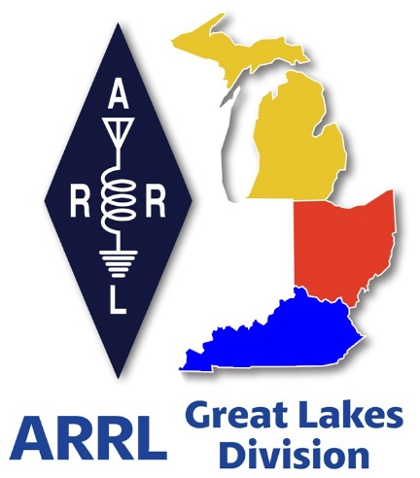 ***Radio Waves***

***The Great Lakes Division***

***Mid- Month Report***

***August***

***From the Michigan Section Manager***

Larry Camp, WB8R

Greetings to all who read this…..

As this is written, we are in mid-August and living in the southern-most part of Michigan, we have had a number of consecutive days in the 90 degree (plus) range. When thinking about the extreme range of outside temperatures that we enjoy (endure) in winter and summer in this part of the country, I find it amazing that we just adapt and go on with our lives. I know that I only pay attention to the weather when I need to go someplace or if the lightning and winds are flashing/blowing or if the snow is being piled up by the wind. I have often heard the statement about Michigan weather that: “If you don’t like the weather, just wait five minutes and it will change…..” and this seems to have some truth to it….

Late summer ham radio events slow down a bit because a great number of event take place in areas that are subject to the whims of the weather plus the ‘vacation factor’ that often takes us out and about with the family and sometimes does not include hamfests.

Upcoming Michigan Ham Radio events with (if applicable) with ARRL official planning to attend:

Aug 24, 2025    Seaway Swap, Port Huron, MI   
Sep 6, 2025      Grand Rapids Area Hamfest, Wyoming, MI (WB8R)  
Sep 13, 2025    OAARS Hamfest, West Branch MI   
Sep 13, 2025    GMARC Trunk Swap, Shelby Twp, MI   
Sep 14, 2025    Adrian Hamfest, Adrian, MI (WB8R)  
Sep 20, 2025    Top of Michigan ARC Hamfest, Gaylord, MI (WB8R)  
Oct 2, 2025      Muskegon ARC Meeting (WB8R)  
Oct 4, 2025      Copper Country Hamfest, Baraga, MI   
Oct 4, 2025      Kalamazoo Hamfest & Vintage Radio Expo, Kalamazoo, MI (WB8R)  
Oct 11, 2025    Muskegon Color Tour Hamfest, Muskegon, MI (WB8R)  
Oct 19, 2025    USECA Hamfest, St. Clair Shores, MI   
Dec 7, 2025     LCARC ARC Hamfest, Troy, MI (WB8R)

Note: Specific event details, including starting times and event addresses can be found by searching for ‘Michigan hamfests’ on the ARRL website ([www.arrl.org](http://www.arrl.org)).

**Opinion: Amateur Radio Clubs**

Having been involved with this ham radio thing pretty much every day since the late 1970’s, I become more convinced that radio clubs are where it’s at….. Radio clubs are where you can have a conversation with knowledgeable hams who are more than willing to give you advice on how best to snag that rare DX, how to put up that tower, how to string that wire antenna up into the trees, how to participate in a net (or even how to properly run a net), how to run that wiring (electrical and antenna) in your new car, and a plethora of other items that you either need or want to do. The advice from a lifetime of learning comes at no cost other than some respect and appreciation for the help…. All we need to do is ask the questions and sit back and absorb some of the life-long learning that other hams have. This is the place where you can offer ideas and suggestions and sometimes physical assistance to that new ham or to assist that elderly ham that can no longer get on a ladder to fasten his/her antenna up in the tree. Opportunities to be helpful abound and the idea that there is strength in numbers absolutely rings true in clubs.

Every club needs ‘sparkplugs’ that offer, free of charge, sage advice that helps solve a problem, or sparks further thought that often ends in an epiphany (and great self-satisfaction) on the part of the individual that is working on a tough project. Nothing beats a friend that has been there and done that, and it is always willing to share their knowledge.

Test drive the clubs in your area………. Do not hesitate to journey over to an adjacent county and meet the hams in that area. Be helpful and attentive. Join in the club activities such as fund raisers, meals together, on the air nets, and any other excuse to get together to talk radio. There is nothing wrong with supporting more than one club.

Volunteer your services for your club(s). There are always areas in which clubs can use some fresh blood, fresh ideas, and enthusiasm.

That is it for this month. If you are at an event that I am also attending, please take a minute to stop by and say hello. I am always interested in what is happening in amateur radio around the state.

That is it for this month.

Have fun, and be Radioactive!

73,

Larry, WB8R  
Michigan ARRL Section Manager  
517-617-4883  
[wb8r@arrl.org](mailto:wb8r@arrl.org)

***From the Ohio Section Manager***

Tom Sly, WB8LCD

The latest edition of the Ohio Section Journal is now online and ready  
for you to read! There’s an awful lot of Ham Radio activities going on  
in the Ohio Section, so get off the chair or couch you’re sitting on  
and get out there, get involved, and get on the air!  
  
The links below will take you directly to the newsletter. Both are also  
available directly from the Ohio Section Web-site ( [www.arrl-ohio.org](http://www.arrl-ohio.org) )  
where you will also find the downloadable PDF of the Ohio Governor’s  
proclamation for Field Day. You’ll want to print it out and display  
it at your Field Day site.  
  
Since the ARRL email reflector is not yet working, please forward this  
announcement everywhere!  
  
<https://arrl-ohio.org/wp-content/uploads/2025/08/OSJ_August_2025.pdf>

Tom…

[wb8lcd@arrl.org](mailto:wb8lcd@arrl.org)

***Scott’s Stuff***

Hi Gang,

***Ah, the Dog Days of Summer…***

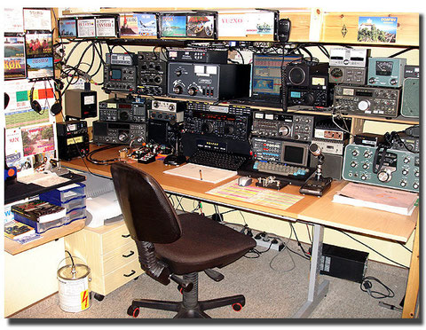You know the ones. The air hangs thick and heavy; the kind of humidity that makes even your thoughts feel like they’re wading through molasses. My trusty old shack, the only place where I can have a beacon of cool, calm communication. It’s my little piece of Heaven with a radio in it. As the mercury climbs, the hum of the radio and the promise of connection keep me from succumbing to full-blown summer lethargy. Because, let’s be honest, ham radio isn't just a hobby; it’s a lifestyle, a perpetual quest for knowledge, and, if you’re doing it right, a whole lot of fun.

I often find myself explaining to bewildered friends exactly why I choose to spend my precious weekend hours fiddling with wires and talking to strangers across continents. They picture me as some sort of reclusive, morse-code tapping monk. And while sometimes, on a particularly good DX night, I do feel a certain monastic peace, the truth is far more dynamic. My ham radio journey has always been about doing more than just communications. It's about responding to the call, whether that call is a whispered faint signal from a rare country or an urgent plea for help in the aftermath of a storm.

This dual nature of ham radio – the fun and the fundamental – is never more apparent than when you get involved with ARRL affiliated clubs. Now, I’ve been around the block a few times. I've seen clubs thrive, and I’ve seen them… well, let's just say I’ve seen meetings that made watching paint dry seem like a thrilling spectator sport. The key, I’ve come to realize, lies in striking that delicate balance between education and entertainment. No one wants to sit through an hour of droning technical specs unless they’re presented with a dash of wit and a sprinkle of practical application. This is where the ARRL 2026 Year of the Clubs initiative, and the renewed efforts of the ARRL, really get my antenna twitching with excitement.

I’ve been a part of the early planning, and it gives me hope. For too long, some clubs have struggled with attracting new members, keeping existing ones engaged, and generally just… being fun. We all love the technical stuff, mind you. Give me a good discussion on antenna theory or propagation any day. But if every meeting is just a dry lecture, it's a recipe for empty chairs. We need to focus on making club meetings fun. I remember one meeting where the guest speaker spent forty-five minutes explaining the intricacies of parallel resonant circuits. By the end, half the room was asleep, and the other half was silently debating whether it was rude to check their email. We've all been there.

The solution, I believe, lies in variety and accessibility. For starters, interesting guest speakers are paramount. Not just the local guru who's been doing this since Marconi invented the spark gap, but someone who can bring a fresh perspective, an interesting project, or a compelling story. I’ve seen meetings light up when a member shares their latest SOTA adventure, or when someone brings in a quirky piece of antique gear. It’s about igniting that spark of curiosity and showing the breadth of what ham radio truly is.

And let's talk about technology. In this post-pandemic world, there's no excuse not to make use of Zoom or other similar A/V programs to make your club meeting fun and interesting. Suddenly, that world-renowned expert who lives 2,000 miles away isn't out of reach. And just as suddenly, members who can't physically make it to the dusty old clubhouse on a Tuesday night can still participate. It opens up a whole new world of possibilities, from virtual tours of famous shacks to interactive Q&A sessions with equipment manufacturers. Imagine inviting a representative from Icom or Yaesu to demo their latest rig virtually, or a renowned DX-peditioner to share tales from their latest adventure. The potential for enhancing club news and reaching a wider audience is immense.

Beyond the monthly meetings, the real meat of ham radio activity often lies in the practical, hands-on experiences. Take the Annual ARRL Simulated Emergency Test (SET), for instance. My local group always throws themselves into it with gusto. It’s a fantastic opportunity to shake off the rust, test our equipment, and practice filling in the gaps in communications. We also work closely with our local emergency management agency during their EMA exercises, simulating everything from widespread power outages to unexpected natural disasters. It's serious business, but there's an undeniable thrill in knowing your skills could genuinely make a difference.

Hey, are you interested in the National Traffic System but just don’t feel comfortable checking in to a net yet? You can get some training and background about the NTS each Wednesday night via Zoom. Here’s the information from the NTS Newsletter

The Virtual NTS Training Net (VNTN) continues to meet on Wednesday evenings at 7PM Eastern time. Anyone interested in learning more about the NTS, radiograms, traffic nets, and message relay is welcome.

Shawn Dodds, N1CVO, has been doing an excellent job in working with folks with varying levels of experience — including none — but would benefit greatly from the ability to share his screen for teaching purposes. Here’s the link… [**bitl.to/4tL3**](https://arrl.informz.net/z/cjUucD9taT0zNDAxNTYyJnA9MSZ1PTUyMDM2NDI5NiZsaT0zOTE1ODg0Mg/index.html) We look forward to seeing you there.

Have you tried out the new “on-line” radiogram portal? It’s really cool how it works and there’s something about it that just makes sending them any other way seem old fashioned. Have you had the opportunity to do this yet? Here’s a link to get you started.. <https://nts2.arrl.org/radiogram/>

And it’s not just about emergencies, although that public service aspect is a huge part of what we do. We often volunteer our communication skills for special club activities like local bicycle races. Imagine a 100-mile cycling event, snaking through rural areas where cell service is non-existent. That’s where we come in, providing vital communication links between race officials, aid stations, and emergency personnel. It's a workout for the radio, and a great way to show the community the practical value of ham radio. Plus, it's a heck of a lot more exciting than just listening to static.

The social aspect, of course, isn't lost on me. Hamfests are like family reunions for the technically inclined. Wandering through rows of dusty old gear, sniffing out bargains, and bumping into friends you only see once a year – it's a quintessential ham radio experience. It's where you pick up that oddball component you've been looking for, or finally get to put a face to the callsign you've chatted with on the air for years. These events are crucial for fostering camaraderie and sharing knowledge, both formally and informally.

So, as we squint through the hazy, sweaty reality of these Dog Days of Summer, I’m already looking forward to the cooler air and the heightened activity that comes with it. But more importantly, I'm genuinely excited about what lies ahead for ARRL affiliated clubs, especially with 2026 Year of the Clubs on the horizon. The goal, as I see it, isn't just to keep our existing members happy, but to reignite the spark for those who might have drifted away and to welcome complete newcomers with open arms. It’s about showing them that ham radio isn't just for grizzled old-timers (like me, perhaps, but don't tell anyone I said that), but a vibrant, ever-evolving hobby that truly offers something for everyone.

From sending a radiogram to supporting a bike race, from learning about cutting-edge digital modes to simply enjoying a friendly chat on the air, the possibilities are endless. And if we can achieve all this while ensuring our club meetings are genuinely fun and engaging – perhaps even offering a virtual escape from the summer heat – then I believe the future of ham radio will be brighter than even the strongest solar flare. Now, if you’ll excuse me, I think I hear my fan complaining.

That’s going to do it from here this time around. Catch you on the air, in a club meeting, or at a hamfest! Until then, **Be Radio Active!!!!!**

73,

Scott, N8SY

Great Lakes Division Director

[n8sy@arrl.org](mailto:n8sy@arrl.org)

***Amateur Radio Clubs***

Larry Camp, WB8R

MI ARRL Section Manager

Having been involved with this ham radio thing since the late 1970’s, every day I become more convinced that radio clubs are where it is at. Radio clubs are where you can have a conversation with knowledgeable hams who are more than willing to give you advice on how best to snag that rare DX, how to put up that tower, how to string that wire antenna up into the trees, how to increase your code speed or how to learn to copy in your head, how to participate in a net (or even how to properly run a net), how to run that wiring (electrical and antenna) in your new car, and a plethora of other items that you either need or want to do. The advice from a lifetime of learning comes at no cost other than some respect and appreciation for the help…. All we have to do is ask the questions. and sit back and absorb some of the life-long learning that other hams have acquired.

Clubs are the place where you can offer ideas and suggestions and sometimes physical assistance to that new ham or to assist that elderly ham that can no longer get on a ladder to fasten his/her antenna up in the tree. Opportunities to be helpful abound and the idea that there is strength in numbers absolutely rings true in clubs.

Every club needs a series of ‘sparkplugs’ that offer, free of charge, sage advice that helps solve a problem, or sparks further thought that often ends in an epiphany (and great self-satisfaction) on the part of the individual that is working on a tough project. Nothing beats a friend that has been there and done that!

Test drive the clubs in your area………. Do not hesitate to journey over to an adjacent county and meet the hams in that area. Be helpful and attentive. Join in the club activities such as fund raisers, meals together, on the air nets, and any other excuse to get together to talk radio. There is nothing wrong with supporting more than one club.

Volunteer your services for your club(s). There are always areas where clubs can use some fresh blood, fresh ideas, and enthusiasm.

It will not be long before fall will show up and with it, some propagation changes as we transition into winter. Make sure your antennas are ready for the winter weather and just sit back and enjoy nature’s fall color show!

Best 73 to all from Michigan…..

LC

***ARRL – RRI Memorandum of Understanding***

James Wades, WB8SIW

The ARRL and Radio Relay International (RRI) formalized their relationship with the signing of a Memorandum of Understanding (MOU) during the recent semi-annual meeting of the ARRL Board of Directors. Both organizations will work together to further improve and promote the National Traffic System (NTS). Many thanks go to Phil Temples, K9HI, ARRL New England Division Vice Director and Chair of the NTS subcommittee of the Emergency Communications - Field Services Committee (EC-FSC), and James Wades, WB8SIW, Board Chairman of RRI, along with Scott Yonally, N8SY, Chair of EC-FSC, for their efforts in bringing this about.

Radio Relay International was formed in 2016 in response to what had been seen as a long decline in NTS activity. Over several decades, NTS had become mostly invisible in the broader Amateur Radio Service, and few initiatives had been developed to encourage continued evolution of the system.

It was therefore the goal of the RRI founders to correct these deficiencies while leveraging the value of NTS as a modern and relevant public service communications asset.

*ARRL President Rick Roderick, K5UR, signs memorandum of understanding between ARRL and RRI.*

*[Photo courtesy of Phil Temples, K9HI]*

Thanks to excellent support from the traffic-handling community, the improvements to NTS didn’t go unnoticed, resulting in renewed support for the program by ARRL leadership. The result was the creation of a new ARRL NTS2.0 Committee, the goals of which were closely aligned with those of RRI. As a result, it seemed logical and beneficial to develop a Memorandum of Understanding between our two organizations. The purpose of this MOU is to encourage cooperation while preventing the development of conflicting or duplicative standards. Most importantly, both ARRL and RRI agree that we must work together to further modernize NTS while restoring its role as a vital component in the Amateur Radio Service.

Within the context of this new spirit of cooperation, it is recognized that ARRL retains an extensive field service organization of immense value. Along with this infrastructure comes the many local relationships ideal to establishing the “last mile” capabilities essential to an effective communications process. It is also recognized that RRI has driven an important evolutionary process, not just within NTS, but in the field of emergency communications in general. The extensive work product of RRI offers a tested and proven plan for continued NTS evolution.

It is no surprise that the Amateur Radio Service of today is much more diverse than it was decades ago. Some of those obtaining FCC licenses are doing so to support their own interests or to obtain access to infrastructure. Others do not see themselves as part of a community of radio amateurs. Within this environment, developing consensus and cooperation is essential to establishing an effective volunteer base. Programs that unify efforts will be important to the future of amateur radio.

Considerable goodwill on the part of both organizations went into the development of this new agreement. We hope that all NTS volunteers understand that the goal of those involved is entirely altruistic and in the interest of the Amateur Radio Service. Won’t you join us on this journey into the future of NTS?

If you missed the press release announcing the MOU, please visit www.arrl.org/news/radio-relay-international-and-arrl-sign-memorandum-of-understanding.

For those unfamiliar with Radio Relay International, please visit our web page at [www.radiorelay.org](http://www.radiorelay.org)

***Learning to Program and Operate My New HF Amateur Radio via YouTube***

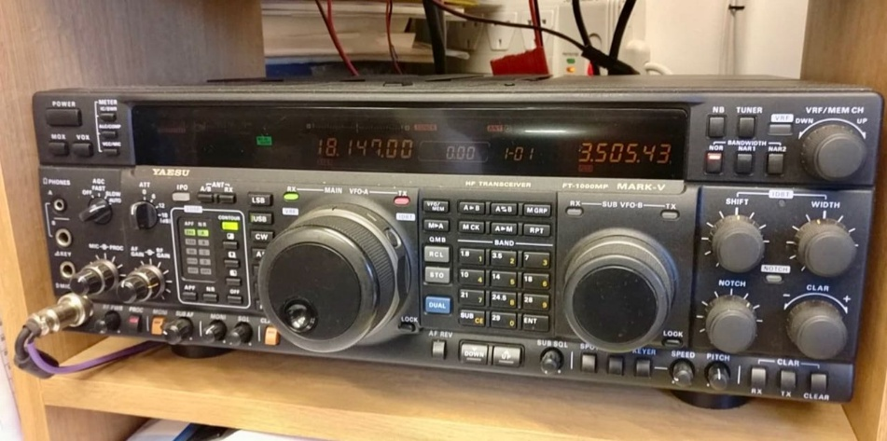

The box arrived, pristine and heavy, bearing the mystical designation: FT-1000MP. Inside, nestled amongst ample foam, was my new High-Frequency Amateur Radio transceiver, a beast of a machine that promised to connect me to the world.

My dream of becoming a licensed ham radio operator was finally coalescing beyond the written exam. I unwrapped it with the reverence of an archaeologist unearthing a lost artifact, ready to begin my global conversations. Little did I know, the real archaeological dig was about to begin – deep into the labyrinthine world of sub-sub menus, arcane operating modes, and the seemingly impenetrable logic of a modern radio.

My initial confidence, fueled by passing the exam and understanding the theory, evaporated faster than a weak signal in a thunderstorm. The front panel of the FT-1000MP wasn't just adorned with knobs; it was festooned with them. Buttons, lights, displays – it looked less like a communication device and more like the cockpit of a 747, if the 747 was designed by a committee that believed in maximum button density. My first thought, a desperate, silent plea to the universe, was: "Too many knobs and too many memories to program. I need a computer and a 10-year-old to figure it all out."

The manual, a tome thicker than most classic novels, seemed to be written in a language vaguely resembling English but definitely not comprehensible to a human mind under duress. This was it. This was the moment for modern solutions. I turned, as so many lost souls before me, to the digital oracle: YouTube.

My journey began optimistically. I typed "FT-1000MP setup" into the search bar, anticipating clear, concise instructions. Forty hours of YouTube videos later, I was still just as confused, but now I had a deeper appreciation for diverse camera angles and varying levels of background clutter in people's basements. Some videos offered tantalizing glimpses into the true power of the rig, only to devolve into rambling explanations of antenna theory that left me cross-eyed.

Others focused solely on the internal power supply module, while I was still trying to figure out which end of the coax do I hook to the antenna. It all made noise, yes, a cacophony of static and strange digital chirps, but it wasn't the kind of noise that suggested communication was imminent.

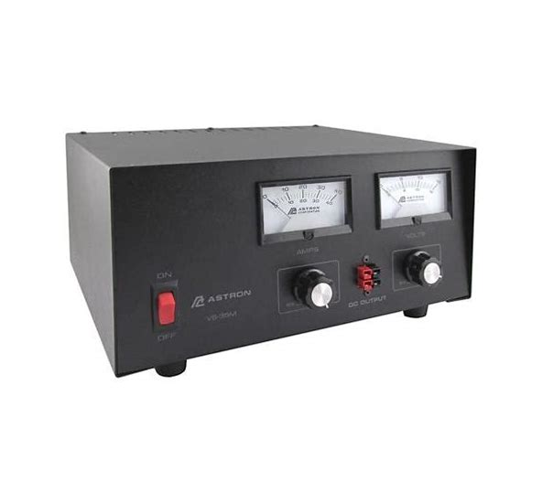

The first hurdle was basic power. I proudly connected my brand-new power supply to the radio, flipped the switch, and… nothing. A faint click, perhaps. More YouTube. More frustrated sighs. Was it the fuse? Was it the polarity (even though I swore I’d checked it)? Finally, after an hour of frantic searching and re-watching, I discovered a hidden master switch that required a combination of button presses and a solemn incantation to activate. Success!

Or so I thought. I tried to transmit, and the power meter barely flickered. Only 5 watts from a 100-watt transceiver?

The online forums, blogs, and a flurry of desperate emails and phone calls confirmed my suspicion: there was always another setting, deeper in the menu, hiding like a digital Easter egg.

My progress was measured in tiny, agonizing steps. I learned that sideband was the default mode for most voice communication, but then there was double side band, and AM, and FM, and then the truly bewildering world of digital modes that required even more software and more cables than my existing spaghetti junction. Each mode demanded its own set of parameters, its own calibration, its own unique way of making me feel profoundly stupid.

One particularly memorable video, featuring a grizzled old-timer (who, I suspect, knew the FT-1000MP before it had a microprocessor), kept referring to "dipping the grid while tuning for peak." My rig had no "grid," no visible tubes, and certainly no archaic meter designed for such an operation. It was a direct link to the golden age of ham radio, a time when radios were simpler, perhaps, but also demanded a level of technical prowess I could only dream of. I eventually figured out (through another YouTube video, naturally) that modern transceivers do this automatically, and that particular advice was about as useful as telling a smartphone user to "adjust the rabbit ears."

Then came the audio issues. My first attempts at transmitting sounded like a squirrel trapped in a tin can. "What do you mean I'm overdriving the modulation?"

I yelled at my screen, as a disembodied voice in a YouTube tutorial calmly explained the concept of audio gain and compression. It turns out, simply yelling into the microphone isn't the most effective strategy. Who knew?

The internal programming of memories was another epic battle. The manual's instructions were clear as mud, and the YouTube videos often skipped crucial steps, assuming a level of prior knowledge I simply didn't possess. This is where my earlier thought about the 10-year-old came back with a vengeance. Surely, a child raised on intuitive touchscreens could navigate the Byzantine logic of these settings faster than my adult brain, which was still trying to parse the difference between "VFO A" and "VFO B."

Connecting the radio to a computer via a myriad of cables and a notoriously finicky serial-to-USB adapter felt like trying to perform open-heart surgery with a butter knife. The thought of remote operation, maybe someday, seemed utterly fantastical, a dream reserved for the truly enlightened.

My salvation, or at least a temporary cease-fire in the war against technology, came in the form of a real human being. After countless fruitless hours online, I decided to take the advice I'd seen in several comments sections: find an Elmer. I reached out to a local club and found "Dave," a seasoned operator with a laugh that could transmit across continents without a radio.

My first timid phone call to him lasted an hour, during which he patiently walked me through several key concepts that had eluded me in 40 hours of YouTube videos. When I asked him about some obscure setting, he just chuckled, "Ah, that's in the third sub-sub menu under 'Configuration Parameters,' but just ignore it for now." Ah, the wisdom of experience!

There was a moment, after weeks of fumbling, after wiring and re-wiring, after countless attempts at programming one of my favorite net frequencies into memory only to have it disappear, when it finally clicked. I heard a familiar voice, clear and strong, bouncing back from a distant station. It wasn't perfect, but it was there. I had achieved the seemingly impossible: getting a signal out after viewing 40 hours of YouTube videos, countless blogs, a mountain of emails, and a lifeline of phone calls to my newfound mentor, Dave.

"Yes," my Elmer, Dave, chuckled, "it always looks like a spaghetti factory exploded inside your head before it finally clicks."

And he was right. The spaghetti was beginning to untangle, slowly, painfully. The FT-1000MP, once an alien spacecraft, was now merely a highly complex piece of very expensive electronics. I still occasionally find myself staring blankly at the screen, wondering which of the myriad options for sideband width I should choose, or why my antenna tuner is complaining. But now, when I hit a wall, I know exactly who to call. And sometimes, just sometimes, I even surprise myself by figuring it out on my own. It's a journey, not a destination, and apparently, the journey involves a lot of noise, a lot of patience, and an endless supply of online tutorials.

***New ARRL® DXCC® Trident Award***

ARRL announces the DXCC® Trident Plaque, a new program to honor the accomplishments of radio amateurs who have confirmed QSOs with at least 100 ARRL DXCC award entities on each of three modes (phone, CW, and digital).

The basic award is issued upon application and confirmation by the ARRL Awards Department, and it is endorsable at levels of 200, 300, and Honor Roll, based on achieving that level on all three modes at the time of application.

The earliest QSO date, and starting date for the DXCC Trident Award, is November 1, 1976, when RTTY (now named digital) DXCC was introduced.

ARRL Radiosport and Regulatory Affairs Manager Bart Jahnke, W9JJ, says the new award should be exciting to hams. “It gives all participants of the DXCC program, especially those new to DXCC, something fresh to work towards,” he said. ARRL has long had the Worked All States Triple Play award, but this introduces the multi-mode achievement to the DXCC program.

Confirmation of QSOs toward the Trident is done only through the standard process by credits within the ARRL DXCC program via Logbook of The World® (LoTW®). No QSL cards will be accepted with a plaque application. If your DXCC credits are not already visible in LoTW, you must first link your DXCC and LoTW profiles by requesting a credit merge from the ARRL Awards Desk.

To apply for the plaque or learn more, visit [www.arrl.org/dxcc-trident-award](http://www.arrl.org/dxcc-trident-award)

Celebrate your achievement and dedication to the DXCC program across all modes with the ARRL DXCC Trident award – a symbol of excellence in amateur radio operating and DXing.

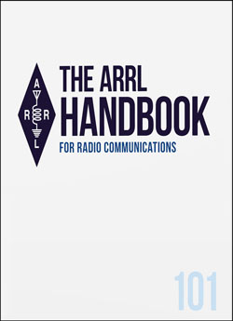

***Winner of the Great Lakes Division “Handbook Give Away”***

Hey Gang,



I just wanted to say thanks to everyone that entered for the chance to win a 2025 ARRL softcover Handbook. This is really becoming popular, and it will be back sometime soon for another chance of winning a really great prize. Just look for the big red arrow on the website…

So, now for the winner… Have I left you in suspense long enough???

Congratulations go to……

*Michael Boyle, WF8B of Martinsville, Ohio*

***The Start-Stop Miseries***

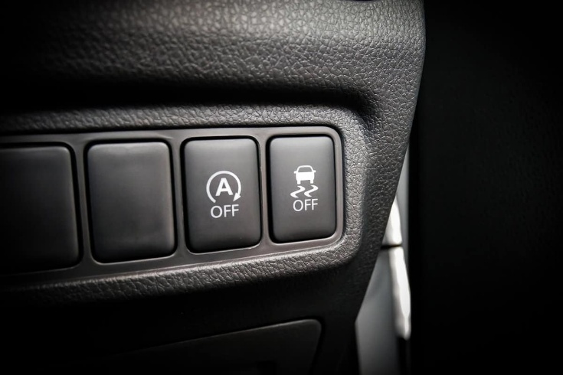I bought a new car about a year ago, and let me tell you, I love it to death. It’s got that new car smell that still hasn’t quite worn off, sleek lines that make me feel like I’m driving something out of a futuristic movie, and enough bells and whistles to make R2-D2 blush. But like a perfectly baked cake with one rogue, unidentifiable hair, there's a single, utterly infuriating feature that just drives me absolutely bonkers every single time I get in the driver's seat. It’s the automotive equivalent of a tiny pebble in your shoe that you can never quite shake out, no matter how much you wiggle your toes.

My car, like far too many of the newer models gracing our roads, is equipped with this truly annoying feature that insists on shutting off the engine every single time I come to a complete stop. And I mean every time. Red light? Engine off. Stop sign? Engine off. Waiting for a squirrel to make up its mind about crossing the street? You guessed it, engine off. Now, if the sudden, jarring silence wasn’t bad enough, the real kicker comes when you go to take off from a stop. There’s a small, but very noticeable, hesitation before the engine finally kicks back to life and the car lurches forward. It's like the car needs a moment to remember what it was doing, perhaps a quick existential crisis before resuming its duties.

This seemingly minor delay has caused me more anxiety than I care to admit. It’s not that I’ve ever jumped out in front of anyone – my reflexes, while not those of a fighter pilot, are still sharp enough to avoid immediate vehicular mayhem. But it’s the sheer feeling, that little hiccup, that feels suspiciously like the car is going to quit right there in the intersection. My imagination, ever the dramatic playwright, conjures scenarios of me stranded, horns blaring behind me, as I frantically pump the gas, willing my technological marvel to simply go. It’s a low-grade, constant hum of worry that undercuts the otherwise blissful driving experience. You buy a new car for peace of mind, not to feel like you’re starring in a poorly directed scene from a low-budget disaster movie every time you stop at a light.

Naturally, my first instinct was to seek professional help – for the car, not for my burgeoning neurosis. I’ve gone to the dealership several times, practically begging them to disconnect this idiotic feature completely. I’ve tried reasoning, pleading, even hinting at a small bribe (okay, maybe not the bribe, but I considered it!). Each time, however, I’m met with the same polite yet firm refusal: "Oh, we can’t do that, sir. It’s a federal regulation that it stay." A federal regulation, they say, delivered with the solemnity of a doctor discussing a terminal illness. This sounded like bureaucratic hogwash to me, a convenient excuse to deflect my justifiable frustration.

What truly adds insult to injury is the little button, the one I have to painstakingly press each and every time I crawl into the car, to temporarily disable this stupid feature. Why, oh why, do they allow me to temporarily disconnect this thing but not permanently? It’s like being given a delicious ice cream cone but only being allowed one lick per hour. The sheer absurdity of it is maddening. If it’s so vital, so federally mandated, why is there even a switch to turn it off? And if there is a switch, why can’t it just stay off? Is the car trying to teach me a lesson in mindfulness, forcing me to engage with its quirks before every journey?

After some persistent digging, wading through forums and automotive tech articles, I did discover that this feature is really designed for those brave souls living in big cities where they sit in soul-crushing traffic jams for hours on end. There, perhaps, the cumulative seconds of engine shutdown actually make a difference, like trying to empty the ocean with a thimble. But here, in the idyllic, sprawling rural areas where I live, it’s considered heavy traffic if three cars stack up at a traffic light. We wave at each other, we exchange pleasantries, we certainly don't need our engines sputtering off and on like a bad fluorescent light. It’s a solution in search of a problem, at least for my neck of the woods. My daily commute is less "rush hour gridlock" and more "leisurely drive interrupted by the occasional tractor."

For those readers who may be blissfully unaware of this modern automotive marvel, automatic engine stop/start is a feature designed with noble intentions: to improve fuel efficiency and reduce emissions. The premise is simple enough: the engine automatically shuts off when the vehicle is at a complete stop, like at a red light or in heavy traffic, and then restarts the moment the driver releases the brake or presses the throttle. Many mainstream car manufacturers have indeed adopted this feature, often touting it as a win for the environment and for your wallet. It's ostensibly a key component of their pollution control strategy, helping them comply with increasingly stringent emissions regulations set by bodies like the EPA.

However, and this is where my research hit a nerve, despite its prevalence, automatic engine stop/start is not mandated by U.S. law.

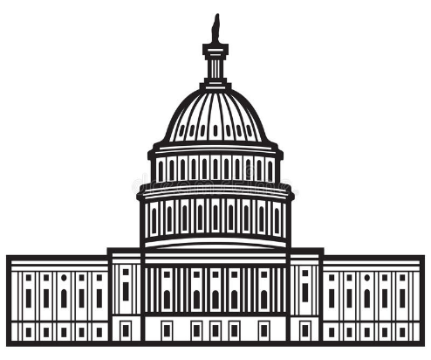That's right. It's not a federal regulation, despite what my dealership insists with a straight face. Rather, automakers have voluntarily implemented the technology as a means of meeting those federal fuel efficiency and emissions standards. It's a choice, a strategy by the car manufacturers to hit their marks, not a direct command from on high to make drivers endure these stop-start miseries. This revelation made my blood boil slightly, knowing I'd been, shall we say, "misinformed."

The irony is not lost on me. While my sophisticated new car goes through this elaborate song and dance to save a wisp of fuel and a molecule of carbon, my ancient, sputtering lawnmower puts out more visible emissions than my car on a Sunday afternoon. You can practically see the polar ice caps melting as I cut the grass. So, do you suppose that soon they will start mandating this feature on lawnmowers? Will I be pausing my turf trimming every time I hit a patch of thick weeds, waiting for the engine to hesitate and restart? The thought alone is enough to send me scurrying to buy a push mower.

Beyond the sheer annoyance and the perceived hesitation when starting, there's a quieter concern that many drivers share: what about the long-term wear and tear? Every time the engine stops and restarts, it puts stress on the starter motor, the battery, and other components. While manufacturers assure us that these systems are designed for durability, one has to wonder if the cumulative effect of hundreds of thousands of extra cycles over a car's lifetime will truly contribute to its longevity, or merely to a future bill at the mechanic's. The trade-off between barely perceptible fuel savings and potential future repair costs begins to feel less like progress and more like a shell game.

And let's not forget the subtle safety implications. While I haven't had a near-miss, the idea of that hesitation when starting at a critical moment – say, needing to quickly avoid an obstacle, or merge into fast-moving traffic, or even just clearing an intersection when the light turns yellow – sends a shiver down my spine. That fraction of a second, that moment of uncertainty, can make all the difference. It’s a subconscious re-calibration of driving instincts, forcing you to anticipate a delay where none existed before, and frankly, I find it quite vexing.

In the grand scheme of things, is this automatic stop/start feature the end of the world? Of course not. But it’s a shining example of technology, implemented with good intentions (to satisfy the EPA and pollution control metrics for car manufacturers), that ultimately detracts from the user experience. It creates a new problem while solving an old one that, for many, wasn't much of a problem in the first place. I long for the days when a car just went when you put it in drive (or first gear for us older drivers), without a moment of existential angst.

Until then, you’ll find me in my car, dutifully pressing that little button every single time, clinging to the faint hope that one day, some benevolent hacker, or perhaps a sympathetic lawmaker, will free me from the misery of the start-stop dance. My blood pressure will thank them.

**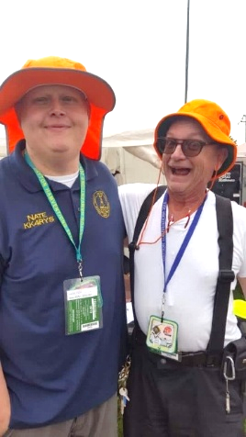*2025 Great Lakes Division Hamfests***

Here in the Great Lakes Division, we have over 50 hamfests a year.

So, if you haven’t started planning your hamfest schedule yet, you really need to start now.

Please post this listing in your club's newsletter and announce the swaps on your local nets. Talk them up.

Let's fully support all of our hamfests in every way possible. It means success for everyone. Be sure to invite your ARRL Officials as soon as your date is set.

If you are planning on having your hamfest listed in QST please be sure to start your planning well in advance of your Hamfest date, as this allows adequate time for QST Listings. QST announcements require a 3-month lead time.

To be fair to our division’s clubs, the Great Lakes Division policy **now has 2 requirements**.

**Any club requesting ARRL sanctioning within the Great Lakes Division must now be an ARRL Affiliated Club with a maximum of two hamfests/swaps in any given calendar year, and they must be at least four months apart.**

|  |  |
| --- | --- |
| 08/16/2025 - [Portsmouth Radio Club 2025 Hamfest](https://www.arrl.org/hamfests/portsmouth-radio-club-2025-hamfest-1) **Location:**New Boston, OH **Sponsor:** ARRL, Jett Fire Equipment, Shawnee Computer and More **Website:** [http://www.portsmouthradioclub.com](http://www.portsmouthradioclub.com/) [**Learn More**](https://www.arrl.org/hamfests/portsmouth-radio-club-2025-hamfest-1) | 08/17/2025 - [Warren Hamfest](https://www.arrl.org/hamfests/warren-hamfest-2) **Location:**Cortland, OH **Sponsor:** Warren Amateur Radio Association **Website:** <http://w8vtd.com/hamfest> [**Learn More**](https://www.arrl.org/hamfests/warren-hamfest-2) |
| 08/24/2025 - [Seaway Trunk Swap](https://www.arrl.org/hamfests/seaway-trunk-swap-10) **Location:**Port Huron, MI **Sponsor:** EMARC [**Learn More**](https://www.arrl.org/hamfests/seaway-trunk-swap-10) | 08/30/2025 - [Athens Trunkfest](https://www.arrl.org/hamfests/athens-trunkfest-1) **Location:**Athens, OH **Sponsor:** Athens County Amateur Radio Association **Website:** <https://www.ac-ara.org/> [**Learn More**](https://www.arrl.org/hamfests/athens-trunkfest-1) |

|  |  |
| --- | --- |
| 09/06/2025 - [Grand Rapids Area Hamfest](https://www.arrl.org/hamfests/grand-rapids-area-hamfest-2) **Location:**Wyoming, MI **Sponsor:** Grand Rapids Amateur Radio Association **Website:** <https://w8dc.org/grand-rapids-area-hamfest/> [**Learn More**](https://www.arrl.org/hamfests/grand-rapids-area-hamfest-2) | 09/06/2025 - [Greater Louisville Hamfest 2025](https://www.arrl.org/hamfests/greater-louisville-hamfest-2025) **Location:**Shepherdsville, KY **Sponsor:** Greater Louisville Hamfest Association, Inc. **Website:** [http://LouisvilleHamfest.com](http://louisvillehamfest.com/) [**Learn More**](https://www.arrl.org/hamfests/greater-louisville-hamfest-2025) |
| 09/07/2025 - [Findlay Hamfest](https://www.arrl.org/hamfests/findlay-hamfest-12) **Location:**Findlay, OH **Sponsor:** Findlay Radio Club **Website:** [http://w8ft.org](http://w8ft.org/) [**Learn More**](https://www.arrl.org/hamfests/findlay-hamfest-12) | 09/13/2025 - [GMARC Trunk Swap](https://www.arrl.org/hamfests/gmarc-trunk-swap-11) **Location:**Shelby Township, MI **Sponsor:** General Motors Amateur Radio Club **Website:** [http://gmarc.org](http://gmarc.org/) [**Learn More**](https://www.arrl.org/hamfests/gmarc-trunk-swap-11) |
| 09/13/2025 - [OAARS Hamfest](https://www.arrl.org/hamfests/oaars-hamfest) **Location:**West Branch, MI **Sponsor:** Ogemaw Arenac A.R.S. **Website:** [http://k8oar.club](http://k8oar.club/) [**Learn More**](https://www.arrl.org/hamfests/oaars-hamfest) | 09/13/2025 - [Richmond KY Hamfest](https://www.arrl.org/hamfests/richmond-ky-hamfest-4) **Location:**Richmond, KY **Sponsor:** Central Kentucky Amateur Radio Society (CKARS) **Website:** [https://www.ckars.org](https://www.ckars.org/) [**Learn More**](https://www.arrl.org/hamfests/richmond-ky-hamfest-4) |
| 09/13/2025 - [Swap Meet / Hamfest](https://www.arrl.org/hamfests/swap-meet-hamfest) **Location:**Toledo , OH **Sponsor:** Lucas County ARES **Website:** [http://WWW.LUCASARES.ORG](http://www.lucasares.org/) [**Learn More**](https://www.arrl.org/hamfests/swap-meet-hamfest) | 09/14/2025 - [Adrian Hamfest](https://www.arrl.org/hamfests/adrian-hamfest-12) **Location:**Adrian , MI **Sponsor:** AARC **Website:** [http://w8tqe.com](http://w8tqe.com/) [**Learn More**](https://www.arrl.org/hamfests/adrian-hamfest-12) |
| 09/20/2025 - [Top of Michigan Amateur Radio Club & Thunder Bay Amateur Radio Club](https://www.arrl.org/hamfests/top-of-michigan-amateur-radio-club-thunder-bay-amateur-radio-club-1)  **Location:**Gaylord, MI **Sponsor:** Top of Michigan ARC Gaylord and Thunder Bay ARC Alpena **Website:** [http://www.nm8rc.org](http://www.nm8rc.org/) [**Learn More**](https://www.arrl.org/hamfests/top-of-michigan-amateur-radio-club-thunder-bay-amateur-radio-club-1) | 09/27/2025 - [Paintsville KY4ARC Hamfest](https://www.arrl.org/hamfests/paintsville-ky4arc-hamfest-1)  **Location:**Paintsville, KY **Sponsor:** KY4ARC **Website:** [http://ky4arc.com](http://ky4arc.com/) [**Learn More**](https://www.arrl.org/hamfests/paintsville-ky4arc-hamfest-1) |
| 09/28/2025 - [Cleveland Hamfest](https://www.arrl.org/hamfests/cleveland-hamfest-5)  **Location:**Berea, OH **Sponsor:** Hamfest Association of Cleveland **Website:** [https://www.hac.org](https://www.hac.org/) [**Learn More**](https://www.arrl.org/hamfests/cleveland-hamfest-5) |  |

You can always find the latest information about upcoming hamfests on the Great Lakes Division website.

](https://www.arrl.org/hamfests/search/Location.division_id:gl)

Just click to get the latest hamfest updates.

***STOP – Right there!!!***

***We’ve come to the end…***

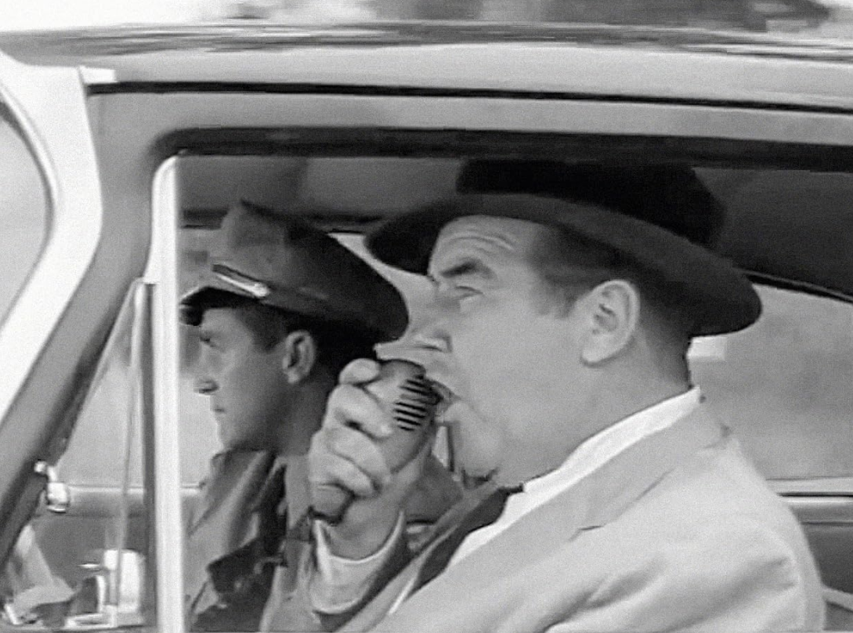

Be Radio-Active --- See Ya’ Soon!

Radio Waves is produced as a look inside of the Great Lakes Division and all that it has to offer. It is our sincerest hope that you have enjoyed this edition and will encourage your friends to be a part of the ARRL and receive the latest news and information about the ARRL and the Great Lakes Division!