***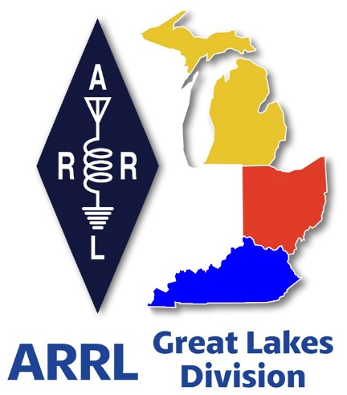 Radio Waves***

***The Great Lakes Division***

***Monthly Journal***

***August 2025***

***Scott’s Stuff***

**Hi Gang, Let's Talk About All Things Ham Radio!**

Well, it’s finally here, the Dog Days of Summer… Hot, muggy and just plain miserable out.

July was a busy month for me. I didn’t get to go to as many hamfests as were scheduled due to the Board meeting, but I did have a lot of fun visiting with many of you at your local club meetings.

I will say that the Board meeting this time around was a lot different than even the one in January. We got a lot of business done and I have to say I was very impressed with how everyone in that room worked together as a team. Yes, this Board can do great work and do it collaboratively, as it was elected to do!! I was busy in meetings from Wednesday when I arrived until late Saturday afternoon when we finished up.

Yes, the Board voted in favor of passage of the changes to By-Law 46.

The Board also voted in favor of the creation of another new DXCC award — 10-Band DXCC — which will recognize those who achieve DXCC on all bands from 6 meters to 160 meters (excluding 60 meters).

The Board also voted in favor of a year-long celebration of the semi quincentennial of the United States. This will include commemorative ARRL US250 Worked All States awards from contacts made during 2026, as well as other on-air activity.

The Board approved making 2026 the Year of the Club and passed other motions in support of the initiative including:

* Creation of a book featuring high-performance clubs.
* Establishment of working with and recognizing outstanding club websites while helping clubs with ineffective websites.
* Recognizing ARRL Affiliated Clubs that maintain a higher-than-required ARRL membership level for affiliation. Clubs that achieve a 70% or a 90% ARRL membership level within their clubs will receive acknowledgment and special recognition.

The Board also unanimously recognized 2 clubs here in the Great Lakes Division for reaching an extraordinary milestone of 100 years of ARRL Affiliation. The clubs recognized are:

**Mahoning Valley Amateur Radio Association**

**Findlay Radio Club**

The Historical Committee met to review the ARRL Heritage Museum’s online collection, Radio Alpha, which currently features more than 3,000 images and documents. The repository is now online and can be found at [**www.arrl.org/arrl-museum-and-research-library**](https://arrl.informz.net/z/cjUucD9taT0zMzkwMzc4JnA9MSZ1PTUyMDM2NDI5NiZsaT0zODkzMjg0OA/index.html)

The Emergency Communications and Field Services Committee of which I’m chairman, reviewed year-to-date activities, including a complete rewrite of the ARES® training modules and the recently executed Memorandum of Understanding between ARRL and Radio Relay International (RRI) and work done on the ARES Groups forms. The ARES Groups page has now been updated to include a mapping program so that you can see exactly where any ARES group is meeting. Also included in the information is their repeater / website-Facebook information.[**https://www.arrl.org/find-an-ares-group/**](https://www.arrl.org/find-an-ares-group/)

The Administration & Finance Committee discussed the current status of ARRL’s Washington advocacy. This includes continuing work to build Congressional support for bills H.R.1094 and S.459 — the Amateur Radio Emergency Preparedness Act — for passage. The committee recommended to the Board that the ARRL CEO take the lead on the efforts, including executing a campaign to involve members in reaching out to their Congressional representatives later this year.

I will say this, there’s a lot more to these Board meetings than meets the eye. I find these meetings a lot like watching C-Span and the activities of our Congress. Yes, there’s lots of parallels to our Board meetings to that of what you will see on C-Span. Discussions abound (politicking) going on in every corner of the room between opposing views. But in the end, it all seems to come together for the betterment of the membership and amateur radio!

What I’ve listed here is just a short synopsis of all the discussions and work that was put into each of these motions. Many hours of thought and collaboration have gone into each and every motion before it is introduced to the Board. For the complete record of what happened at the Board meeting, stand-by… The minutes will be posted soon.

Have you seen that QST is offering a column for radio clubs? Clubs are the backbone of the amateur radio community, that’s why we are making 2026 the Year of the Club. Whether you are a part of a special interest or general club, its members are the community that you serve. In the same way that every ham is different, each club is also different. Not every club will offer the same programs and projects to their member community.

"Club Station," is a space for clubs to share their practical ideas about what has helped lead them to their success. If your club has developed a creative way to get around common challenges, the ARRL wants to hear from you! They have published author guidelines that are geared toward "Club Station." Want more information on how to submit an article? Go to: [**https://www.arrl.org/qst-club-station-guidelines-and-profile-form**](https://www.arrl.org/qst-club-station-guidelines-and-profile-form) . All clubs are welcome to participate.

Hey Gang, don’t forget that the Simulated Emergency Test (S.E.T.) is October 4-5 and next to Field Day, one of the busiest times for ham radio! Is your ARES group or club already in the planning stage yet? If not, it should be, like Field Day, S.E.T. demonstrates to our served agencies what amateur radio is really all about, communications.

So, that’s a quick rundown of what’s been happening from my end. I’m looking forward to connecting with more of you throughout the rest of the summer. Until next time, keep those radios on and that enthusiasm high!

73… Stay safe… and I hope to "Catch You On The Air, at a meeting, or at a hamfest!" Most importantly... Have FUN and... Get On The Air!

Scott…

Scott Yonally, N8SY

Director - Great Lakes Division

[**n8sy@n8sy.com**](mailto:n8sy@n8sy.com)

NNNNN

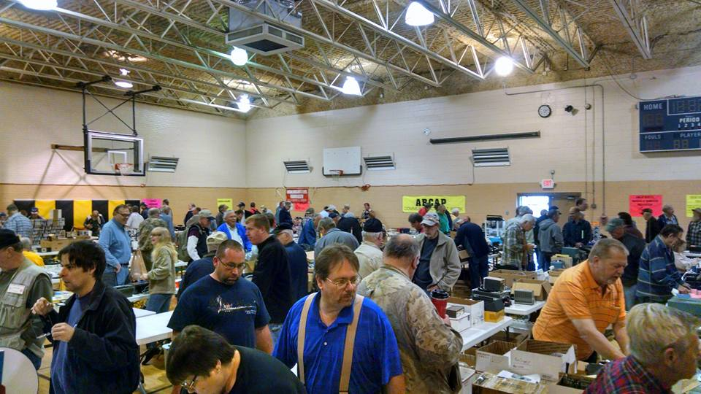***2025 Great Lakes Division Hamfests***

Here in the Great Lakes Division, we have over 50 hamfests a year.

So, if you haven’t started planning your hamfest schedule yet, you really need to start now.

Please post this listing in your club's newsletter and announce the swaps on your local nets. Talk them up.

Let's fully support all of our hamfests in every way possible. It means success for everyone. Be sure to invite your ARRL Officials as soon as your date is set.

If you are planning on having your hamfest listed in QST please be sure to start your planning well in advance of your Hamfest date, as this allows adequate time for QST Listings. QST announcements require a 3-month lead time.

To be fair to our division’s clubs, the Great Lakes Division policy **now has 2 requirements**. **Any club requesting ARRL sanctioning within the Great Lakes Division must now be an ARRL Affiliated Club with a maximum of two hamfests/swaps in any given calendar year, and they must be at least four months apart.**

You can always find the latest information about upcoming hamfests on the Great Lakes Division website.

](https://www.arrl.org/hamfests/search/Location.division_id:gl)

Just click to get the latest hamfest updates.

|  |  |
| --- | --- |
| **08/02/2025 -**[**Columbus Hamfest**](https://www.arrl.org/hamfests/columbus-hamfest-6)  **Location:**Grove City, OH **Type:** ARRL Hamfest **Sponsor:** Aladdin Shrine Audio Unit **Website:** [http://columbushamfest.com](http://columbushamfest.com/) [**Learn More**](https://www.arrl.org/hamfests/columbus-hamfest-6) | **08/02/2025 -**[**U.P. Hamfest 2025**](https://www.arrl.org/hamfests/u-p-hamfest-2025-1)  **Location:**Rapid River, MI **Type:** ARRL Hamfest **Sponsor:** Delta County Amateur Radio Society [**Learn More**](https://www.arrl.org/hamfests/u-p-hamfest-2025-1) |
| **08/09/2025 -**[**Cincinnati Hamfest℠**](https://www.arrl.org/hamfests/cincinnati-hamfest-4)  **Location:**Owensville, OH **Type:** ARRL Hamfest **Sponsor:** Milford Amateur Radio Club **Website:** [https://CincinnatiHamfest.org](https://cincinnatihamfest.org/) [**Learn More**](https://www.arrl.org/hamfests/cincinnati-hamfest-4) | **08/09/2025 -**[**Letcher County Hamfest**](https://www.arrl.org/hamfests/letcher-county-hamfest-3)  **Location:**Whitesburg, KY **Type:** ARRL Hamfest **Sponsor:** Letcher County Amateur Radio Club **Website:** [http://www.lcarcky.com](http://www.lcarcky.com/) [**Learn More**](https://www.arrl.org/hamfests/letcher-county-hamfest-3) |

|  |  |
| --- | --- |
| **08/16/2025 -**[**Portsmouth Radio Club 2025 Hamfest**](https://www.arrl.org/hamfests/portsmouth-radio-club-2025-hamfest-1)  **Location:**New Boston, OH **Type:** ARRL Hamfest **Sponsor:** ARRL, Jett Fire Equipment, Shawnee Computer and More **Website:** [http://www.portsmouthradioclub.com](http://www.portsmouthradioclub.com/) [**Learn More**](https://www.arrl.org/hamfests/portsmouth-radio-club-2025-hamfest-1) | **08/17/2025 -**[**Warren Hamfest**](https://www.arrl.org/hamfests/warren-hamfest-2)  **Location:**Cortland, OH **Type:** ARRL Hamfest **Sponsor:** Warren Amateur Radio Association **Website:** <http://w8vtd.com/hamfest> [**Learn More**](https://www.arrl.org/hamfests/warren-hamfest-2) |
| **08/30/2025 -**[**Athens Trunkfest**](https://www.arrl.org/hamfests/athens-trunkfest-1)  **Location:**Athens, OH **Type:** ARRL Hamfest **Sponsor:** Athens County Amateur Radio Association **Website:** <https://www.ac-ara.org/> [**Learn More**](https://www.arrl.org/hamfests/athens-trunkfest-1) | **09/06/2025 -**[**Grand Rapids Area Hamfest**](https://www.arrl.org/hamfests/grand-rapids-area-hamfest-2)  **Location:**Wyoming, MI **Type:** ARRL Hamfest **Sponsor:** Grand Rapids Amateur Radio Association **Website:** <https://w8dc.org/grand-rapids-area-hamfest/> [**Learn More**](https://www.arrl.org/hamfests/grand-rapids-area-hamfest-2) |
| **09/06/2025 -**[**Greater Louisville Hamfest 2025**](https://www.arrl.org/hamfests/greater-louisville-hamfest-2025)  **Location:**Shepherdsville, KY **Type:** ARRL Hamfest **Sponsor:** Greater Louisville Hamfest Association, Inc. **Website:** [http://LouisvilleHamfest.com](http://louisvillehamfest.com/) [**Learn More**](https://www.arrl.org/hamfests/greater-louisville-hamfest-2025) | **09/07/2025 -**[**Findlay Hamfest**](https://www.arrl.org/hamfests/findlay-hamfest-12)  **Location:**Findlay, OH **Type:** ARRL Hamfest **Sponsor:** Findlay Radio Club **Website:** [http://w8ft.org](http://w8ft.org/) [**Learn More**](https://www.arrl.org/hamfests/findlay-hamfest-12) |
| **09/13/2025 -**[**GMARC Trunk Swap**](https://www.arrl.org/hamfests/gmarc-trunk-swap-11)  **Location:**Shelby Township, MI **Type:** ARRL Hamfest **Sponsor:** General Motors Amateur Radio Club **Website:** [http://gmarc.org](http://gmarc.org/) [**Learn More**](https://www.arrl.org/hamfests/gmarc-trunk-swap-11) | **09/13/2025 -**[**OAARS Hamfest**](https://www.arrl.org/hamfests/oaars-hamfest)  **Location:**West Branch, MI **Type:** ARRL Hamfest **Sponsor:** Ogemaw Arenac A.R.S. **Website:** [http://k8oar.club](http://k8oar.club/) [**Learn More**](https://www.arrl.org/hamfests/oaars-hamfest) |
| **09/13/2025 -**[**Richmond KY Hamfest**](https://www.arrl.org/hamfests/richmond-ky-hamfest-4)  **Location:**Richmond, KY **Type:** ARRL Hamfest **Sponsor:** Central Kentucky Amateur Radio Society (CKARS) **Website:** [https://www.ckars.org](https://www.ckars.org/) [**Learn More**](https://www.arrl.org/hamfests/richmond-ky-hamfest-4) | **09/13/2025 -**[**Swap Meet / Hamfest**](https://www.arrl.org/hamfests/swap-meet-hamfest)  **Location:**Toledo , OH **Type:** ARRL Hamfest **Sponsor:** Lucas County ARES **Website:** [http://WWW.LUCASARES.ORG](http://www.lucasares.org/) [**Learn More**](https://www.arrl.org/hamfests/swap-meet-hamfest) |
| **09/14/2025 -**[**Adrian Hamfest**](https://www.arrl.org/hamfests/adrian-hamfest-12)  **Location:**Adrian , MI **Type:** ARRL Hamfest **Sponsor:** AARC **Website:** [http://w8tqe.com](http://w8tqe.com/) [**Learn More**](https://www.arrl.org/hamfests/adrian-hamfest-12) | **09/20/2025 -**[**Top of Michigan Amateur Radio Club & Thunder Bay Amateur Radio Club**](https://www.arrl.org/hamfests/top-of-michigan-amateur-radio-club-thunder-bay-amateur-radio-club-1)  **Location:**Gaylord, MI **Type:** ARRL Hamfest **Sponsor:** Top of Michigan ARC Gaylord and Thunder Bay ARC Alpena **Website:** [http://www.nm8rc.org](http://www.nm8rc.org/) [**Learn More**](https://www.arrl.org/hamfests/top-of-michigan-amateur-radio-club-thunder-bay-amateur-radio-club-1) |
| **09/27/2025 -**[**Paintsville KY4ARC Hamfest**](https://www.arrl.org/hamfests/paintsville-ky4arc-hamfest-1)  **Location:**Paintsville, KY **Type:** ARRL Hamfest **Sponsor:** KY4ARC **Website:** [http://ky4arc.com](http://ky4arc.com/) [**Learn More**](https://www.arrl.org/hamfests/paintsville-ky4arc-hamfest-1) | **09/28/2025 -**[**Cleveland Hamfest**](https://www.arrl.org/hamfests/cleveland-hamfest-5)  **Location:**Berea, OH **Type:** ARRL Hamfest **Sponsor:** Hamfest Association of Cleveland **Website:** [https://www.hac.org](https://www.hac.org/) [**Learn More**](https://www.arrl.org/hamfests/cleveland-hamfest-5) |

***Put NOAA Weather Radio in Cars***

Five years ago, if one were to ask about the continued utility of AM radio in cars, the answer might have been a resounding "no." The evolving media consumption habits of younger generations, who largely gravitate towards FM radio, satellite radio, and internet streaming, have seemingly diminished the relevance, and indeed, even the awareness, of the venerable AM band. However, as discussions about the potential removal of AM radio from motor vehicles intensify, a compelling argument emerges instead of doing away with AM why not integrate NOAA Weather Radio (NWR) into every car's audio system instead. This would not be a direct replacement for AM entertainment, but as an essential, dedicated safety feature.

The landscape of in-car entertainment and information has undergone a seismic shift. Once a staple, AM radio, with its unique propagation characteristics and often niche programming, now faces significant challenges. Technologically, its signals are susceptible to electromagnetic interference from modern vehicle electronics, leading to static, crackling, and a generally degraded listening experience compared to the crisp digital clarity of other mediums.

Furthermore, the content once exclusive to AM – news, talk shows, and sports – has largely migrated to FM, satellite, or digital platforms, eroding its unique selling proposition for a majority of listeners. While some rural areas or specific communities still rely on AM for local news and emergency alerts, its broad appeal has undoubtedly waned.

This decline, however, presents an opportunity to re-evaluate the core safety function that AM radio has historically, albeit indirectly, served. In emergency scenarios, AM stations have often been a crucial conduit for public safety announcements. Yet, their general-purpose nature means they share airtime with regular programming, and their reach can be limited by terrain and interference. This is where NOAA Weather Radio steps forward as a superior, dedicated solution for critical information dissemination.

NOAA Weather Radio All Hazards (NWR) is a nationwide network of radio stations broadcasting continuous weather information directly from the nearest National Weather Service (NWS) office. It is far more than just "weather forecasts"; it is a direct, reliable, and instantaneous link to life-saving alerts, watches, and warnings for all types of hazards, both natural and technological. This includes not only severe weather phenomena like tornadoes, hurricanes, floods, and blizzards, but also civil emergencies like Amber Alerts, hazardous material spills, and national security alerts.

The benefits of integrating NWR into cars could directly address critical safety needs. Firstly, and most importantly, NWR provides real-time, hyper-localized emergency information. Unlike generic television or internet alerts that might cover a broad region, NWR transmissions are tailored to specific counties, ensuring that drivers receive warnings relevant to their immediate location or the area they are travelling into. In fast-developing weather events, such as flash floods or sudden tornado touchdowns, having direct access to NWS warnings without relying on potentially congested cellular networks or internet connections can be the difference between safety and catastrophe. For a driver navigating unfamiliar territory during a storm, an NWR alert could provide vital instructions on evacuation routes or shelter-in-place directives.

Secondly, from a technical standpoint, NWR broadcasts operate on very high frequency (VHF) bands (around 162 MHz). This makes their transmissions significantly less susceptible to the noise, static, and interference that plague AM radio. The clarity and reliability of VHF signals ensure that critical voice alerts are heard unambiguously, even in challenging environments. The existing network of NWR transmitters is robust and widely distributed across the United States and its territories, designed specifically for broad coverage, making it an ideal candidate for universal automotive integration.

Furthermore, integrating NWR could be achieved cost-effectively. Instead of merely offering optional weather broadcasts on car AM radio as a secondary function, which would still suffer AM's inherent drawbacks, a dedicated NWR receiver module could be seamlessly incorporated into a vehicle's infotainment system. This would allow for a separate, dedicated "Weather Radio" button or mode, providing instant access. More advanced implementations could even leverage the Specific Area Message Encoding (SAME) technology used by NWR to automatically trigger audible alerts and display specific warning information on the car's dashboard when a threat is detected in the vehicle's vicinity. This proactive alerting capability would elevate automotive safety to a new level, ensuring drivers are warned even if they aren't actively listening.

The very proposition of elevating NWR's role in vehicular safety brings a critical concern to the forefront, one echoed by many who value public safety infrastructure: the future of NOAA Weather Radio itself.

The federal government, in its ongoing quest for cost efficiencies, has at times considered divesting from or streamlining services that were once taken for granted. The thought of federal cost cutters eliminating or severely curtailing the NOAA Weather Radio service is deeply troubling.

Removing this pathway of emergency information would leave vast segments of the general public more vulnerable, particularly those in rural areas, during severe weather events, or in situations where other communication methods fail. The cost of maintaining NWR is miniscule compared to the potential human and economic costs of failing to deliver timely warnings. It is a critical investment in public safety, directly contributing to saving lives and mitigating property damage nationwide.

As cars evolve and the role of AM radio diminishes, the focus should shift to enhancing, not diminishing, vital safety features. The integration of NOAA Weather Radio into every vehicle should be seen as a necessary modernization of automotive safety, providing drivers and passengers with direct, reliable access to life-saving weather and emergency information. Concurrently, it is imperative that policymakers recognize and actively protect the foundational role of the NOAA Weather Radio service. Its continued funding and operational integrity are not just matters of convenience but essential components of national resilience and public safety. To allow its discontinuation would indeed be sad and tragically dangerous.

***What kind of Ham Radio Classes is your club teaching?***

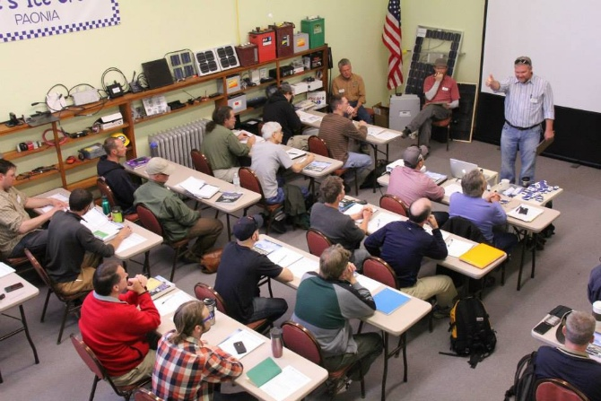

**The Power of Comprehensive Classes -- More Than Just Memorization**

Yes, back in the 1960s thru 1980s clubs were the center of comprehensive training classes that didn't simply focus on rote memorization of correct answers. Without these clubs dedicating their time and talents to teaching the next generations of Amateur Radio operators, we wouldn’t have many of the things we have today.

They taught the art, science, and technology of radio, emphasizing why specific knowledge was essential and ensuring members understood the principles behind the questions. It was about fostering a deep understanding of the underlying concepts.

Today, in our fast-paced world, the temptation is to take every shortcut available and worry about the details later. Unfortunately, those details are important. A superficial understanding of the regulations or the technology can be detrimental, especially in emergency situations. You really do need to know the "WHY" behind each question and the implications of each action.

By fostering a culture of genuine learning and practical application, amateur radio clubs can not only attract new members but also empower them to become skilled and responsible operators, strengthening the entire amateur radio community.

So, you're thinking about getting your ham radio license, or maybe you're already teaching a licensing class. That's awesome! But let's be real, wading through the FCC rules and technical jargon can feel a bit like slogging through mud. That's why I believe that a good ham radio licensing course needs to be more than just reciting the ARRL study guide.

Let's face it, the world moves fast. We're constantly bombarded with information and feel pressured to achieve instant results. So, the idea of cramming for the amateur radio license exam in one day and becoming a licensed operator by the weekend is undeniably appealing. I get it! The desire for instant gratification is strong.

Sure, covering the required material is crucial. You need to know the rules and understand some of the basics to pass the exam. But simply drilling facts and figures? That's a recipe for boredom, and it misses the whole point of amateur radio!

I've had the privilege of witnessing countless individuals embark on their amateur radio journey. What I've observed is a fascinating spectrum of approaches to learning the material required to obtain that coveted amateur radio license. Some focus solely on memorization, a sprint to the finish line. Others, however, choose a more comprehensive path, delving deeper into the principles and practices of this amazing hobby. I firmly believe it's the latter approach that unlocks a truly enriching and fulfilling experience.

Securing an amateur radio license is more than just passing a test. It's an initiation into a global community of innovators, experimenters, and communicators. When you truly understand the foundations of radio technology, the etiquette of the airwaves, and the vast possibilities that amateur radio offers, you're not just licensed – you're empowered.

“The Amateur Radio operator is not driven by the necessity of earning a living, however, some, like me, have Amateur Radio to thank for their careers.

Yes, my career might not have taken off as fast or at all, had it not been that I was an Amateur Radio operator and the man that hired me was also. He understood the hours of work and dedication that it took to get that license and gave me that opportunity.”

This quote perfectly encapsulates the spirit of amateur radio. It's a space for limitless exploration and learning. But the sad truth I've witnessed is that too many individuals, after diligently studying to obtain their license, never truly utilize the knowledge and privilege they've earned. Their radios gather dust; their potential remains untapped.

I truly believe that if you approach the licensing process with a desire for genuine understanding, you'll be far more likely to appreciate the work that went into earning that license. And more importantly, you'll be motivated to actually *use* it! Imagine the satisfaction of building your own antenna, participating in emergency communications, or connecting with fellow enthusiasts across the globe. These experiences are the true reward, so start your journey today.

Amateur radio is more than just memorizing frequency bands and regulations. It's about community, experimentation, and continuous learning. It's about connecting with people across the globe, experimenting with antennas, and even providing vital communication during emergencies.

Think of it this way: a one-day cram is like trying to force-feed yourself a gourmet meal in five minutes. You might swallow it all, but you won't savor the flavors or appreciate the artistry. Instead, consider taking your time, learning the fundamentals, and truly understanding the principles behind the technology.

***As legendary inventor Nikola Tesla wisely said:***

***"The present is theirs; the future, for which I really worked, is mine."***

While a one-day cram might get you a license *now*, the future of your amateur radio journey will be much brighter if you invest in a solid foundation.

Don't just aim to pass the test; aim to understand the material. Explore online resources, join a local radio club, and connect with experienced hams. Ask questions, experiment with different modes of communication, and most importantly, have fun!

The journey of learning about amateur radio is just as rewarding as the destination of holding a license. So, embrace the opportunity to discover the wonders of this amazing hobby. You won't regret it. I know I haven't!

This approach, however, demands a different kind of commitment. This will mean that your courses will need to be much longer than just a weekend. It's about investing time and energy to understand the underlying principles and practical applications, not just memorizing answers for a test.

So, while the one-day cram might seem like the fastest route, I encourage you to consider the long game. Invest in a deeper, more engaging learning experience. You'll not only pass the test, but you'll also gain a genuine understanding and appreciation for the wonderful world of amateur radio. You might even discover a lifelong passion you never knew you had!

***Let's face it: "The best way to learn is by doing and that takes time."***

But how do you make sure that you are providing the knowledge needed to pass the exam? The trick is weaving the required knowledge into these real-world discussions. Instead of just saying "Part 97 says...", explain why those rules are in place, and then give real-world examples. For the technical portions, try setting up demonstrations of the concepts being discussed. For example, you could connect a transmitter to a dummy load and oscilloscope to demonstrate different modes and modulation.

Ultimately, the goal isn't just to get people licensed; it's to get them excited about amateur radio and equip them with the skills and knowledge to actually participate and contribute to the hobby. Let's make these classes fun, engaging, and inspiring!

***As the old saying goes:***

***"Tell me and I forget. Teach me and I remember. Involve me and I learn."***

***Amateur Radio Helps Locate Family***

Amateur radio had a crucial role in locating a mother and her 9-year-old son, lost in California’s Stanislaus National Forest. On Friday July 11, 2025, the pair was reported overdue from a day trip to Camp Wolfeboro, a popular scout camp in the Sierra Nevada Mountains, according to a news release.

On Saturday July 12, the Calaveras County Volunteer Search and Rescue Team (SAR) was conducting its monthly training exercise along the Stanislaus River when members received notification that Tami and son Stirling had been reported missing since Friday afternoon and were not answering their cell phones.

The SAR team set up a command post at Black Springs Off-Highway Vehicle riding (OHV) Recreational Area and quickly began initiating a road-based search using four-wheel-drive vehicles and air support from the California Highway Patrol.

Joining the search was a Deputy and a Forest Service Law Enforcement Ranger who responded to 911 texts from campers in the area that a vehicle possibly matching the description of the pair’s missing car had been found. The SAR team began to find handwritten notes posted near a remote Forest Service road and then another about a mile away that included a telephone number and the names of the missing individuals. Just before 6:00 PM, the car and the lost mother and son were found. But the rescue was not over.

SAR team members were unable to communicate with their command post using conventional frequencies and cell phones from their deep woods location. So they used amateur radio frequency to report their emergency traffic. The call was immediately answered by a retired El Dorado County communications supervisor, who is also an amateur radio operator, monitoring from his home. He contacted the El Dorado 911 center, which provided the information to Calaveras County Dispatch. The SAR command post was notified, and the mother and her son were transported to waiting family members.

Young Stirling also had a hand with the rescue. He used his scout whistle to blow SOS, the internationally recognized Morse code distress signal, to give searchers a better chance of locating their position.

***Club Links***

](https://arrl-greatlakes.org/links.html)I’ve received a number of new requests from clubs to be listed on the “Links” club page.

Is your club listed? If not, send the URL of your club website to me [n8sy@n8sy.com](mailto:n8sy@n8sy.com) and I’ll get it listed.

***Handbook Give Away!!***

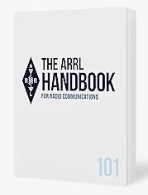Hey there!

Guess what?

I'm going to give away a FREE 2025 ARRL softcover Handbook!

Yep, you read that right. I'm giving away a softcover Handbook and you just might be the one that gets it!!!

Want to enter? It's super simple! Just fill out a couple of quick questions (shouldn't take more than a minute!) and you're entered.

Good luck!

[***Click Here To Enter***](https://forms.office.com/Pages/ResponsePage.aspx?id=Dx2iugFz_kC91gPUQ6jCGEYWzQfXysZHvDC8hUJ9GuFUQlgyT0c4NzhYWEs0SFhJUFo4REw1TTU3OS4u)

Drawing ends Monday, August 11th, so you better enter now…!!

***Murphy’s Law…***

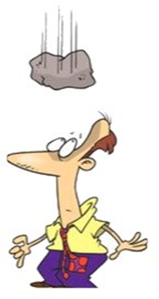

First rule of financial literacy: “When your outgo exceeds your income, your upkeep becomes your downfall.”

Nonreciprocal Laws of Expectations: “Negative expectations yield negative results. Positive expectations yield negative results.”

Skinner’s Constant, also known as Flannagan’s Finagling Factor: “That quantity when multiplied by, divided by, added to, or subtracted from the answer you get, gives you the answer you should have gotten.”

Jenning’s Corollary: “The chance of the bread falling with the buttered side down is directly proportional to the cost of the carpet.”

Hoare’s Law of Large Problems: “Inside every large problem is a small problem struggling to get out.”

***STOP!!!***

***We’ve come to the end…***

*Be Radio-Active --- See Ya’ Soon!*

Radio Waves is produced as a look inside of the Great Lakes Division and all that it has to offer. It is our sincerest hope that you have enjoyed this edition and will encourage your friends to be a part of the ARRL and receive the latest news and information about the ARRL and the Great Lakes Division!