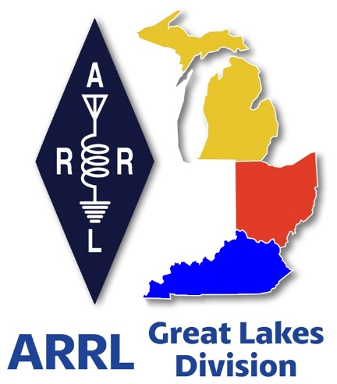 ***Radio Waves***

***The Great Lakes Division***

***Special Edition***

***ARRL Launches Nationwide Grassroots Campaign…***

[ARRL The National Association for Amateur Radio](https://www.arrl.org/)® has launched a nationwide [grassroots campaign](https://www.arrl.org/HOA) aimed at securing the passage of federal legislation that would grant Amateur Radio Operators the same rights to install antennas on their property as those enjoyed by users of

TV antennas, wireless internet, and flagpoles.

****“This legislation is about restoring equal rights to licensed Amateur Radio operators,” said ARRL President Rick Roderick, K5UR. “These restrictions hinder not only the enjoyment of Amateur Radio, but also its vital role in emergency communication during disasters.”

***Public Support Needed for Passage***

To advance the legislation, ARRL is calling on its members and all licensees of the US Amateur Radio Service to take action by sending letters to their congressional representatives. Through a dedicated online tool at [**send-a-letter.org/hoa**](https://send-a-letter.org/hoa/), amateurs can easily generate and submit pre-drafted letters with a few clicks.

**Go to —**[**send-a-letter.org/hoa**](https://send-a-letter.org/hoa/)

***New Survey – Age or Term Limits for ARRL Board Members...***

](https://forms.office.com/r/uCg5BSw8Mg)

**Please, please, please…** There is a new survey posted on the Great Lakes Division website and waiting for YOUR input on this really important question. I really want to hear your honest feedback on this topic.

Please take just a 2 minutes of your time and it will let me know just how YOU feel on this very important subject.

Got a question that you think should be asked? Let me know… [n8sy@n8sy.com](mailto:n8sy@n8sy.com)

***Do you know someone who is not getting this newsletter***

Hi Gang,

If you know someone who isn’t already getting Radio Waves, have them sign up to receive it!! They don’t have to be ARRL members to sign up, just click on the button below and in no time, they will start receiving it.

[](https://arrl-greatlakes.org/glnews/index.html)

***Scott’s Stuff***

**The Great Antenna Paradox: Why HB 1094 Matters, Even to My Unrestricted Yard (and My Witty Brain)**

Alright, fellow inhabitants of the digital age and beyond, let’s talk about antennas. Specifically, let’s talk about the curious case of what’s aesthetically acceptable in our neighborhoods versus what’s, shall we say, a massive thorn in the side of common sense. I’m here to spill the beans on why something like HB 1094, a piece of legislation aimed at protecting amateur radio operators from arbitrary restrictions, resonates deeply with me, even though my own yard isn’t currently under the iron fist of a HOA or overly stimulated village council.

You see, I live in a fairly chilled area. My village council hasn’t yet decided to pass legislation to regulate what shade of green my lawn *should* be, nor have they dictated that my garden gnomes must adhere to a strict height requirement. For now, my potential for erecting an antenna that could literally talk around the world is unburdened by restrictive legislation. Why am I interested in legislation intended to support individuals residing in communities governed by homeowners' associations? Because, dear reader, it’s about principle. It’s about the ludicrous double standards we often unwittingly accept, and frankly, it’s about ensuring that critical lines of communication remain open when the chips are down.

**The Plot Thickens: Ugly Dishes vs. Unobtrusive Wires**

Picture this: You stroll through a meticulously manicured neighborhood. Every lawn is a perfect carpet, every house, a picture of architectural conformity. And then, there it is. Bolted to a roof, perched precariously on a fence post, or even proudly displayed on a pole in the yard – a satellite dish. Sometimes it’s a sleek, subtle affair, other times it looks like a dinner plate that survived a particularly aggressive meteor shower. And you know what? It’s fine. It’s absolutely, unequivocally A-OK in the eyes of the neighborhood association, the architectural review board, and pretty much every governing body from here to Timbuktu. Why? Because you’re allowed to receive your TV signals. It’s a basic right, enshrined by certain federal regulations!

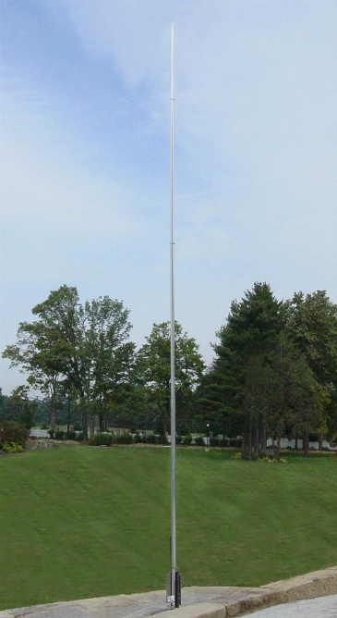

Now, let’s consider my humble aspirations. I’m thinking maybe a nice, unobtrusive vertical antenna tucked away in the corner of my yard. Perhaps a long wire antenna, nearly invisible, stretched subtly across the back. Or, if I’m feeling particularly stealthy, maybe even an antenna squirrelled away in the attic. My goal? Not to catch the latest episode of "The Real Housewives of Wherever," but to engage in ham radio. To explore the fascinating world of PSK 31, FT 8 or simply chat away on voice, or heaven forbid, to be an extra hand during a local disaster. And yet, for my counterparts in restricted areas, my perfectly sensible, often significantly *less* conspicuous antenna would be met with the kind of animus usually reserved for rogue lawn gnomes.

This is where my eyebrows do a fascinating interpretive dance. Why is it perfectly acceptable, even encouraged, for a homeowner to mount what often amounts to a fairly unsightly piece of plastic and metal on their roof for entertainment purposes, but a comparatively tiny vertical or an invisible wire for emergency communications is branded an aesthetic atrocity? An antenna, my friends, is an antenna.

Whether it’s sucking down the latest episode of Yellowstone on Netflix from my Dish TV or letting me chat with a fellow communicator in Japan, it’s still performing the fundamental function of receiving and, in my case, transmitting radio waves. The distinction, in the government’s eyes, becomes utterly baffling.

**"Reasonable Accommodation": The Phrase That Launched a Thousand Glared Stares**

Ah, "reasonable accommodation." It sounds so… reasonable, doesn’t it? Like finding a compromise, meeting in the middle, or perhaps agreeing that yes, we can all live together without someone's prized petunias being trampled. But append it to the discussion of a ham radio antenna in an HOA, and suddenly it conjures images of anarchy, property value plummeting, and frankly, a general sense of panic.

It’s as if the very idea of a "reasonable accommodation" for a ham radio operator brings such animus to the neighborhood that you'd think we were asking for a nuclear power plant in our backyards. Meanwhile, that ugly satellite dish, which often looks like it's perpetually tuning into the mothership, is just part of the landscape. And don't even get me started on the plethora of other outdoor "improvements" that are routinely approved! A gigantic, inflatable Santa Claus? Fine. A tasteful flagpole? Sure. But a small, utilitarian antenna that could literally save lives? Prepare for a full-scale legal battle.

Yes, there was a contract signed. I get it. We all agree to certain terms when we move into a community. But surely, those agreements should evolve with technology and, more importantly, with an understanding of what constitutes a public good. An antenna is an antenna, dish or wire, for TV reception or for talking around the world on. Nevertheless, it remains an antenna.

**Beyond the Backdoor: Why Ham Radio is More Than a Hobby**

Now, let's pivot from the philosophical to the profoundly practical. Why is it so crucial that we protect the rights of ham radio operators, even if my own unrestricted yard gives me free rein?

Think about it. When the inevitable happens – a hurricane rips through, a tornado levels a town, floods isolate communities, or a major earthquake shakes things to their core – what’s the first thing to go? Often, it’s the wired infrastructure. Cell towers become overloaded or knocked out. Internet cables have been disconnected. Suddenly, those indispensable push to talk cell phones and Wi-Fi telephones are nothing more than expensive paperweights. This is where RF versus wired connections shows its true resilience.

This is precisely when ham radio operators, often powered by portable power solutions, step up. These communicators are extra hands for first responders, providing vital communications when all other systems fail or simply get overloaded. They establish remote stations, getting out communications from the affected area with remarkable efficiency and accuracy.

There are mountains of examples of how amateur radio has provided the critical link during disasters. Whether it's relaying vital health and welfare messages, coordinating logistics, or simply providing the outside world with the first accurate reports from a devastated zone, hams are there. This isn't just theory; it's a proven track record.

HB 1094 isn't just about an individual's right to pursue a hobby; it's about bolstering our national and local resilience. It’s about recognizing that these antennas, far from being unsightly nuisances, are potential lifelines. They represent a decentralized, robust communication infrastructure that kicks in when the centralized systems fail. This is exactly what amateur radio is all about, just read Part 97.1 (a), the very first subpart states…

*Recognition and enhancement of the value of the amateur service to the public as a voluntary noncommercial communication service, particularly with respect to providing emergency communications...*

**The Unseen Chain Reaction**

So, while my little unrestricted slice of heaven currently allows me the freedom to put up whatever antenna my heart desires (within reason, of course – I'm not planning a full-scale radio observatory), I understand that the fight for HB 1094 in restricted areas is my fight too. It sets a precedent. It acknowledges the critical role of amateur radio. It pushes back against arbitrary restrictions that prioritize aesthetic conformity over community safety and individual liberty.

Ultimately, HB 1094 isn't just about my ability to experiment with FT 8 or other modes or chat with someone half a world away. It's about empowering people who dedicate their time and effort to being prepared to lend a vital hand when every other modern convenience has gone dark.

That’s going to do it from here this time around. Catch you on the air, in a club meeting, or at a hamfest! Until then, **Be Radio Active!!!!!**

73,

Scott, N8SY

Great Lakes Division Director

[n8sy@arrl.org](mailto:n8sy@arrl.org)

***STOP – Right there!!!***

***We’ve come to the end…***

Be Radio-Active --- See Ya’ Soon!

Radio Waves is produced as a look inside of the Great Lakes Division and all that it has to offer. It is our sincerest hope that you have enjoyed this edition and will encourage your friends to be a part of the ARRL and receive the latest news and information about the ARRL and the Great Lakes Division!