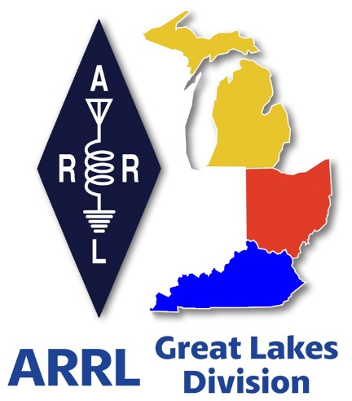 ***Radio Waves***

***The Great Lakes Division***

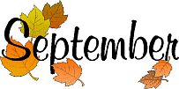 ***Monthly Journal***

***2025***

***Scott’s Stuff***

Greetings fellow amateur radio community! It's time once again to gather 'round the digital campfire and delve into 'All Things Ham Radio' – from exciting new technologies to the timeless joy of making connections across the airwaves.

What an absolutely wild and unforgettable August we've just navigated! The relentless grip of summer truly made its mark, with sweltering heat and oppressive humidity blanketing much of the Great Lakes Division. It felt like every day brought a new record, transforming this past month into one for the history books – a testament to the sheer power of Mother Nature and a challenge for even the most air-conditioned shacks.

With September here now, a new kind of excitement electrifies the air: Football season is officially upon us! The gridiron action returns with a vengeance, bringing a bunch of exciting games back into our lives. From the raw, local passion of high school rivalries – always a personal favorite of mine – to the storied traditions and fierce competition of college football, and finally, the elite plays of the professional leagues, there's something for every fan. Early projections and the buzz from training camps suggest this year's matchups across all three tiers will deliver some truly captivating, "real" football (Well… I’m keeping my fingers crossed that the Browns finally wake up and actually play some good football).

So, hang on to your hats and let’s get rolling into a season of thrilling touchdowns and unforgettable plays! Amidst all this excitement, and as we embrace the back-to-school season, a crucial reminder is in order.

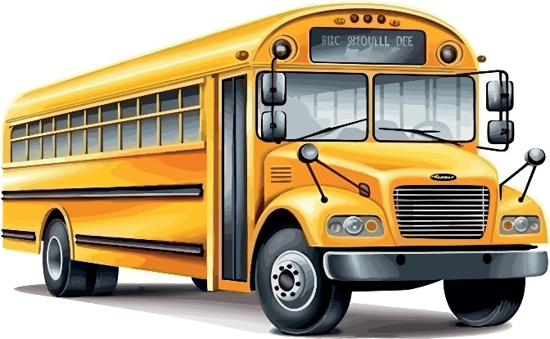Those iconic big yellow school buses are back on the roads, making their essential rounds. Please, everyone, exercise extreme caution when driving. Always be mindful of their flashing red lights and extended stop signs – they're there for a reason. Grant these buses ample space as children embark and disembark, and when they're crossing streets. The safety of our youngest community members is paramount, and a moment of patience can prevent a lifetime of regret for everyone involved.

True to form, August and September have proven to be incredibly dynamic and fulfilling months on my calendar. I've had the distinct pleasure and genuine 'blast' of immersing myself in our vibrant ham radio community. This has involved crisscrossing the region to attend lively hamfests – where the air buzzes with deals, camaraderie, and technical discussions – participating in engaging club meetings and even enjoying several wonderful social picnics with fellow operators. At one particularly memorable picnic, (MVARA) near Youngstown, it was my honor and a true privilege to present this great club with their 100th-anniversary plaque from the ARRL. Witnessing a century of dedicated amateur radio service is truly inspiring, and it's a testament to the enduring spirit of our hobby.

Crucially, these trips aren't just for socializing; they're an invaluable opportunity to connect with you, our dedicated members. My trusty notebook is fast becoming filled with page after page of your insightful thoughts, innovative ideas, and constructive feedback regarding the state and future of amateur radio and the Great Lakes Division. Rest assured, these vital contributions will be shared with the relevant standing committees as they convene over the coming months.

Your voice matters!! It helps shape the direction of our organization. Thank you, not just for sharing your wisdom, but for your continued commitment as a valued ARRL member!

Speaking of member feedback, I've recently become aware of some common frustrations regarding the digital experience with our flagship publication, QST magazine. Specifically, members have expressed challenges with navigating the digital editions and finding them difficult to read or fully utilize once accessed. I want to assure everyone that these concerns are heard, and thankfully, there's an excellent, long-standing resource designed to address these very issues. Many members may not be aware that the ARRL offers a comprehensive video guide specifically created to help you master the digital magazine platform.

This invaluable resource doesn't just show you how to *get* to your digital publications; it expertly walks you through the features that allow you to truly leverage your membership benefits, including the ability to seamlessly download and permanently archive these high-quality editions for your personal library. This helpful tutorial has been assisting our members for several years, empowering them to unlock the full potential of their digital magazine experience. It's also a great opportunity to remind everyone that your ARRL membership grants you exclusive digital access to *four* high-quality, specialized magazines: the renowned QST, the engaging On The Air, the technically deep QEX, and the contest-focused NCJ. If you have any lingering questions or concerns about maximizing your enjoyment and utility of these fantastic digital editions, this dedicated video, readily available on the official ARRLHQ YouTube channel, is your ultimate guide.

This insightful video, skillfully hosted by the knowledgeable Jherica Goodgame, KI5HTA, offers a step-by-step exploration of numerous powerful features. Viewers will learn how to effortlessly switch between the various magazine titles, how to save entire editions or specific articles as downloadable PDFs for offline reading, how to effectively search for specific content across all publications, how to utilize bookmarks for quick reference, and how to zoom in to content for enhanced readability on any device. The tutorial thoughtfully covers access methods across various platforms, demonstrating its functionality not only for the web browser version but also for the dedicated ARRL Magazines applications available on both Android and iOS devices.

For those who prefer mobile access, a particularly convenient feature of the ARRL Magazines app for Android or iOS is the push notification system. By downloading and installing the app, you'll receive an automated alert directly to your device the moment a new edition becomes available, ensuring you never miss out on the latest amateur radio news and articles. To access this comprehensive guide and enhance your digital magazine experience, simply visit the following link: <https://youtu.be/vmZflC2IUIs>

As time continues its swift passage, we're rapidly approaching another critical event on the amateur radio calendar. Mark your calendars, because the annual Simulated Emergency Test (S.E.T.) is scheduled for October 4-5! This vital exercise stands as one of the busiest and most significant periods for ham radio operators, second only to the beloved Field Day. It's imperative to ask: Is your ARES® group or club already deep into the planning stages for S.E.T.? If not, now is absolutely the time to start! Just like Field Day, S.E.T. offers an invaluable opportunity – a live demonstration – to our served agencies and the broader public of precisely what amateur radio is truly all about: reliable, resilient, and crucial emergency communications. It’s a chance to hone our skills, test our equipment, and prove our readiness to serve our communities when conventional systems fail.

Well, that brings us to the end of this update – this has been a quick rundown of what's been occupying my time and thoughts. I genuinely look forward to the continued privilege of connecting with many more of you, whether virtually or in person, as we move through the remainder of this active season and beyond. Until we meet again, remember to keep those transceivers humming, your antennas pointed skyward, and that infectious amateur radio enthusiasm burning brightly!

73, my friends.

Please continue to stay safe and vigilant in all your endeavors. I eagerly anticipate the chance to "Catch You On The Air," perhaps at a forthcoming club meeting, or at an exciting hamfest in the near future!

But above all, regardless of your preferred mode or band, remember the golden rules of our incredible hobby: Have FUN, and most importantly, Get On The Air!

73, Scott…

Scott Yonally, N8SY

Director - Great Lakes Division

[**n8sy@n8sy.com**](mailto:n8sy@n8sy.com)

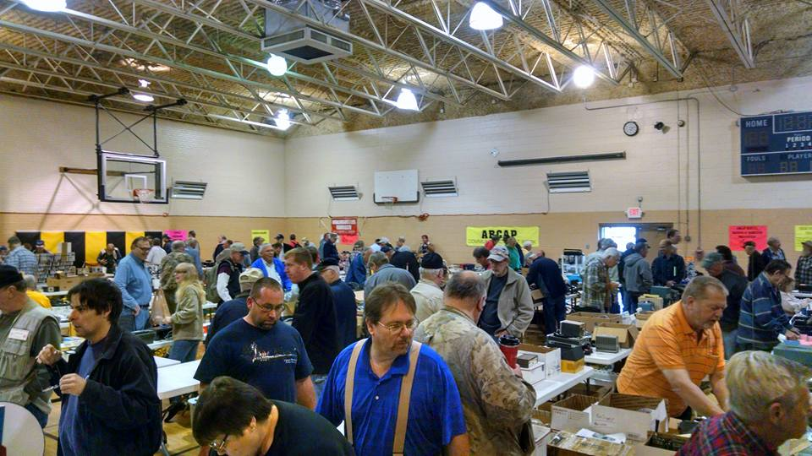***2025 Great Lakes Division Hamfests***

Here in the Great Lakes Division, we have over 50 hamfests a year.

So, if you haven’t started planning your hamfest schedule yet, you really need to start now.

Please post this listing in your club's newsletter and announce the swaps on your local nets. Talk them up.

Let's fully support all of our hamfests in every way possible. It means success for everyone. Be sure to invite your ARRL Officials as soon as your date is set.

If you are planning on having your hamfest listed in QST please be sure to start your planning well in advance of your Hamfest date, as this allows adequate time for QST Listings. QST announcements require a 3-month lead time.

|  |  |
| --- | --- |
| **09/06/2025 -**[**Grand Rapids Area Hamfest**](https://www.arrl.org/hamfests/grand-rapids-area-hamfest-2)  **Location:**Wyoming, MI **Type:** ARRL Hamfest **Sponsor:** Grand Rapids Amateur Radio Association **Website:** <https://w8dc.org/grand-rapids-area-hamfest/> [**Learn More**](https://www.arrl.org/hamfests/grand-rapids-area-hamfest-2) | **09/06/2025 -**[**Greater Louisville Hamfest 2025**](https://www.arrl.org/hamfests/greater-louisville-hamfest-2025)  **Location:**Shepherdsville, KY **Type:** ARRL Hamfest **Sponsor:** Greater Louisville Hamfest Association, Inc. **Website:** [http://LouisvilleHamfest.com](http://louisvillehamfest.com/) [**Learn More**](https://www.arrl.org/hamfests/greater-louisville-hamfest-2025) |
| **09/07/2025 -**[**Findlay Hamfest**](https://www.arrl.org/hamfests/findlay-hamfest-12)  **Location:**Findlay, OH **Type:** ARRL Hamfest **Sponsor:** Findlay Radio Club **Website:** [http://w8ft.org](http://w8ft.org/) [**Learn More**](https://www.arrl.org/hamfests/findlay-hamfest-12) | **09/13/2025 -**[**GMARC Trunk Swap**](https://www.arrl.org/hamfests/gmarc-trunk-swap-11)  **Location:**Shelby Township, MI **Type:** ARRL Hamfest **Sponsor:** General Motors Amateur Radio Club **Website:** [http://gmarc.org](http://gmarc.org/) [**Learn More**](https://www.arrl.org/hamfests/gmarc-trunk-swap-11) |
| **09/13/2025 -**[**OAARS Hamfest**](https://www.arrl.org/hamfests/oaars-hamfest)  **Location:**West Branch, MI **Type:** ARRL Hamfest **Sponsor:** Ogemaw Arenac A.R.S. **Website:** [http://k8oar.club](http://k8oar.club/) [**Learn More**](https://www.arrl.org/hamfests/oaars-hamfest) | **09/13/2025 -**[**Richmond KY Hamfest**](https://www.arrl.org/hamfests/richmond-ky-hamfest-4)  **Location:**Richmond, KY **Type:** ARRL Hamfest **Sponsor:** Central Kentucky Amateur Radio Society (CKARS) **Website:** [https://www.ckars.org](https://www.ckars.org/) [**Learn More**](https://www.arrl.org/hamfests/richmond-ky-hamfest-4) |
| **09/13/2025 -**[**Swap Meet / Hamfest**](https://www.arrl.org/hamfests/swap-meet-hamfest)  **Location:**Toledo , OH **Type:** ARRL Hamfest **Sponsor:** Lucas County ARES **Website:** [http://WWW.LUCASARES.ORG](http://www.lucasares.org/) [**Learn More**](https://www.arrl.org/hamfests/swap-meet-hamfest) | **09/14/2025 -**[**Adrian Hamfest**](https://www.arrl.org/hamfests/adrian-hamfest-12)  **Location:**Adrian , MI **Type:** ARRL Hamfest **Sponsor:** AARC **Website:** [http://w8tqe.com](http://w8tqe.com/) [**Learn More**](https://www.arrl.org/hamfests/adrian-hamfest-12) |
| **09/20/2025 -**[**Top of Michigan Amateur Radio Club & Thunder Bay Amateur Radio Club**](https://www.arrl.org/hamfests/top-of-michigan-amateur-radio-club-thunder-bay-amateur-radio-club-1)  **Location:**Gaylord, MI **Type:** ARRL Hamfest **Sponsor:** Top of Michigan ARC Gaylord and Thunder Bay ARC Alpena **Website:** [http://www.nm8rc.org](http://www.nm8rc.org/) [**Learn More**](https://www.arrl.org/hamfests/top-of-michigan-amateur-radio-club-thunder-bay-amateur-radio-club-1) | **09/27/2025 -**[**Paintsville KY4ARC Hamfest**](https://www.arrl.org/hamfests/paintsville-ky4arc-hamfest-1)  **Location:**Paintsville, KY **Type:** ARRL Hamfest **Sponsor:** KY4ARC **Website:** [http://ky4arc.com](http://ky4arc.com/) [**Learn More**](https://www.arrl.org/hamfests/paintsville-ky4arc-hamfest-1) |

|  |  |
| --- | --- |
| **09/28/2025 -**[**Cleveland Hamfest**](https://www.arrl.org/hamfests/cleveland-hamfest-5)  **Location:**Berea, OH **Type:** ARRL Hamfest **Sponsor:** Hamfest Association of Cleveland **Website:** [https://www.hac.org](https://www.hac.org/) [**Learn More**](https://www.arrl.org/hamfests/cleveland-hamfest-5) |  |

To be fair to our division’s clubs, the Great Lakes Division policy **now has 2 requirements**. **Any club requesting ARRL sanctioning within the Great Lakes Division must now be an ARRL Affiliated Club with a maximum of two hamfests/swaps in any given calendar year, and they must be at least four months apart.**

You can always find the latest information about upcoming hamfests on the Great Lakes Division website.

](https://www.arrl.org/hamfests/search/Location.division_id:gl)

Just click to get the latest hamfest updates.

***RFI – Did you hear that??***

Ah, the halcyon days, back when the airwaves were a pristine, albeit sometimes static-laced, canvas of possibilities, a wild frontier just waiting for my eager antenna to explore. I remember tuning in, the dial twirling beneath my fingertips, searching for that elusive DX, a faint whisper from across continents, only to have it savagely assaulted by some grotesque, unidentifiable squawk, a rhythmic hum of doom, or a truly unholy buzz that would make a banshee sound harmonious. It’s a distinct sensation, that moment when your hopeful signal morphs into a chaotic mess, a pure cacophony of electronic frustration, and you just know, deep in your amateur radio soul, that it isn't atmospheric; no, this, my friend, is the unmistakable, soul-crushing sound of Radio Frequency Interference, or RFI, a truly spectral nemesis from your own neighborhood that arrives without warning.

As most interference is usually found to be local to the person being interfered with, it has become common place and even encouraged by our national organization (ARRL) for local ham clubs to form RFI Committees to help hams resolved RFI issues on a localized basis. These committees are dedicated to mitigating RFI and serve as critical, often volunteer-run, entities within the amateur radio and broader wireless communication communities.

They function as a primary resource for diagnosis and resolution of electromagnetic compatibility issues, addressing signal degradation and operational disruptions experienced by licensed operators. These committees typically comprise experienced technical enthusiasts possessing a deep understanding of RF propagation, spectrum analysis, and the mechanisms by which man-made and natural noise sources contaminate the radio spectrum.

Their existence underscores the pervasive nature of RFI, which, if unchecked, can render entire frequency bands unusable, thereby impinging upon the utility and enjoyment of wireless activities for a significant demographic of tech-savvy individuals. The initial point of contact for an operator experiencing interference often leads directly to the expertise resident within these specialized local groups, initiating a structured process of investigation.

The core functions of these RFI committees encompass a systematic approach to identifying, locating, and advising on the mitigation of interference sources. This typically involves a multi-stage process commencing with an initial report from an affected station operator, detailing the observed symptoms, affected frequencies, and temporal characteristics of the interference. Subsequently, committee members, often utilizing highly specialized portable spectrum analyzers, directional antennas, and sophisticated noise-locating receivers, embark on field investigations. Their methodology frequently employs triangulation techniques and power-line carrier detection to pinpoint the exact origin, whether it emanates from faulty electrical infrastructure, switching power supplies, LED lighting, or other non-compliant electronic devices.

From the perspective of an affected radio operator, RFI often manifests as an insidious and frustrating phenomenon, ranging from annoying background noise to complete obliteration of desired signals, severely impacting their ability to communicate effectively. When personal troubleshooting efforts prove insufficient, operators should turn to their local RFI committee as a last resort, providing anecdotal evidence and technical observations to aid the investigation. The committee often will request detailed audio recordings or spectrum screenshots to characterize the interference profile accurately. This collaborative engagement between the affected party and the committee is paramount, as the operator's detailed observations can significantly narrow the scope of the investigation, allowing committee members to target their efforts more precisely and efficiently, ultimately moving closer to identifying the specific noise source disrupting the operator's radio environment.

Establishing an RFI committee within your club provides a structured approach to identifying, mitigating, and documenting interference sources, ensuring robust system performance for all members. This proactive initiative is paramount for a technically proficient organization aiming for peak operational excellence.

Such a committee fosters an invaluable learning environment for everyone within the club. Members gain practical, hands-on experience by helping troubleshoot complex RFI scenarios, deepening their understanding of electromagnetic compatibility principles. This collaborative problem-solving cultivates advanced technical aptitude, empowering individuals to confidently tackle future interference challenges within their own projects and beyond. It truly elevates collective expertise.

Elevating the club's standing, an active RFI committee positions us as a critical resource within the broader community. Our demonstrated ability to diagnose and resolve insidious interference issues not only benefits our members but also showcases our technical leadership and commitment to public service. This capability strengthens our reputation, attracting new talent and fostering valuable external collaborations based on proven expertise.

Proactively addressing RFI also champions innovation and future-proofing our technological endeavors. By continuously monitoring the RF landscape and evaluating emerging interference sources, the committee ensures the club remains adaptable to new technologies and evolving regulations. This foresight allows for the development of resilient system designs, preparing us for tomorrow's complex electromagnetic environments and inspiring cutting-edge research.

The establishment of an RFI committee is not merely a technical necessity but an unparalleled opportunity for growth and empowerment within the club. It cultivates an environment of operational excellence, ensuring reliable performance across all spectrum-dependent activities. Consider its profound impact: collective expertise flourishes, projects succeed, and our club truly leads the way in technical proficiency and collaborative problem-solving.

Even now, as technology marches relentlessly forward, introducing new and ever more complex forms of electronic chatter, the spirit of those local RFI committees endures, a quiet, tenacious presence in the background. While the sources of interference might have evolved from sputtering vacuum cleaners to high-speed data transmission lines, the fundamental challenge remains: keeping our beloved radio spectrum clean and usable for everyone. It's a never-ending battle, a constant vigilance against the unseen electronic pollution of our modern world. But I look back with a genuine fondness, a touch of nostalgic amusement, at those days of amateur sleuthing, the camaraderie, and the quirky dedication of individuals who, simply put, just wanted to hear a clear signal, reminding me that the good fight for quiet airwaves is, indeed, eternal and often quite comically rewarding.

***Club Links***

](https://arrl-greatlakes.org/links.html)I’ve received a number of new requests from clubs to be listed on the “Links” club page.

Is your club listed? If not, send the URL of your club website to me [n8sy@n8sy.com](mailto:n8sy@n8sy.com) and I’ll get it listed.

***Renewing your FCC Amateur Radio License***

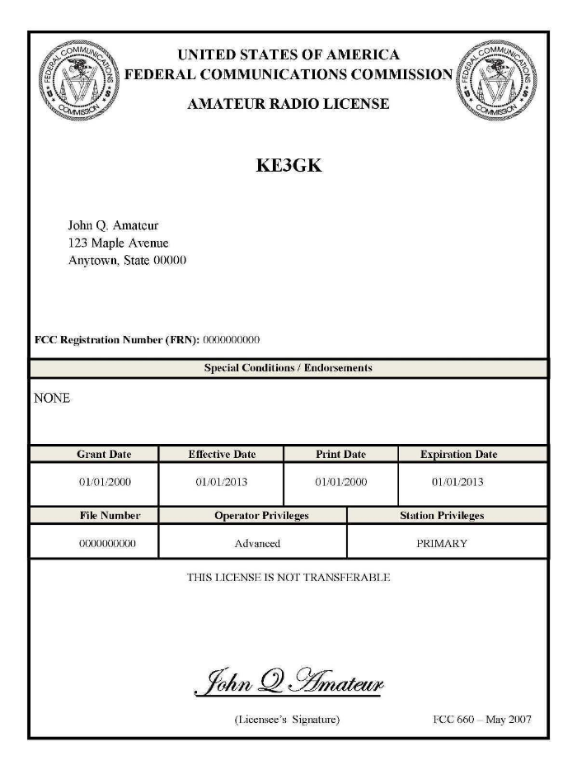Renewing your Ham license isn’t as easy as it used to be. Since the FCC is now collecting a $35 fee with all renewals there’s a little more to it now than just completing the 605 and sending it in.

To renew, update, or add an email address or phone number to a license record, amateurs may file online (electronically) on the [FCC ULS website](https://www.fcc.gov/wireless/systems-utilities/universal-licensing-system) via the [License Manager System](https://wireless2.fcc.gov/UlsEntry/licManager/login.jsp) using their FCC issued FCC Registration Number (FRN) and password.  Manually filed paper applications are not accepted by the FCC.  A valid email address is required on all applications and filings.  Applicants are required to answer the [FCC Basic Qualification Question](http://www.arrl.org/fcc-qualification-question) (felony question) if they are filing for one of the following purposes indicated: New, Amendment, Modification (Upgrade or Call sign change), Renewal Only, or Renewal with Modification.  Applicants applying for any other purpose are not required to answer this question.  
  
The FCC permits administrative updates and call sign changes at any time. License renewals are allowed at 90 days or less before a license will expire, and when the license has expired but is still within the two-year grace period. Licenses that have been expired for more than two years are not eligible for renewal or reinstatement.   
  
Visit the FCC’s [License Renewal Instructions](https://www.fcc.gov/common-amateur-filing-task-renewing-license) page and the FCC’s [Renewal Application Checklist](https://fccprod.servicenowservices.com/wireless?id=kb_article_view_public&sysparm_article=KB0015786) page. This checklist is a preparation guide to help license holders gather the necessary information before they begin the License Renewal process, direct them to the proper websites, and provide help articles to common issues some people encounter.

The checklist is intended to help the Amateur community navigate the ULS and CORES systems, to file and pay for their applications. There are also instructions available on the FCC’s [Knowledge Base](https://fccprod.servicenowservices.com/wireless?id=kb_search_public&kb_knowledge_base=1a6409a61b035950cc135247624bcb46&spa=1) page to help the Amateur community find the appropriate FCC resources.  
  
The FCC charges an application fee for certain filings including new licenses, vanity call sign requests, and license renewals. There are no fees for administrative updates, such as a change of name, mailing or email address, modification applications to upgrade an amateur radio licensee’s operator class or to request a sequentially issued call sign.  
  
o file applications and pay any FCC application fees, the applicant must set up a new FCC CORES Username account. After creating the account, when logged in, you must associate your existing FRN to your new username. Most amateurs have not yet registered for a CORES account. Follow the "Legacy CORES Users" instructions on the [FCC CORES Registration Instructions](http://www.arrl.org/fcc-cores-registration-instructions) page before attempting to file an application online.  
  
After completing the application online, if a payment is required, the system will automatically open a page asking how the applicant wants to pay and will walk the applicant through the payment process. If the application is filed through a VEC organization, the FCC fee must still be paid online directly to the FCC not to the organization processing the application form. View the application fee filing guide and instructions on the ARRL's [FCC Application Fee](https://www.arrl.org/fcc-application-fee) webpage.   
  
Licensees can log into the ULS [License Manager System](https://wireless2.fcc.gov/UlsEntry/licManager/login.jsp) with their FRN and password at any time and update anything in their FCC license record, including adding an email address.  
  
Amateur radio licensees and examination candidates must provide the FCC with an email address on all applications.

For additional assistance or to reset a password, call the FCC Licensing Support Center at 877-480-3201 (Mon.-Fri. 8 a.m.-6 p.m. ET), or submit a help request on the [FCC’s Wireless Licensing Help Center](https://www.fcc.gov/wtbhelp) website.  
  
ARRL members may manually file an application for free (via mail, email, or FAX) to the ARRL VEC using the [NCVEC Form 605](http://www.arrl.org/605-instructions).  Non-members will be charged a processing fee to use this member service.

Here’s a step by step set of instructions from our ARRL V.E.C. on how to accomplish this task.

<https://www.arrl.org/files/file/QST/This%20Month%20in%20QST/2023/10%20october%2023/10%2023%20Somma%20renew%20license%20online.pdf>

***DXAC***

I'm writing to you today to provide an important update on the ongoing "DXCC 2025" review and to directly seek your input on a particularly nuanced aspect of our rules. As you probably know, the DXAC undertook this comprehensive, top-down review of all current DXCC rules several months ago. It's been an ambitious but necessary endeavor to ensure our foundational award remains clear, consistent, and fair for all amateur radio operators.

I'm pleased to report that we've reached a significant milestone: the initial pass, systematically going through every rule on the list, is now complete. This has allowed us to identify areas for clarification, modernization, and potential improvement across the board.

However, the journey isn't over. Our next several meetings are going to dive deep into an area that often sparks considerable discussion and requires careful consideration: the inactive and deleted country aspect of the current DXCC rules.

This isn't just about current operations; it's about the historical fabric of the DXCC award itself. How we handle entities that are no longer active, or have been deleted due to political or geographical changes, profoundly impacts not only the historical integrity of the award but also the aspirations of DXers around the globe. These rules affect whether an operator can claim a past entity, how we verify contacts, and what constitutes a valid "country" for DXCC credit when its status has changed over time. It requires a specialist's understanding of both history and the operational realities of ham radio.

As we dedicate our next several meetings to this crucial and often complex area, I'm reaching out to our Division membership to seek your valuable input. Do you have specific experiences, concerns, or suggestions regarding how inactive or deleted countries are currently addressed? Perhaps you've encountered ambiguities, or you have ideas for how the rules could be made more efficient, accurate, or easier to interpret.

Your perspective as a dedicated ham radio operator is vital. Clear, consistent, and well-understood rules are essential for the long-term health and credibility of the DXCC program. Your insights help us to "harden" our systems against ambiguity and ensure that the DXCC award remains the pinnacle of amateur radio achievement for generations to come.

Please share your thoughts on the inactive/deleted country aspect of the DXCC rules with me.

Your active participation ensures that the DXCC rules reflect the collective wisdom and experiences of our community. I look forward to hearing from you.

Email me at: [dward8@gmail.com](mailto:dward8@gmail.com)

73 Dennis Ward KT8X

***New ARRL Book Release: Stealth Antennas for Ham Radio***

*Designs for Discreet Amateur Radio Operating!*

*Stealth Antennas for Ham Radio* is full of antennas to get you on the air no matter where you live. Even radio amateurs who live with antenna restrictions or covenant limitations will find solutions in this book. Learn how to install a multiband vertical that looks like a flagpole, or how to run an end-fed random wire along your roof, so the neighbors never notice. If you are looking for an invisible repeater connection, try the Ham Walking Stick. If you want five bands but cannot put wires in trees or display anything even remotely antenna-like, try the Compact Stealth Inverted L.

*Stealth Antennas for Ham Radio* will also help hams who want to stay unnoticed by neighbors. There are ideas for small lots, covenant-restricted properties, and many other living situations. Steve Ford, WB8IMY, kicks off the collection with safe, effective, and ethical stealth operation. “Stealth operating can be highly rewarding if you understand your limitations and work to alleviate them as much as possible” Ford says.

Try out these 28 unobtrusive stealth antennas today!

*Stealth Antennas for Ham Radio* is now shipping. Order from the ARRL [online store](https://arrl.informz.net/z/cjUucD9taT0zNDE1NDE0JnA9MSZ1PTUyNTgxODI4NCZsaT0zOTM1NTA1OA/index.html) or find an ARRL [publication dealer](https://arrl.informz.net/z/cjUucD9taT0zNDE1NDE0JnA9MSZ1PTUyNTgxODI4NCZsaT0zOTM1NTA1OQ/index.html); ARRL Item No. 2288, ISBN: 978-1-62595-228-8, $22.95 retail, member price $19.95. For additional questions or ordering, call 1-888-277-5289 toll-free in the US, Monday through Thursday 8 AM to 7 PM, and Friday 8 AM to 5 PM, Eastern Time. Outside the US, call (860) 594-0200.

***Special Service Clubs***

The Special Service Club Program is a special program that exists within the ARRL to recognize those clubs who do more than usual for their communities and for Amateur Radio. These well-rounded groups are the Special Service Clubs (SSCs).

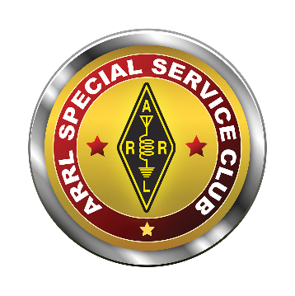SSCs are the leaders in their Amateur Radio communities. They're the ones with the active training classes, the publicity program and the members who actively pursue technical projects and operating activities.

Participation in the SSC program means a more ambitious program for your club. By taking an active role in coordination with the ARRL Field Organization, you will create a stronger, more effective Amateur Radio presence in your area. The SSC program was designed to be flexible--there's room for a host of creative ideas, and regardless of your club's size, if the members are willing, there's a place for your club.

SSCs have gone through a process above and beyond the requirements for other affiliated clubs. These clubs have demonstrated proficiency in the following areas:

a. Training and supporting local Amateur Radio efforts in licensing, upgrading and continuing education or mentoring.

b. Public Relations and improving the visibility of Amateur Radio, promoting it as a positive force within the community.

c. A willingness to become involved in any local emergency or drill.

d. Technical Advancement and encouraging members to become more familiar and knowledgeable in technical Amateur Radio aspects in the community.

e. Operating Activities in which a substantial program is conducted in an area of particular interest of the club; and,

f. Miscellaneous Activities in which ongoing programs or activities are in additional established areas (or suitable substitutes).

Here’s a list of Active SSC’s in the Great Lakes Division. Is your club listed? If not, why not contact your club officers and ask why your club isn’t a SSC!

|  |  |
| --- | --- |
| [ARROW COMMUNICATION ASSOCIATION](https://www.arrl.org/system/arrl_clubs/view/1000041187) | [Monroe County Radio Comm Assn](https://www.arrl.org/system/arrl_clubs/view/1000002634) |
| [Motor City RC Inc](https://www.arrl.org/system/arrl_clubs/view/1000015265) | [ALLIANCE AMATEUR RADIO CLUB](https://www.arrl.org/system/arrl_clubs/view/0007102406) |
| [CENTRAL OHIO RADIO CLUB INC](https://www.arrl.org/system/arrl_clubs/view/1000077451) | [Clark County Amateur Radio Assoc](https://www.arrl.org/system/arrl_clubs/view/2000062945) |
| [CUYAHOGA AMATEUR RADIO SOCIETY](https://www.arrl.org/system/arrl_clubs/view/0010036792) | [CUYAHOGA FALLS ARC](https://www.arrl.org/system/arrl_clubs/view/1000092034) |
| [Delaware ARA](https://www.arrl.org/system/arrl_clubs/view/1000058923) | [GERMANTOWN AMATEUR RADIO SOCIETY](https://www.arrl.org/system/arrl_clubs/view/2001187011) |
| [Highland ARA](https://www.arrl.org/system/arrl_clubs/view/1000018266) | [Mahoning Valley ARA](https://www.arrl.org/system/arrl_clubs/view/2000091923) |
| [MASSILLON AMATEUR RADIO CLUB](https://www.arrl.org/system/arrl_clubs/view/0004000059) | [Medina County Amateur Radio Club / Medina 2 Meter Group](https://www.arrl.org/system/arrl_clubs/view/2000890050) |
| [Mount Vernon Amateur Radio Club](https://www.arrl.org/system/arrl_clubs/view/1000008348) | [Northern Ohio Amateur Radio Society](https://www.arrl.org/system/arrl_clubs/view/1000054253) |
| [OH-KY-IN AMATEUR RADIO SOCIETY](https://www.arrl.org/system/arrl_clubs/view/2000263865) | [Portage County Amateur Radio Service Inc.](https://www.arrl.org/system/arrl_clubs/view/2000207852) |
| [Sandusky Valley ARC](https://www.arrl.org/system/arrl_clubs/view/2000182458) | [Seneca Radio Club](https://www.arrl.org/system/arrl_clubs/view/2000889960) |
| [Silvercreek Amateur Radio Assn](https://www.arrl.org/system/arrl_clubs/view/2000214573) | [TOLEDO MOBILE RADIO ASSOCIATION](https://www.arrl.org/system/arrl_clubs/view/1000118253) |
| [WESTERN RESERVE AMATEUR RADIO CLUB](https://www.arrl.org/system/arrl_clubs/view/2000597898) |  |

***Murphy’s Law…***

The Golden Rule: "Whoever has the gold makes the rules."

Gold’s Law: "If the shoe fits, it’s ugly."

Green’s Law of Debate: "Anything is possible if you don’t know what you’re talking about."

The Sausage Principle: "People who love sausage and respect the law should never watch either one being made."

***STOP!!!***

***We’ve come to the end…***

*Be Radio-Active --- See Ya’ Soon!*

Radio Waves is produced as a look inside of the Great Lakes Division and all that it has to offer. It is our sincerest hope that you have enjoyed this edition and will encourage your friends to be a part of the ARRL and receive the latest news and information about the ARRL and the Great Lakes Division!