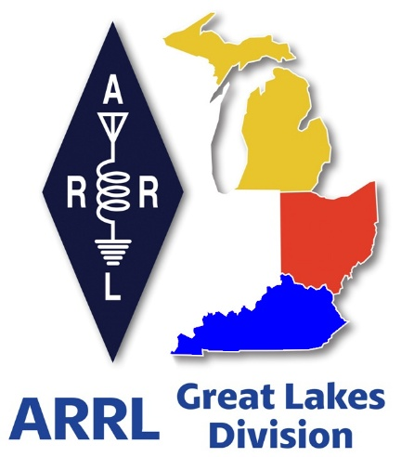
Radio Waves

^{The} Great Lakes Division
Monthly Journal
October 2025

Scott’s Stuff
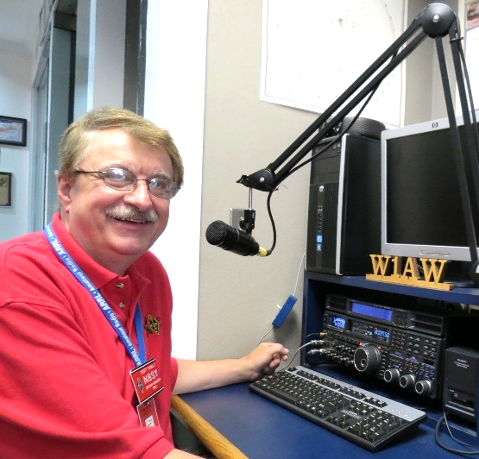
Hi Gang,

It is with sadness that I inform you of the recent passing of our Kentucky Section Manager, Alan Morgan, KY1O. Alan had been experiencing health challenges for an extended period. On behalf of Janie and myself, we extend our deepest condolences to the Morgan family during this difficult time. We trust that his suffering has come to an end.

Ready for fall? Like it or not, the leaves have started their traditional turning and dropping—which means more cleanup for me, yuck!

This year, they don’t seem to be as bright and beautiful as they have been in the past, likely due to the drought we've been experiencing. They also seem much crunchier, which is actually a good thing since I mulch them for winter cover over our garden. The worms love it, and since I use those worms for fishing, it makes the entire recycling process complete!

Clubs, have you taken the time to write a letter to your Congressperson and Senators to Eliminate HOA Prohibitions on Amateur Radio Antennas!!!? I am strongly encouraging you to do so now. If every club in Michigan, Ohio and Kentucky were to write a letter it would be such a monumental drive that Congress and the Senate could no longer ignore.

We’ve made it really simple to write to them with a letter that just needs a few things for you to fill in. Are you with me on this??


Now, before I switch over to another subject, have YOU taken just 1 minute of your time to “Send a Letter”??? It’s so easy that even a caveman could do it!! All you have to do is type in your call sign and allow the form to fill in the rest of your information, then hit the big RED button to submit. It’s just that easy to do. You don’t have to be an ARRL member either. Any licensed ham is able to do this. And we want EVERY Ham in the Great Lakes Division to sign the letter. Here’s a link to it… https://send-a-letter.org/hoa/

Oh… And not to skip over an even more important part of this effort, I need all the clubs in the Great Lakes Division to write letters too. Yes, it’s easy to do and we’ve even provided a sample letter where you just add in your club information and signatures of your club officer(s) to it and mail it off to our central collection point.

Here’s a link… https://arrl-greatlakes.org/hoa_club.html

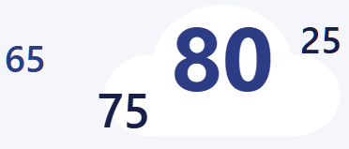
Now, let’s switch gears… On another note, have you participated in my latest survey? If not, it's not too late. I really want to hear from everyone on the topic of term vs. age limits. A number of you have already expressed your views, but I'm hoping to hear from all of you. Your opinion on this topic is important to me and possibly to the future of the ARRL. So, what’s your excuse in not spending just 2 minutes of your time to let me know just how you feel on this…

Here's the link…. https://forms.office.com/r/uCg5BSw8Mg

This past month has been a very busy month for me. I not only went out and visited some very interesting clubs, and I even got to a number of hamfests as well, including one in Kentucky!
I had the opportunity to spend time in Newington this past month. As some of you may know, I am honored to be the only presenter at the Section Manager Workshop who is not employed by ARRL. This workshop is a mandatory class for new Section Managers, and there were ten participants in attendance this session. My role was to deliver the presentation on "What does it take to be a successful Section Manager." I thoroughly enjoy discussing the various responsibilities associated with the role, and I was pleased that our newest Section Manager for Michigan, Ralph, participated as well. Overall, it was an excellent weekend, and I believe several of the new Section Managers left with numerous ideas to implement within their respective Sections. Please stay tuned for future developments.

How many of you view "Club Station" in QST? If you haven’t or don’t know that this is all about this is a space for clubs to share their practical ideas about what has helped lead them to their success. If your club has developed a creative way to get around common challenges, the ARRL wants to hear from you! They have published author guidelines that are geared toward "Club Station." Want more information on how to submit an article?

Go to: https://www.arrl.org/qst-club-station-guidelines-and-profile-form

All clubs are welcome to participate. Also, have you noticed in the ARRL ARES E-Newsletter that they are now publishing news from many of the Section Emergency Coordinators from around the country? Got an interesting ARES news story? Send to: k1ce@arrl.net

This weekend is S.E.T. weekend. Are you ready to participate? For all E.C.s, your reporting form is (Form A). Net Managers your reporting form is (Form B)... This year we have great news for you. You have new on-line forms to complete.

They bring this reporting up to the 21st century in that these forms will auto-calculate your raw data. Once submitted, the forms go directly into Headquarters and anyone that you have added with a proper email address. Yes, you can even add as many people to the email as you wish. Each email needs to be separated by a comma only.

There is even an additional Form for you to attach your supporting documentation, pictures, etc... which really brings things into today’s world.

Here’s the link to all the forms... https://ares.arrl.org/aresSET/

As I hope you can see, we ARE moving in a positive direction! It sometimes takes longer than we’d like, but we are listening to you and are working very hard every day to try to make things better for not only the Field Appointees, but you, the member as well!

Please continue to stay safe and vigilant in all your endeavors. I eagerly anticipate the chance to "Catch You On The Air," perhaps at a forthcoming club meeting, or at an exciting hamfest in the near future!

But above all, regardless of your preferred mode or band, remember the golden rules of our incredible hobby: Have FUN, and most importantly, Get On The Air!

73, Scott…

Scott Yonally, N8SY
Director - Great Lakes Division
n8sy@n8sy.com

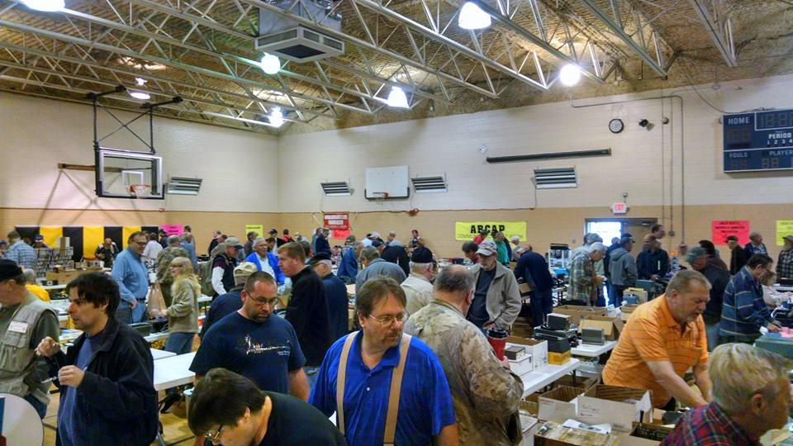
2025 Great Lakes Division Hamfests

Here in the Great Lakes Division, we have over 50 hamfests a year.

So, if you haven’t started planning your hamfest schedule yet, you really need to start now.

Please post this listing in your club's newsletter and announce the swaps on your local nets. Talk them up.

Let's fully support all of our hamfests in every way possible. It means success for everyone. Be sure to invite your ARRL Officials as soon as your date is set.

If you are planning on having your hamfest listed in QST please be sure to start your planning well in advance of your Hamfest date, as this allows adequate time for QST Listings. QST announcements require a 3-month lead time.

To be fair to our division’s clubs, the Great Lakes Division policy now has 2 requirements. Any club requesting ARRL sanctioning within the Great Lakes Division must now be an ARRL Affiliated Club with a maximum of two hamfests/swaps in any given calendar year, and they must be at least four months apart.

10/04/2025 - 2025 Kalamazoo Hamfest and Vintage Electronic Expo  Location: Kalamazoo, MI  Sponsor: Kalamazoo Amateur Radio Club, Southwest Michigan Amateur Radio Team, Vintage Electronics Expo  Website: http://www.kalamazoohamfest.org/  Learn More | 10/04/2025 - Copper Country Hamfest  Location: Baraga, MI  Sponsor: KCRA CCRAA BCRA  Website: https://kcra-mi.net/  Learn More
10/04/2025 - DX Workshop  Location: Bowling Green , KY  Sponsor: Western Kentucky DX Association  Website: http://www.wkdxa.org/events  Learn More | 10/04/2025 - Northwest Ohio Amateur Radio Club (NWOARC) Hamfest  Location: Lima, OH  Sponsor: Northwest Ohio Amateur Radio Club  Website: http://www.nwoarc.com  Learn More
10/06/2025 - 10/10/2025  FMCA-Amateur Radio Chapter Rally  Location: Paducha, KY  Sponsor: Family RV Association  Website: http://frvaarc.com  Learn More | 10/11/2025 - Muskegon Color Tour Hamfest  Location: Muskegon, MI  Sponsor: Muskegon County Emergency Communication Services, Inc.  Website: http://mcecs.net/Hamfest.htm  Learn More
10/11/2025 - Po Boy Amateur Radio Tailgate Swapfest  Location: London, KY  Sponsor: Po Boy Amateur Radio Group  Website: http://Facebook/Po Boy Amateur Radio Group  Learn More | 10/11/2025 - Williams County ARA Hamfest  Location: Montpelier, OH  Sponsor: Williams County ARA  Learn More

10/12/2025 - Ashland Trunkfest  Location: Ashland, OH  Sponsor: Ashland Area Amateur Radio Club  Learn More | 10/19/2025 - U.S.E.C.A. (Utica Shelby Emergency Communication Association) Hamfest  Cancelled  Location: St. Clair Shores, MI  Sponsor: U.S.E.C.A. (Utica Shelby Emergency Communication Association)  Website: http://usecaarc.org  Learn More
10/25/2025 - Hazard Hamfest
Location: Hazard, KY
Sponsor: Kentucky Mountains Amateur Radio Club
Learn More

You can always find the latest information about upcoming hamfests on the Great Lakes Division website.
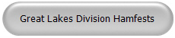
Just click to get the latest hamfest updates.

My First Car…

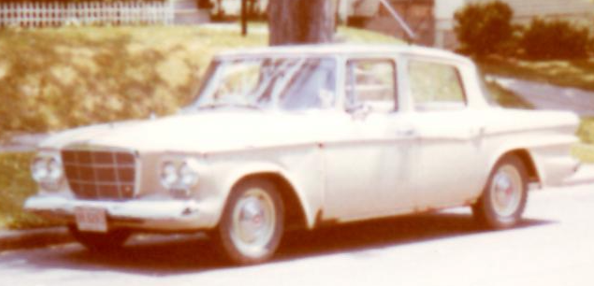
Janie and I were going through some old pictures that had been just thrown into a box from way back in time the other night. Most of them were of family members that dated back to when my mom was just a youngster. But just when I was growing tired of trying to figure out what side of the family that picture was of I came across a picture that almost brought tears to my eyes. It was of my very first car. When I pulled the picture out of the bottom of the box and showed it to Janie, she started laughing. Now, I don't know about you, but I still have some very fond memories of my first car. No, it wasn't a car you could brag about – unless your definition of bragging involved tales of automotive near-death experiences and rust-induced ventilation. But it was mine. All mine. It was a pink 1962 Studebaker Lark, and despite its many, many eccentricities, it was a chariot of pure, unadulterated freedom for a sixteen-year-old me.

Yes, I got kidded about it. Oh, did I get kidded. "Is your grandma coming to pick us up?" "Hey, Barbie called, she wants her car back!" The jibes were endless, delivered with the merciless precision only teenage boys can muster. But you know what? It really didn't matter much. The sheer, overwhelming fact that I owned a car, a vehicle that could transport my eager, hormone-addled self beyond the confines of my suburban street, was all that mattered. It wasn't a sleek Maserati, nor a roaring Jaguar, but it was mine. And in the mid-1960s, for a kid scraping by on a dollar an hour from odd jobs, that pink Studebaker was more valuable than a fleet of luxury imports.

Most jobs a kid could get back then paid a dollar, maybe a dollar and a quarter on a good day. That meant that acquiring even the most decrepit vehicle required months of diligent saving and aggressive scrimping. Every ice cream cone forgone, every movie ticket skipped, every spare dime hoarded, went into the Studebaker fund. To my parents, it was a $100 car – a mere pittance. To me, it was a fortune, a culmination of endless hours of sweat and sacrifice. And when I finally handed over those crumpled bills, receiving the keys to that magnificent, faded flamingo on wheels, it was my dream car. It meant I could go anywhere I wanted, or at least anywhere within a 30-mile radius before it started making sounds like a dying moose attempting to tap dance. I was free, except for the inconvenient necessities of going to school and working a full-time job to keep her fueled and vaguely operational.

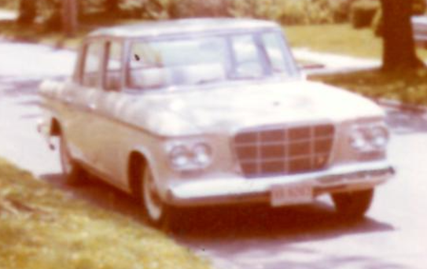
That car of mine… Bless its rusty, pink heart, had a 3-speed shift on the column. For those of you raised on automatic transmissions and paddle shifters, imagine trying to stir a thick pot of stew with a long, wobbly spoon while simultaneously navigating a busy intersection. That was the Studebaker’s gear shift. It required a unique blend of finesse, brute force, and prayer. And then there was the engine: a short block 283 Chevy. Why a Chevy engine found its way into a Studebaker remains one of the great automotive mysteries of the universe, but it gave the old girl a surprising, if occasionally alarming, burst of speed. She wasn't fast, not by any stretch of the imagination, but when that little 283 decided to sing, it was a gravelly, off-key anthem of sheer will.

Kids today, with their cupholders, touchscreens, and airbags, would probably refuse to even get in it. Heck, they’d probably call child protective services on me for suggesting it. Because you see, there were no real floorboards. Oh, there were floorboards once, I’m sure, in the glorious year of 1962. But by the time I took possession, they had mostly rusted through, leaving gaping holes that offered a clear view of the asphalt whizzing beneath us.

It was like a real-life Flintstones mobile, but without the benefit of being able to power it with your feet. You had to be extra careful where you put your feet, especially after a rain shower, unless you enjoyed the sensation of a spontaneous foot bath at 60 miles an hour. Passengers were given strict instructions: "Watch your feet! And if you see a squirrel, just wave."

The advanced technological features were a marvel in their own right. I remember the windshield wipers were run from the engine vacuum. This meant that they only sped up when you raced the engine. Picture this: a torrential downpour, visibility approaching zero, and me, desperately revving the engine at every turn, sending the RPM needle soaring just to get the wipers to make a pathetic, sluggish sweep across the grimy windshield. It was less of a wiper system and more of an interactive performance art piece. And the windshield washer? Forget your fancy electric sprayers. Mine was nothing more than a little foot pump that, with a vigorous stomp, would squirt a short, anemic blast of fluid onto the windshield. It rarely hit the actual glass, often opting for the roof or the unfortunate pedestrian walking by. Yes, it was a bomb for sure, a glorious, sputtering, slightly pink bomb, but it was my first car.

That car and I… we had some adventures. There was the time the exhaust pipe decided to detach itself entirely in the middle of Main Street, announcing our arrival with a roar that would make a drag racer blush.

There was the constant, low-level hum of anxiety that accompanied every longer journey, wondering if this was the day the wheels would simply decide to pack up and go home without me. And the repairs! I learned more about basic auto mechanics from that Studebaker than I did in any science class. Changing spark plugs, adjusting the carburetor, patching rust holes with sheet metal that I got from swiping a stop sign off of a pole late one night and an alarming amount of Bondo – it was all part of the ownership experience. Every trip to the auto parts store was an event, a quest for some obscure part that might, just might, keep the old girl chugging along for another week.

Despite its questionable roadworthiness, the Studebaker was my ticket to independence. It ferried me to countless A&W Root Beer runs with friends, to drive-in movies where the speakers were tinny and the picture blurry, and to dates that usually ended with Janie making sure the stop sign was over the hole on her side of the car. It was the backdrop to countless late-night conversations, bad decisions, and the exhilarating feeling of being young and unencumbered. That pink behemoth wasn’t just a car; it was a character, a loyal (if slightly unreliable) companion through the awkward, exhilarating rites of passage of adolescence. It taught me about perseverance, the value of a dollar, and the surprising resilience of a car that probably should have been in a junkyard decades prior.

I eventually sold her, or rather, she was taken off my hands by a desperate neighbor who needed a temporary vehicle and apparently had a high tolerance for rust and questionable electrical systems. I like to imagine she went on to live a long, happy life, perhaps as a very slow, very loud, very pink farm vehicle. But I doubt it. More likely, she finally gave up the ghost in a spectacular, smoky fashion, leaving behind a trail of pink paint chips and fond, if slightly horrified, memories.

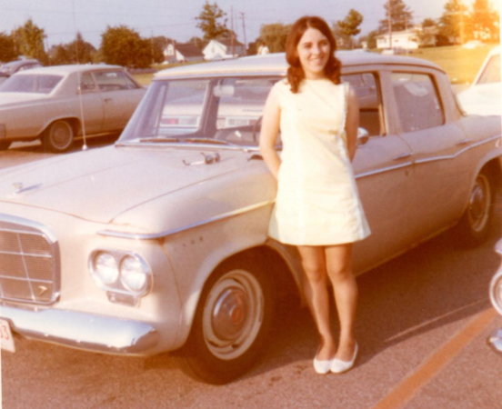
So, tell me. What was yours? What was that first, unforgettable vehicle that wasn't just transportation, but a symbol of freedom, a source of endless anecdotes, and a testament to your youthful optimism (or naivete)? Did it have rust holes you could wave through? Did its wipers refuse to cooperate? Did it have a peculiar smell that only deepened with age? Because while that 1962 pink Studebaker Lark was far from perfect, it was everything a first car should be: a completely ridiculous, utterly essential, and eternally cherished memory.

Oh, If you don’t recognize this gal, she’s my high school sweetheart and wife of 54 plus years…

Club Links

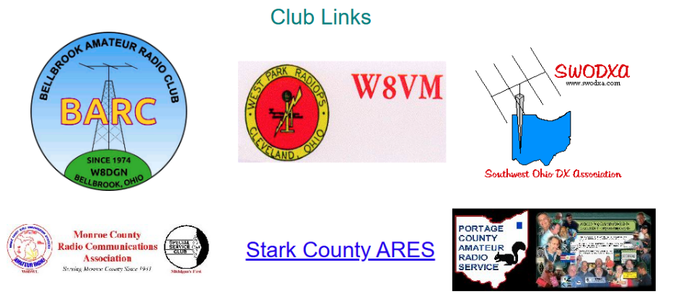
I’ve received a number of new requests from clubs to be listed on the “Links” club page.

Is your club listed? If not, send the URL of your club website to me n8sy@n8sy.com and I’ll get it listed.


Hams Needed to Track NASA Moon Misson

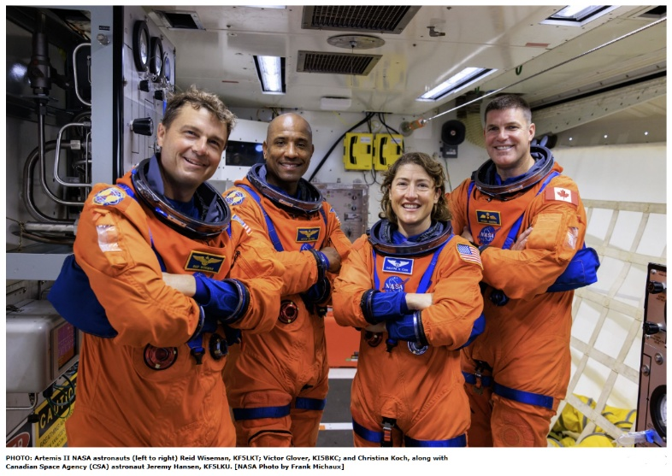
The National Aeronautics and Space Administration (NASA) is seeking volunteers to passively track the 2026 Artemis II Orion spacecraft as the crewed mission travels to the Moon and back to Earth.

The Artemis II test flight will send NASA astronauts Reid Wiseman, KF5LKT; Victor Glover, KI5BKC; and Christina Koch, along with Canadian Space Agency (CSA) astronaut Jeremy Hansen, KF5LKU, on an approximately 10-day mission around the Moon.

Targeted for no later than April 2026, the mission will rely on NASA’s Near Space Network and Deep Space Network for primary communications and tracking support throughout its launch, orbit, and reentry. However, with a growing focus on commercialization, NASA wants to further understand industry’s tracking capabilities.

This collaboration opportunity builds upon a previous request released by NASA’s Space Communication and Navigation Program (SCaN ) during the Artemis I mission in 2022. Ten volunteers successfully tracked the uncrewed Orion spacecraft on its journey thousands of miles beyond the Moon and back.

One of those volunteers tracking in 2022 was Scott Chapman, K4KDR, of Montpelier, Virginia. “Sometimes it’s what you don’t know that makes this kind activity interesting,” said Chapman. “All I had was a small S-band dish and receiver and wasn’t sure what I could or couldn’t hear...but when I started hearing the signals...it made everything worth it.”

There were also other participants during the Artemis I mission, including international space agencies, academic institutions, commercial companies, nonprofits, and private citizens who were also attempting to receive Orion’s signals. Chapman added that NASA is also looking for commercial partnerships to share in the process.

If you’re interested in volunteering for next year’s event, all of the information can be found at SAM.gov. The response deadline is October 27, 2025, at 5:00 PM EDT.

Ohio State Parks on the Air – Indian Lake 2025
(Author: Tom Foy N4HAI)
This past weekend, Karen (K2KAR), Joe (K8MP), and I activated Indian Lake State Park in Logan County for Ohio State Parks on the Air. We used our new club callsign W8HCG - Hilliard Contest Group. The site worked out great—while RVs were across the road, we had no immediate neighbors, and plenty of trees at the north end of the park for antennas.

We put up the DXCommander and laid out the radials, only to discover a few broken radial wires. No problem —we stripped the ends and wrapped them around the wing nuts. Around an hour before sunset, Joe (K8MP) rolled in and quickly shot a line over a tree to hang his 40m bazooka.
Afterward, we drove to a local Mexican restaurant for dinner before turning in—Karen and I slept in her Subaru that night. It felt just like Field Day!

Saturday morning started with coffee and setting up a 10'x10' canopy. Two tables became our “shack,” and by 10 AM we were on the air. Joe was back early to finish his antenna, and soon we were calling CQ. It was tough at times to track down other Ohio parks, but we made plenty of Midwest contacts, snagged a few West Coast stations, and even worked some DX.

Karen jumped right in and ran several pileups like a pro. Joe and I tag-teamed between CW and SSB, filling the log all afternoon. The K3 gave us a scare, but we traced it to a flaky MFJ tuner that had been problematic since Field Day. Once we pulled it out, everything ran smoothly. Later, I realized that hammering CQ in Morse Code into an End Fed Half Wave rated at 250 watts wasn’t the best idea—the SWR crept up, and when I took it down, the balun was still warm!

Between us, we had three radios on site (K3, K4, and a TenTec Omni VI Plus), three antennas (80m EFHW, 40m bazooka, and a 80m DXCommander), three laptops, and our home 5G Wi-Fi as an easy way to network the laptops, and to look for spots on line. Plenty of gear, plenty of learning, and lots of laughs.

We wrapped up the weekend with dinner at Texas Roadhouse in Marysville. Our server was fantastic, and we even got to share a little about ham radio with her manager. It was the perfect ending to a weekend of radio, camping, and good company.

Lessons Learned

1. Don’t worry about your score—just have fun.

2. Bring backups for everything that could fail.

3. Test your equipment before you head out.

4. Use a checklist! (We didn’t forget anything this trip!)

Greetings!

Relationships matter, and working closely with our state's good neighbors is important for everyone. Indiana public safety communications is a good neighbor with a strong system and great people, and they treat amateur radio and AuxComm properly with appreciation and respect.

This is particularly evident with the following Indiana event. I've found an opportunity for expanding Michigan's participation into this Indiana radio exercise, and I hope we can add a LARGE number of Michigan amateur stations to support them. They are particularly interested in having Michigan operators reach out to them ASAP to register to run BONUS STATIONS in advance (see web page below)!

In 2 weeks on Saturday October 4th, Indiana is launching their 3rd annual "10-4 Day" public safety radio event that also includes AuxComm and amateur radio. We can easily participate on at least 40 meter and Winlink. This year "10-4 Day" is code named "Project Snoopy".

This is an EXCELLENT AuxComm / amateur opportunity for us. I've recently reached out to Indiana public safety, and they've already impressed me. That's why I'm taking the initiative for supporting "10-4 Day" awareness in southeast Michigan. Every licensed operator statewide is invited. Want even more action? Become a BONUS STATION by registering NOW!

Indiana is offering certificates to participants, so let's all get recognized. We can all proudly represent Michigan, practice our skills, and demonstrate our abilities.

When you get your recognitions, email a copy to me WITH YOUR CALL SIGN before October 31st, and I'll bundle them and send them all to Max Schnieder for his Michigan AuxComm records! If we get enough, perhaps he will make a note about the event on the state website.

The event page for Indiana's "10-4 Day" is:
https://www.in.gov/ipsc/Divisions/training/annual-10-4-day/

Near the end of the page is the "AUXCOMM ALL CALL" section with amateur radio details. Everything below that heading relates to YOU.

Let's all join this fun event and support our good friends across Michigan's southwest border!
Thank you,
-Tony Griffin
Michigan PEM

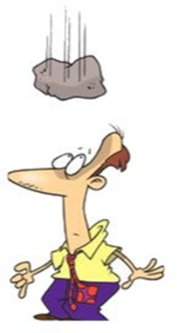
Murphy’s Law…

Attorneys Operating Principle -
Any simple idea must be worded in the most complicated and lengthy way.

Baker's Law -
Misery no longer loves company. Nowadays it insists on it.

First Law of Bicycling –
No matter which way you ride, it's uphill and against the wind.

Captain Penny's Law -
You can fool all of the people some of the time, and some of the people all of the time, but you can't fool MOM.

Doc's Laws of Automotive Repair -
1.If you can reach the faulty part, you don't have the tool to get it off.
2.Quality is inversely proportional to the time left to complete the job.
3.If it jams-force it. If it breaks, it needed replacing anyhow.

Laws of Applied Confusion –
Truck deliveries that normally take one day will take five when you are waiting for the truck.

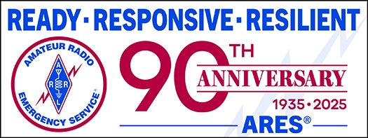
All Ohio ARES Conference

Come join us for All Ohio ARES Conference.

November 22nd 9am – 4pm
Informative presentations -- Door prizes

Bring your Go-Boxes and Comms vehicles to display.

Doors open at 08:30 - Sign in from 08:30 – 09:00

Seating is limited so please register today to reserve your seat. OSU/COTC

Newark, 1219 University Dr. Newark, Ohio 43055 (Warner Library Building)
Registration required.
>> Registration <<

STOP!!!
We’ve come to the end…



Be Radio-Active --- See Ya’ Soon!

Radio Waves is produced as a look inside of the Great Lakes Division and all that it has to offer. It is our sincerest hope that you have enjoyed this edition and will encourage your friends to be a part of the ARRL and receive the latest news and information about the ARRL and the Great Lakes Division!

