
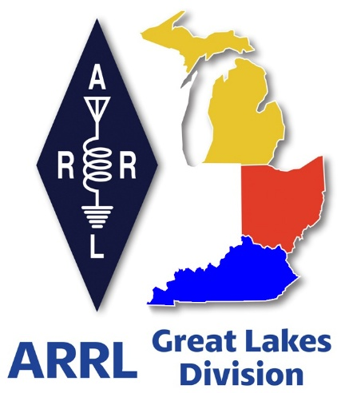
Radio Waves
^{The} Great Lakes Division
Mid- Month Report
November


From the Michigan Section Manager
Larry Camp, WB8R

Greetings from Branch County!

We have had our first snow of the season and here in the southern-most portion of Michigan, it appeared as though we may have had as much as 2 inches of snow in the Coldwater area. A harbinger of what is to come….

ARRL Home Page

Have you stopped by the ARRL website lately? If not, you are missing some good opportunities to dig deeper into what is currently in store for you this month (and beyond). It is really easy to not pay attention to the digital QST as it generally remains as a file on one or more of our devices. This is opposed to having a physical magazine copy resting on the arm of our favorite chair or on the coffee table. In order to reap all the benefits of our subscription, we really have to make sure that we electronically review each issue and perhaps make notes of what interests us. I find it is easy to miss good information by simply not paying close attention to each new issue.

A few examples of said neat stuff in the current (December) issue:

ARRL November Sweepstakes
Solar Update (and we have had a significant amount of visible solar activity in Michigan lately)
Essay Contest for young hams
New Online LIVE courses for Ham Radio Licensing
And more……

Michigan Hamfest Schedule
Dec 7, 2025 LCARC Hamfest, Troy, MI (WB8R, AA8RK, NS8Y)
Feb 21, 2026 Livonia ARC, Northville, MI
Mar 21, 2026 Lowell Amateur Radio Youth Club, Lowell, MI
Apr 11, 2026 AC8RC Mini-Swap, Burnips, MI’
Jun 6, 2026 IRA Hamfest, Hudsonville, MI

Closing Remarks
Thanksgiving is only 10 days away and the end of year Holidays are also fast approaching. Be careful when you are using those semi-retired winter driving skills as we make the shift to winter mode here in Michigan and surrounding states.

Stay safe and be Radio Active!

Best 73,

LC

Larry Camp, WB8R
MI ARRL Section Manager
wb8r@arrl.org
517-617-4883


From the Ohio Section Manager
Tom Sly, WB8LCD

The latest edition of the Ohio Section Journal is now online and ready
for you to read! There’s an awful lot of Ham Radio activities going on
in the Ohio Section, so get off the chair or couch you’re sitting on
and get out there, get involved, and get on the air!
The links below will take you directly to the newsletter. Both are also
available directly from the Ohio Section Web-site ( www.arrl-ohio.org )
https://arrl-ohio.org/wp-content/uploads/2025/11/OSJ_November-2025.pdf

Tom… wb8lcd@arrl.org


From the Kentucky Section Manager
Bob Selbrede, K6ZZ

Hello Fellow Kentuckians,

Welcome from your newly appointed Section Manager! As you may know, previous Section Manager Alan Morgan, KY1O, became a Silent Key in September. Alan was a mult-term Section Manager for the state of Kentucky, and he will be missed by all. After seeing requests for someone to fill this critical position, I decided to step forward and give it my best.

First a little bit about me. I'm a 50-year Life Member and supporter of the ARRL. Born and raised in Wisconsin, I was first licensed as WN9QKH at age 14 in 1975. I upgraded to Extra at age 16 and became W9NQ and then K6ZZ in 1995. As a young ham I spent a lot of time chasing DX, working CD Parties and supporting various nets in the National Traffic System. It was a ton of fun. After High School I joined the Air Force and was stationed at Edwards AFB in Southern California where I remained working as a Telemetry Systems Engineer until June of 2025. Retirement and family connections brought me to the great state of Kentucky. Over the years I've been active in many different facets of our great hobby.

Although I've only been Section Manager for a few weeks, I've already met a lot of great people across the Commonwealth. People are doing great work to support Emergency Communications in their respective areas, but there is still room for improvement, which is what I am currently focused on. In particular, I'm actively searching for someone to fill the vacant position of Section Emergency Coordinator (SEC). This is a critical position that needs to be filled with the right person in order to improve Emergency Communications organization and readiness across the Section. We also need more volunteers to become Emergency Coordinators for Counties that have no coverage. If you would like to help support these very important functions, please contact me to discuss how you can help.

Thanks for your time!

73, Bob K6ZZ
Kentucky Section Manager
K6ZZ@ARRL.ORG

Survey – Age or Term Limits for ARRL Board Members...

Hi Gang!

I’m still scraping myself off the floor after seeing the sheer volume of responses to our little Great Lakes Division survey—over 600 of you decided to drop everything and weigh in!

Seriously, thank you, because this overwhelming participation means we have actual data, not just basement theories whispered into the repeater. You clearly felt strongly about this subject.
When we asked if the issue was about turning a specific number or just serving too darn long, the answer was loud and clear: 55% of you are firmly in the "Term Limits Now" camp. It seems the general consensus is less about wrinkles and more about preventing those long-serving members from achieving administrative immortality, which is slightly less popular than the restrictive 15% who only cared about age.

Now, let’s talk about the 25% who suggested we "Keep it as it is today." Bless their traditional hearts. I picture these folks sitting in their favorite armchair, surrounded by their old Crosley radios whispering, "If it ain't broke, don't fix it—and if it is broke, maybe we just don't talk about it loudly." They seemed to be the anchor that’s dragging against change, demanding stability, or perhaps just running low on batteries.

Moving on to the minimum age results, the math wizards among you calculated a perfect entry point of 26.5 years old. Apparently, we decided candidates need to be old enough to legally rent a car, but not so ancient they forget how to log into Zoom meetings. That half-year is crucial, implying half a year more wisdom or maybe just a slightly better credit score needed for governance.

Conversely, the collective wisdom decided that 78 years old is the ideal maximum retirement age for a Board member. Seventy-eight! That seems generous, suggesting that competence officially wanes right about the time you start confusing your call sign with your social security number. The public clearly wants leadership that can still accurately decode Morse code without requiring an afternoon nap immediately afterward.

When it came to the sweet spot for term limits, you decided that 2.75 terms was the magic number. I have no idea how one serves three-quarters of a term before being gently escorted out, but I love the precision! This average suggests a maximum allowance for about nine years of service before the membership collectively decides that nine years of paperwork is quite enough, thank you very much.

Overall, the message is undeniable: the majority of participants—55% favoring term limits and only 25% endorsing the status quo. It’s clear many of you are actively pushing for a structural change in the ARRL leadership model and I couldn’t agree more!

This mandate for reform contrasts sharply with the mysterious 5% who selected "No Opinion," the true heroes who apparently filled out the survey purely for the excitement of being non-committal about organizational longevity.

This highly unscientific data, ranging from a 26.5 minimum age to 2.75 terms, gives us a very clear, if slightly eccentric, roadmap for ARRL’s future direction. Thanks again for telling us exactly what you think, even if you are just a quarter of a term away from retirement!

Do you know someone who is not getting this newsletter


Hi Gang,

If you know someone who isn’t already getting Radio Waves, have them sign up to receive it!! They don’t have to be ARRL members to sign up, just click on the button below and in no time, they will start receiving it.



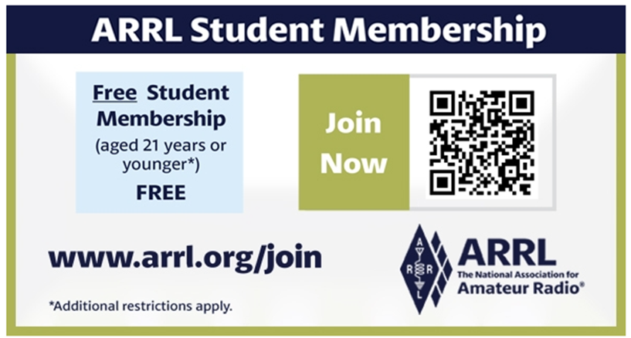

2025 “Dream Rig” Essay Contest for Young Ham Radio Operators

Six years ago, the Intrepid-DX Group, a international group of amateur radio operators, began their annual youth “Dream Rig” essay contest as a means to reach young people and interest them in amateur radio.


“This year, rather than our past essays, we are seeking well thought-out and clearly communicated project proposals for a public access amateur radio station,” said Paul S. Ewing, N6PSE, president of The Intrepid-DX Group.

This year’s contest is called “Amateur Radio for the Greater Good.” Written proposals may be submitted between November 10 and December 10, 2025, by amateurs age 25 or younger, describing how they would establish a club, contest, community, or emergency communication station in a school, church, fire station, community center, hospital, or other public building. The station must be in the USA and only US-licensed amateurs may submit proposals.

“This is a departure from our conventional essay contest,” added Ewing. “We are looking for proposals that would place the station in a secure and common area where it could be enjoyed by other licensed amateurs. Once the winning proposal is selected, the proposal author will have sixty days to secure written permission from the owner or guardian of the facility. The written permission must indicate approval for the station and antenna to be installed. The proposal author may be the trustee of the station.”

The equipment provided will include an HF transceiver, VHF/UHF transceiver, 13.8V power supply, two 100' lengths of coax, and antennas.

The awardee of the complete station will be announced on December 15, 2025.
Proposals may be submitted via email to intrepiddxgroup@gmail.com or via USPS to:

The Intrepid-DX Group
3052 Wetmore Dr.
San Jose, CA 95148

For more information about the Intrepid-DX Group, visit its website at https://intrepid-dx.com.

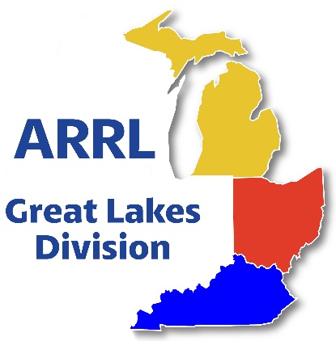
Scott’s Stuff

Hi Gang,

I know it's a bit early, but consider this my official, first-in-line "Happppppy Thanksgiving" shout-out to all of you! Soon enough, we'll all be diving headfirst into that glorious "Turkey Day" tradition where calories simply cease to exist, and the only rule is to eat absolutely everything in sight – possibly even eyeing the dog's bowl or making a tactical raid on the kids' table before you're fully committed to the recliner, pants unbuttoned, only to declare, "Hey, where are all the leftovers?" and plot an emergency run to the Stop & Shop for more snacks.
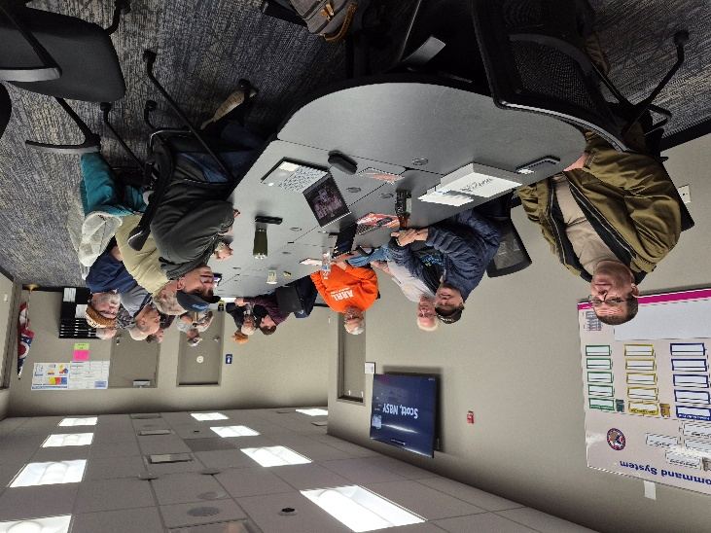
Amidst all that glorious gluttony, I truly hope you and yours have a wonderful Thanksgiving, and please remember to give a very special thanks to those incredible folks in uniform who tirelessly keep us safe all year long.

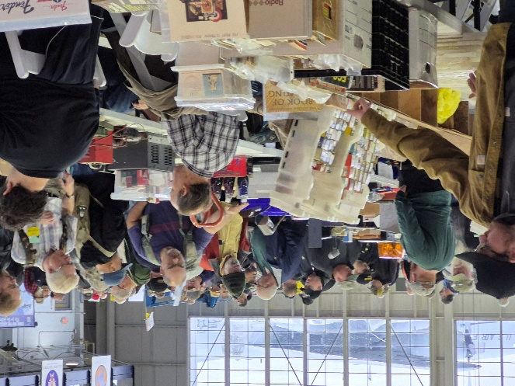
On a slightly less caloric note, I've genuinely been having a blast hitting various club meetings lately, and I want to extend a massive thank you for all the hospitality and amazing friendship; it's genuinely refreshing to witness how much every club is actively giving back to their communities.
While the hamfest season might be rapidly winding down, fear not, because club meetings are quickly ramping up, ensuring there are still plenty of fantastic opportunities for all of us to get together, swap stories, and continue having a whole lot of FUN!

I have been working around the house getting it ready for winter. How about you? Have you started any antenna projects yet? Remember, the best working antennas are the ones that were put up in the worst weather, and that’s a very unscientific fact!!

Now, since my home has double glazed casement windows throughout the house, all I have to do is make sure that they get seated properly in their frames and that’s that… they are ready for the winter.

I’ve gotten the generator all gassed up and have tested it numerous times to be sure that it will start on the first pull. Around here we never know just when we will need it next, as we are at the end of the power line for our provider, and our power can go out on a day when there’s absolutely no wind and the sun is shining nice and bright. I can’t explain it, but that’s been the history here in the big metropolis of Lexington for as long as Lexington has been here. Most everyone here has some sort of backup power ready to go, that’s how prevalent the power outages are around here. Oh well. Even though we have this issue, I wouldn’t move for the world.

Oh, and listen, did you happen to skim the article about Carbon Monoxide poisoning in the last newsletter? I know, I know, sometimes my eyes just glide right over anything that sounds too serious! But honestly, if you missed that one, do me and yourself a big favor and dig it back out. Consider it your homework, but without the pop quiz this time.

No kidding, this stuff is nothing to mess around with. We seniors know all about things sneaking up on us – like that extra wrinkle or forgetting where we parked the car – but CO is a whole different ballgame. It's the ultimate ninja of dangers, silent as a mime, and way less entertaining than one too, if you ask me.

What really gets me is how polite it isn't. Most things give you a little heads-up; a creaky knee, an occasional groan, or that annoying 'low battery' beep on your remote. But Carbon Monoxide? Nope! It just waltzes in like it owns the place, doesn't even send an invitation, and certainly no RSVP needed. Very rude, if you ask me.

Seriously though, despite my attempts at levity, this silent gas does kill. It doesn't give you the common courtesy of a cough, a dizziness spell, or even a sudden urge for an early bird special. You just, poof, check out. It’s like falling asleep in your favorite armchair, but permanently. Not exactly the retirement plan anyone signs up for, right?

So, do yourself a solid and locate that old newsletter…. Dust it off, grab your reading glasses – or that giant magnifying sheet we all secretly own – and give that article a good, careful read. Better safe than sorry, especially when 'sorry' means you won't even realize you are! Keep those detectors beeping, folks! And, if you haven’t purchased a CO detector yet, now is the time. They’re cheap, easy to install and they just sit there until CO decides to raise its ugly head. https://arrl-greatlakes.org/glnews/2025/11-radio_waves.pdf

Have you taken a look at the Great Lakes Division website lately? It changes all the time with new information and even some new graphics once in a while. If you haven’t visited lately, go now… https://arrl-greatlakes.org Oh, by the way, that’s why I am doing a “Handbook Give Away..” to get you to go to the website!!!

Now, if you’ll excuse me, I think I hear a pumpkin pie calling me… That’s going to do it from here this time around. Catch you on the air, in a club meeting, or at a hamfest! Until then,
Be Radio Active!!!!!

73,

Scott, N8SY
Great Lakes Division Director
n8sy@arrl.org

Club Leaders Everywhere

We need your club’s voice now more than ever. As part of ARRL’s nationwide grassroots campaign, we asked all hams to send letters to Congress urging support for the Amateur Radio Emergency Preparedness Act -- but we need more radio clubs to stand up to be counted too.

Why your club matters:

Your radio club isn’t just a group of hams. Your club is a resource that serves your local community. You've built trust, provided public service and emergency communications, and trained new generations of hams. A letter from your club carries the weight of all that community goodwill -- and when lawmakers see that clubs like yours are behind this bill, it makes a difference.

What we’re asking:

We’re asking every ARRL Affiliated Club to prepare formal letters to your Congressional representatives in support of the bill. Your letters show collective support from an organized, respected local group -- not just individuals. That’s powerful.

We’ve made it easy:

Use the following, simple, step-by-step guide to help your club draft and send your letters:

https://send-a-letter.org/club

You’ll find everything you need -- including a sample letter in WORD format -- on our dedicated campaign page at https://send-a-letter.org/club.

Please take a moment to review the instructions to create your club’s 3 letters: one for your US Representative, and two for your Senators. Follow all of the instructions closely, and email your letters to the address provided on the site. The process is quick -- but the impact is lasting.

If you have any questions or need help, please contact ARRL HQ or Director John Robert Stratton, N5AUS (N5AUS@n5aus.com or 512-445-6262).

Let’s get all radio clubs to help us PASS THE BILL.

ARRL Introduces New LIVE Online Course for Ham Radio Licensing

ARRL The National Association for Amateur Radio® has introduced a new, fully-interactive two-day online course for ham radio licensing. The ARRL Technician Class LIVE Video Course includes everything needed to prepare for the FCC Technician Class amateur radio license exam. Enrollment is open now for the inaugural course, which will take place December 20 - 21, 2025.
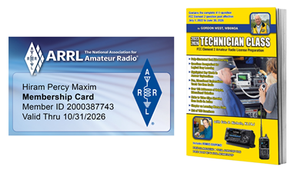
Join ARRL Education Specialist Wayne Greene, KB4DSF, for this interactive online class. “We’re going to have fun!,” said Greene. “I’ll guide you through operating your first ham radio to how to communicate through amateur radio satellites. We are going to get fully immersed in every question and answer with the info you need to pass the test!”

In addition to live instruction, course participants will receive the popular Technician Class prep book authored by ARRL National Instructor Gordon West, WB6NOA, which has helped thousands of new hams get licensed with fast results. One-year of ARRL Membership is also included, ensuring these new hams will have quick access to all ARRL benefits, services, and programs.

- Two days of LIVE instruction with expert ARRL Education Specialist Wayne Greene, KB4DSF
- Technician Class prep book by Gordon West, WB6NOA
- One-year of ARRL Membership

Course Includes:

Those who remember ARRL’s recorded video courses of the past will recall how valuable it is to see and hear lively video instruction. This new course will ensure students have an even more personal, interactive experience. Greene will present the material in bite-sized sections, demonstrating just how much fun amateur radio is!

Visit the ARRL Shop to complete the paid enrollment for a special introductory price of $99. Registrants will receive a follow-up email with instructions for registering for the live video course after completing your order. If you have any questions regarding the course, please contact the ARRL Education and Learning Department at 860-594-0285 or email ead@arrl.org

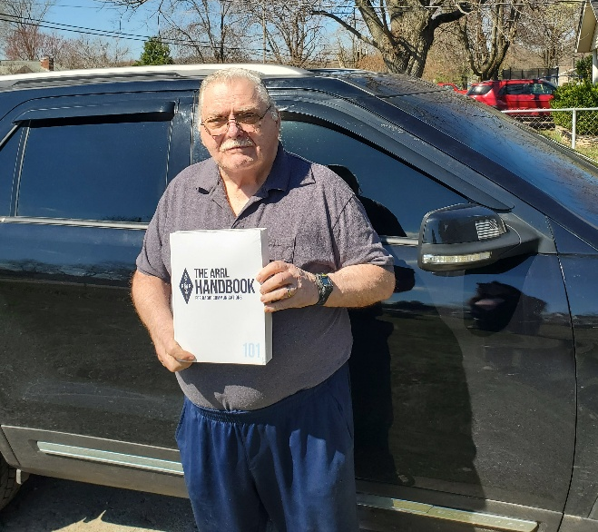
Handbook Give Away – Have you
entered yet???

How’s about I give away an ARRL softcover Handbook absolutely FREE !!!

Yes, I’m holding a little contest to "GIVE AWAY" a 2025 ARRL softcover Handbook. Why you ask? It’s to get you to check-in to the Great Lakes Division website and take a look around.

Getting signed up is just as simple as filling out a couple of quick questions and you’re entered!!

>> Click Here To Enter <<

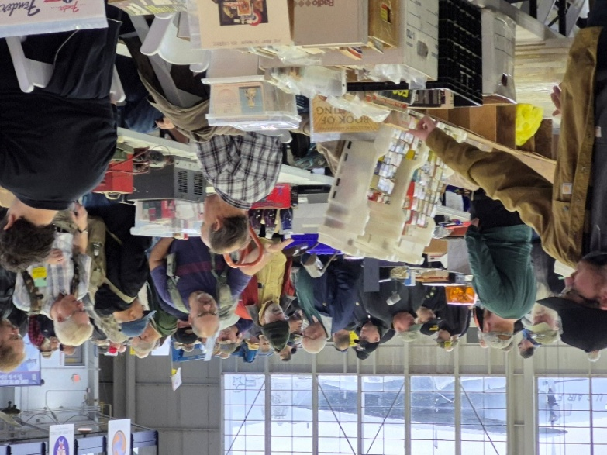
Great Lakes Division Hamfests

Here in the Great Lakes Division, we have over 50 hamfests a year.
So, if you haven’t started planning your hamfest schedule yet, you really need to start now.

Let's fully support all of our hamfests in every way possible. It means success for everyone. Be sure to invite your ARRL Officials as soon as your date is set.

If you are planning on having your hamfest listed in QST please be sure to start your planning well in advance of your Hamfest date, as this allows adequate time for QST Listings. QST announcements require a 3-month lead time.

To be fair to our division’s clubs, the Great Lakes Division policy now has 2 requirements.
Any club requesting ARRL sanctioning within the Great Lakes Division must now be an ARRL Affiliated Club with a maximum of two hamfests/swaps in any given calendar year, and they must be at least four months apart.

12/06/2025 - FCARC Winter Hamfest  Location: Delta, OH  Sponsor: FCARC  Website: https://k8bxq.org/hamfest  Learn More | 12/07/2025 - LCARC Amateur Radio Swap/Hamfest  Location: Troy, MI  Sponsor: L'Anse Creuse Amateur Radio Club  Website: http://www.n8lc.org  Learn More
2026
01/18/2026 - SCARF Hamfest  Location: Shade, OH  Sponsor: SCARF members  Learn More | 01/31/2026 - Struthers ROAR Mid-Winter Hamfest  Location: Struthers, OH  Sponsor: Struthers Regional Operators of Amateur Radio  Website: https://www.facebook.com/profile.php?id=61580196127715  Learn More
You can always find the latest information about upcoming hamfests on the Great Lakes Division website.


Just click to get the latest hamfest updates.

Have You Bought A Brick?

A Lasting Honor for a Special Radio Amateur
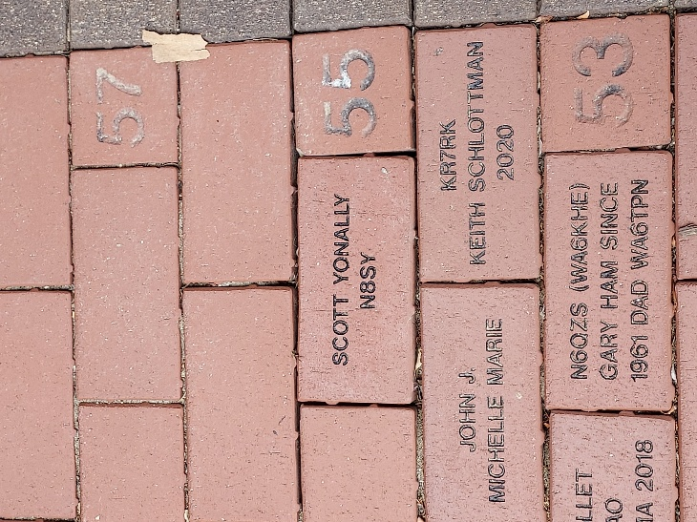
The ARRL Diamond Terrace is a distinctive opportunity to make a permanent mark at ARRL Headquarters in Newington, Connecticut. Started in 2007 and prominently located at the entrance to Headquarters, the Diamond Terrace is composed of inscribed bricks placed by committed ARRL Diamond Club members.

The Diamond Terrace recognizes donors who wish to honor their own call sign or the call sign of a special family member, Elmer, club or Silent Key. Amateur Radio organizations are welcome to participate to honor accomplishments and memorable occasions.
The Diamond Terrace at ARRL is part of the annual giving program. Donations to the ARRL Diamond Club provides financial support for programs not supported by member dues. Information about the different levels of giving and the benefits included at each level can be found here: The ARRL Diamond Club.Gifts at the Brass Level or higher include a brick in the Diamond Terrace.

Specially designed certificates representing the inscription on your brick are available upon request. Lucite brick replicas are also available for an additional charge of $30.00.

SPECIAL NOTE FOR MEMORIAL GIFTS: Individuals or clubs that wish to place a brick in the Diamond Terrace as a memorial to a Silent Key or to honor a friend or family member, may make a one-time donation of $250. Please complete the ARRL Brick Order Form to provide information on the brick inscription.

ARRL Year of the Club Newsletter Contest - Call for Submissions

Club Newsletter Contest — Call for Submissions!
As part of ARRL’s Year of the Club ARRL is hosting a Club Newsletter Contest.


A club newsletter can keep members informed of news and upcoming events, keep them interested between meetings and activities, teach them about ham radio skills and technology, or even make them laugh, remember, or set an operating goal — the sky’s the limit! ARRL wants to see what your club does with the mix of information that can go into a newsletter. Enter the Club Newsletter Contest for the chance to have your newsletter honored in QST. Here are the rules and requirements: The Club Newsletter Contest is open to ARRL Affiliated Clubs that have published a newsletter for at least one (1) year.

Submit PDF files of 1 year’s worth of consecutively published issues — no gaps — ending with your most recent issue. If your newsletter is monthly, submit 12 consecutive issues. If your newsletter is bimonthly, submit six consecutive issues. If your newsletter is quarterly, submit four consecutive issues.

Publication dates may span 2024/2025/2026, if necessary. For example, if your newsletter is published monthly and the September 2025 issue is your most recent publication at the time of your submission, send us all 12 issues from October 2024 through September 2025. Do not send additional issues once you have submitted 1 year’s worth of issues.

Submissions must include a completed Club Newsletter Contest Submission form www.arrl.org/club-newsletter-contest, which asks for information about your club and newsletter, as well as a 500-word statement on the purpose of your newsletter, and how the newsletter’s contents and design fulfill that purpose. Part of the judging process will include a comparison of these statements with the newsletter samples.

Winners will be notified in May 2026, with awards presented at Huntsville Hamfest in August 2026. Winners will be announced in a 2026 issue of QST, as part of ARRL’s Year of the Club celebration. The QST article may present material from the 500-word statements supplied in the winners’ Club Newsletter Contest Submission Form. Please note that winners may be asked to supply high-resolution files of specific newsletter pages.

Submission Deadline: Friday, January 30, 2026, 4 p.m. Eastern time.

All Ohio ARES Conference
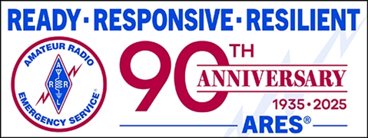
Come join us for All Ohio ARES Conference.

November 22nd 9am – 4pm
Informative presentations -- Door prizes

Bring your Go-Boxes and Comms vehicles to display.

Doors open at 08:30 - Sign in from 08:30 – 09:00

Seating is limited so please register today to reserve your seat. OSU/COTC

Newark, 1219 University Dr. Newark, Ohio 43055 (Warner Library Building)
Registration required.
>> Registration <<

Club Website Contest - Call For Submissions
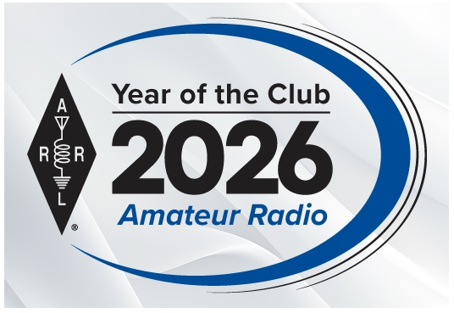
The Club Website Contest is open to ARRL Affiliated Clubs that maintain a club website. To enter your submission you must include a completed Club Website Contest Submission Form, which asks for basic information about your club and its website, as well as a 500-word statement on the purpose or goals of your website, and how the features and configuration of the website fulfill the purpose/goals. Part of the judging process will include a comparison of your statement with the website itself. https://www.arrl.org/club-website-contest

Submission Deadline: Friday, January 30, 2026, 4 p.m. Eastern time.

NOTE: Once you send your Submission Form, you may update content (text, images, data) on your website as needed, per your club’s normal operation, but you may not make significant changes to the site’s structure or functionality until April 1, 2026.

Winners will be notified in May 2026, with awards (a certificate or plaque) presented at Huntsville Hamfest in August 2026.

Winners will be announced in a 2026 issue of QST, as part of ARRL’s Year of the Club celebration. The QST article may present material from the 500-word statements supplied in the winners’ Club Website Contest Submission Form.

STOP – Right there!!!
We’ve come to the end…


Be Radio-Active --- See Ya’ Soon!

Radio Waves is produced as a look inside of the Great Lakes Division and all that it has to offer. It is our sincerest hope that you have enjoyed this edition and will encourage your friends to be a part of the ARRL and receive the latest news and information about the ARRL and the Great Lakes Division!

The pictures throughout this newsletter are from various newsletters, Facebook posts and/or were sent directly to me in recent weeks. Take a good look at them, you just might be in one of the pictures! “SMILE… you might just be in the Great Lakes Division News!!”

