
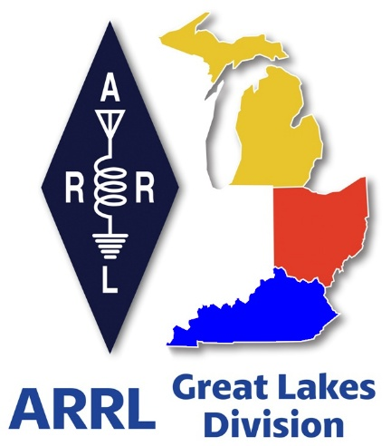
Radio Waves
^{The} Great Lakes Division
Monthly Journal
November 2025

Scott’s Stuff
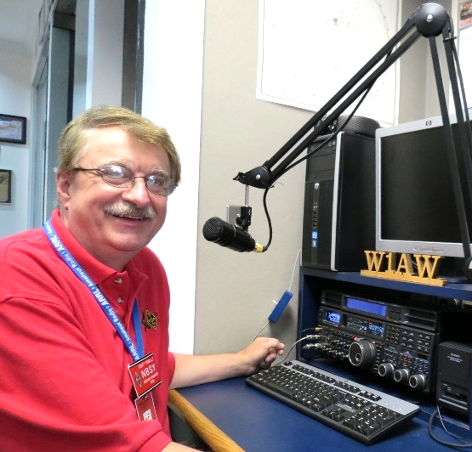
Hi Gang,

Wow, what a week this has been. For those of you keeping track, I had my second eye surgery this past week for cataracts, left eye this time. My vision is still a little blurry, but it’s coming along. My ophthalmologist says that I’m at a 20/20 -2 vision category. I guess that’s good. Anyway, things look so much brighter than before, so much so that I had to turn down the brightness on my monitor to about half of what it was.

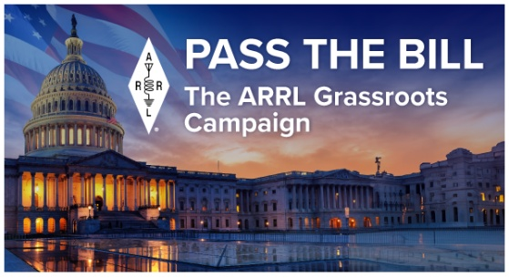
As I’m writing this just a few days before Halloween, Janie and I are preparing for “Beggers Night” here in the big Megatropolis of Lexington by getting the bags of candy out and ready to pass out to the kids as they come up the drive. Janie doesn’t buy candy that I like, so there’s little for me to steal. Most of the houses where we live are set back far enough from the street that not all that many kids like coming to our neighborhood. It’s too much walking for them, I guess. But the ones that do come get well rewarded.

Have you signed your letter to Congress yet? If not, please take just 1 minute of your time to “Send a Letter” All you have to do is type in your call sign and allow the form to fill in the rest of your information, then hit the big RED button to submit. It’s just that easy to do. You don’t have to be an ARRL member either. Any ham or licensed GMRS person is able to do this. And we want EVERY Ham in the Great Lakes Division to sign the letter.
Here’s a link to it… https://send-a-letter.org/hoa/

Oh… And not to skip over an even more important part of this effort, I need all the clubs in the Great Lakes Division to write letters too. Yes, it’s easy to do and we’ve even provided a sample letter where you just add in your club information and signatures of your club officer(s) to it and mail it off to our central collection point.

Here’s a link… https://arrl-greatlakes.org/hoa_club.html

The month of November is “birthday” month for the Yonally family. Me, Janie and our daughter were all born in November. No, I’m not going to give away the dates, but I will say that we are all exactly 14 days apart from each other. Now, with all the birthdays and let’s not forget the celebration of celebrations, Thanksgiving, November is quite a busy month around here.

Like many of you I have been working on getting things ready for winter. I’ve gone around and checked the poly ropes on the dipoles to make sure that they aren’t frayed, and the springs have the right amount of tension on them to take the snow and ice and still be operatable. No, I don’t have a beam here, I use a vertical and dipoles and find that I can compete with the best of them if I really stay at it. After a demonstration of Free DV by Ken Dorsey, KA8OAD, I’m really curious to see if I can get this new option up and running here. I can’t believe the difference that this software makes to take out all the junk and noise to hear nothing but a clear voice on HF SSB just like they are sitting next to you. If you haven’t heard this yet, I highly recommend that you do a little research on Free DV - https://freedv.org/

It’s like watching the waterfall on your radio for a FT-8 signal and seeing the text come through so precisely. Now this is pure magic for sure. Anyway, I’ll be working on this over the winter and will keep you all updated on my progress.
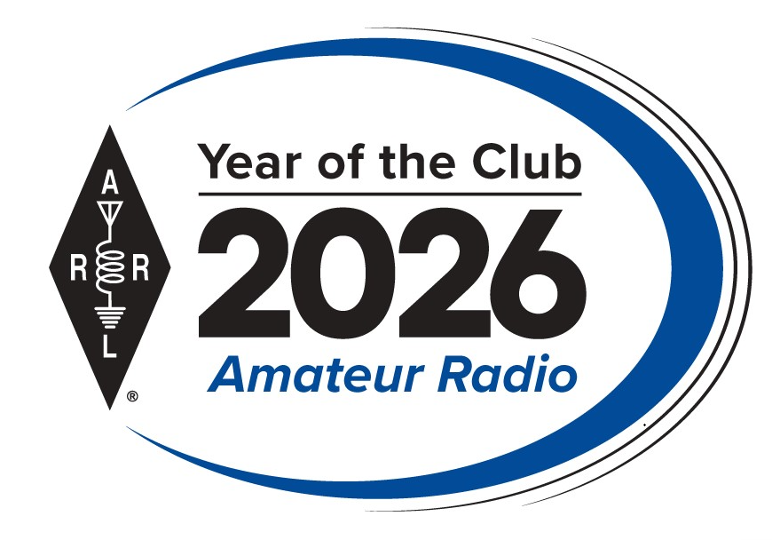
Now I want to discuss “The Year of the CLUBS” with you and your club. The EC FSC and HQ are working hard to get things all setup and running for this huge year long event.

As part of ARRL’s Year of the Club ARRL is hosting a Club Newsletter Contest and the sky’s the limit!

ARRL wants to see what your club does with the mix of information that can go into a newsletter. Enter the Club Newsletter Contest for the chance to have your newsletter honored in QST.

Click Here for the rules and requirements: https://www.arrl.org/club-newsletter-contest

Oh, and has your club entered the Website Contest yet? This is open to ARRL Affiliated Clubs that maintain a club website.

Submissions must include a completed Club Website Contest Submission Form, which asks for basic information about your club and its website, as well as a 500-word statement on the purpose or goals of your website, and how the features and configuration of the website fulfill the purpose/goals. Part of the judging process will include a comparison of your statement with the website itself.

Click here to go to the Submission Form… https://www.arrl.org/club-website-contest

Ok… that’s going to just about do it from here this time around. Clubs, you have your assignments, let’s get moving and show the rest of the country that the Great Lakes Division is second to NONE…!!!

Enjoy the bands and get Radio Active, but above all, regardless of your preferred mode or band, remember the golden rules of our incredible hobby: Have FUN, be respectful and most importantly, Get On The Air!

73, Scott…

Scott Yonally, N8SY
Director - Great Lakes Division
n8sy@n8sy.com

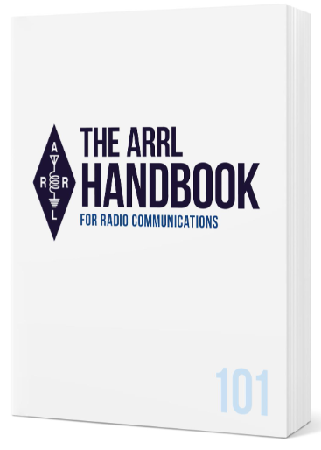
Handbook Give Away

How’s about I give away an ARRL softcover Handbook absolutely FREE !!!

Yes, I’m holding a little contest to "GIVE AWAY" a 2025 ARRL softcover Handbook. Why you ask? It’s to get you to check-in to the Great Lakes Division website and take a look around.

Getting signed up is just as simple as filling out a couple of quick questions and you’re entered!!

>> Click Here To Enter <<

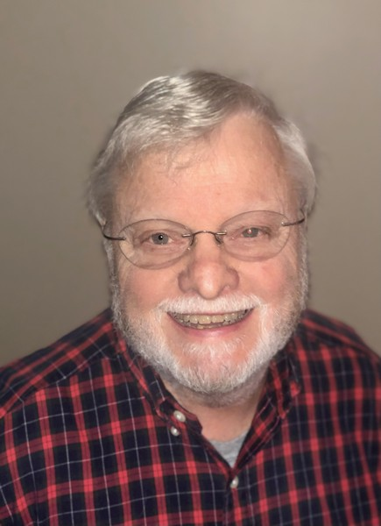

Being a “Relic”
Roy Hook, W8REH
Vice Director – Great Lakes Division

Being a “relic” might not be easy

I was in a conversation where a comment about a particular hamfest being a relic event was made. It kind of hit a nerve with me, but I wasn’t sure why. It prompted me to research the term “relic” and I found an amazing number of definition entries. This list was much, much longer, but in attempting to pick one, the following made my top 10.

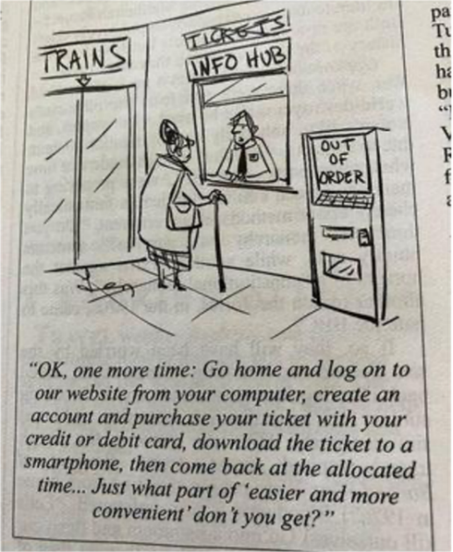
- An object having interest by reason of its age or its association with the past.
- An object from the past, esp. one that has no modern use but is often valued for its meaning or importance in history
- Something that has survived the passage of time, especially an object or custom whose original culture has disappeared.
- Something cherished for its age or historic interest.
- A surviving memorial of something past.
- A surviving trace of something.
- An object kept for its association with the past; a memento.
- That which remains; that which is left after loss or decay; a remaining portion; a remnant.
- The body from which the soul has departed; a corpse; especially, the body, or some part of the body, of a deceased saint or martyr.
- A memorial; anything preserved in remembrance.
Some may think being a “relic” is just part of getting old but I see examples of people who have chosen to not allow that to happen. Some are even famous enough you may have heard of them.

Albert Einstein, Grace Hopper, Jane Goodall.

“What you do makes a difference, and you have to decide what kind of difference you want to make.” - Dr. Jane Goodall

These people have persevered a lifetime, without getting sucked into old thinking. American Grace Hopper (1906–1992) was a computer scientist, mathematician, and US Navy rear admiral who pioneered machine-independent programming languages and compilers which are the roots of modern programming languages of today including COBOL which most of us have heard of. She was known for keeping a clock that ran backward. She would explain, “Humans are allergic to change”. They say things like, we've always done it this way or that can’t be done. The famous quote from Dr. Jane Goodall (chimpanzee researcher) who recently passed at age 91, “What you do makes a difference, and you have to decide what kind of difference you want to make” should make us think. Her discoveries are said to have redefined what it means to be human. I am often told that it’s just human nature to be resistant to change. Is “human nature” just another term for instinctive?

Are humans born with these or are they learned behaviors? Can they be modified? It seems many forces impact human nature among which some are fear, pain, hunger, etc. Could fear of losing aspects of the hobby we personally enjoy drive resistance to change? Getting outside our comfort zone can be very difficult and uncomfortable. That’s why it’s called the comfort zone. We can learn a lot from everyone and should value both new and old thinking.

Further pondering my own relic-ness (is that a word?), I realized there must have been a point in time I was not perceived as a relic. How did I view the relics of my younger days? How do others view and interact with relics today? Is that what we call the generation gap? Is it possible to build bridges instead of fortifying walls?

Everyone will grow old, but it's a choice to give up youthful exuberance and curiosity. Are we lifetime learners or just relics? Amateur radio skills are not static and can be useful in entertaining relics as well as provide an interesting playground for curious contemporary and futuristic thinkers at the same time. How we figure out to do that will define the future. How do you think we can do that?

Let’s talk. royehook@gmail.com W8REH@ARRL.org

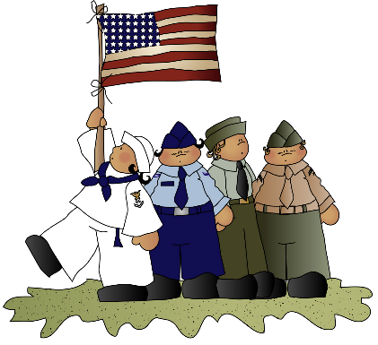
Don’t Forget Our Vets…

As I set here this morning with a fresh cup of coffee perusing the internet to see what the latest crisis in the world is, I noticed that we are already in the beginnings of November. How the heck did that happen so soon?

As I do every year, I organize our local Veterans in our radio club (and beyond) to meet together for our annual pilgrimage to our local Applebee's Restaurant, who, among other restaurants, offer a free meal for veterans on our very own holiday. We utilize this opportunity to get together, swap tall tales and war stories and generally reminisce about our individual tours of duty in the service of our country.

There are a significant number of restaurants that offer free meals to veterans, and I mention Applebee's as we have one here in Coldwater and meeting there is convenient and their food is good. A quick search for 'free veterans day meals' will get you a number of restaurants that do this on Veterans day.

I suggest that those in our individual radio clubs that are military veterans make an effort to meet up with fellow vets and enjoy a meal together. This is a great way to make new friends and swap tall tales. Pick a participating restaurant near you and make it happen!

73,
--
Larry, WB8R

50th Year of Remembering the Edmund Fitzgerald

This year marks the 50th Anniversary of the tragedy which claimed the lives of 29 sailors and the mighty ship on November 10, 1975.

The ship rests at the bottom of Lake Superior. W8LRK - Livingston County Amateur Radio Klub will be sponsoring this event with several members of the club. We will operate special event stations N8F, K8F & W9F from the Upper Peninsula of Michigan.

Lark members and guests will be travelling to Michigan's Lake Superior to do Special Event radio operation 'Remembering the SS Edmund Fitzgerald'. We will be there from Nov. 5th - 9th (Bonus 10th) modes will be mostly SSB and FT8 / FT4

In addition to the certificate below, we have commissioned a Special Commemorative QSL Card:

2025 EDMUND FITZGERALD

QSL Information for Commemorative QSL Card:
W8LRK
PO BOX 283
Howell, MI 48844

US Hams, please send a SASE or +$1 postage - International Hams please send SASE with international postage or +$2 Postage

QSL requests that do not follow these instructions may be delayed indefinitely.

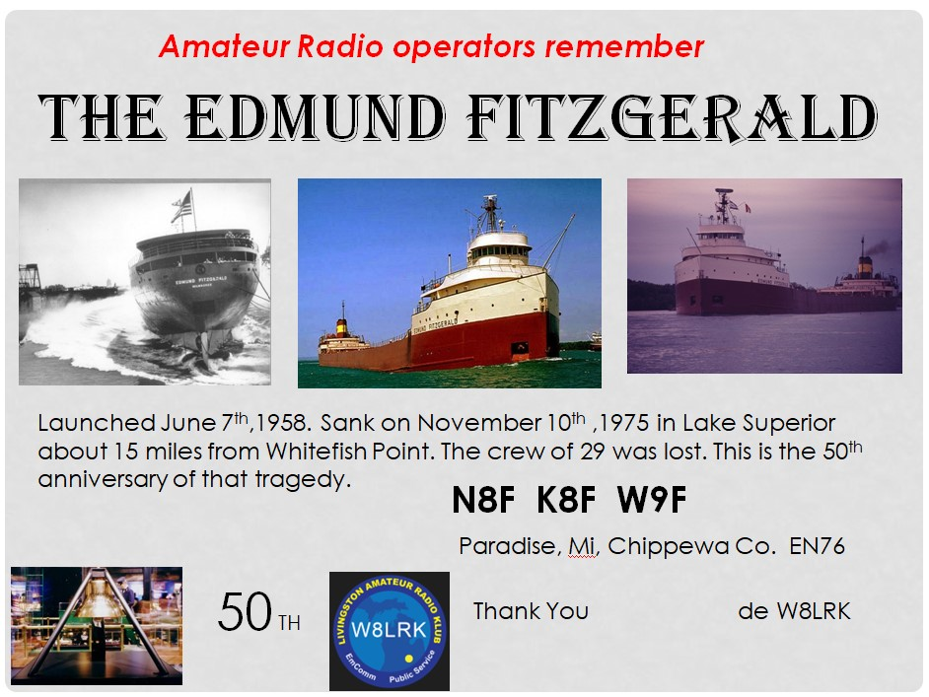

The ARRL Foundation Scholarship Program

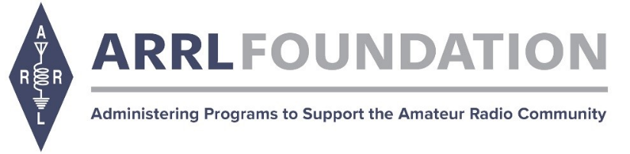
Thank you for your interest in the ARRL Foundation Scholarship Program for eligible amateur radio operators pursuing higher education. The ARRL Foundation manages more than 150 scholarships established by generous donors ranging from $500 to $25,000.

Click HERE for the scholarship application.

Applications will be accepted through December 30, 2025 at 12:00 PM EST.

The ARRL Foundation Scholarship Committee will review all applicants for eligibility and award decisions. All applicants must be an active, FCC-licensed amateur radio operators.
[NOTE: Active foreign amateur radio operators are eligible for the ARDC Scholarships].

All applicants must submit a completed online application. Transcripts and any additional required documents must be submitted WITH the application and not emailed separately. A number of scholarships require additional documents, such as a letter of recommendation from a sitting Officer of an ARRL-affiliated club. Applications without accompanying transcripts and additional required documents (if applicable) will not be considered. Scholarship recipients will be notified in June.

Awards are mailed directly to recipients' schools and will be awarded in July.

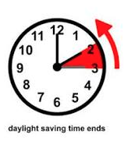
Daylight Saving Time Coming To An End

Nov 2, 2025 - Daylight Saving Time Ends

Sunday, November 2, 2025, 2:00:00 am clocks are turned backward 1 hour to local standard time instead.

As we adjust to the time change, it's a good opportunity to review your daily routines and make sure you're prepared for the shift in daylight hours. Whether it's planning outdoor activities to take advantage of the early morning light or ensuring your home is ready for longer evenings, a little foresight can help you transition smoothly into standard time.

CARBON MONOXIDE (CO) POISONING
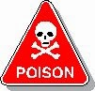
Hi Gang,

I’m sure that a number of you are asking what the heck is the Division Director writing about this stuff, it’s not Amateur Radio related!! Well, my friends, you are very mistaken. It’s not only Amateur Radio related, but also something that as a HAM operator you may not ever have thought about. Where's your ham shack located? In the basement, garage or outbuilding. Most generally ham shacks are not in the living room or main part of the house. As such, heating devices are usually some sort of a supplemental heater/furnace, and that’s why I’m writing about this.

First, let’s describe what Carbon Monoxide (CO) is. Carbon Monoxide (CO) is the poisonous gases emitted from carbon fueled heat sources (i.e... gas or fuel oil furnaces, wood burning fireplaces or stoves, kerosene heaters, propane heaters). I could go on but I think you get the idea. It’s colorless, odorless and it will definitely kill you if you breathe very much of it in. How does this gas kill? It actually migrates into the blood stream and replaces the oxygen in your blood with the Carbon Monoxide. Once it invades your blood stream it will be with you for a very long time, in fact, most of your life! Just ask any firefighter about that. Going into burning buildings without a Self-Contained Breathing Apparatus (SCBA) on will definitely subject you to Carbon Monoxide poisoning, and it takes years and years to get it out of your system, if ever. Sometimes, if consumed in a large enough quantity, you may need a complete blood transfusion to just keep you alive. Yes Virginia, it is that deadly!!
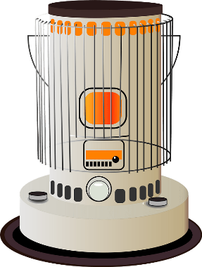
Why am I writing about this? It’s very personal to me. A number of years ago a very close friend (and his entire family) died in their sleep because they consumed Carbon Monoxide (CO) without knowing it. They lived in an old house on the north side of Mansfield and because it was old, it was drafty with leaks around the doors and windows, and the walls didn’t have any insulation in them. We had gotten a cold snap in early November, and back in the middle 1970’s kerosene heaters were all the rage to supplement heat in just this kind of house. Well, with the help of my co-workers we were able to purchase a big kerosene heater to help them through this cold snap. They got the heater all set up and running and all was fine for the first several days, then on the third day the dad came to work complaining of a very bad headache. None of us thought much about it that day and the dad continued his job on the assembly line with the rest of us. The next afternoon we all found out that the heater had been malfunctioning, and every member of the family had died of this very dangerous gas.

I was absolutely torn apart. I had been one of several people at work that help take up the collection to purchase the heater. It took me a long, long time to get over that. Don’t get me wrong, there’s nothing wrong with using these types of supplemental heating sources but be very careful when you do.

At that time CO detectors were truly non-existent for homes, and the ones that were available were for scientific and commercial use and cost hundreds and hundreds of dollars. That’s all changed now. CO detectors are as cheap now as smoke detectors. You can get one for as little as $10 now. That’s an extremely cheap form of protection from this deadly gas.

Winter is almost here. I don’t know how it is at your house, but here in the little burg of Lexington, when it gets cold outside, you’ll see the smoke coming out of many chimneys around here. That means that the temperature has dropped to below where it is comfortable. This is the point where the furnaces come on and people start thinking about lighting up the fireplaces and so forth.

Now if these devices haven’t been recently serviced, birds can make nests in the chimney’s and like your car, the heat source most likely needs a tune-up to make sure that it’s running efficiently and safely. Having the chimney stuffed up with bird nests or the heat source not burning correctly can cause Carbon Monoxide to accumulate in your house without you even knowing it. That’s where the CO detector comes into play... Please, please buy one or two of these really inexpensive CO detectors for your safety and use it!

By the way, it’s not all about detection either. Do you have a properly rated fire extinguisher within your reach? If not, get one. Learn how to properly use it. It will save you from a lot of damage if you know how to use it properly. Don’t assume that all you do is pull the pin and squeeze the trigger. It’s about knowing how to sweep and aim at the base of the fire. Do yourself a HUGE favor, buy a cheap extinguisher and teach your entire family how to properly use the extinguisher! Yes, even the kids need to know how to use it!

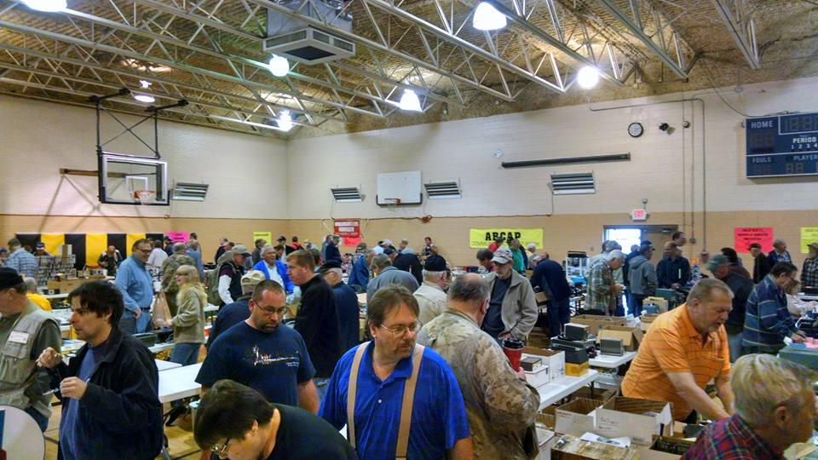
2025 Great Lakes Division Hamfests

Here in the Great Lakes Division, we have over 50 hamfests a year.

So, if you haven’t started planning your hamfest schedule yet, you really need to start now.

Please post this listing in your club's newsletter and announce the swaps on your local nets. Talk them up.

Let's fully support all of our hamfests in every way possible. It means success for everyone. Be sure to invite your ARRL Officials as soon as your date is set.

If you are planning on having your hamfest listed in QST please be sure to start your planning well in advance of your Hamfest date, as this allows adequate time for QST Listings. QST announcements require a 3-month lead time.

To be fair to our division’s clubs, the Great Lakes Division policy now has 2 requirements. Any club requesting ARRL sanctioning within the Great Lakes Division must now be an ARRL Affiliated Club with a maximum of two hamfests/swaps in any given calendar year, and they must be at least four months apart.

11/02/2025 - 2025 MARC Hamfest at MAPS  Location: N. Canton, OH  Sponsor: Massillon ARC  Website: http://www.w8np.net  Learn More | 12/06/2025 - FCARC Winter Hamfest  Location: Delta, OH  Sponsor: FCARC  Website: https://k8bxq.org/hamfest  Learn More
12/07/2025 - LCARC Amateur Radio Swap/Hamfest
Location: Troy, MI
Sponsor: L'Anse Creuse ARC
Website: http://www.n8lc.org
Learn More

You can always find the latest information about upcoming hamfests on the Great Lakes Division website.
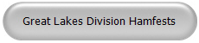
Just click to get the latest hamfest updates.

Send a Radiogram… What’s a Radiogram?

You’ve probably heard of amateur radio (“ham”) operators, and you might know a friend, family member, or neighbor who loves to build radio equipment and talk to thousands of other ham operators around the world!

But, you might not know that amateur radio operators are primed and ready to step in and provide valuable communications to the general public, when all else fails. Even if Internet service, power lines, and phone lines are all down, amateur radio still can get the message through. To be ready for this, many amateurs have joined a network called the National Traffic System (NTS), which is like a telegraph office over radio. NTS volunteers spend their free time relaying messages, called Radiograms, entirely by amateur radio, completely free of charge.
This is great practice to be sure they can serve the public during a true emergency!

Send a Radiogram Now — It’s Free! Radiogram – NTS

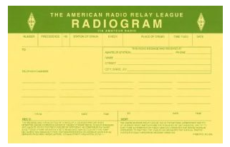
Now, there’s a way that YOU can try Amateur Radio messaging! Think of a friend or family member you’d like to contact by Radiogram. You can send any short message, as long as it’s not business-related, urgent or critical, or too private or personal. Your message will be picked up by an Amateur Radio volunteer operator and relayed across the country to near its destination; finally, the recipient will get a local phone call from a nearby ham, or the message might even be delivered in person.
Along the way, ham operators will be relaying your message by voice, digital, or even Morse code, and getting valuable practice in emergency public service. To make it easy, please choose one of the standard message texts contained in the form.

(Note: Both the sender and the recipient must be in the United States or Canada).

Club Links

I’ve received a number of new requests from clubs to be listed on the “Links” club page.

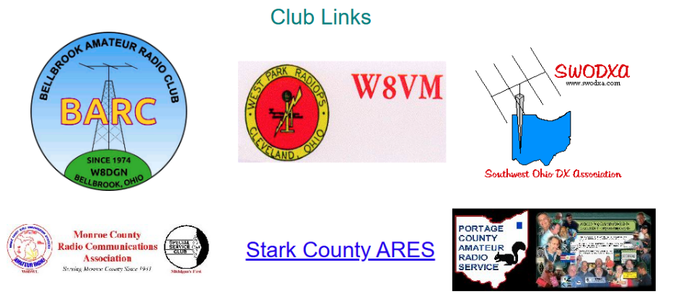

Is your club listed? If not, send the URL of your club website to me n8sy@n8sy.com and I’ll get it listed.


All Ohio ARES Conference
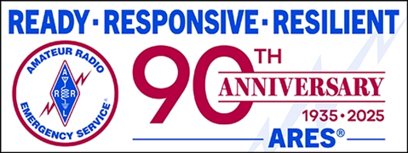
Come join us for All Ohio ARES Conference.

November 22nd 9am – 4pm
Informative presentations -- Door prizes

Bring your Go-Boxes and Comms vehicles to display.

Doors open at 08:30 - Sign in from 08:30 – 09:00

Seating is limited so please register today to reserve your seat. OSU/COTC

Newark, 1219 University Dr. Newark, Ohio 43055 (Warner Library Building)
Registration required.
>> Registration <<

Bringing back great memories of learning CW
Scott, N8SY

I had an encounter at a hamfest recently and the conversation began innocently enough, sparked by an article about my first car. For many, that initial set of wheels represented freedom and youthful ambition. Some even asked me what’s an article about an old car having to do with ham radio.

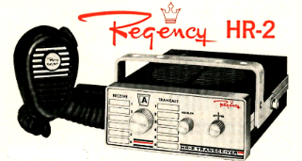
Well, for some of the old hams, it often meant the thrilling prospect of installing their first mobile rig in it, and the gentleman at the hamfest fondly recalled mounting his old HR-2B Regency 2-meter radio under the dashboard of his first car. "You had so much room back then," he mused, "even for the biggest of radios. Now days you barely have space enough for your knees, let alone a radio."

This seemingly simple observation, about car interiors, acts as a powerful metaphor for the broader shifts in technology and skill. Older vehicles, less cluttered with intricate electronics and safety features, offered a blank canvas for customization. Similarly, the world of amateur radio, while always at the forefront of communication technology, once demanded a more hands-on, foundational skill: the mastery of Morse Code.

The discussion naturally turned to the once-mandatory Morse Code requirement for obtaining an amateur radio license. For decades, passing a CW proficiency test was a rite of passage, a barrier to entry that ensured operators possessed a fundamental understanding of radio communication and a certain level of discipline. It wasn't just about sending and receiving; it was about connecting with the very essence of wireless communication, where signals were interpreted aurally.

Both of us recounted the arduous process of learning CW. It wasn't a skill easily acquired; it demanded patience, persistence, and countless hours of practice. This shared struggle created a unique bond even among the most seasoned of hams, a silent understanding of the effort invested.

The methods for learning CW seem to be as varied as the people themselves. The hamfest visitor shared his experience through the U.S. Navy. "I sat in a classroom for eight hours a day, doing nothing but copying code," he explained, describing an immersive, intensive environment designed to forge disciplined radio operators.

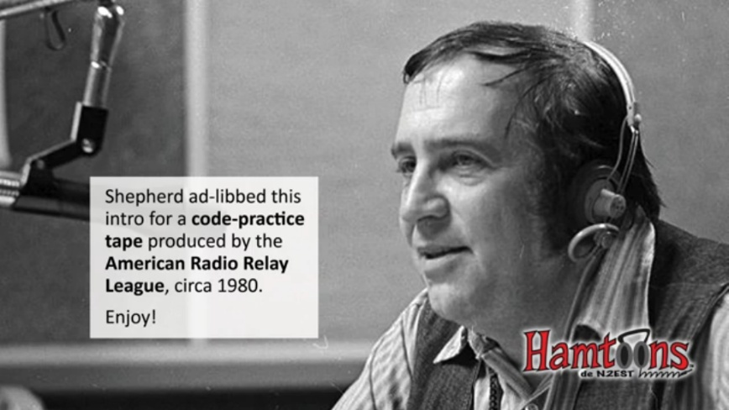
This formal, structured approach was common in military and commercial settings, where speed and accuracy were critical for operational effectiveness. My own journey, however, took a more informal, yet equally dedicated, route. For months, my kitchen table was transformed into a classroom. Every night, I would setup the tape recorder and play back the voice of Jean Shephard, K2ORS – a legendary radio personality, author, and humorist whose broadcasts were not only entertaining but also highly educational for aspiring hams. Shephard, famous for his storytelling (and immortalized by the film "A Christmas Story," which he narrated and co-wrote), had a very unique gift for making the monotonous task of copying random letters and numbers engaging. His soothing voice, interspersed with encouraging remarks, guided me and countless other individuals through the intricacies of dots and dashes, turning what could have been a solitary chore into a communal learning experience. The distinct sound of his voice still evokes those long nights, diligently scribbling down characters, making an indelible connection to a beloved holiday film.

The challenge of learning CW wasn't just about passing a basic test; it was a continuous journey of improvement. For many hams, the ultimate goal was to achieve the highest class of license: the Amateur Extra. Back then, this required not only advanced technical knowledge but also proficiency at a higher CW speed, that dreaded 20 words per minute (WPM).

The path to Extra was often paved with intense self-motivation and external encouragement. My boss at the time, himself an Extra class licensee, was a strong advocate for upgrading. I held an Advanced class license, as did my older brother Gary, WA8BIW. For many, the Advanced test was considered the most challenging of all, requiring a deep dive into complex radio theory with questions from Novice all the way up to Extra included. Overcoming that hurdle made me hesitant to take on yet another arduous test. However, the combination of my boss's unwavering push and the tantalizing prospect of "getting one up" on my big brother provided the final impetus.

This decision meant many more months of dedicated practice, returning to those old, but very useful cassette tapes that the ARRL and Jean Shephard produced.

The repetition of listening to random code, followed by his reassuring voice and witty banter, became a nightly ritual. It wasn't just about memorizing patterns; it was about developing a subconscious understanding, where the individual dits and dahs coalesced into recognizable characters and then entire words. The satisfaction of finally hearing that one had passed the 20 WPM test by the FCC examiner was immense – a testament to countless hours of focused effort and mental endurance.

I almost decided to quit right then and there. I felt like I had just given birth to a 900-pound gorilla. I was exhausted, but I decided that I wasn’t going home without being able to “one up” my big brother. And I passed that written test too. I was now KC8SS – EXTRA. Wow..

With the removal of the mandatory CW requirement for amateur radio licenses in most countries, including the U.S., one might expect the skill to fade into obscurity. Yet, something remarkable is happening, there's an "insurgence of new folks that now want to learn CW." In an age of instant gratification, why are new enthusiasts voluntarily embracing a discipline once seen as a formidable hurdle?

I believe the answers lie in the unique benefits and intrinsic satisfaction that CW offers. For many, it's a deep dive into the roots of radio communication, connecting them to a rich history of telegraphy and early wireless pioneers. CW is incredibly efficient; it can be copied under extremely noisy conditions where voice communication would be impossible, and it requires less power to transmit over long distances, making it ideal for low-power (QRP) operations and emergency communication.

Beyond the practical advantages, there's a profound sense of accomplishment in mastering CW. It's a skill that transcends language barriers, allowing hams from across the globe to communicate using a universal code. The act of listening to the rhythmic flow of dots and dashes, decoding them in real-time, and responding in kind, fosters a unique form of mental engagement and mindfulness.

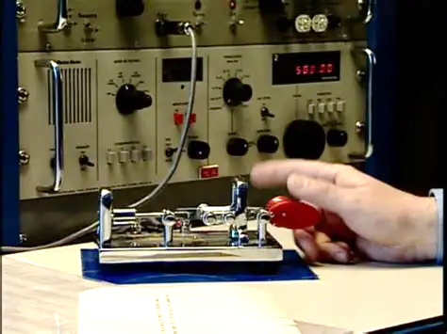
It's a challenging intellectual puzzle, a personal discipline, and a shared passion all rolled into one. The successful copying of a 20 WPM message isn't just a test passed: it's a badge of honor, a confirmation of mastery over a demanding, yet infinitely rewarding, skill.

The journey from struggling with random letters and numbers at a kitchen table to effortlessly engaging in CW conversations across continents is a testament to perseverance. The shift from ample under-dash space for large radios to today's cramped car interiors symbolizes the broader evolution of technology. Yet, within the amateur radio community, the enduring appeal of Morse Code reminds us that some challenges, though demanding, offer a timeless form of entertainment, connection, and profound personal satisfaction and comradery that continues to captivate new generations of learners.

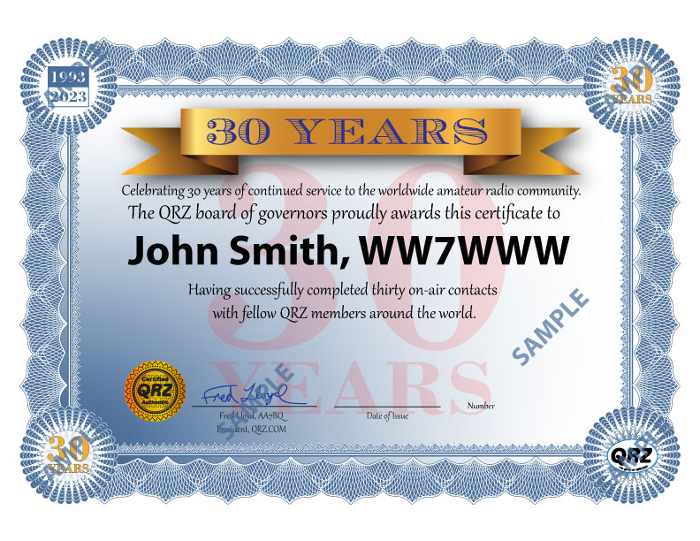
New Operating Award Celebrates QRZ’s 30th Anniversary
It’s been eight years since QRZ began its operating awards program and in that time, they have issued over 373,000 awards. They want to thank all of you who use the QRZ Logbook on a daily basis, and there are A LOT of you. At this time, QRZ logbooks contain over 817 Million QSOs!
There newest operating award is called the 30 Years of QRZ Award and it is based solely on communications between QRZ users. The award is achieved when an operator has successfully completed on-air contacts with 30 members of QRZ from around the world. The award celebrates QRZ’s 30th Anniversary by recognizing your achievements.

Want more details? >> Click Here <<

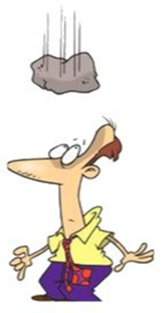
Murphy’s Law…

Laws of Government
1.If anything can go wrong, it will do so, in triplicate.

2.Things go right so they can go wrong.

3.Men and nations will act responsibly when all other possibilities
have been exhausted.

4.Life liberty or property are not safe while the legislature is in session.

STOP!!!
We’ve come to the end…



Be Radio-Active --- See Ya’ Soon!

Radio Waves is produced as a look inside of the Great Lakes Division and all that it has to offer. It is our sincerest hope that you have enjoyed this edition and will encourage your friends to be a part of the ARRL and receive the latest news and information about the ARRL and the Great Lakes Division!

