
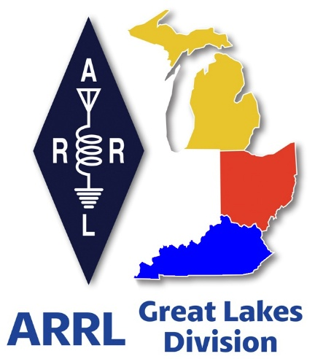
Radio Waves
^{The} Great Lakes Division
Mid- Month Report
December


From the Michigan Section Manager

Michigan ARRL Section

Good morning to all who read this and welcome to my final opportunity as Michigan Section Manager to comment directly to the members of the ARRL Great Lakes Division.

Effective January 1, 2026, there will be a new Michigan Section Manager. Ralph Katz, AA8RK has stepped forward to lead the Michigan Section. Ralph and I have spent some time together in recent weeks and I am certain that he will do a great job representing the hams of Michigan (and beyond). As 2026 approaches, the hams of Michigan are already at work planning hamfests and other activities for the coming year.

On a personal note, I reflect on many years of working with our Great Lakes Division in one capacity or another and will miss the friendly banter with Scott concerning the usual MI/OH rivalries. I also enjoyed the conversations with Roy as we discussed the problems of the world at Dayton.

I am looking forward to a calendar that is less filled with planned activities and just slowing down a bit.

I very much appreciate the opportunity to serve Amateur Radio and the ARRL.

Best 73,

Larry, WB8R


From the Ohio Section Manager
Tom Sly, WB8LCD

The latest edition of the Ohio Section Journal is now online and ready
for you to read! There’s an awful lot of Ham Radio activities going on
in the Ohio Section, so get off the chair or couch you’re sitting on
and get out there, get involved, and get on the air!
The link below will take you directly to the Ohio Section newsletter.

https://arrl-ohio.org/wp-content/uploads/2025/12/OSJ-December-2025.pdf

Tom… wb8lcd@arrl.org


From the Kentucky Section Manager
Bob Selbrede, K6ZZ

Greetings and Happy Holidays to my fellow Kentucky hams!

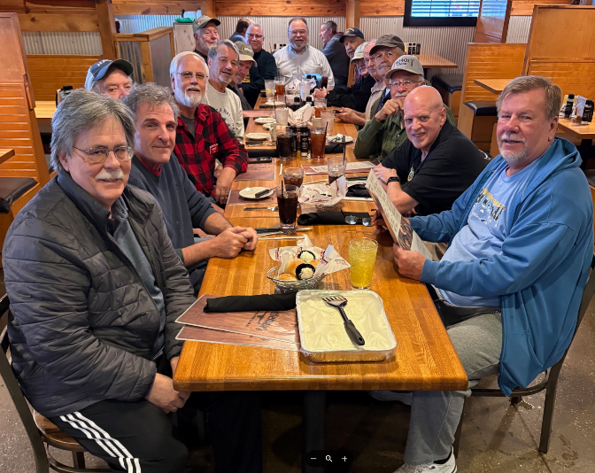
It has been another busy month. As I mentioned last month, a lot of focus is being placed on trying to get ARES in Kentucky healthy again. I am pleased to announce we finally have a new Section Emergency Coordinator (SEC). The Kentucky SEC is Mr. Dennis Lutz, W2QN. Dennis brings a lot of background and experience in several areas of Emergency Management, and he has a real passion for ARES, which is great. Dennis feels strongly about getting Kentucky back on track when it comes to ARES, and he is working hard to accomplish that goal. If you are interested in helping, please reach out to Dennis and let him know. His email address is dennislutz2@aol.com.

We still need Emergency Coordinators in many Counties and a few District Emergency Coordinators as well. A huge thank you to Dennis for helping to take on this big task. ARES is vitally important for obvious reasons. One of the less obvious reasons is ARES helps secure the future of Amateur Radio. Every time you turn around it seems like someone wants a chunk of our spectrum or wants to limit our ability to install antenna systems. Our willingness and ability to provide Emergency Communications services in times of disaster helps to defend the need for Amateur Radio.

If you are a member of an ARRL Affiliated Club, keep your eyes open for information about next year's America 250 WAS Program and opportunity to operate as W1AW/4. Details will be sent out soon. The Kentucky Affiliated Club Coordinator (ACC) Steve Morgan W4NHO will be in touch with affiliated clubs and will be setting up the operating schedule for W1AW/4.

Until next time...

Thanks for your time!

73, Bob K6ZZ
Kentucky Section Manager
K6ZZ@ARRL.ORG

Do you know someone who is not getting this newsletter


Hi Gang,

If you know someone who isn’t already getting Radio Waves, have them sign up to receive it!! They don’t have to be ARRL members to sign up, just click on the button below and in no time, they will start receiving it.



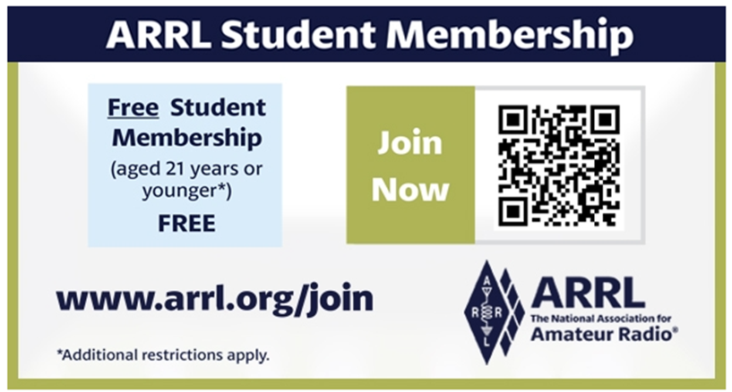

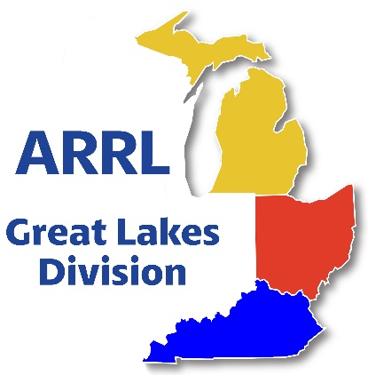
Scott’s Stuff

Hi Gang,

Happy Holidays from the ARRL Great Lakes Division: Spreading Joy and Peace on Earth

As the holiday season is upon us, I want to take a moment to wish each and every one of you a very "Happy Holidays"! It's that time of year when we come together to spread love, kindness, and peace on earth. But let's not forget to also bring happiness and joy into everyone's life as well.

I just got back from a trip to ARRL Headquarters, where I attended the Administrative and Finance (A&F) Committee meeting. It was an informative and productive meeting, and I'm excited by some of the great ideas that came out of that meeting. Over the coming weeks, you can expect to hear more about the health and longevity of the ARRL, as well as some new ideas and initiatives that are in the works. One thing is for sure - the ARRL is committed to continuing to serve YOU, the amateur radio community, and provide the best possible resources and support to its members.

December is always a busy month for contests, and this year is no exception. Whether you're a seasoned contester or just starting out, there's something for everyone. Here are just a few of the contests and events you can look forward to:

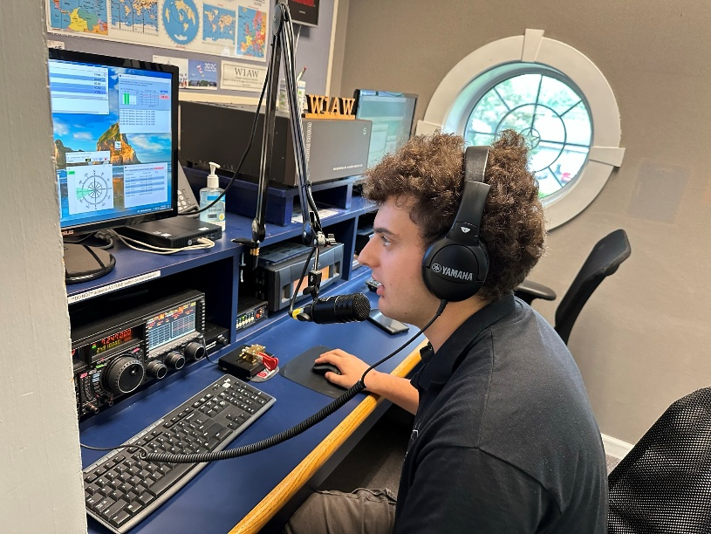
ARRL 10 Meter Contest: This popular contest is a great way to get on the air and make some new contacts.

ARRL RTTY Roundup: If you're interested in digital modes, this is the contest for you.

ARRL International DX Contest: This contest is a great opportunity to work stations from around the world and add some new countries to your list.

ARRL VHF Sweepstakes: If you're interested in VHF and UHF operating, this contest is a must-do.

These are just a few examples of the many contests and events that are happening in December. Whether you're a casual operator or a serious contester, there's something for everyone.

In addition to the contests and events, the ARRL is also working on some new programs and initiatives.

2026 will be the “Year of the Clubs” and we have lots of exciting things for clubs this coming year. The ARRL will be working closely with clubs to provide support and resources. If you're a club member or leader, be sure to check out the latest news and updates.
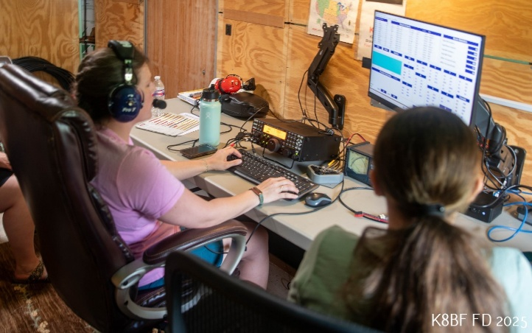
Youth programs: The ARRL has always been committed to promoting amateur radio to young people and providing resources and support to help them get started.

As we move forward into the new year, I want to encourage all of you to get involved and work together to promote amateur radio and the ARRL. Whether you're a seasoned operator or just starting out, there are many ways to get involved and make a difference.

Here are just a few ideas:
Join a club: Clubs are a great way to meet other operators and get involved in local activities.

Volunteer: The ARRL is always looking for volunteers to help with events, contests, and other activities.

Spread the word: Share your passion for amateur radio with others and help to promote the hobby.

As we celebrate the holiday season, I want to thank each and every one of you for your support and participation in the ARRL. It's a privilege to be a part of this community, and I'm excited to see what the future holds. Whether you're a contest enthusiast, a casual operator, or just starting out, there's something for everyone in the world of amateur radio. So, let's come together to spread joy, kindness, and peace on earth, and make the most of this special time of year. Happy Holidays, and I look forward to hearing you on the air!
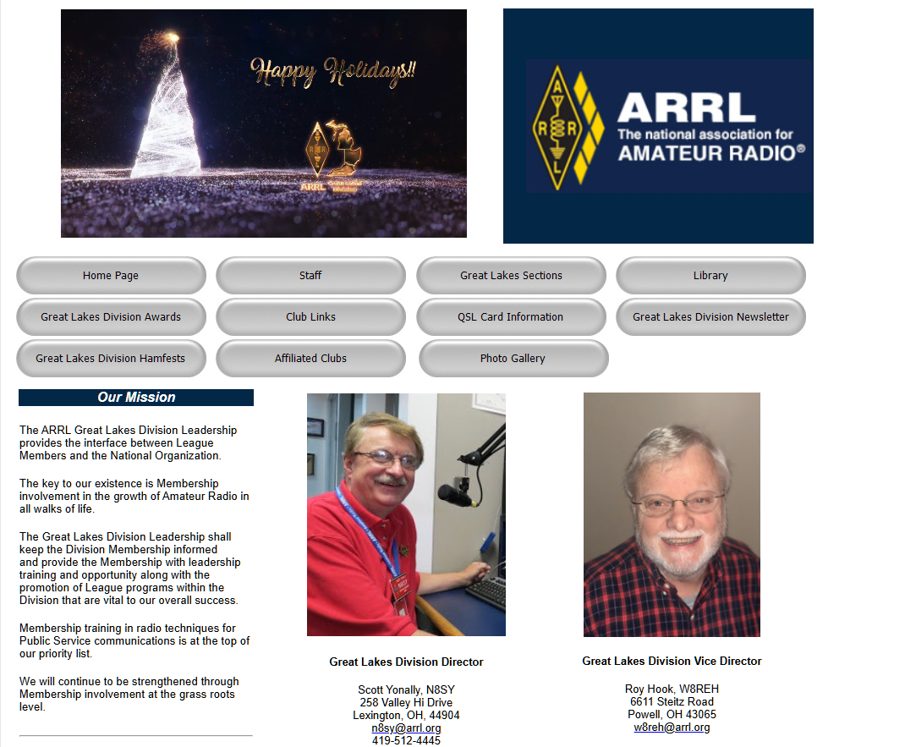
Have you taken a look at the Great Lakes Division website lately? It changes all the time with new information and even some new graphics once in a while. If you haven’t visited lately, go now…

https://arrl-greatlakes.org

Oh, by the way, that’s why I am doing a “Handbook Give Away..” to get you to go to the website!!!

Now, if you’ll excuse me, I think I hear a glass of egg nogg calling my name…

That’s going to do it from here this time around. Catch you on the air, in a club meeting, or at a hamfest! Until then, Be Radio Active!!!!!

73,

Scott, N8SY
Great Lakes Division Director
n8sy@arrl.org

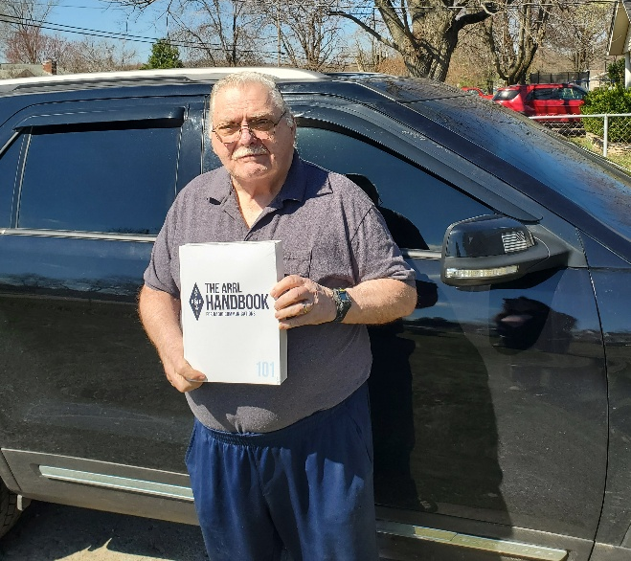
Handbook Give Away – Have you
entered yet???

How’s about I give away an ARRL softcover Handbook absolutely FREE !!!

Yes, I’m holding a little contest to "GIVE AWAY" a 2025 ARRL softcover Handbook. Why you ask? It’s to get you to check-in to the Great Lakes Division website and take a look around.

Getting signed up is just as simple as filling out a couple of quick questions and you’re entered!!

>> Click Here To Enter <<

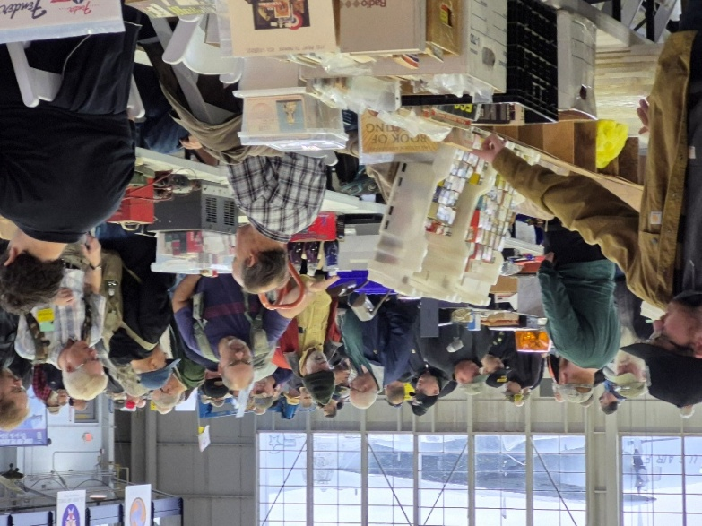
Great Lakes Division Hamfests

Here in the Great Lakes Division, we have over 50 hamfests a year.
So, if you haven’t started planning your hamfest schedule yet, you really need to start now.

Let's fully support all of our hamfests in every way possible. It means success for everyone. Be sure to invite your ARRL Officials as soon as your date is set.

If you are planning on having your hamfest listed in QST please be sure to start your planning well in advance of your Hamfest date, as this allows adequate time for QST Listings. QST announcements require a 3-month lead time.
To be fair to our division’s clubs, the Great Lakes Division policy now has 2 requirements.
Any club requesting ARRL sanctioning within the Great Lakes Division must now be an ARRL Affiliated Club with a maximum of two hamfests/swaps in any given calendar year, and they must be at least four months apart.

2026
01/18/2026 - SCARF Hamfest  Location: Shade, OH  Sponsor: SCARF members  Learn More | 01/31/2026 - Struthers ROAR Mid-Winter Hamfest  Location: Struthers, OH  Sponsor: Struthers Regional Operators of Amateur Radio  Website: https://www.facebook.com/profile.php?id=61580196127715  Learn More
02/08/2026 - Cherryland ARC Annual Swap & Shop  Location: Traverse City, MI  Sponsor: ARRL  Website: http://cherrylandarc.com  Learn More | 02/21/2026 - Livonia Amateur Radio Club Annual Swap & Shop  Location: Northville, MI  Sponsor: Livonia Amateur Radio Club  Website: http://livoniaarc.com/larc-annual-swap-and-shop/  Learn More
03/15/2026 - Toledo Mobile Radio Association Hamfest and Computer Fair  Location: Perrysburg, OH  Sponsor: Toledo Mobile Radio Association  Website: http://www.w8hhf.org  Learn More | 03/21/2026 - Lowell Amateur Radio Youth Club Hamfest  Location: Lowell, MI  Sponsor: Lowell Amateur Radio Club  Website: http://larc.club  Learn More
You can always find the latest information about upcoming hamfests on the Great Lakes Division website.

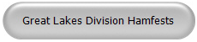

Just click to get the latest hamfest updates.

Have You Bought A Brick?
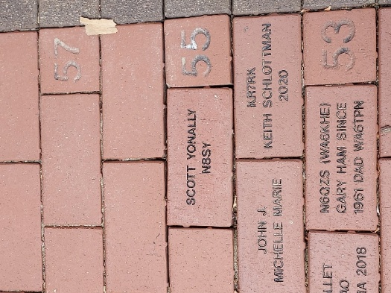
A Lasting Honor for a Special Radio Amateur
The ARRL Diamond Terrace is a distinctive opportunity to make a permanent mark at ARRL Headquarters in Newington, Connecticut. Started in 2007 and prominently located at the entrance to Headquarters, the Diamond Terrace is composed of inscribed bricks placed by committed ARRL Diamond Club members.

The Diamond Terrace recognizes donors who wish to honor their own call sign or the call sign of a special family member, Elmer, club or Silent Key. Amateur Radio organizations are welcome to participate to honor accomplishments and memorable occasions.
The Diamond Terrace at ARRL is part of the annual giving program. Donations to the ARRL Diamond Club provides financial support for programs not supported by member dues. Information about the different levels of giving and the benefits included at each level can be found here: The ARRL Diamond Club.Gifts at the Brass Level or higher include a brick in the Diamond Terrace.

Specially designed certificates representing the inscription on your brick are available upon request. Lucite brick replicas are also available for an additional charge of $30.00.

SPECIAL NOTE FOR MEMORIAL GIFTS: Individuals or clubs that wish to place a brick in the Diamond Terrace as a memorial to a Silent Key or to honor a friend or family member, may make a one-time donation of $250. Please complete the ARRL Brick Order Form to provide information on the brick inscription.

ARRL Year of the Club Newsletter Contest - Call for Submissions

Club Newsletter Contest — Call for Submissions!
As part of ARRL’s Year of the Club ARRL is hosting a Club Newsletter Contest. A club newsletter can keep members informed of news and upcoming events, keep them interested between meetings and activities, teach them about ham radio skills and technology, or even make them laugh, remember, or set an operating goal — the sky’s the limit! ARRL wants to see what your club does with the mix of information that can go into a newsletter.

Enter the Club Newsletter Contest for the chance to have your newsletter honored in QST. Here are the rules and requirements: The Club Newsletter Contest is open to ARRL Affiliated Clubs that have published a newsletter for at least one (1) year.

Submit PDF files of 1 year’s worth of consecutively published issues — no gaps — ending with your most recent issue. If your newsletter is monthly, submit 12 consecutive issues. If your newsletter is bimonthly, submit six consecutive issues. If your newsletter is quarterly, submit four consecutive issues.

Publication dates may span 2024/2025/2026, if necessary. For example, if your newsletter is published monthly and the September 2025 issue is your most recent publication at the time of your submission, send us all 12 issues from October 2024 through September 2025. Do not send additional issues once you have submitted 1 year’s worth of issues.

Submissions must include a completed Club Newsletter Contest Submission form www.arrl.org/club-newsletter-contest, which asks for information about your club and newsletter, as well as a 500-word statement on the purpose of your newsletter, and how the newsletter’s contents and design fulfill that purpose. Part of the judging process will include a comparison of these statements with the newsletter samples.

Winners will be notified in May 2026, with awards presented at Huntsville Hamfest in August 2026. Winners will be announced in a 2026 issue of QST, as part of ARRL’s Year of the Club celebration. The QST article may present material from the 500-word statements supplied in the winners’ Club Newsletter Contest Submission Form. Please note that winners may be asked to supply high-resolution files of specific newsletter pages.

Submission Deadline: Friday, January 30, 2026, 4 p.m. Eastern time.

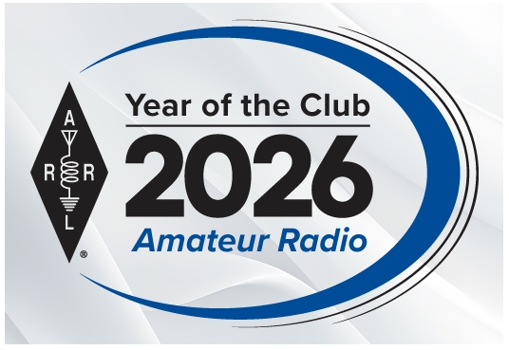
Club Website Contest - Call For Submissions

The Club Website Contest is open to ARRL Affiliated Clubs that maintain a club website. To enter your submission you must include a completed Club Website Contest Submission Form, which asks for basic information about your club and its website, as well as a 500-word statement on the purpose or goals of your website, and how the features and configuration of the website fulfill the purpose/goals. Part of the judging process will include a comparison of your statement with the website itself. https://www.arrl.org/club-website-contest

Submission Deadline: Friday, January 30, 2026, 4 p.m. Eastern time.

NOTE: Once you send your Submission Form, you may update content (text, images, data) on your website as needed, per your club’s normal operation, but you may not make significant changes to the site’s structure or functionality until April 1, 2026.

Winners will be notified in May 2026, with awards (a certificate or plaque) presented at Huntsville Hamfest in August 2026.

Winners will be announced in a 2026 issue of QST, as part of ARRL’s Year of the Club celebration. The QST article may present material from the 500-word statements supplied in the winners’ Club Website Contest Submission Form.

FCC Allocates 60-Meter World-Wide Amateur Band Approved at WRC-15

Continues Amateur Use of Four Additional 60-Meter Channels, and Updates 420 MHz Coordination Information


The Federal Communications Commission (FCC) on December 9, 2025, released a long-awaited Report and Order adopting a new amateur radio spectrum allocation in the 60-meter band that was approved for world-wide use on a secondary basis in the WRC-15 (World Radiocommunication Conference 2015) Final Acts. The Commission also agreed with a petition from ARRL The National Association for Amateur Radio® to continue to allow amateur operations on four existing 60-meter channels outside the international allocation with a full 100 watts. The new rules will go into effect 30 days after publication in the Federal Register, when amateurs may then begin using the allocation.

Specifically, the Commission allocated 5351.5 - 5366.5 kHz (60 meters) to the amateur service on a secondary basis with a permitted power of 9.15 watts ERP. The Commission also authorized amateurs to continue using four existing channels outside of the 5351.5 - 5366.5 kHz band centered on 5332, 5348, 5373, and 5405 kHz on a secondary basis with a permitted power of 100 watts ERP. There are no antenna restrictions but antenna gain must be used to calculate ERP.

The 60-meter allocation is available to amateurs holding a General Class or above license. The maximum permissible signal bandwidth is 2.8 kHz.

Amateurs are cautioned that this allocation is strictly on a secondary basis, and amateurs must avoid interfering with non-amateur stations using this spectrum. This obligation includes the responsibility to monitor for such stations using appropriate receiver bandwidths. The FCC emphasized that “allowing amateur operations in this band while fully protecting incumbent primary Federal operations is our priority, and even intermittent interference in this band could jeopardize important Federal operations.”

The Commission left open ARRL’s 2017 Petition for Rulemaking to implement this WRC allocation (RM-11785), stating that “we expect the Commission may address any necessary power adjustments for the new 15 kilohertz international allocation in that proceeding.” ARRL will be observing operations in the new band to evaluate the effect of the 9.15-watt limit and already has been monitoring the regulations and experiences of amateurs in other countries.
Finally, in the same Report and Order, the FCC updated 420 - 450 MHz coordination and contact information for geographic areas where the peak envelope power (PEP) of amateur stations operating is generally limited to 50 watts. There was no substantive change to the areas covered by the power limitation.

Links in my Thunderbird email program not working to open up the Great Lakes Division newsletter. Why?

If you’re one of those readers and you are using Thunderbird for your email client, you’re not alone. It wasn’t until yesterday at a hamfest that I even put it together. I was talking with a fellow yesterday that stated the link I was sending out for the newsletter wasn’t any good. He stated that it just isn’t a link and needs to be converted into one. I demonstrated to him that the link was definitely a link and worked just fine in several programs that I have loaded on my phone. We talked briefly about this and that’s when it hit me, I’ve heard this complaint before and the folks complaining were also using Thunderbird as their email clients. The good news is that the issue has already been documented by the developers of Thunderbird, and there are concrete steps anyone can take to restore normal functionality.

Below, the problem is broken down, the underlying causes are explained, and a step-by-step guide is provided so you can get back to reading the GLD newsletter without a hitch.

Why Does Thunderbird Struggle With This Link?
The root cause lies in how Thunderbird parses and sanitizes URLs that contain certain characters. The GLD newsletter link is built with a tracking query string that looks like this:
https://gldivision.org/newsletter?uid=12345&src=email&campaign=2024Q4

Thunderbird’s URL-handling module treats the ampersand (&) as a delimiter for multiple mail-to parameters when the link is embedded in an HTML email. In some cases, the client mistakenly interprets the URL as a mailto link, or it strips part of the query string, leaving an incomplete address that the browser cannot resolve.

The Thunderbird development team confirmed the issue in their bug tracker and released a set of work-arounds (see the article on Regain Software for the full technical breakdown: https://www.regainsoftware.com/blog/hyperlinks-not-working-in-thunderbird/).

In short, the problem is not with the GLD newsletter itself, but with how Thunderbird treats hyperlinks that contain a complex query string.

The inability to open the Great Lakes Division newsletter from Thunderbird is not a flaw in the newsletter itself, but a quirk in how the email client parses complex URLs. By updating Thunderbird, tweaking a couple of hidden preferences, or simply copying the link manually, readers can regain the one-click experience they expect.

Still stuck? Reach out to the detailed troubleshooting article on RegainSoftware: https://www.regainsoftware.com/blog/hyperlinks-not-working-in-thunderbird/.

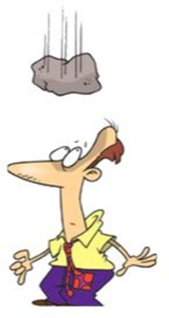
Murphy’s Law…

Army Law - If it moves, salute it; if it doesn't move, pick it up; if you can't pick it up, paint it.

Arnold's First Law of Documentation - If it should exist, it doesn't.

Arnold's Second Law of Documentation - If it does exist, it's out of date.

Arnold's Third Law of Documentation - Only useless documentation transcends the first two laws.

Ashleigh's First Law - If you can't learn to do it well, you should learn to enjoy doing it badly.

Attorneys Operating Principle - Any simple idea must be worded in the most complicated way.

Atwoods Corollary - No books are lost by lending except those you particularly wanted to keep.

Law of Attraction - Power attracts people but it cannot hold them.

STOP – Right there!!!
We’ve come to the end…

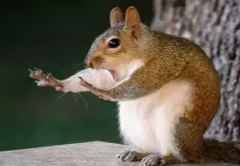

Be Radio-Active --- See Ya’ Soon!

Radio Waves is produced as a look inside of the Great Lakes Division and all that it has to offer. It is our sincerest hope that you have enjoyed this edition and will encourage your friends to be a part of the ARRL and receive the latest news and information about the ARRL and the Great Lakes Division!

The pictures throughout this newsletter are from various newsletters, Facebook posts and/or were sent directly to me in recent weeks. Take a good look at them, you just might be in one of the pictures! “SMILE… you might just be in the Great Lakes Division News!!”

