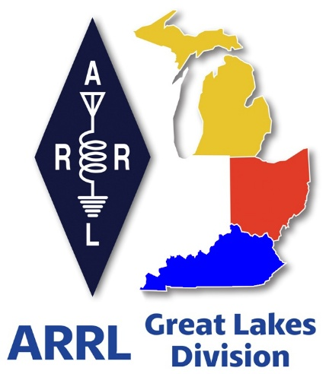
Radio Waves
^{The} Great Lakes Division
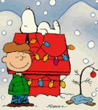
Monthly Journal
December 2025

Scott’s Stuff
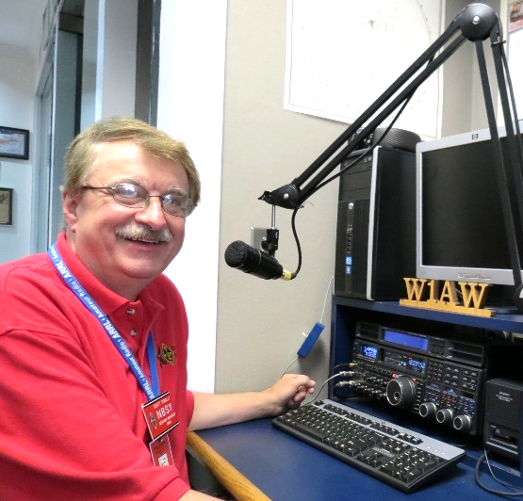
Hi Gang,

Well, Thanksgiving is over and there were no major accidents to report at the Yonally home this year. Some of you know my tale about a Thanksgiving some 12 years ago, but for those of you who don’t know…. It was Thanksgiving morning here at Yonally Acres and the morning was getting off to a fantastic start. The turkeys are in the oven baking, the ham is in the crockpot simmering away, with potatoes cooking and all the other usual fixin’s that go with this celebration. You see we normally have all of the family come here and just enjoy the day while Janie and I do the cookin, cleanin, and making sure that everything is going good for everyone. Well, on this particular Thanksgiving morning it was spitting snow and it had just started to accumulate some on the driveway. So, Janie suggested that I go out and make sure that the driveway was clean so no one would slip and fall. This was around 10:30 in the morning. I gave it my usual look and thought that it would just take a few minutes to sweep off what little snow there was, so I didn’t even put on a coat. I opened the garage doors and started my sweeping when all of a sudden, I hit some ice in the drive and away I went. I didn’t just fall; I rolled and tumbled down three quarters of the drive before finally getting my senses back to stop the rolling. Now, there I lay in the middle of the drive, my right leg feeling numb and because of the ice, I couldn’t get a grip to at least be able to sit up. So, I started yelling. I saw some neighbors down the street starting to get into their car, so I yelled even louder. They just waved and continued to get into their car. I continued to yell with no one responding. To add insult to all of this the neighbors that were leaving drove up the street and continued waving to me as they passed the drive. I couldn’t believe it; there I lay with no coat on in the middle of the drive and they didn’t even stop to ask what the heck I was doing.
Well, if that didn’t take the cake, I ended up laying there for another 20 minutes screaming my head off until Janie, (remember her?) she’s the one that decided I should go out and make sure that the drive was safe for everyone else, opened the door from the kitchen and yelled out and asked what the heck I was doing. I screamed that I was hurt and couldn’t get up. For a moment I could tell that she was laughing her head off at me for using that same line as I had joked about in that now infamous commercial. You know, “I’ve fallen and I can’t get up..” I have never made fun of that commercial ever since. Janie finally decided that I wasn’t joking and came out and tried to pick me up. This was to no avail since in the fall I later found out that I had broken both big bones of my ankle. That’s why I couldn’t feel anything. Anyway, with her pulling on my arm and me pushing with my good leg we finally got inside the garage. Janie went in and called 911. They came and confirmed that I had broken some things and loaded me up in the back of the squad and took me to the emergency room. Now, please keep in mind that we still had the turkeys, ham and all the fixins’ cooking away, and a house full of company coming, so we decided that it would be best for me to just go alone until she could at least greet the company and let them know what happened.

I got the hospital where they sent me to X-ray and then to MRI. They later said that I had not only broken my ankle but fractured a few ribs as well. So, by the time they started taping me up and immobilizing my leg my son in-law shows up. He tells me not to worry about anything as that they will take over and make sure that everything goes as originally planned. But, not for me. I had to stay at the hospital overnight so that the orthopedic surgeon could do his magic on me the next day. This meant that there was no turkey, no dressing, no cranberry sauce, no nothin’ except a half a glass of 7-up and some clear Jello. That’s because they needed me to be cleaned out before the surgery and this gave them the perfect opportunity to make sure I was.

Later that afternoon Janie, (remember her?) she came to visit and told me that everyone had a good time, which was good to hear, but she then dropped the bomb and said that we were wiped out of food, so it was probably better that I was in the hospital instead of recovering at home. Anyway, the surgery went well the next day, I had a 10-inch steel bar inserted into my ankle area along with 8 screws to hold me all together. Now, if that wasn’t enough, they decided that I needed to be in a cast from my foot all the way up to my crotch. So, now I was on crutches and couldn’t walk. Janie finally got me home, sat me down on the couch where I just sat there and had a good cry. Remember, I missed out on all the great food yesterday and there wasn’t even a small piece of turkey, or anything left over for me to even sniff!

So, every Thanksgiving I’m reminded of how lousy that one Thanksgiving was, all because I was trying to be the really good host and make sure that everyone was safe!!! You know, this would be really funny if it weren’t so true.

Okay… Let’s switch gears… December is a time when ham radio emphasizes its community spirit. Clubs often host holiday dinners, toy drives, or charity nets, blending service with celebration.

Winter propagation adds a unique twist. Long nights improve low-band conditions (160m and 80m), making December excellent for experimenting with antennas and chasing distant stations. Cold weather also tests portable setups. Operators who brave the outdoors for Winter Field Day prep or holiday portable activations sharpen their skills in resilience and adaptability.

For many, it’s also a month of reflection, operators log their final QSOs of the year, review contest scores, and set goals for the upcoming year. What do you have planned for the holidays? Here at the Yonally home, we are in the middle of baking cookies! Yes, I even pitch in and help with the baking. I remember fondly one year Janie and I baked over 100 dozen cookies for me to take in to work and share with everyone. By noon they were completely gone! There wasn’t even a crumb left over. Reflecting back on that, I still laugh about it and remember that this is the season for giving.

Okay, I know that this is getting old fast, but it is sooooo important to make sure we have got absolutely everyone to sign their letter to Congress. If you haven’t already done this, please take just 1 minute of your time to “Send a Letter” All you have to do is type in your call sign and allow the form to fill in the rest of your information, then hit the big RED button to submit. It’s just that easy to do. You don’t have to be an ARRL member either. Any ham or licensed GMRS person is able to do this. And we want EVERY Ham in the Great Lakes Division to sign the letter.
Here’s a link to it… https://send-a-letter.org/hoa/

Oh… And not to skip over an even more important part of this effort, I need all the clubs in the Great Lakes Division to write letters too. Yes, it’s easy to do and we’ve even provided a sample letter where you just add in your club information and signatures of your club officer(s) to it and mail it off to our central collection point.

Here’s a link… https://arrl-greatlakes.org/hoa_club.html

Okay… December is also a great month to work those rare ones that you can never get because you’re at work, but now you have some vacation time that will make this time an event that you definitely won’t forget. Here are just a couple of them…

• December 2 -- ARS Spartan Sprint (CW)
• December 4 -- QRP ARCI Top Band Sprint (CW)
• December 4 - 5 -- Walk for the Bacon QRP Contest (CW)
• December 4 -- NRAU 10m Activity Contest (CW, phone, digital)
• December 4 -- SKCC Sprint Europe (CW)
• December 5 -- NCCC FT4 Sprint (digital)
• December 5 -- Weekly RTTY Test (digital)
• December 5 - 7 -- ARRL 160-Meter Contest (CW)
• December 5 -- NCCC Sprint (CW)
• December 6 - 7 -- Kalbar Contest (phone)

• December 6 -- Wake-Up! QRP Sprint (CW)
• December 6 - 7 -- PRO CW Contest (CW)
• December 6 - 7 -- INORC Contest (CW)
• December 6 - 7 --FT Challenge (digital)

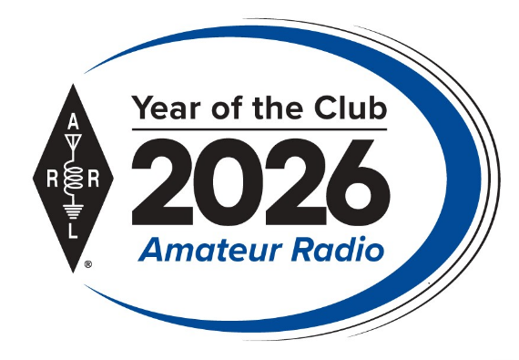
Now I also want to discuss “The Year of the CLUBS” with you and your club. The EC FSC and HQ are working hard to get things all setup and running for this huge year long event.

As part of ARRL’s Year of the Club ARRL is hosting a Club Newsletter Contest and the sky’s the limit!

ARRL wants to see what your club does with the mix of information that can go into a newsletter. Enter the Club Newsletter Contest for the chance to have your newsletter honored in QST. Click Here for the rules: https://www.arrl.org/club-newsletter-contest

Oh, and has your club entered the Website Contest yet? This is open to ARRL Affiliated Clubs that maintain a club website.

Submissions must include a completed Club Website Contest Submission Form, which asks for basic information about your club and its website, as well as a 500-word statement on the purpose or goals of your website, and how the features and configuration of the website fulfill the purpose/goals. Part of the judging process will include a comparison of your statement with the website itself.

Click here to go to the Submission Form… https://www.arrl.org/club-website-contest

Ok… that’s going to do it from here this time around. Clubs, you have your assignments, let’s get moving and show the rest of the country that the Great Lakes Division is second to NONE…!!!

Enjoy the bands and get Radio Active, but above all, regardless of your preferred mode or band, remember the golden rules of our incredible hobby: Have FUN, be respectful and most importantly, Get On The Air!

73, Scott…

Scott Yonally, N8SY
Director - Great Lakes Division
n8sy@n8sy.com

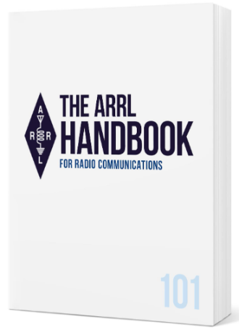
Handbook Give Away

And… Here’s the Thanksgiving winner!!

Linda Fox, KM4GSF

of Lorain Ohio…!!!

The ARRL Foundation Scholarship Program

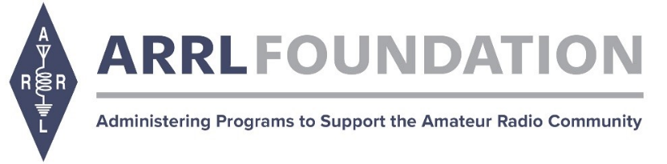
Thank you for your interest in the ARRL Foundation Scholarship Program for eligible amateur radio operators pursuing higher education. The ARRL Foundation manages more than 150 scholarships established by generous donors ranging from $500 to $25,000.

Click HERE for the scholarship application.

Applications will be accepted through December 30, 2025 at 12:00 PM EST.

The ARRL Foundation Scholarship Committee will review all applicants for eligibility and award decisions. All applicants must be an active, FCC-licensed amateur radio operators.
[NOTE: Active foreign amateur radio operators are eligible for the ARDC Scholarships].

All applicants must submit a completed online application. Transcripts and any additional required documents must be submitted WITH the application and not emailed separately. A number of scholarships require additional documents, such as a letter of recommendation from a sitting Officer of an ARRL-affiliated club. Applications without accompanying transcripts and additional required documents (if applicable) will not be considered. Scholarship recipients will be notified in June.

Awards are mailed directly to recipients' schools and will be awarded in July.

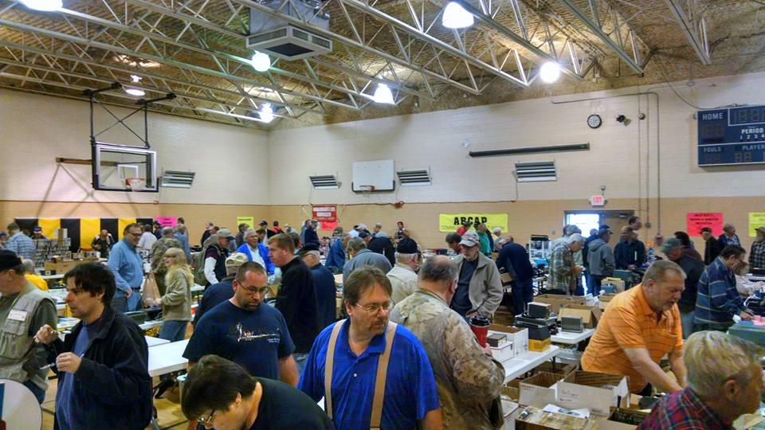
2025 Great Lakes Division Hamfests

Here in the Great Lakes Division, we have over 50 hamfests a year.

So, if you haven’t started planning your hamfest schedule yet, you really need to start now.

Please post this listing in your club's newsletter and announce the swaps on your local nets. Talk them up.

Let's fully support all of our hamfests in every way possible. It means success for everyone. Be sure to invite your ARRL Officials as soon as your date is set.

If you are planning on having your hamfest listed in QST please be sure to start your planning well in advance of your Hamfest date, as this allows adequate time for QST Listings. QST announcements require a 3-month lead time.

To be fair to our division’s clubs, the Great Lakes Division policy now has 2 requirements. Any club requesting ARRL sanctioning within the Great Lakes Division must now be an ARRL Affiliated Club with a maximum of two hamfests/swaps in any given calendar year, and they must be at least four months apart.

12/06/2025 - FCARC Winter Hamfest  Location: Delta, OH  Sponsor: FCARC  Website: https://k8bxq.org/hamfest  Learn More | 12/07/2025 - LCARC Amateur Radio Swap/Hamfest  Location: Troy, MI  Sponsor: L'Anse Creuse ARC  Website: http://www.n8lc.org  Learn More

You can always find the latest information about upcoming hamfests on the Great Lakes Division website.

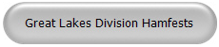
Just click to get the latest hamfest updates.

December - Youth on the Air
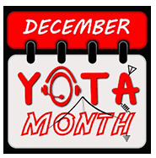
In the US, look for 1x1 special event calls and regular call signs. Many of these young hams are encouraging other youth to be active on the amateur radio bands. Some will give demonstrations at their schools, introducing ham radio to friends while making QSOs or enjoying a great pile-up.

Licensed and unlicensed youth (with the help of a licensed operator) will be making QSOs. Everyone is reminded that this could be the first radio contact ever for some newcomers.

Help fill their logbooks! Use this direct link to the DX cluster (already filtered) to spot active stations during December YOTA Month: DYM Stations 2025 hosted by DXSummit.fi.

Club Links

I’ve received a number of new requests from clubs to be listed on the “Links” club page.

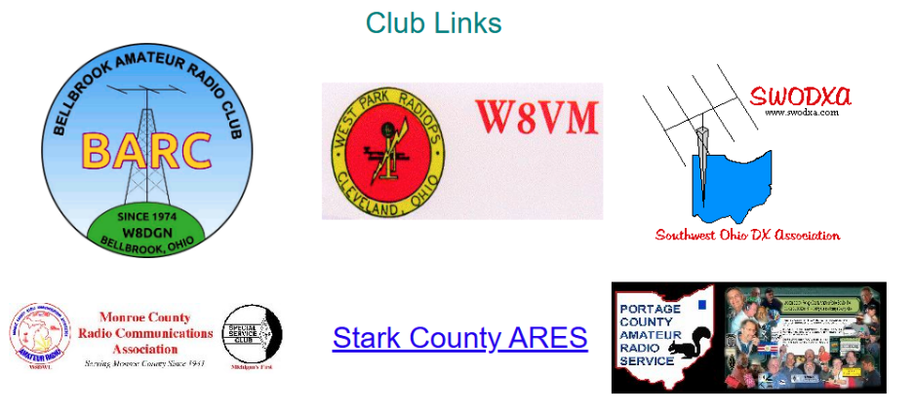

Is your club listed? If not, send the URL of your club website to me n8sy@n8sy.com and I’ll get it listed.



Renewing your FCC Amateur Radio License

NOTE…


ARRL is reporting that the FCC has extended the filing deadline to March 5, 2026, for amateur radio licenses that otherwise were due to expire from October 1, 2025, to March 5, 2026. The announcement is included in an FCC Public Notice (DA-25-943) released on Monday, November 17, 2025.

The news follows the recent reopening of the federal government on November 13, following a lengthy 43-day shutdown. Since reopening, many federal agencies, including the FCC, have resumed activities, though reducing backlogs and rebounding to full operations may take some time. This includes significant delays in filing amateur radio license applications.

******************
Hey ARRL Members: License modifications/changes and renewals will be processed to the FCC for FREE for current ARRL members as part of your membership services. An FCC fee may apply to your license transaction which must be paid directly to the FCC. ARRL VEC can help you make the FCC payment. As soon as the application and payment is pending in the FCC system, call our office and have a credit card ready. We can login to the CORES payment system and effortlessly pay the $35 FCC fee using your credit card. See the FCC Fee section below.

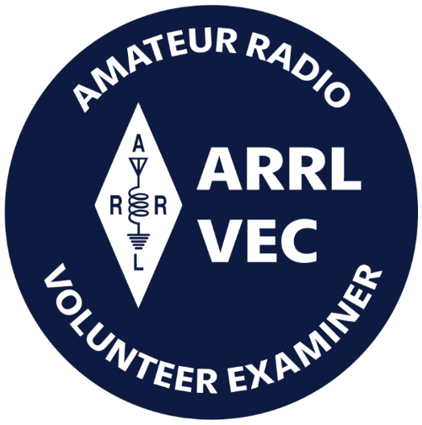
Renewing your Ham license isn’t as easy as it used to be. Since the FCC is now collecting a $35 fee with all renewals there’s a little more to it now than just completing the 605 and sending it in.

To renew, update, or add an email address or phone number to a license record, amateurs may file online (electronically) on the FCC ULS website via the License Manager System using their FCC issued FCC Registration Number (FRN) and password. Manually filed paper applications are not accepted by the FCC. A valid email address is required on all applications and filings.

Applicants are required to answer the FCC Basic Qualification Question (felony question) if they are filing for one of the following purposes indicated: New, Amendment, Modification (Upgrade or Call sign change), Renewal Only, or Renewal with Modification. Applicants applying for any other purpose are not required to answer this question.
The FCC permits administrative updates and call sign changes at any time. License renewals are allowed at 90 days or less before a license will expire, and when the license has expired but is still within the two-year grace period. Licenses that have been expired for more than two years are not eligible for renewal or reinstatement.
Visit the FCC’s License Renewal Instructions page and the FCC’s Renewal Application Checklist page. This checklist is a preparation guide to help license holders gather the necessary information before they begin the License Renewal process, direct them to the proper websites, and provide help articles to common issues some people encounter.
The checklist is intended to help the Amateur community navigate the ULS and CORES systems, to file and pay for their applications.
There are also instructions available on the FCC’s Knowledge Base page to help the Amateur community find the appropriate FCC resources.
The FCC charges an application fee for certain filings including new licenses, vanity call sign requests, and license renewals. There are no fees for administrative updates, such as a change of name, mailing or email address, modification applications to upgrade an amateur radio licensee’s operator class or to request a sequentially issued call sign.
To file applications and pay any FCC application fees, the applicant must set up a new FCC CORES Username account. After creating the account, when logged in, you must associate your existing FRN to your new username.

Most amateurs have not yet registered for a CORES account. Follow the "Legacy CORES Users" instructions on the FCC CORES Registration Instructions page before attempting to file an application online. After completing the application online, if a payment is required, the system will automatically open a page asking how the applicant wants to pay and will walk the applicant through the payment process. If the application is filed through a VEC organization, the FCC fee must still be paid online directly to the FCC not to the organization processing the application form. View the application fee filing guide and instructions on the ARRL's FCC Application Fee webpage.
Licensees can log into the ULS License Manager System with their FRN and password at any time and update anything in their FCC license record, including adding an email address.
Amateur radio licensees and examination candidates must provide the FCC with an email address on all applications.

For additional assistance or to reset a password, call the FCC Licensing Support Center at 877-480-3201 (Mon.-Fri. 8 a.m.-6 p.m. ET), or submit a help request on the FCC’s Wireless Licensing Help Center website.
ARRL members may manually file an application for free (via mail, email, or FAX) to the ARRL VEC using the NCVEC Form 605. Non-members will be charged a processing fee to use this member service.

Here’s a step by step set of instructions from our ARRL V.E.C. on how to accomplish this task.

https://www.arrl.org/files/file/QST/This%20Month%20in%20QST/2023/10%20october%2023/10%2023%20Somma%20renew%20license%20online.pdf

Send a Radiogram… What’s a Radiogram?
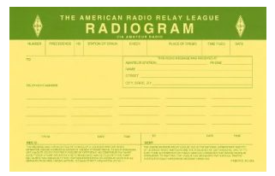
You’ve probably heard of amateur radio (“ham”) operators, and you might know a friend, family member, or neighbor who loves to build radio equipment and talk to thousands of other ham operators around the world!

But, you might not know that amateur radio operators are primed and ready to step in and provide valuable communications to the general public, when all else fails. Even if Internet service, power lines, and phone lines are all down, amateur radio still can get the message through. To be ready for this, many amateurs have joined a network called the National Traffic System (NTS), which is like a telegraph office over radio. NTS volunteers spend their free time relaying messages, called Radiograms, entirely by amateur radio, completely free of charge.
This is great practice to be sure they can serve the public during a true emergency!

Send a Radiogram Now — It’s Free! Radiogram – NTS
Now, there’s a way that YOU can try Amateur Radio messaging! Think of a friend or family member you’d like to contact by Radiogram. You can send any short message, as long as it’s not business-related, urgent or critical, or too private or personal.
Your message will be picked up by an Amateur Radio volunteer operator and relayed across the country to near its destination; finally, the recipient will get a local phone call from a nearby ham, or the message might even be delivered in person.
Along the way, ham operators will be relaying your message by voice, digital, or even Morse code, and getting valuable practice in emergency public service. To make it easy, please choose one of the standard message texts contained in the form.

(Note: Both the sender and the recipient must be in the United States or Canada).

Is Your Ham Radio Club Rolling Out the Red Carpet?

Ah, the humble ham radio club. A venerable institution, often steeped in tradition, static, and the comfortable hum of familiar voices. It’s a place where seasoned operators swap tales of epic DXpeditions and debate the merits of various antenna designs. But here’s the million-dollar question – or perhaps the more pertinent, "how-do-we-get-more-members?" question: Is your club a welcoming beacon for the uninitiated, or does it inadvertently project a "members only" vibe that would make even the most intrepid guest feel like an interloper?

Let’s face it, every club, regardless of its niche, needs fresh blood to thrive. And for ham radio, a hobby that combines fascinating technology with vital community service, attracting new operators isn't just a nice-to-have; it's essential for its very future. So, let’s hold up a metaphorical mirror to our beloved clubs and ponder some home truths.

The Importance of a Welcoming Committee
Does your club have a designated welcoming committee, or at the very least, someone friendly whose job it is to greet visitors at the door? Walking into a room filled with people who are already engaged in their own conversations can be intimidating, especially for newcomers. It can leave a new guest feeling awkward and unsure of where to go or how to join in, especially if they find themselves lingering by the coffee pot, hoping for someone to acknowledge their presence.

A simple greeting, such as, "Hi there, welcome! Glad you could make it," can make a world of difference. It takes very little effort, but that small act can help someone feel seen and valued, instead of feeling like they have accidentally wandered into a private poker game. By making this initial connection, your club can set a positive tone and make visitors feel comfortable and included from the moment they arrive.

Officer Introductions: Putting Faces to Callsigns: Are your club officers introduced at the beginning of the meeting? This isn't just about formality; it humanizes the leadership. Knowing who the president, vice-president, and secretary are, complete with their callsigns, helps guests understand the club’s structure and who to approach with questions. It shows an intentional effort to include everyone from the get-go.

The Power of the Pamphlet: Imagine handing a visitor a neatly designed pamphlet or handout. This isn't just a nostalgic nod to bygone marketing; it's a practical tool. Such a document could briefly explain the club’s history, its mission, upcoming club activities, and crucially, how to get involved. Mentioning affiliation with organizations like the ARRL adds credibility and hints at the broader ham radio community. Don't forget contact information and meeting schedules! It's a physical reminder of their visit and an invitation to return, without the pressure of remembering everything said aloud.

The Business Meeting Dilemma
Business meetings are essential for the effective operation of any club, ensuring that important matters such as finances, approval of minutes, and planning for future events are properly addressed. However, it is important to consider the experience of new guests. If the business portion of the meeting extends beyond 20 minutes, it can become tedious—especially for newcomers who may not be invested in detailed discussions about last month's budget or debates over the color of the new repeater shack paint.

To maintain engagement and prevent boredom, the business portion should be kept concise and efficient. Consider offering a separate, more detailed report for those members who wish to explore the specifics further. By prioritizing engaging content during the general meeting, the club can create a more dynamic and welcoming atmosphere for all attendees.
The One-Hour Rule of Thumb: Do your meetings run over one hour? While passion for ham radio can be boundless, people's attention spans and evening schedules are not. A well-structured, engaging meeting that respects people’s time is more likely to see repeat attendance. It sends a message that the club values its members’ time as much as its own agenda.
To achieve this, the leader should be prepared to gently redirect off-topic discussions and encourage participants to concentrate on subjects that support the club’s mission. Familiarity with Roberts’ Rules of Order is also beneficial, as it provides a framework for managing the flow of conversation and maintaining order throughout the meeting. By actively overseeing discussions and making ham radio-related content a priority, clubs can create more valuable and efficient meeting experiences for all attendees.

Prioritizing Guest Speakers: Respecting Time and Maximizing Value
Allocating sufficient time for guest speakers is crucial for the enrichment and educational growth of club members. External presenters, whether they are experts in electromagnetic compatibility or representatives from local emergency services, offer fresh perspectives and valuable insights that can greatly benefit attendees.
When guest speakers are rushed through their presentations, it not only diminishes the effort they have put into preparing but also reduces the educational value for the audience.

Presentations that cover topics such as antenna theory, digital modes, contesting strategies, or even a simple show-and-tell of a member’s latest project can invigorate club gatherings. These sessions provide valuable learning opportunities and spark curiosity for both experienced operators and newcomers alike. By prioritizing informative and stimulating activities, clubs can foster a vibrant atmosphere that encourages ongoing involvement and enthusiasm for ham radio.

Community Engagement: More Than Just Talk: Does your club participate in activities that benefit your community? This is where ham radio truly shines. Engaging in public service events, supporting local runs or festivals, or being an active part of ARES (Amateur Radio Emergency Service) demonstrates the practical, invaluable side of the hobby. These club activities not only serve the community but also provide hands-on experience and a sense of purpose for members, making the club more attractive to those looking to contribute.

Embracing the Digital Age: In a post-pandemic world, flexibility is key. Are your club meetings hybrid utilizing video platforms like Zoom or Teams? Offering a hybrid option significantly expands your reach, allowing members and guests who live far away, have mobility issues, or are simply juggling busy schedules to participate. It shows the club is forward-thinking and committed to inclusion, rather than stubbornly clinging to analog methods for digital interactions.

After attending a meeting, a guest who has enjoyed the experience and felt welcomed may be eager to join the club. It is at this critical juncture that the process for becoming a member should be straightforward and inviting. If the sign-up procedure is complicated, requiring multiple forms, confusing payment methods, or resulting in delayed confirmation—it can quickly discourage even the most enthusiastic potential members.

To foster growth and make a positive impression, clubs should ensure that joining is simple, clear, and immediate. This can be achieved by offering a direct link on the club’s website for online sign-ups, providing a concise and easy-to-understand form available at meetings, or designating a specific individual who is responsible for handling new memberships efficiently. By streamlining the membership process, clubs remove unnecessary barriers and demonstrate their commitment to welcoming new members into the community.

The Bottom Line: Why All This Fuss?
Ultimately, the vibrancy and longevity of any ham radio club depend on its ability to attract and retain members. A club that is genuinely inviting, transparent, informative, and community-minded will not only thrive but also continue to keep the spirit of amateur radio alive for generations to come. So, perhaps it's time for every club to take a long, honest look in that metaphorical mirror. Is your club truly rolling out the red carpet, or is it inadvertently signaling "QRT" to potential new blood? The future of ham radio might just depend on it.

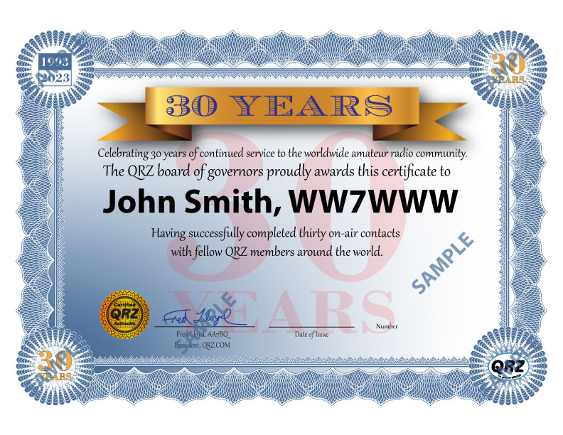
New Operating Award Celebrates QRZ’s 30th Anniversary
It’s been eight years since QRZ began its operating awards program and in that time, they have issued over 373,000 awards. They want to thank all of you who use the QRZ Logbook on a daily basis, and there are A LOT of you. At this time, QRZ logbooks contain over 817 Million QSOs!
There newest operating award is called the
30 Years of QRZ Award and it is based solely on communications between QRZ users.

The award is achieved when an operator has successfully completed on-air contacts with 30 members of QRZ from around the world. The award celebrates QRZ’s 30th Anniversary by recognizing your achievements.

Want more details? >> Click Here <<

SKYWARN Recognition Day 2025 Cancelled

NOAA’s National Weather Service (NWS) has announced the cancellation of SKYWARN™ Recognition Day (SRD) 2025.

The necessary time and resources required to plan a comprehensive national event for SKYWARN™ Recognition Day 2025 are not available this year. Thus, the difficult decision was made to cancel this year's event by the NWS.

The NWS will work with ARRL and SKYWARN™ spotters to brainstorm ideas to redevelop a spotter appreciation event in 2026.

ARRL The National Association for Amateur Radio®, which has a Memorandum of Understanding with NWS, emphasized the strength of the long-standing partnership behind the event. “ARRL is proud of the continued partnership with the National Weather Service to promote and recognize SKYWARN and the volunteers around the country. We look forward to working together to revitalize and promote SKYWARN Recognition Day again next year,” said Josh Johnston, KE5MHV, ARRL Director of Emergency Management.
Established in 1999 by the National Weather Service and ARRL, SKYWARN Recognition Day celebrates the critical contributions SKYWARN volunteers make in supporting the NWS mission to protect life and property. Amateur radio operators constitute a significant portion of these volunteers, providing essential communication links between NWS and emergency management agencies when traditional communications fail.

The NWS-ARRL SRD National Committee extends its appreciation to all SKYWARN volunteers for their dedication and service to their communities and offers best wishes for a safe and happy holiday season.

Worth Noting…

Tim Duffy, of DX Engineering is among this year’s award winners at the RCA awards.
Several well-known radio amateurs are among recipients of this year’s honors from the Radio Club of America (RCA), an organization of both professionals and amateurs that has been promoting advancements in wireless communication for more than 100 years.
Among the amateurs recognized this year by RCA are:
Noted contester, former RCA President, and DX Engineering CEO Tim Duffy, K3LR, recipient of the Edgar F. Johnson Pioneer Citation for noteworthy contributions to RCA or the radio industry; Chester B. Scholl, Jr., K3LA, receiving the Special Services Award for significant work to promote RCA’s goals and objectives; Julio Ripoll, WD4R, longtime amateur radio coordinator at the National Hurricane Center, recognized for his service at WX4NHC with the Barry Goldwater Amateur Radio Award.

Dr. Kristina Collins, KD8OXT, this year’s recipient of the Carole Perry (WB2MGP) Young Professional Award. Collins is the Chief Operations Scientist for the HamSCI Personal Space Weather Station Network. She also voices announcements heard each hour on WWV and WWVH as part of the WWV/H Scientific Modulation Working Group.
In addition, several hams were named as RCA Fellows, including:
AT&T executive Brian Daly, WB7OML; HamSCI founder and coordinator Dr. Nathaniel Frissell, W2NAF;Radio historian Felicia Kreuzer, KA2GXL; Public safety communicator and former ARRL Western Washington Section Manager Monte Simpson, W7FF; and Angel Vazquez, WP3R, Head of Telescope Operations for the Arecibo Observatory in Puerto Rico.
The awards were presented at RCA’s annual Technical Symposium and Awards Banquet on November 22, in Washington, DC.

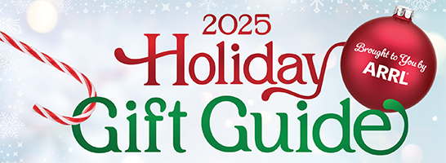

ARRL's 2025 Holiday Gift Guide is now available, featuring amateur radio equipment and station accessories from well-known businesses. The guide also includes a special offer from ARRL. 'Tis the Season! Browse and shop at tinyurl.com/arrl-holiday-gift-guide-2025.

STOP!!!
We’ve come to the end…

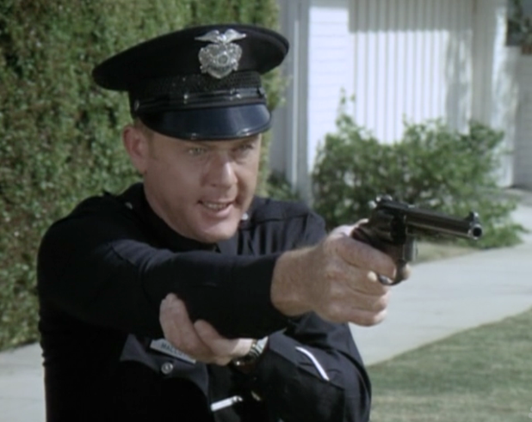

Be Radio-Active --- See Ya’ Soon!

Radio Waves is produced as a look inside of the Great Lakes Division and all that it has to offer. It is our sincerest hope that you have enjoyed this edition and will encourage your friends to be a part of the ARRL and receive the latest news and information about the ARRL and the Great Lakes Division!

Many pictures throughout this newsletter are from various other newsletters, Facebook posts and/or were sent directly to me in recent weeks. Take a good look at them, you just might be in one of the pictures! “SMILE… you might just be in the Great Lakes Division News!!”

