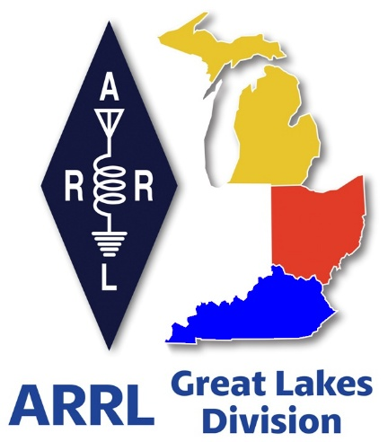
Radio Waves
^{The} Great Lakes Division
Mid- Month Report
January

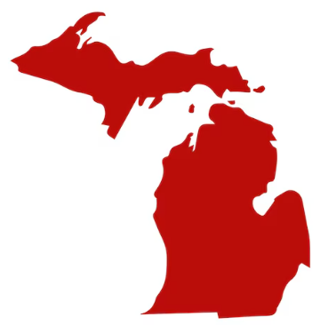
From the Michigan Section Manager
Ralph Katz, AA8RK
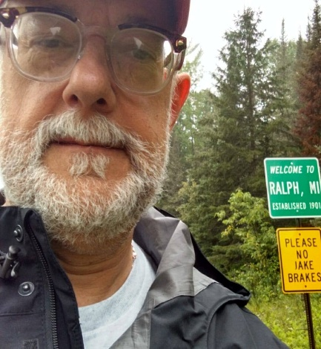

Thank you for letting me be your Michigan Section Manager for the next two years.

We all owe our gratitude to Larry Camp W8BR, our previous multi-term Michigan Section Manager, especially for stepping up again following the untimely and tragic passing of Les Butler W8MSP. Les is missed by all.

Both Larry and former Michigan SM Jim Kvochick K8JK urged me, after 5 years as Public Information Coordinator, to apply for this new position, and there was no good reason not to. So, I went to 3 club breakfasts and got 11 signatures. In a very short few hours, I submitted an application, it was accepted, and as the only candidate, I was appointed the new SM. I wish to thank all the loyal supporters who stood with me during this arduous effort, and thank all of my opponents for waging clean and fair campaigns (hi hi).

I was lucky to snag this job, and am here to help. Like my predecessors, I want to see the ARRL and especially the Michigan Section prosper and grow.

I haven't had a lot of state-wide exposure, but will allow myself just one horn-tooting and here it is. I am 75, a life-long Michigander, and have been a ham for 30 years. Typical stuff: WAS, VE, AUXC, ARPSC, vanity callsign.
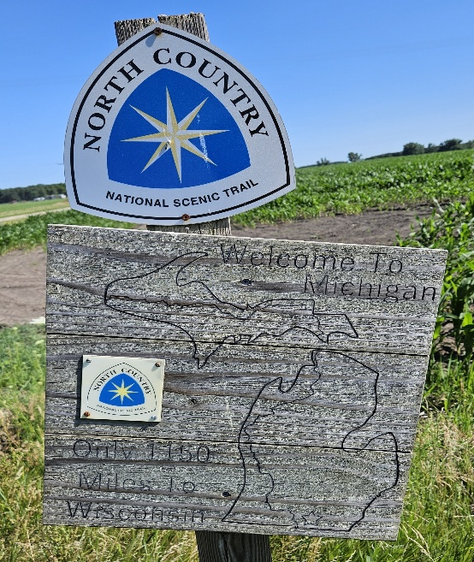
My CW is not so great, but improved quite a bit in isolation during COVID. A lot of relatives have had licenses, including my parents, wife, and children. My home club, ARROW Communication Assoc., Inc., had 137 paid members in 2024. Life memberships with the ARRL, the Society of Manufacturing Engineers, and the Ann Arbor Federation of Musicians. Possibly the first SM who is also an AUXC. Probably the first clarinetist, too. After retiring in 2018 after 27 years as a contract IT employee at Chrysler/Daimler/Fiat/Stelantis, time has until recently been complicated by caring for ill relatives. The list of musical groups I have played with is too long to list here. A series of home construction projects has left an antenna-less shack (sigh), but a POTA go-kit is nicely taking shape. We all took up this hobby to have a nerdy kind of fun. Our motto should be, “Are we having fun?” I am, and hope you are, too.

The North Country National Scenic Trail spans both Michigan peninsulas. Where it crosses into Michigan from Ohio, southeast of Coldwater, a funky hand-made sign says, “Welcome to Michigan. Only 1150 miles to Wisconsin”. The trail is not at all straight in Michigan, yet we are a big state, and everyone should feel free to bring issues to me. We may not get what we want, but if enough people raise an issue, it will hopefully gain consideration. This is how democracy should work, and we won't get anything if we don't try.

Our previous Michigan SM's have put together a great staff. There is no reason to change things, but still we might benefit from additional staff. Michigan’s population center in 2020 was just south of Owosso in Shiawassee County. From there, it is a 500 mile drive to Ironwood in the western UP, and there are opportunities to be had all along the way.

Just as PIC's from neighboring states have helped me, I hope to collaborate with neighboring SM's. I am grateful for the clubs who have already reached out. In 2 weeks, 8 swaps have come up, there are couple of club meetings to speak at, and some other events to attend. Sounds like some kind of fun. Please let me know how I can help you and your club.

The ARRL has proclaimed 2026 as “Year of the Club” and it is getting a lot of coverage which you can find elsewhere. We all would benefit from knowing what other clubs are doing. How was your club's Field Day? What cool presentations have you had? How are your EmComm efforts going? What other public events do you support? How are your repeaters doing? Have you had club Kit Builds? What other fun things are you doing? Several clubs have already put me on their mailing lists. It will take a little effort to fine-tune things and not be the overwhelmed by a deluge of information. But, “Keep the hits coming” our way. Sand send pictures.
The ARRL is a volunteer organization, and every volunteer organization can always use more volunteers. Do you have ideas and/or want to help? Or just want to kvetch? Please contact me. It is my honor to serve you.

Calendar of events in Michigan for 2026

https://calendar.google.com/calendar/u/0?cid=YXJybC5taS5zZWN0aW9uLm1hbmFnZXJAZ21haWwuY29t

Happy New Year & 73,

Ralph Katz AA8RK
Ann Arbor, MI
arrl.mi.section.manager@gmail.com
aa8rk@arrl.org


From the Ohio Section Manager
Bret Stemen, KD8SCL

The latest edition of the Ohio Section Journal is now online and ready
for you to read! There’s an awful lot of Ham Radio activities going on
in the Ohio Section, so get off the chair or couch you’re sitting on
and get out there, get involved, and get on the air!
The link below will take you directly to the Ohio Section newsletter.

https://arrl-ohio.org/wp-content/uploads/2026/01/OSJ_January_2026.pdf

Bret… kd8scl@arrl.org

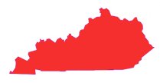
From the Kentucky Section Manager
Bob Selbrede, K6ZZ

Hello Folks and Happy New Year!

In case you were not aware, the ARRL is celebrating the Year of the Club (YOTC) in 2026. One of the activities taking place this year is an opportunity for Affiliated Clubs to operate as W1AW/portable. Kentucky has been assigned March 18th-24th and September 9th-15th. During these two 7-day periods of time ARRL Affiliated Clubs in Kentucky will be able to operate as W1AW/4. This is a great opportunity you won't want to miss out on.

So how do you get involved? If you are a member of an ARRL Affiliated Club, please encourage your club President (or other club point of contact) to get ahold of our Affiliated Club Coordinator (ACC) Steve Morgan W4NHO. Steve is coordinating the Kentucky operating schedule for W1AW/4. Don't wait too long and end up missing out on this great opportunity.

Please go the following website for additional information: WWW.KYHAM.INFO

In addition, there is a special America 250 Worked All States Award being offered by the ARRL. The objective is to work as many of the W1AW/portable stations as possible. The first two states started operating today; New York (W1AW/2) and Nebraska (W1AW/0)

There are also a few events coming up I want to bring to your attention so you can put them on your calendar if interested.

First, on Saturday January 31st our Section Emergency Coordinator Dennis W2QN will be hosting a mini ARES conference in Shelbyville, Kentucky. This will be the first of several to be conducted at various locations across Kentucky. It will start at 9am and will be over no later than 4pm. Attendance is open to anyone interested in helping develop and improve ARES operations in Kentucky. It will be held at Shelby County Fire Station #1, 200 Alpine Road, Shelbyville, KY 40065. If you have any questions or suggestions, please reach out to Dennis directly. He’s working hard to rebuild ARES in Kentucky and welcomes help from all who share his passion for ARES. Dennis can be reached via email: dennislutz2@aol.com.

The second event to place on your calendar is the Cave City Hamfest on Saturday March 7th. This will be an ARRL sanctioned hamfest, and should be a lot of fun.

See: https://www.ky4x.org/hamfest for more details.

73 and hope to see you at these events and more!

Bob, K6ZZ
Kentucky Section Manager
K6ZZ@ARRL.ORG

Do you know someone who is not getting this newsletter


Hi Gang,

If you know someone who isn’t already getting Radio Waves, have them sign up to receive it!! They don’t have to be ARRL members to sign up, just click on the button below and in no time, they will start receiving it.

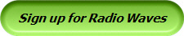

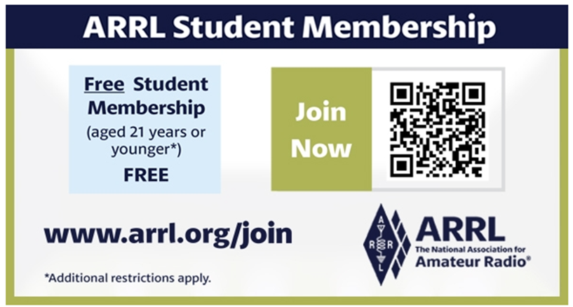

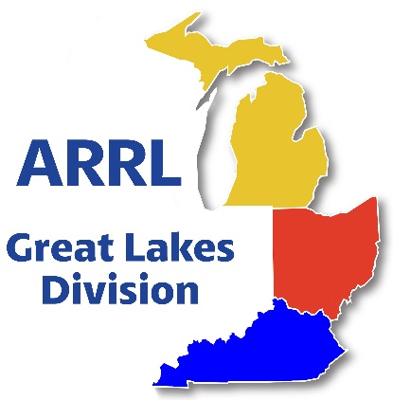
Scott’s Stuff

Hi Gang,

Welcome to 2026!!!!

The holiday season is now history. Did you make a New Years Resolution? I’m not a quitter, unless you count my New Year’s resolutions, which are swiftly abandoned by mid-January. But this year, I’ve decided to double down and become the Michael Jordan of ham radio self-improvement. So, without further ado, here are my 2026 resolutions, served up with a side of humor and a dash of CW.

- Get Off the Couch and Onto the Airwaves
I’ve spent far too many evenings on Zoom meetings and watching old reruns on TV instead of tuning around 20 meters. My goal? Log at least one HF nets session every week. If I can manage to stay awake past 10 PM, I might even try a 40-meter net at o’dark-thirty. Fingers crossed I don’t accidentally key the mic with my earbud cord.

- Earn That ARRL Award
I’ve been a card-collector for years, QSL cards, that is. This year I’m going all in on an ARRL Worked All States 250 award. Picture me hunched over the hobby table, monster clip leads in hand, coax snaking around the floor like a mechanical python. I’m determined to glue stamps on envelopes until my sneezes get mistaken for Morse code.

- Tidy Up the Shack (Again)
My radio “shack” looks like a science experiment in electromagnetic chaos. Last year’s resolution was to organize cables—three zip ties later, I found them tangled in next year’s Christmas lights. This time, I’ll label everything: “Left Speaker,” “Right Speaker,” “Ham Clock (Not Yet Installed),” and “That Mystery Box I Bought on eBay.” If I can’t find a part, I have a backup plan—panic loudly.

- Master One New Digital Mode
I’ve flirted with FT8, D-STAR, and PSK31, but I’ve never fully committed. In 2026, my goal is to conquer one digital beast—not just decode the waterfall display but actually hold a conversation. If I succeed, I’ll treat myself to a shiny new T-shirt proclaiming, “I SPEAK FT8 FLUENTLY (Sort Of).”

If all else fails and I end up backsliding into my old ways—lying on the couch, dreaming of DX—I’ll at least have a pile of unanswered QSL cards, a very organized radio desk, and the undying support of the ARRL community. Here’s to a year of full break-in listening, perfectly tuned SWR, and HF nets that don’t end in “CQ CQ de [my callsign], QRZ?” Happy New Year, fellow hams—may your resolutions be as reliable as your transceiver’s power supply!

AI or is it real?...
I’ve been around long enough to remember when “fake news” meant the Sunday comics and not some AI-generated pickle cartoon convincing you that the President was a giant dill. Today, we’ve got deepfakes, doctored audio clips, and full-blown synthetic personas created by AI to twist reality. And sometimes, that twist lands squarely on the ARRL or an unsuspecting ham operator who just wanted to set up a Winlink gateway in their garage. If you believe everything you see or hear—even if it’s wrapped in official‐looking memos—you might end up chasing a phantom emergency net about a tornado in Peoria that never happened.

A few months back I saw a “press release” — clearly AI-spun nonsense — claiming someone had used Starlink terminals to broadcast recipes for turning GMRS radios into nuclear detectors. The story spread, ruffled many feathers and then… poof. No such recipes. No such detectors. Just a lot of worried communicators and one very confused grocery‐store cashier asking why I needed eleven pounds of pickles. The point is: AI in the wrong hands can make ham radio professionals look ridiculous or worse, erode trust in our public‐service capabilities.

So yes, read with a healthy dose of skepticism. I hope you’ve read my ARES deep-dive in the February issue of QST (if you haven’t, whatcha’ wait’n for? Turn to page 65). In that article I explore ARES today—and where it could be in 5 or 10 years.

Coding Competition…
If you have young enthusiasts in your club or community, mark your calendars for our 2026 Coding Competition. The competition runs from January 1st – March 31st. This is a great way to blend amateur radio with STEM education. This competition invites students and young hams to develop innovative software or coding projects that interface with amateur radio technology. From creating apps for contest logging to designing tools for satellite tracking, participants will have the chance to showcase their creativity while learning critical programming and problem-solving skills. We’re not just promoting ham radio; we’re nurturing the next generation of innovators. Winning projects will be highlighted in amateur radio publications, and top contributors could walk away with scholarships or tech prizes. The goal? To inspire curiosity and bridge the gap between radio, technology and our youth. ARRL Student Coding Competition - Specifications 1 Jan 2026.pdf

Newsletter and Website Contests…
For those passionate about public information and outreach, we’re revamping our contests to celebrate the power of communication. The Newsletter Contest invites club members and groups in the Public Information sector to submit their best amateur radio newsletters. Whether your focus is emergency preparedness, community service, or promoting the hobby to newcomers, we want to see how you’re sharing the magic of ham radio. Judges will look for creativity, clarity, and impact, with awards going to the most outstanding entries. http://www.arrl.org/club-newsletter-contest

Meanwhile, the Website Competition challenges clubs to elevate their online presence. A well-designed website can be a hub for event calendars, educational resources, and club announcements. We’re looking for clean layouts, engaging content, and accessible design that makes it easy for visitors to learn about your club. These contests aren’t just about winning—we hope they spark ideas and friendly collaboration as members work together to shine a spotlight on their communities as well as sharing “Best Practices” between all of our Affiliated Clubs! https://www.arrl.org/club-website-contest

Contest Portal and America250 WAS…
On the contest front, we’re rolling out the new Contest Portal, a one-stop digital hub that will revolutionize how operators access and participate in events. Picture this: real-time standings, downloadable logs, contest rules, and registration links—all in one easily navigable platform. This tool is designed to make contesting more efficient and enjoyable, whether you’re a casual participant or a seasoned sprinter. https://contests.arrl.org/

And for those of you chasing the thrill of global connections, don’t miss America250 WAS (Worked All States)! This special event is part of the broader America250 initiative, celebrating 250 years of American independence. The goal? Work stations in all 50 U.S. states, plus territories, through a mix of on-air contacts and digital modes.

The best part? Every successful contact contributes to “wallpapering” your log with unique call signs, creating a tangible memento of your participation. With this contest, you’re not just improving your skills; you’re honoring a pivotal chapter in our nation’s history.

Enjoy the bands and get Radio Active, but above all, regardless of your preferred mode or band, remember the golden rules of our incredible hobby: Have FUN, be respectful and most importantly, Get On The Air!

73, Scott…

Scott Yonally, N8SY
Director - Great Lakes Division
n8sy@n8sy.com

Are We Prepared?

James Wades, WB8SIW & NTS Newsletter

Are you really prepared?

During the “Basic Voice Communications Procedures” class conducted by Radio Relay International, we ask students to engage in a simple exercise. While traveling out of town, check into an ARES® or similar local EmComm net. Transmit your call sign slowly and carefully, using the standard ITU phonetic alphabet. Then wait to see if the NCS gets it right!

During 25 years of business travel, I conducted this experiment many times. In 95 percent or more cases, the typical NCS couldn’t transcribe my call sign correctly despite two or three attempts. In many cases, the net sounded like a well-oiled machine, with stations checking in and being acknowledged without error - until a strange call sign appeared.

Now imagine that same NCS during an ARES® net operating under the stress of emergency conditions in which important messages are being conveyed on behalf of a served agency.

Perhaps a request for medical supplies is being transmitted or someone is reporting the release of a hazardous chemical. If an ARES operator can’t copy an unfamiliar call sign, will he or she be able to accurately transcribe and deliver a message containing a term such as “acute subdural hematoma” or “ethylene oxide?”

The example of the volunteer fire company applies well here. When you dial 9-1-1 to report a fire, you have a reasonable expectation that the firefighters arriving on scene have been trained. They should know how to ventilate the structure, attack the fire, operate the apparatus, or extricate victims, even if they are unpaid volunteers. Likewise, when radio amateurs offer their “emergency communications” services to an agency, the agency has a similar expectation that those assisting have been trained in basic communications procedures and protocols.

Learning to convey tactical or record message traffic is an essential skill. It is NOT enough to simply establish connectivity. One must be able to communicate accurately and efficiently, keep a concise radio log, transcribe information without error, and perform the basic administrative functions required of a message center or EOC.

This is why participation in traffic nets is so important. Traffic nets are the only place where one can check into a net any day of the week at your convenience and practice sending and receiving messages using standard prowords, proper ITU phonetic alphabet, and concise procedures.
Some dismiss traffic handling because they see the content of routine messages as “unimportant,” but they are missing the point. The real value proposition is in the practice of transmitting variable message content. Every address is different. Network management data varies from message to message. One must transmit the message at a pace that allows transcription by the receiving operator. Likewise, the receiving operator must be able to understand exactly what is being transmitted. These same skills are also essential to an efficient emergency communications process, whether the content being conveyed is tactical in nature or served agency messages intended for delivery to an emergency services official.

Let’s be honest! Many EmComm volunteers are not prepared to handle important agency traffic. They have little training in the mechanics of message handling, and too few participate in traffic nets.

For the first time in many years, we are beginning to see real cooperation between NTS and ARES. This cooperation isn’t just “nice,” it’s essential. Every EmComm volunteer should practice handling traffic because establishing connectivity is only a small piece of the overall communications process.

The time has come to bridge the gap between traffic operations and local EmComm. Let’s work together for the benefit of the Amateur Radio Service and our communities.

Contests…

The ARRL January VHF Contest is January 17 – 19. This is a grid-based contest, taking place on frequencies 50 MHz and above. Though digital modes are very popular, don’t neglect the analog modes in this contest. Some operating plans suggest trying CW and SSB at the top of every hour, and being attuned to the activity on FM frequencies.

Rovers play a big part in this contest, especially in the more populated portions of the US. Some rovers publish their operating plans in advance — here are AA2SD’s. His plans are very comprehensive, including details of his path, and how to sign up for text message alerts during the operation. He has also set up his QRZ.com page to make it easy to contact him in the contest.

Here in the more sparsely populated west, SOTA fans get climbing for the January VHF Contest to take advantage of more people being on the air. During 2026, there’s an emphasis on 2-meter and 70 cm contacts using SSB or CW as part of the 2026 SOTA Challenge. SOTA operators are looking for six-digit grid squares, so be ready with yours. On SSB, 144.200 MHz or 432.1 MHz are common frequencies (Etienne, K7ATN via PNWVHFS reflector).

January 15
- CWops Test (CWT)
- NTC QSO Party

January 16
- NCCC FT4 Sprint
- Weekly RTTY Test
- QRP Fox Hunt
- NCCC Sprint
- K1USN Slow Speed Test

January 17
- Hungarian DX Contest
- PRO Digi Contest
- RSGB AFS Contest, SSB
- North American QSO Party, SSB
- NA Collegiate Championship, SSB
- ARRL January VHF Contest
- Feld Hell Sprint

January 18
- Run for the Bacon QRP Contest

January 19
- K1USN Slow Speed Test
- ICWC Medium Speed Test
- OK1WC Memorial (MWC)
- ICWC Medium Speed Test
- RSGB FT4 Contest

January 20
- Worldwide Sideband Activity Contest
- ICWC Medium Speed Test

January 21
- QRP Fox Hunt
- Phone Weekly Test
- A1Club AWT
- CWops Test (CWT)
- VHF-UHF FT8 Activity Contest
- Mini-Test 40
- Mini-Test 80
- CWops Test (CWT)

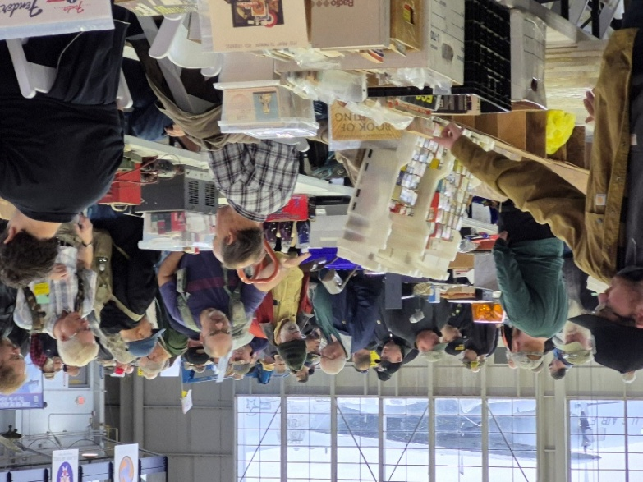
Great Lakes Division Hamfests

Here in the Great Lakes Division, we have over 50 hamfests a year. So, if you haven’t started planning your hamfest schedule yet, you really need to start now.

Let's fully support all of our hamfests in every way possible. It means success for everyone. Be sure to invite your ARRL Officials as soon as your date is set.

If you are planning on having your hamfest listed in QST please be sure to start your planning well in advance of your Hamfest date, as this allows adequate time for QST Listings. QST announcements require a 3-month lead time.

2026
01/18/2026 - SCARF Hamfest  Location: Shade, OH  Sponsor: SCARF members  Learn More | 01/31/2026 - Struthers ROAR Mid-Winter Hamfest  Location: Struthers, OH  Sponsor: Struthers Regional Operators of Amateur Radio  Website: https://www.facebook.com/profile.php?id=61580196127715  Learn More
02/08/2026 - Cherryland ARC Annual Swap & Shop  Location: Traverse City, MI  Sponsor: ARRL  Website: http://cherrylandarc.com  Learn More | 02/21/2026 - Livonia Amateur Radio Club Annual Swap & Shop  Location: Northville, MI  Sponsor: Livonia Amateur Radio Club  Website: http://livoniaarc.com/larc-annual-swap-and-shop/  Learn More

03/15/2026 - Toledo Mobile Radio Association Hamfest and Computer Fair  Location: Perrysburg, OH  Sponsor: Toledo Mobile Radio Association  Website: http://www.w8hhf.org  Learn More | 03/21/2026 - Lowell Amateur Radio Youth Club Hamfest  Location: Lowell, MI  Sponsor: Lowell Amateur Radio Club  Website: http://larc.club  Learn More

You can always find the latest information about upcoming hamfests on the Great Lakes Division website.

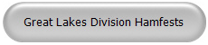

Just click to get the latest hamfest updates.

Celebrating Community Connections:

How the ARRL Amateur Radio Activity Report Shines a Light on Non-Emergency Events
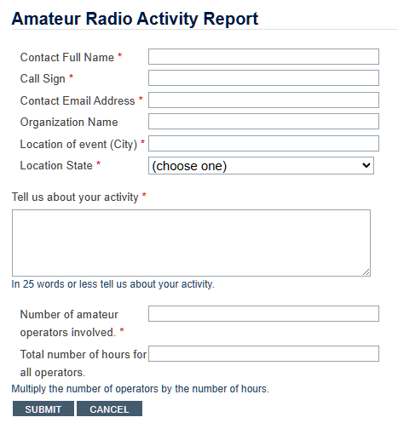

When most people think of amateur radio, their minds jump to emergency communications, storm nets, and disaster relief. While emergency preparedness is certainly a critical mission for hams, it’s only part of the story. At its heart, amateur radio is about community, education, and the pure thrill of connecting with people—nearby and around the globe. That spirit is on full display in the ARRL’s new Amateur Radio Activity Report, a spotlight on the countless non-emergency events that bring ham radio’s friendly energy to life.

The Launch of the Amateur Radio Activity Report
With the “Year of the Club” initiative in full swing, the ARRL has introduced the Activity Report as a way to track and celebrate everything amateur radio clubs and individual hams are doing outside of formal emergency service. Whether it’s a license training session at the local library, a high school STEM demonstration, working on a repeater or radios at the finish line of a charity 5K race, these activities demonstrate how thriving and diverse our community truly is—and why amateur radio remains a gateway to lifelong learning.

Why Non-Emergency Events Matter
• Community Outreach: Public appearances at festivals, fairs, and historical reenactments build goodwill. Local residents see firsthand how operators set up portable stations, demonstrate antennas, and even let passersby speak on HF bands.
• Education and Licensing: Weekend license classes and Tech-to-General upgrade courses inspire newcomers. When clubs bring equipment into science fairs or school assemblies, they plant the seeds for tomorrow’s ham operators, engineers, and broadcasters.
• Public Service Without Crisis: Supporting county marathons, cycling races, working on repeaters and club equipment to keep it updated and in good working order and parades may not involve saving lives, but it does require precision and teamwork. That same reliability enhances overall public trust in amateur radio’s capabilities.

How the Activity Report Fuels Club Success
- Enhanced Visibility
By submitting stories to the Activity Report, clubs get recognized on arrl.org and in The ARRL Letter. Those public mentions raise awareness among potential members, local officials, and community partners.
- Data-Driven Support
ARRL leadership uses Report data to see what kinds of events are resonating across regions. Do license classes spring up more often in college towns? Are operators more active at outdoor festivals during the summer? These insights help the ARRL allocate resources—like instructor training and publicity materials—where they’re needed most.

- Model Replication
When one club’s school outreach program draws a crowd of eager students, other clubs can learn from their signage, presentation style, and hands-on demos. The Activity Report makes successful initiatives easy to discover and adapt.

Stories from the Field
• Riverbend Radio Club’s “Portable HF in the Park” event brought fold-out tables and solar panels to a summer festival. Dozens stopped by to learn Morse code basics and sent their first-ever on-air greetings.
• University ARC’s STEM Day booth at a state science fair led to five new General licensees—and a partnership with the campus engineering department for future projects.
• The Marathon Runners’ Net, staffed by volunteers from four local clubs, handled check-in calls, time splits, and safety alerts for a charity race that drew 3,000 participants. Instead of ambulances paging each other on busy frequencies, race officials relied on the precision of ham-to-HAM coordination.

How to Participate
If your club or group is hosting a non-emergency event, it’s easy to share the story:

- Go to https://www.arrl.org/amateur-radio-activity-report

- Fill out the brief form with event details: date, location, type of activity, and number of participants.

- Attach photos, flyers, or news coverage if you have them.

- Hit submit—and watch for your feature in upcoming ARRL communications.

By simply reporting what you’re already doing—mentoring, teaching, demonstrating, and supporting—you help the entire amateur radio community shine.

Looking Ahead
The Amateur Radio Activity Report is more than a bulletin; it’s a living archive of our shared passion and purpose. As we move deeper into the Year of the Club, let’s celebrate every license class taught, every public demo hosted, and every marathon checkpoint staffed. These non-emergency events underscore how vital amateur radio is—not just in crises, but as a vibrant hobby and community service.

Whether you’re a one-man portable operation or a decades-old radio club, your efforts matter. Submit your activity today, and let’s showcase the full spectrum of ham radio in action.

FAQ

Q: What is the ARRL Amateur Radio Activity Report?
A: It’s an online platform where ARRL-affiliated clubs and individual radio amateurs can log non-emergency events—like license classes, festival demos, and public service communications.

Q: How much time does it take to complete this report?
A: It can take as little as 2 minutes, depending on just how detailed you are with reporting your activities

Q: Who can submit to the Activity Report?
A: Any ARRL member, club secretary, or designated representative can file a report. Individual hams without a formal club role are also welcome to share their community activities.

Q: What types of events qualify?
A: Any ham radio activity outside of ARES or emergency response. Examples include STEM outreach, charity race communications, field day-style exhibits, school presentations, and more.

Q: Why not ARES or emergency responses or planning?
A: That will be reported by the Emergency Coordinator on his/her monthly reporting

Q: Are photos and media coverage required?
A: They’re not required, but highly encouraged. Images and news articles help illustrate the event and can boost your club’s visibility when published.

Q: How often should clubs or individuals report?
A: You can report each event as it happens. Monthly or quarterly summaries are fine too—whatever works best for you and or your club’s workflow.

Q: What happens after I submit an event?
A: ARRL staff review submissions and may feature your story on arrl.org, in The ARRL Letter, or in social media posts. You’ll also see your data contribute to broader trends and resource planning.

For more information or assistance, contact the ARRL Club Services Department at clubs@arrl.org. Let’s keep the momentum going—community connections start with you!

STOP – Right there!!!
We’ve come to the end…

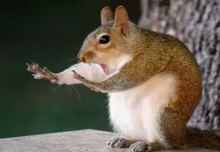

Be Radio-Active --- See Ya’ Soon!

Radio Waves is produced as a look inside of the Great Lakes Division and all that it has to offer. It is our sincerest hope that you have enjoyed this edition and will encourage your friends to be a part of the ARRL and receive the latest news and information about the ARRL and the Great Lakes Division!

The pictures throughout this newsletter are from various newsletters, Facebook posts and/or were sent directly to me in recent weeks. Take a good look at them, you just might be in one of the pictures! “SMILE… you might just be in the Great Lakes Division News!!”

