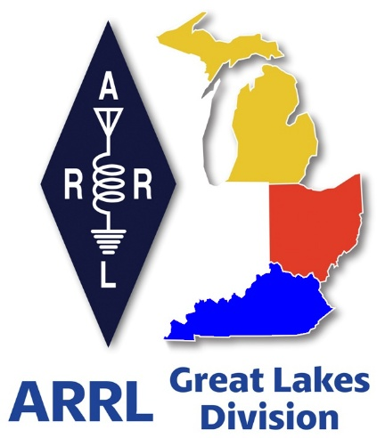
Radio Waves

^{The} Great Lakes
Division
Monthly Journal
January 2026

Scott’s Stuff
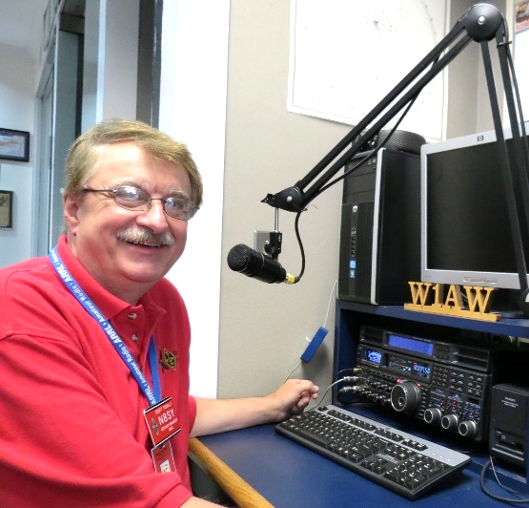
Hi Gang,

Happy New Year Everyone!

Today a fresh chapter starts for ARRL clubs. As the calendar flips to a brand-new year, I’m bursting with excitement to share some incredible updates and opportunities from ARRL that will enhance engagement, creativity, and community for clubs and individuals alike. This is a time for renewal, growth, and connecting with the vibrant world of amateur radio, and we’re thrilled to unveil a range of exciting initiatives designed to inspire and empower our clubs and its members. Whether you’re a seasoned club leader, a tech-savvy young ham, or someone passionate about public outreach, there’s something here for everyone. Let’s dive into what’s in store for 2026!

Modernizing New Club Affiliations. First and foremost, the heart of our mission is you, our clubs. To make it easier than ever to stay connected and active, we’re introducing a modernized Club Affiliation form for our new clubs this year. This updated form is designed with user-friendly interfaces, digital submission options, and clearer guidelines to help clubs streamline their administrative tasks. No more sifting through outdated paperwork or waiting for snail-mail confirmations! By simplifying the process, we hope to save you time and energy so you can focus on what truly matters: fostering camaraderie, mentoring new operators, and advancing the hobby. Think of this as a digital upgrade that aligns with how we live and communicate today.

Coding Competition…
If you have young enthusiasts in your club or community, mark your calendars for our 2026 Coding Competition—a dynamic way to blend amateur radio with STEM education. This competition invites students and young hams to develop innovative software or coding projects that interface with amateur radio technology. From creating apps for contest logging to designing tools for satellite tracking, participants will have the chance to showcase their creativity while learning critical programming and problem-solving skills. We’re not just promoting ham radio; we’re nurturing the next generation of innovators. Winning projects will be highlighted in amateur radio publications, and top contributors could walk away with scholarships or tech prizes. The goal? To inspire curiosity and bridge the gap between radio, technology and our youth.

Newsletter and Website Contests…
For those passionate about public information and outreach, we’re revamping our contests to celebrate the power of communication. The Newsletter Contest invites club members and groups in the Public Information sector to submit their best amateur radio newsletters. Whether your focus is emergency preparedness, community service, or promoting the hobby to newcomers, we want to see how you’re sharing the magic of ham radio. Judges will look for creativity, clarity, and impact, with awards going to the most outstanding entries.

Meanwhile, the Website Competition challenges clubs to elevate their online presence. A well-designed website can be a hub for event calendars, educational resources, and club announcements. We’re looking for clean layouts, engaging content, and accessible design that makes it easy for visitors to learn about your club. These contests aren’t just about winning—we hope they spark ideas and friendly collaboration as members work together to shine a spotlight on their communities as well as sharing “Best Practices” between all of our Affiliated Clubs!

Contest Portal and America250 WAS…
On the contest front, we’re rolling out the new Contest Portal, a one-stop digital hub that will revolutionize how operators access and participate in events. Picture this: real-time standings, downloadable logs, contest rules, and registration links—all in one easily navigable platform. This tool is designed to make contesting more efficient and enjoyable, whether you’re a casual participant or a seasoned sprinter.

And for those of you chasing the thrill of global connections, don’t miss America250 WAS (Worked All States)! This special event is part of the broader America250 initiative, celebrating 250 years of American independence. The goal? Work stations in all 50 U.S. states, plus territories, through a mix of on-air contacts and digital modes. The best part? Every successful contact contributes to “wallpapering” your log with unique call signs, creating a tangible memento of your participation. With this contest, you’re not just improving your skills; you’re honoring a pivotal chapter in our nation’s history.

A New Year, A New Adventure…
As I reflect on these launches, I’m reminded of why amateur radio remains such a special community. You’re not just operators; you’re innovators, educators, volunteers, and connectors. Whether you’re mentoring a rookie in Morse code, designing a website that inspires new members, or building software that pushes the boundaries of radio technology, every contribution matters. This New Year, let’s embrace the opportunities before us to grow, collaborate, and celebrate the joy of communication.

So, grab your handiwork, rally your club, and dive into these initiatives. The new forms, contests, and resources are just the beginning. Together, we’ll continue building a future where amateur radio thrives as a dynamic and inclusive hobby for generations to come.

Now, on a final note for the year, because clearly 2025 wasn’t done handing me emotional gut punches of pure joy. I have some great news from the grandkid front.

My youngest granddaughter, yes, the one who still thinks kale is a conspiracy invented by adults to ruin snacks, has officially entered the thrilling, static-filled world of amateur radio. That’s right. She enrolled in the ARRL-sponsored Technician Class license program that ran just before Christmas, sat through the course like a tiny, focused Einstein with better hair, and then, brace yourself, passed the test.

Let me repeat that for dramatic effect: My granddaughter. Passed. The Technician Class license exam. On her first try, no less. She will soon be an officially a licensed ham, call sign KF8***.

And get this, she isn’t stopping at just passing. Oh no. In a move that nearly gave me emotional whiplash, she also signed up to become a Full Member of the ARRL. That’s right. While her peers are swiping on TikTok and arguing about avocado toast, she’s reading QST magazine and talking about antenna polarization like it’s a brunch conversation.

I’ve never been prouder, and also slightly terrified. Now she wants me to help her learn CW!!! Can you believe that?

Look, I knew she was smart. I’ve seen her beat her older brother at chess while simultaneously texting and eating a popsicle. But this? This is next level. I’m starting to suspect she’s not even my grandchild—she’s a government experiment sent to make me feel obsolete. Still, I’ll admit it: I cried a little with so much joy and excitement for her.

So, here’s to you, KF8***, the youngest licensed ham in our family!! May your signals be strong, your noise floor low, and may you never, ever have to explain to your friends what “73” means.

And grandma? She’s already assembling a quilt with call signs embroidered on it.

Enjoy the bands and get Radio Active, but above all, regardless of your preferred mode or band, remember the golden rules of our incredible hobby: Have FUN, be respectful and most importantly, Get On The Air!

73, Scott…

Scott Yonally, N8SY
Director - Great Lakes Division
n8sy@n8sy.com

Celebrating Community Connections

ARRL “Amateur Radio Activity Report” Shines a Light on Non-Emergency Events.
Amateur radio isn’t just about emergency preparedness—though that’s an essential role it plays. It’s also about community, education, and shared passion. Across the country, ARRL-affiliated clubs and individual hams are organizing and participating in events that bring the spirit of ham radio to life in vibrant, often unexpected ways. From science fairs and school classrooms to local festivals and marathon finish lines, amateur radio operators are making meaningful connections—and the ARRL Amateur Radio Activity Report is the place to share those stories. https://www.arrl.org/amateur-radio-activity-report

The newly created Activity Report, a key tool for the ARRL to track and celebrate non-ARES (Amateur Radio Emergency Service) events, captures the full spectrum of amateur radio engagement. Whether it's a weekend license class, a high school STEM presentation, or supporting communications at a charity 5K run, these events showcase how amateur radio continues to thrive as a hobby, a service, and a gateway to lifelong learning.

With the ARRL’s ongoing “Year of the Club” initiative, local clubs have been energized to connect more deeply with their communities and with each other. These clubs, whether urban, rural, or university-based, are the heartbeat of amateur radio. The Activity Report not only documents their efforts but also improves their impact.

Reports like these help ARRL leaders understand what’s working, what resources clubs need, and how to replicate successful models elsewhere. But more importantly, they let clubs know their efforts are seen, valued, and celebrated.

Amateur radio operators are also supporting public events in non-emergency roles. From marathons to county fairs to historical reenactments, hams help keep communications flowing smoothly. These gigs may not involve emergency response, but they build public awareness and trust in amateur radio’s capabilities.

Sharing Your Story with the ARRL. If you or your club recently hosted or participated in a non-ARES event—especially one involving licensing, public outreach, or community support—we encourage you to submit it to the ARRL Amateur Radio Activity Report. It’s simple: just visit the ARRL website, fill out the form with basic details (date, location, number of participants, type of activity), and share what made the event special.

And if you’ve got a write-up with photos, testimonials, or media coverage? Even better. Send it to qst@arrl.org. Selected stories may be featured in QST magazine or on ARRL’s social media channels, giving your club national recognition.

Frequently Asked Questions (FAQ)

Q: What kind of activities should I report?
A: Any non-emergency amateur radio activity—licensing classes, school presentations, public demonstrations at fairs or festivals, race or event support, youth outreach programs, and more.

Q: Can individuals submit, or only clubs?
A: Both individuals and clubs can submit reports. If you helped at a community event or hosted a training session, your contribution counts.

Q: Do I need photos or a write-up?
A: Not required for the basic Activity Report, but highly encouraged. If you have a detailed story or images, send them to qst@arrl.org for potential publication.

Q: Is there a deadline for submissions?
A: No strict deadline—reports can be submitted anytime. However, earlier submissions help ARRL track annual trends and celebrate events in a timely way.

Q: How will my report be used?
A: Reports help ARRL measure community engagement, support the "Year of the Club" goals, and share success stories with the wider amateur radio community.

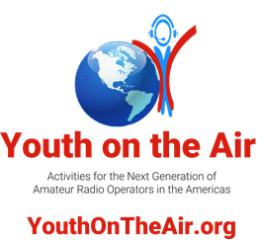
The application period for the sixth camp for young amateur radio operators in North, Central, and South America is now open at YouthOnTheAir.org.
UNION, Kentucky, December 1, 2025—Applications are now being accepted for campers interested in attending Youth on the Air Camp. Licensed amateur radio operators ages 15 through 25 who want to attend are encouraged to apply online at YouthOnTheAir.org. The camp is scheduled to take place June 14-19, 2026, in Huntsville, Alabama, United States of America.

For the first time, YOTA Camp will have a theme for the week: Space. For the best chance at being selected, applications should be submitted by 2359Z on January 15, 2026. Campers will be selected by the working group and notified by February 1. To encourage attendance from across the Americas, allocations for campers are being held open for various areas of North, Central, and South America. If countries do not use their allocation or should someone decline acceptance within an allocation, those positions will be filled from the remaining pool of applicants. As this will be an ongoing process, everyone will not receive notification of acceptance at the same time. Preference will be given to first-time attendees.
Applications will continue to be accepted through May 1.
The application process is FREE. A $100 USD deposit is required upon acceptance. Should a potential camper be unable to pay the $100 deposit, he or she may apply for a scholarship or waiver. Campers are also responsible for their own arrival and departure transportation to the camp location. Travel assistance may also be available, especially for those traveling from outside of the USA and Canada but within the Americas. Travel during camp events is provided.
Up to 50 campers will be accepted. Priority will be given to first-time attendees and youth residing outside of the USA. Only a limited number of returning attendees will be accepted and must serve as leaders during the camp. Leaders will be selected based on staffing needs to facilitate this year’s session choices.
Potential campers that reside outside of the USA are encouraged to begin the process of obtaining the necessary passport (and appointment to obtain a tourist VISA, where applicable) NOW, as processing times may extend into several months.
Huntsville Amateur Radio Club is the local host for the 2026 camp.
For details about the camp, visit the camp web page at YouthOnTheAir.org.
For additional information, please contact Camp Director Neil Rapp, WB9VPG at director@youthontheair.org.

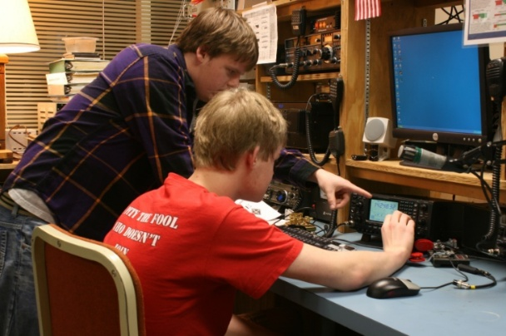
Fun Contests / Things To Do

ARRL KIDS DAY
Kids Day is designed to give on-the-air experience to young people and hopefully foster interest in getting a license of their own. It is also intended to give older hams a chance to share their station and love for Amateur Radio with their children.

Kids Day is Saturday, January 3. Kids Day always runs from 1800 UTC through 2359 UTC. Operate as much or as little as you like. For more information visit:
www.arrl.org/kids-day

ARRL RTTY ROUNDUP
ARRL RTTY Roundup is January 3 from 1800 UTC to January 4 to 2359 UTC. For more information go to www.arrl.org/rtty-roundup for more information.

ARRL STRAIGHT KEY NIGHT
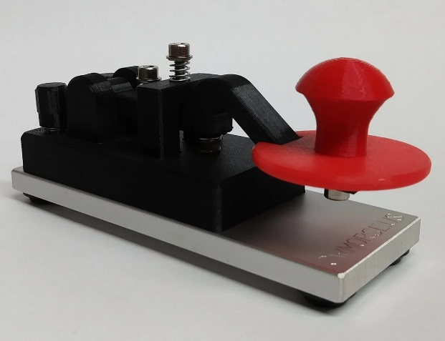
Straight Key Night is held every January 1 from 0000 UTC through 2359 UTC. This 24-hour event is not a contest; rather it is a day dedicated to celebrating our CW heritage.

Participants are encouraged to get on the air and simply make enjoyable, conversational CW QSOs. The use of straight keys or bugs to send CW is preferred. There are no points scored and all who participate are winners.

ARRL JANUARY VHF CONTEST
The ARRL January VHF Contest starts at 1900UTC on January 17 and goes to 0359 UTC on January 18. For more information go to www.arrl.org/january-vhf.

WINTER FIELD DAY
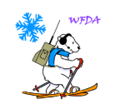
Winter Field Day is January 24 from 1600 UTC to January 25 to 2159 UTC. The Winter Field Day event aims to help participants improve their preparedness for disasters and enhance their operational abilities in adverse conditions.

Amateur radio operators have the freedom to use frequencies on the HF, VHF, or UHF bands while employing voice, CW, and digital transmissions.

The event designates specific objectives to encourage a diverse range of activities, including the use of non-commercial power sources, the deployment of multiple antennas, establishing satellite contacts, and more. For more information visit: www.winterfieldday.org

Follow-up to “Links in my Thunderbird email program not working”
I’ve heard from a number of you that are using Thunderbird for your email client with this same issue, the link that I’m sending won’t work.

After much research and help from a good friend, he’s come up with a really cool and easy way to work around the issue of the links not working… Are you ready for this…?? Simply forward the email to yourself. As crazy as this sounds, "The link(s) will show up"..!!

Until a more permanent fix can be initiated, this sounds like the easiest way of working around a glitch in software.

Give it a try and let me know if you were successful or not.

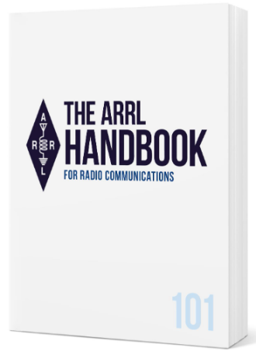
Handbook Give Away

And… Here’s the New Year’s winner!!

DARRELL JORDAN - KG4AOF

of Lancaster, KY…!!!

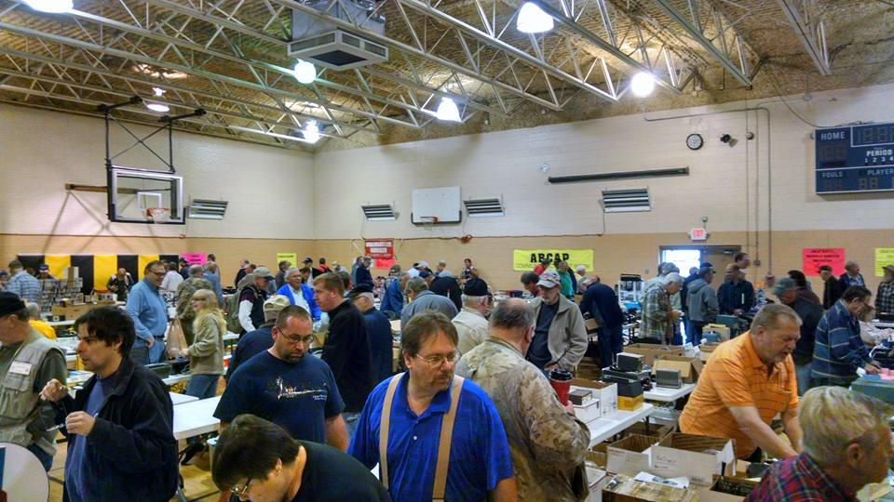
2026 Great Lakes Division Hamfests

Here in the Great Lakes Division, we have over 50 hamfests a year.

So, if you haven’t started planning your hamfest schedule yet, you really need to start now.

Please post this listing in your club's newsletter and announce the swaps on your local nets. Talk them up.

Let's fully support all of our hamfests in every way possible. It means success for everyone. Be sure to invite your ARRL Officials as soon as your date is set.

If you are planning on having your hamfest listed in QST please be sure to start your planning well in advance of your Hamfest date, as this allows adequate time for QST Listings. QST announcements require a 3-month lead time.

To be fair to our division’s clubs, the Great Lakes Division policy now has 2 requirements. Any club requesting ARRL sanctioning within the Great Lakes Division must now be an ARRL Affiliated Club with a maximum of two hamfests/swaps in any given calendar year, and they must be at least four months apart.
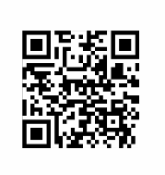
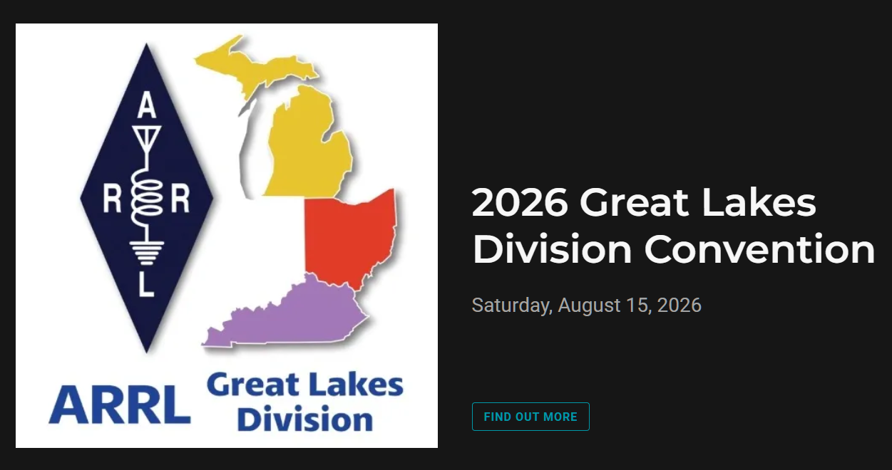

01/18/2026 - SCARF Hamfest  Location: Shade, OH  Sponsor: SCARF members  Learn More | 01/31/2026 - Struthers ROAR Hamfest  Location: Struthers, OH  Sponsor: Struthers Regional Operators  Website: https://www.facebook.com/profile.php?id=61580196127715  Learn More

02/08/2026 - Cherryland ARC Annual Swap & Shop  Location: Traverse City, MI  Sponsor: ARRL  Website: http://cherrylandarc.com  Learn More | 02/21/2026 - Livonia Amateur Radio Club Annual Swap & Shop  Location: Northville, MI  Sponsor: Livonia Amateur Radio Club  Website: http://livoniaarc.com/larc-annual-swap-and-shop/  Learn More
03/07/2026 - Cave City Hamfest  Location: Cave City, KY  Sponsor: Mammoth Cave ARC  Website: http://www.ky4x@org  Learn More | 03/08/2026 - Northern Ohio Amateur Radio Society Winter Hamfest  Location: Elyria, OH  Sponsor: Northern Ohio Amateur Radio Society  Website: https://www.noars.net/hamfests/winter-hamfest/  Learn More

You can always find the latest information about upcoming hamfests on the Great Lakes Division website.

Just click to get the latest hamfest updates.

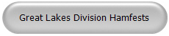

Club Links

I’ve received a number of new requests from clubs to be listed on the “Links” club page.
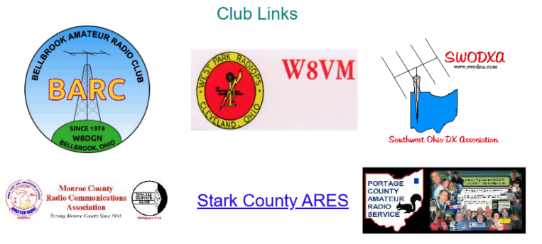

Is your club listed? If not, send the URL of your club website to me n8sy@n8sy.com and I’ll get it listed.



Renewing your FCC Amateur Radio License

NOTE…


ARRL is reporting that the FCC has extended the filing deadline to March 5, 2026, for amateur radio licenses that otherwise were due to expire from October 1, 2025, to March 5, 2026. The announcement is included in an FCC Public Notice (DA-25-943) released on Monday, November 17, 2025.

The news follows the recent reopening of the federal government on November 13, following a lengthy 43-day shutdown. Since reopening, many federal agencies, including the FCC, have resumed activities, though reducing backlogs and rebounding to full operations may take some time. This includes significant delays in filing amateur radio license applications.

******************
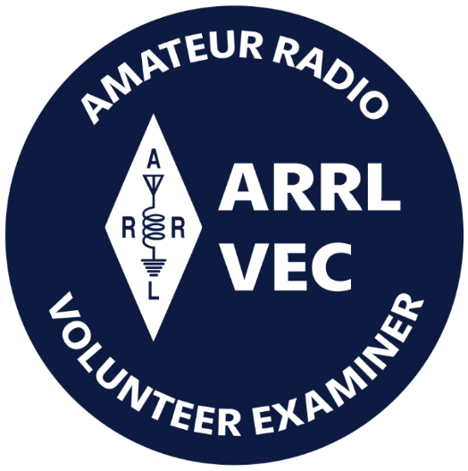
Hey ARRL Members: License modifications/changes and renewals will be processed to the FCC for FREE for current ARRL members as part of your membership services. An FCC fee may apply to your license transaction which must be paid directly to the FCC. ARRL VEC can help you make the FCC payment. As soon as the application and payment is pending in the FCC system, call our office and have a credit card ready. We can login to the CORES payment system and effortlessly pay the $35 FCC fee using your credit card. See the FCC Fee section below.

Renewing your Ham license isn’t as easy as it used to be. Since the FCC is now collecting a $35 fee with all renewals there’s a little more to it now than just completing the 605 and sending it in.

To renew, update, or add an email address or phone number to a license record, amateurs may file online (electronically) on the FCC ULS website via the License Manager System using their FCC issued FCC Registration Number (FRN) and password. Manually filed paper applications are not accepted by the FCC. A valid email address is required on all applications and filings.

Applicants are required to answer the FCC Basic Qualification Question (felony question) if they are filing for one of the following purposes indicated: New, Amendment, Modification (Upgrade or Call sign change), Renewal Only, or Renewal with Modification. Applicants applying for any other purpose are not required to answer this question.
The FCC permits administrative updates and call sign changes at any time. License renewals are allowed at 90 days or less before a license will expire, and when the license has expired but is still within the two-year grace period. Licenses that have been expired for more than two years are not eligible for renewal or reinstatement.
Visit the FCC’s License Renewal Instructions page and the FCC’s Renewal Application Checklist page. This checklist is a preparation guide to help license holders gather the necessary information before they begin the License Renewal process, direct them to the proper websites, and provide help articles to common issues some people encounter.
The checklist is intended to help the Amateur community navigate the ULS and CORES systems, to file and pay for their applications. There are also instructions available on the FCC’s Knowledge Base page to help the Amateur community find the appropriate FCC resources.
The FCC charges an application fee for certain filings including new licenses, vanity call sign requests, and license renewals. There are no fees for administrative updates, such as a change of name, mailing or email address, modification applications to upgrade an amateur radio licensee’s operator class or to request a sequentially issued call sign.
To file applications and pay any FCC application fees, the applicant must set up a new FCC CORES Username account. After creating the account, when logged in, you must associate your existing FRN to your new username.

Most amateurs have not yet registered for a CORES account. Follow the "Legacy CORES Users" instructions on the FCC CORES Registration Instructions page before attempting to file an application online. After completing the application online, if a payment is required, the system will automatically open a page asking how the applicant wants to pay and will walk the applicant through the payment process. If the application is filed through a VEC organization, the FCC fee must still be paid online directly to the FCC not to the organization processing the application form. View the application fee filing guide and instructions on the ARRL's FCC Application Fee webpage.
Licensees can log into the ULS License Manager System with their FRN and password at any time and update anything in their FCC license record, including adding an email address.
Amateur radio licensees and examination candidates must provide the FCC with an email address on all applications.
For additional assistance or to reset a password, call the FCC Licensing Support Center at 877-480-3201 (Mon.-Fri. 8 a.m.-6 p.m. ET), or submit a help request on the FCC’s Wireless Licensing Help Center website.
ARRL members may manually file an application for free (via mail, email, or FAX) to the ARRL VEC using the NCVEC Form 605. Non-members will be charged a processing fee to use this member service.

Here’s a step by step set of instructions from our ARRL V.E.C. on how to accomplish this task.

https://www.arrl.org/files/file/QST/This%20Month%20in%20QST/2023/10%20october%2023/10%2023%20Somma%20renew%20license%20online.pdf

Send a Radiogram… What’s a Radiogram?
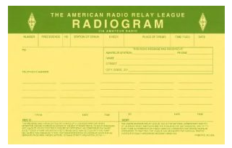
You’ve probably heard of amateur radio (“ham”) operators, and you might know a friend, family member, or neighbor who loves to build radio equipment and talk to thousands of other ham operators around the world!

But, you might not know that amateur radio operators are primed and ready to step in and provide valuable communications to the general public, when all else fails. Even if Internet service, power lines, and phone lines are all down, amateur radio still can get the message through. To be ready for this, many amateurs have joined a network called the National Traffic System (NTS), which is like a telegraph office over radio. NTS volunteers spend their free time relaying messages, called Radiograms, entirely by amateur radio, completely free of charge.
This is great practice to be sure they can serve the public during a true emergency!

Send a Radiogram Now — It’s Free! Radiogram – NTS
Now, there’s a way that YOU can try Amateur Radio messaging! Think of a friend or family member you’d like to contact by Radiogram. You can send any short message, as long as it’s not business-related, urgent or critical, or too private or personal.
Your message will be picked up by an Amateur Radio volunteer operator and relayed across the country to near its destination; finally, the recipient will get a local phone call from a nearby ham, or the message might even be delivered in person.
Along the way, ham operators will be relaying your message by voice, digital, or even Morse code, and getting valuable practice in emergency public service. To make it easy, please choose one of the standard message texts contained in the form.

(Note: Both the sender and the recipient must be in the United States or Canada).

Does the room go absolutely silent when it comes time for Officer nominations?

Here’s an idea that I’ve been kicking around after seeing many of our club’s leadership pipeline stall over the past few years, and frankly, it’s been frustrating to witness this.

It seems that every time nominations for Officers comes around, the room feels a little emptier than it should. Talented hams are busy with families, jobs, and the endless stream of projects that keep our radios humming. The result? A handful of volunteers shoulder the entire weight of running the club, and the rest of us watch from the sidelines, wishing we could step in but hesitating because the extra commitment feels like a hidden cost we can’t afford. That’s when the idea hit me: what if the club covered the ARRL dues for someone who serves as an officer for a year or so? It sounds simple, but the ripple effect could be profound.

First, the financial barrier disappears. For many members, especially newer ones, the annual ARRL membership, while a modest $59 adds up when you factor in all the expenses that a person has. By removing that line item, we’re saying, “We value your time and leadership enough to invest in you.” This is a tangible acknowledgment that the work we ask of our officers isn’t just a favor; it’s a partnership.

Second, the gesture sends a powerful message about our culture. When a club steps up to support its leaders, it builds an environment where service feels rewarding rather than burdensome. I can already picture a new wave of volunteers walking into the next election night, their eyes bright with the knowledge that the club has their back. That confidence can translate into more dynamic programming, fresh ideas for contests, and stronger community outreach, all the things that keep this hobby of ours alive and thriving.

Finally, there’s a strategic upside that goes beyond the numbers. The ARRL isn’t just a dues-collecting entity; it’s a gateway to resources, contests, and a national network that can amplify our club’s voice.

Officers who are members gain instant access to these tools, which they can then bring back to our meetings, workshops, and mentorship programs. In effect, we’re not only covering a fee, but we’re unlocking a treasure chest of benefits for the entire membership.

I know what you might be wondering: “Can our budget really accommodate this?” I firmly believe that it can, if we start viewing this expense as an investment in the club’s future rather than just another cost. By reevaluating our current spending, perhaps by making modest adjustments to our event budget or seeking a small sponsorship, we could easily free up the funds required to cover ARRL dues for our officers. The benefits would extend far beyond financial figures. The true return would be seen in the renewed energy, fresh ideas, and greater enthusiasm that our officers would bring back to the club.


With this in mind, the next step is clear: the club should bring this proposal before the board at the next meeting. An open discussion about the financial details, followed by a vote which would allow them to develop a concrete plan for funding the officers’ ARRL memberships. By doing so, we can eliminate the uncertainty that discourages many from stepping into leadership roles and instead send a strong, supportive message, one that affirms we are united and committed to each other’s success.

Ultimately, investing in our officers is an investment in the future of our clubs. By removing the financial barrier of ARRL dues, we recognize and value the time and leadership that officers contribute. This step creates a supportive environment, encouraging more members to take on leadership roles without worrying about the extra cost. When the club actively supports its leaders, it sends a message that service is appreciated and that the organization is committed to building a positive, rewarding culture.

Covering ARRL membership fees also connects officers directly to resources, contests, and a national network, all of which help strengthen the club’s programs and outreach. The benefits go far beyond numbers—they foster renewed energy, fresh ideas, and greater enthusiasm, ensuring the club remains vibrant and well connected to the broader amateur radio community.
Bringing this proposal to the board for open discussion and a formal vote will allow the club to create a concrete plan for funding, ensuring transparency and collective support. Taking this action reinforces our commitment to one another and secures a more dynamic and engaged leadership for the future.

Being Left-Handed in a Right-Handed World…

If you ever see a person with a “Left-Handed Club” badge on their laptop, you’ll know you’ve stumbled upon a rare species. I’m that species. I’m left-handed, and I’m here to tell you that while the world may claim to be balanced, it is, in fact, a gloriously right-handed playground—complete with right-handed shifters, right-handed door handles, and even right-handed butter knives that make you wonder if the universe conspired against us lefties.

Below is my (somewhat exaggerated) field report from the front lines of everyday life. Buckle up, because the left-handed experience is a wild ride that, surprisingly, usually ends with a right-handed sigh of relief.

The Car: A Mobile Right-Handed Museum
I bought my first car at the tender age of sixteen, eager to feel the wind in my hair and the freedom of the open road. The first thing I noticed, the gear shifter, starter switch, and all the climate-control buttons are glued to the right side of the dashboard.

For a left-handed driver, reaching for the gear lever feels like trying to pick a cherry off a cake that’s perched on a high shelf—awkward, slightly dangerous, and inevitably leading to a few “oops, I almost threw the car into neutral” moments.
My left hand spends most of its time hovering uselessly on the drivers door, like a nervous spectator at a sporting event. I’ve tried to “train” myself in the ways of the right-handed vehicle, but the more I practice, the more my left hand reminds me that it’s not a trained circus performer. It’s simply... left.

The Storm Door: An Entrapment Device
If you have a storm door on your house, you’ve probably never thought about which way it swings—until you’re a left-handed homeowner. In my neighborhood, more than 80 % of storm doors open toward the right. This means I have to stand on the right side of the handle, sometimes the stoop that you’re standing on doesn’t have that much room and then you are dangling your left foot in mid-air which would make a professional dancer wince.

Result? I usually end up getting smacked in the face by an errant door that seems to have a personal vendetta against lefties. Neighbors often ask, “Why do you look like you’re fighting a door?” I reply, “Because the door is winning.”

Assembly Lines: Left Handedness = Uphill Climbing
Ever walked through a U.S. manufacturing plant? In every facility that I’ve ever visited or worked in the conveyor belts move from left to right, a subtle yet powerful metaphor for the whole system. For a right-handed worker, that direction feels like a gentle downhill stroll—everything is positioned for the dominant hand to grab, place, and release with ease.

For a left-handed worker, it’s a perpetual uphill climb. My left hand constantly reaches across the line, battling the flow, while the right hand (the “supporting actor”) tries to keep up. It’s a bit like trying to write a novel with the page turned the wrong way—possible, but you’ll be constantly re-orienting yourself.

Power Tools: Oh… The humorous Right-Handed Safety Net
I’d love to say I enjoy home-improvement projects, but the reality is a bit grimmer. Most power tools have safety switches on the right side. When I try to start a drill, I have to awkwardly twist my wrist, flick a switch with my right hand, and then hope my left hand can maintain a firm grip on the handle. The same is true with most battery operated lawn tools as well.

The moment I’m halfway through a project and the safety button slips—the right hand jerks away, and the left hand is left to “hold” the tool like a toddler clutching a balloon. In many cases, this leads to a right-handed sigh of “Why didn’t I just buy the left-handed version?” Spoiler: those versions are so scarce they might as well be unicorns.

Everyday Objects: The Butter Knife and Scissors Conspiracy
Butter knives: sleek, stylish, and designed for right-handed spreaders. I’ve tried spreading butter with my left hand, only to end up flicking the butter onto the toast—then onto the table, and finally onto my lap. The knife’s curvature simply refuses to cooperate with a left-handed grip.

Scissors, however, are the real horror show. Normal scissors force a left-hander to look like a contortionist performing a modern dance routine. My wrist twists, my knuckles ache, and the cut line wavers like a nervous line of text. Left-handed scissors exist, but they’re as rare as hen’s teeth. I once ordered a pair online; the package arrived with a note: “Sorry, we only sell right-handed scissors—like the rest of the world.”

Even something as simple as a coffee cup with any kind of a design on it is normally made to face way from the user if he’s left-handed. For left-handed coffee drinkers, the experience is oddly reversed. When holding the cup in the left hand, the decorative design or logo is hidden from view, facing outwards so that only others can see it. Meanwhile, the right-handed user gets to enjoy the artwork directly, making even a morning ritual like sipping coffee feel subtly exclusive.

The Computer Mouse: A Right-Handed Ergonomic Nightmare
When you think of ergonomics, you picture a perfectly arched mouse that fits the hand like a glove—for a right-handed user. My mouse’s left side is a flat, uncomfortably sharp edge that makes my wrist feel like it’s been pressed into a vise after a few hours of work.
Yes, you can flip the mouse orientation in the settings, but the physical shape remains stubbornly right-handed. I’ve resorted to using a what is humorously called an ambidextrous mouse and even that feels like a tiny, digital version of the struggle I experience with every ordinary tool.

The Hidden Perks (If Any)
Before I end this confession, I must acknowledge the tiny benefits of being left-handed in a right-handed world:

Some studies suggest left-handers have more bilateral brain activity, which can translate into unique problem-solving skills. I like to regard this as being in my Right Brain!!!

In the world of sports, being left-handed can be a surprisingly advantageous. Whether it's baseball, tennis, or fencing, left-handed athletes often catch their right-handed opponents off guard. Not all that long ago there were no professional left-handed boxers. Many players and competitors are accustomed to facing right-handed moves, so when a left-hander steps up, their approach and techniques can feel unfamiliar and challenging to counter. This unexpected element allows left-handed individuals to gain a unique edge, turning their difference into a genuine "secret superpower" on the field or court.

Conversation Starter… “Did you know I’m left-handed?” is an instant ice-breaker that leads to fascinating anecdotes about the hidden right-handed biases of everyday life.

Most left-handers are ambidextrous, It’s been said that left-handers have a brain wired for creativity—probably because we spend half our lives figuring out how to use scissors, can openers, and spiral notebooks without injury. Studies claim we have more bilateral brain activity, which means both hemispheres are working overtime, possibly arguing about whose idea it was to make every mug in the kitchen face the wrong way.
So, if you ever see a left-hander coming up with clever solutions, just remember it’s not just talent, it’s survival. Our brains became creative out of pure necessity, and probably a couple of snack-related emergencies.

My Call to Action… Let’s Right-Hand the World a Little
If you’re right-handed reading this (and you probably are), I ask you for a tiny favor: when you’re shopping for scissors, a butter knife, or a mouse, consider grabbing the left-handed version. It’s not just a gesture; it’s a rebellion against an invisible design rulebook that has ruled our world for centuries.

And to my fellow left-handed comrades: keep your left hand proud, keep the jokes flowing, and remember that every time you wrestle with a right-handed door, you’re a living testament to the fact that difference is deliciously, hilariously, and sometimes inconveniently special. Being left-handed can be something very special—because we navigate a world built for the opposite hand, we develop a unique mix of flexibility, humor, and (occasionally) bruised knuckles.

STOP!!!
We’ve come to the end…

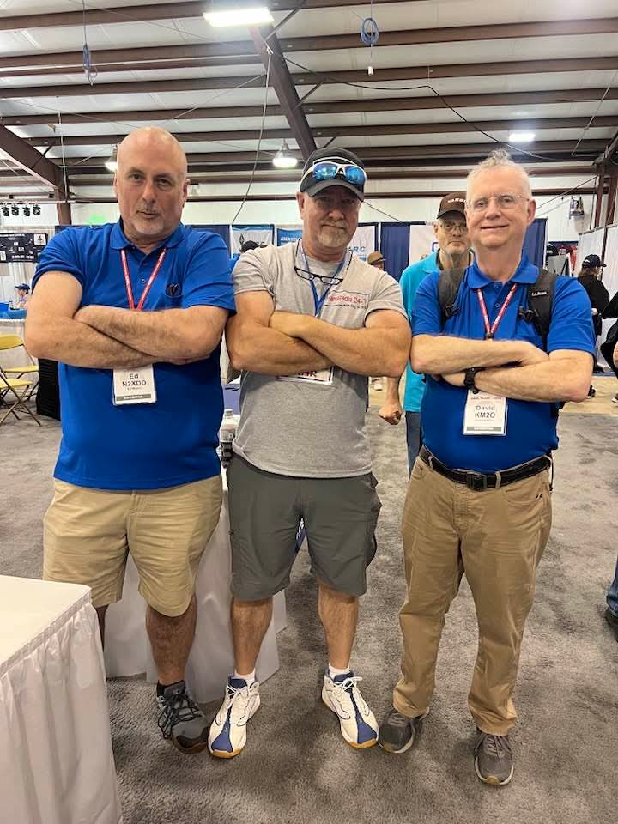

Be Radio-Active --- See Ya’ Soon!

Radio Waves is produced as a look inside of the Great Lakes Division and all that it has to offer. It is our sincerest hope that you have enjoyed this edition and will encourage your friends to be a part of the ARRL and receive the latest news and information about the ARRL and the Great Lakes Division!

Many pictures throughout this newsletter are from various other newsletters, Facebook posts and/or were sent directly to me in recent weeks. Take a good look at them, you just might be in one of the pictures! “SMILE… you might just be in the Great Lakes Division News!!”

