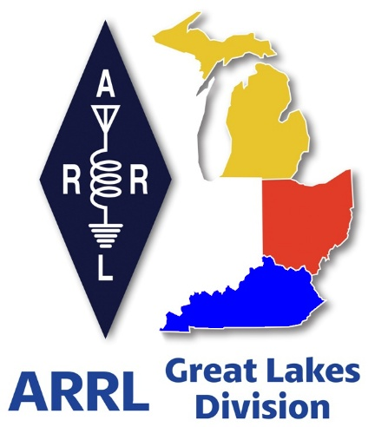
Radio Waves
^{The} Great Lakes Division
Mid- Month Report
February

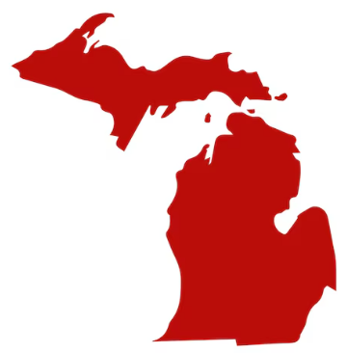
From the Michigan Section Manager
Ralph Katz, AA8RK
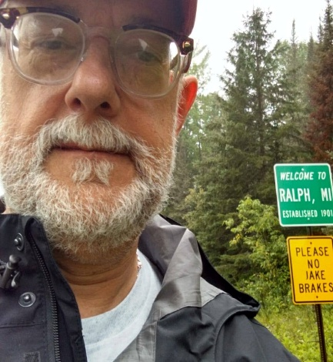
This has been a fun month with POTA events, Winter Field Day, a swap, and of course the fun Michigan weather. But also, KD8ESJ and I are back to normal after the lone bathroom in our little house was gutted and reconstructed. The weather and everything else just seem like added details

It has also been fun to watch the two Brits Josh and Jase report on their adventures working up the western part of the lower peninsula and into the UP and Mackinaw Island. We enjoyed their amazement over all of things in our great state that we tend to take for granted. Maybe they want to become radio hams?

I was able to attend a POTA event held by the South Lyon Area Amateur Radio Club (SLAARC, N8SL) at Bishop Lake State Park. Propane space heaters did not make this outdoor event particularly warmer, but did give folks a fun place to stand and talk. In particular, a diesel fuel heater kept a laptop warm enough to stay working.

They thought of everything - chicken noodle soup and hot dogs were especially appreciated.

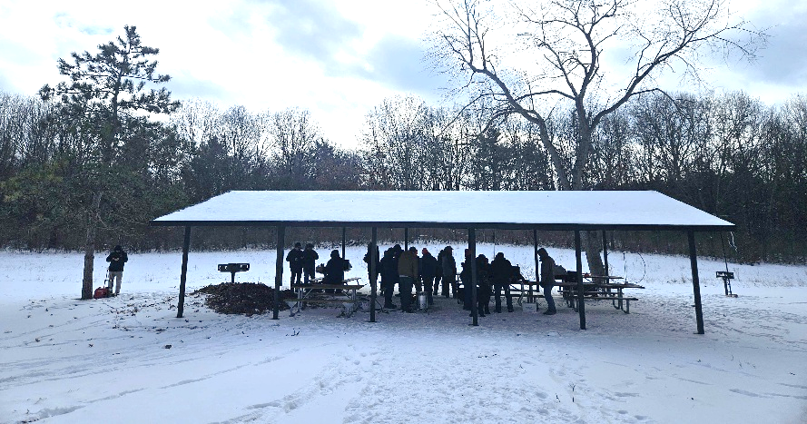

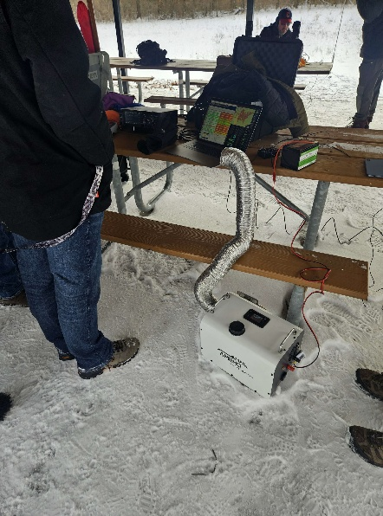

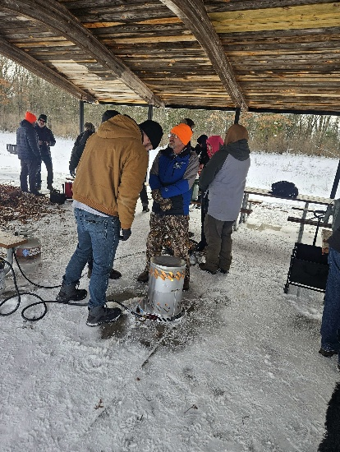
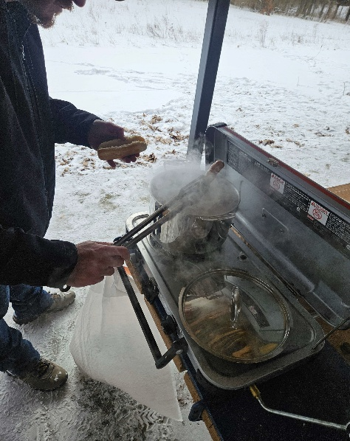

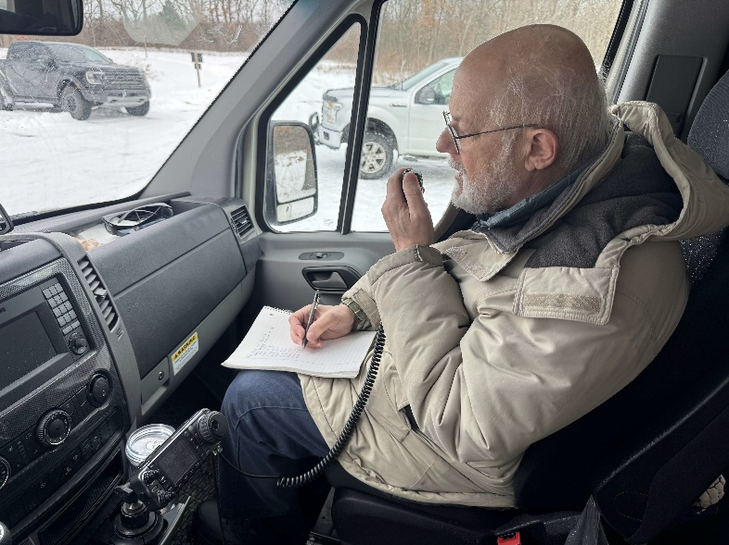
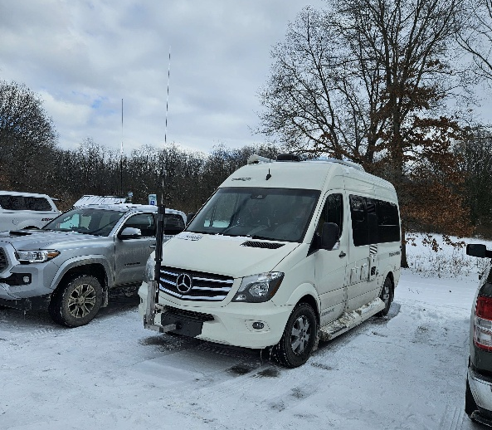
Mark Pinsky W8MP and his wife Rose KD8EGG found that I had never done a POTA activation before and dragged me into their RV to activate US-3315 with 26 contacts.
The Livingston Amateur Radio Klub (LARK – W8LRK) and ARROW Communication Assoc. (Ann Arbor, W8RP) both had Winter Field Day events in cabins at Bishop Lake State Park near Brighton. Nice, toasty warm cabins. These photos are from ARROW.
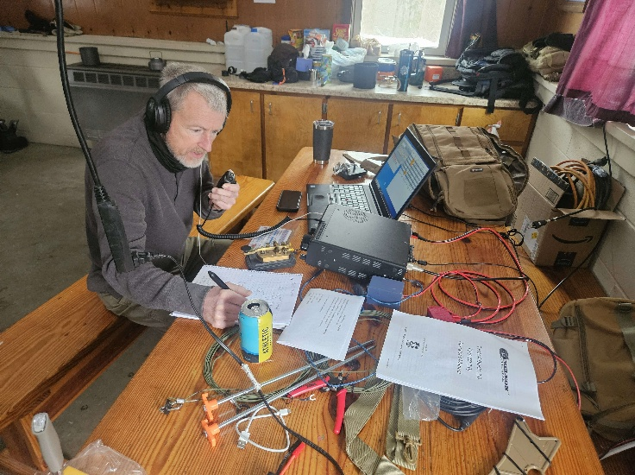
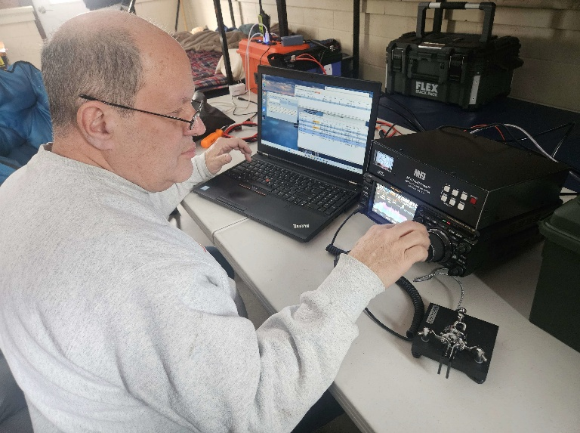

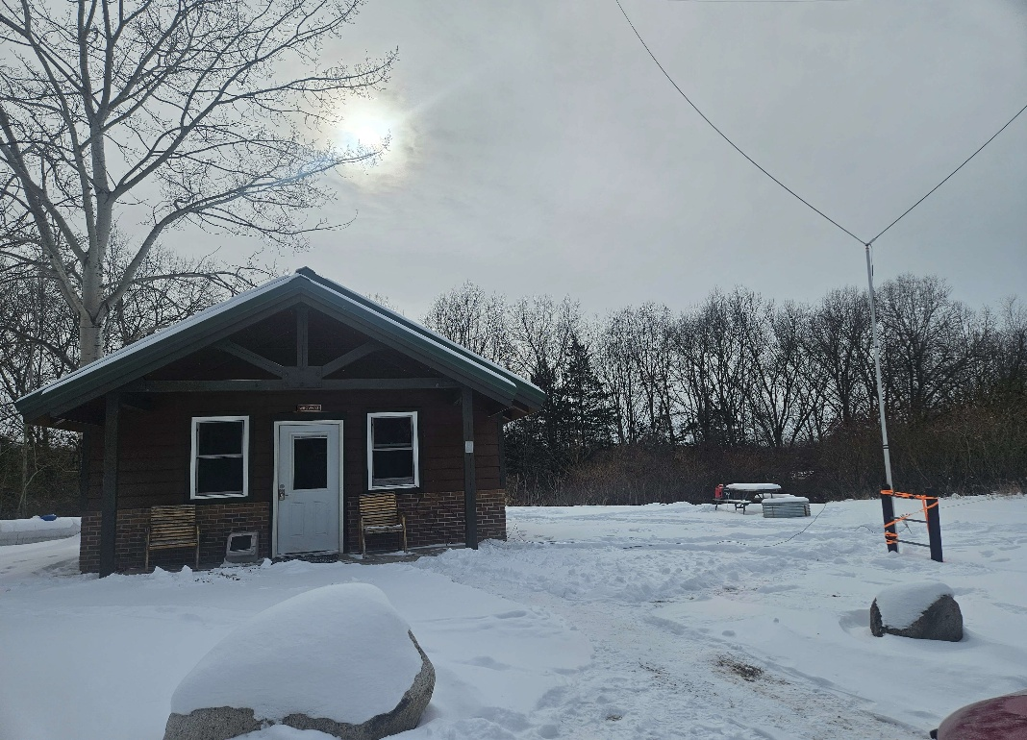

Many thanks to Levi N8GMZ, Tim K8LK and Eric N8RJR for sending photos of the North Ottawa ARC participation in Winter Field Day (sorry I cannot identify all of the people).

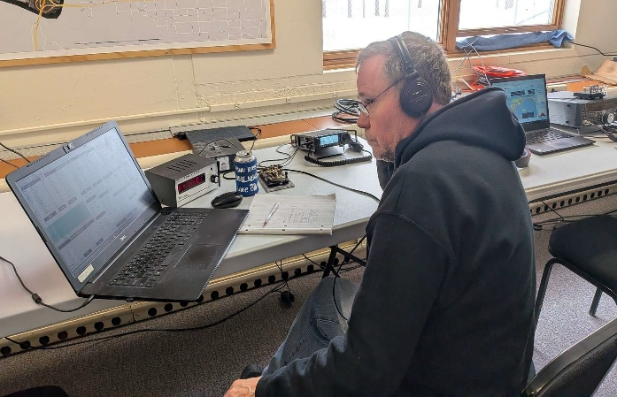
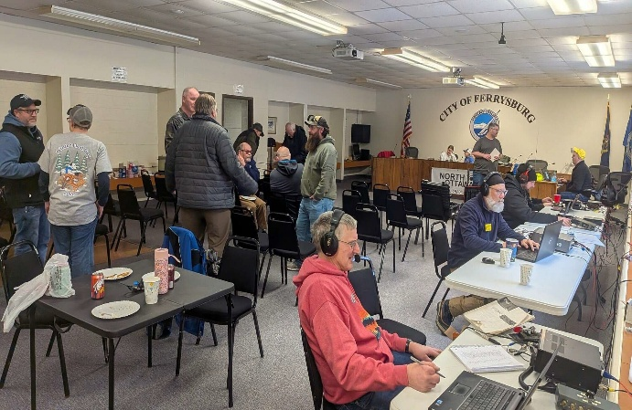

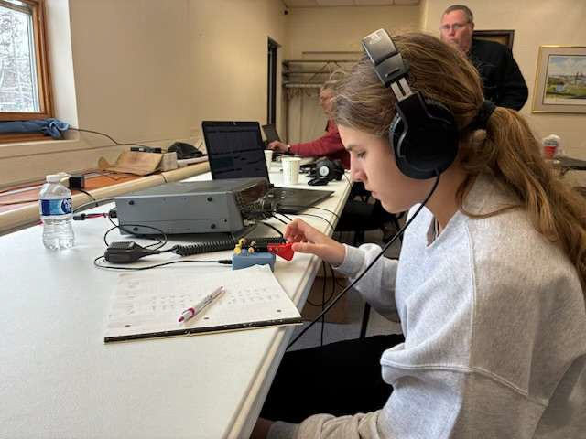
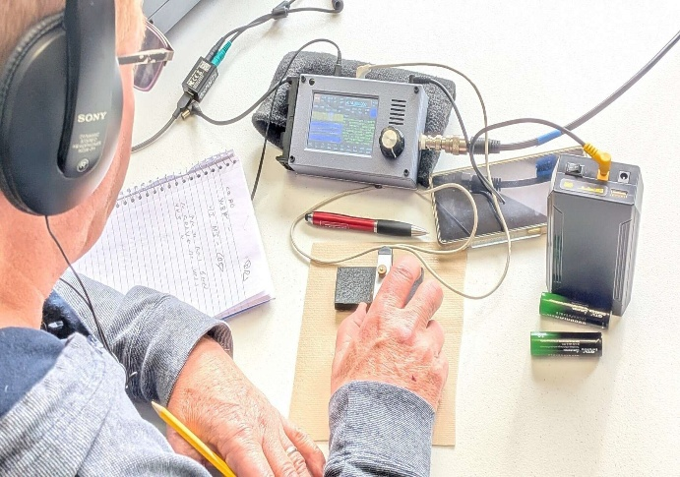

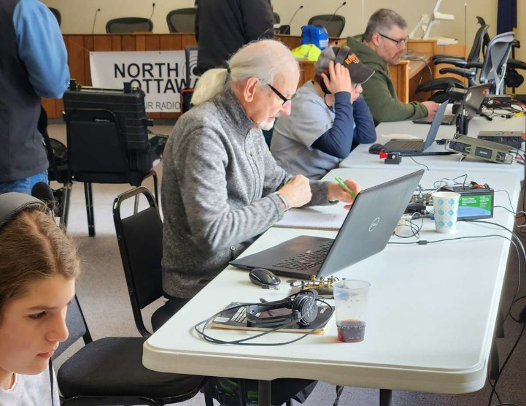
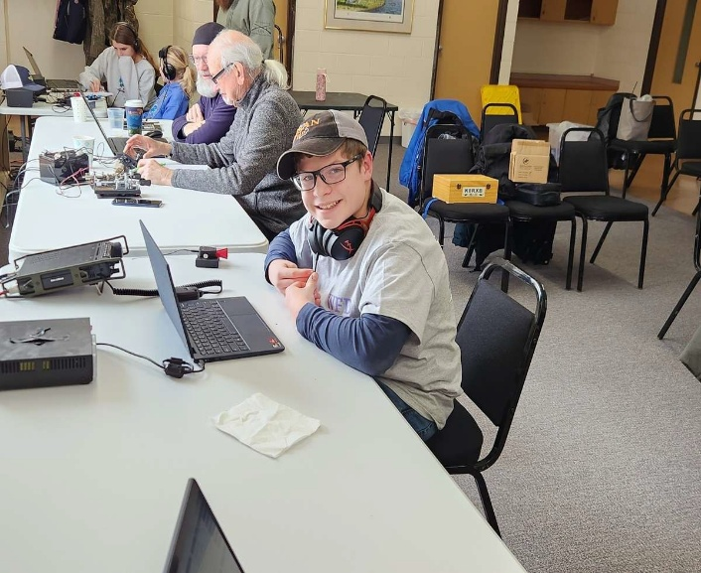

I am happy to pass on information from Fred Schebor K8NGW, the Michigan Coordinator for America250 W1AW/8 operations. He says it was a blast to be a member of the 2014 ARRL Centennial W1AW/8 operations and encourages you to participate.

The ARRL is holding a Year-Long Worked All States (WAS-250) operating event to recognize the 250th Anniversary (Semi-quin-centennial) of the Declaration of Independence. (https://www.arrl.org/america250-was) Nebraska and New York have already hosted W1AW/x stations.

If you would like a respite and switch from chaser to chased, then from Wednesday February 18 at 00:00 UTC to Tuesday February 24 at 23:59 UTC, ARRL Michigan Section operators will be putting W1AW/8 on the air! Our goal is to activate as many bands (excluding 60 Meters) as possible on the three modes of CW, Phone and Digital, plus satellite.

If you are interested in being a W1AW/8 operator, the requirements are straightforward:

- You must be an ARRL Michigan Section member.
- Your transmitter and antenna must physically reside within the state of Michigan.
(If your station is in Michigan, then as W1AW/8 you can send Hellschreiber remotely from
Miami Beach!)
- You are expected to observe all FCC allocated frequencies, modes and power levels allocated to your license class.
- All logging must be submitted in ADIF format.

Notice that there’s no requirement for station hardware or experience. So yes, while we want all the mega-transmitter, multi-antenna and multi-thousand-hour experienced operators we can get, we also encourage relatively new operators with 100 watts and a wire to apply. We can shepherd/shelter you with appropriate band and time-slot suggestions to keep you from getting into the pileup deep end. In return you get to gently develop your pileup handling skills.

Still interested? If so, please e-mail Fred (fschebor@arrl.net) with your:

- name and call as it appears on your FCC license.
- class of FCC license
- QTH address and maidenhead grid ID
- phone number (would only be used in an emergency)
- e-mail address (if different from the address you’re responding from)
- capabilities and experience - a couple of sentences to save me from reading all the QRZ bios :-)

If your schedule won’t permit the February event, you’re not out of luck. The February event is the first of two. The second event will be seven days starting October 28 thru November 3. A call for that event will be made in July/August.

The ARRL has opened up a new Affiliated Clubs website here: https://affiliatedclubs.arrl.org/

This has a lot of new resources, map-based searching, and other good stuff. If your club is affiliated or not, you are encouraged to check this out. If your club is affiliated, then especially check that the information listed for you is up to date.

And, if your club is not affiliated, you are encouraged to talk to me.

The Michigan Section Manager calendar of events is associated with this Gmail account: arrl.mi.section.manager@gmail.com

Please let me know if you have problems accessing this.

As always: Do you have ideas and/or want to help? Or just want to kvetch? Please contact me. It is my honor to serve you.

73,

Ralph Katz AA8RK
Ann Arbor, MI
arrl.mi.section.manager@gmail.com
aa8rk@arrl.org


From the Ohio Section Manager
Bret Stemen, KD8SCL
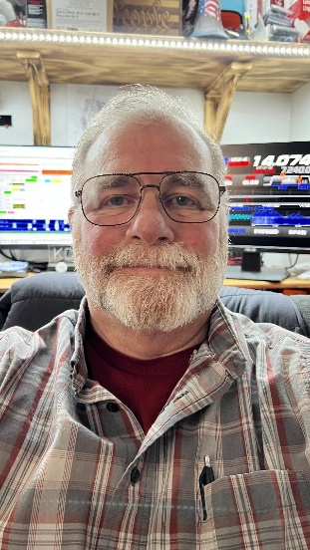

The latest edition of the Ohio Section Journal is now online and ready for you to read! There’s an awful lot of Ham Radio activities going on
in the Ohio Section, so get off the chair or couch you’re sitting on
and get out there, get involved, and get on the air!
The link below will take you directly to the Ohio Section newsletter.

https://arrl-ohio.org/wp-content/uploads/2026/02/OSJ_February_2026.pdf

Bret… kd8scl@arrl.org

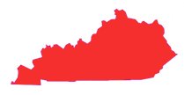
From the Kentucky Section Manager
Bob Selbrede, K6ZZ

Hi Folks,
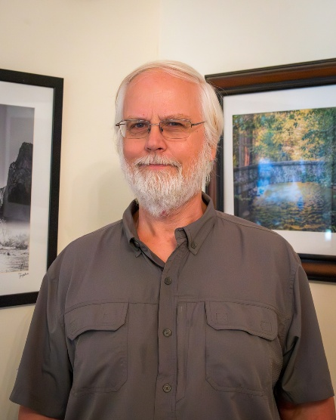
I hope everyone managed to make it through the snow and ice with minimal complications! We had roughly 8" in La Grange and it stuck around for several weeks due to the low temps.

We continue to make slow but steady progress getting Kentucky ARES back on its feet. Some ARES groups are doing pretty well, and some not. To help with this our Section Emergency Coordinator (SEC) Dennis W2QN will be conducting several ARES mini conferences across the Section with the goal of helping folks establish well-functioning ARES groups in areas that need it the most. The first of these took place in Shelbyville on 31 January. The event was well attended, and the consensus was gatherings of this sort are very beneficial. The next mini conference is TBD. More information will be forthcoming soon.

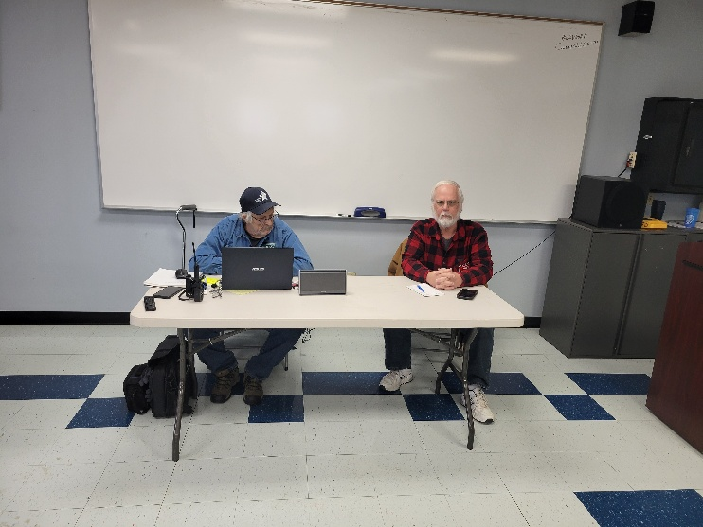
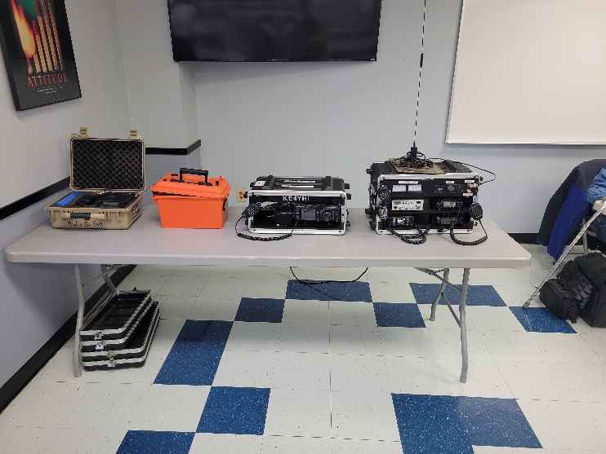
There will be an ARRL Forum at the upcoming Cave City Hamfest on Saturday March 7th. We plan to have an ARRL Forum at the Hamfest where ARES and other topics of interest will be discussed. It should be a great Hamfest so hopefully you can make it.

A quick reminder that ARRL Affiliated Clubs in Kentucky will have two opportunities this year to operate W1AW/4 as part of the America250 WAS Program sponsored by the ARRL. The first being in March and the second in September. Refer to last month's Division Newsletter for more details. These opportunities do not come up often. If you are a member of an ARRL Affiliated Club and have not heard about this, check with your Club POC since they would have been contacted by our Affiliated Club Coordinator (ACC) Steve Morgan W4NHO.
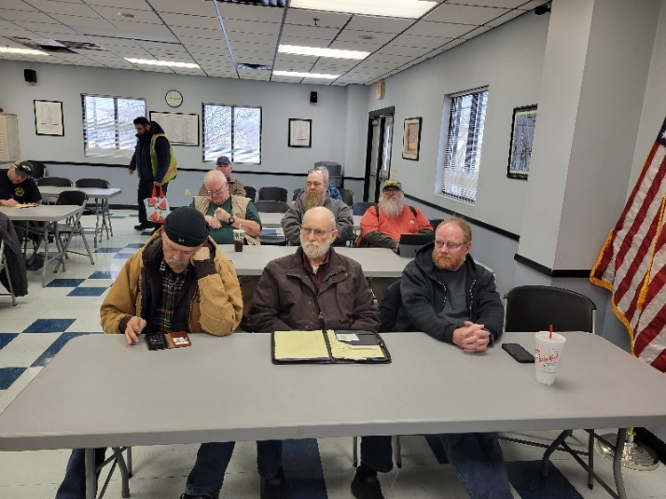
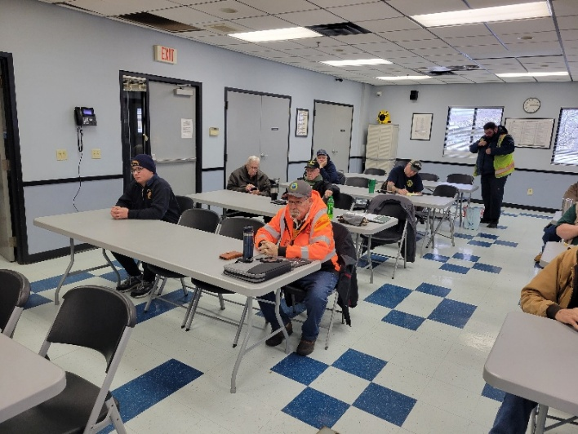
Pictures from our ARES mini conference in Shelbyville last month.

73 for now...

Bob, K6ZZ
Kentucky Section Manager
K6ZZ@ARRL.ORG

Do you know someone who is not getting this newsletter


Hi Gang,

If you know someone who isn’t already getting Radio Waves, have them sign up to receive it!! They don’t have to be ARRL members to sign up, just click on the button below and in no time, they will start receiving it.

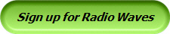

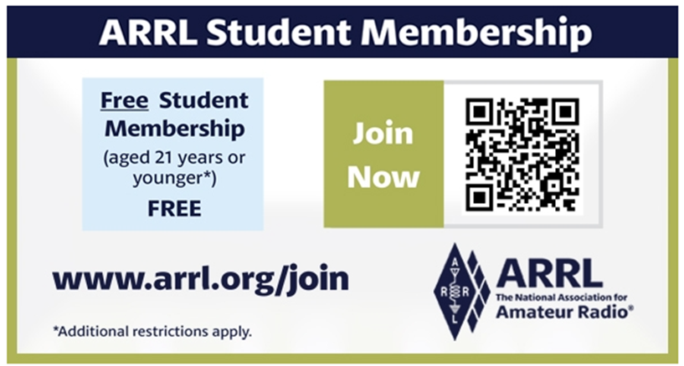

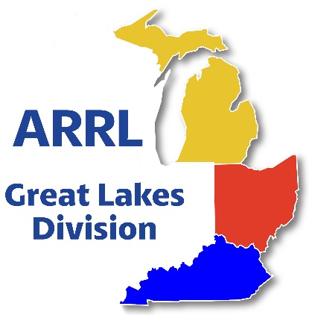
Scott’s Stuff

Hi Gang,

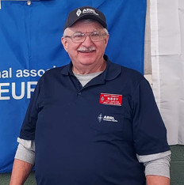
February here in the big megatropolis of Lexington it has been a relentless test of patience. With snow everywhere blanketing the village and temperatures clinging stubbornly to almost subzero levels, even the most seasoned outdoor enthusiasts are hibernating by the fireplace. Winter has overstayed its welcome, leaving us locals yearning for the promise of spring, that kind of time where the sun emerges, temperatures rise, and the world feels alive again. While the season may still be clinging to its final moments, the ham radio community is already looking ahead to the opportunities that spring and beyond will bring.

And for good reason. February isn’t just a month of icy sidewalks; it’s a time of anticipation. For ham radio operators and communications enthusiasts, the ARRL is gearing up with a slate of exciting initiatives during this “Year of the Club”, contests, and resource updates poised to elevate the community’s impact and expertise. From enhancing local club activities to supporting critical emergency communications, the ARRL is positioning itself as a beacon of innovation and resilience in 2026!

ARISS came to Hilltop Elementary School
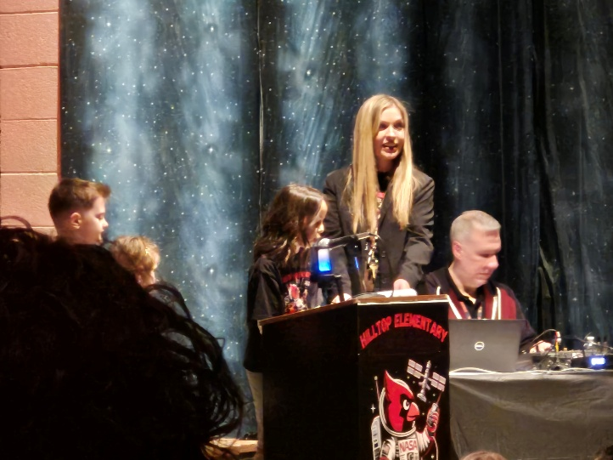
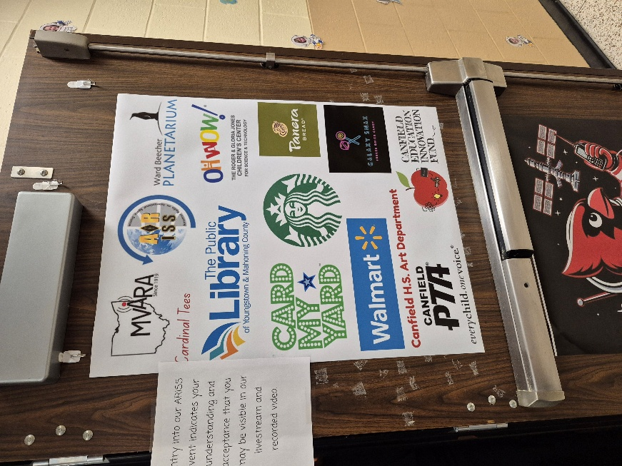
This past week I got to witness pure, unadulterated magic in a medium sized elementary school gym. I’m a bit of an ARISS groupie as many of you know. For the uninitiated, ARISS is the program that lets kids talk to astronauts on the International Space Station. It’s like cosmic show-and-tell, and I show up to these things like a moth to a very expensive, orbital flame.
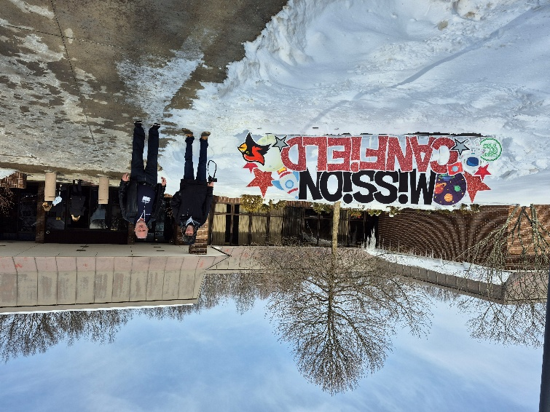

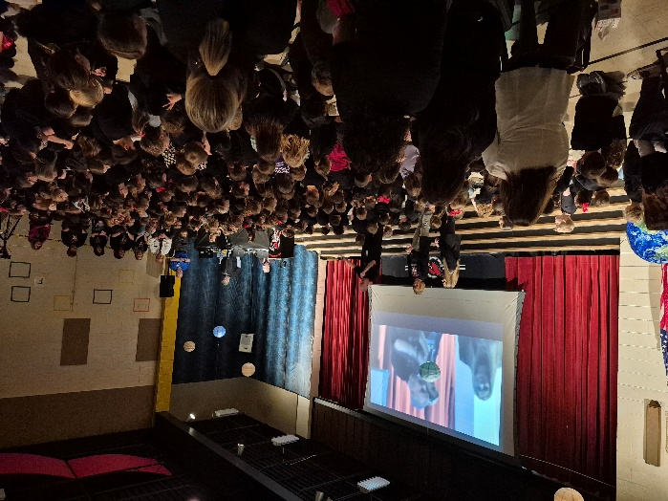

Hilltop Elementary in Canfield, Ohio, was my latest pilgrimage. From the outside, it’s a perfectly nice, medium-sized brick building that contains the hopes and dreams of what the future can bring. Inside, the room was buzzing with twenty preselected students ranging in age from 5 – 10 years old, their teachers vibrating with caffeine, and a few “dignitaries” in suits.

The setup is always the same delicious build-up. The ham radio volunteers, a lovely patient saint named something or other, explains the orbital mechanics. They point to the tracking map on the screen, a little ISS crawling across a globe. “The station is currently over… Kazakhstan. No, wait, Mongolia. Actually, the Pacific. It moves very fast.” The kids stare, polite but clearly wondering if they will really get to talk to the astronauts or not.

Then comes the tense moment. The headsets are on and listening intently. The room falls silent. You hear the initial static—a cosmic hiss, the sound of the universe’s radio dial not being quite tuned in. Then, clear as a bell from 250 miles up and moving at 17,500 mph, a voice cuts through: “November Alpha One Sierra Sierra, this is… ISS.”

And that’s when the magic happens. A whole room full of eyes instantly balloon to the size of soccer balls. I’m not joking. There’s a physical pop of awe. The first kid fumbles the mic a bit and then reads his question to the astronaut and as soon as he says “over” he’s hearing the astronaut address him by name. Wow… What sheer joy in this kids head now. An Astronaut is actually talking to him and him alone. The next kids gets up and it goes on and on until they’ve reached the end. Yes, the end of the questions, but also the end of time that they can actually talk as the ISS is now disappearing over the horizon. The kids were riveted through the entire nine minutes of conversations.

The whole thing lasted just nine minutes. That’s right, just nine! That’s the blink of an eye, the time it takes to microwave a potato. But in that gym, time stretched. You could see the cogs turning in their heads, the connection being forged not just to an astronaut, but to the idea of possibility. It wasn’t about the fancy tech (though the gear is cool). It was about a voice from the void saying, “Hello, kids,” and making it personal.

As the signal faded into that friendly static again (the ISS had flown over the horizon), the room erupted in applause. The chattering tsunami of “OH MY GOSH” and “HE SAID MY NAME” and “WE TALKED TO SPACE!” was heard everywhere.

I walked out into the Ohio winter, my heart full. Hilltop Elementary probably went back to normal ten minutes later—spelling tests, scraped knees, the same old stuff. But for those nine minutes, they weren’t just a school in Canfield. They were Mission Control. They were the nexus of the universe. And me? I’m already checking the calendar for the next ARISS pass.

The ARRL’s Year of the Club’s Vision:
Strengthening Clubs, Strengthening Communities
At the heart of the ARRL’s mission is its commitment to fostering strong, active ham radio clubs. Our Affiliated clubs are the lifeblood of the amateur radio community, serving as hubs for education, innovation, and collaboration. After what feels like a decade of winter, the ARRL has already launched programs designed to reignite that sense of camaraderie and growth.

Contests and Competitions:
For many ham radio operators, contests are the highlight of the year. They’re not just competitions—they’re opportunities to connect with fellow operators worldwide, test technical skills, and refine emergency communication practices. With the ARRL rolling out a new slate of contests in 2026, winter no longer feels like a period of hibernation but a chance to stay active and engaged.

The ARRL’s efforts aren’t just about fun contests or technical upgrades—they’re about life-critical communication. In a world where natural disasters are increasingly localized and unpredictable, the need for ham radio operators has never been greater.

Moreover, the ARRL has been looking forward at what ARES is to become in the future. I’ve written several articles about these changes, the latest is in the March issue of QST (page 69). All this year you will be seeing articles like this leading the charge in promoting interoperability between ARES teams and official emergency responders. By aligning ham radio protocols with those served agencies, operators can communicate more efficiently during crises, turning spontaneous volunteers into essential specialists.

February may drag on, but for ham radio enthusiasts, the challenges of winter are a reminder of the community’s resilience. Whether it’s troubleshooting a stubborn antenna through the snow or participating in a digital contest from the warmth of a study room, the ham radio spirit thrives in adversity.

As the ARRL’s new initiatives roll out, there’s one undeniable truth: the future of ham radio is bright—and it’s rooted in the hands of its operators. By embracing contests, adapting to urban constraints, and honing emergency skills, the community is not just surviving winter—it’s preparing to lead when it truly counts.

So, grab your cocoa, fire up your transmitter, and keep an eye on the horizon. Spring might still be a few weeks away, but the ARRL’s spring of innovation is here now.

Stay Connected, Staying Engaged
The ARRL’s upcoming releases and programs are a testament to the enduring power of amateur radio. Whether you’re an experienced operator or just starting out, there’s never been a better time to get involved. Follow the ARRL’s announcements, join local clubs, and explore their new resources. Together, we’ll turn the page from this long winter to a season of connection, innovation, and community.

Coding Competition…
If you have young enthusiasts in your club or community, mark your calendars for our 2026 Coding Competition. The competition runs from January 1st – March 31st. This is a great way to blend amateur radio with STEM education. This competition invites students and young hams to develop innovative software or coding projects that interface with amateur radio technology. From creating apps for contest logging to designing tools for satellite tracking, participants will have the chance to showcase their creativity while learning critical programming and problem-solving skills. We’re not just promoting ham radio; we’re nurturing the next generation of innovators. Winning projects will be highlighted in amateur radio publications, and top contributors could walk away with scholarships or tech prizes. The goal? To inspire curiosity and bridge the gap between radio, technology and our youth.

ARRL Student Coding Competition - Specifications 1 Jan 2026.pdf

Contest Portal and America250 WAS…
On the contest front, we’re rolling out the new Contest Portal, a one-stop digital hub that will revolutionize how operators access and participate in events. Picture this: real-time standings, downloadable logs, contest rules, and registration links—all in one easily navigable platform. This tool is designed to make contesting more efficient and enjoyable, whether you’re a casual participant or a seasoned sprinter. https://contests.arrl.org/

And for those of you chasing the thrill of global connections, don’t miss America250 WAS (Worked All States)! This special event is part of the broader America250 initiative, celebrating 250 years of American independence. The goal? Work as many stations in all 50 U.S. states, plus territories, as you can through a mix of on-air contacts and digital modes.

Enjoy the bands and get Radio Active, but above all, regardless of your preferred mode or band, remember the golden rules of our incredible hobby: Have FUN, be respectful and most importantly, Get On The Air!

73, Scott…

Scott Yonally, N8SY
Director - Great Lakes Division
n8sy@n8sy.com

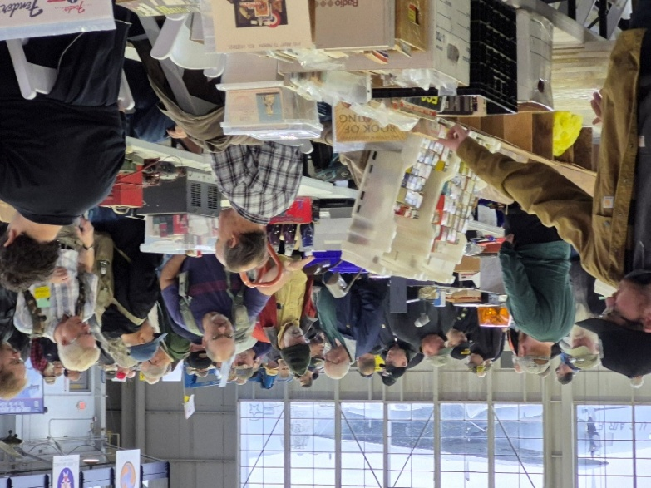
Great Lakes Division Hamfests

Here in the Great Lakes Division, we have over 50 hamfests a year. So, if you haven’t started planning your hamfest schedule yet, you really need to start now.

Let's fully support all of our hamfests in every way possible. It means success for everyone. Be sure to invite your ARRL Officials as soon as your date is set.

If you are planning on having your hamfest listed in QST please be sure to start your planning well in advance of your Hamfest date, as this allows adequate time for QST Listings. QST announcements require a 3-month lead time.

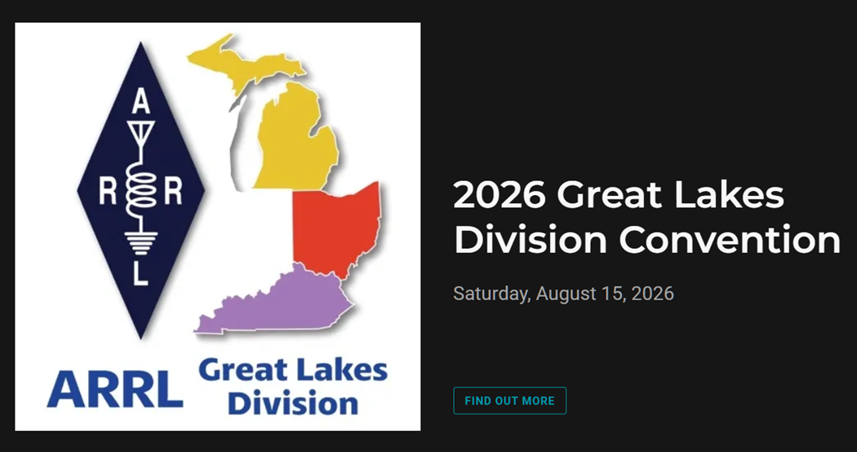

02/21/2026 - Livonia Amateur Radio Club Annual Swap & Shop  Location: Northville, MI  Sponsor: Livonia Amateur Radio Club  Website: http://livoniaarc.com/larc-annual-swap-and-shop/  Learn More | 03/07/2026 - Cave City Hamfest  Location: Cave City, KY  Sponsor: Mammoth Cave ARC  Website: http://www.ky4x@org  Learn More
03/08/2026 - Northern Ohio Amateur Radio Society Winter Hamfest  Location: Elyria, OH  Sponsor: Northern Ohio Amateur Radio Society  Website: https://www.noars.net/hamfests/winter-hamfest/  Learn More | 03/15/2026 - Toledo Mobile Radio Association Hamfest and Computer Fair  Location: Perrysburg, OH  Sponsor: Toledo Mobile Radio Association  Website: http://www.w8hhf.org  Learn More
03/21/2026 - Lowell Amateur Radio Youth Club Hamfest  Location: Lowell, MI  Sponsor: Lowell Amateur Radio Club  Website: http://larc.club  Learn More | 04/11/2026 - AC8RC Mini-Swap  Location: Burnips, MI  Sponsor: AC8RC  Website: http://ac8rc.org  Learn More
04/11/2026 - Cuyahoga Falls Amateur Radio Club 70th Hamfest  Location: Cuyahoga Falls, OH  Sponsor: Cuyahoga Falls Amateur Radio Club, Inc.  Website: https://www.cfarc-hamfest.org  Learn More | 04/18/2026 - SJCARC Hamfest  Location: Centreville, MI  Sponsor: SJCMIARC  Learn More
04/25/2026 - Tusco Amateur Radio Club's 2026 Hamfest, Computer & Electronics Show  Location: Dover, OH  Sponsor: Tusco Amateur Radio Club W8ZX  Website: http://www.w8zx.net/hamfest  Learn More | 04/26/2026 - Athens Hamfest  Location: Athens, OH  Sponsor: Athens County Amateur Radio Association  Website: http://ac-ara.org  Learn More

You can always find the latest information about upcoming hamfests on the Great Lakes Division website.

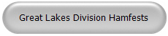

Just click to get the latest hamfest updates.

Celebrating Community Connections:

How the ARRL Amateur Radio Activity Report Shines a Light on Non-Emergency Events
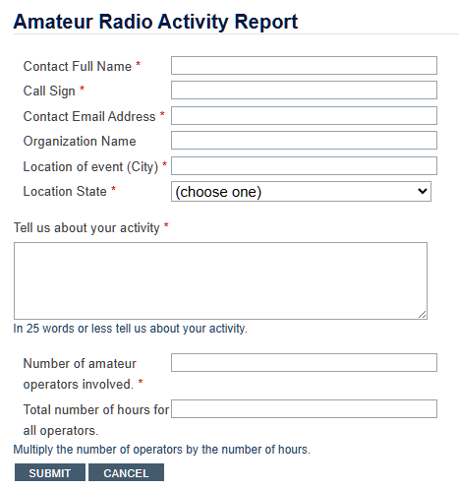

When most people think of amateur radio, their minds jump to emergency communications, storm nets, and disaster relief. While emergency preparedness is certainly a critical mission for hams, it’s only part of the story. At its heart, amateur radio is about community, education, and the pure thrill of connecting with people—nearby and around the globe. That spirit is on full display in the ARRL’s new Amateur Radio Activity Report, a spotlight on the countless non-emergency events that bring ham radio’s friendly energy to life.

Amateur Radio Activity Report

The Launch of the Amateur Radio Activity Report
With the “Year of the Club” initiative in full swing, the ARRL has introduced the Activity Report as a way to track and celebrate everything amateur radio clubs and individual hams are doing outside of formal emergency service. Whether it’s a license training session at the local library, a high school STEM demonstration, working on a repeater or radios at the finish line of a charity 5K race, these activities demonstrate how thriving and diverse our community truly is—and why amateur radio remains a gateway to lifelong learning.

Why Non-Emergency Events Matter
• Community Outreach: Public appearances at festivals, fairs, and historical reenactments build goodwill. Local residents see firsthand how operators set up portable stations, demonstrate antennas, and even let passersby speak on HF bands.
• Education and Licensing: Weekend license classes and Tech-to-General upgrade courses inspire newcomers. When clubs bring equipment into science fairs or school assemblies, they plant the seeds for tomorrow’s ham operators, engineers, and broadcasters.
• Public Service Without Crisis: Supporting county marathons, cycling races, working on repeaters and club equipment to keep it updated and in good working order and parades may not involve saving lives, but it does require precision and teamwork. That same reliability enhances overall public trust in amateur radio’s capabilities.

How the Activity Report Fuels Club Success
- Enhanced Visibility
By submitting stories to the Activity Report, clubs get recognized on arrl.org and in The ARRL Letter. Those public mentions raise awareness among potential members, local officials, and community partners.
- Data-Driven Support
ARRL leadership uses Report data to see what kinds of events are resonating across regions. Do license classes spring up more often in college towns? Are operators more active at outdoor festivals during the summer? These insights help the ARRL allocate resources—like instructor training and publicity materials—where they’re needed most.

- Model Replication
When one club’s school outreach program draws a crowd of eager students, other clubs can learn from their signage, presentation style, and hands-on demos. The Activity Report makes successful initiatives easy to discover and adapt.

Stories from the Field
• Riverbend Radio Club’s “Portable HF in the Park” event brought fold-out tables and solar panels to a summer festival. Dozens stopped by to learn Morse code basics and sent their first-ever on-air greetings.
• University ARC’s STEM Day booth at a state science fair led to five new General licensees—and a partnership with the campus engineering department for future projects.
• The Marathon Runners’ Net, staffed by volunteers from four local clubs, handled check-in calls, time splits, and safety alerts for a charity race that drew 3,000 participants. Instead of ambulances paging each other on busy frequencies, race officials relied on the precision of ham-to-HAM coordination.

How to Participate
If your club or group is hosting a non-emergency event, it’s easy to share the story:

- Go to https://www.arrl.org/amateur-radio-activity-report

- Fill out the brief form with event details: date, location, type of activity, and number of participants.

- Attach photos, flyers, or news coverage if you have them.

- Hit submit—and watch for your feature in upcoming ARRL communications.

By simply reporting what you’re already doing—mentoring, teaching, demonstrating, and supporting—you help the entire amateur radio community shine.

Looking Ahead
The Amateur Radio Activity Report is more than a bulletin; it’s a living archive of our shared passion and purpose. As we move deeper into the Year of the Club, let’s celebrate every license class taught, every public demo hosted, and every marathon checkpoint staffed. These non-emergency events underscore how vital amateur radio is—not just in crises, but as a vibrant hobby and community service.

For more information or assistance, contact the ARRL Club Services Department at clubs@arrl.org. Let’s keep the momentum going—community connections start with you!

FCC Changes – New Rules About Keeping Your FRN Information Updated

As of February 5, 2026, all U.S.-licensed radio amateurs have an obligation to update their FRN (FCC Registration Number) information within 10 business days of any change to that information. Heretofore the rule was that FRN holders must keep their contact information up to date, but there was no specific deadline for doing so.

The change came about unexpectedly in a proceeding intended simply to strengthen rules to combat illegal robocalling. In that proceeding the FCC required subject entities to file and keep current within 10 business days information in a “Robocall Mitigation Database” (RMD). But this RMD relies on the FRN database to auto-populate some of its information. So, when setting the 10-day deadline for keeping information up to date in the RMD, the FCC added a conforming 10 business day deadline for updating the FRN database as well without any public discussion about the large number of unrelated licensees that would be subject to the new deadline.

Last week a D.C. law firm specializing in broadcast licensing realized the broader applicability of the new FRN deadline and started alerting others. Last Friday the FCC clarified that a $1,000-per-day base forfeiture for failing to keep information up to date that was also adopted only applies to those required to use the RMD (and not to radio amateurs, broadcasters, cellular licensees, etc.). But it left intact the new deadline for everyone.

The upshot is that the new deadline (but no monetary penalties) now applies to all FCC licensees, including radio amateurs, since registering in the Commission Registration System (CORES) is required to get the FCC Registration Number (FRN) needed to submit any application.

Related but unchanged, is the need to keep up-to-date contact information for amateur licenses themselves. This is a separate process (!) so now when one moves or changes an email address one must update BOTH the FRN information AND the ULS license information FOR EACH LICENSE HELD. If people have different FRNs for different licenses, ALL must be updated. For reference, section 97.21(a)(1) requires keeping the ULS license contact information up to date, but there is no stated deadline for doing so. Section 97.23 provides that “if FCC correspondence is returned as undeliverable because of an incorrect address/email” the FCC may suspend or revoke the license(s).

Bus to Dayton Hamvention

The ARROW Communication Association and the Toledo Mobile Radio Association (TMRA) are proud to sponsor a motor coach trip to the Hamvention 2026 in Dayton, Ohio. This one-day trip leaves early in the morning on May 16, 2026 and returns the same day after Hamvention closes for the day at 5:00 p.m. The bus has two pickup spots, in Ann Arbor and in Toledo (Rossford). Please join us!

Tickets are $95 per person January 1st 2026 – April 17th 2026
$110 per person April 18th 2026 – May 15th 2026
Please note that this does not include the Hamvention ticket, which you need to purchase separately.

To Register and see full Details visit: https://w8rp.org/daytonbus2026/

There are two pickup/drop off locations on May 16th, 2026
Ann Arbor – 601 W Stadium Blvd, Ann Arbor, MI – Departing 4:30 am
Toledo – 727 Lime City Rd. Rossford, OH – Departing 5:30 am

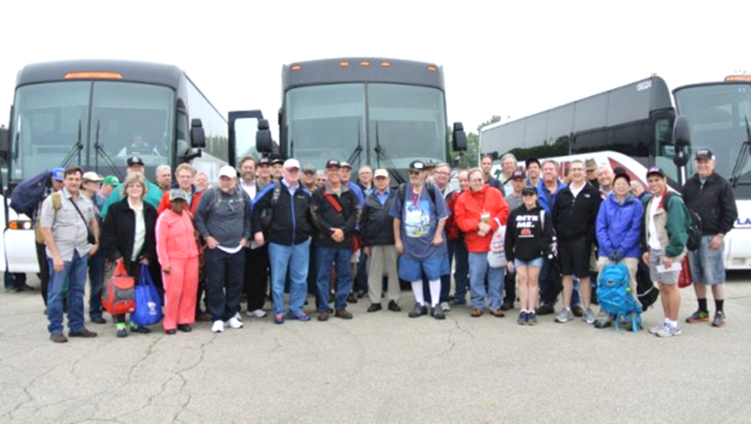

On board, you can stretch out, relax, take a nap, chat with other hams, and enjoy a light breakfast with coffee as the coach takes you directly to the country’s largest amateur radio event!

Thanks
ARROW & TMRA

Handbook Give Away – Have you entered yet???

How’s about I give away an ARRL softcover Handbook absolutely FREE !!!
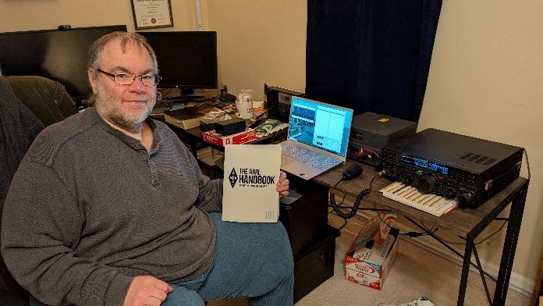

Yes, I’m holding a little contest to "GIVE AWAY" an ARRL softcover Handbook. Why you ask? It’s to get you to check-in to the Great Lakes Division website and take a look around.

Getting signed up is just as simple as filling out a couple of quick questions and you’re entered!!

>> Click Here To Enter <<

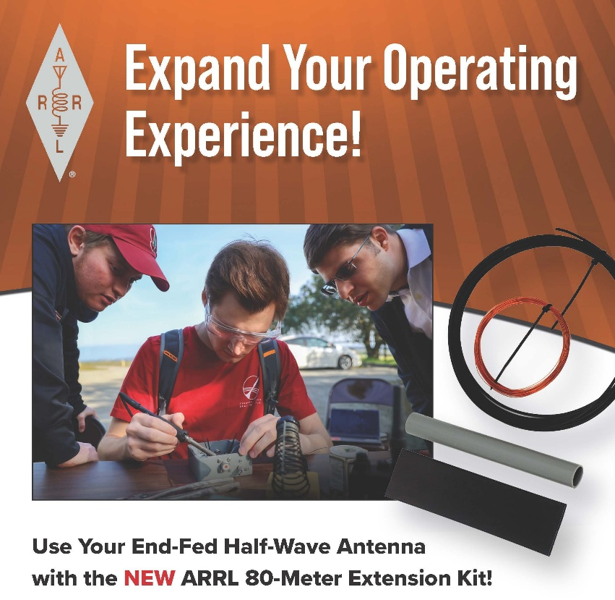

The ARRL 80-Meter Extension Kit adds a loading coil and short wire extension to the ARRL End-Fed Half-Wave (EFHW) antenna, electrically lengthening it for resonance on the 80-meter band. The coil provides the required inductance, while the wire extension allows for fine-tuning. Operating on 80 meters typically results in a narrow bandwidth and may require the use of an antenna tuner. Expand your reach today!

ARTEMIS II Launch and Amateur Radio Involvement
By Bob Bross, W8NFM & QCEN Listening Post

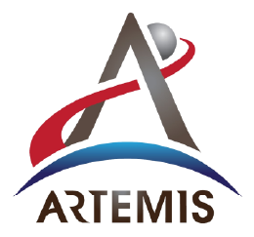
Sometime in March of this year (latest information as of this writing) the crewed ARTIMIS II mission will launch on a planned 10-day mission to circle around the moon and return safely to Earth. This will allow the crew to check all environmental, communication and tracking systems. Unlike the International Space Station, there will be no amateur radio equipment on board (even though three of the four astronauts ARE licensed.)

There IS a civilian role during this mission; selected commercial organizations and individuals (including four amateur radio operators) will be providing telemetry tracking information to NASA. This is to test alternate/backup tracking capabilities for accuracy and consistency as the private sector continues to expand its role in space.

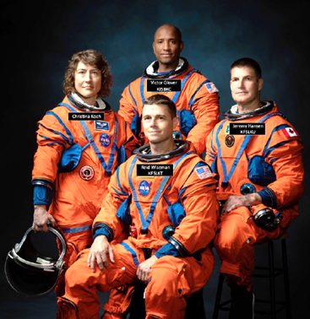
Amateur radio 2-way communications have been relayed via satellite since the 1960’s; OSCAR 3 was the first with a transponder in 1965, and more sophisticated amateur radio satellites (AMSAT) have been launched since. The first direct 2-way conversation between the Earth and someone in space was 18 years later; on December 1st, 1983, Astronaut Owen Garriot W5LFL (SK) sent out a CQ from the Space Shuttle Columbia on STS-9 and made contact with Lance Collister, WA1JXN (now W7GU.) As Garriot was the first amateur radio operator in space, he decided to try and make “a few more” contacts, finishing with almost 300 before the end of that mission. This was 15 years before the first piece of the International Space Station was put into orbit. The ISS regularly makes contact with ground stations; if you have not already done so, add 145.800 MHz to your scanner and listen on the downlink as various school groups communicate with the ISS.

Could there be 2-way amateur radio communication from the Moon (or even Mars) in the future? A considerable number of astronauts are licensed amateur radio operators, and their enthusiasm is likely to continue as we expand throughout our solar system. Any lunar base would simply aim their antenna once, as Earth is always in the same location when viewed from the Moon; the shifting directional work would have to be on our end! Expect any QSL card exchange to take a bit of time.

STOP – Right there!!!
We’ve come to the end…

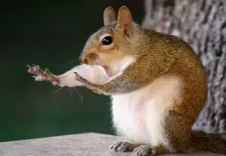

Be Radio-Active --- See Ya’ Soon!

Radio Waves is produced as a look inside of the Great Lakes Division and all that it has to offer. It is our sincerest hope that you have enjoyed this edition and will encourage your friends to be a part of the ARRL and receive the latest news and information about the ARRL and the Great Lakes Division!

The pictures throughout this newsletter are from various newsletters, Facebook posts and/or were sent directly to me in recent weeks. Take a good look at them, you just might be in one of the pictures! “SMILE… you might just be in the Great Lakes Division News!!”

