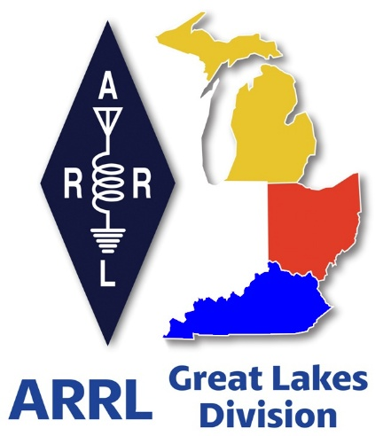
Radio Waves
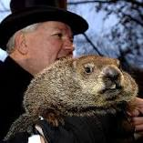
^{The} Great Lakes
Division
Monthly Journal
February 2026

Scott’s Stuff
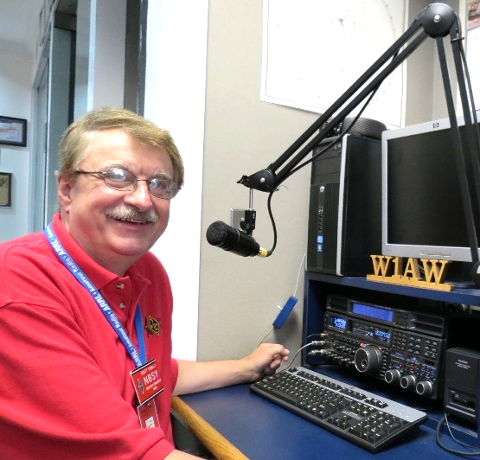
Hey Gang, Let’s Turn Up the Heat (on the Radio, That Is): A Freezer-Fueled Update from the Shack

The thermostat in my kitchen currently reads “Arctic Tundra,” which, for those of you who speak Fahrenheit, is just 3 degrees. That means my coffee is less “caffeinated motivation” and more “solid brick of regret.” If you’ve ever stood in your kitchen, arms flailing like a marionette with a snapped string, yelling, “WHO LEFT THE FREEZER DOOR OPEN?!” you know the feeling. It’s the kind of cold that makes you question whether the universe is mocking us—plotting a sequel to The Day After Tomorrow with extras paid in frostbite. And honestly, I think the cat did it. You know, the one with the “I’m innocent, I swear!” face. No, the other one. Yeah, the one that’s part-Narnia, part-escape artist.

But enough about the Great Freezer Caper (yes, it’s now a thing). Let’s pivot to spring. Or, more accurately, to Groundhog Day. Will Phil see his shadow? Is winter really just six weeks of suffering away? I’m too busy wrapped up in my sweats, layering socks like they’re a last-ditch fashion statement, to take bets. But if I had to wager, I’d put my money on “yes, spring is coming”—even if it’s arriving in the same fashion as my Wi-Fi: intermittently and with a side of frustration.

Enough of my melodramatic weather rant. You’re here for the good stuff: updates, contests, and the thrill of amateur radio. So, let’s thaw things out, shall we?

The Future of Clubs Is Digital (and So Is Your Coffee, If You Look at It Funny)
First up: the all-new Club Affiliation form. Picture this: joining a club feels like swiping right on a dating app—no awkward small talk, just a “MATCH!” and a warm fuzzy feeling. The form is sleek, user-friendly, and built for our era of instant gratification (yes, even for those of us who still use “password123”). No more sifting through paperwork that looks like a Cold War-era tax return. No more waiting weeks for a confirmation letter that could double as a museum artifact. This form is grandma-approved (and by “grandma,” I mean mine, who still thinks the internet is a place where birds live). It’s all digital, all jargon-free, and all about getting you back to what matters: making contacts, mentoring newbies, and occasionally arguing over propagation predictions.

Club Commission – Is your club taking advantage of this great program?
One of the benefits of being an ARRL Affiliated Club is a commission for recruiting new ARRL members and securing timely ARRL member renewals. The commission structure has been updated, and the process has changed to make it more lucrative and easier for the clubs. All membership dues are sent to ARRL to be processed, and the club receives a commission payment directly from ARRL. No more complicated adjusting funds around credit cards, checks and cash. ARRL does all the processing. As a result, your club could earn money while promoting the many benefits and programs of ARRL to ensure that amateur radio is protected and continues to be strong. Oh, did I mention that your club will get $20 for every new member it signs up? Look, that can add up to some big bucks for your club. Now, here’s a thought for you… Instead of the club keeping the $20, why not give it back to the new member as an incentive for signing up! You could easily do the same thing with the renewals as well. What member wouldn’t want to get $20 or even $5 back just for belonging to the ARRL.
Code Away: The ARRL Student Coding Competition Is On
Now, for the tech-savvy among you—yes, the ones who think Morse code is overrated and prefer to communicate in Python—here’s some exciting news. The ARRL Student Coding Competition is live until March 31, and it’s your golden ticket to hack, build, and shine. The challenge? Design a mobile app that could one day join the ARRL’s toolkit. Think contact-logging wizards, real-time propagation visualizers, or (my personal favorite) a gamified phonetic alphabet tutor for those QSO-hesitant newbies.

The prizes? National recognition, a certificate that screams “I’m a genius,” and cash awards that’ll either fund your dream antenna or, at the very least, a decent coffee maker for your shack. This isn’t just a competition—it’s a proving ground. Whether you’re a seasoned coder or a student still getting the hang of “for loops,” this is your chance to shape the digital future of our hobby. And let’s be real: having a line on your résumé like “Designed an app for the ARRL” will make potential employers forget you once burned down a college dorm’s microwave.

Contest Portals, Log Files, and Less Head-Scratching
Ah, contests. Those thrilling sprints of DX chasing, signal hunting, and the occasional existential crisis when you realize you’ve been transmitting on the wrong band. (Don’t worry, it happens to the best of us.) To streamline the chaos, the ARRL Contests Portal is now your new BFF. Think of it as the Marie Kondo of contesting: it tidies up your logs, scores, and certificates with the efficiency of a well-tuned antenna.

No more digging through PDFs like a digital archaeologist. The portal lets you submit logs, check scores in real time, and even download certificates without waiting for a snail-mail letter that arrives after you’ve retired. It’s one stop for everything—log submissions, eligibility checks, and yes, even club membership lists. For those of you still tracking contests the old-fashioned way (pro tip: avoid the phrase “Where did I put that 2012 logbook?”), head to ncjweb.com for submission guidelines and updates.

Your future self—and your spreadsheet-soaked desk—will thank you.

The Next Generation: KF8FLJ Rises

My youngest granddaughter, Emma, got her Technician license just the other week and now she’s KF8FLJ. She passed the Technician course, passed her exam, and now calls CQ with the enthusiasm of someone who’s already planning to pilot F-47 jets and colonize Mars. (Or maybe that’s just me projecting. Either way, she’s winning.)

When you hear KF8FLJ on the air, give her a shout out.

So, here’s to you, my fellow radio enthusiasts. Whether you’re crunching CW, splashing on SSB, or playing with digital modes, keep the three golden rules close: Have FUN, be respectful, and Get On The Air. And if you ever find yourself in a kitchen colder than the surface of Europa… just blame the cat.

Stay warm, stay curious, and keep those antennas pointed skyward. Now, if you’ll excuse me, I’ve got a freezer to inspect. Someone’s got to make sure the polar bears haven’t taken over.

73 (and stay out of my tundra),
Scott…

Scott Yonally, N8SY
Director - Great Lakes Division
n8sy@n8sy.com

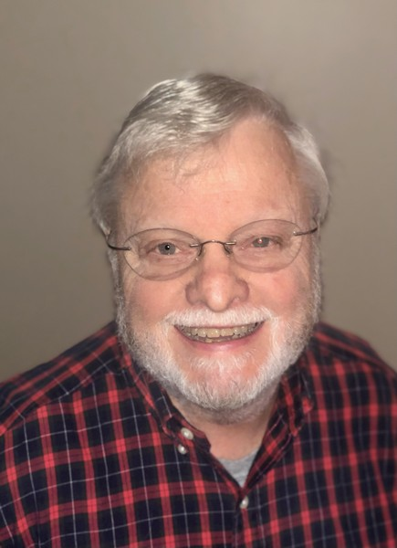

“What does ARRLs “Year of the Club” mean to you?”
Roy Hook, W8REH
Vice Director – Great Lakes Division

This question comes to mind because as I often travel around the division, I hear innovative thinking that may not be well known or respected. I believe it is important to encourage a broad spectrum of dialog including local group perspectives, but also thoughts beyond the local environment. Some important comments I have heard:

- “Every year should be the year of the club.”
- “Sorry, but these newsletter or website contests don’t excite me. What else is there? In fact, contests and awards don’t generally excite me.”

Tell us your thoughts - without using criticism:
What excites you about your club, group or ham activities?
What is your group’s current and future goals?
What have you identified as “best practices” for your group’s vision and mission?
Does your group’s activities align with its identity and mission?
Do you have a team culture of collaboration serving a diverse population of interests?
How can we avoid being in an either/or situation supporting the rich traditions of our hobby (and its aging population) while at the same time providing equal support for emerging technologies and passions?

Just to get things started I’ll point out just a couple of local focused innovations I have encountered recently within our division that could change the future of Amateur Radio.

- Local Radio Media - An Amateur Radio group in a rural Ohio area observed that their area lacked a local broadcast radio voice. Typical large area media had overwhelmed all local broadcast stations (two of which I had worked for as a teenager), delivering essentially the same broad based, finely researched programming, playing the same few hundred songs repeatedly without any locally relevant information. Now in its first year of full operation, this group has pooled their years of Amateur Radio involvement and broadcast industry experience, leveraging updated FCC rule opportunities for low-power FM broadcasting, to create a community centric station.

The station is funded by the local Amateur Radio group with some help from local sponsors and partners who see its exceptional value. The station’s no charge community support clearly provides better community understanding of the opportunities Amateur Radio provides. Local business has embraced the opportunity by using this local programming instead of other typical background options in their establishments and websites.

- Radios in Recovery Program – From a recovering alcoholic: “AA and Amateur Radio saved my life. AA taught me how to live and amateur radio gave me a new identity. Show me your five friends and I’ll show you your future. People in amateur radio have always been good people. The opposite of addiction is connection, and I feel like if you always have a radio you’re always connected to good people. I call amateur radio the world’s hobby and within this one hobby there’s thousands of different rabbit holes you can go down. I am never bored.”

This is the beginning of a great opportunity. This local group’s initiative can create new beginnings for all of us. As we face licensing obstacles of felony convictions of some candidates, we are told the FCC will work to push these people through as long as they aren’t murderers, arsonists, rapists or pedophiles. They should be welcome in the community. All of our support will be required to make this happen.

Follow up on my November newsletter
Following up on my November newsletter article, “Being a “relic” might not be easy, I was impressed with some of the comments I received. If you missed it, it can be found on the Great Lakes Division website or send me an email, and I will happily send you a copy. It is interesting that comments on my writing seems to always come from Michigan. Ohio, Kentucky take note. One member reflected on a story told when employed at a major computer firm during a time when Admiral Hopper was still active. At lectures, Grace Hopper was fond of handing out "nanoseconds," pieces of wire about a foot long.

This was an illustration that light and electrical pulses (also RF) travel about one foot per nanosecond. Her argument was that computers could get faster by making them physically smaller. The reader provided a link accurately describing the experience https://dataphys.org/list/grace-hopper-nanoseconds/. He wondered what Grace would say about the Raspberry Pi today. Another reader noticed that the relic issue is not new, pointing out its existence over 70 years ago. She reminisced as a child her mother referred to these people as fossils while determining her own path forward.
Attracting young people to Amateur Radio

As one of today’s relics, I was recalling my younger days when we said, “don’t trust anyone over 30”. I have been attempting to better understand the Gen-Z and younger demographic that we continue to try to attract to our hobby. At an old folk’s breakfast gathering I noticed a TV interview in the background.

The morning show host was interviewing English movie star Sophie Turner, Sansa Stark from Game of Thrones, a popular influencer of her own generation. She was contemplating how to proceed to her 30th birthday. Sophie said: “Life really is just a series of endings and beginnings. On a loop. Every up and down comes at a point in this cycle. Perhaps embracing the start of something new must be balanced with accepting the reality of something coming to an end. The sooner we realize this — and welcome it — the better we process our experiences and we see life is working for us, not against us.”

Although not a new concept, she seems to be referencing thoughts of Phoenix, the legendary immortal bird from Greek mythology that cyclically regenerates new life by rising from the ashes of its predecessor

Balance may be the solution we are all striving for preserving our hobby. This is the year of YOUR club. What activities have you and your club found that not only creates excitement but balances all the wide variety of interests our hobby offers. I started out this article with a couple of out of the box ideas I have run into (certainly not my creation). Thanks in advance for sharing what you have found.

Let’s talk. royehook@gmail.com W8REH@ARRL.org

Celebrating Community Connections

ARRL “Amateur Radio Activity Report” Shines a Light on Non-Emergency Events.
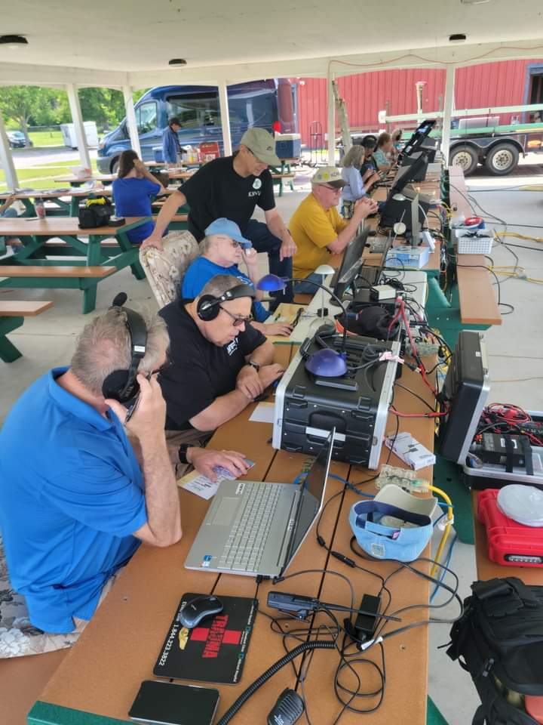
Amateur radio isn’t just about emergency preparedness—though that’s an essential role it plays. It’s also about community, education, and shared passion. Across the country, ARRL-affiliated clubs and individual hams are organizing and participating in events that bring the spirit of ham radio to life in vibrant, often unexpected ways.

From science fairs and school classrooms to local festivals and marathon finish lines, amateur radio operators are making meaningful connections—and the ARRL Amateur Radio Activity Report is the place to share those stories.

https://www.arrl.org/amateur-radio-activity-report

The newly created Activity Report, a key tool for the ARRL to track and celebrate non-ARES (Amateur Radio Emergency Service) events, captures the full spectrum of amateur radio engagement. Whether it's a weekend license class, a high school STEM presentation, or supporting communications at a charity 5K run, these events showcase how amateur radio continues to thrive as a hobby, a service, and a gateway to lifelong learning.

With the ARRL’s ongoing “Year of the Club” initiative, local clubs have been energized to connect more deeply with their communities and with each other. These clubs, whether urban, rural, or university-based, are the heartbeat of amateur radio. The Activity Report not only documents their efforts but also improves their impact.

Reports like these help ARRL leaders understand what’s working, what resources clubs need, and how to replicate successful models elsewhere. But more importantly, they let clubs know their efforts are seen, valued, and celebrated. Amateur radio operators are also supporting public events in non-emergency roles. From marathons to county fairs to historical reenactments, hams help keep communications flowing smoothly. These gigs may not involve emergency response, but they build public awareness and trust in amateur radio’s capabilities.

Sharing Your Story with the ARRL. If you or your club recently hosted or participated in a non-ARES event—especially one involving licensing, public outreach, or community support—we encourage you to submit it to the ARRL Amateur Radio Activity Report. It’s simple: just visit the ARRL website, fill out the form with basic details (date, location, number of participants, type of activity), and share what made the event special.

And if you’ve got a write-up with photos, testimonials, or media coverage? Even better. Send it to qst@arrl.org. Selected stories may be featured in QST magazine or on ARRL’s social media channels, giving your club national recognition.

Frequently Asked Questions (FAQ)

Q: What kind of activities should I report?
A: Any non-emergency amateur radio activity—licensing classes, school presentations, public demonstrations at fairs or festivals, race or event support, youth outreach programs, and more.

Q: Can individuals submit, or only clubs?
A: Both individuals and clubs can submit reports. If you helped at a community event or hosted a training session, your contribution counts.

Q: Do I need photos or a write-up?
A: Not required for the basic Activity Report, but highly encouraged. If you have a detailed story or images, send them to qst@arrl.org for potential publication.

Q: Is there a deadline for submissions?
A: No strict deadline—reports can be submitted anytime. However, earlier submissions help ARRL track annual trends and celebrate events in a timely way.

Q: How will my report be used?
A: Reports help ARRL measure community engagement, support the "Year of the Club" goals, and share success stories with the wider amateur radio community.

Handbook Give Away – Have you entered yet???

How’s about I give away an ARRL softcover Handbook absolutely FREE !!!
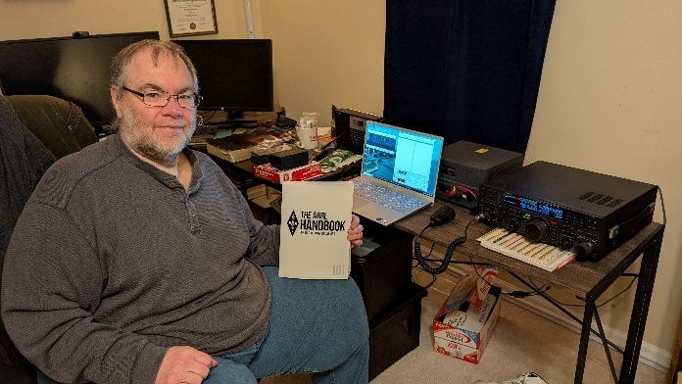

Yes, I’m holding a little contest to "GIVE AWAY" an ARRL softcover Handbook. Why you ask? It’s to get you to check-in to the Great Lakes Division website and take a look around.

Getting signed up is just as simple as filling out a couple of quick questions and you’re entered!!

>> Click Here To Enter <<

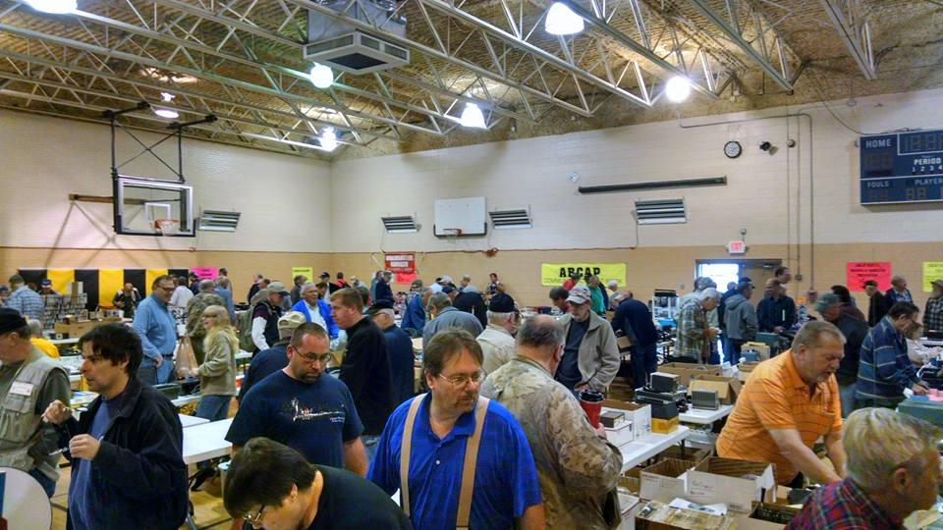
2026 Great Lakes Division Hamfests

Here in the Great Lakes Division, we have over 50 hamfests a year.

So, if you haven’t started planning your hamfest schedule yet, you really need to start now.

Please post this listing in your club's newsletter and announce the swaps on your local nets. Talk them up.

Let's fully support all of our hamfests in every way possible. It means success for everyone. Be sure to invite your ARRL Officials as soon as your date is set.

If you are planning on having your hamfest listed in QST please be sure to start your planning well in advance of your Hamfest date, as this allows adequate time for QST Listings. QST announcements require a 3-month lead time.
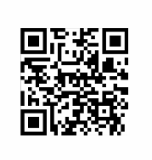
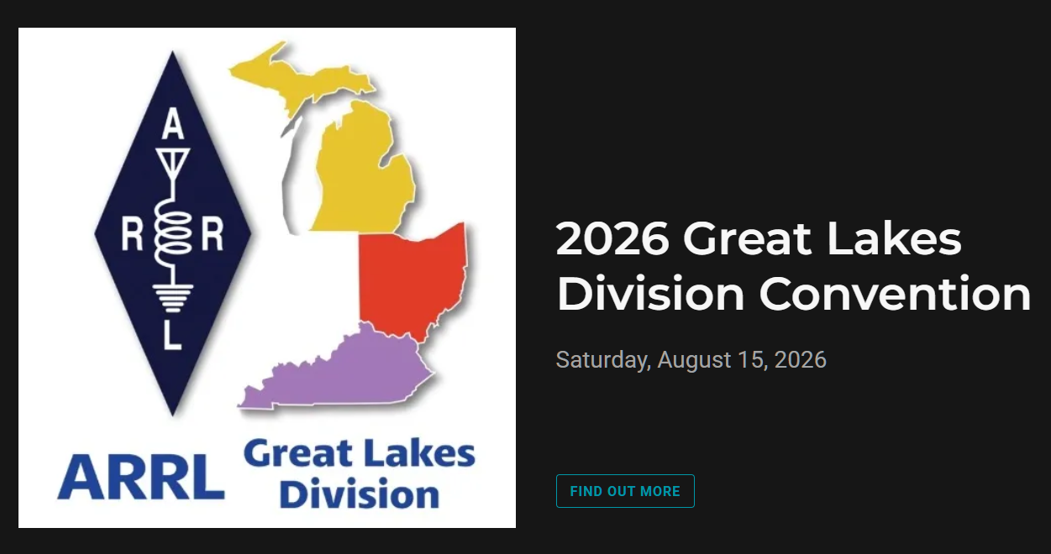

02/07/2026 - Cherryland ARC Annual Swap & Shop  Location: Traverse City, MI  Sponsor:  Website: http://cherrylandarc.com  Learn More | 02/21/2026 - Livonia Amateur Radio Club Annual Swap & Shop  Location: Northville, MI  Sponsor: Livonia Amateur Radio Club  Website: http://livoniaarc.com/larc-annual-swap-and-shop/  Learn More
03/07/2026 - Cave City Hamfest  Location: Cave City, KY  Sponsor: Mammoth Cave ARC  Website: http://www.ky4x@org  Learn More | 03/08/2026 - Northern Ohio Amateur Radio Society Winter Hamfest  Location: Elyria, OH  Type: ARRL Hamfest  Sponsor: Northern Ohio Amateur Radio Society  Website: https://www.noars.net/hamfests/winter-hamfest/  Learn More

03/15/2026 - Toledo Mobile Radio Association Hamfest and Computer Fair  Location: Perrysburg, OH  Sponsor: Toledo Mobile Radio Association  Website: http://www.w8hhf.org  Learn More | 03/21/2026 - Lowell Amateur Radio Youth Club Hamfest  Location: Lowell, MI  Sponsor: Lowell Amateur Radio Club  Website: http://larc.club  Learn More
04/11/2026 - AC8RC Mini-Swap  Location: Burnips, MI  Sponsor: AC8RC  Website: http://ac8rc.org  Learn More | 04/11/2026 - Cuyahoga Falls Amateur Radio Club 70th Hamfest  Location: Cuyahoga Falls, OH  Sponsor: Cuyahoga Falls ARClub, Inc.  Website: https://www.cfarc-hamfest.org  Learn More

You can always find the latest information about upcoming hamfests on the Great Lakes Division website.

Just click to get the latest hamfest updates.

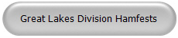

Club Links

I’ve received a number of new requests from clubs to be listed on the “Links” club page.
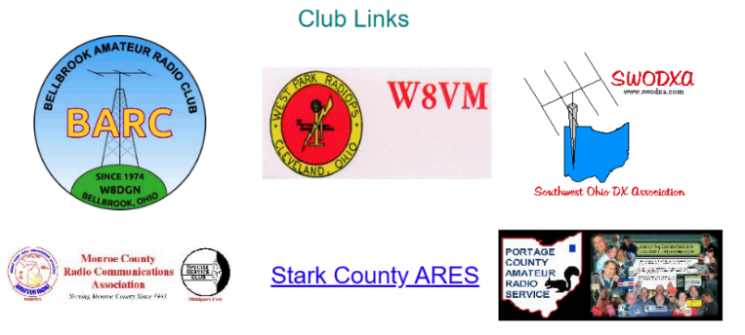

Is your club listed? If not, send the URL of your club website to me n8sy@n8sy.com and I’ll get it listed.



Send a Radiogram… What’s a Radiogram?
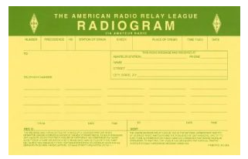
You’ve probably heard of amateur radio (“ham”) operators, and you might know a friend, family member, or neighbor who loves to build radio equipment and talk to thousands of other ham operators around the world!

But, you might not know that amateur radio operators are primed and ready to step in and provide valuable communications to the general public, when all else fails. Even if Internet service, power lines, and phone lines are all down, amateur radio still can get the message through. To be ready for this, many amateurs have joined a network called the National Traffic System (NTS), which is like a telegraph office over radio. NTS volunteers spend their free time relaying messages, called Radiograms, entirely by amateur radio, completely free of charge.
This is great practice to be sure they can serve the public during a true emergency!

Send a Radiogram Now — It’s Free! Radiogram – NTS
Now, there’s a way that YOU can try Amateur Radio messaging! Think of a friend or family member you’d like to contact by Radiogram. You can send any short message, as long as it’s not business-related, urgent or critical, or too private or personal.
Your message will be picked up by an Amateur Radio volunteer operator and relayed across the country to near its destination; finally, the recipient will get a local phone call from a nearby ham, or the message might even be delivered in person.
Along the way, ham operators will be relaying your message by voice, digital, or even Morse code, and getting valuable practice in emergency public service. To make it easy, please choose one of the standard message texts contained in the form.

(Note: Both the sender and the recipient must be in the United States or Canada).

ARRL VEC Youth License Test Fee Only $5!

Youth examinees under age 18, you can earn your initial Technician license or upgrade your current license through the ARRL VEC Volunteer Examiner Coordinator program for only $5.
The ARRL Youth Licensing Grant Program, in effect since April 19, 2022, covers the one-time $35 application fee for new license candidates younger than 18-years old for tests administered under the ARRL VEC program.
The $35 FCC application fee will be reimbursed after the ARRL VEC receives the completed reimbursement form and the new license has been issued by the FCC. The reimbursement check will be mailed to the fee payer.
Additionally, candidates younger than 18-years old pay a reduced exam fee of $5 to the ARRL VEC VE team at the time of the exam. The $5 fee is for all candidates under the age of 18 regardless of the exam level taken. Proof of under 18 status is required at the session (what to bring to an exam session).
The program is sponsored by ARRL The National Association for Amateur Radio®.

New 60-Meter Frequencies Available as of February 13

The new 60-meter frequencies approved by the FCC in December will become available to amateurs as of February 13, 2026, along with new power restrictions on those frequencies. It’s a bit confusing, as different rules apply to different segments of the band. The changes result from the FCC’s action to approve a worldwide 60-meter amateur allocation made by the World Radiocommunication Conference in 2015 (WRC-15). See https://tinyurl.com/mt8p8jpa.

As of February 13, FCC-licensed amateur operators holding General Class or higher licenses may operate on a secondary basis anywhere between 5351.5 and 5366.5 kHz, subject to a maximum bandwidth of 2.8 kHz and maximum transmit power of 9.15 watts ERP (effective radiated power). For the purpose of computing ERP, the transmitter PEP (peak envelope power) is multiplied by the antenna gain relative to a half-wave dipole antenna. A half-wave dipole is presumed to have a gain of 1 (0 dBd). Amateurs using other antennas must maintain in their station records either the antenna manufacturer's data on the antenna gain or calculations of the antenna gain.

Here’s the confusing part: The existing 60-meter channels centered on 5332, 5348, 5373, and 5405 kHz remain as secondary amateur allocations with maximum power of 100 watts ERP. However, the old channel at 5358.5 kHz is eliminated as it is now part of the new 5351.5-5366.5 kHz subband and subject to the lower power limit.

For all 60-meter transmissions, emission bandwidth is limited to 2.8 kHz or less and amateurs must not cause harmful interference to, and must accept interference from, stations authorized by the United States (NTIA and FCC) and other nations in the fixed service; and all other nations in the mobile service (except aeronautical mobile). Data or RTTY emissions in particular must be limited in transmission length so as not to cause harmful interference. Digital mode operators must be familiar with offsets in order to stay within the authorized frequencies.

Bus to Dayton Hamvention

The ARROW Communications Association and the Toledo Mobile Radio Association (TMRA) are proud to sponsor a motor coach trip to the Hamvention 2026 in Dayton, Ohio. This one-day trip leaves early in the morning on May 16, 2026 and returns the same day after Hamvention closes for the day at 5:00 p.m. The bus has two pickup spots, in Ann Arbor and in Toledo (Rossford). Please join us!

Tickets are $95 per person January 1st 2026 – April 17th 2026
$110 per person April 18th 2026 – May 15th 2026
Please note that this does not include the Hamvention ticket, which you need to purchase separately.

To Register and see full Details visit: https://w8rp.org/daytonbus2026/

There are two pickup/drop off locations on May 16th, 2026
Ann Arbor – 601 W Stadium Blvd, Ann Arbor, MI – Departing 4:30 am
Toledo – 727 Lime City Rd. Rossford, OH – Departing 5:30 am
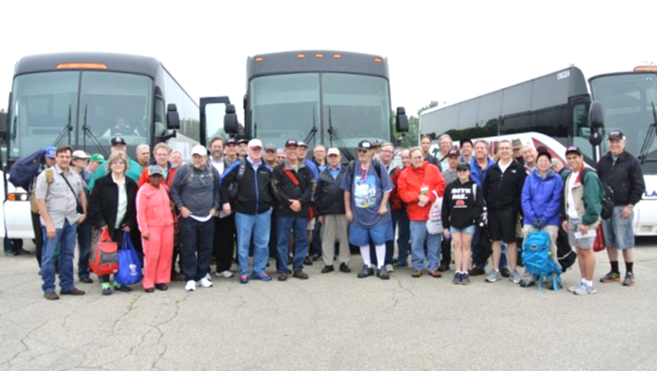

On board, you can stretch out, relax, take a nap, chat with other hams, and enjoy a light breakfast with coffee as the coach takes you directly to the country’s largest amateur radio event!

Thanks
ARROW & TMRA

What’s been happening at the FCC
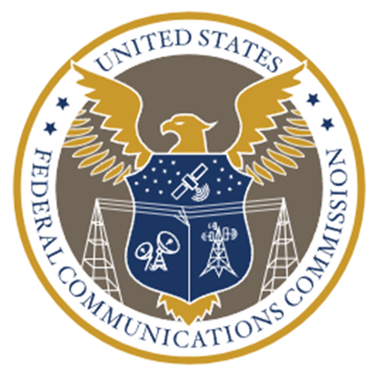
Satellite Authorization Pared Back for 5 Channels in the 430-440 MHz Band Outside the U.S.

ARRL, joined by multiple other national societies and hundreds of individual radio amateurs, succeeded in convincing the FCC to pare back the request of a satellite operator (AST & Science LLC) to employ five channels in the 430-440 MHz band outside the U.S. AST is seeking FCC authority for a constellation of 248 satellites.

The operator reported to the FCC during the proceeding that it had ceased using the channels on its existing five satellites, and amateur monitoring seemed to confirm that the signals were no longer being detected.

In the new license for the operator’s next group of 20 satellites, the Commission limited the licensee’s use of the five 430-440 MHz channels strictly to launch and emergency operations when no other band is available; to a maximum period of 24 hours; and limited to communication with five specific ground stations well outside the United States. Seemingly in response to complaints that transmitters on the earlier satellites sometimes were left on even when no permissible earth station was visible to the satellite, including over the United States where operation was not allowed, the FCC further explicitly limited transmissions to times when one of the five non-U.S. earth stations is visible to the satellite. Consideration of the remaining 223 satellites requested in the application was deferred.

Note that each of the five non-U.S. earth stations with which communication is authorized must be licensed separately by their country of jurisdiction in order to communicate with AST’s satellites. This provides an opportunity for amateurs in those countries to object to their governing administrations about authorizing use of the 430-440 MHz channels.

Experimental Application to use 5 Megahertz in the 420-450 MHz Band Successfully Opposed

An applicant for two experimental licenses (Caos Capital) proposed to conduct experiments in the 420-450 MHz band using up to 5 MHz bandwidths. In July ARRL filed written objections against both applications given the applicant’s history of causing interference in the 220 MHz band, the potential disruption of the wide bandwidth signals to multiple amateur operations, and the proposed locations in highly-populated areas of California. The applications have not been granted as of this date.

Foreign Adversary Reporting Requirements Expected to be Avoided for All Amateurs

The FCC has preliminarily agreed with ARRL objections to amateur licensees and applicants being required to make attestations or certifications to the FCC if they are “subject to the jurisdiction or direction of a foreign adversary.” The FCC proposed such requirements to protect the public communications networks but included amateur radio and other personal radio services in its Notice of Proposed Rule Making. At ARRL’s urging the FCC is poised to exempt amateurs and other licensees in the personal radio services from the requirements.

The publicly-released draft Report and Order (R&O) is due for final adoption at the FCC’s next meeting on January 29. As requested by the ARRL, in the draft proposal the Commission would exempt radio amateurs from the requirements that would have applied reporting obligations of unclear detail on every FCC-authorized radio amateur “subject to the jurisdiction or direction of a foreign adversary.” This included “Any individual, wherever located, who is a citizen of a foreign adversary or a country controlled by a foreign adversary, and is not a United States citizen or permanent resident of the United States”. Foreign Adversaries as defined in the draft R&O are (1) China, including Hong Kong and Macau; (2) Cuba; (3) Iran; (4) North Korea; (5) Russian Federation; and (6) “Venezuelan politician Nicolás Maduro”. The public draft approvingly cites and extensively quotes from ARRL’s comments.

Obsolete Rules in Part 97 will be Deleted on February 10

In April ARRL filed comments in the FCC “Delete, Delete, Delete” proceeding in which it proposed that a number of Part 97 rules be deleted or changed. In October the FCC, operating under expedited rule making procedures that do not require prior public notice and comment, decided to delete almost 400 obsolete rules pertaining to its wireless services. Among those were four in the Part 97 amateur regulations:

• § 97.27. This provision is duplicative of a statutory provision related to the FCC’s right to modify station licenses.
• § 97.29. This provision specified an obsolete procedure to replace paper licenses. ARRL proposed deleting this section in comments filed earlier this year.

• § 97.315 (b)(2). This obsolete provision grandfathered HF amplifiers purchased before April 28, 1978 by an amateur radio operator for use at that operator's station, and grandfathered those manufactured before April 28, 1978, for which a marketing waiver was issued.

• § 97.521(b) and Appendix 2. This rule and appendix relate to obsolete VEC regions.

The expedited procedures employed in this case limited the scope of rules that the Commissioners would consider. However, the proceeding remains open and the FCC Chairman has publicly said to expect more substantive rulemakings in 2026 with prior notice and comment stemming from the record in the “Delete, Delete, Delete” proceeding.
NextNav Continues Push for Rulemaking to Re-Allocate 902-928 MHz

NextNav has submitted multiple filings in its continued “no-holds-barred” campaign to convince the FCC to initiate a Notice of Proposed Rulemaking (NPRM) to reallocate spectrum in the 902-928 MHz band to accommodate its proposal for 5G/6G cellular service accompanied by position location (PNT) capabilities as a back-up to GPS. In March of 2025 the FCC released a Notice of Inquiry soliciting comment on the broad array of many alternatives to NextNav’s proposal for PNT. Both proceedings remain open.

Update on High Frequency Trading (HFT) Proposals

In response to complaints and suggestions, including those from ARRL, the FCC has started explicitly stating on some HFT experimental licenses that stock trading is prohibited. Using an experimental license for everyday business operations, such as stock trading, is prohibited under the FCC’s experimental rules. But now at least in some cases it is being explicitly added to license conditions to emphasize the prohibition.

In the case of experimental license WK2XJK (Bergen County, NJ), at renewal the FCC revoked a waiver of station ID requirements in addition to adding the explicit stock trading prohibition. The Commission reminded the licensee that “an experimental radio station shall transmit its assigned call sign at the end of each complete transmission at least once every thirty minutes in clear voice or Morse code, with all digital encoding and digital modulation disabled during station identification”.

Recently the SMC (Shortwave Modernization Coalition) has re-invigorated its lobbying efforts to convince the FCC to issue an NPRM proposing to amend HF spectrum rules to accommodate HFT uses with the technical rules that the filed ARRL analysis found would allow significant interference into the amateur bands. In December the SMC submitted to the FCC a report authored for it by ex-FCC Commissioner Harold Furchtgott-Roth.

As one might expect, it concludes that “the SMC members and the American public have benefitted substantially from the non-voice communications in the 2-25 MHz band over the past decade and that the SMC members’ use of experimental licenses provides “empirical rather than purely theoretical evidence to demonstrate that a reallocation would not cause harmful interference….” and “imposes no costs on authorized incumbent users.”

ARRL Successful in Protecting Small Balloon Deployments

Steve Goodgame was appointed to represent radio amateur balloon enthusiasts on a statutorily mandated FAA Federal Advisory Committee. The FAA recently published the Committee’s final recommendations. The outcome is positive for radio amateurs who employ balloons as STEM projects and for other purposes.

The Mysterious Case of the Duplicate Articles: Uncovered!
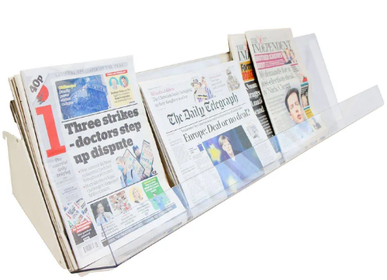
Hey there, young adventurers! Are you curious about why you sometimes see the same articles in this newsletter and on the ARRL website? Well, I've got a secret to share with you, but first, let me ask you a question: Did you know that less than half of the ARRL members have signed up to receive emails from the Section Manager and Director? Yep, you heard that right - less than half! And, I wonder, how many of you actually take the time to read the cool stuff posted on the website? As a curious observer, I'm here to get to the bottom of this mystery and share some answers with you.

Imagine we're sitting down for a chat, and I'm asking you all about your favorite things to read and learn about. You might tell me about the awesome projects you're working on, or the new ham radio skills you're trying to master. But I'd also ask you: Do you ever wonder why some articles seem to appear in multiple places? Is it because they're just that good, or is there another reason? As it turns out, the answer is quite simple. You see, the ARRL newsletter and website are like two different channels that offer similar content, but with a slight twist.

The ARRL website is like a big library where you can find all sorts of information, from news and articles to tutorials and resources. It's a one-stop shop for all things ham radio! In fact, it’s over 5,000 pages of information! On the other hand, the newsletter is like a special delivery of handpicked articles and updates, tailored just for you. Sometimes, the same article might appear in both places because it's just that important or interesting. But here's the thing: not everyone gets to see the newsletter, and that's where the mystery comes in.

As I mentioned earlier, less than half of the ARRL members have signed up to receive the newsletter. That means that many of you might be missing out on some fantastic content, just because you haven't “opted in” to receive it. And, when it comes to the website, well... let's just say that not everyone makes it a habit to visit regularly. But that's okay! We're here to help you stay connected and up to date on all things ham radio.

So, what can you do to stay in the loop? First, make sure to sign up for the newsletter, so you can get the latest and greatest delivered right to your inbox. And take some time to explore the ARRL website - you never know what hidden gems you might discover! By doing so, you'll be part of the inner circle, getting the inside scoop on all things ham radio. Who knows, you might even find yourself looking forward to reading the newsletter and exploring the website, just for fun!

So, there you have it, the mystery of the duplicate articles is solved! It's not a mistake or a coincidence; it's just a result of the different channels that the ARRL and I use to share information with YOU. By understanding how these channels work, you can make the most of your ham radio experience and stay connected with the community. So, go ahead, sign up for that newsletter, and start exploring the website - your adventure awaits!

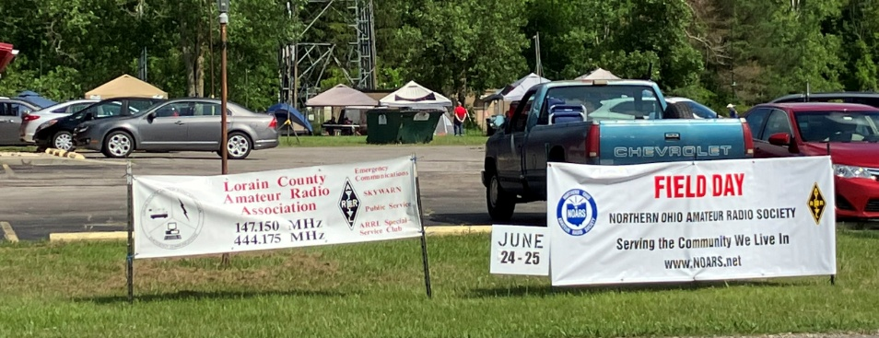
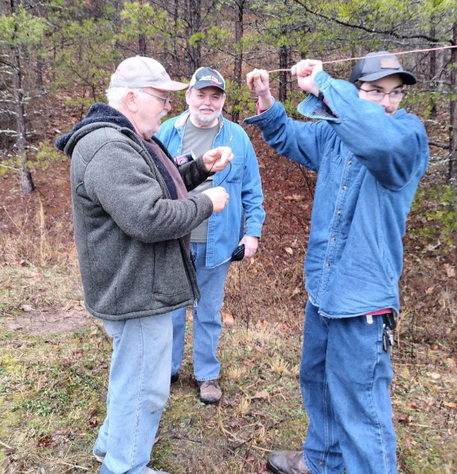
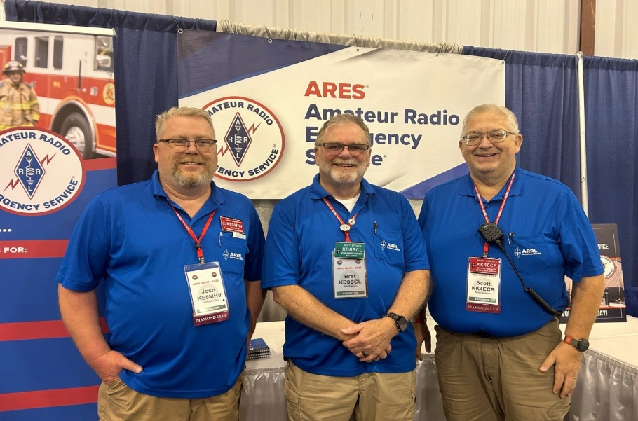
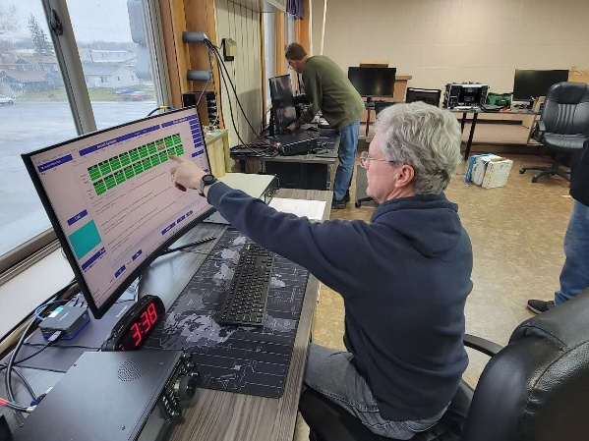
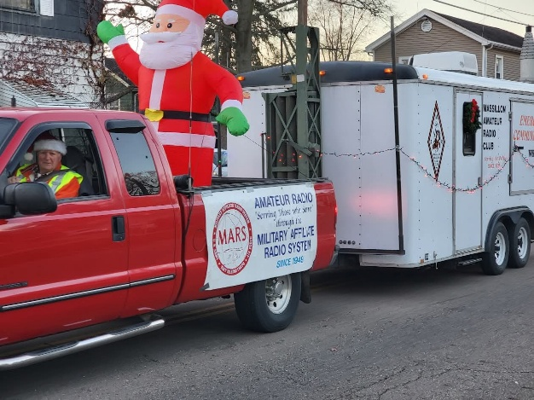
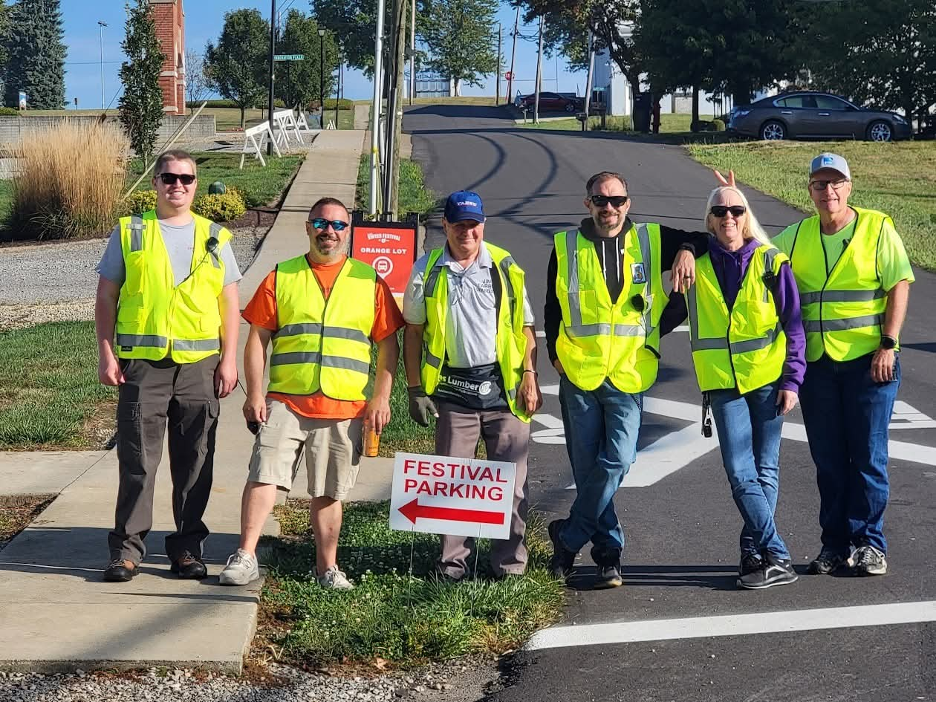

STOP!!!
We’ve come to the end…

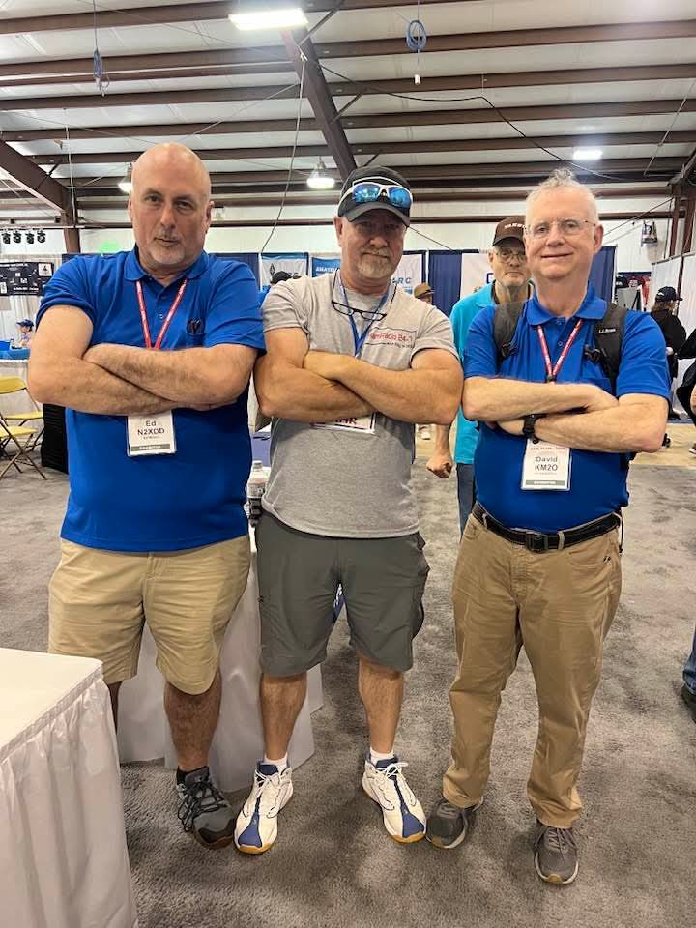

Be Radio-Active --- See Ya’ Soon!

Radio Waves is produced as a look inside of the Great Lakes Division and all that it has to offer. It is my sincerest hope that you have enjoyed this edition and will encourage your friends to be a part of the ARRL and receive the latest news and information about the ARRL and the Great Lakes Division!

Many pictures throughout this newsletter are from various other newsletters, Facebook posts and/or were sent directly to me in recent weeks. Take a good look at them, you just might be in one of the pictures! “SMILE… you might just be in the Great Lakes Division News!!”

