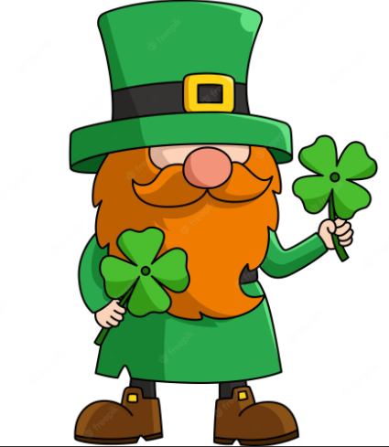
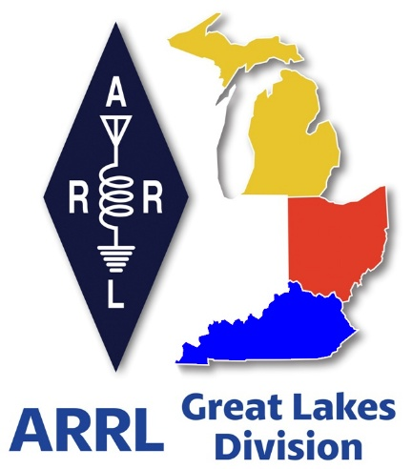
Radio Waves ^{The} Great Lakes Division
Mid- Month Report
March

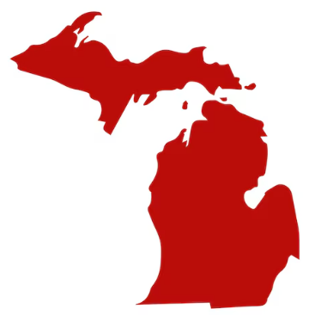
From the Michigan Section Manager
Ralph Katz, AA8RK
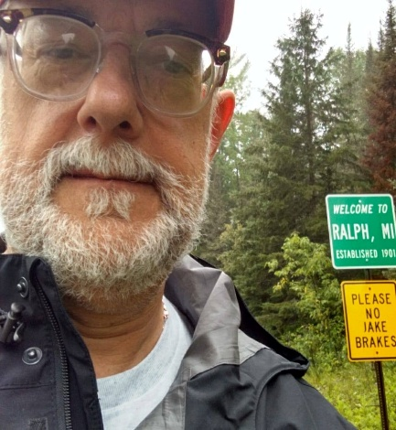
Time flies like nothing and here it is already my 3rd monthly newsletter. This will probably be one of the longer ones, because it seems a lot of hams had fun in the hobby. I hope you are one of them.

In the last month, I have attended ARRL hamfests in Traverse City and Livonia and talked in-person to the Southern Michigan ARS in Battle Creek.

In the next month, I plan to attend hamfests in Lowell on 3/21, Allegan on 4/11, and Burr Oak on 4/18. I will also talk to the North Ottawa ARC meeting in Ferrysburg on 3/26.

Remember that 4/18 is World Amateur Radio Day – contact me if you are having an event that should be included in the ARRL web mapping app: https://www.arrl.org/world-amateur-radio-day

As always, my schedule is on the google calendar for: arrl.mi.section.manager@gmail.com

==> ARRL Michigan Section Staff – proposed additions
It would be helpful to have a new Assistant Section Manager for the Northern Lower Peninsula, and at least one more for the Upper Peninsula. Please contact me if you would like to volunteer or can suggest someone. They will need to be ARRL members.
And also, it would be great to add at least one Assistant Traffic Manager. A coordinated staff will be able to respond better than a single person. As you all know, Traffic Handling was the main reason for the ARRL's founding in 1914. An ATM will especially make Section Traffic Manager Mark Shaw K8ED happy, as he has been handling the load all by himself for a number of years

America250 – Michigan Week 1
Congrats also to Fred Schebor K8NGW for coordinating the first Michigan week of W1AW/8 operation in Michigan, part of the ARRL's America250 commemoration, which was February 18 – 25.

==> Link to Fred's full report this month

Here’s a quick summary: Participants submitting logs: 24 - Technician:1, General:3, Amateur Extra:20 Total On-the-Air time: 380 hours Total QSO’s: 8,390 (!)

QSO’s/band:
6M: 6 | 10M: 420 | 12M: 96 | 15M: 703
17M: 411 | 20M: 3009 | 30M: 376 | 40M: 2479
80M: 704 | 160M: 186

QSO’s/mode:
CW: 1978 | Digital: 3830 | Phone: 2582

On the IRA link system on Thursday 3/5, Tom Behler KB8TYJ told me that he “had a blast” on this event, making over 240 QSO's in 6 hours of operation. Sorry I have only a couple of W1AW/8 photos so far.
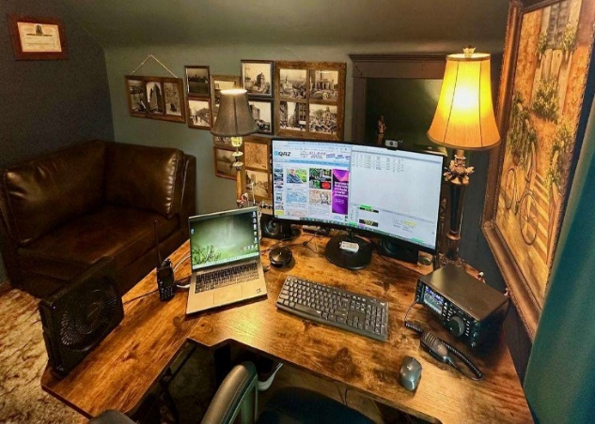
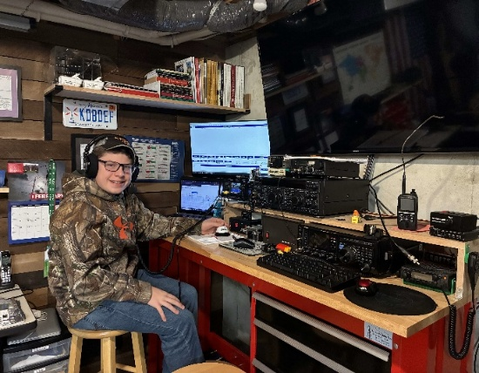

Photos left to right: Ian Alkema KI8AN, and the station of Jay Aho N8QYQ, who both worked America250.

UP200 Dogsled Race
Congrats to the team of Upper Peninsula hams providing communications support for this 228-mile event, February 11-16, 2026. This race was covered on WLUC/TV6 in Negaunee with a 2/14/2026 piece by reporter Julia Seitz:

https://www.uppermichiganssource.com/2026/02/14/ham-radio-operators-bridge-up200-communications/

Event support was headed by Tom Perry KE8TPT of Ishpeming, with Communications Center Coordinator Paul Racine KB0P of Green Bay, WI. Steve Gingras KC0TPU Eli River MN, who was interviewed in the above video, coordinated the start and finish of the event. With another 42 other hams participating, 326 man-hours of support was provided.

==> This is the 37th year of participation for Paul Racine KB0P.

Thanks to all of the participants for their work, over so many years, to make this a successful and safe Yooper event.

Photos L – R (Tom KE8TPT Sean KC8NUH and Jesse KE8FSS)
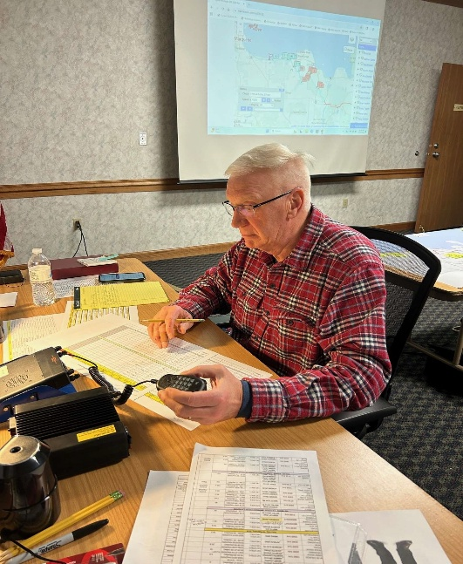
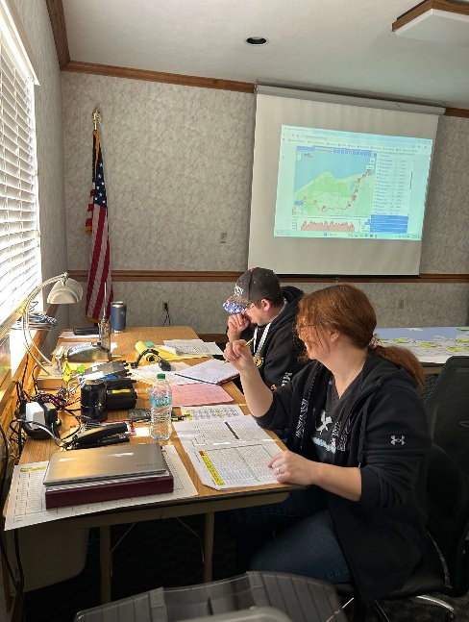

(Lyn KC8GKH) (Night Shift)
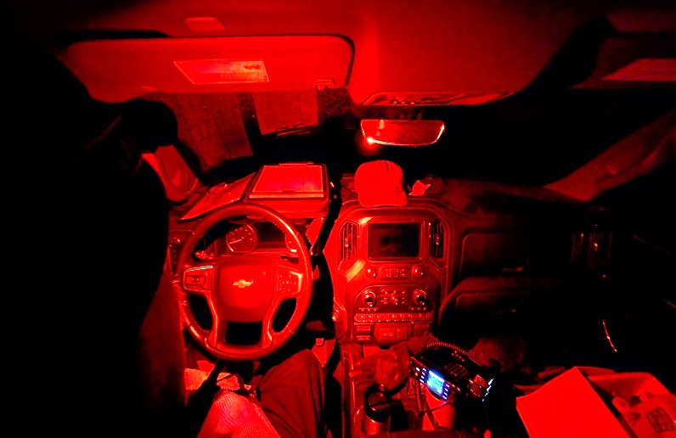
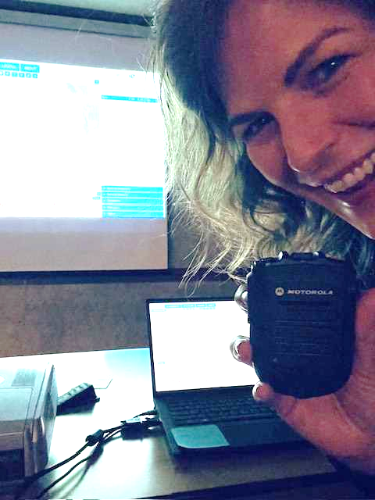

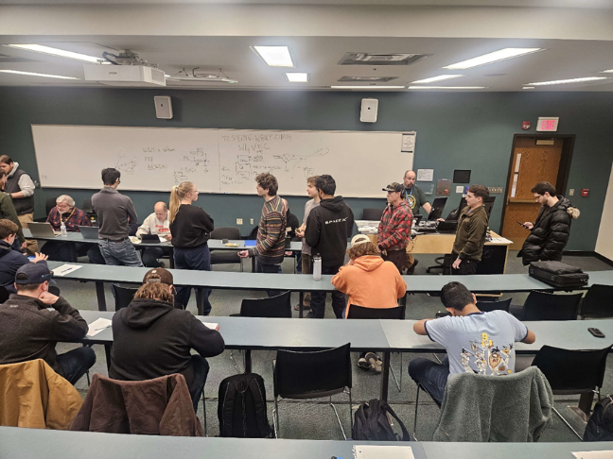
On February 7, 2026, Dan KB6NU held one of his 1-day Technician license classes on the University of Michigan campus, with ARROW Communications doing testing afterwards using ExamTools software. Most of the 20 applicants passed, but I don't have the exact number. The club has acquired 20 inexpensive tablets for testing.

Are you testing electronically? How's it going for you? Please let me know.

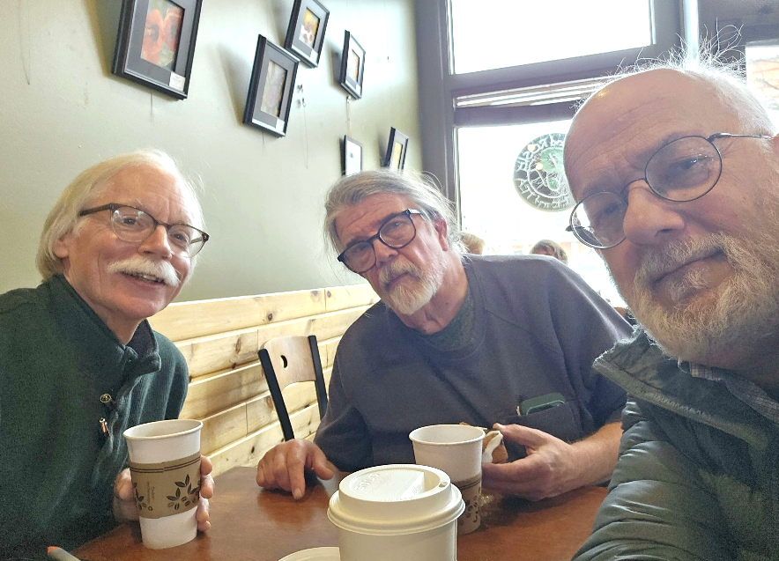
Here are L – R Fred Schebor K8NGW, Jeff Cowall KN8A, and yours truly, strategizing at a coffee shop in Dexter.

The Monthly Gripe
This newsletter is composed as a document in Open Office. Should it be fancier? Let me know. Especially if you can show me how.

The Cockles of My Heart
I recently saw a Facebook Marketplace post by Lisa in Texas asking what to do with ham radio equipment from her late husband. So, I responded, “A nearby club might be able to assist you pricing out everything.”

Lisa replied, “I've asked to thank you. I swear I don't believe there are a nicer bunch of people than ham operators. It’s amazing how many are sharing info. So, I don’t get shorted on our stuff. Thank you I really needed this” This absolutely made my day. Lisa approved me re-posting this.

Ham VoIP Applications
Folks who used Hamshack Hotline (HSH) know that it shut down operations on August 29, 2025. I had been using an HSH connection number to monitor the W8CCE repeater in Stutsmansville (north of Harbor Springs), but also that repeater has moved and its HSH connection is not yet available.

I was happy to hear that Dave Neal W2DAN, one of the principals in HSH, now has a made NexNet available to hams. I am now 4191 on NexNet.

To be provisioned on NexNet, e-mail Dave at w2dan@cox.net with this information: Callsign
Name; City and State; Type of phone - You will need a VoIP telephone to do this.

Wide-Area Linked Repeater Networks in Michigan
These are the ones that I know of:

https://nmlrn.org/ (northern LP)
https://w8ira.org/ (western LP)
https://kb0p.com/index.php/u-p-linked-system/ (north-central UP)

I can monitor repeaters on Allstar with a W8LRK club project Pi-based node. Please email me if you know a way to do this on any of the amateur radio VoIP apps.

New website for ARRL Affiliated Clubs
The ARRL has opened up a rebuilt Affiliated Clubs website here: https://affiliatedclubs.arrl.org/
This has a lot of new resources, map-based searching, and other good stuff. If your club is affiliated or not, you are encouraged to check this out. If your club is affiliated, then especially check that the information listed for you is up to date. And, if your club is not affiliated, or you cannot update your information, then please contact me.

This Month's Numbers Game
New licenses are the lifeblood of our hobby, so I would like to thank all of the 686 Michigan hams who have taken the trouble to become Volunteer Examiners with the ARRL. However, ahem, 133 ARRL VE's in Michigan have never officiated at an exam session.

Why is this? Don't know what to do next? Don't know where sessions are being held near you? Stage fright? Have you moved out of Michigan? Afraid of flunking a 9-year-old or your boss? Can't find your stinkin' badge? Not a problem. I never met a VE who was unwilling to help and encourage other VE's, or for that matter help and encourage applicants (so far as allowed.)

You are encouraged to try this. Personally, there is very little that is quite so cool as saying that they passed, especially a youngster. And even if a youngster doesn't pass, and you can encourage them to study more, and you can give them some help along the way, you are imparting valuable life lessons about the grit that it may take to achieve a goal that initially seems out-of-reach. It is just wonderful to see a youngster get their ticket on the second or even third pass. And it is also wonderful if this happens with an adult.

Many clubs are moving away from paper tests, such as the Livingston Amateur Radio Klub in Howell and the ARROW club in Ann Arbor, and these are just the ones that I have VE'ed for. The biggest hurdle is getting enough tablets, but there can be grant money available. Go for it. [Numbers as of February 11, 2026.]

Talk To Me
An old Chinese curse says, “May you live in interesting times.” Once again this has been an interesting month. Being Section Manager is enough work that I can now admit to being as over-committed as when I was still working. Hoping that you are having half this much fun. What could be better than talking to hams around Michigan about what they are doing?

I may soon be at a swap near you. The Michigan Section Manager events calendar is publicly available, associated with this e-mail address: arrl.mi.section.manager@gmail.com
Please let me know if there are problems accessing this.

If there is no nearby swap, I might be able to come to your club meeting, either in-person or via Zoom. As always: Do you have ideas and/or want to help? Have something to brag about? Or just want to gripe? Please contact me. It is my honor to serve you.

73,

Ralph Katz, AA8RK
Ann Arbor, MI arrl.mi.section.manager@gmail.com aa8rk@arrl.org
734-657-5059 cell


From the Ohio Section Manager
Bret Stemen, KD8SCL
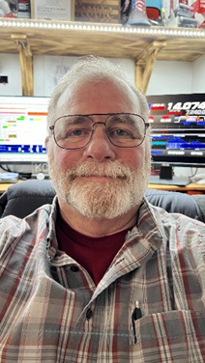

Spring Is Almost Here!
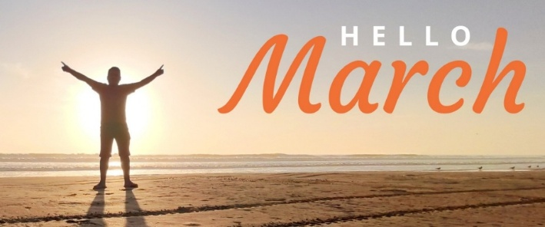

Hamfests are currently underway. I recently attended the Struthers and NOARS Hamfests and thoroughly enjoyed the opportunity to engage in face-to-face conversations with many of the attendees. I am going to attend as many hamfests that I will be able to attend this year. I will be present at Dayton once again, assisting with the Great Lakes Division, Ohio Section Booth and the ARRL ARES Booth.

During a recent conversation last year at the Toledo Hamfest, I was asked about leadership roles and the distinction between a club and ARES. It is crucial to recognize that the club president serves as the sole leader of the club, while the Emergency Coordinator serves as the sole leader of the local ARES team. Now you may be asking, What if the club president is also the Emergency Coordinator? That’s fine, but they must switch hats between the club and ARES (so to speak). Several clubs within the section provide support to the local ARES team by allowing the ARES team to utilize their repeater during ARES weekly or monthly practice nets and for severe weather nets. Approximately 50 to 75% of the membership of these clubs consists of ARES members. Additionally, there are several ARES teams that possess their own repeaters for these activities.

I know that there are a few counties in the Ohio Section where clubs and the ARES teams do not work together for one reason or another. One thing to think about is that many ARES members are also the local club member, but the local club may or does not support the local ARES group.

Why doesn’t the club support the ARES group? There are many reasons for this and we must reconcile the situation and our differences and work together. We all are friends one way or another, if it’s through the local repeaters, clubs etc. We as hams should be mentoring and working with new hams and members.

At one point or another, we will be working together to serve our communities and served agencies during an event such as a severe weather event, bicycle race, parade etc.

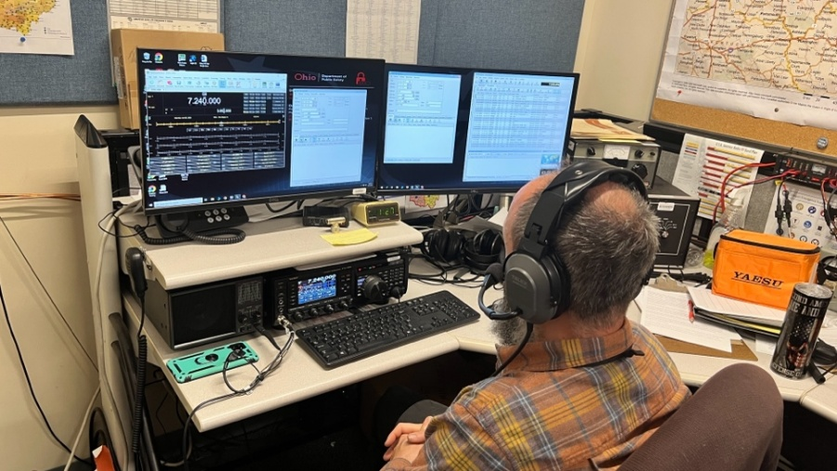
Richard KD8PHG operating the voice station during an exercise

With spring approaching, the SARGE (W8SGT) stationed at the Ohio EMA in the EOC is on the air every Tuesday evening (Ohio HF Net) at 19:00 on 3.902 +/-, this is a great time to test your equipment. All hams are welcome and encouraged to check into the net. We take check-ins by our 10 ARES Districts first then ask for all others that may have missed their district and from anybody that may hear our station

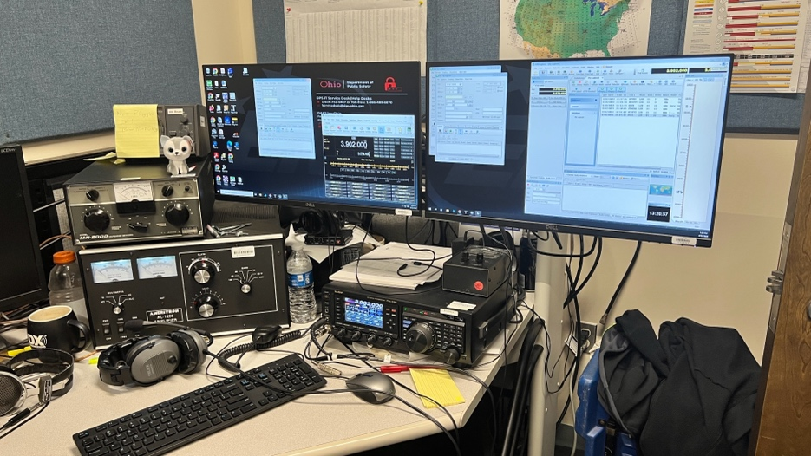
W8SGT Digital station (The digital station has Fldigi capabilities)

The SARGE is available for activation during exercises and real-world events from any county in the section or from any surrounding state that would need to make contact with the Ohio EMA.

The latest edition of the Ohio Section Journal is now online and ready for you to read! There’s an awful lot of Ham Radio activities going on in the Ohio Section, so get off the chair or couch you’re sitting on and get out there, get involved, and get on the air! The links below will take you directly to the newsletter. Both are also available directly from the Ohio Section Web-site ( www.arrl-ohio.org
https://arrl-ohio.org/wp-content/uploads/2026/03/OSJ_March_2026.pdf
https://arrl-ohio.org/wp-content/uploads/2026/03/OSJ_March_2026.docx
73,
ret, KD8SCL

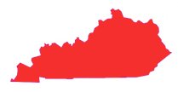
From the Kentucky Section Manager
Bob Selbrede, K6ZZ

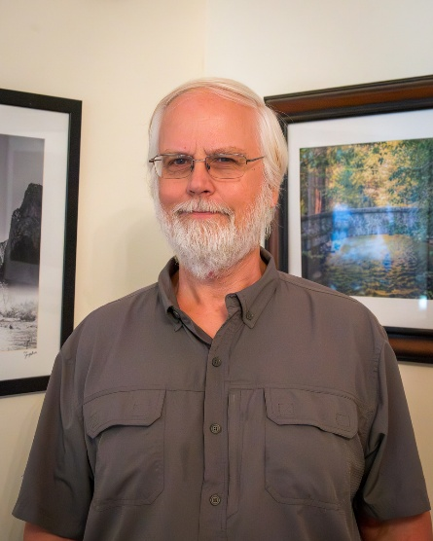

Hello Fellow Kentucky Hams,

The Mammoth Cave Amateur Radio Club hosted the Cave City Hamfest last weekend. It was a great event and well attended The swapmeet was packed and we conducted ARRL and ARES Forums which were both well attended.

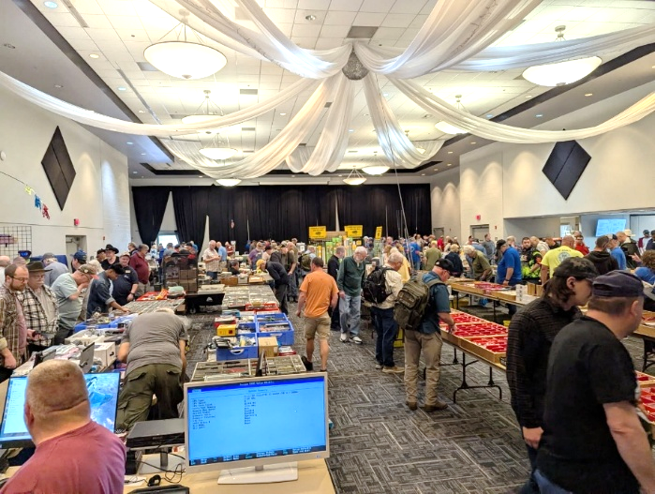
The ARRL was well represented with Great Lakes Division Director N8SY, Kentucky Section Manager K6ZZ, Kentucky Section Emergency Coordinator W2QN, Kentucky Section Traffic Manager KO4OL and numerous Kentucky Emergency Coordinators in attendance.

Thank you to the Mammoth Cave ARC for hosting the event and thanks to N8SY and W2QN for hosting the ARRL and ARES Forums respectively. This was my first Cave City Hamfest but definitely not my last!

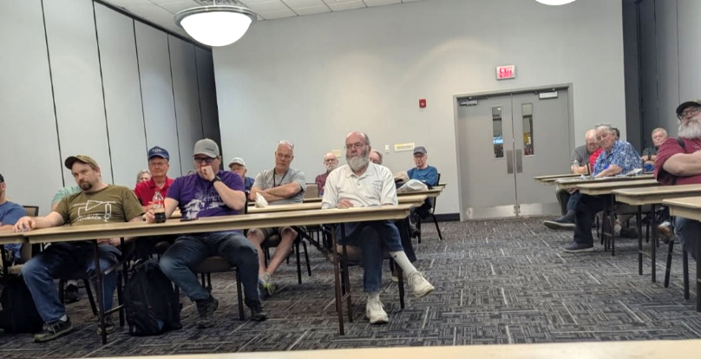
As you have no doubt heard, we are working hard to rebuild Kentucky ARES. ARES is truly a vital resource when disasters happen, and I encourage you to do your part and help any way you can. Public Service is one of the principal reasons Amateur Radio exists, and continues to exist, so please help if you can. Kentucky needs more hams to join their local ARES groups, and we need more Emergency Coordinators. Can you imagine the perception State

Leadership would have if amateurs were called upon to help out after a tornado or serious flood, and we said "sorry, we can't help". That is the sort of thing we need to avoid. Please reach out to me or our Section Emergency Coordinator Dennis W2QN to find out how YOU can help!

Lastly, you'll hear several W1AW/4 stations on the air beginning at 0000Z on 18 March (Tuesday night) and operating through 24 March. Operators will be from ARRL Affiliated Clubs in Kentucky putting Kentucky on the air for hams pursuing the ARRL America250 Worked All States Award. Give them a QSO!

73 for now...

Bob, K6ZZ
Kentucky Section Manager
K6ZZ@ARRL.ORG

Do you know someone who is not getting this newsletter


Hi Gang,

If you know someone who isn’t already getting Radio Waves, have them sign up to receive it!! They don’t have to be ARRL members to sign up, just click on the button below and in no time, they will start receiving it.

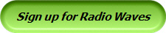

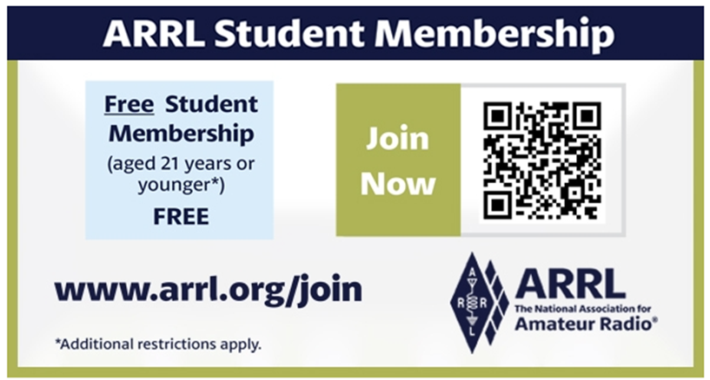

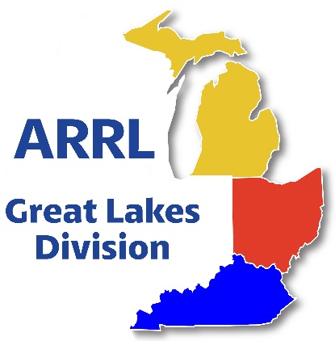
Scott’s Stuff
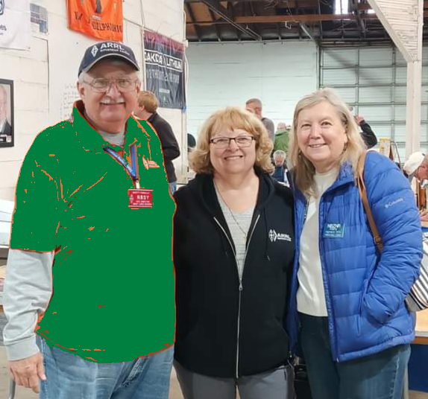

Hi Gang!

If you’re wondering why my inbox is buzzing with green emojis and a sudden craving for corned beef, the answer is simple: I’m 5 % Irish and Ancestry dot com confirms it. Yes, you read that right, I’m 5% of the good-looking, mischievous lineage that gave the world leprechauns, shamrocks, and the uncanny ability to turn a rainy Tuesday into a “just add a little good ol’ fashioned bourbon” to the celebration. That tiny genetic shot of Emerald Isle runs in my veins, and it’s about to hit full-volume on March 17th.

Every year I set two alarms, one for the time change (hello, “spring forward”—a collective assault on our circadian systems) and another for the moment my inner leprechaun whispers, “It’s time to wear the green, not the green-ish.” This year the clocks jumped forward on March 8th, and let me tell you, my internal alarm clock is still trying to figure out whether it should be snoozing or sprinting. I need more coffee!!
If you missed either extravaganzas, that was the Cave City Hamfest or NOARS (Northern Ohio Amateur Radio Society) Fest this past weekend, you missed a slice of radio heaven. The fellowship was, as always, the secret sauce that makes any hamfest feel like a family reunion, except you don’t have to bring a casserole; you just bring a willingness to swap stories about the time you accidentally keyed a 10-meter “SOS” while trying to change a light bulb.

If you ever wonder why the ARRL’s logo appears on hundreds of t-shirts and badges, it’s because they actually make the whole thing possible. From licensing support to the emergency communication backbone we rely on during disasters, the ARRL keeps the airwaves humming while we’re busy debating whether a “green-shirt-with-antennas” costume is appropriate for St. Patrick’s Day. Are you a member? If not, why? I’d really like to know.

The ARRL’s Year of the Club’s Vision:
Strengthening Clubs, Strengthening Communities. At the heart of the ARRL’s mission is its commitment to fostering strong, active ham radio clubs. Our Affiliated clubs are the lifeblood of the amateur radio community, serving as hubs for education, innovation, and collaboration. After what feels like a decade of winter, the ARRL has already launched programs designed to reignite that sense of camaraderie and growth. Are you a part of it? If not, why not?

Coding Competition…
If you have young enthusiasts in your club or community, mark your calendars for our 2026 Coding Competition. The competition runs from January 1st – March 31st. This is a great way to blend amateur radio with STEM education. This competition invites students and young hams to develop innovative software or coding projects that interface with amateur radio technology. From creating apps for contest logging to designing tools for satellite tracking, participants will have the chance to showcase their creativity while learning critical programming and problem-solving skills. We’re not just promoting ham radio; we’re nurturing the next generation of innovators. Winning projects will be highlighted in amateur radio publications, and top contributors could walk away with scholarships or tech prizes. The goal? To inspire curiosity and bridge the gap between radio, technology and our youth.

ARRL Student Coding Competition - Specifications 1 Jan 2026.pdf

Contest Portal and America250 WAS…
On the contest front, we’re rolling out the new Contest Portal, a one-stop digital hub that will revolutionize how operators access and participate in events. Picture this: real-time standings, downloadable logs, contest rules, and registration links—all in one easily navigable platform.
This tool is designed to make contesting more efficient and enjoyable, whether you’re a casual participant or a seasoned sprinter. https://contests.arrl.org/ And for those of you chasing the thrill of global connections, don’t miss America250 WAS (Worked All States)!

This special event is part of the broader America250 initiative, celebrating 250 years of American independence. The goal? Work as many stations in all 50 U.S. states, plus territories, as you can through a mix of on-air contacts and digital modes.

Ok… I hope that you get on the bands and just go crazy!!! There’s so much to enjoy on the bands, so, get Radio-Active, but above all, regardless of your preferred mode or band, remember the golden rules of our incredible hobby: Have FUN, be respectful and most importantly, be Radio Active!

73, Scott…

Scott Yonally, N8SY
Director - Great Lakes Division
n8sy@n8sy.com

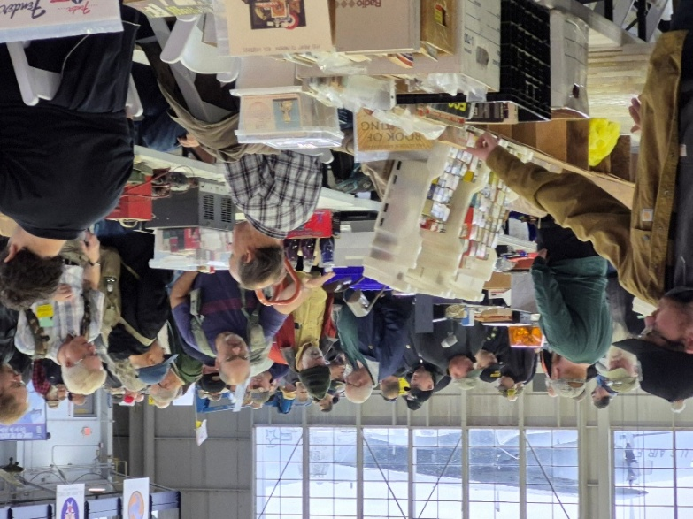
Great Lakes Division Hamfests

Here in the Great Lakes Division, we have over 50 hamfests a year. So, if you haven’t started planning your hamfest schedule yet, you really need to start now.

Let's fully support all of our hamfests in every way possible. It means success for everyone. Be sure to invite your ARRL Officials as soon as your date is set.

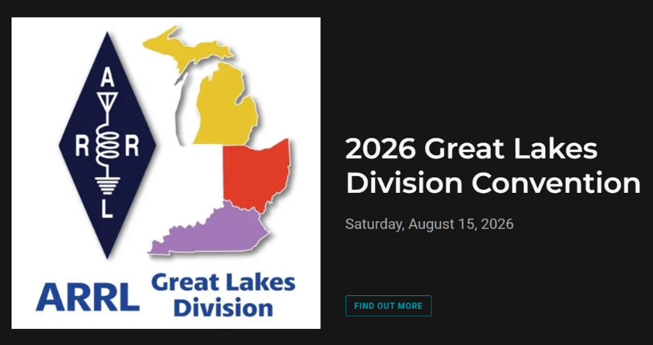

If you are planning on having your hamfest listed in QST please be sure to start your planning well in advance of your Hamfest date, as this allows adequate time for QST Listings. QST announcements require a 3-month lead time.

03/15/2026 - Toledo Mobile Radio Association Hamfest and Computer Fair  Location: Perrysburg, OH  Sponsor: Toledo Mobile Radio Association  Website: http://www.w8hhf.org  Learn More | 03/21/2026 - Lowell Amateur Radio Youth Club Hamfest  Location: Lowell, MI  Sponsor: Lowell Amateur Radio Club  Website: http://larc.club  Learn More
04/11/2026 - AC8RC Mini-Swap  Location: Burnips, MI  Sponsor: AC8RC  Website: http://ac8rc.org  Learn More | 04/11/2026 - Cuyahoga Falls Amateur Radio Club 70th Hamfest  Location: Cuyahoga Falls, OH  Sponsor: Cuyahoga Falls Amateur Radio Club, Inc.  Website: https://www.cfarc-hamfest.org  Learn More
04/18/2026 - SJCARC Hamfest  Location: Centreville, MI  Sponsor: SJCMIARC  Learn More | 04/25/2026 - Tusco Amateur Radio Club's 2026 Hamfest, Computer & Electronics Show  Location: Dover, OH  Sponsor: Tusco Amateur Radio Club W8ZX  Website: http://www.w8zx.net/hamfest  Learn More
04/26/2026 - Athens Hamfest  Location: Athens, OH  Sponsor: Athens County Amateur Radio Association  Website: http://ac-ara.org  Learn More | 05/02/2026 - Crossroads Hamfest  Location: Marshall , MI  Sponsor: Southern Michigan Amateur Radio Society  Website: http://www.w8df.com  Learn More
05/02/2026 - Lucas County ARES Hamfest  Location: Toledo, OH  Sponsor: Lucas County Amateur Radio Emergency Service, Inc.  Website: http://WWW.LUCASARES.ORG  Learn More | 05/02/2026 - Wexaukee ARC Swap & Shop  Location: Cadillac, MI  Sponsor: Wexaukee Amateur Radio Club  Website: http://wexaukeearc.org  Learn More

You can always find the latest information about upcoming hamfests on the Great Lakes Division website.
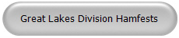

Just click to get the latest hamfest updates.

Celebrating Community Connections:

How the ARRL Amateur Radio Activity Report Shines a Light on Non-Emergency Events

When most people think of amateur radio, their minds jump to emergency communications, storm nets, and disaster relief. While emergency preparedness is certainly a critical mission for hams, it’s only part of the story. At its heart, amateur radio is about community, education, and the pure thrill of connecting with people—nearby and around the globe. That spirit is on full display in the ARRL’s new Amateur Radio Activity Report, a spotlight on the countless non-emergency events that bring ham radio’s friendly energy to life.

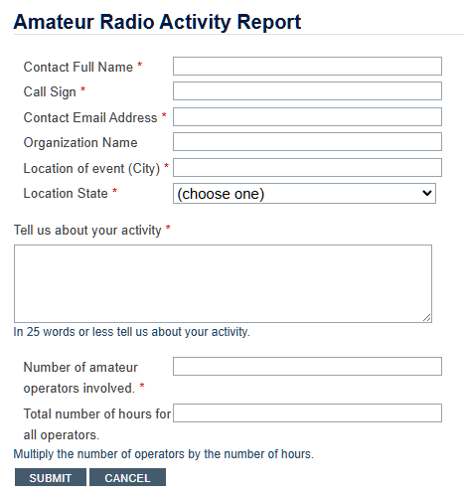

Amateur Radio Activity Report

The Launch of the Amateur Radio Activity Report
With the “Year of the Club” initiative in full swing, the ARRL has introduced the Activity Report as a way to track and celebrate everything amateur radio clubs and individual hams are doing outside of formal emergency service.
Whether it’s a license training session at the local library, a high school STEM demonstration, working on a repeater or radios at the finish line of a charity 5K race, these activities demonstrate how thriving and diverse our community truly is—and why amateur radio remains a gateway to lifelong learning.

Why Non-Emergency Events Matter
• Community Outreach: Public appearances at festivals, fairs, and historical reenactments build goodwill. Local residents see firsthand how operators set up portable stations, demonstrate antennas, and even let passersby speak on HF bands.
• Education and Licensing: Weekend license classes and Tech-to-General upgrade courses inspire newcomers. When clubs bring equipment into science fairs or school assemblies, they plant the seeds for tomorrow’s ham operators, engineers, and broadcasters.
• Public Service Without Crisis: Supporting county marathons, cycling races, working on repeaters and club equipment to keep it updated and in good working order and parades may not involve saving lives, but it does require precision and teamwork. That same reliability enhances overall public trust in amateur radio’s capabilities.

How to Participate
If your club or group is hosting a non-emergency event, it’s easy to share the story:

- Go to https://www.arrl.org/amateur-radio-activity-report
- Fill out the brief form with event details: date, location, type of activity, and number of participants.
- Attach photos, flyers, or news coverage if you have them.
- Hit submit—and watch for your feature in upcoming ARRL communications.

By simply reporting what you’re already doing—mentoring, teaching, demonstrating, and supporting—you help the entire amateur radio community shine.

For more information or assistance, contact the ARRL Club Services Department at clubs@arrl.org. Let’s keep the momentum going—community connections start with you!

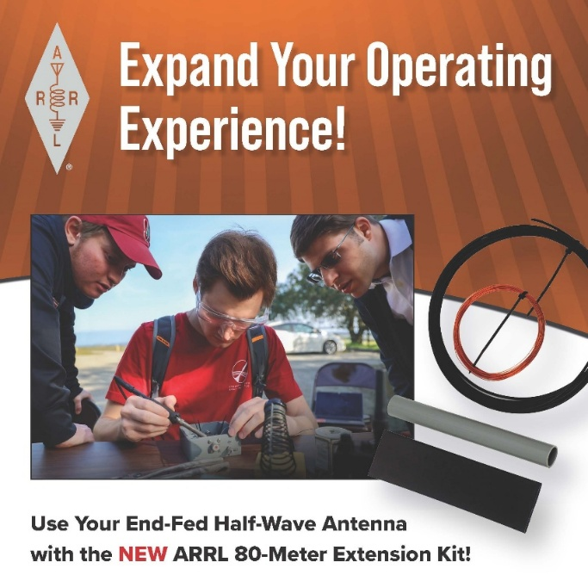

The ARRL 80-Meter Extension Kit adds a loading coil and short wire extension to the ARRL End-Fed Half-Wave (EFHW) antenna, electrically lengthening it for resonance on the 80-meter band. The coil provides the required inductance, while the wire extension allows for fine-tuning. Operating on 80 meters typically results in a narrow bandwidth and may require the use of an antenna tuner. Expand your reach today!

Bus to Dayton Hamvention

The ARROW Communication Association and the Toledo Mobile Radio Association (TMRA) are proud to sponsor a motor coach trip to the Hamvention 2026 in Dayton, Ohio. This one-day trip leaves early in the morning on May 16, 2026 and returns the same day after Hamvention closes for the day at 5:00 p.m. The bus has two pickup spots, in Ann Arbor and in Toledo (Rossford). Please join us!

Tickets are $95 per person January 1st 2026 – April 17th 2026
$110 per person April 18th 2026 – May 15th 2026
Please note that this does not include the Hamvention ticket, which you need to purchase separately.

To Register and see full Details visit: https://w8rp.org/daytonbus2026/

There are two pickup/drop off locations on May 16th, 2026
Ann Arbor – 601 W Stadium Blvd, Ann Arbor, MI – Departing 4:30 am
Toledo – 727 Lime City Rd. Rossford, OH – Departing 5:30 am

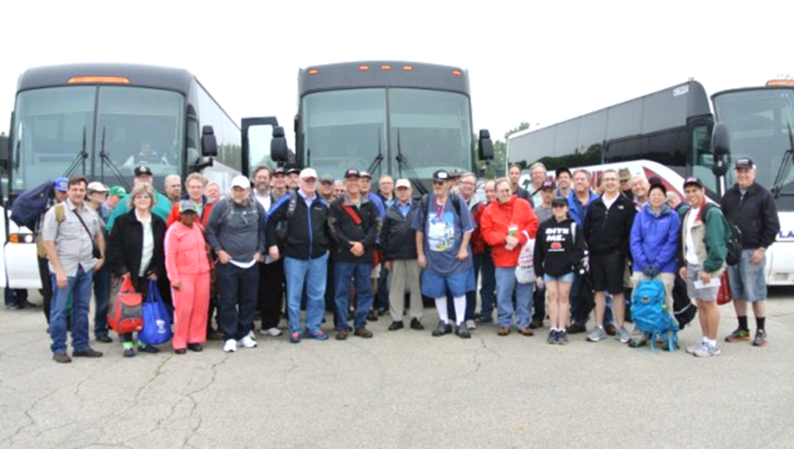

On board, you can stretch out, relax, take a nap, chat with other hams, and enjoy a light breakfast with coffee as the coach takes you directly to the country’s largest amateur radio event!

Thanks
ARROW & TMRA

STOP – Right there!!!
We’ve come to the end…

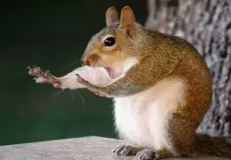

Be Radio-Active --- See Ya’ Soon!

Radio Waves is produced as a look inside of the Great Lakes Division and all that it has to offer. It is our sincerest hope that you have enjoyed this edition and will encourage your friends to be a part of the ARRL and receive the latest news and information about the ARRL and the Great Lakes Division!

The pictures throughout this newsletter are from various newsletters, Facebook posts and/or were sent directly to me in recent weeks. Take a good look at them, you just might be in one of the pictures! “SMILE… you might just be in the Great Lakes Division News!!”

