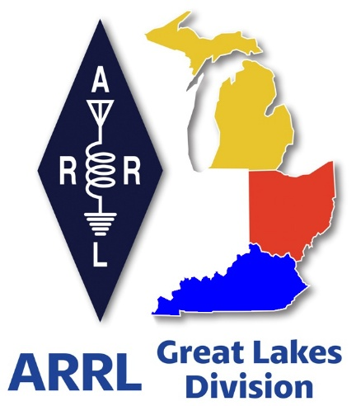
Radio Waves
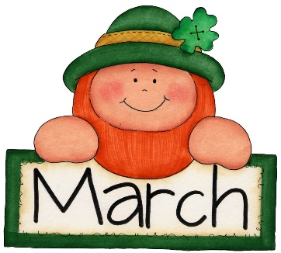
^{The} Great Lakes
Division
Monthly Journal
March 2026

Scott’s Stuff
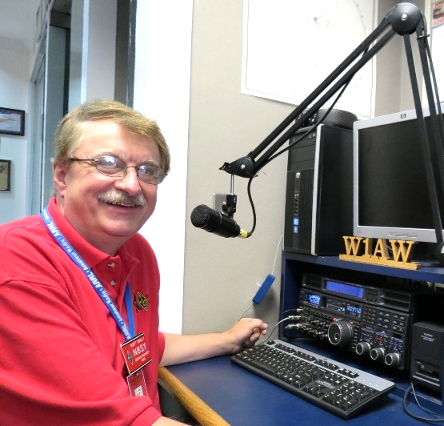
March, You’re a Real Jerk (and a Sweetheart)

Spring is Knocking, But Daylight-Saving Time Is Stealing My Sleep. Wow. I can’t believe it’s already March. I’m still half‑expecting a “January‑again” memo in my inbox, but the calendar says otherwise. The planet is doing that slow‑motion spin where the days get a tiny bit longer, the birds start rehearsing their “I’m‑back‑from‑the‑cold” concert, and somewhere, a mysterious force called “spring” is poised to burst onto the scene on March 20th.

I’ve already imagined myself shedding my winter coat. Picture this: I strut out of my house, a lightweight jacket fluttering in the breeze, birds tweeting a sassy “good‑morning!” while I wave goodbye to the snow thrower. It’s my most faithful (and frankly, most obnoxious) winter companion for sure, but I couldn’t live without it either. I can already hear the sighs of relief from my car’s all-wheel drive, finally free from the icy grip of winter. Yes, March, you’re basically a celebrity makeover for the planet, and I’m ready for the red‑carpet reveal.

But then—cue the dramatic music—the universe drops a “plot twist” on March 8th: Daylight‑Saving Time. We lose an hour of sleep! My inner child, who still clings to the notion that “spring forward, fall back” is a polite invitation to nap, is now sobbing into a pillow. I’ve already set three alarms, brewed a pot of coffee strong enough to convince a cactus to dance, and Googled “how to survive an hour‑short night without turning into a zombie.” Spoiler: there is no spoiler; you just become a slightly more jittery version of yourself.

So, here’s the deal. I’m caught in a love‑hate triangle with March. I love the promise of blossoms, longer evenings, and the sweet freedom of ditching that ridiculous, wind‑blown coat that makes me look like a walking snowman.

I just hate the ruthless theft of 60 minutes of precious, pre‑spring sleep. I mean, who decided that we needed to wake up earlier just as the sun finally decides to stay up a bit longer? It feels like the cosmos is playing a cruel joke.

So, here’s to spring! Just please, be gentle on the sleep part.

Stay warm, stay curious, and keep those antennas pointed skyward, but most of all, stay Radio-Active!.

73,
Scott…

Scott Yonally, N8SY
Director - Great Lakes Division
n8sy@n8sy.com

Club Commission – Is your club taking advantage of this great program?


When an amateur-radio club becomes an ARRL-affiliated club, it opens the door to a suite of resources that most hams take for granted: contest-entry discounts, grant opportunities, technical publications, and a powerful voice on Capitol Hill. One of the most under-used, yet potentially lucrative, benefits is the Club Commission program—a streamlined way for clubs to earn money while they recruit new members and keep existing ones renewed.

Below is a motivational look at why the commission matters, how the updated structure makes it easier than ever, and a creative twist that can turn every new sign-up into a win-win for both the club treasury and the fresh-faced ham who just joined.

1. The New Commission Landscape – Simpler, Faster, More Lucrative
Until recently, clubs had to juggle credit-card receipts, handwritten checks, and cash envelopes to collect their share of the ARRL commission. The administrative burden often outweighed the payout, and many clubs simply let the opportunity slip through their fingers.

The 2024 commission overhaul eliminates that friction:

Old Process | New Process
Club collected dues, reconciled cash/credit-card fees, then mailed a claim to ARRL. | All dues are sent directly to ARRL for processing; the organization notifies the club of the earned commission.
Clubs had to track each member’s payment method and adjust for processing fees. | ARRL handles all fees; clubs receive a clean, flat-rate payment.
Payments arrived on an irregular schedule, often months after the member joined. | Commission payments are issued quarterly, with transparent reporting.

The result? $20 for every new member and $5 for each renewal flow straight from ARRL to the club’s treasury, the paperwork required is a simple ARRL application form that each new or renewing member completes and the single page Club Commission form that the clubs completes along with payment in full for all memberships. That’s it. The ARRL will process the forms and send back to the club the commission earned via direct deposit or check.

Think about this for just a second… For a club that signs up 30 newcomers in a year, that’s a $600 boost—enough to fund a new repeater, purchase a set of portable antennas, or subsidize a youth outreach event.

2. Why the Commission Is Important for Every Club
A. Boosting the Club Treasury
Cash is the lifeblood of any organization. Whether it’s paying rent for a clubhouse, buying tools for a field-day project, or covering travel to a regional contest, a healthy treasury gives the club the freedom to pursue ambitious projects. The commission adds a predictable revenue stream that grows in direct proportion to the club’s recruiting efforts.

B. Helping a New Ham Feel Welcome
First-time members often face a steep learning curve. Providing money back incentives—such as a $20 “welcome-back” check—creates an immediate sense of belonging. It signals that the club cares about its members’ investment in the hobby and that the ARRL community is supportive from day one.

C. Strengthening the ARRL’s Advocacy Mission
Every new member adds a voice to the national conversation about spectrum protection, emergency communications, and hobby education. By encouraging members to join and stay renewed, clubs play a pivotal role in keeping amateur radio important to regulators and policymakers. The commission is essentially a reward for doing the right thing for the whole hobby.

3. Turning the $20 Into a Membership Incentive
Imagine a scenario where the club does not keep the $20 commission for itself but instead gifts it back to the new member as a “new-ham bonus.” The mechanics are simple:

- Collect the commission from ARRL as usual.

- Issue a $20 check or e-gift card to the new member at the time of their first club meeting.

- Announce the program on the club’s website, social media, and during open-house events—“Join the ARRL, get $20 back in your pocket!”

The same can be done for renewals: a $5 “loyalty rebate” each year serves as a gentle reminder that staying active is both financially and socially rewarding.

The Ripple Effect
- Word-of-mouth marketing: A member who receives cash back will tell friends, who then become prospective members.

- Higher retention: The small financial “thank-you” reinforces the habit of participating in club activities.

- Elevated club profile: Clubs that publicly offer these incentives are seen as forward-thinking and member-centric, attracting sponsors and grant opportunities.

All of these outcomes feed back into the club projects pipeline, enabling bigger, bolder initiatives.

4. Steps to Get the Commission Working for You
- Verify affiliation status on the ARRL website. If the club is not yet affiliated, complete the application—membership dues are a small price for the long-term payoff.

- Designate a commission liaison. This person (usually the Treasurer) will monitor the quarterly ARRL report, ensure the club’s banking details are up-to-date, and coordinate any member-incentive payouts.

- Promote the program during every recruitment drive. Include the $20 figure in flyers, newsletters, and booth signage at ham fairs.
So, if your club has not yet tapped into this opportunity, the time to act is now. Update your affiliation status, train a liaison, and start shouting the news: “Join us, get $20 back, and help keep amateur radio strong!”

In the world of amateur radio, every extra dollar translates into another antenna on a hill, another workshop for fledgling hams, and another voice in the fight to protect the spectrum. Let the Club Commission be the engine that drives those dreams forward—one new member at a time.

Code Away: The ARRL Student Coding Competition Is On

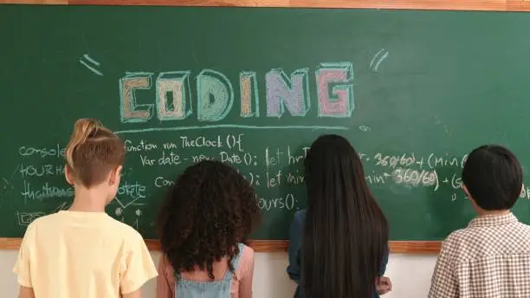
Now, for the tech-savvy among you—yes, the ones who think Morse code is overrated and prefer to communicate in Python—here’s some exciting news. The ARRL Student Coding Competition is live until March 31, and it’s your golden ticket to hack, build, and shine. The challenge? Design a mobile app that could one day join the ARRL’s toolkit. Think contact-logging wizards, real-time propagation visualizers, or (my personal favorite) a gamified phonetic alphabet tutor for those QSO-hesitant newbies.

Turning Dreams into Realities
When the ARRL announced its inaugural Coding Competition, the buzz in ham-radio circles turned into a low-frequency hum that soon grew into a full-blown chorus. The promise was simple, yet powerful: national recognition, a certificate that shouts “I’m a genius,” and cash awards that could fund a good education. But the real treasure lies deeper—in the way the contest fuels creativity, and cements a sense of belonging for every participant, from seasoned coders to the student still wrestling with “for loops.”

A Prize Package That Means More Than Money
- National Recognition – Winning projects are highlighted on the ARRL website, featured in QST, and shared across the League’s social channels. The visibility doesn’t just celebrate an individual; it puts the individual on the map.

- The Certificate – It’s more than a piece of paper. In a world where résumés are scrolling past recruiters in seconds, a line that reads “Designed an app for the ARRL” can turn a routine interview into a conversation starter. Employers quickly forget a college dorm microwave mishap when they see concrete evidence of problem-solving and community impact.

The Proving Ground for Tomorrow’s Innovators
Whether the participant is a veteran programmer who’s already built an APRS-mapper or a freshman still debugging an endless loop of “Hello, World!”, the competition levels the playing field.



“Toto, I’ve a feeling we’re not in Kansas anymore.”

Roy Hook, W8REH
Vice Director – Great Lakes Division

I think most people have heard this month’s title from the 1939 film, The Wizard of Oz or at least variations like “we’re not in Kansas anymore”. It continues to be relevant today and began to be used idiomatically sometime during the 1980s. I believe it carries a meaning that we are no longer in a familiar place; we are in a new and unknown situation; we are beyond what we believe to be normal; we are in an uncomfortable circumstance, conveying a sense of unease or uncertainty.

It seems to me that this describes situations all around us and particularly within our Amateur Radio community. We are constantly bombarded with topics seemingly impossible to sort out or achieve consensus on within our extremely small part of the world called Ham Radio. Many issues seem completely out of our personal control leading to contention and frustration. National and worldwide politics poke at our long-established beliefs and organizations leading us to seek answers we naturally gravitate to.

If you missed the “Scotts Stuff” in the Division Mid-Month Newsletter that hit your email box the evening of 2/14, look it up. His story on the recent ARISS event from our own back yard in Canfield, Ohio reminds me of Harry Smith’s LIVE coverage last year on NBC TODAY of the ARISS event at Harbor Creek Pennsylvania High School. I nominated that coverage to the Public Relations Committee for the ARRL Leonard Professional Media Award last year. The board unanimously approved that award last year.

Tell us what you are doing with ham radio to support your community. When the existence of our hobby appears to be under attack we logically fall back on the thought, “When all else fails, ham radio works”. A long-term friend and constituent forwarded me an interesting podcast. Although the podcast author clearly has a commercial interest and a resulting bias, my friend thought his two specific videos worthy of some consideration regardless of the author’s wildly different thinking. The first podcast title “The Storm Proved It – ARES & RACES is Dead” alone is enough to be viewed as inflammatory but try to set that aside and think outside the box for a moment.
His second follow-up video “If ARES & RACES are Dead, What's Next?” actually discussed his possible solution he acknowledges is only one personal suggestion. The author’s business, RANT Strategies appears to be a Maryland based training company for high-risk scenarios across multiple emergency response disciplines. What information I could find states his career as a State Trooper has led him to be a training coordinator specializing on K-9 topics and tactical rope instruction. He is also a paramedic with a degree in criminal justice.

He certainly makes enough points in his podcasts to debate and even outright disagree with like:
- This year’s winter storm didn't break RACES or ARES; it was already broken.
- Ham radio itself is very much alive.
- Public safety communication systems of the 70’s and 80’s were pretty fragile.
- Learning from their own failures, many modern public safety communications systems are believed to have adapted and evolved over recent decades.
- Amateur radio is being challenged to serve agencies the same ways it has in the past. Today many served agencies operate on communication systems featuring built-in redundancy, hard and trunked radio systems, dedicated emergency backup channels, satellite overlays, mobile command units, deployable repeaters, multi-site simulcast networks.
- Assuming today’s served agencies communications systems are professionally designed and can survive storms, power outages, fiber cuts, tower failures, even complete site loss, where do hobbyist systems fit in.
- The public service agencies appear to buy into the technology providers assurances these professionally built, complex systems are not likely to have any catastrophic system failures.
- There appears to be a perception within public safety agencies that a group of less trained hobbyists with handheld radios and flashy vests is not a path to restore any unlikely failures in today’s public service communications systems. (What do you think? How do amateur radio systems compare?)
- On a positive note, in many areas Skywarn is known to provide real time on the ground truth to the National Weather Service, their served agency - calling out snow and ice accumulation, visibility, wind damage, the road conditions, power outages, in short, actionable intelligence that matters.

Particularly in his follow-up, the author’s experience with sophisticated major metropolitan areas, does not seem to prevent him from having some understanding that a vertically structured “one size fits all” approach may not be appropriate. The effectiveness of the relationship between official agencies and the volunteer community comes down to the willingness of each to effectively understand the other, which he views as the major contributor to any perceived ineffectiveness of our traditional organizations. From a 2026 liability standpoint he points out some concerns held by many agencies in dealing with volunteer hobbyists but goes on to present one idea how to overcome those concerns.

Just as the podcast author reports receiving overwhelming responses, in circulating the essence of his podcasts among a few of our division EC and EMA minded, I am impressed with many of the out of the box responses I have had so far. Of particular significance is the overwhelming thought of grass roots management as a model for success. One rural constituent pointed out that their ARES/Skywarn groups are all the same volunteers. He further pointed out how different organizational and volunteer management approaches may be needed depending on local circumstances. He compared metropolitan areas which may have resources and funds many rural areas can only dream of with the difficulty convincing a young farm boy he should pay for a chainsaw training course when he has grown up keeping his family warm by harvesting their own wood; especially considering that his only income is from selling an occasional chain saw sculptor at the local farmer’s market.

Recalling from my 1980’s local team experience in Skywarn, local spotter education/training was always top of mind. This required not only meteorological training, but operational training. We were constantly challenged to explain why it was a problem to tie up resources with “sunshine” reports when, however rare, someone might have a tornado. Volunteer management is difficult, requiring a unique skill not easily transferred from the general environment. We were challenged to instill the understanding that quiet, but active volunteers were essential to our overall success.

After you read Scott’s March QST article on page 69 about ARES tell us what you think about the Skywarn, ARES/RACES models in your area. Could we still be in Kansas or not.

Comments on my last month’s article again came out of Michigan focusing on Admiral Grace Hopper and the list of questions to ask about your own club. I look forward to everyone’s thoughts and comments again.

73,

Roy
W8REH@ARRL.org

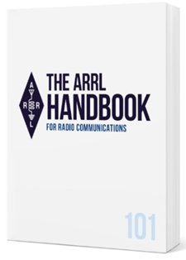
Handbook Give Away – Winner!!

And… the WINNER is…!!

Jenny Taylor, N8QKE

of Ontario, OH…!!!

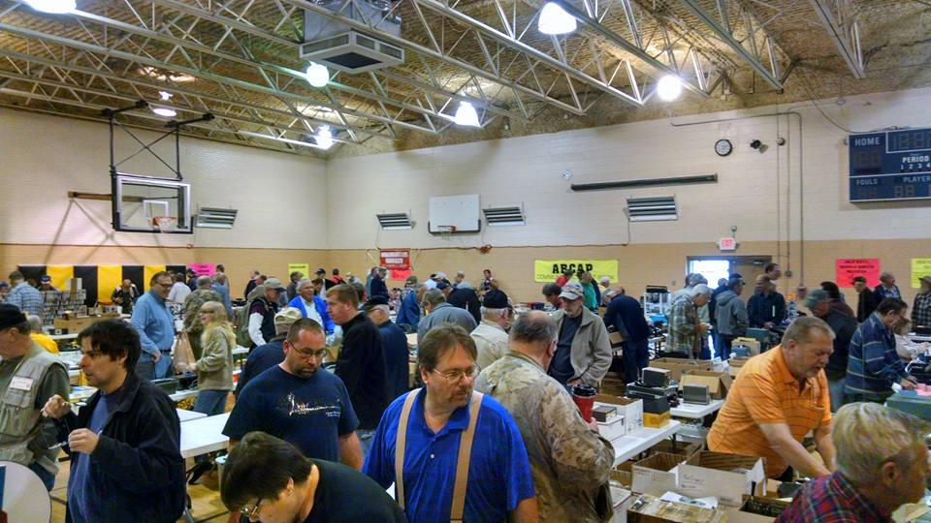
2026 Great Lakes Division Hamfests

Here in the Great Lakes Division, we have over 50 hamfests a year.

So, if you haven’t started planning your hamfest schedule yet, you really need to start now.

Please post this listing in your club's newsletter and announce the swaps on your local nets. Talk them up.

Let's fully support all of our hamfests in every way possible. It means success for everyone. Be sure to invite your ARRL Officials as soon as your date is set.

If you are planning on having your hamfest listed in QST please be sure to start your planning well in advance of your Hamfest date, as this allows adequate time for QST Listings. QST announcements require a 3-month lead time.
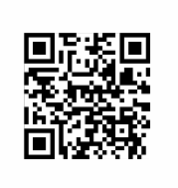
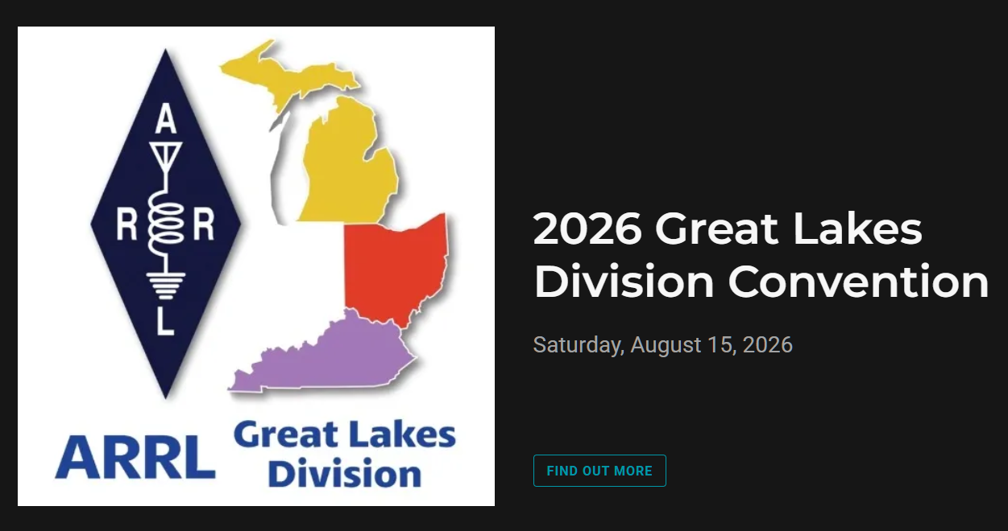

03/07/2026 - Cave City Hamfest  Location: Cave City, KY  Sponsor: Mammoth Cave ARC  Website: https://www.ky4x.org/hamfest  Learn More | 03/08/2026 - Northern Ohio Amateur Radio Society Winter Hamfest  Location: Elyria, OH  Sponsor: Northern Ohio Amateur Radio Society  Website: https://www.noars.net/hamfests/winter-hamfest/  Learn More
03/15/2026 - Toledo Mobile Radio Association Hamfest and Computer Fair  Location: Perrysburg, OH  Sponsor: Toledo Mobile Radio Association  Website: http://www.w8hhf.org  Learn More | 03/21/2026 - Lowell Amateur Radio Youth Club Hamfest  Location: Lowell, MI  Sponsor: Lowell Amateur Radio Club  Website: http://larc.club  Learn More
04/11/2026 - AC8RC Mini-Swap  Location: Burnips, MI  Sponsor: AC8RC  Website: http://ac8rc.org  Learn More | 04/11/2026 - Cuyahoga Falls Amateur Radio Club 70th Hamfest  Location: Cuyahoga Falls, OH  Sponsor: Cuyahoga Falls Amateur Radio Club, Inc.  Website: https://www.cfarc-hamfest.org  Learn More
04/18/2026 - SJCARC Hamfest  Location: Centreville, MI  Sponsor: SJCMIARC  Learn More | 04/25/2026 - Tusco Amateur Radio Club's 2026 Hamfest, Computer & Electronics Show  Location: Dover, OH  Sponsor: Tusco Amateur Radio Club W8ZX  Website: http://www.w8zx.net/hamfest  Learn More
04/26/2026 - Athens Hamfest  Location: Athens, OH  Sponsor: Athens County Amateur Radio Association  Website: http://ac-ara.org  Learn More | 05/02/2026 - Crossroads Hamfest  Location: Marshall , MI  Sponsor: Southern Michigan Amateur Radio Society  Website: http://www.w8df.com  Learn More

You can always find the latest information about upcoming hamfests on the Great Lakes Division website.

Just click to get the latest hamfest updates.

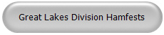

Something To Chew On – Why Should I join the ARRL?

Many people ask, “Why should I join the ARRL? What have they ever done for me?” It’s a reasonable question, especially when $59 is a significant amount and doesn’t just appear out of nowhere. I understand that everyone is entitled to ask this, whether they are a current member, a former member, or have never joined the ARRL. If you’re considering membership or your dues have lapsed, I encourage you to read this article in its entirety. It might offer a different perspective and help you understand the value of the ARRL. Ultimately, the decision is yours—it’s your money, and I respect everyone’s choice regarding membership.

To begin with, the ARRL is the only organization that consistently advocates for Amateur Radio before the U.S. Congress and the Federal Communications Commission (FCC). While there are countless YouTube channels, Facebook groups, and news outlets—both in text and video formats—reporting to amateur radio enthusiasts worldwide every day, and although several national magazines have been in circulation over the years, none fulfill this critical advocacy role like the ARRL.

Consider this: Who, besides the ARRL, has stood before Congress to present the case for Amateur Radio? Who else has entered into Memorandums of Understanding with organizations such as FEMA, the American Red Cross, and the Salvation Army to support and advocate for the interests of Amateur Radio operators? These partnerships and appearances are unique to the ARRL. It's worth taking a moment to reflect on this and, if you’re curious, try searching online to find another organization with the same level of engagement in these areas. Chances are, you will not find one.

Some people claim that the ARRL is simply a book publishing company and that it doesn’t care about its dues-paying members. But this perception overlooks the valuable resources the ARRL provides. For example, if the ARRL didn’t publish the Handbook, where else would radio enthusiasts find unique information about RF circuitry? The organization has produced numerous “How To” guides that help amateurs set up their stations, work with digital modes, and understand proper grounding techniques. Publishing is an essential part of the ARRL’s mission, and many members appreciate the wealth of books and materials produced over more than a century. As for the idea that the ARRL isn’t attentive to its members, this doesn’t seem to hold up. If you call their office at: 860-594-0200, you’ll find staff who are both understanding and helpful.

It’s not uncommon to come across articles or posts from individuals who consistently point out perceived flaws in how the ARRL operates. What is truly surprising is how quickly some people react to these negative perspectives, often without taking the time to verify whether the information being shared is accurate.

While it’s human nature to occasionally jump to conclusions, it’s important for all of us to remember the value of independent research. Before contributing to conversations on social media, we should make an effort to uncover the facts for ourselves. Reacting impulsively or spreading unverified claims only perpetuates the cycle of misinformation that has become so prevalent online today.

Now, if you really want to know “what does the ARRL do for that $59, here’s just a brief list of some of those things.”

Advocacy Programs  - PRB-1 and Antenna Protection Legislation  - Lobbies for spectrum protection – Intruders  - Lobbies for additional bands. - WARC and VLF  - Represents the interests of US hams at IARU  - Rules Enforcement – Volunteer Monitor Program | Training Courses  - Technician Licensing  - General Licensing  - Extra Licensing  - Teachers Institute  - On-Line Technician Class license course  - W1AW - Training and Bulletins  - VEC - examinations
ARRL Laboratory  - Technical Information Service  - Tests new equipment and provides reports  - RFI Assistance  - Provides Social Media Programming | Advisory Help  - Volunteer Counsel Program – Yes, you can get an hour of time with an attorney - FREE  - Volunteer Consulting Engineer Program  - Technical Specialists  - Volunteer Instructors  - Electromagnetic Compatibility Committee  - RF Safety Committee
Publications & Services  - Publications - Technical and Operating Journals  - QST Monthly Journal  - On The Air, QEX and NCJ Bi-Monthly Journals  - QSL Service - incoming and outgoing | ARRL Outreach Program  - Youth  - Schools  - Collegient  - ARISS
- ARRL Foundation - Scholarships  - Heritage Museum  - NTS  - ARES  - Public Service Honor Roll  - LoTW  - Renew your ham license for FREE | On the Air Awards  - DXCC  - WAS  - WAC  - VCC  - A-1 Operator Club | - Triple Play  - Fred Fish Memorial Award  - Morse Code Proficiency  - Elmer Award  - First Contact Award
Contests  - Straight Key Night  - Kids Day  - RTTY Roundup  - January VHF  - School Club Roundups  - International DX, CW and Phone  - June VHF  - Field Day  - Rookie Roundup – CW  - International Digital Contest | - IARU HF World  - 222 MHz and Up  - 10 GHz and Up  - Rookie Roundup RTTY  - EME 23 GHz and Up  - EME 50-1296  - Nov Sweepstakes CW and Phone  - 160 Meter Contest  - 10 Meter Contest
Ok, I think you get the idea. Yes, $59 per year is steep, especially for those of us on fixed incomes. What I’ve listed above is not everything that they do either. Look at the dues this way, it’s less than a cup of McDonald’s coffee per week.

Got questions? Feel free to contact me anytime.

Scott, N8SY
n8sy@arrl.org 419-512-4445

Club Links

I’ve received a number of new requests from clubs to be listed on the “Links” club page.
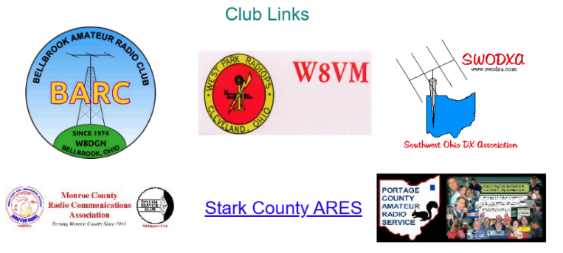

Is your club listed? If not, send the URL of your club website to me n8sy@n8sy.com and I’ll get it listed.




Spring Forward!!

On Sunday, March 8th we once again “Spring Forward” at 2am so that we can all loose 1 hour of sleep as Daylight Saving Time begins.

ARRL VEC Youth License Test Fee Only $5!

Youth examinees under age 18, you can earn your initial Technician license or upgrade your current license through the ARRL VEC Volunteer Examiner Coordinator program for only $5.
The ARRL Youth Licensing Grant Program covers the one-time $35 application fee for new license candidates younger than 18-years old for tests administered under the ARRL VEC program. The $35 FCC application fee will be reimbursed after the ARRL VEC receives the completed reimbursement form and the new license has been issued by the FCC. The reimbursement check will be mailed to the fee payer.
Additionally, candidates younger than 18-years old pay a reduced exam fee of $5 to the ARRL VEC VE team at the time of the exam. The $5 fee is for all candidates under the age of 18 regardless of the exam level taken. Proof of under 18 status is required at the session (what to bring to an exam session).
The program is sponsored by ARRL The National Association for Amateur Radio®.

New Survey – GLD-12
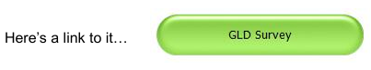
There is a new survey posted GLD-12 and it is on the website and waiting for input from you. I really would like to hear your feedback.

Please take just a couple of minutes of your time and take the survey.

Got a question that you think should be asked? Let me know… n8sy@n8sy.com

Bus to Dayton Hamvention

The ARROW Communications Association and the Toledo Mobile Radio Association (TMRA) are proud to sponsor a motor coach trip to the Hamvention 2026 in Dayton, Ohio. This one-day trip leaves early in the morning on May 16, 2026 and returns the same day after Hamvention closes for the day at 5:00 p.m. The bus has two pickup spots, in Ann Arbor and in Toledo (Rossford). Please join us!

Tickets are $95 per person January 1st 2026 – April 17th 2026
$110 per person April 18th 2026 – May 15th 2026
Please note that this does not include the Hamvention ticket, which you need to purchase separately.

To Register and see full Details visit: https://w8rp.org/daytonbus2026/

There are two pickup/drop off locations on May 16th, 2026
Ann Arbor – 601 W Stadium Blvd, Ann Arbor, MI – Departing 4:30 am
Toledo – 727 Lime City Rd. Rossford, OH – Departing 5:30 am
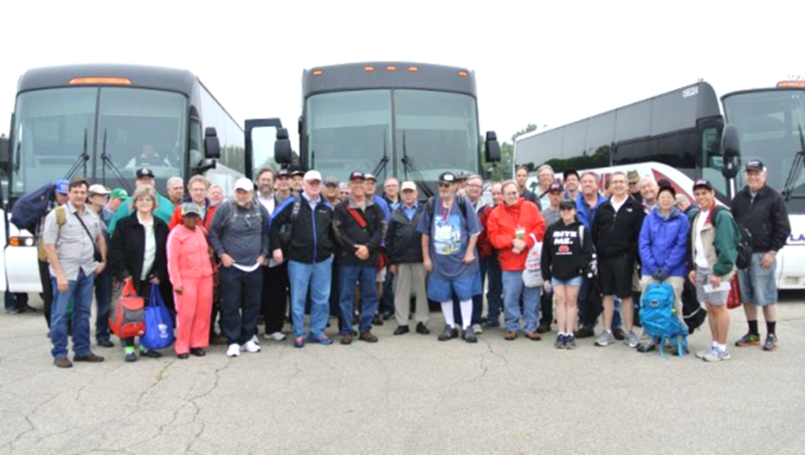

On board, you can stretch out, relax, take a nap, chat with other hams, and enjoy a light breakfast with coffee as the coach takes you directly to the country’s largest amateur radio event!

Thanks
ARROW & TMRA

W1AW to change digital mode

W1AW will change digital mode in Keplerian Data Transmission on Tuesday, March 31, 2026

Beginning with the 6:30 PM EDT (2230z) Keplerian data transmission on Tuesday, March 31, 2026, Hiram Percy Maxim Memorial Station W1AW will replace the second digital mode - BPSK31 - with MFSK16.

RTTY (Baudot) will continue to be the first digital mode used in the Keplerian data transmissions. The frequencies used by W1AW for all its digital transmissions remain the same.

The current W1AW operating schedule - complete with times and frequencies - can be found on the ARRL website at www.arrl.org/w1aw-operating-schedule. The online digital schedule will be updated on the day of the Keplerian data transmission mode change.

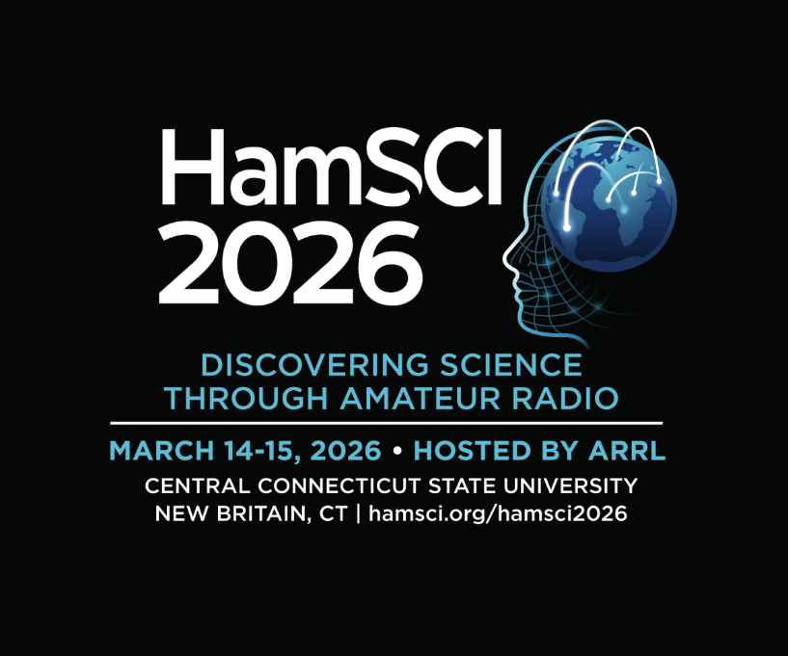

The 9th annual HamSci 2026 Workshop is March 14 - 15, 2026.

Registration ends March 3. The workshop will be hosted by ARRL at Central Connecticut State University in New Britain, Connecticut, and brings together radio amateurs and citizen scientists. Registrants will enjoy a private tour of nearby ARRL Headquarters. Check out the full agenda and registration details at hamsci.org/hamsci2026.

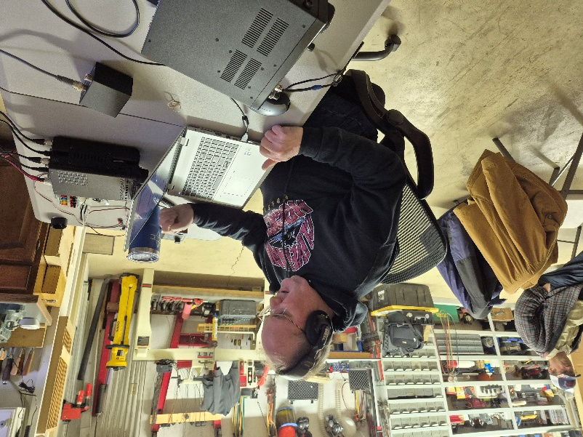
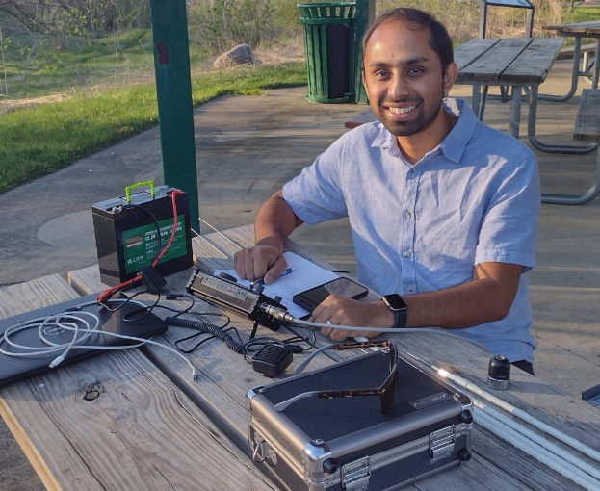
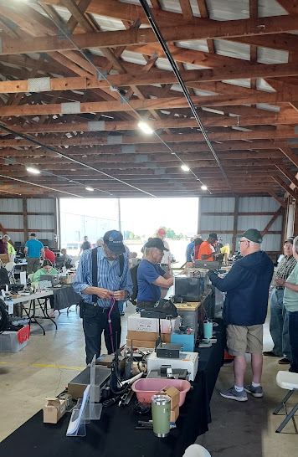
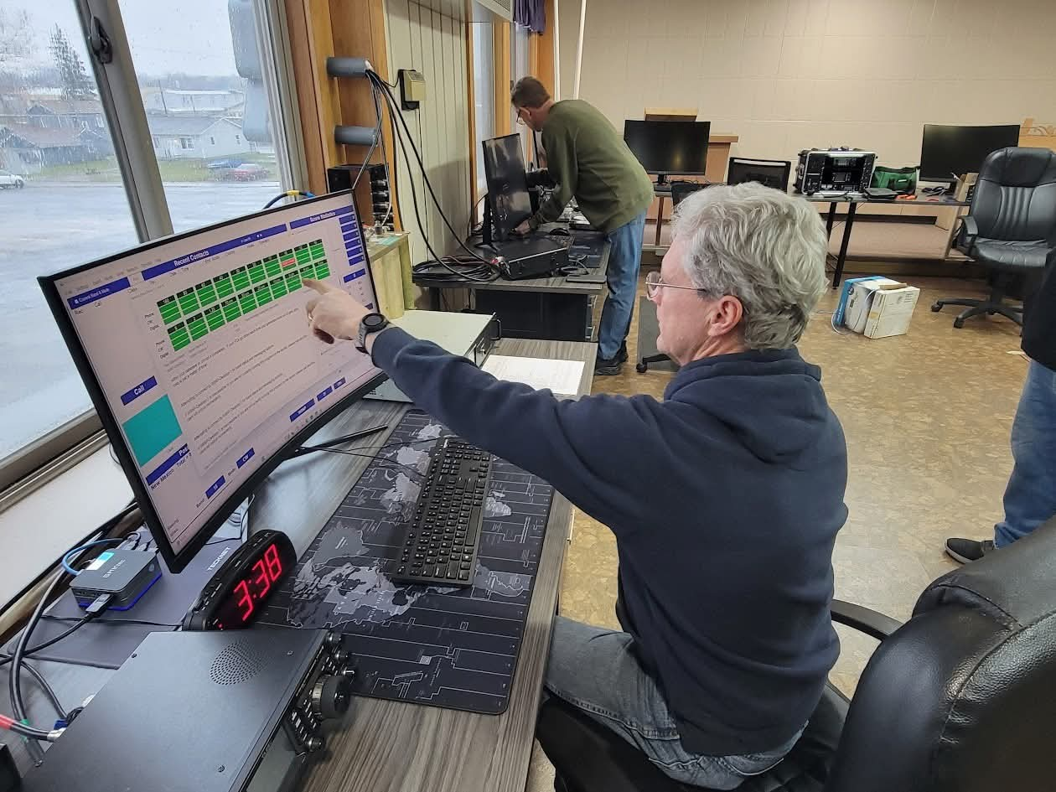
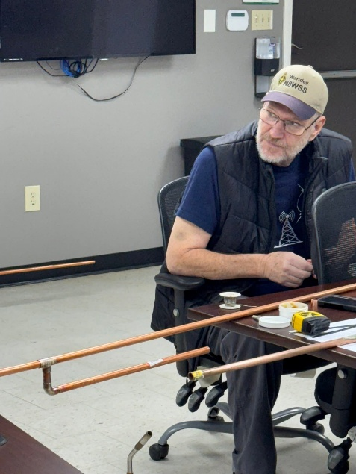

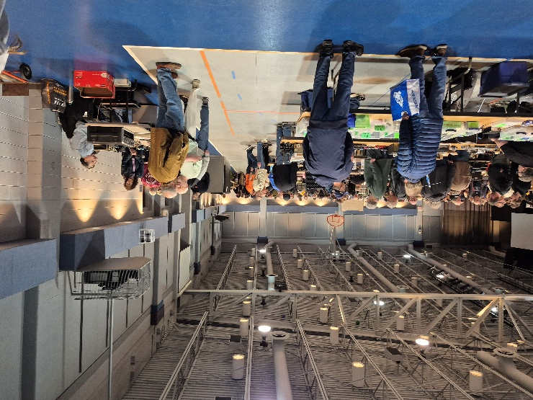

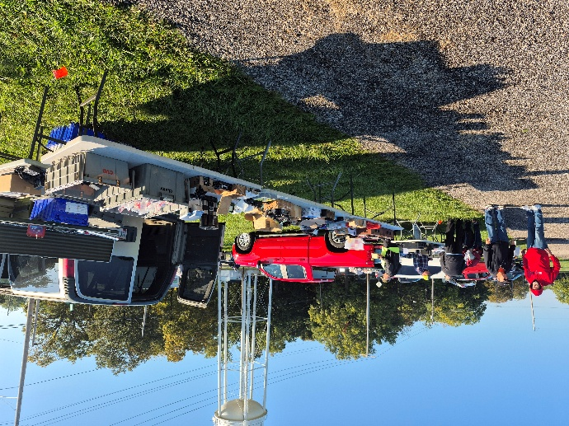

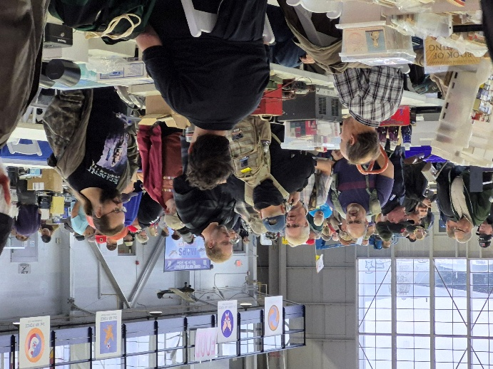

STOP!!!
You’ve come to the end…

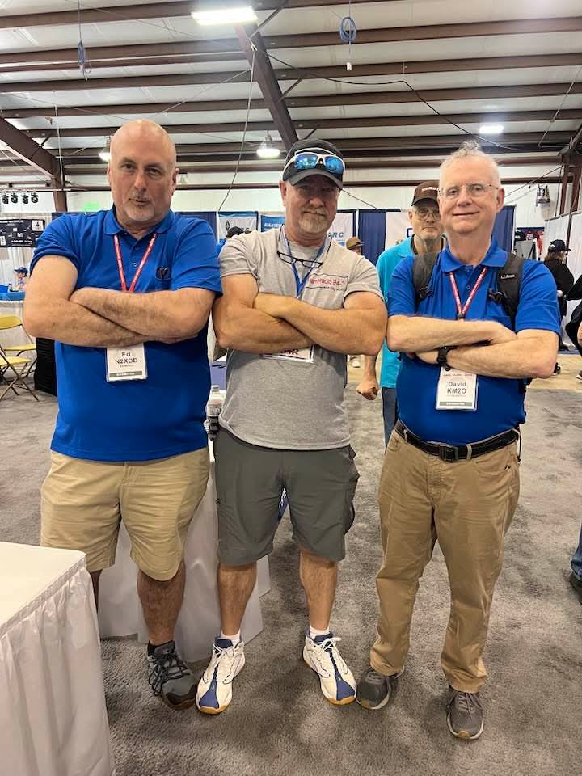

Be Radio-Active --- See Ya’ Soon!

Radio Waves serves as a window into the vibrant activities and many opportunities available within the Great Lakes Division. Through this publication, we aim to showcase the diverse events, achievements, and community spirit that define our division. It is my sincerest hope that you have found this edition both enjoyable and informative.

I encourage you to share your experience with Radio Waves by inviting your friends to join the ARRL and stay up to date with the latest news and information about both the ARRL and the Great Lakes Division. By being part of our community, you and your friends can stay connected to exciting developments and opportunities.

Throughout this newsletter, you will find a variety of photographs that provide a visual glimpse into our recent activities. Many of these images have been gathered from other newsletters, Facebook posts, or have been sent directly to me in the past few weeks. I invite you to take a close look at these snapshots—they reflect the energy and engagement of our division’s members.

“SMILE…
you might be featured in the Great Lakes Division News!!”

