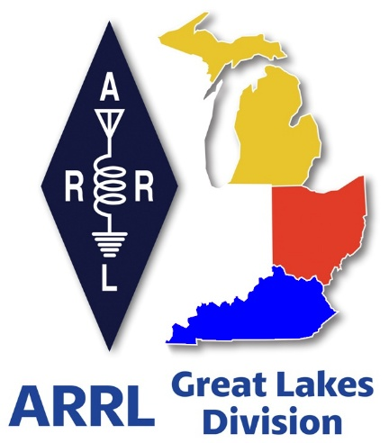
Radio Waves
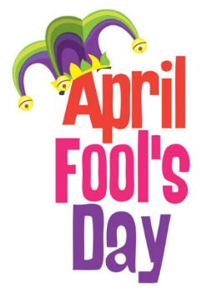
^{The} Great Lakes
Division
Monthly Journal
April 2026

Scott’s Stuff
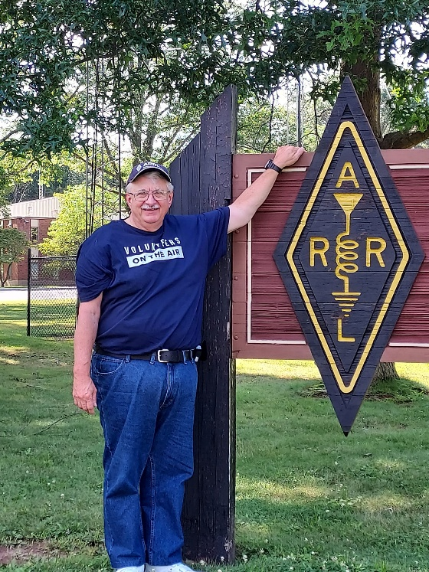

Hi Gang,

Happy April 1st! If you’re reading this and already suspecting a hidden punchline, you’re right. Today the universe has decided to throw a little mischief our way, and the first victim is, drum roll, please, the weather…!!

I stepped outside this morning expecting the usual “spring-ish” temperature swing, but instead, Mother Nature seemed to have signed up for a comedy improv class. One minute the sky was a soft pastel blue, the next a dramatic, overcast thunderhead rolled in as if auditioning for a dramatic soap-opera. I half-expected a flock of rubber ducks to start raining from the heavens.

Why the absurdity? Because spring has officially sprung, and with it, a parade of hamfests that would make any amateur-radio enthusiast’s heart skip a beat (or at least flicker like a well-tuned CW beacon).

I’ve been lucky enough to attend a bunch of them lately, and each one feels like a secret rendezvous where the only dress code is “casual nerd” and the free coffee is as strong as a 100-watt CW transmitter.

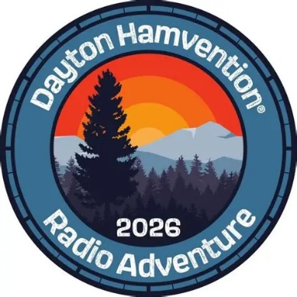
Dayton Hamvention:
I’ll admit, my excitement level has been trending upward like a perfectly tuned SSB signal on the 20-meter band. Have you gotten your tickets and rooms reserved for Hamvention yet? You know it’s just 45 days away, so you’d better get on the stick quickly, as room reservations are going fast! Yes, me, Roy and all the Great Lakes Division Section Managers are planning on being there as well. Make sure you stop by and say “Hey” to all of us.

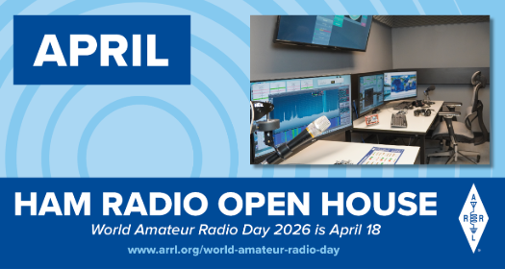
World Amateur Radio Day is coming up on Saturday, April 18th. Is your club doing any kind of special event or operating that day? If not, it’s not too late to put something together and have a blast doing it. Remember, World Amateur Radio Day is to celebrate all the contributions that amateurs have made to their communities and citizens around the world.

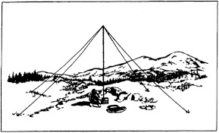
NVIS DAY IS COMING IN OHIO!
Saturday, April 25, 2026 10 A.M.–4 P.M.

April 25th marks another significant event in the Ohio Section, the Ohio NVIS Antenna Day. As you are aware, this day presents an opportunity for enthusiasts to gather and evaluate their antenna configurations.

Kicking off at 10:00 AM, this event is not a formal competition. Its primary objective is to simultaneously engage multiple counties in Ohio, testing their antennas and facilitating communications among them.

We anticipate that this gathering will provide an enjoyable platform for camaraderie, experimentation, and testing within our beloved hobby. W8SGT at the Ohio EMA will be active and monitoring the following (band conditions permitting)
- 3902
- 7240
- DMR ARES Talkgroup 31395
- 146.760/R PL 123 Columbus
Although the objective is to contact via HF, feel free to call in on DMR or VHF to help schedule your contact.

EXCHANGE
Please exchange the following:
- 6 digit Maidenhead Grid
- County
- Signal Report
- Indicate if you are an EOC station, or an ARES official (ASEC, DEC, EC, AEC)

Ever build a NVIS antenna before? Here a link to a video on that very topic NVIS Antenna Building

Field Day
Yup, it’s coming fast (June 27/28). Is your club making plans to have Field Day this year? If they are, don’t let them forget to get signed up on the Field Day locator http://www.arrl.org/field-day-locator

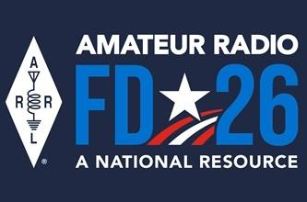
Hey, if you can, meet with your local government officials and ask them for a Proclamation for Amateur Radio that weekend. Most local governments will be happy to do this and don’t forget to invite the news media to be there as well. This is great PR for everyone, and you get extra points for your efforts too!

Amateur radio groups are encouraged to share a copy of their proclamations with ARRL via pr@arrl.org ARRL will often share these proclamations to advance legislative efforts, creating additional support of awareness for amateur radio among lawmakers.

Hey club leaders
Do you have your meetings hybrid (ie... Zoom, Teams, Go-To-Meeting) as well as in-person? Doing a hybrid meeting does take a little extra effort on the club’s part, but for those who don’t travel well at night, or just can’t make the meeting because of distance, this is really a great thing for them. Yes, it’s a little more work for whomever sets the equipment up, but it means so much to those who just could not attend the meeting any other way. It also opens the door for acquiring new members too.

Yes, I have been told by a few club leaders that they have actually seen an uptick in membership from people outside of their area/state since starting their hybrid meetings.
Having hybrid meetings also opens doors for a whole new world of programs and guest speakers for your club as well! You might consider one of the great recorded webinars that are listed in the ARRL Learning Center or even a live presentation from a guest that’s hundreds or thousands of miles away.
Hybrid meetings doesn’t mean that you don’t show up in person when you can. It’s more for those who just can’t attend but would really like to. There are many great recorded webinars out there from folks all over the world that are informative and fun. Most of these webinars are around 30 minutes or so, which is just the right amount of time. Remember the posterior rule... “The brain can only absorb with what the butt can withstand!”

Ok… I hope that you get on the bands and just go crazy!!! There’s so much to enjoy on the bands, so, get Radio-Active, but above all, regardless of your preferred mode or band, remember the golden rules of our incredible hobby: Have FUN, be respectful and most importantly, be Radio Active!

73, Scott…

Scott Yonally, N8SY
Director - Great Lakes Division
n8sy@n8sy.com

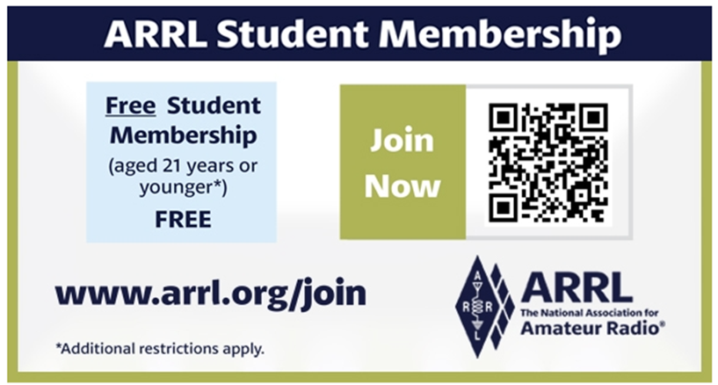

Do you know someone who is not getting this newsletter

Hi Gang,
If you know someone who isn’t already getting Radio Waves, have them sign up to receive it!! They don’t have to be ARRL members to sign up, just click on the button below and in no time, they will start receiving it.



Update on Letter Writing Campaign
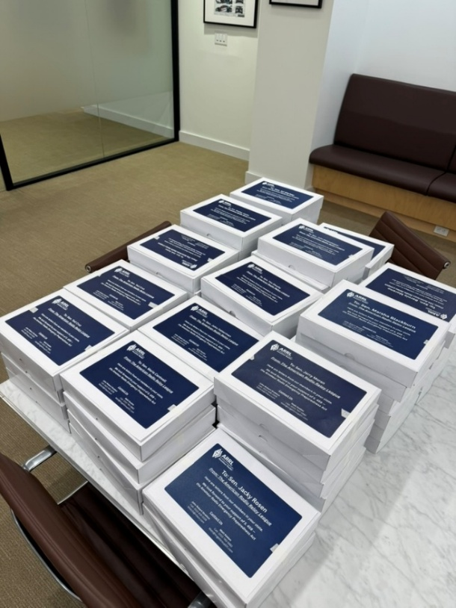

Pictured are 27,776 letters addressed to the 13 Democrat and 15 Republican members of the Senate Commerce Committee. Each of these boxes contains 500 letters.

Senator Wicker stated that he would deliver our letters to the Senate Committee Members before there is a broader distribution.

It is our understanding that his office made the deliveries this past week.
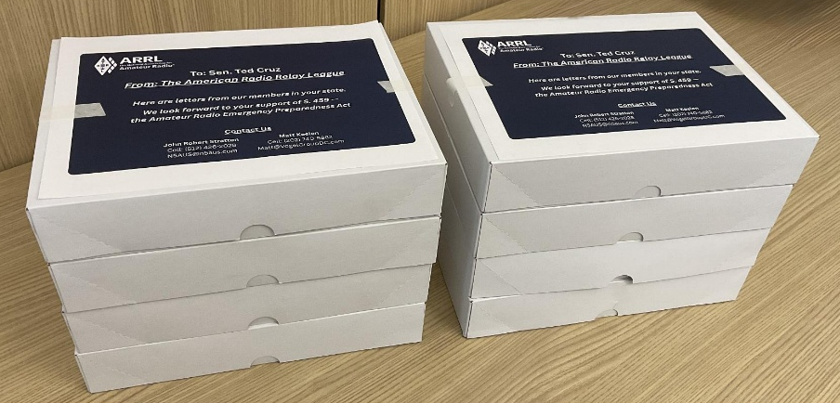
This is a close up of the 4,011 letters just for Senator Cruz to illustrate the labeling used on each box of letters that were delivered.

The other way to quantify the letters to Cruz is that the delivery to him represents 16" of letters.

The number of letters in this distribution ranged from a low of 129 for Sen. Lummis (Wyoming) to Sen. Cruz's 4,011.

Handbook Give Away – Have you entered yet???

How’s about I give away an ARRL softcover Handbook absolutely FREE !!!

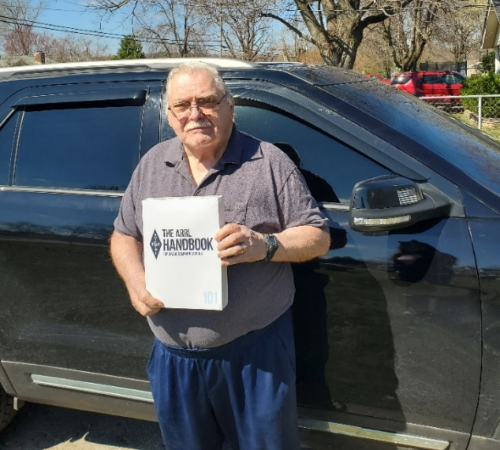

Yes, I’m holding a little contest to "GIVE AWAY" an ARRL softcover Handbook. Why you ask? It’s to get you to check-in to the Great Lakes Division website and take a look around.

Getting signed up is just as simple as filling out a couple of quick questions and you’re entered!!

>> Click Here To Enter <<

2026 Great Lakes Division Hamfests

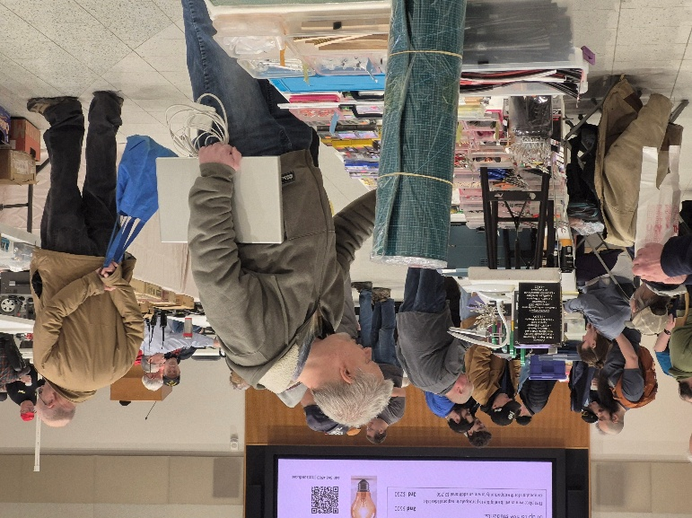
Here in the Great Lakes Division, we have over 50 hamfests a year.

So, if you haven’t started planning your hamfest schedule yet, you really need to start now.

Please post this listing in your club's newsletter and announce the swaps on your local nets.

Let's fully support all of our hamfests in every way possible. It means success for everyone. Be sure to invite your ARRL Officials as soon as your date is set.

If you are planning on having your hamfest listed in QST please be sure to start your planning well in advance of your Hamfest date, as this allows adequate time for QST Listings. QST announcements require a 3-month lead time.
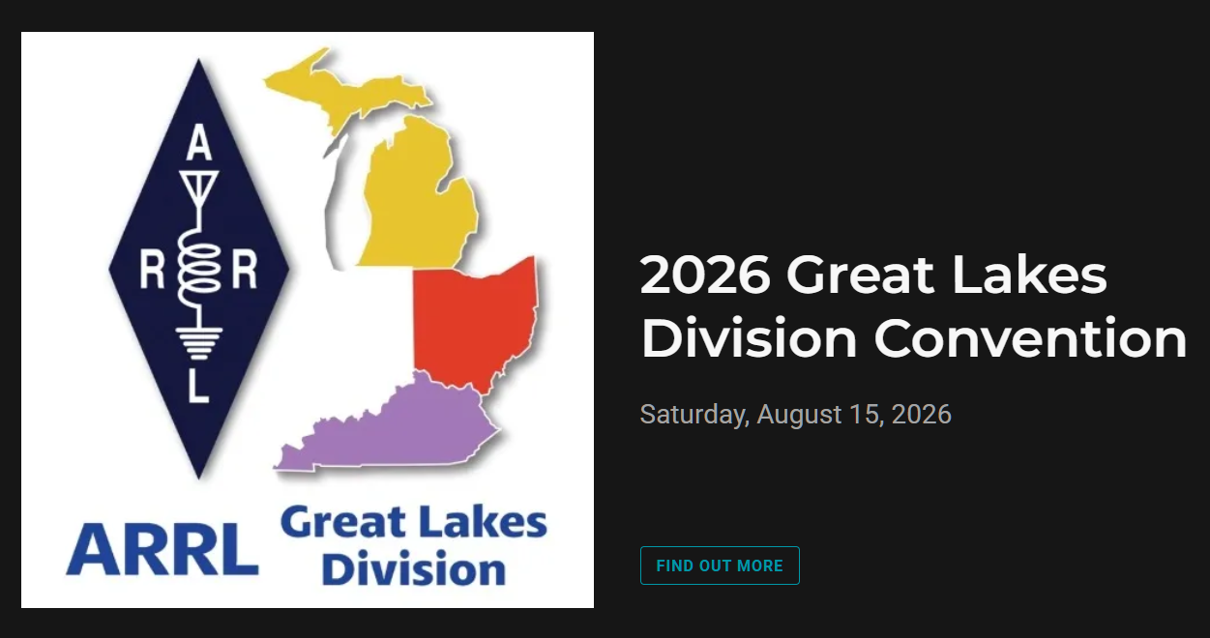
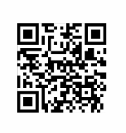
04/11/2026 - AC8RC Mini-Swap  Location: Burnips, MI  Sponsor: AC8RC  Website: http://ac8rc.org  Learn More | 04/11/2026 - Cuyahoga Falls Amateur Radio Club 70th Hamfest  Location: Cuyahoga Falls, OH  Sponsor: Cuyahoga Falls Amateur Radio Club, Inc.  Website: https://www.cfarc-hamfest.org  Learn More
04/18/2026 - SJCARC Hamfest  Location: Centreville, MI  Sponsor: SJCMIARC  Learn More | 04/25/2026 - Tusco Amateur Radio Club's 2026 Hamfest, Computer & Electronics Show  Location: Dover, OH  Sponsor: Tusco Amateur Radio Club W8ZX  Website: http://www.w8zx.net/hamfest  Learn More
04/26/2026 - Athens Hamfest  Location: Athens, OH  Sponsor: Athens County Amateur Radio Association  Website: http://ac-ara.org  Learn More | 05/02/2026 - Crossroads Hamfest  Location: Marshall , MI  Sponsor: Southern Michigan Amateur Radio Society  Website: http://www.w8df.com  Learn More
05/02/2026 - Lucas County ARES Hamfest  Location: Toledo, OH  Sponsor: Lucas County Amateur Radio Emergency Service, Inc.  Website: http://WWW.LUCASARES.ORG  Learn More | 05/02/2026 - Wexaukee ARC Swap & Shop  Location: Cadillac, MI  Sponsor: Wexaukee Amateur Radio Club  Website: http://wexaukeearc.org  Learn More

05/09/2026 - General Motors ARC Swap Meet  Location: Shelby Township, MI  Sponsor: General Motors Amateur Radio Club  Website: http://gmarc.org  Learn More | 05/14/2026 - 05/17/2026  Four Days In May  Location: Fairborn, OH  Sponsor: QRP Amateur Radio Club International  Website: http://qrparci.org/fdim  Learn More
05/15/2026 - 05/17/2026  Dayton Hamvention  Location: Xenia , OH  Sponsor: Dayton Amateur Radio Association  Website: www.hamvention.com  Learn More | 06/05/2026 - 06/06/2026  LARS 2026 Yooper Hamfest  Location: Newberry, MI  Sponsor: Luce County Amateur Radio Society  Website: http://w8nby.org  Learn More

You can always find the latest information about upcoming hamfests on the Great Lakes Division website.

Just click to get the latest hamfest updates.

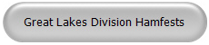

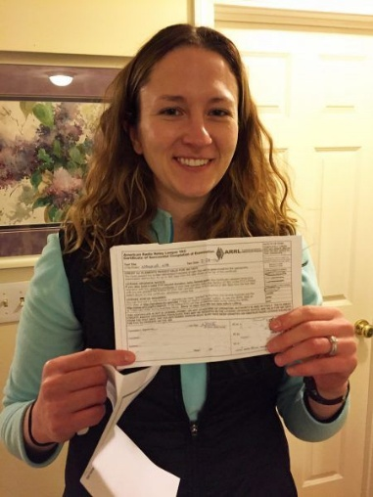
ARRL VEC Youth License Test Fee Only $5!

Youth examinees under age 18, you can earn your initial Technician license or upgrade your current license through the ARRL VEC Volunteer Examiner Coordinator program for only $5.
The ARRL Youth Licensing Grant Program covers the one-time $35 application fee for new license candidates younger than 18-years old for tests administered under the ARRL VEC program. The $35 FCC application fee will be reimbursed after the ARRL VEC receives the completed reimbursement form and the new license has been issued by the FCC. The reimbursement check will be mailed to the fee payer.
Additionally, candidates younger than 18-years old pay a reduced exam fee of $5 to the ARRL VEC VE team at the time of the exam. The $5 fee is for all candidates under the age of 18 regardless of the exam level taken. Proof of under 18 status is required at the session (what to bring to an exam session).

Club Links

I’ve received a number of new requests from clubs to be listed on the “Links” club page.
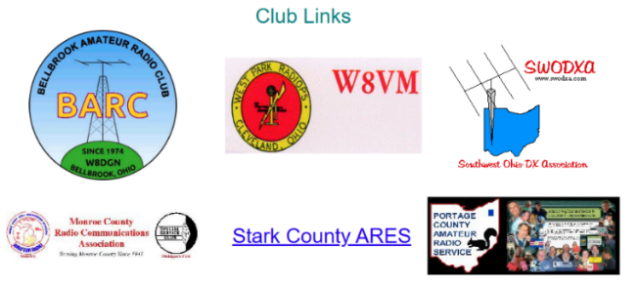

Is your club listed? If not, send the URL of your club website to me n8sy@n8sy.com and I’ll get it listed.


New Survey – GLD-12

There is a new survey posted GLD-12 and it is on the website and waiting for input from you. I really would like to hear your feedback.

Please take just a couple of minutes of your time and take the survey.

Got a question that you think should be asked? Let me know… n8sy@n8sy.com

“On The Air Live” Offers Learning Opportunities for ARRL Members

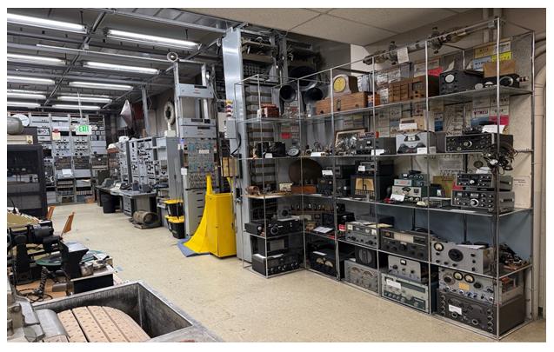
“On The Air Live” offers hams the opportunity to receive instructional content each month from ARRL Education Specialist Wayne Greene, KB4DSF. Wayne provides a monthly topic that is related to various capabilities, practices, and abilities within amateur radio. “My goal is to inspire ham radio operators to try something new or try different approaches to enhance their ham radio experience,” says Greene. “In the past year, we have covered topics including how to use your HT, a deep dive into APRS, how to send and receive SSTV images, and how to use your ham radio privileges to keep in contact with family and loved ones outside of a disaster area where you may be at that moment.”

“On the Air Live” airs on the ARRL Learning Center website, learn.arrl.org, on the fourth Tuesday of each month at 8 PM eastern.

Get your club together like the Metrocrest Amateur Radio Society in Argyle, Texas, did and take a photo to send to QST. Each 2026 issue of QST will include club group photos. Get all the details at www.arrl.org/year-of-the-club.

Start Planning for ARRL Field Day 2026
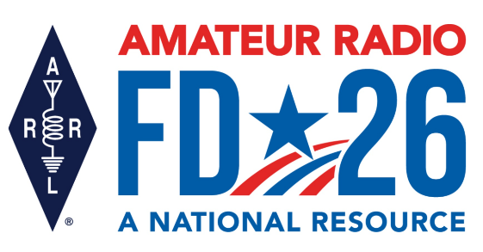
It’s not too early to gear up and get ready for ARRL Field Day! Field Day 2026 takes place June 27 – 28 and will bring together more than 30,000 amateur radio operators for one of the most popular on-the-air events in the US and Canada.

This year’s Field Day theme is “Amateur Radio: A National Resource.” Combined with the ARRL Year of the Club, it provides the perfect opportunity for radio clubs to set up stations in public places to demonstrate ham radio's science, skill, and service to our communities and our nation.

All of the information you need to get started can be found on the Field Day web page, including how to join the ARRL Field Day Facebook Group, where you can share your plans, tips, and tricks for a successful Field Day.

The overall objective for Field Day is to contact as many stations as possible on the 160-, 80-, 40-, 20-,15- and 10-meter HF bands, as well as all bands above 50 MHz, and to learn to operate in less than optimal conditions. Many clubs choose to set up in camp-style fashion with portable equipment, temporary antennas, and off-grid power sources.

Field Day is open to all amateurs in the areas covered by the ARRL/RAC Field Organizations and countries within IARU Region 2 (North and South America). DX stations residing in other regions may be contacted for credit, but are not eligible to submit entries. Each claimed contact must include contemporaneous direct initiation by the operator on both sides of the contact. Initiation of a contact may be either locally or by remote.

Also check out the Field Day site locator page to help find participating stations near you. As an added incentive for anyone participating in ARRL’s yearlong America250 Worked All States (WAS) Award, contacts made with ARRL Affiliated Radio Clubs all year, including during Field Day, will count toward your America250 WAS Affiliated Club Endorsement. Check out those details at www.arrl.org/america250-was.

For more information about ARRL Field Day, visit www.arrl.org/field-day.

Bus to Dayton Hamvention

The ARROW Communications Association and the Toledo Mobile Radio Association (TMRA) are proud to sponsor a motor coach trip to the Hamvention 2026 in Dayton, Ohio. This one-day trip leaves early in the morning on May 16, 2026 and returns the same day after Hamvention closes for the day at 5:00 p.m. The bus has two pickup spots, in Ann Arbor and in Toledo (Rossford). Please join us!

Tickets are $95 per person January 1st 2026 – April 17th 2026
$110 per person April 18th 2026 – May 15th 2026
Please note that this does not include the Hamvention ticket, which you need to purchase separately.

To Register and see full Details visit: https://w8rp.org/daytonbus2026/

There are two pickup/drop off locations on May 16th, 2026
Ann Arbor – 601 W Stadium Blvd, Ann Arbor, MI – Departing 4:30 am
Toledo – 727 Lime City Rd. Rossford, OH – Departing 5:30 am
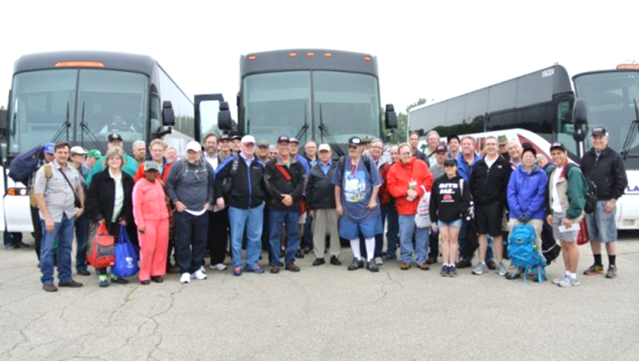

On board, you can stretch out, relax, take a nap, chat with other hams, and enjoy a light breakfast with coffee as the coach takes you directly to the country’s largest amateur radio event!

Thanks
ARROW & TMRA

Shots from around the Division
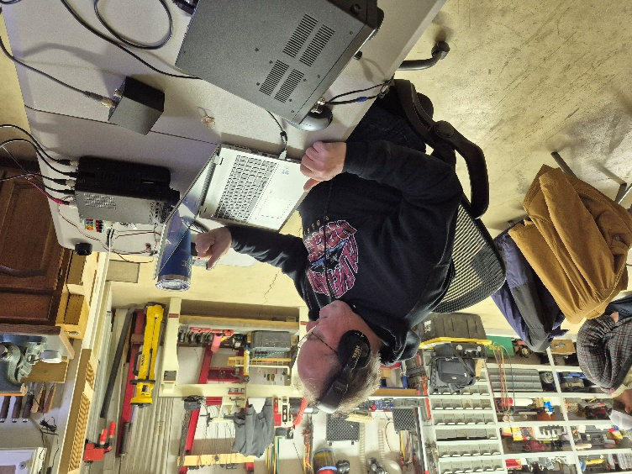
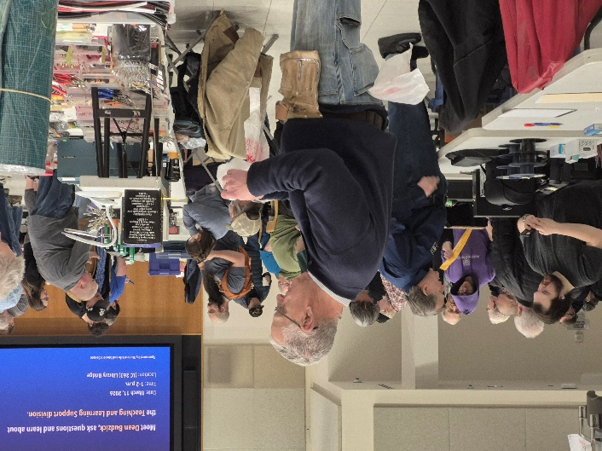
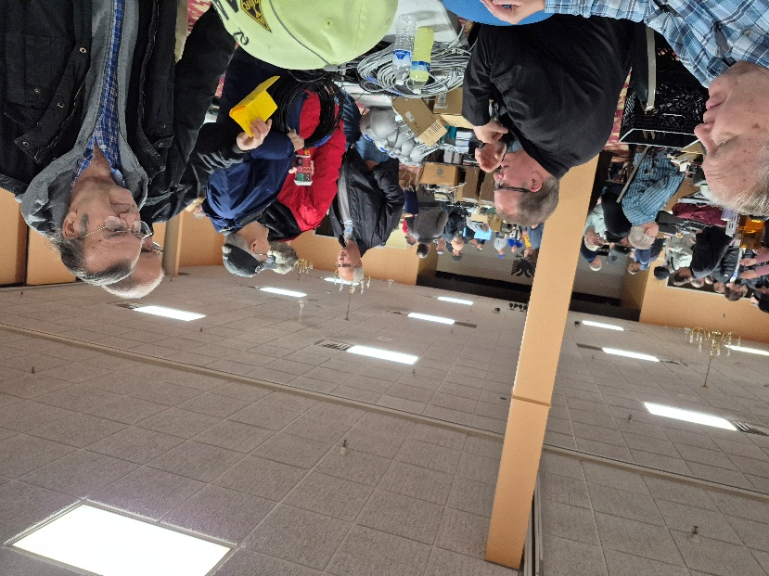
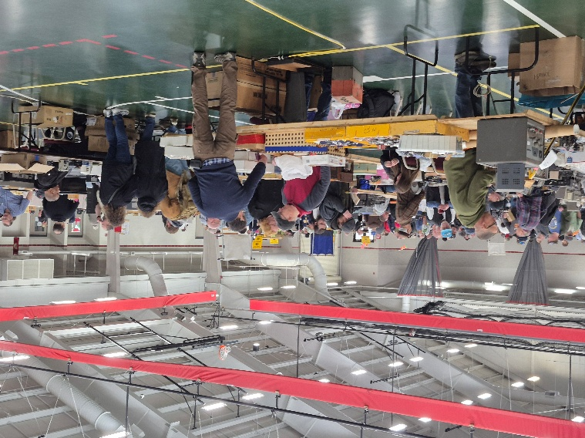
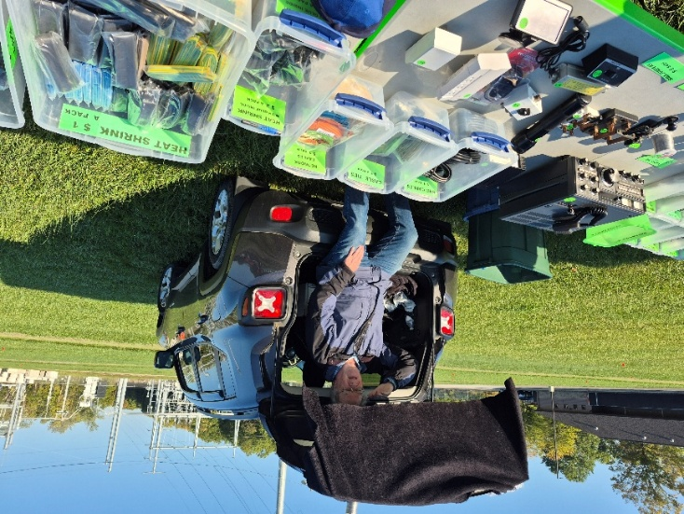
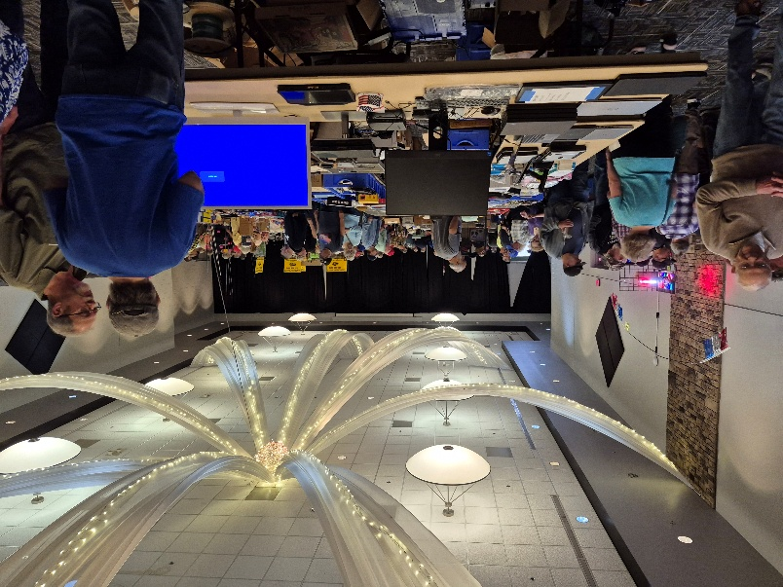

STOP!!!
You’ve come to the end…

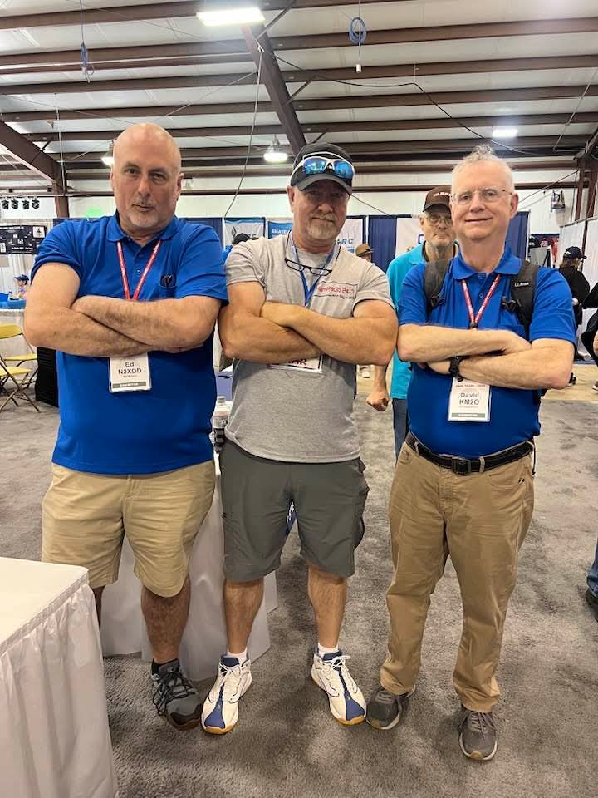

Be Radio-Active --- See Ya’ Soon!

Radio Waves serves as a window into the vibrant activities and many opportunities available within the Great Lakes Division. Through this publication, we aim to showcase the diverse events, achievements, and community spirit that define our division. It is my sincerest hope that you have found this edition both enjoyable and informative.

I encourage you to share your experience with Radio Waves by inviting your friends to join the ARRL and stay up to date with the latest news and information about both the ARRL and the Great Lakes Division. By being part of our community, you and your friends can stay connected to exciting developments and opportunities.

Throughout this newsletter, you will find a variety of photographs that provide a visual glimpse into our division’s recent activities. Many of these images I have taken, gathered from other newsletters, Facebook posts, or have been sent directly to me in the past few weeks. I invite you to take a close look at these snapshots—they reflect the energy and engagement of our division’s members.

“SMILE…
YOU just might be featured in the Great Lakes Division News!!”

