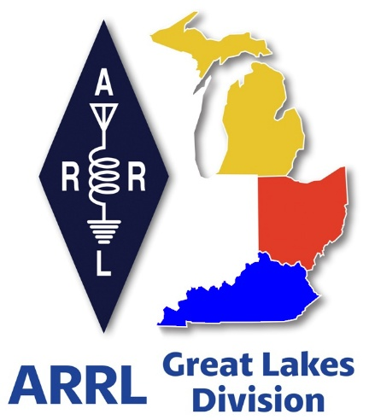
Radio Waves ^{The} Great Lakes Division
Special Report

What’s Inside

Scott’s Stuff 2
Register Now for the 2026 ARRL Youth Rally at Dayton Hamvention® 3
NVIS DAY IS COMING IN OHIO! 4
Field Day 5
Handbook Give Away – Have you entered yet??? 6
2026 ARRL Field Day Merch Now Shipping 7
Bus to Dayton Hamvention 8
Great Lakes Division Hamfests 9
Amateur Television Friday Night Dinner 11
This & That’s 11

Scott’s Stuff
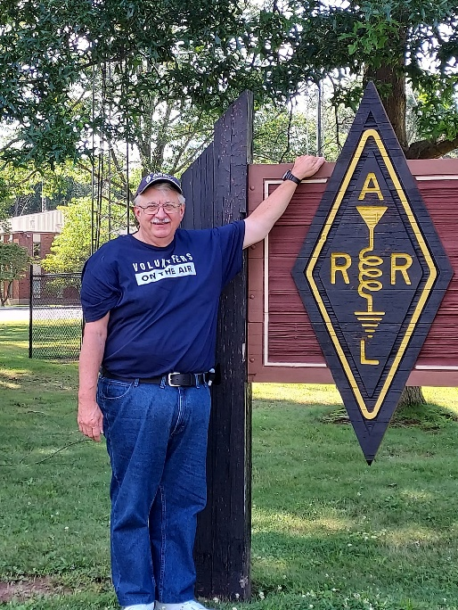

Hi Gang,

BREAKING: My Self-Control Has Officially Left the Building
I had a plan. I really did. I had a perfectly curated content calendar, a sophisticated strategy for end-of-month engagement, and a mental promise to myself that I would be the picture of professional composure.

But then, something happened. And let’s just say, my restraint has officially packed its bags, taken a vacation, and left me holding the bag of secrets.

I’m breaking protocol. I’m ignoring the "best practices" handbook. I’m currently sweating through my shirt because I simply cannot—I repeat, cannot—wait until the end of the month to tell you what’s going on. If I keep this inside for another three weeks, I’m fairly certain my head will spontaneously combust, and frankly, that’s a mess I don't want to clean up.

Usually, I’m the type of person who saves the dessert for last. I’m the person who lets the movie build tension before the big reveal. But right now? I’m the person eating the entire cake in the parking lot of the grocery store with a plastic fork.

So, what is it?

I know, I know—the "suspense" is supposed to be part of the marketing magic. But have you ever tried to keep a secret when you’re this excited? It’s like trying to hold a beach ball underwater. It just keeps popping up and hitting you in the face.

I’ve reached a point where waiting feels dishonest. You deserve to know now. You deserve to be in on the chaos now. If I wait until the end of the month, I’ll have aged six years from the stress of holding back, and nobody wants to look at a blog post written by a person who has aged six years in three weeks.

Consider this your formal warning: The dam has broken. The flood gates are open. Please forgive my lack of decorum, my abandonment of the calendar, and the sheer, unadulterated enthusiasm currently leaking from my keyboard.

Stick around. It’s about to get weird, it’s about to get loud, and it’s definitely happening way sooner than I promised.

Stay tuned. Or don't—I’m probably going to tell you anyway.

So, what is it?

This is a special report… I just can’t hold off on this information until the end of the month.

73, Scott…

Scott Yonally, N8SY
Director - Great Lakes Division
n8sy@n8sy.com

Register Now for the 2026 ARRL Youth Rally at Dayton Hamvention®

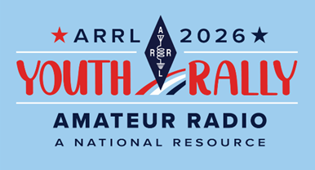
Get ready for amateur radio’s biggest annual gathering! Dayton Hamvention® 2026 is
May 15 – 17 at the Greene County Fair and Expo Center in Xenia, Ohio.

Among the activities taking place is the
ARRL Youth Rally, returning on Saturday, May 16. The rally is designed for students ages 11 to 21 and offers a great opportunity to connect with other young hams. Youth Rally activities will be led by ARRL Director of Education and Learning Steve Goodgame, K5ATA, and volunteers from the ARRL Collegiate Amateur Radio Program (CARP).

Advance registration is recommended. While Hamvention admission is already free for students (high school and younger), the $20 Youth Rally registration fee includes a T-shirt (to be worn on Saturday), badge and lanyard, reusable tote bag, and a complimentary three-day Hamvention admission ticket (Friday through Sunday).

Students will enjoy an afternoon of hands-on activities, learning, and fun. Highlights include satellite communications, a short sprint contest, a fox hunt, and a chance to make contact with a parachute-mobile station. Attendees are encouraged to bring a 2-meter handheld radio if you have one.

The Youth Rally will be followed by the ARRL Collegiate Amateur Radio Meetup.
For more information about the Youth Rally and registration, and to find other ARRL activities and exhibits at Hamvention, visit www.arrl.org/dayton-hamvention-2026. For Hamvention information and general admission tickets, visit hamvention.org.

ARRL Youth Rally Registration https://pci.jotform.com/form/260975827202158
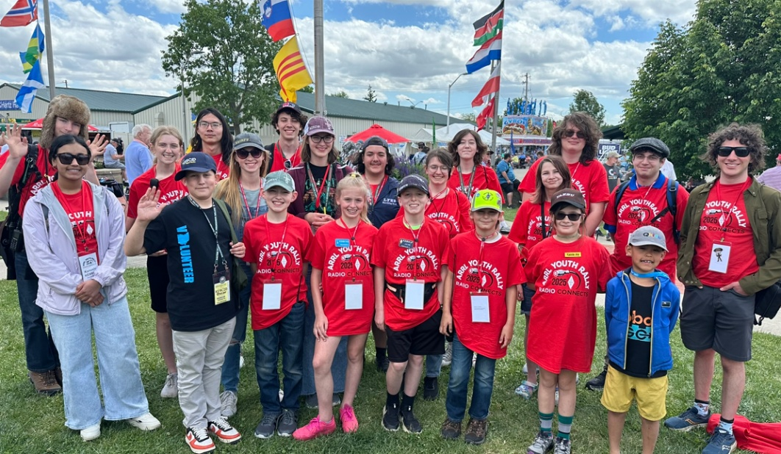

Photo from 2025 ARRL Youth Rally. Caption:
ARRL Youth Rally participants at 2025 Dayton
Hamvention®. [Bob Inderbitzen, NQ1R, photo]

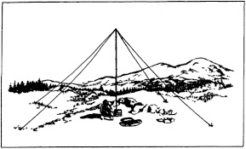
NVIS DAY IS COMING IN OHIO!
Saturday, April 25, 2026 10 A.M.–4 P.M.

April 25th marks another significant event in the Ohio Section, the Ohio NVIS Antenna Day. As you are aware, this day presents an opportunity for enthusiasts to gather and evaluate their antenna configurations.

Kicking off at 10:00 AM, this event is not a formal competition. Its primary objective is to simultaneously engage multiple counties in Ohio, testing their antennas and facilitating communications among them.

We anticipate that this gathering will provide an enjoyable platform for camaraderie, experimentation, and testing within our beloved hobby. W8SGT at the Ohio EMA will be active and monitoring the following (band conditions permitting)
- 3902
- 7240
- DMR ARES Talkgroup 31395
- 146.760/R PL 123 Columbus
Although the objective is to contact via HF, feel free to call in on DMR or VHF to help schedule your contact.

EXCHANGE
Please exchange the following:
- 6 digit Maidenhead Grid
- County
- Signal Report
- Indicate if you are an EOC station, or an ARES official (ASEC, DEC, EC, AEC)

Ever build a NVIS antenna before? Here a link to a video on that very topic NVIS Antenna Building

Field Day
Yup, it’s coming fast (June 27/28). Is your club making plans to have Field Day this year? If they are, don’t let them forget to get signed up on the Field Day locator http://www.arrl.org/field-day-locator

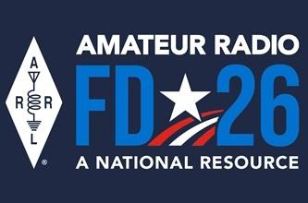
Hey, if you can, meet with your local government officials and ask them for a Proclamation for Amateur Radio that weekend. Most local governments will be happy to do this and don’t forget to invite the news media to be there as well. This is great PR for everyone, and you get extra points for your efforts too!

Amateur radio groups are encouraged to share a copy of their proclamations with ARRL via pr@arrl.org ARRL will often share these proclamations to advance legislative efforts, creating additional support of awareness for amateur radio among lawmakers.

Ok… I hope that you get on the bands and just go crazy!!! There’s so much to enjoy on the bands, so, get Radio-Active, but above all, regardless of your preferred mode or band, remember the golden rules of our incredible hobby: Have FUN, be respectful and most importantly, be Radio Active!

Handbook Give Away – Have you entered yet???

How’s about I give away an ARRL softcover Handbook absolutely FREE !!!
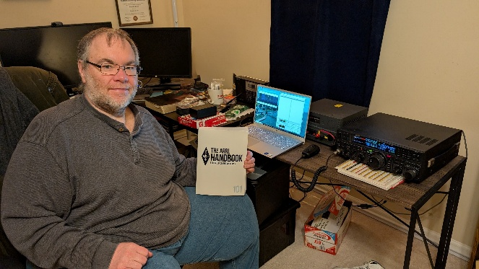

Yes, I’m holding a little contest to "GIVE AWAY" an ARRL softcover Handbook. Why you ask? It’s to get you to check-in to the Great Lakes Division website and take a look around.

Getting signed up is just as simple as filling out a couple of quick questions and you’re entered!!

>> Click Here To Enter <<

Field Day 2026: Webinar Promoting ARRL Field Day | Thursday, Apr 23

Attention Public Information Coordinators and Public Information Officers! The 2026 ARRL Field Day is June 27 – 28, and it's already time to begin planning to promote amateur radio's number one annual demonstration. This year is special, because ARRL has partnered with America250, making this year’s Field Day theme, Amateur Radio: A National Resource.

Back by popular demand: Members of the ARRL Public Relations Committee have organized Zoom meetings to provide training, tips, and best practices to help you in your role to promote ARRL Field Day. These meetings are intended for ARRL Public Information Officers, Public Information Coordinators, and other ARRL Section volunteers. Before attending these meetings, please review the resources available at www.arrl.org/FieldDay, and prepare any questions you may have.

Register now! Use the following links to register for the session you want to attend. After registering, you’ll receive a confirmation email containing information about joining the meeting.

Thursday, April 23, 2026 — Best Practices & Tips for Promoting Field Day (choose a time)
6:30 PM Eastern Time (US and Canada)

us06web.zoom.us/meeting/register/wXvAoz-AQJ2_SO3vRpZ21w

9:30 PM Eastern Time (US and Canada) us06web.zoom.us/meeting/register/FIHWN5gdSQ2SgJTX9jGbqw

2026 ARRL Field Day Merch Now Shipping

Field Day is approaching fast...and so is the 4th of July! Stock up on official 2026 ARRL Field Day merchandise and own a piece of history with this year’s patriotic red, white, and blue design honoring America’s 250th anniversary.

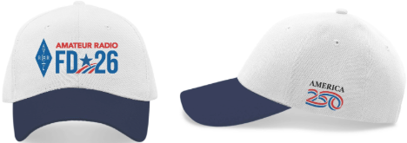

This year’s theme, “Amateur Radio: A National Resource,” highlights the vital role ham radio plays in public service, emergency communications, and connecting communities. Whether you plan to operate as a group, with a friend, or simply visit a local site—there’s no better time to get ready.

The 2026 Field Day collection is now shipping and includes t-shirts, hats, mugs, pins, patches, stickers, notebooks, banners, recruitment posters, and more. The t-shirt lists ARRL and RAC sections on the back—a fun way to track contacts. Comfortable, durable, and unisex, it’s ideal for both Field Day and Fourth of July celebrations.

Be among the first to shop the collection at www.arrl.org/shop and celebrate Field Day in style. The America 250 word mark and logo are trademarks of the U.S. Semiquincentennial Commission and are used under license.

Bus to Dayton Hamvention

The ARROW Communication Association and the Toledo Mobile Radio Association (TMRA) are proud to sponsor a motor coach trip to the Hamvention 2026 in Dayton, Ohio. This one-day trip leaves early in the morning on May 16th and returns the same day after Hamvention closes for the day at 5:00 p.m. The bus has two pickup spots, in Ann Arbor and in Toledo (Rossford). Please join us!

Tickets are $95 per person January 1st 2026 – April 17th
$110 per person April 18th 2026 – May 15th
Please note that this does not include the Hamvention ticket, which you need to purchase separately. To Register and see full Details visit: https://w8rp.org/daytonbus2026/
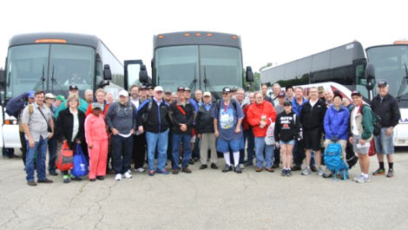

There are two pickup/drop off locations on May 16th
Ann Arbor – 601 W Stadium Blvd, Ann Arbor, MI – Departing 4:30 am
Toledo – 727 Lime City Rd. Rossford, OH – Departing 5:30 am

On board, you can stretch out, relax, take a nap, chat with other hams, and enjoy a light breakfast with coffee as the coach takes you directly to the country’s largest amateur radio event!

Thanks - ARROW & TMRA

Great Lakes Division Hamfests
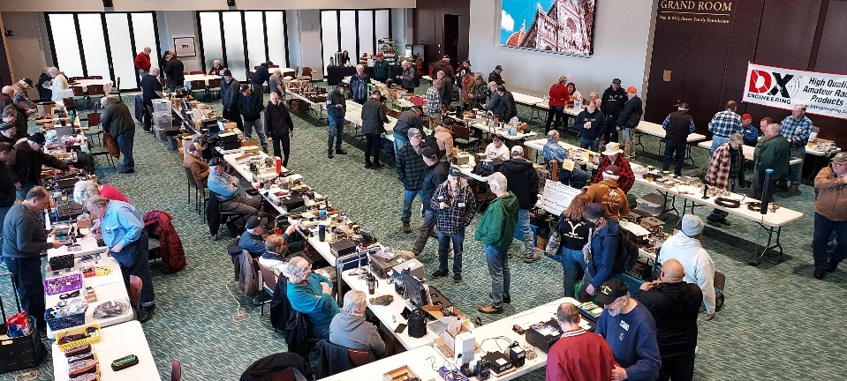
Here in the Great Lakes Division, we have over 50 hamfests a year. So, if you haven’t started planning your hamfest schedule yet, you really need to start now.

Let's fully support all of our hamfests in every way possible. It means success for everyone. Be sure to invite your ARRL Officials as soon as your date is set.
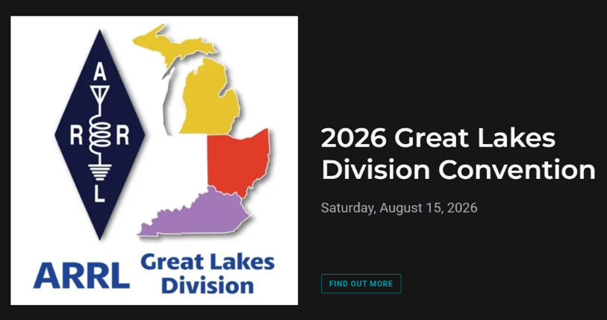

If you are planning on having your hamfest listed in QST please be sure to start your planning well in advance of your Hamfest date, as this allows adequate time for QST Listings. QST announcements require a 3-month lead time.

04/25/2026 - Tusco Amateur Radio Club's 2026 Hamfest, Computer & Electronics Show  Location: Dover, OH  Type: ARRL Hamfest  Sponsor: Tusco Amateur Radio Club W8ZX  Website: http://www.w8zx.net/hamfest  Learn More | 04/26/2026 - Athens Hamfest  Location: Athens, OH  Type: ARRL Hamfest  Sponsor: Athens County Amateur Radio Association  Website: http://ac-ara.org  Learn More
05/02/2026 - Crossroads Hamfest  Location: Marshall , MI  Type: ARRL Hamfest  Sponsor: Southern Michigan Amateur Radio Society  Website: http://www.w8df.com  Learn More | 05/02/2026 - Lucas County ARES Hamfest  Location: Toledo, OH  Type: ARRL Hamfest  Sponsor: Lucas County Amateur Radio Emergency Service, Inc.  Website: http://WWW.LUCASARES.ORG  Learn More
05/02/2026 - Wexaukee ARC Swap & Shop  Location: Cadillac, MI  Type: ARRL Hamfest  Sponsor: Wexaukee Amateur Radio Club  Website: http://wexaukeearc.org  Learn More | 05/09/2026 - General Motors ARC Swap Meet  Location: Shelby Township, MI  Type: ARRL Hamfest  Sponsor: General Motors Amateur Radio Club  Website: http://gmarc.org  Learn More
05/14/2026 - 05/17/2026  Four Days In May  Location: Fairborn, OH  Type: ARRL Convention  Sponsor: QRP Amateur Radio Club International  Website: http://qrparci.org/fdim  Learn More | 05/15/2026 - 05/17/2026  Dayton Hamvention  Location: Xenia , OH  Type: non-ARRL Hamfest  Sponsor: Dayton Amateur Radio Association  Website: www.hamvention.com  Learn More
06/05/2026 - 06/06/2026  LARS 2026 Yooper Hamfest  Location: Newberry, MI  Type: ARRL Hamfest  Sponsor: Luce County Amateur Radio Society  Website: http://w8nby.org  Learn More | 06/06/2026 - FCARC SummerFest  Location: Delta, OH  Type: ARRL Hamfest  Sponsor: Fulton County Amateur Radio Club  Website: https://k8bxq.org/hamfest  Learn More
06/06/2026 - IRA Hamfest  Location: Hudsonville, MI  Type: ARRL Hamfest  Sponsor: Independent Repeater Association  Website: https://w8ira.org/hudsonville-hamfest/  Learn More | 06/20/2026 - Midland Amateur Radio Club Swap  Location: Midland, MI  Type: ARRL Hamfest  Sponsor: Midland Amateur Radio Club Inc  Website: http://www.w8kea.org  Learn More

You can always find the latest information about upcoming hamfests on the Great Lakes Division website.
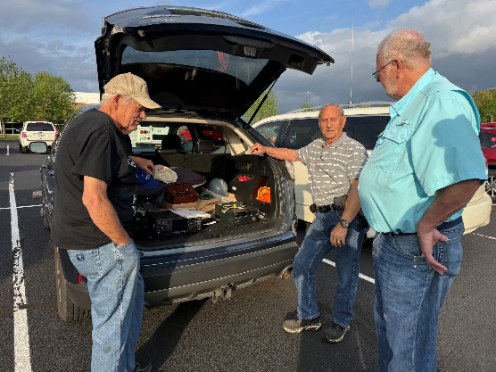

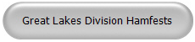

Just click to get the latest hamfest updates.

Amateur Television Friday Night Dinner

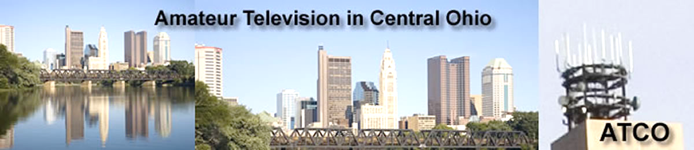
Amateur Television Friday Night dinner.

The ATV Friday Night Dinner will be on Friday May 15 at 6:30 PM at the China Garden Buffet Restaurant (937-781-9999), 112 Woodman Drive, Dayton, Ohio 45431 (Airway Shopping Center). The all you can eat Buffet Dinner is ~ $15.00 We will have dinner and then ATV presentations concluding at 9 PM. All are invited. Door prizes will be awarded.

This & That’s
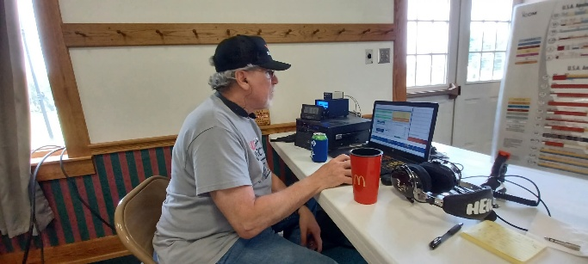
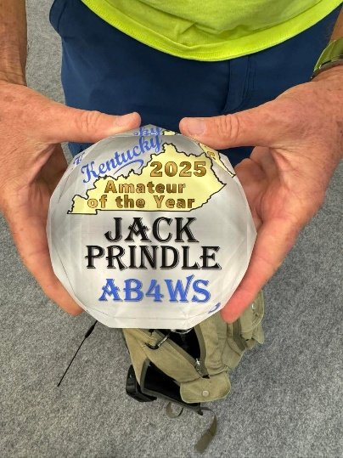
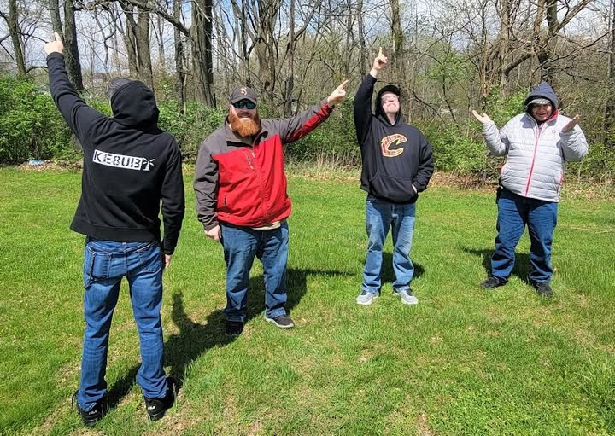
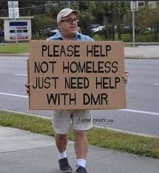

STOP – Right there!!!
We’ve come to the end…

Be Radio-Active --- See Ya’ Soon!
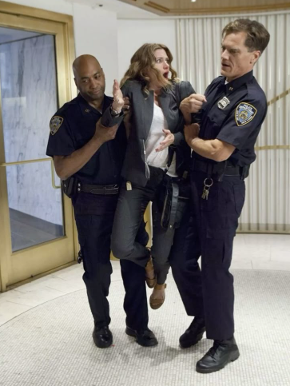

Radio Waves is produced as a look inside of the Great Lakes Division and all that it has to offer. It is our sincerest hope that you have enjoyed this edition and will encourage your friends to be a part of the ARRL and receive the latest news and information about the ARRL and the Great Lakes Division!

The pictures throughout this newsletter are from various newsletters, Facebook posts and/or were sent directly to me in recent weeks. Take a good look at them, you just might be in one of the pictures! “SMILE… you might just be in the Great Lakes Division News!!”

