
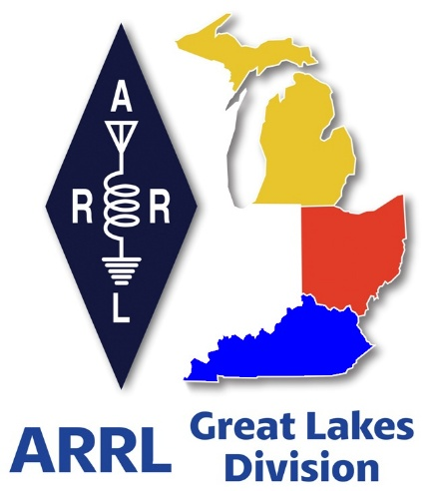
Radio Waves ^{The} Great Lakes Division
Mid- Month Report
April

What’s Inside

From the Michigan Section Manager 2
From the Ohio Section Manager 6
From the Kentucky Section Manager 8
W1AW/8 Activation 9
Do you know someone who is not getting this newsletter 11
Scott’s Stuff 11
Handbook Give Away – Have you entered yet??? 15
2026 ARRL Field Day Merch Now Shipping 15
Murphy’s Law… 16
Bus to Dayton Hamvention 17
Great Lakes Division Hamfests 18
GLD – 12 Survey Results 20
Amateur Television Friday Night Dinner 23
This & That’s 24

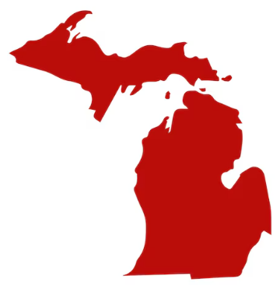
From the Michigan Section Manager
Ralph Katz, AA8RK
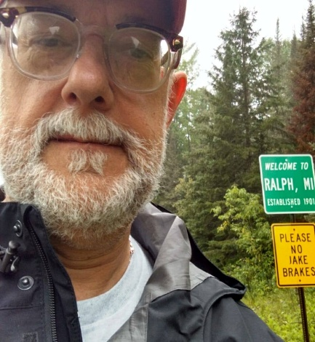

Time flies like nothing and here is my 4th monthly write-up. In the last month, I attended the Lowell ARC & Lowell AR
Youth Club Hamfest, and the Allegan Mini-Swap in Burnips. The North Ottawa Amateur Radio Club in Ferrysburg.
graciously invited me to speak at their monthly meeting. Please reach out if you want me to speak to your club.

Hoping you were able to contact the Bouvet Island Dxpedition 3Y0K while they were operating.

Snow and ice storms of March 13-16 played havoc with things in the great state of Michigan. 50- to 60-mph wind gusts that accompanied the snow made accurate depth measurement difficult, but newspapers reported:
- 87% of homes in Roscommon County were without electric power after the storm.
- 52 inches of snow over 48 hours near Round Lake in Luce County
- 48.5 inches at Cusino Lake in Schoolcraft County
- 42.5 inches in an Alger County location
- 45 inches of snow in 48 hours, two miles south of Herman, in L'Anse Township
- 37.6 inches at the NWS office in Negaunee Township, Marquette County
- 33.5 inches in Escanaba
Logan Johnson KD8VRD, President of Copper Country Radio Amateur Association and Secretary of the Houghton County Fire Department, reported a few inches of snow (not the three feet that was predicted), some wind, and “it got cold”. Their regular nets operated, including the Skywarn net on Friday night, and continued to Saturday and Sunday as well.

Nelson Ogden W8NWO of the Charlevoix, Cheboygan and Emmet Counties Public Service Communication Organization (CCECPSCO) reports that their response was the longest single Skywarn event in their history. CCECPSCO, Traverse Bay Amateur Radio Group (TBARG), and many other Auxcomm-affiliated and Skywarn-affiliated volunteers cooperated to form a network of spotter stations across District 7 and District 8 in the Northern Lower and Eastern Upper Peninsula of Michigan.”

Nelson's full report is attached separately. >> Click Here for Report <<

Section News
Do you have experience developing web pages? The section needs a new webpage and with that we also need a Webmaster. Please contact me if you have experience and are willing to volunteer.

We could also make good use of Assistant Section Managers in the northern Lower Peninsula (north of Midland), and in the Upper Peninsula. Please contact me if you want to know more, or have someone you could recommend.

Club News
==> The Livingston Amateur Radio Klub (LARK – W8LRK) summer Ham Camp is scheduled for Sunday June 14 through Tuesday June 16, although as always, some people will come in on Saturday and/or leave on Thursday. This will be held at Proud Lake Recreation Area near Wixom. You will need to either have a Michigan State Recreation Pass or buy a daily entry fee to enter the park. Wine Tasting will be Monday night, and the Pancake Breakfast will be Tuesday morning. You will most likely need to reserve a campsite in advance. Contact Mark Torigian K8MST or Rich Barker W8VS about which campsites they will be using or for other information.

==> The 3rd ANNUAL Michigan POTA Meetup will be at Hartwick Pines State Park Saturday June 6. This stunning park (US-1503) just north of Grayling has one of only two stands of old growth trees in the state. More information is here: https://www.michiganpotameetup.com/

==> The Livingston ARK will be running special event stations as K8M in Forts Mackinac and Michilimackinac from Wednesday September 16 to Sunday September 20, 2026. Schedules in respective parks are not yet set. Contact Mark Torigian W8MST or Russ Kozakov W8UKY for more information.

Michigan QSO Party
Once again, the Michigan QSO Party, sponsored by the Mad River Radio Club, is on Saturday, April 18, 2026, from 1200 EDT (noon in Detroit, MI / 16Z Saturday UTC) to 2400 EDT (midnight in Detroit, MI / 04Z Sunday UTC).

The stated object of this event is (from their website):
"For amateurs outside the state of Michigan to make contact with as many Michigan stations as possible. Non-Michigan stations may work only Michigan stations, while Michigan stations may contact anyone."

Full information can be found here: https://miqp.org/

You can receive e-mail updates for this event by applying for membership in a groups.io list here (you must be logged in to Groups.io using the e-mail address you wish to be enrolled):
https://groups.io/g/MIQP
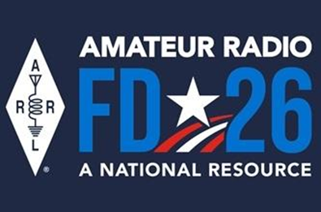
Field Day
Here is the ARRL's most recent newsletter article on Field Day 2026, which is fast approaching:

Start Planning for ARRL Field Day 2026

This year’s Field Day theme is “Amateur Radio: A National Resource.” Combined with the ARRL Year of the Club, it provides the perfect opportunity for radio clubs to set up stations in public places to demonstrate ham radio's science, skill, and service to our communities and our nation.

All of the information you need to get started can be found on the Field Day web page, including how to join the ARRL Field Day Facebook Group, where you can share your plans, tips, and tricks for a successful Field Day.

The overall objective for Field Day is to contact as many stations as possible on the 160-, 80-, 40-, 20-,15- and 10-meter HF bands, as well as all bands above 50 MHz, and to learn to operate in less than optimal conditions. Many clubs choose to set up in camp-style fashion with portable equipment, temporary antennas, and off-grid power sources.

Field Day is open to all amateurs in the areas covered by the ARRL/RAC Field Organizations and countries within IARU Region 2 (North and South America). DX stations residing in other regions may be contacted for credit, but are not eligible to submit entries. Each claimed contact must include contemporaneous direct initiation by the operator on both sides of the
contact. Initiation of a contact may be either locally or by remote.

Also check out the Field Day site locator page to help find participating stations near you.\\
As an added incentive for anyone participating in ARRL’s yearlong America250 Worked All States (WAS) Award, contacts made with ARRL Affiliated Radio Clubs all year, including during Field Day, will count toward your America250 WAS Affiliated Club Endorsement. Check out those details at www.arrl.org/america250-was. For more information about ARRL Field Day, visit www.arrl.org/field-day

Numbers Game
Did you know that there are roughly 20,500 active Amateur Radio licenses in Michigan?
This breaks down to 124 Novices, 9491 Technicians, 5372 Generals, 818 Advanced, and 4673
Extras. I will not dispute these numbers, which are from here: https://www.arrl.org/fcc-license-counts The ARRL has <1400?> members in Michigan, or about <7%?> of licensees. This could be better. What can we do to improve this?

<blah blah blah>
My side-note: I am just a little bit sad, for no good reason, whenever an Advanced class licensee tests up to Extra. Can't explain this. [Numbers are as of February 11, 2026.]

Fly on the Wall
As countries come and go, the requirements of the Honor Roll have to change. So, it is predictable that OM's will argue that their HR is better than someone who got theirs last week. For example: “You slobs didn't get 348 countries and I did.” “I got Upper Volta and you didn't.” Etc. Does this mean that we need different levels of Honor Roll? Does this designation need to be qualified by date?

The Southern Michigan Amateur Radio Team (SMART) repeater in Pontiac used to have a reputation for equal opportunity insulting, so he thin-skinned hams were warned about throwing out their callsigns.

One of the SMART denizens called me a “paper extra” for not passing 20wpm, so I responded that I was a 13wpm General. “Oh,” he said. “I guess you aren't completely worthless.” “Great,” I thought, “I have just been praised via faint damnation.” [FYI this may contain unattributed quotes from people Smarter than me, or not.]
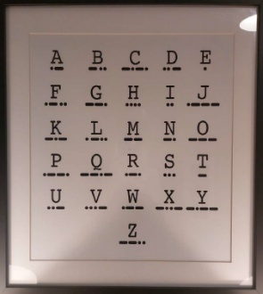

Good Grief
My brother Louis W0IT saw this in a hotel in Seattle:

Wish I had more photos this month – please send them to me.

As always: Do you have ideas and/or want to help? Have something to brag about? Or just want to kvetch? Please contact
me. It is my honor to serve you.

73,
Ralph Katz AA8RK
Ann Arbor, MI
arrl.mi.section.manager@gmail.com
aa8rk@arrl.org


From the Ohio Section Manager
Bret Stemen, KD8SCL
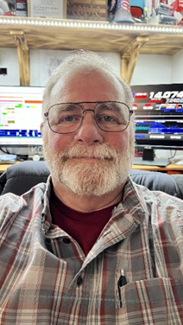

Spring has Sprung

Hamfests are currently underway. I will be attending the Cuyahoga Falls Amateur Radio Club 70th Hamfest and the Tusco Amateur Radio Club's 2026 Hamfest this month and look forward to the opportunity to engage in face-to-face conversations with many of the attendees. I am going to attend as many hamfests that I will be able to attend this year. I will be present at Dayton once again, assisting with the Great Lakes Division booth as well as the ARRL ARES Booth.


Yes, spring has sprung and Mother Nature has been teasing us the last few weeks. As they say, “April showers bring may flowers”. I for one am ready for the warmer weather so I can get outside and get some antenna work done. But with some of the windy conditions we’ve had, I don’t want to try to lower my folder-over mast.
With spring here, the State of Ohio has already had a few tornados hit us. Do you monitor severe weather? Many of us have smart phone and are able to download weather apps. How many weather apps do you have to get alerts?

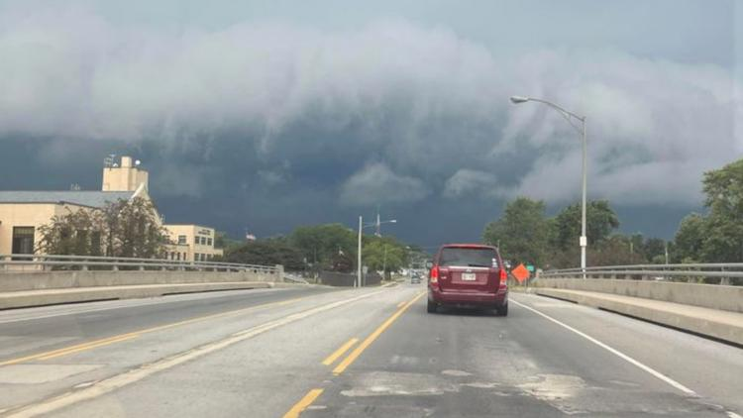
I personally prefer using the iNWS- Interactive NWS (iNWS Mobile Alerting) which is a website that you can sign up for text and email alerts for your area. https://inws.ncep.noaa.gov

It’s easy to sign up for and I highly recommend it. Of course, I also have other weather apps that I also get alerts from on my phone, there are free apps as well as paid apps.
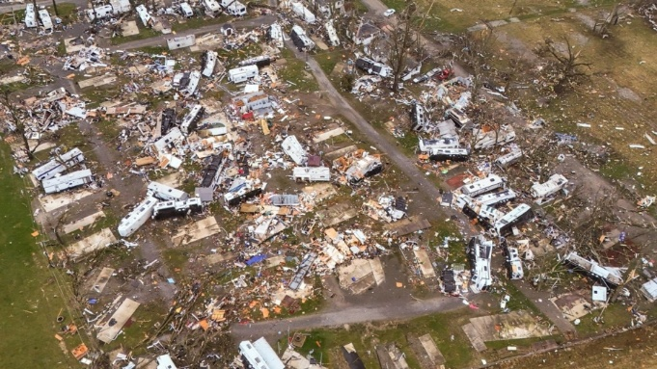
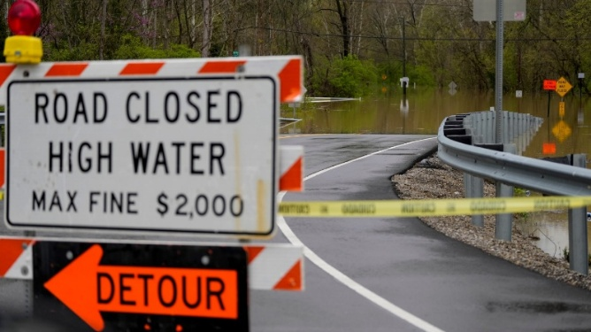

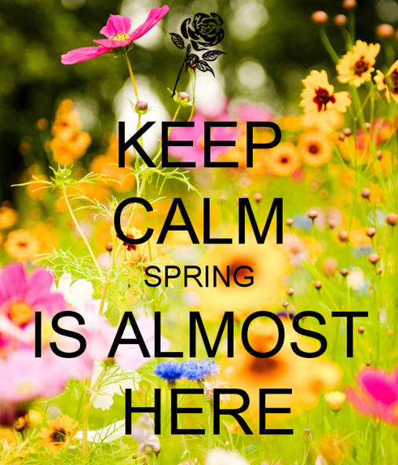
We need to stay vigilant during these severe storms and track them as they move across the state when they occur. You can even check into your local severe weather net for local updates as the storms move through your area if your county has one, this may also be an opportunity to start your local club net if necessary to pass any information along. Please be sure to check on your neighbors, family and friends before and after the storms.

The latest edition of the Ohio Section Journal is now online and ready for you to read! There’s an awful lot of Ham Radio activities going on in the Ohio Section, so get off the chair or couch you’re sitting on and get out there, get involved, and get on the air!
The links below will take you directly to the newsletter. Both are also available directly from the Ohio Section Website

www.arrl-ohio.org https://arrl-ohio.org/wp-content/uploads/2026/04/OSJ_April_2026.pdf
73,

Bret, KD8SCL
Ohio Section Manager
KD8SCL@ARRL.ORG

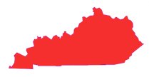
From the Kentucky Section Manager
Bob Selbrede, K6ZZ

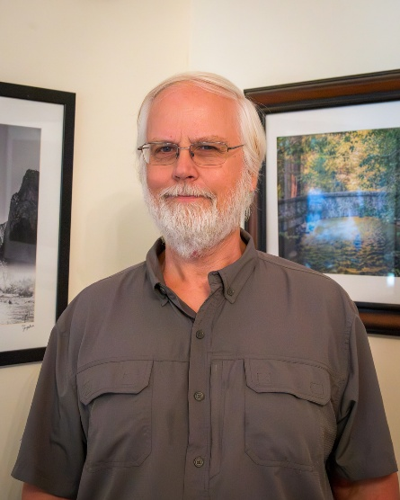
Hi Folks,

I hope everyone is enjoying Spring so far!

Kentucky was well represented as W1AW/4 the week of 18-24 March. Roughly 4,000 QSO's were logged by operators from seven different ARRL Affiliated Clubs here in Kentucky. Not too bad! Mark your calendars for the second Kentucky operating week of 9-15 September. Operation will be limited to ARRL Affiliated Clubs this week as well. Thank you to Affiliated CLub Coordinator Steve, W4NHO, for organizing activities for the Kentucky Section.

On the subject of Affiliated Clubs, make sure your club is keeping its information current on the ARRL website. Many emails to club POC's go unanswered due to outdated contact info. This can result in missed opportunities and missed important information. Check the status of your Club using this link: https://www.arrl.org/find-a-club Check to be sure that the primary POC listed is still correct and that the contact information is correct. If it is not correct, please take action to correct it.

Speaking of Club activities, congratulations to the Amateur Radio Community Services Club of Paintsville, KY. The club received recognition from Floyd County Judge Executive Paul Burchett for providing support during the winter storms this past January. Nice Work! A picture and nice write-up appears in the Paintsville Herald. You can access it here:

https://www.paintsvilleherald.com/news/amateur-radio-club-members-recognized-for-help-during-winter-storm/article_3779e3ae-3d86-4ce9-a68d-6c0055142b03.html

I am pleased to announce that there is a new website available for sharing Kentucky ARES information. Please check out https://www.kyares.org and let us know what you think. This is a work-in-progress, so please let the webmaster know if you spot anything that needs to be corrected, missing information, or anything you think should be added to make this a better resource for ARES members in Kentucky. This website will be replacing the www.kyham.info website. There will also be a companion website geared toward "what's happening in Kentucky". This website will hold information of general interest to hams in Kentucky, not just ARES. More on this resource in the next update.

Lastly, a new Kentucky Ham Radio discussion channel has been created on Discord. So far over 100 Kentucky hams have signed up. If you are interested in giving it a try, here is an invitation link: https://discord.gg/J9BXVZaRG5

Hopefully you find these new tools useful. A big thank you to Luke Schwartz, KR4KOS, for making this a reality!

Hope to see many of you at Hamvention in Xenia Ohio on 15-17 May. I'll be at the ARRL booth so stop by and say hello!

73 for now...

Bob, K6ZZ
Kentucky Section Manager
K6ZZ@ARRL.ORG

W1AW/8 Activation

I would like to personally invite your club to participate in this Statewide activity. There are two ways:
- As a club activity under a club call sign, coordinating club members in the operation
  - Use the application form tiny.cc/w1aw8-app
    - Enter Club Callsign and Name
    - Also include name, phone number and email for the person coordinating & scheduling the operations
- As individual operators under their personal call signs
Please consider adding the article below to your club newsletter, website, Facebook page, emails and other channels.

If you have any questions, please contact me at k8zt73@gmail or 330-650-1110 (voice only landline, no text)
---------------------------------------------------------
W1AW/8 Activation ARRL Ohio Section May & August 2026
tiny.cc/w1aw8-info

Ohio operators will have two opportunities to activate W1AW/8 as part of the year-long ARRL USA-250 operations.
- 05/6/2026- Starts 00:01 UTC Wed, May 6th to 23:59 Tues, May 12th
(EST- 7 PM Tues, May 5th to 7 PM Tues, May 12th)
- 08/12/2026- Starts 00:01 UTC Wed, Aug 12th to 23:59 Tues, Aug 18th
(EDT- 8 PM Tues, Aug 11th to 8 PM Tues Aug 18th)
For additional information on ARRL America250 WAS, visit- www.arrl.org/america250-was.

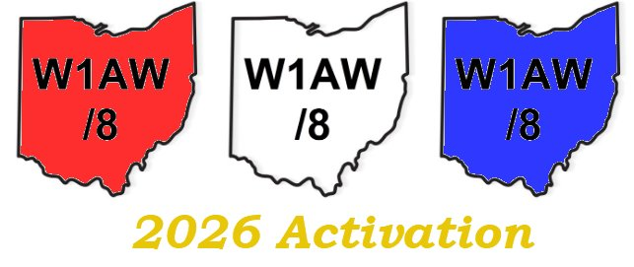
The W1AW/8 activation will take place on 2200 Meters LF through all of HF (excluding 60 Meters) and VHF/UHF using CW, Phone and Digital (FT8/FT4, RTTY, etc.) modes.

If you would like to operate using the special callsign, you must meet a few guidelines and agree to follow a few rules:
- Currently valid FCC Amateur Radio license
- Operate from within the state of Ohio
- Agree to:
  - Follow all US Amateur Radio rules and licensing class restrictions (operate only on frequencies and modes allowed by YOUR LICENSE)
  - Follow the Radio Amateur’s Code and the Considerate Operator’s Guide and other accepted Amateur Radio Etiquette. Remember, you are representing the ARRL and the Ohio Section
  - Accurately log all contacts using computer logging software
  - Export an ADIF file of all contacts and submit it via email to Anthony Luscre, K8ZT (k8zt73@gmail.com)

Note- you do not need to be an ARRL official/volunteer to activate W1AW/8.

If you meet the above requirements, you can apply for time slots by submitting an online form- tiny.cc/w1aw8-app. If accepted, you will receive a confirmation email. Later, you will receive complete operating information and access to an online schedule of time slots. A pre-event training session will be held via Zoom, and if needed, assistance will be provided on setting up computer logging software.
If you are interested in making contacts with W1AW/8 Ohio during the week, an online schedule will be available before and during the event. “2026 May- W1AW/8 Ohio- Web Schedule” - at tiny.cc/w1aw8 is a publicly available, view-only listing of scheduled operations.

Do you know someone who is not getting this newsletter

Hi Gang,

If you know someone who isn’t already getting Radio Waves, have them sign up to receive it!! They don’t have to be ARRL members to sign up, just click on the button below and in no time, they will start receiving it.

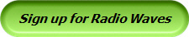

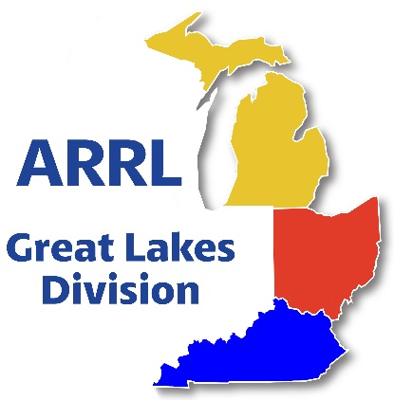
Scott’s Stuff
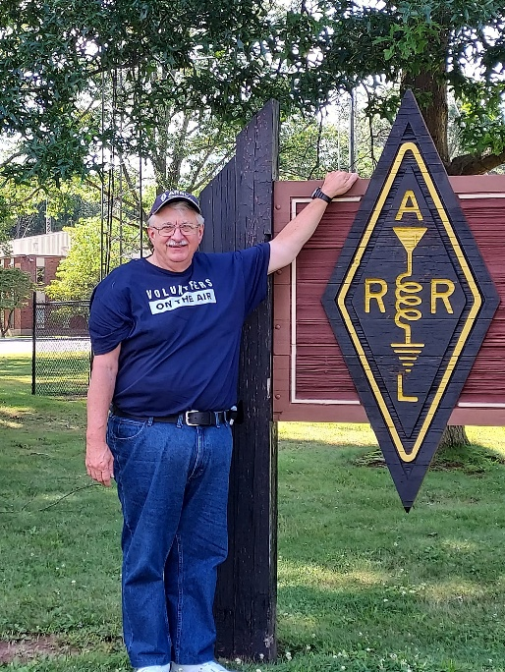

Hi Gang,

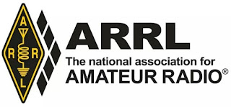
Are you going to Dayton this year? Just wanted you to know that if you do, look for the Great Lakes Division booth right next to the ARES / America 250 booths in building 2. Stop in and see all of your representatives from the Great Lakes Division. Yes, all 3 Section Managers as well as Roy and I will be there to meet and welcome you. Come and say “HEY” to all of us.

Are you a member of the ARRL?? If you aren’t a League member, this is a great opportunity to become one. Want more information on how to join? Here’s the link: https://www.arrl.org/membership

Got questions about being a member or what the League is all about? Send me an email n8sy@n8sy.com I’ll be happy to call or write to you. We can even meet and have coffee if you’d like, and I’ll even buy!!
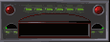
I’m sure that many of you have heard me say that I’m always available for you, whether you’re an ARRL member or not. It’s true, and you can feel free to write or call me anytime. If you have any questions, concerns, or would just like to sit and chat for a while over a cup of coffee or something cold to drink, feel free to call or write me (419) 512-4445 or n8sy@n8sy.com

Contest Portal and America250 WAS…
On the contest front, we’re rolling out the new Contest Portal, a one-stop digital hub that will revolutionize how operators access and participate in events. Picture this: real-time standings, downloadable logs, contest rules, and registration links—all in one easily navigable platform.
This tool is designed to make contesting more efficient and enjoyable, whether you’re a casual participant or a seasoned sprinter. https://contests.arrl.org/ And for those of you chasing the thrill of global connections, don’t miss America250 WAS (Worked All States)!

This special event is part of the broader America250 initiative, celebrating 250 years of American independence. The goal? Work as many stations in all 50 U.S. states, plus territories, as you can through a mix of on-air contacts and digital modes.

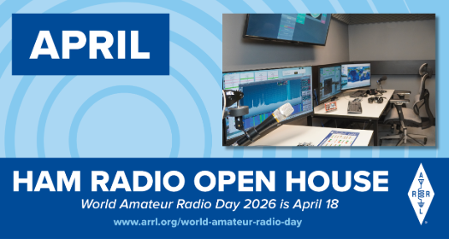
World Amateur Radio Day is coming up on Saturday, April 18th. Is your club doing any kind of special event or operating that day? If not, it’s not too late to put something together and have a blast doing it. Remember, World Amateur Radio Day is to celebrate all the contributions that amateurs have made to their communities and citizens around the world.

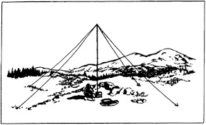
NVIS DAY IS COMING IN OHIO!
Saturday, April 25, 2026 10 A.M.–4 P.M.

April 25th marks another significant event in the Ohio Section, the Ohio NVIS Antenna Day. As you are aware, this day presents an opportunity for enthusiasts to gather and evaluate their antenna configurations.

Kicking off at 10:00 AM, this event is not a formal competition. Its primary objective is to simultaneously engage multiple counties in Ohio, testing their antennas and facilitating communications among them.

We anticipate that this gathering will provide an enjoyable platform for camaraderie, experimentation, and testing within our beloved hobby. W8SGT at the Ohio EMA will be active and monitoring the following (band conditions permitting)
- 3902
- 7240
- DMR ARES Talkgroup 31395
- 146.760/R PL 123 Columbus
Although the objective is to contact via HF, feel free to call in on DMR or VHF to help schedule your contact.

EXCHANGE
Please exchange the following:
- 6 digit Maidenhead Grid
- County
- Signal Report
- Indicate if you are an EOC station, or an ARES official (ASEC, DEC, EC, AEC)

Ever build a NVIS antenna before? Here a link to a video on that very topic NVIS Antenna Building

Field Day
Yup, it’s coming fast (June 27/28). Is your club making plans to have Field Day this year? If they are, don’t let them forget to get signed up on the Field Day locator http://www.arrl.org/field-day-locator

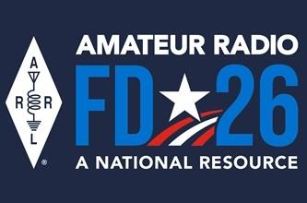
Hey, if you can, meet with your local government officials and ask them for a Proclamation for Amateur Radio that weekend. Most local governments will be happy to do this and don’t forget to invite the news media to be there as well. This is great PR for everyone, and you get extra points for your efforts too!

Amateur radio groups are encouraged to share a copy of their proclamations with ARRL via pr@arrl.org ARRL will often share these proclamations to advance legislative efforts, creating additional support of awareness for amateur radio among lawmakers.

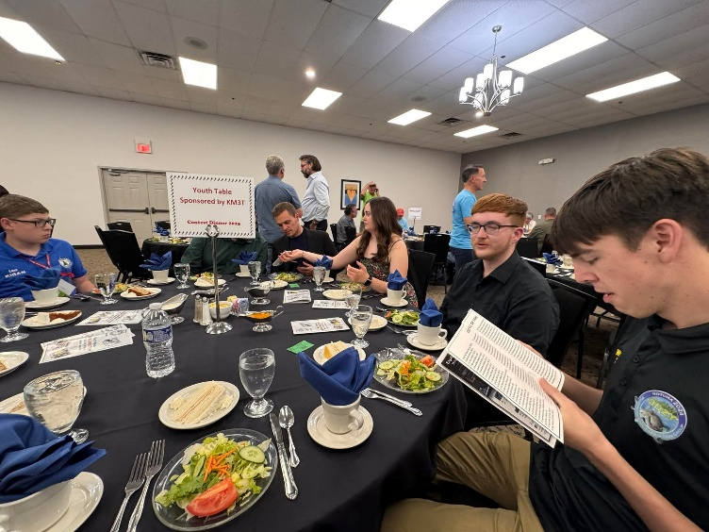
Hey club leaders
Do you have your meetings hybrid (ie... Zoom, Teams, Go-To-Meeting) as well as in-person? Doing a hybrid meeting does take a little extra effort on the club’s part, but for those who don’t travel well at night, or just can’t make the meeting because of distance, this is really a great thing for them. Yes, it’s a little more work for whomever sets the equipment up, but it means so much to those who just could not attend the meeting any other way. It also opens the door for acquiring new members too.

Yes, I have been told by a few club leaders that they have actually seen an uptick in membership from people outside of their area/state since starting their hybrid meetings.
Having hybrid meetings also opens doors for a whole new world of programs and guest speakers for your club as well! You might consider one of the great recorded webinars that are listed in the ARRL Learning Center or even a live presentation from a guest that’s hundreds or thousands of miles away.

Hybrid meetings doesn’t mean that you don’t show up in person when you can. It’s more for those who just can’t attend but would really like to. There are many great recorded webinars out there from folks all over the world that are informative and fun. Most of these webinars are around 30 minutes or so, which is just the right amount of time. Remember the posterior rule... “The brain can only absorb with what the butt can withstand!”

Ok… I hope that you get on the bands and just go crazy!!! There’s so much to enjoy on the bands, so, get Radio-Active, but above all, regardless of your preferred mode or band, remember the golden rules of our incredible hobby: Have FUN, be respectful and most importantly, be Radio Active!

73, Scott…

Scott Yonally, N8SY
Director - Great Lakes Division
n8sy@n8sy.com

Handbook Give Away – Have you entered yet???

How’s about I give away an ARRL softcover Handbook absolutely FREE !!!
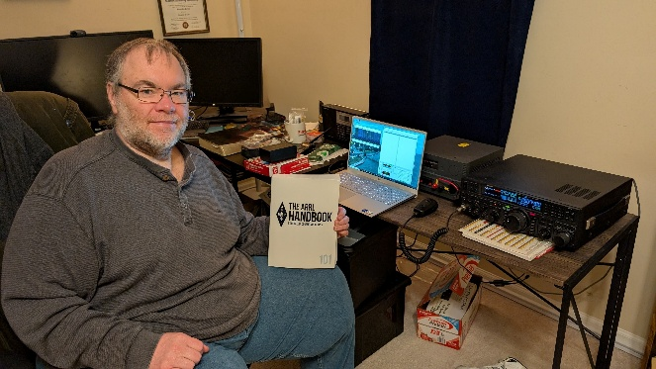

Yes, I’m holding a little contest to "GIVE AWAY" an ARRL softcover Handbook. Why you ask? It’s to get you to check-in to the Great Lakes Division website and take a look around.

Getting signed up is just as simple as filling out a couple of quick questions and you’re entered!!

>> Click Here To Enter <<

2026 ARRL Field Day Merch Now Shipping

Field Day is approaching fast...and so is the 4th of July! Stock up on official 2026 ARRL Field Day merchandise and own a piece of history with this year’s patriotic red, white, and blue design honoring America’s 250th anniversary.

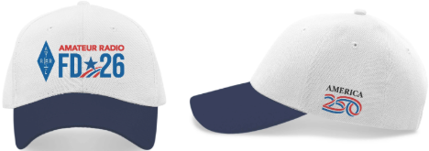

ARRL Field Day, June 27–28, is amateur radio’s largest on-the-air event and part of the nationwide America250 celebration.
This year’s theme, “Amateur Radio: A National Resource,” highlights the vital role ham radio plays in public service, emergency communications, and connecting communities. Whether you plan to operate as a group, with a friend, or simply visit a local site—there’s no better time to get ready.

The 2026 Field Day collection is now shipping and includes t-shirts, hats, mugs, pins, patches, stickers, notebooks, banners, recruitment posters, and more. The t-shirt lists ARRL and RAC sections on the back—a fun way to track contacts. Comfortable, durable, and unisex, it’s ideal for both Field Day and Fourth of July celebrations.

Be among the first to shop the collection at www.arrl.org/shop and celebrate Field Day in style.

For rules, resources, and the latest information, visit www.arrl.org/FieldDay

The America 250 word mark and logo are trademarks of the U.S. Semiquincentennial Commission and are used under license.

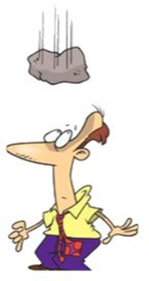
Murphy’s Law…

Keiko's Law of Golf
The only way to avoid hitting a tree is to aim at it.

Kennedy's Law
Excessive official restraints on information are inevitably self-defeating and productive of headaches for the officials concerned.

Kirkland's Law
The usefulness of any meeting is in inverse proportion to the attendance.

First Law of Laboratory Work
Hot glass looks exactly the same as cold glass.

Laird's Law
Toothache tends to start on Saturday night.

Bus to Dayton Hamvention

The ARROW Communication Association and the Toledo Mobile Radio Association (TMRA) are proud to sponsor a motor coach trip to the Hamvention 2026 in Dayton, Ohio. This one-day trip leaves early in the morning on May 16th and returns the same day after Hamvention closes for the day at 5:00 p.m. The bus has two pickup spots, in Ann Arbor and in Toledo (Rossford). Please join us!

Tickets are $95 per person January 1st 2026 – April 17th
$110 per person April 18th 2026 – May 15th
Please note that this does not include the Hamvention ticket, which you need to purchase separately. To Register and see full Details visit: https://w8rp.org/daytonbus2026/
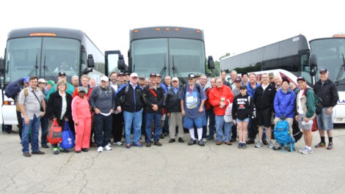

There are two pickup/drop off locations on May 16th
Ann Arbor – 601 W Stadium Blvd, Ann Arbor, MI – Departing 4:30 am
Toledo – 727 Lime City Rd. Rossford, OH – Departing 5:30 am

On board, you can stretch out, relax, take a nap, chat with other hams, and enjoy a light breakfast with coffee as the coach takes you directly to the country’s largest amateur radio event!

Thanks - ARROW & TMRA

Great Lakes Division Hamfests
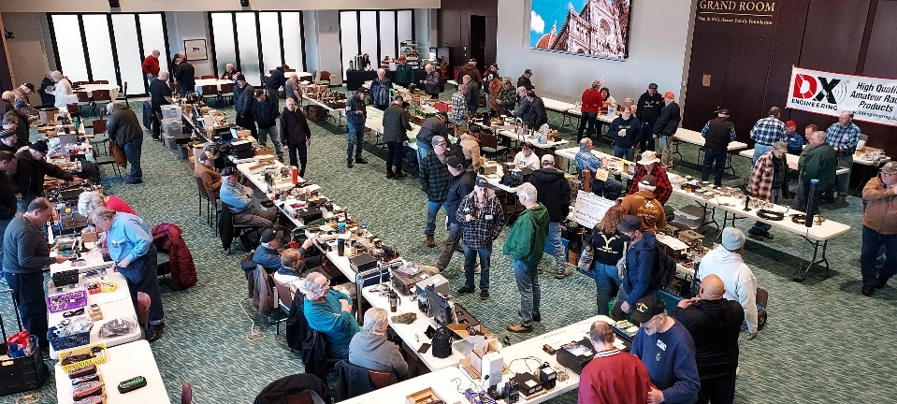
Here in the Great Lakes Division, we have over 50 hamfests a year. So, if you haven’t started planning your hamfest schedule yet, you really need to start now.

Let's fully support all of our hamfests in every way possible. It means success for everyone. Be sure to invite your ARRL Officials as soon as your date is set.

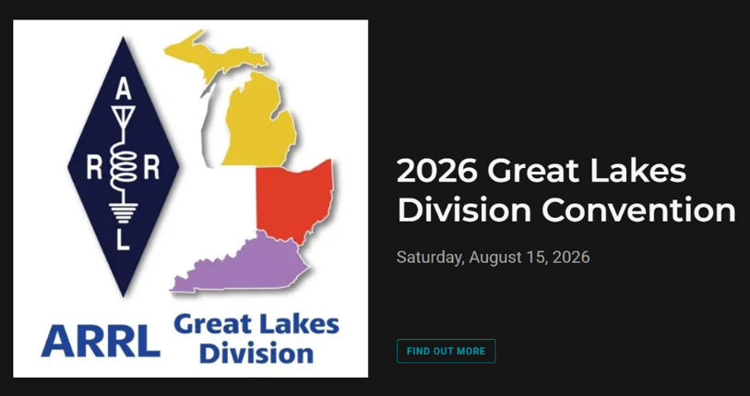

If you are planning on having your hamfest listed in QST please be sure to start your planning well in advance of your Hamfest date, as this allows adequate time for QST Listings. QST announcements require a 3-month lead time.

04/18/2026 - SJCARC Hamfest  Location: Centreville, MI  Type: ARRL Hamfest  Sponsor: SJCMIARC  Learn More | 04/25/2026 - Tusco Amateur Radio Club's 2026 Hamfest, Computer & Electronics Show  Location: Dover, OH  Type: ARRL Hamfest  Sponsor: Tusco Amateur Radio Club W8ZX  Website: http://www.w8zx.net/hamfest  Learn More
04/26/2026 - Athens Hamfest  Location: Athens, OH  Type: ARRL Hamfest  Sponsor: Athens County Amateur Radio Association  Website: http://ac-ara.org  Learn More | 05/02/2026 - Crossroads Hamfest  Location: Marshall , MI  Type: ARRL Hamfest  Sponsor: Southern Michigan Amateur Radio Society  Website: http://www.w8df.com  Learn More
05/02/2026 - Lucas County ARES Hamfest  Location: Toledo, OH  Type: ARRL Hamfest  Sponsor: Lucas County Amateur Radio Emergency Service, Inc.  Website: http://WWW.LUCASARES.ORG  Learn More | 05/02/2026 - Wexaukee ARC Swap & Shop  Location: Cadillac, MI  Type: ARRL Hamfest  Sponsor: Wexaukee Amateur Radio Club  Website: http://wexaukeearc.org  Learn More
05/09/2026 - General Motors ARC Swap Meet  Location: Shelby Township, MI  Type: ARRL Hamfest  Sponsor: General Motors Amateur Radio Club  Website: http://gmarc.org  Learn More | 05/14/2026 - 05/17/2026  Four Days In May  Location: Fairborn, OH  Type: ARRL Convention  Sponsor: QRP Amateur Radio Club International  Website: http://qrparci.org/fdim  Learn More
05/15/2026 - 05/17/2026  Dayton Hamvention  Location: Xenia , OH  Type: non-ARRL Hamfest  Sponsor: Dayton Amateur Radio Association  Website: www.hamvention.com  Learn More | 06/05/2026 - 06/06/2026  LARS 2026 Yooper Hamfest  Location: Newberry, MI  Type: ARRL Hamfest  Sponsor: Luce County Amateur Radio Society  Website: http://w8nby.org  Learn More
06/06/2026 - FCARC SummerFest  Location: Delta, OH  Type: ARRL Hamfest  Sponsor: Fulton County Amateur Radio Club  Website: https://k8bxq.org/hamfest  Learn More | 06/06/2026 - IRA Hamfest  Location: Hudsonville, MI  Type: ARRL Hamfest  Sponsor: Independent Repeater Association  Website: https://w8ira.org/hudsonville-hamfest/  Learn More

You can always find the latest information about upcoming hamfests on the Great Lakes Division website.
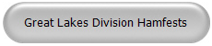

Just click to get the latest hamfest updates.
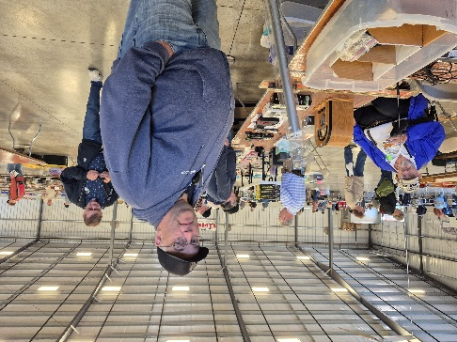
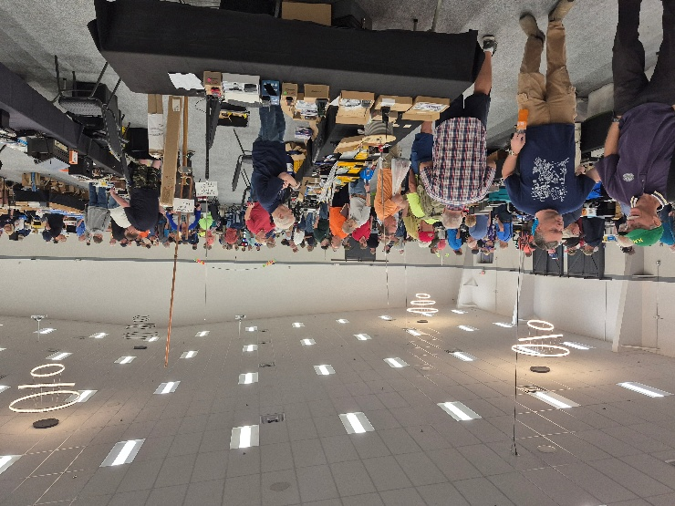

GLD – 12 Survey Results

I want to extend my sincere gratitude to everyone who took the time to complete this survey. Looking through your responses, I am struck by the depth and honesty of your perspectives on the subjects we have explored together. Please know that this was not merely a data-gathering exercise; I have been carefully reading every comment, reflecting on your insights, and truly listening to the feedback you provided. Your voices are essential in shaping the direction of our collective efforts. By sharing your experiences and opinions, you have given me a clearer understanding of your needs and expectations. Thank you for your transparency and for inviting me into your thoughts—I am committed to carrying these lessons forward as we continue this journey together.
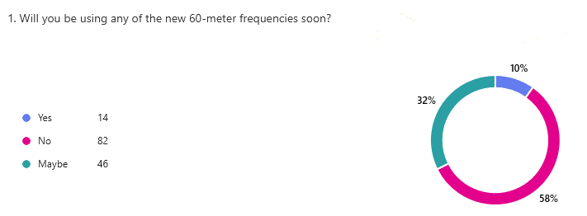
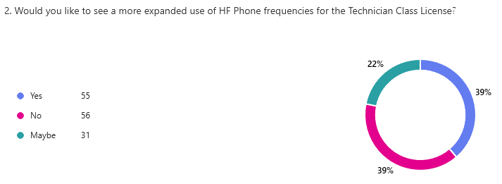
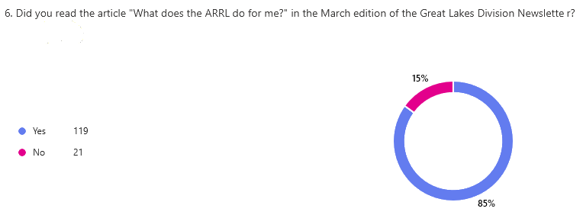
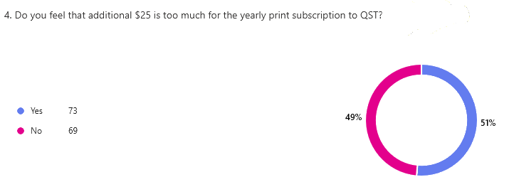
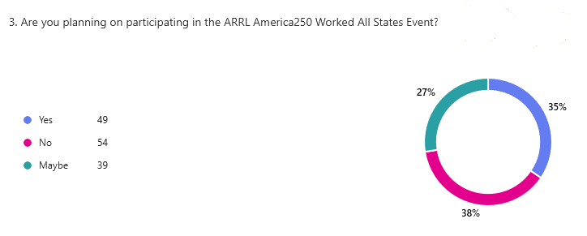

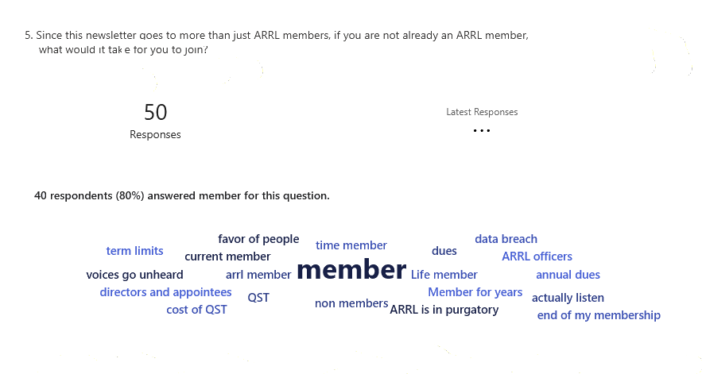
Refining Our Future Together

I want to start by saying a sincere thank you to everyone who participated in our recent survey. I’ve spent the last few days reading through your feedback, and the diversity of sentiment is both eye-opening and deeply meaningful. I’ve heard from voices across the spectrum: from those who have been members since 1964 and remain steadfast advocates, to those who are currently sitting in a state of "purgatory" following the data breach, and everyone in between.

Your responses were refreshingly candid. I hear your frustrations loud and clear—ranging from concerns about the structure of membership dues and the changes to QST, to the critical need for term limits on leadership to ensure our representatives are truly listening to the rank-and-file. Many of you feel that your voices have been sidelined, or that the organization has lost its connection to the members. Whether you are a Life Member, a recent holdout, or someone considering whether to renew in 2026, your input is not just data—it is a roadmap.

I want to be clear: I am listening. I know that for many, this isn’t just about the cost of an annual dues; it is about trust, transparency, and the feeling that your influence actually shapes the direction of the ARRL. You’ve challenged me to ask the right questions—not just why someone might leave, but what exactly it would take to keep our members engaged, valued, and empowered for decades to come.

The surveys I am conducting are created with one primary purpose: to hear directly from you, the members of our community. I remain dedicated to maintaining this open line of communication and continuing our ongoing conversation, with your support and participation. By openly addressing challenging subjects and confronting issues head-on, we have the opportunity to overcome current tensions and to build the vibrant and inclusive organization that we all envision.

It is important for you to know that I listen to everyone, regardless of background or status, and not only to those who speak most loudly. A valuable lesson I have learned from wise and honorable individuals is that the loudest voices do not necessarily represent the majority. Often, those who shout the most believe they speak for everyone, but this is not always the case. I am committed to ensuring that every perspective is heard and considered as we move forward together.

I want you to know that I am genuinely interested in hearing from you. Your thoughts and feedback matter to me—not only when problems arise, but also when you have ideas, suggestions, or even questions about how the ARRL operates. If there is ever something you don’t understand or if you want to share your perspective, please feel free to reach out. I am always available and open to having a conversation with you at any time.

Scott, N8SY…

Amateur Television Friday Night Dinner

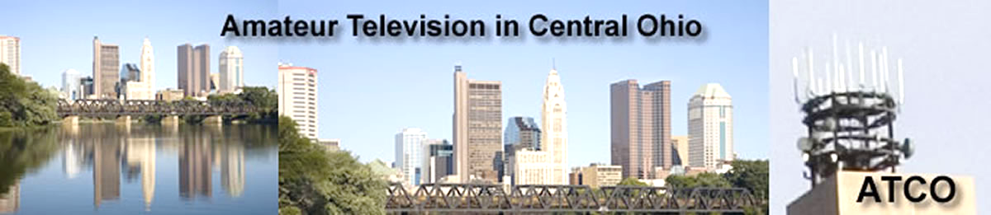

Amateur Television Friday Night dinner.

The ATV Friday Night Dinner will be on Friday May 15 at 6:30 PM at the China Garden Buffet Restaurant (937-781-9999), 112 Woodman Drive, Dayton, Ohio 45431 (Airway Shopping Center). The all you can eat Buffet Dinner is ~ $15.00 We will have dinner and then ATV presentations concluding at 9 PM. All are invited. Door prizes will be awarded.

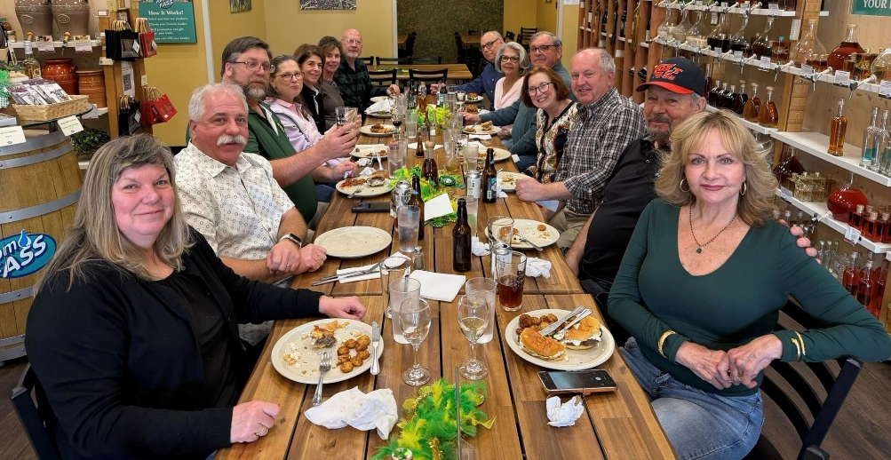
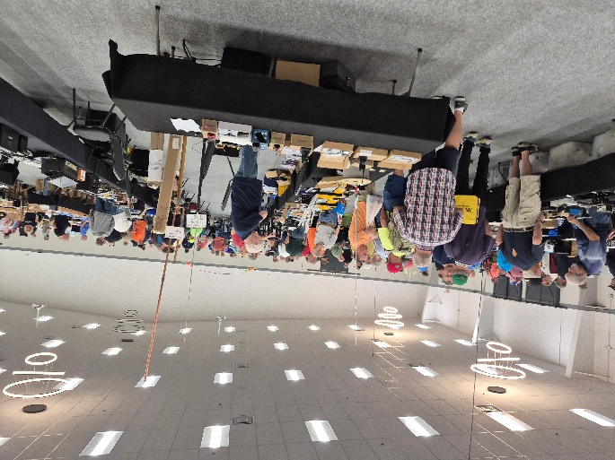
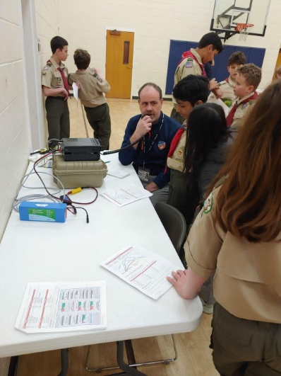
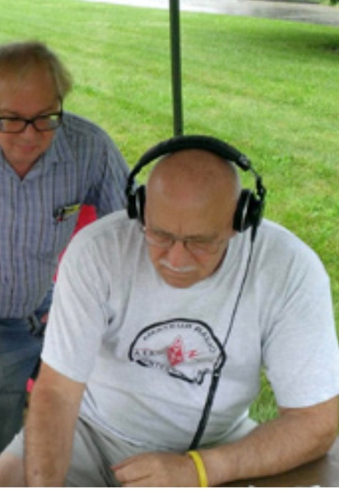
This & That’s
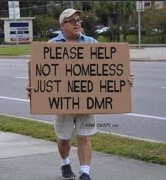
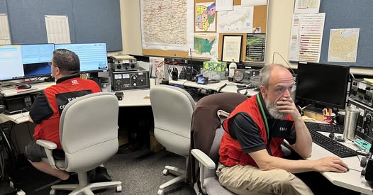
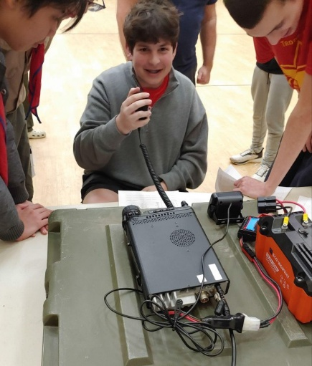

STOP – Right there!!!
We’ve come to the end…

Be Radio-Active --- See Ya’ Soon!

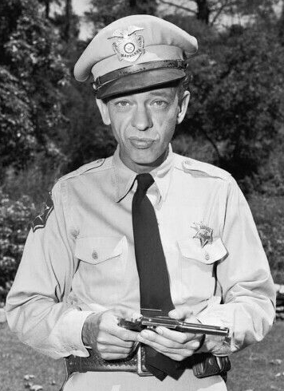

Radio Waves is produced as a look inside of the Great Lakes Division and all that it has to offer. It is our sincerest hope that you have enjoyed this edition and will encourage your friends to be a part of the ARRL and receive the latest news and information about the ARRL and the Great Lakes Division!

The pictures throughout this newsletter are from various newsletters, Facebook posts and/or were sent directly to me in recent weeks. Take a good look at them, you just might be in one of the pictures! “SMILE… you might just be in the Great Lakes Division News!!”

