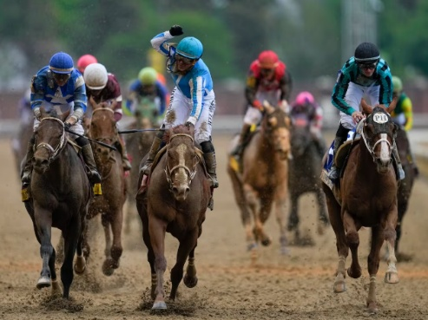
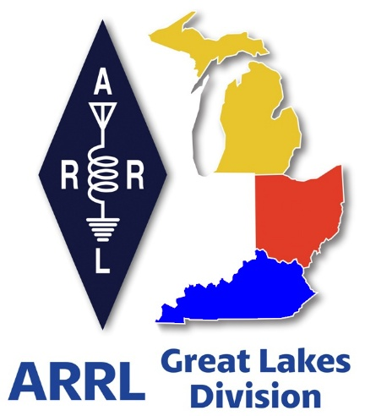
Radio Waves
^{The} Great Lakes
Division
Monthly Journal
May 2026

What’s inside…

Scott’s Stuff 2
2026 Great Lakes Division Hamfests 5
Contest Update 8
Register Now for the 2026 ARRL Youth Rally at Dayton Hamvention® 9
W1AW / 8 Activation 10
Handbook Give Away – 10
Do you know someone who is not getting this newsletter 11
Club Links 11
ARRL VEC Youth License Test Fee Only $5! 11
Start Planning for ARRL Field Day 2026 12
Michigan POTA Meetup 13
Amateur Radio to Participate in DoD Armed Forces Day Crossband Test 13
Club News Announcement 14
ARRL Affiliated Club Reminder 15
Amateur Radio Communications 15
Bus to Dayton Hamvention 17
Pix from around the Division 18

Scott’s Stuff
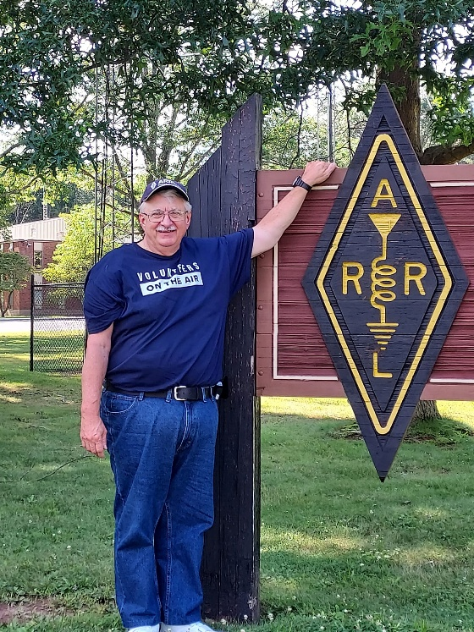

Hi Gang,

May 1st, or as the history buffs call today, May Day. I’ve never actually danced around a maypole, but I appreciate the sentiment. It’s an ancient European festival marking the onset of summer, a time to celebrate life and the fact that we no longer have to wear three layers of wool socks just to check the mailbox. I personally celebrate May Day by attempting to ride my bike on the B&O Bike Trail without getting run over by a spandex-clad cyclist, which is, in its own way, a high-stakes competitive sport.

But just as the May Day flowers begin to wilt, the month shifts gears into pure excitement with the Kentucky Derby on May 2nd. There is nothing quite like watching people spend two grand on a hat that looks like a structural engineering disaster, all to watch horses run in a circle for two minutes while sipping a mint julep. I love the Derby. It’s the only time of year where it’s socially acceptable for me to bet money on a horse named "Right to Party" based solely on the fact that I like his jockey’s silks. It’s sophisticated, it’s muddy, and it’s a heck of a lot of fun.

For the tech-obsessed among us, there’s Hamvention, where more than 30,000 people who have one of the most diverse hobbies in the world congregate on the Greene County Fairgrounds here in Ohio to talk about those missed rare ones, radio frequencies and antennas. It’s the best spent 3 days of any ham radio operators life for sure.

Before the month is up, we’ve also got the Indianapolis 500. I’m convinced that May in the Midwest is just a continuous hum of excitement. Between the horses, Hamvention and the Indy cars, I’m pretty sure we’re all suffering from a collective adrenaline spike that won't dissipate until June.

Hey, let’s also not forget that as the month rolls on, the calendar becomes a minefield of "things I should be doing." Baseball season is in full swing, which means I can justify sitting on the couch for three hours eating peanuts under the guise of "national pastime appreciation." Meanwhile, the basketball finals are also taking place right now and turning my living room into a theater of dramatic sighs and frantic remote-control clicking.
But May isn’t just about watching other people be athletic. It’s the month I convince myself that I am an outdoorsman. I drag my bike out of the garage, inflate the tires, and hit the bike trails with the confidence of a professional athlete. Usually, this lasts exactly forty-five minutes before I realize that my "cardio" is really just an excuse to eat a celebratory cheeseburger. I also find myself wandering onto a golf course, where I spend most of my time pretending my ball didn’t just vanish into the woods, but rather that it was a "tactical placement for a better angle." (Spoiler: It wasn't.)

Then there’s the looming specter of the end of school. If you’re a parent, you know the look in our eyes. It’s a mix of joy (no more packing lunches!) and existential terror (how do I keep these small humans entertained for three months without them burning down the house?). We start eyeing the swimming pools, waiting for that magical moment when the water temperature reaches something above "arctic glacier" so we can finally submerge ourselves and pretend we aren’t stressed.

There is a specific, frantic magic to May. It starts with maypoles and ends with sunscreen-slicked skin and the smell of charcoal grills. It’s a month of movement—walking, biking, driving, racing, and frantically finishing projects before the summer slump hits.

So, here’s to May. May your mint juleps be cold, your maypoles be sturdy, your horses be fast, and may you survive the transition from "productive member of society" to "person who spends all their time staring at a pool."

Now, if you’ll excuse me, I have to go see if I can find a hat big enough to distract people from my terrible golf swing. It’s going to be a long month, and I’m ready for every second of it.

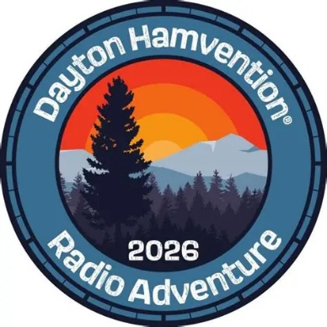
Dayton Hamvention
I’ll admit, my excitement level has been trending upward like a perfectly tuned FT-8 signal on the 20-meter band. Have you gotten your tickets and rooms reserved for Hamvention yet? You know it’s just a few days away now, so you’d better get on the stick quickly if you’re planning on going. Yes, me, Roy and all the Great Lakes Division Section Managers are planning on being there as well. Make sure you stop by our Great Lakes Division Booth right next to the ARES / America 250 booths and say “Hey” to all of us.

Field Day
Yup, it’s coming fast (June 27/28). Is your club making plans to have Field Day this year? If they are, don’t let them forget to get signed up on the Field Day locator http://www.arrl.org/field-day-locator

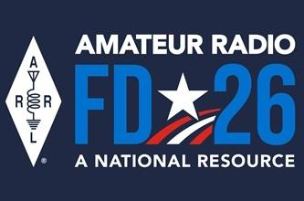
Hey, if you can, meet with your local government officials and ask them for a Proclamation for Amateur Radio that weekend. Most local governments will be happy to do this and don’t forget to invite the news media to be there as well. This is great PR for everyone, and you get extra points for your efforts too!

Amateur radio groups are encouraged to share a copy of their proclamations with ARRL via pr@arrl.org ARRL will often share these proclamations to advance legislative efforts, creating additional support of awareness for amateur radio among lawmakers.

Ok… I hope that you get on the bands and just go crazy!!! There’s so much to enjoy on the bands, so, get Radio-Active, but above all, regardless of your preferred mode or band, remember the golden rules of our incredible hobby: Have FUN, be respectful and most importantly, be Radio Active!

73, Scott…

Scott Yonally, N8SY
Director - Great Lakes Division
n8sy@n8sy.com

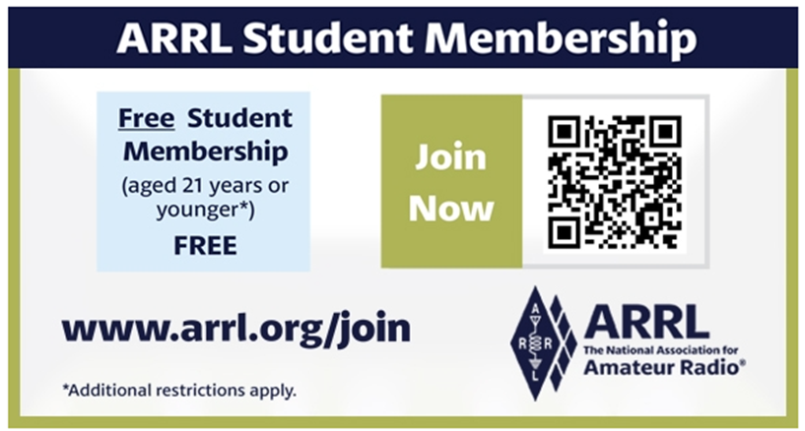

2026 Great Lakes Division Hamfests
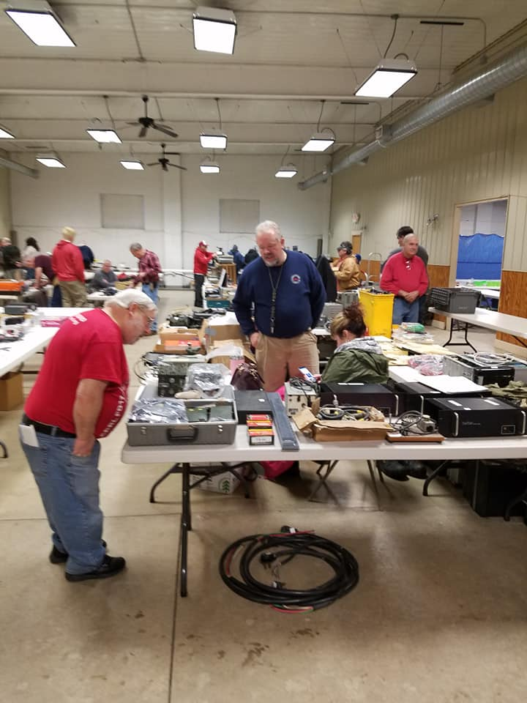
Here in the Great Lakes Division, we have over 50 hamfests a year.

So, if you haven’t started planning your hamfest schedule yet, you really need to start now.

Please post this listing in your club's newsletter and announce the swaps on your local nets.

Let's fully support all of our hamfests in every way possible. It means success for everyone. Be sure to invite your ARRL Officials as soon as your date is set.

If you are planning on having your hamfest listed in QST please be sure to start your planning well in advance of your Hamfest date, as this allows adequate time for QST Listings. QST announcements require a 3-month lead time.

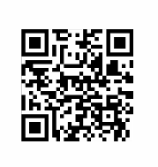
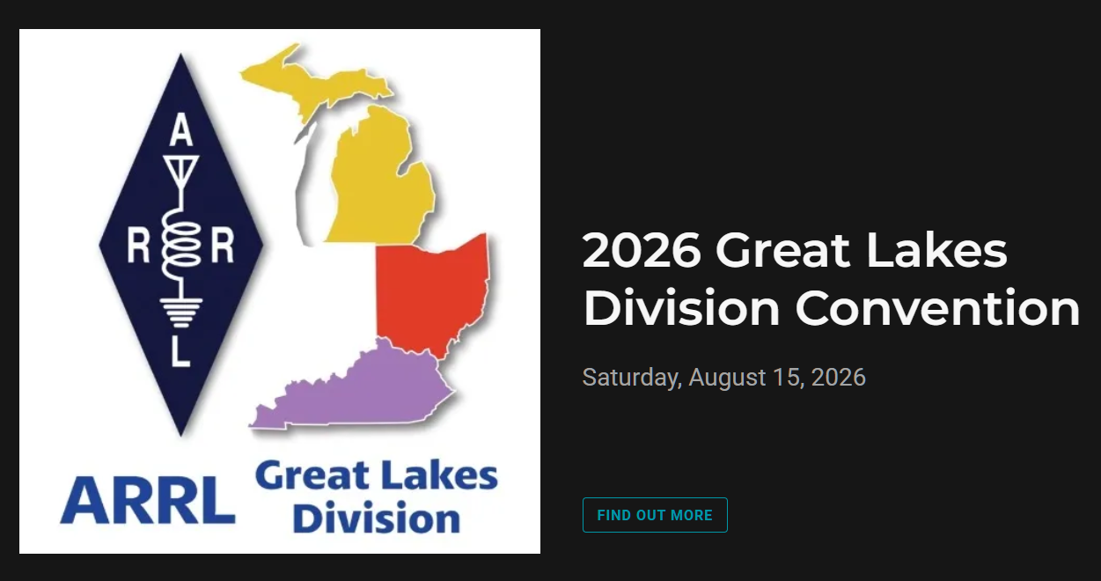
05/02/2026 - Crossroads Hamfest  Location: Marshall , MI  Type: ARRL Hamfest  Sponsor: Southern Michigan Amateur Radio Society  Website: http://www.w8df.com  Learn More | 05/02/2026 - Lucas County ARES Hamfest  Location: Toledo, OH  Type: ARRL Hamfest  Sponsor: Lucas County Amateur Radio Emergency Service, Inc.  Website: http://WWW.LUCASARES.ORG  Learn More
05/02/2026 - Wexaukee ARC Swap & Shop  Location: Cadillac, MI  Type: ARRL Hamfest  Sponsor: Wexaukee Amateur Radio Club  Website: http://wexaukeearc.org  Learn More | 05/09/2026 - General Motors ARC Swap Meet  Location: Shelby Township, MI  Type: ARRL Hamfest  Sponsor: General Motors Amateur Radio Club  Website: http://gmarc.org  Learn More
05/14/2026 - 05/17/2026  Four Days In May  Location: Fairborn, OH  Type: ARRL Convention  Sponsor: QRP Amateur Radio Club International  Website: http://qrparci.org/fdim  Learn More | 05/15/2026 - 05/17/2026  Dayton Hamvention  Location: Xenia , OH  Type: non-ARRL Hamfest  Sponsor: Dayton Amateur Radio Association  Website: www.hamvention.com  Learn More
06/05/2026 - 06/06/2026  LARS 2026 Yooper Hamfest  Location: Newberry, MI  Type: ARRL Hamfest  Sponsor: Luce County Amateur Radio Society  Website: http://w8nby.org  Learn More | 06/06/2026 - FCARC SummerFest  Location: Delta, OH  Type: ARRL Hamfest  Sponsor: Fulton County Amateur Radio Club  Website: https://k8bxq.org/hamfest  Learn More
06/06/2026 - IRA Hamfest  Location: Hudsonville, MI  Type: ARRL Hamfest  Sponsor: Independent Repeater Association  Website: https://w8ira.org/hudsonville-hamfest/  Learn More | 06/20/2026 - Midland Amateur Radio Club Swap  Location: Midland, MI  Type: ARRL Hamfest  Sponsor: Midland Amateur Radio Club Inc  Website: http://www.w8kea.org  Learn More
06/27/2026 - W8ACW-Trunk Sale/Field Day  Location: Grand Blanc, MI  Type: ARRL Hamfest  Sponsor: Genesee County Radio Club Inc  Website: http://w8acw.org  Learn More | 07/11/2026 - Intercity Amateur Radio Club Hamfest  Location: Ontario , OH  Type: ARRL Hamfest  Sponsor: Intercity Amateur Radio Club  Website: http://W8WE.ORG  Learn More

You can always find the latest information about upcoming hamfests on the Great Lakes Division website.
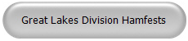
Just click to get the latest hamfest updates.

Contest Update
Note: Contest dates and times are in UTC. This means that a contest that is listed to start on a Saturday at 0000z, for example, really starts on a Friday night in US time zones.

May 1  - NCCC FT4 Sprint  - Weekly RTTY Test  - NCCC Sprint  - AGCW QRP/QRP Party  - K1USN Slow Speed Test | May 2  - RCC Cup  - SBMS 2.3 GHz and Up Contest and Club Challenge  - Microwave Spring Sprint  - ARI International DX Contest  - F9AA Cup, PSK  - 7th Call Area QSO Party  - Indiana QSO Party  - Delaware QSO Party  - New England QSO Party
May 3  - WAB 7 MHz Phone | May 4  - K1USN Slow Speed Test  - ICWC Medium Speed Test  - OK1WC Memorial (MWC)  - ICWC Medium Speed Test  - MIE 33 Contest
May 5  - ARS Spartan Sprint  - Worldwide Sideband Activity Contest  - ICWC Medium Speed Test | May 6  - Phone Weekly Test  - A1Club AWT  - CWops Test (CWT)  - VHF-UHF FT8 Activity Contest  - Mini-Test 40  - Mini-Test 80  - CWops Test (CWT)
May 7  - VHF-UHF FT8 Activity Contest-NA  - Walk for the Bacon QRP Contest  - CWops Test (CWT)  - SKCC Sprint Europe | May 8  - NCCC FT4 Sprint  - Weekly RTTY Test  - NCCC Sprint  - K1USN Slow Speed Test

May 9  - Flemish Windmill Contest  - VOLTA WW RTTY Contest  - CQ-M International DX Contest  - SKCC Weekend Sprintathon  - Canadian Prairies QSO Party  - 50 MHz Spring Sprint | May 11  - 4 States QRP Group Second Sunday Sprint  - K1USN Slow Speed Test  - ICWC Medium Speed Test  - OK1WC Memorial (MWC)  - RSGB 80m Club Championship, SSB  - ICWC Medium Speed Test
May 12  - Worldwide Sideband Activity Contest  - ICWC Medium Speed Test  - DARC FT4 Contest | May 13  - Phone Weekly Test  - A1Club AWT  - CWops Test (CWT)  - VHF-UHF FT8 Activity Contest  - Mini-Test 40  - Mini-Test 80  - CWops Test (CWT)

Register Now for the 2026 ARRL Youth Rally at Dayton Hamvention®

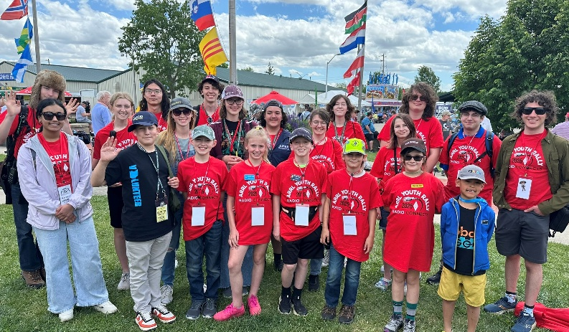
Get ready for amateur radio’s biggest annual gathering! Dayton Hamvention® 2026 is May 15 – 17 at the Greene County Fair and Expo Center in Xenia, Ohio.

Among the activities taking place is the ARRL Youth Rally, returning on Saturday, May 16. The rally is designed for students ages 11 to 21 and offers a great opportunity to connect with other young hams.

[Bob Inderbitzen, NQ1R, photo]

Youth Rally activities will be led by ARRL Director of Education and Learning Steve Goodgame, K5ATA, and volunteers from the ARRL Collegiate Amateur Radio Program (CARP).

Advance registration is recommended. While Hamvention admission is already free for students (high school and younger), the $20 Youth Rally registration fee includes a T-shirt (to be worn on Saturday), badge and lanyard, reusable tote bag, and a complimentary three-day Hamvention admission ticket (Friday through Sunday).
Students will enjoy an afternoon of hands-on activities, learning, and fun. Highlights include satellite communications, a short sprint contest, a fox hunt, and a chance to make contact with a parachute-mobile station. Attendees are encouraged to bring a 2-meter handheld radio if you have one.

The Youth Rally will be followed by the ARRL Collegiate Amateur Radio Meetup.
For more information about the Youth Rally and registration, and to find other ARRL activities and exhibits at Hamvention, visit www.arrl.org/dayton-hamvention-2026

W1AW / 8 Activation

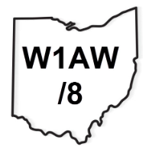
Ohio operators will have an opportunity to work W1AW/8 Ohio as part of
the year-long ARRL USA-250 operations, which run from 00:01 UTC May 6th
through 23:59 UTC Tuesday, May 12th (EST: 7 PM Tuesday, May 5th to 7 PM
Tuesday, May 12th). You can get general information at this link- tiny.cc/w1aw8-info.
You can be a W1AW/8 OH "hunter" simply by finding the stations on the bands and working them from your home station. During the week, stations will be on 160 to 6 Meters with SSB, CW, FT8/FT4 & RTTY. You can find the stations in a couple of ways:
There is a schedule that will be updated throughout the operation:
tiny.cc/w1aw8 (remember, this schedule is live and will be updated often during the event).
You can use your favorite DX Cluster to watch for spots. On FT8 & FT4, you can use PSKReporter and enter W1AW/8 as callsign to view Using the RBN (Reverse Beacon Network), you can see CW activity If you have any additional questions, please contact: Anthony Luscre, K8ZT

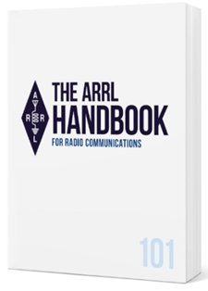
Handbook Give Away –
We have a winner!!!

And… the WINNER is…!!

Randy Stiles, W4EP
of

Pikeville, Kentucky…!!!

Do you know someone who is not getting this newsletter

Hi Gang,
If you know someone who isn’t already getting Radio Waves, have them sign up to receive it!! They don’t have to be ARRL members to sign up, just click on the button below and in no time, they will start receiving it.

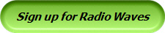

Club Links

I’ve received a number of new requests from clubs to be listed on the “Links” club page.
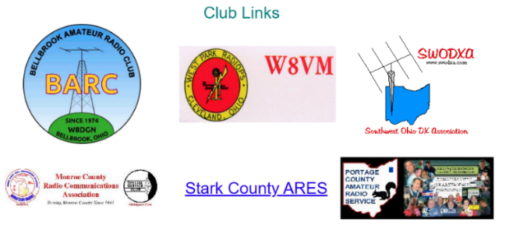

Is your club listed? If not, send the URL of your club website to me n8sy@n8sy.com and I’ll get it listed.



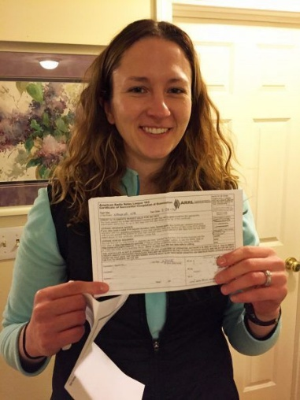
ARRL VEC Youth License Test Fee Only $5!

Youth examinees under age 18, you can earn your initial Technician license or upgrade your current license through the ARRL VEC Volunteer Examiner Coordinator program for only $5.
The ARRL Youth Licensing Grant Program covers the one-time $35 application fee for new license candidates younger than 18-years old for tests administered under the ARRL VEC program. The $35 FCC application fee will be reimbursed after the ARRL VEC receives the completed reimbursement form and the new license has been issued by the FCC.

The reimbursement check will be mailed to the fee payer. Additionally, candidates younger than 18-years old pay a reduced exam fee of $5 to the ARRL VEC VE team at the time of the exam. The $5 fee is for all candidates under the age of 18 regardless of the exam level taken. Proof of under 18 status is required at the session (what to bring to an exam session).

Start Planning for ARRL Field Day 2026
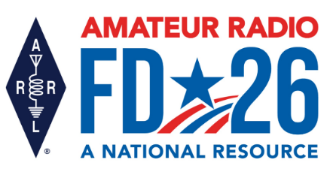
It’s not too early to gear up and get ready for ARRL Field Day! Field Day 2026 takes place June 27 – 28 and will bring together more than 30,000 amateur radio operators for one of the most popular on-the-air events in the US and Canada.

This year’s Field Day theme is “Amateur Radio: A National Resource.” Combined with the ARRL Year of the Club, it provides the perfect opportunity for radio clubs to set up stations in public places to demonstrate ham radio's science, skill, and service to our communities and our nation.
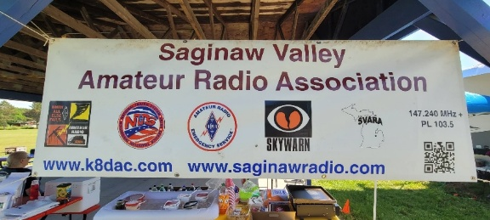
All of the information you need to get started can be found on the Field Day web page, including how to join the ARRL Field Day Facebook Group, where you can share your plans, tips, and tricks for a successful Field Day.

The overall objective for Field Day is to contact as many stations as possible on the 160-, 80-, 40-, 20-,15- and 10-meter HF bands, as well as all bands above 50 MHz, and to learn to operate in less-than-optimal conditions. Many clubs choose to set up camp-style fashion with portable equipment, temporary antennas, and off-grid power sources.

Field Day is open to all amateurs in the areas covered by the ARRL/RAC Field Organizations and countries within IARU Region 2 (North and South America). DX stations residing in other regions may be contacted for credit but are not eligible to submit entries. Each claimed contact must include contemporaneous direct initiation by the operator on both sides of the contact. Initiation of a contact may be either locally or by remote.

Also check out the Field Day site locator page to help find participating stations near you. As an added incentive for anyone participating in ARRL’s yearlong America250 Worked All States (WAS) Award, contacts made with ARRL Affiliated Radio Clubs all year, including during Field Day, will count toward your America250 WAS Affiliated Club Endorsement.

Check out those details at www.arrl.org/america250-was. For more information about ARRL Field Day, visit www.arrl.org/field-day.

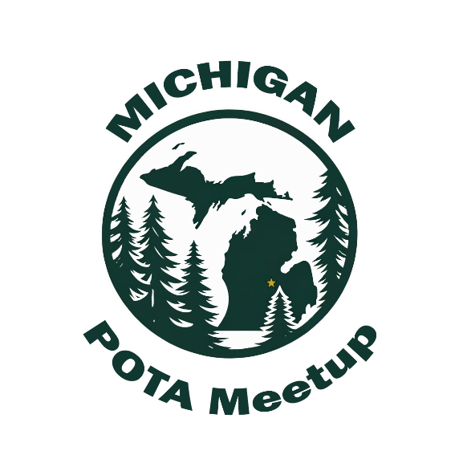
Michigan POTA Meetup

We're back for round three this year. Join fellow Parks on the Air
and amateur radio enthusiasts for a day of portable operations, hands-on radio, and community connection in one of Michigan’s
most scenic state parks. This event has grown into something
that you need to look forward to every year. Watching new
POTA folks meet the activators they've been working from
across the state, swap stories, and just hanging out in a
beautiful park is the best part of the hobby. We'd love to see anyone who can make the drive up to Grayling.

Here are the details:
Michigan POTA Meetup 2026 (3rd Annual)
Saturday, June 6, 2026
11:00 AM to 3:00 PM
Hartwick Pines State Park (US-1503), Grayling, MI - Day Use Shelter near the Chapel in the Woods. Free to attend, free hamburgers and hot dogs (first come first served), dish-to-pass welcome. We'll have POTA setups from attendees, HT Park-to-Parks activity, a raffle, and a group photo at 1:00 PM at the banner. More info at michiganpotameetup.com or facebook.com/michiganpotameetup. Folks can reach out to michiganpotameetup@gmail.com with questions.

Amateur Radio to Participate in DoD Armed Forces Day Crossband Test

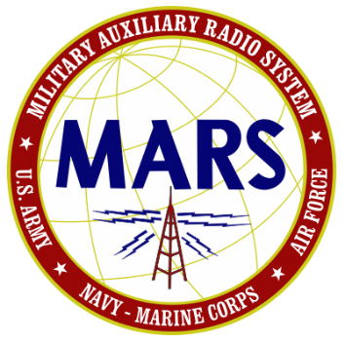
Amateur radio operators will participate in the Department of Defense’s Armed Forces Day (AFD) Crossband Test on May 9, 2026. The annual event will not impact any public or private communications.

For more than 50 years, military and amateur stations have participated in this interoperability exercise between the amateur and government radio services. The AFD Crossband Test provides a unique opportunity to conduct two-way communication between military communicators and stations in the Amateur Radio Service (ARS), as authorized in 47 CFR 97.111. These tests present both opportunities and challenges for radio operators to demonstrate individual technical skills in a tightly controlled exercise scenario.

ARRL The National Association for Amateur Radio® hails the Armed Forces Day Crossband Test as an example of the core principles of the US Amateur Radio Service, with its volunteers contributing technical proficiency and readiness in support of public service and national needs.

Military stations will transmit on selected military frequencies and will announce the specific ARS frequencies they are monitoring. All times are ZULU (Z), and all frequencies are upper sideband (USB) unless otherwise noted.

An AFD message will be transmitted using the Military Standard (MIL-STD) Serial PSK waveform (M110), followed by MIL-STD Wide Shift FSK (850 Hz RTTY), as described in MIL-STD 188-110A/B. Technical information regarding these waveforms is available at:
drive.google.com/drive/folders/1pYDj7kQbm-QAyY4RPtx0dOXKohjaEjq9?usp=sharing

To document your contacts with a QSL, visit: www.usarmymars.org/events-and-announcements and complete the request form.

The US Naval Academy Amateur Radio Club, W3ADO, will activate the historic NSS call sign during the Crossband Test. Several Naval Academy midshipmen and members of the Potomac Valley Radio Club (PVRC), including team leader Frank Donovan, W3LPL, will be operating on the grounds of the former US Navy radio transmitting facility in Annapolis, Maryland. PVRC is an ARRL Affiliated Club.

In June, radio amateurs in the US and Canada will participate in ARRL Field Day, the largest annual demonstration of the Amateur Radio Service. Amateur stations will be set up in public places such as a town park to practice emergency preparedness and acquaint the general public with the capabilities of amateur radio. ARRL Field Day will be held June 27 –28, 2026, and this year’s theme is Amateur Radio: A National Resource. For more information, visit www.arrl.org/field-day.

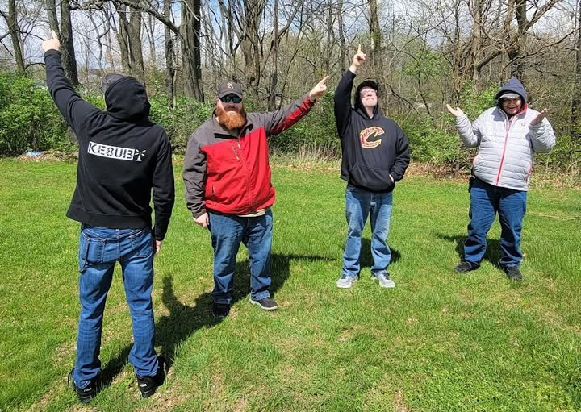
Club News Announcement
To ensure that all ARRL Affiliated Clubs are receiving information to support Year of the Club, ARRL Club News is now being sent to all club email addresses of record, club presidents, and club newsletter editors, as submitted in affiliated club listings. If you’re not receiving the Club News and you are the club president / newsletter editor or club email recipient, please contact Member Services at HQ ASAP and let them know that you want to receive it. They will assist you in getting everything all setup for you.

Get your club together and take a photo to send to QST. Each 2026 issue of QST will include club group photos. Get all the details at www.arrl.org/year-of-the-club

ARRL Affiliated Club Reminder
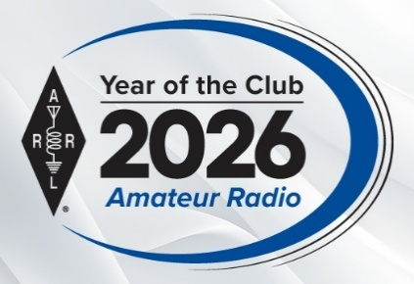

This is a quick reminder that every ARRL Affiliated Club should update their club information annually. These simple instructions will walk you through the process: www.arrl.org/files/file/Clubs/Club%20Update%20Online_20150806.pdf

This only takes a few minutes, and it keeps your club up to date and in active status.

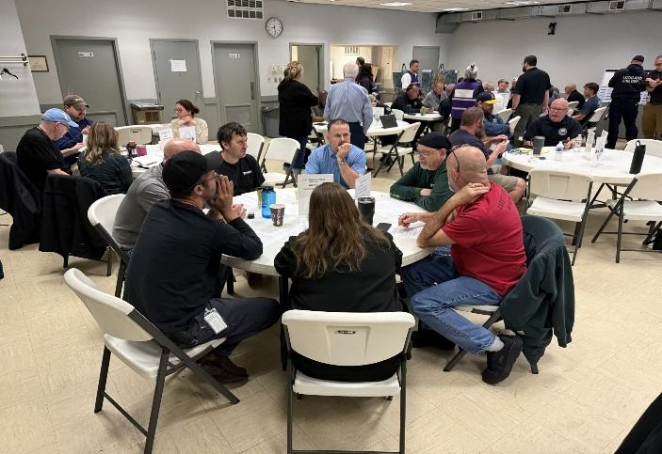
Amateur Radio Communications

Congratulations! We are all licensed Amateur Radio Operators – and recipients of all the rights and privileges of our respective license class. It’s a testament to the interest, education and proficiency we have accumulated through our years. I have often said that Amateur Radio is “The Greatest Hobby in the World” – and I firmly believe that today as much as I did 50+ years ago when I was first licensed as a Novice.

We, like many other organizations, have found ourselves in a social situation where Amateur Radio does not hold the allure that it once held, especially in the interests of younger people. We must turn that around, or we could face extinction as a hobby. If we let that happen, we will have done a huge disservice to those who follow and will not have this opportunity available to them.

Radio was once an emerging technology that captured the attention and interest of almost everyone. Amateur Radio Operators were the ones who knew how to make it happen. We have pushed radio technology from its beginnings and have been responsible for many of the advancements in and importance of radio technology and its role in our society.

Today it’s everywhere. Today it’s taken for granted that it will be there (wherever “there” is) and that it will work. But those of us who have even a minimal understanding of how radio works have become a very small segment of our society.
For us to turn that around, and create an interest and participation in our hobby, we need to become as intentional as to “WHAT” we communicate as we are to “HOW” we communicate. And, what we communicate especially to those we want to attract to our hobby. Most of this communication takes place on channels which are outside of our Amateur Radio Communications. They happen in person and via other media. Some are direct and others are indirect. But they influence those who receive them and their interest in joining us, or not.

I’m going to start by talking about language. We have our own language, and if you are not a ham, you don’t get it. When speaking to non-hams about our hobby, we need to do it in terms that a non-technical person can understand. They don’t know about (or care) if you’re using a vertical or horizontally polarized cubical quad or 42 element directional Yagi array. They understand the word “antenna” – the rest is just gobbledygook to them. They don’t even begin to understand the difference between the Icom 7300 and the Baofeng UV-5R. If you don’t know a person or what their level of understanding technology is – just speak in simple English! Make it as understandable as possible. As we pique their interest, they will ask questions of interest to them. Let this happen. Answer the questions, again as simply as possible, and in plain English (for most of us).

In regard to language, and particularly when we are trying to attract a younger audience (and their PARENTS), it’s important that we keep our language appropriate. Vulgar language may be a habit we have fallen into, but it’s not appropriate when we are trying to encourage others whom we don’t necessarily know all that well to join us. Imagine parents bringing a young teen to a function where “F”-bombs are freely dropped into the conversation. Don’t expect them to return. Words and behaviors can be detrimental to recruiting new people to our hobby. Choose both carefully!

Think about it, if someone asks you what Ham / Amateur Radio is about, you should have a short description prepared ahead of time. Know what you are going to say and keep it simple and short. Let them ask a question or two and you’ll be able to determine how interested they are and how much more they want to hear.

If you’re in a public space (a POTA activation for instance) have a handout prepared that someone can leave with telling them where to find more information and a local club. If someone approaches you, introduce yourself to them and ask them their name. Use their name when addressing them, it will put them at ease and make them feel that you are truly interested in them.

In general, Hams are excellent using the tools and technology of communication, but not always as good at sending the right messages to the audience we want to reach. We can do better. Let’s not let the hobby disappear!

Tom WB8LCD

Bus to Dayton Hamvention
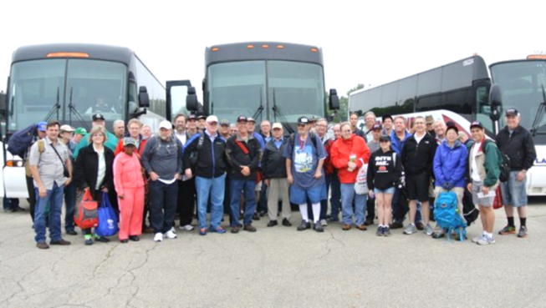

The ARROW Communications Association and the Toledo Mobile Radio Association (TMRA) are proud to sponsor a motor coach trip to the Hamvention 2026 in Dayton, Ohio. This one-day trip leaves early in the morning on May 16, 2026 and returns the same day after Hamvention closes for the day at 5:00 p.m. The bus has two pickup spots, in Ann Arbor and in Toledo (Rossford). Please join us!

Tickets are $110 per person April 18th 2026 – May 15th 2026
Please note that this does not include the Hamvention ticket, which you need to purchase separately.

To Register and see full Details visit: https://w8rp.org/daytonbus2026/

There are two pickup/drop off locations on May 16th, 2026
Ann Arbor – 601 W Stadium Blvd, Ann Arbor, MI – Departing 4:30 am
Toledo – 727 Lime City Rd. Rossford, OH – Departing 5:30 am

On board, you can stretch out, relax, take a nap, chat with other hams, and enjoy a light breakfast with coffee as the coach takes you directly to the country’s largest amateur radio event!

Thanks - ARROW & TMRA

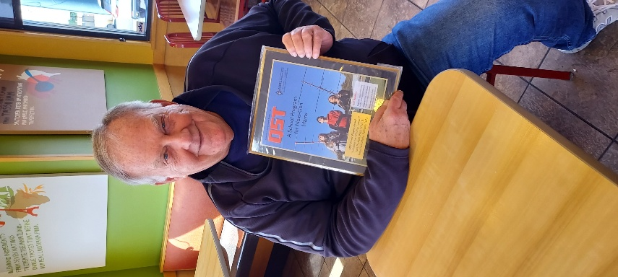
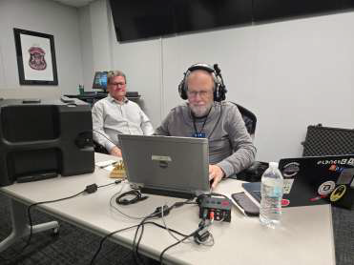
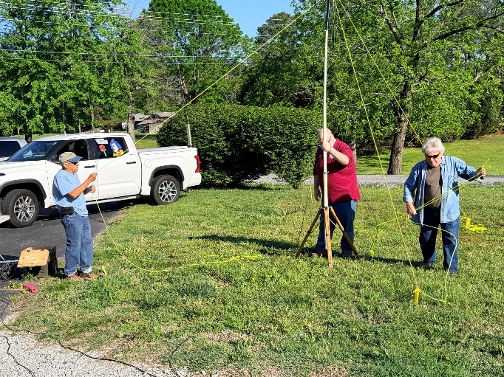
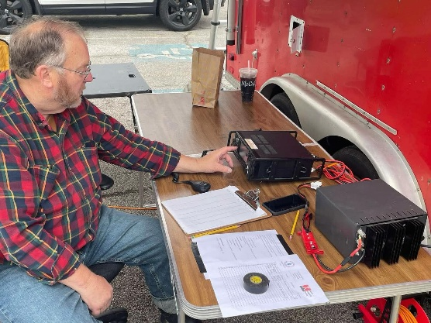
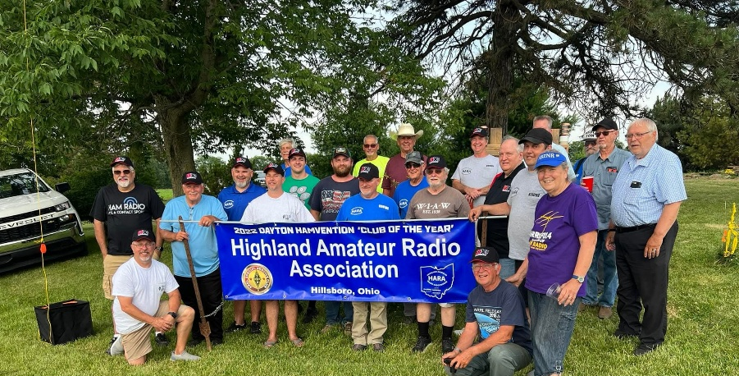
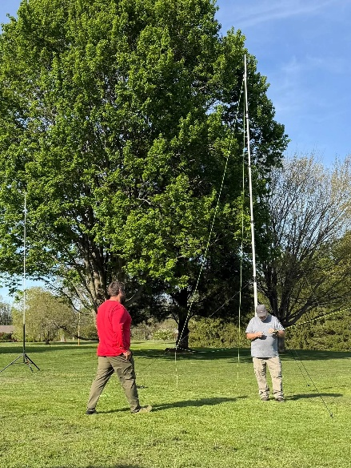
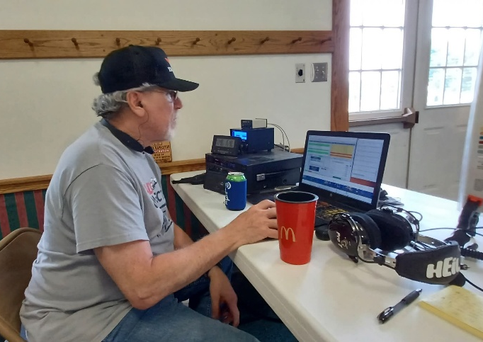
Pix from around the Division
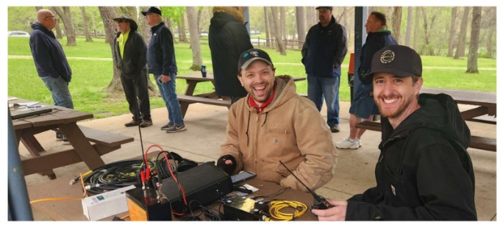

STOP!!!

You’ve come to the end…

Be Radio-Active --- See Ya’ Soon!

Radio Waves serves as a window into the vibrant activities and many opportunities available within the Great Lakes Division. Through this publication, we aim to showcase the diverse events, achievements, and community spirit that define our division. It is my sincerest hope that you have found this edition both enjoyable and informative.

I encourage you to share your experience with Radio Waves by inviting your friends to join the ARRL and stay up to date with the latest news and information about both the ARRL and the Great Lakes Division. By being part of our community, you and your friends can stay connected to exciting developments and opportunities.

Throughout this newsletter, you will find a variety of photographs that provide a visual glimpse into our division’s recent activities. Many of these images I have taken, gathered from other newsletters, Facebook posts, or have been sent directly to me in the past few weeks. I invite you to take a close look at these snapshots—they reflect the energy and engagement of our division’s members.

“SMILE…
YOU just might be featured in the Great Lakes Division News!!”

