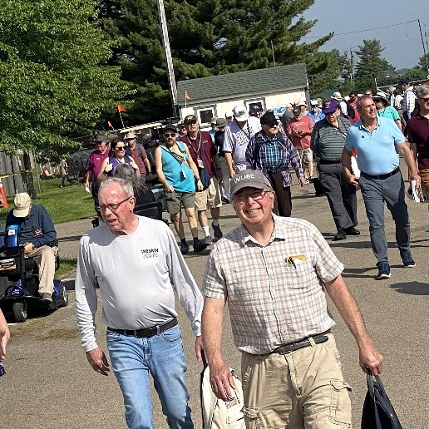
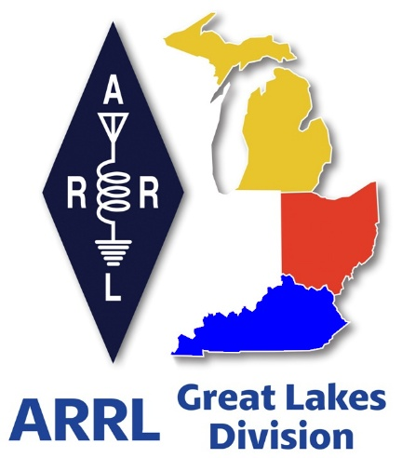
Radio Waves ^{The} Great Lakes Division
Mid- Month Report
May

What’s Inside…

From the Michigan Section Manager 2
From the Ohio Section Manager 8
From the Kentucky Section Manager 11
Do you know someone who is not getting this newsletter 13
Scott’s Stuff 13
Handbook Give Away – Have you entered yet??? 16
Start Planning for ARRL Field Day 2026 16
New Book Release: Satellite Operating for Amateur Radio 17
Introducing the QTC App 18
YOTA at Hamvention 2026 19
Great Lakes Division Hamfests 21
Murphy’s Law… 23

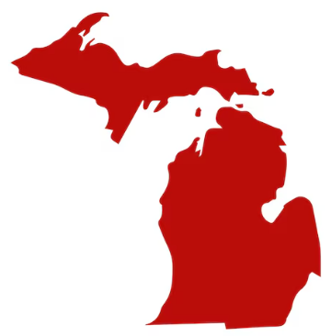
From the Michigan Section Manager
Ralph Katz, AA8RK
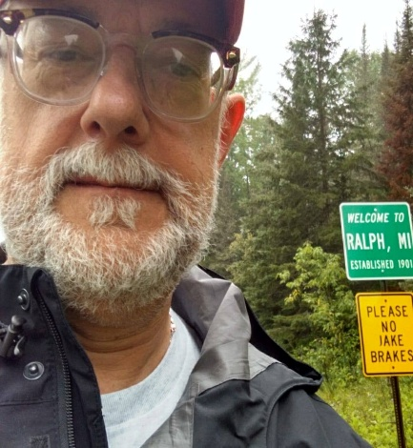
Time flies like nothing and here is my 5th monthly write-up. I try to keep these e-mails to manageable size, but there is a lot going on, as you can see below. In the last month, I attended the Crossroads Hamfest in Marshall. Assistant Section
Manager Tom Bosscher K8TB attended the Wexaukee ARS hamfest in Cadillac. Scheduling conflict prevented me from attending the St Joseph County ARC Hamfest on April 18, but I did send brochures. Please reach out if you want some ARRL handouts, or would like me to speak to your club, either in person or via Zoom.

I will be at the ARRL Great Lakes Section table at the Dayton Hamvention May 15-17. Please stop by to say “hi” or just to gripe.

“Whan that April with his shoures soote”
It is spring now, when a young man's fancy turns to Dayton, POTA, public events, Field Day, and trying to find his antenna launcher.

Our first three concerns should be 1) Safety, 2) Safety, and 3) Safety. Think through all of the risks ahead of time. Have enough people to keep your task safe. Don't attempt anything out of your skill level or that another set of hands would make safer. Stay clear of all electrical power distribution lines. Use lightning arresters on all of your antenna feeds. Mind your grounding. Do research beforehand if you have any questions. Doing all these things will make sure that you are on track to keep having fun.

(FYI that above text, in Middle English from the late 1300's, is the first line from Geoffrey Chaucer's Canterbury Tales. Translation: “When April with its sweet-smelling showers”.)

Severe Weather Response
In mid-April, every Michigan County was under a Flood Watch, the only time this has ever happened. Even smaller streams like the Ocqueoc River turned into raging torrents. The Charlevoix, Cheboygan, and Emmet Counties Public Services Communication Organization (CCECPSCO) provided volunteers in the Cheboygan County EOC. It is clear that other
groups' EmComm volunteers were active – please e-mail be about your activities. I will report on this as information becomes available because the streams have not settled down yet.

Condolences
We are sorry to report that Judith Anne “Judy” Williams, wife of retired ARRL Great Lakes Division Director Dale Williams WA8EFK, passed away in April. Please keep Dale and his family in your thoughts.

It was surprising to realize that Judy and I both worked at global giant engineering and construction firm Bechtel Corporation in Ann Arbor during the 1980's, but only met Dale much later, I never made this connection. Judy was an executive secretary in the 10th floor and I was an IT person on the 7th floor. It is indeed a small world.

Soo Locks – Engineers Day 5/26/2026
If you will be near Sault Ste Marie between 9:00AM and 3:30PM on Friday June 26, it will be Engineers Day 2026 at the locks, and there will be several public events in addition to the normal displays. The viewing platform will remain open until 10 p.m., and the Soo Locks Visitor Center will be open from 10 a.m. to 7 p.m. https://www.lrd.usace.army.mil/News/News-Releases/Display/Article/4454713/soo-locks-to-host-engineers-day-2026/

And more: the Eastern Upper Peninsula Amateur Radio Club (EUPAR) will be running AuxComm support for the event, as well special event station W8S. Bob Sterner KB0BS (906)430-1215 (kb0bs@arrl.net) is the lead - contact him if you want to participate in either AuxComm support or the W8S Special Event Station.

Note that you will not be able to cross the locks due to “increased construction activity and evolving security protocols”. This is not out of the ordinary. My parents K8JZT and KD8GTT claimed to be the last civilians to walk across the locks at the beginning of the Korean War.

Open Shack day 4/18/2026
If you opened your shack on April 18 and have photos or other information, then I would like to hear from you. Do you have photos?

Unfilled Michigan Section Positions
Do you have an urge to help? Want a neato-keen badge? I am looking for people willing to fill these Michigan Section positions, and will keep posting them until they are filled.

Public Information Coordinator
The ideal candidate will have some sort of public relations experience, which could be anywhere on the spectrum from handling media activity for amateur radio clubs to professional work. Since this used to be my job, I can help get you started.

Assistant Section Traffic Manager
Mark Shaw K8ED is doing a fabulous job, but it is just him. In an emergency, trained traffic-passing staff will be critical.
We are the American Radio Relay League, so the more folks that are involved in this activity, the better. Woe be unto us if there is only one person to pass traffic during an ongoing emergency.

Assistant Section Manager
2-3 people would help greatly, one assigned to the northern part of the Lower Peninsula, and 1 or 2 assigned to the Upper Peninsula (Eastern and Western), to generally keep pulse on ham radio activities, to interface with clubs, and to represent the ARRL at hamfests. A small MI Section travel budget can be used to assist.

NOARS Repeaters Moving to New Tower
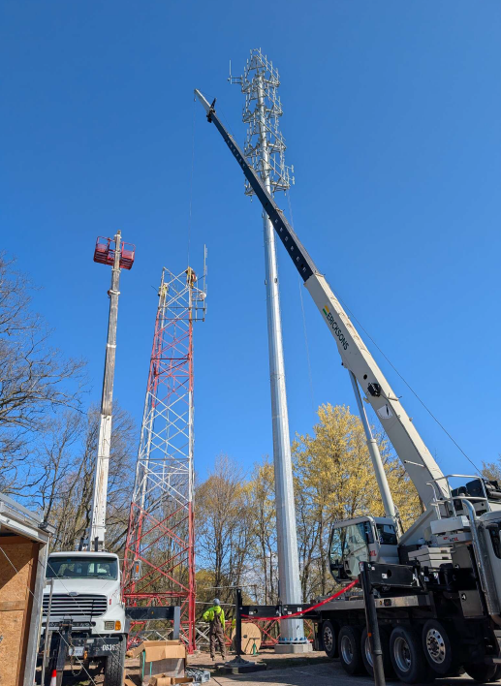
The North Ottawa Amateur Radio Club (NOARS - Grand Haven) repeaters are moving to a new tower, and may be back in business by the time this newsletter is distributed. The old tower was end-of-life. As you can see below, the new tower sits on a big honking chunk of concrete. Most of the old antennas are moving to the new tower.
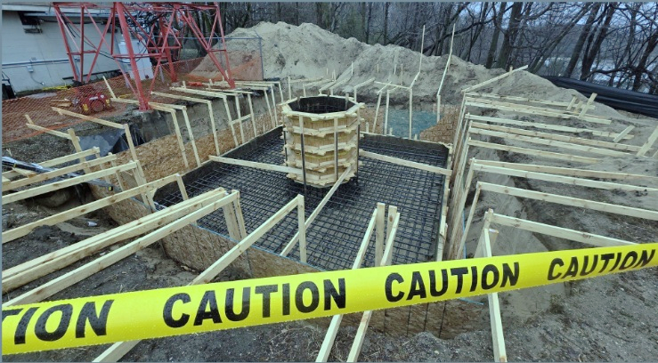
Mark Korroch WB8TGY of Charlotte sent these photos of the May Microwave Activity Day (MAD), held the first Saturday of the month, typically only when the weather is warmer. Russ Dwarshuis KB8U, Bob Thomas WA8VPD and Mark were
on the morning and early afternoon of 5/2 at EN82EM, former Lyon Township Park, a.k.a. Garbage Pit Hill, now called James F Atchison Memorial Park, just off I-96 at Milford Rd, between Milford and South Lyon.

Bob and Mark have were active on 5760MHz. Russ also brought his 10GHz and 24GHz stations. Russ worked the best DX of the day on 24Ghz working Tony K8ZR across southern Ontario and Lake Erie, at the Perry Township Park in Perry, OH / EN91KT. Other band operation was not very successful.
Clockwise from upper left: WA8VPD on 5760MHz, KB8U hearing K8ZR in OH on 24GHz, WB8TGY 5760MHz station, WA8VPD (front) and WB8TGY 5760MHz stations.

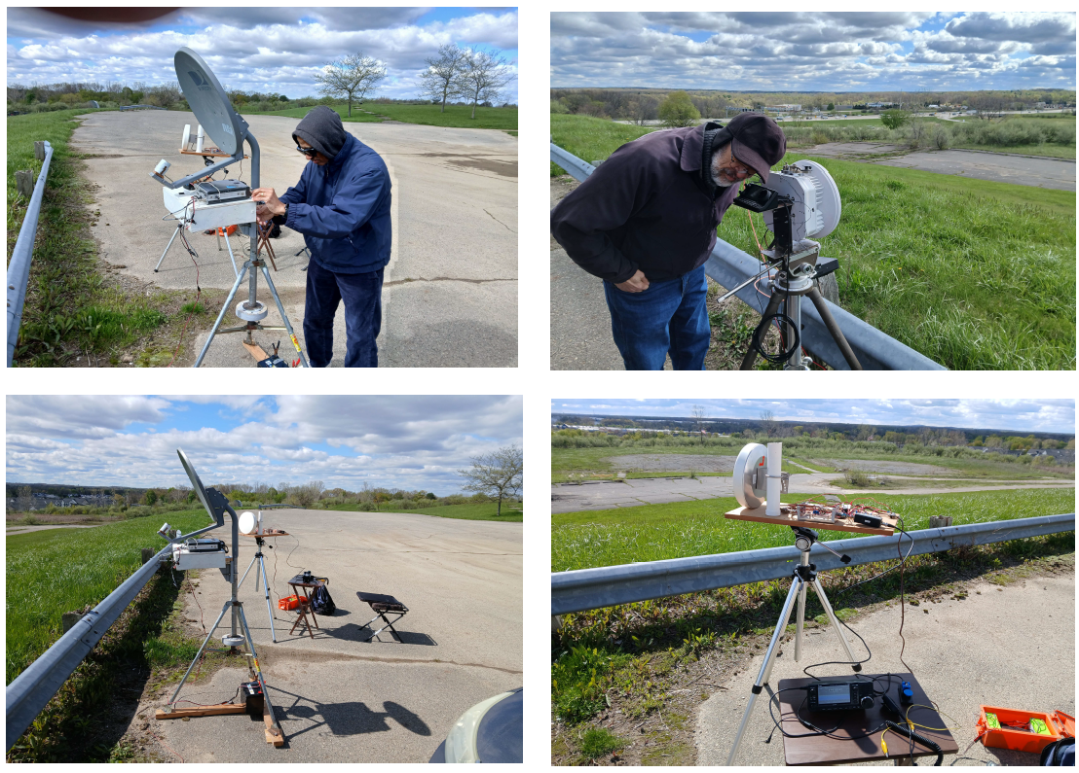

Michigan POTA Meetup – June 6, 2026 - Grayling
Hello,

My name is James (K8JKU) and I help organize the Michigan POTA Meetup. We're hosting our 3rd annual event on Saturday, June 6, 2026, at Hartwick Pines State Park (US-1503) in Grayling, and I'd love your help spreading the word to your members.

The meetup runs from 11:00 AM to 3:00 PM at the Day Use Shelter near the Chapel in the Woods. It's free and open to anyone, whether they're a seasoned POTA activator, a casual hunter, or someone who's just curious about portable operations.

We'll have:

- Free hamburgers and hot dogs (first come first served, dish-to-pass welcome)

- Groups setup/Demonstrations

- HT Park-to-Parks activity

- A group photo at 1:00 PM at the banner

This has grown into a real highlight of the Michigan ham radio calendar, and the best part is watching folks meet activators they've been working from across the state in person for the first time. More info, photos from past years, and updates can be found at:
www.michiganpotameetup.com or www.facebook.com/michiganpotameetup

Thanks for everything you do for amateur radio in Michigan. Hope to see some of your members in Grayling on June 6.

73,

James, K8JKU
Michigan POTA Meetup Organizer
www.michiganpotameetup.com

Advertise All of Your Events
My home club ARROW's April VE session had 4 candidates, with all earning a new ticket or an upgrade. One Technician, two Generals and one Extra class. How is your club doing?

It helps to post all of your activities, VE Sessions, club meetings, everything, on local events calendars. Our most effective local events calendar is mLive.com, but we also know that e-mailing PDF's of announcements to our public library system gets them posted in all of the branches. How do you post events?

Technical explanation: this will reinforce durable community awareness of your activities.

Simple version: this will make people know that you exist.

Random Photos
Pictured: Dan, KB6NU / POTA US-13184
Pictured: Dennis Ward, KT8X
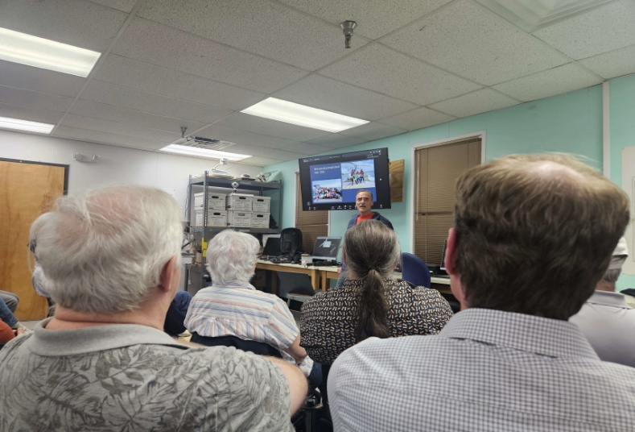
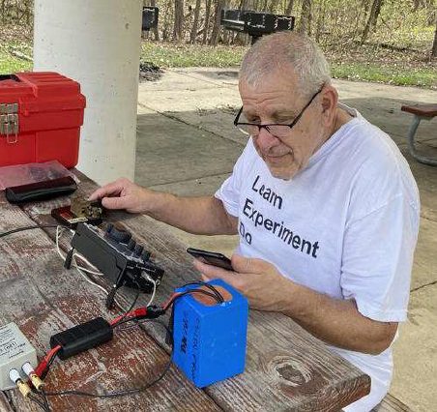

Dennis Ward KT8X of Ypsilanti was a
principal organizer of the recent 3Y0K 2026 Bouvet Island DXpedition (!!!) and spoke at the ARROW club monthly meeting in Ann Arbor about this intense, grueling experience of a lifetime. He can do this presentation again. Articles are forthcoming.

ARRL Groups.io Problem
A number of people have reported not receiving e-mails sent to the entire Michigan Section, such as Scott Yonally N8SY's monthly Great Lakes Division e-mail. Initially, Michigan State Government Liaison Ed Hude WA8QJE fixed this this by contacting the ARRL to have his e-mail address reset at their end. But when I didn't receive Scott Yonally W8SY's tax day
letter, I contacted the ARRL. They were able to see that Scott's message had 1343 deliveries fail (in addition to the usual refused, invalid address, and other specific reasons). This issue has been forward to the League's IT department.

After 25 years of working Computer Help Lines, maybe not surprisingly, I actually enjoy complaints. There is a joke about this, not appropriate to re-tell here. But as always: Do you have ideas and/or want to help? Have something to brag about? Or just want to gripe? Please contact me. It is my honor to serve you.

73,

Ralph Katz AA8RK
Ann Arbor, MI
arrl.mi.section.manager@gmail.com
AA8RK@ARRL.ORG
734-657-5059 cell


From the Ohio Section Manager
Bret Stemen, KD8SCL
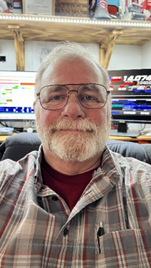

May is Here!

The May calendar is filling up fast with a lot of activities from Hamfests to community events exercises and club meetings.

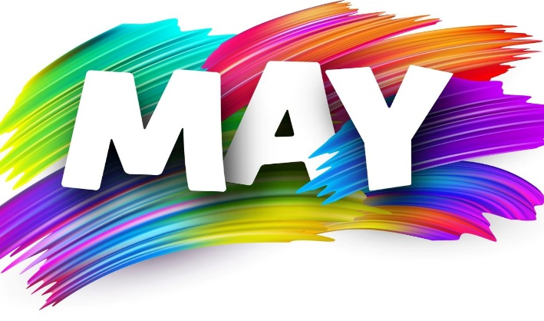
Hamfests are currently underway. I will be attending the Dayton Hamvention and attended the Lucas County ARES Hamfest this month and it was a great opportunity to engage in face-to-face conversations with many of the attendees.

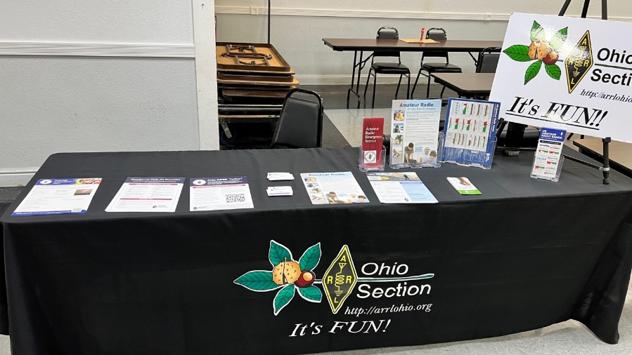
Figure 2 - Lucas County ARES Hamfest
April was a busy month for me as I attended several hamfests and club meetings. I was invited to the Highland County ARA for a meet and greet. Thank you HARA for your hospitality and the invitation to speak to your club, I had a great time. May is going by pretty fast, it’s hard to believe that Hamvention 2026 is just a few days away and my calendar is filling up fast.

I was able to attend the Lucas Co. ARES Hamfest on the 2nd, they had a good turn out and I really enjoyed the time that I had speaking to several of the attendees. I am looking forward to attending Hamvention this year as the Ohio Section Manager and to be able to speak to everyone that stops by the Great Lakes Division Booth.
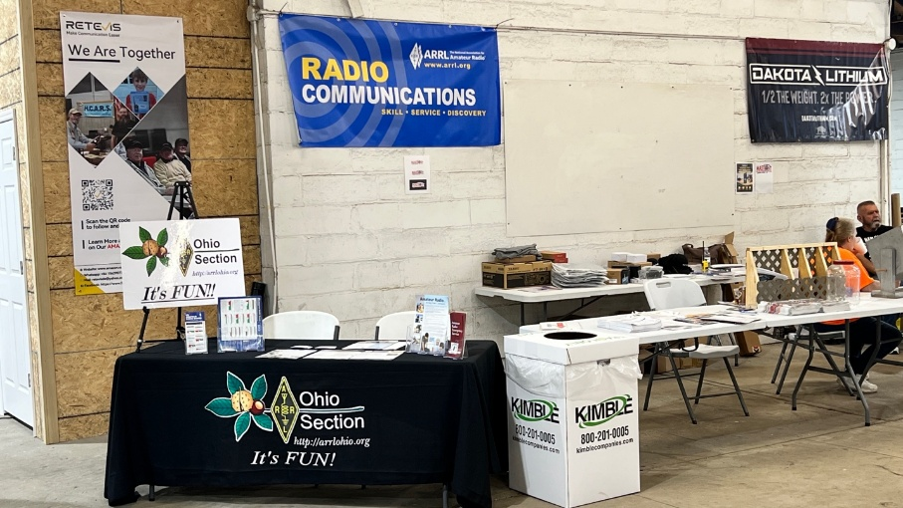
I had the pleasure of being a part of the Delaware Co, Franklin Co and Ohio EMA communications Drill at the Ohio EOC (The SARGE). Thank you OEMA, Franklin Co and Delaware Co. for allowing the SARGE to be a participant in the drill. We discovered a couple of small areas that we need to work on at the SARGE.

Figure 3 - TUSCO Hamfest
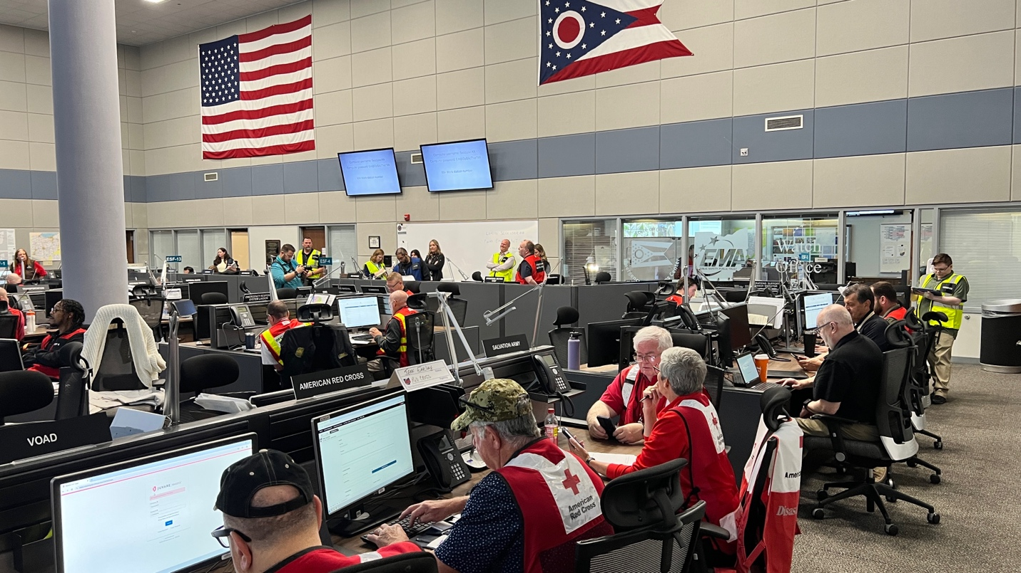

The EOC was filled with various agencies that participated, one of the Delaware Co. ARES members was in the SARGE helping with the drill. I believe this was his real exercise and he did a fantastic job helping with voice communications while the other operator was running the digital station using FlDigi.

The EOC was filled with various agencies that participated, one of the Delaware Co. ARES members was in the SARGE helping with the drill. I believe this was his real exercise and he did a fantastic job helping with voice communications while the other operator was running the digital station using FlDigi.
ARRL Field Day
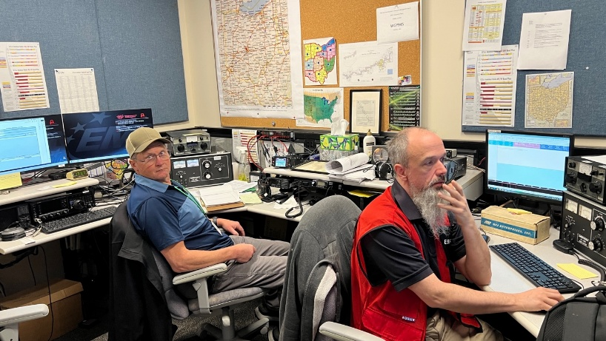
ARRL Field Day is the most popular on-the-air event held annually in the US and Canada. On the fourth weekend of June, more than 31,000 radio amateurs gather with their clubs, groups or simply with friends to operate from remote locations. Is your club getting ready and making plans for Field Day 2026? If your club is planning a Field Day event, make to registrar your FD 2026 site on the Field Day Locator page and your site may receive a visit from an Ohio Section official. https://www.arrl.org/field-day-locator
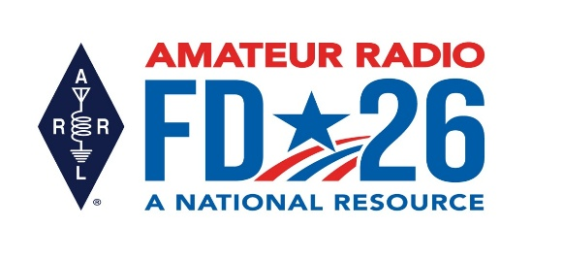
Most clubs and ARES groups in the Ohio Section are already planning for Field Day 2026, I am planning on getting out to visit as many FD sites as I can. Is your club or ARES group working on FD 2026 plans?

The latest edition of the Ohio Section Journal is now online and ready for you to read! There’s an awful lot of Ham Radio activities going on in the Ohio Section, so get off the chair or couch you’re sitting on and get out there, get involved, and get on the air!
The links below will take you directly to the newsletter. Both are also available directly from the Ohio Section Website ( www.arrl-ohio.org).
Please forward this announcement everywhere!
https://arrl-ohio.org/wp-content/uploads/2026/05/OSJ_May_2026.pdf

73,

Bret, KD8SCL
Ohio Section Manager
KD8SCL@ARRL.ORG

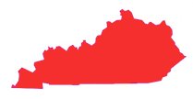
From the Kentucky Section Manager
Bob Selbrede, K6ZZ

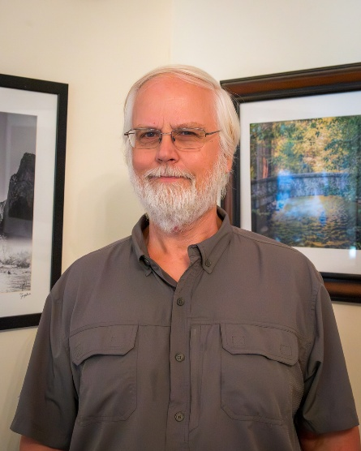
Hello Folks,

Hope your Spring is going well. Are you getting those antenna projects completed! Hamvention is coming up quickly, hopefully you'll be able to attend. I'll be there so stop by the ARRL booth and say hello.

June is just around the corner with several great events scheduled. The Kentucky QSO Party will be happening on Saturday June 9th. Whether you're an avid Contester, a County Hunter or just enjoy working stations on the bands, the Kentucky QSO Party is a great way to have fun on a Saturday. Here's a link to the KY QSO Party website. Join in on the fun! https://kyqsoparty.org/.

Of course, June also means ARRL Field Day. Hopefully you'll be participating with your local Club. I'm going to try to visit several Clubs during Field Day this year so please drop me a note and let me know if your Club has any plans. My email address is k6zz@arrl.org. Also, don't forget, your Club can earn bonus points by sending the Section Manager (me) a message during Field Day. See the ARRL website for complete information on Field Day to include rules and instructions on how to send the SM a message.

See https://www.arrl.org/field-day. Also, if your Club does have operating plans, please update the Field Day Locator on the ARRL website. This will allow visitors to find your Field Day site more easily.

In other news, I received a note from Kentucky Youth Coordinator Mark, AI4BJ. Mark had the following to report:

- In March, I once again volunteered to teach the Radio merit badge at the annual Dan Beard Council Merit Badge Challenge, held at Scott High School in Taylor Mill. This took place over two Saturdays, and eight scouts successfully completed the requirements for the badge. The second Saturday coincided with the CQ WW contest, and the scouts were thrilled to make HF contacts with hams all over Europe!

- Teacher Sherri Edmondson, KJ4MOB, has led the Dixie Heights High School ARC (KY4DH) for the past 11 years. The club has been very successful, usually earning one of the highest scores during ARRL School Roundup each year. Unfortunately, Sherri will be moving back to Maine this summer, so the fate of the club is up in the air. The last I heard, Sherri was trying to talk a couple of fellow teachers into assuming co-sponsorship of the club. The school club has always had the full support of the Northern Kentucky Amateur Radio Club (NKARC).

- Last year Shawn Grubb, KE8BBC, formed the Dan Beard Council Radio Scouting Committee to promote amateur radio among packs, troops, crews and ships in southwest Ohio and northern Kentucky. The committee has been busy organizing events that showcase amateur radio. Upcoming events include:

- In preparation for the 2026 National Scout Jamboree, the Dan Beard Council will be holding a shake-down campout at Camp Michaels in Union, KY, on May 16. They will be practicing skill-building challenges, one of which includes decoding a Morse Code message. I have volunteered to assist with this. I will also be setting up an amateur radio demo (POTA style) to allow the scouts to make QSOs.

- Scouts are being invited to participate in ARRL Field Day with the Northern Kentucky Amateur Radio Club on June 27, at Lincoln Ridge Park in Independence, KY. Aside from having the opportunity to make contacts at the GOTA station (manned by yours truly), Shawn has various other activities planned for the scouts (see flyer below).
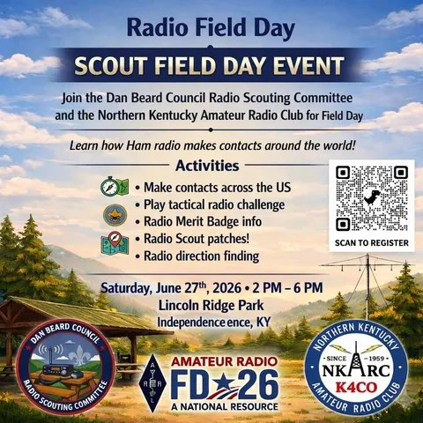

It's still in the early stages, but Shawn is also planning a Jamboree-on-the-Air (JOTA) event next October. This will possibly be held at the VOA museum in West Chester, Ohio.

73, Bob K6ZZ
Kentucky Section Manager
K6ZZ@ARRL.ORG

Do you know someone who is not getting this newsletter

Hi Gang,

If you know someone who isn’t already getting Radio Waves, have them sign up to receive it!! They don’t have to be ARRL members to sign up, just click on the button below and in no time, they will start receiving it.

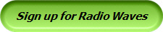

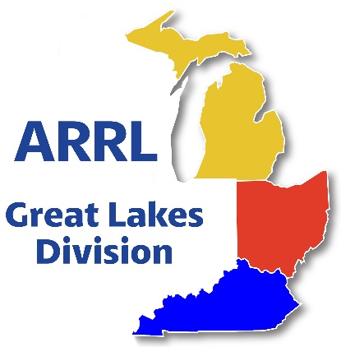
Scott’s Stuff
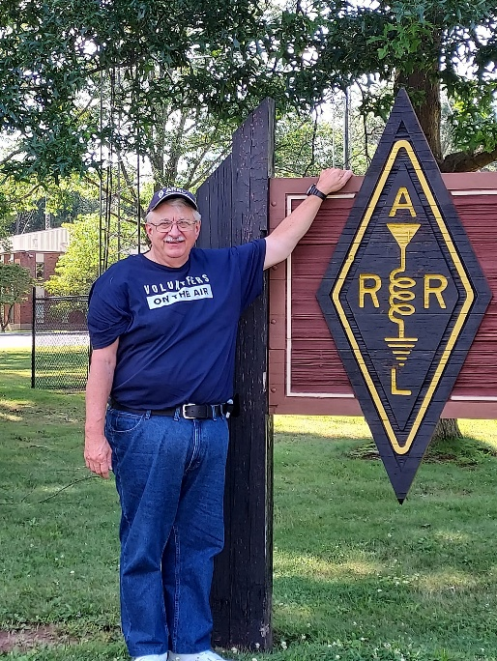
Hey Gang,

If you’ve noticed a sudden, inexplicable shortage of cargo shorts and large safari hats in your local neighborhood Target or Walmart, don’t panic. There hasn’t been a clandestine hardware store heist. It’s simply that time of year again: Dayton Hamvention weekend is upon us.

For the uninitiated, Dayton is the equivalent of the Super Bowl, Woodstock, and a chaotic science fair rolled into one sweaty, caffeine-fueled weekend. It is, without a doubt, the largest gathering of amateur radio operators in the United States. It’s the one place on Earth where you can walk up to a complete stranger, utter a string of alphanumeric gibberish like “Kilo-Five-United-Radio,” and be met with a handshake and a grin from ear to ear, rather than a call to the local psychiatric authorities.

The Treasure Hunt of a Lifetime
As the crowds surge through the doors of the Greene County Fairgrounds and Expo Center, the real adventure begins. It’s a sensory overload of vintage vacuum tubes, state-of-the-art SDR (Software Defined Radio) rigs, and enough coaxial cable to loop around the planet twice.

One moment, you’re sifting through a cardboard box filled with mysterious, oxidized connectors from the 1970s that look like they belong in a Soviet-era submarine, and the next, you’re staring at a high-tech transceiver that costs as much as a used sedan and can probably contact extraterrestrial life if the atmospheric conditions are just right. Whether you’re hunting for that specific piece of hardware to fix a radio you bought purely for its aesthetic charm or looking for a modern antenna that doesn’t require a degree in structural engineering to install, Dayton has it all.

A Deep Dive into the Niche
But Dayton isn’t just about the hardware. It’s about the sheer, unbridled intellectual curiosity of the hobby. Where else on this green earth can you spend an entire morning sitting in a folding chair, drinking lukewarm coffee, and listening to a lecture on the nuances of Earth-Moon-Earth (EME) communication—or "moon bounce," as the cool kids call it?

The air at the forums is thick with the passionate, occasionally heated debates that define the community. You’ll hear practitioners argue the merits of FT8 versus FT4 with the intensity of two rival football coaches. There are discussions on propagation that sound like high-level meteorology, and tales of long-range contact that make the Odyssey look like a quick trip to the corner store. These are the programs that document how to hear distant stations you could only dream about last year—stations hidden behind mountains, across oceans, or cloaked in the fickle whims of the ionosphere.

The Human Element: From Pixels to People
Perhaps the most magical—and, let’s be honest, slightly surreal—aspect of Hamvention is the "Meet and Greet." For many, these radio operators are nothing more than disembodied voices on a frequency. You’ve spent hours chatting with them, sharing life stories, and bonding over signal reports while sitting in your shack at 3:00 AM.

Then, you turn a corner near a booth selling high-gain yagis, and bam—there is the voice behind the callsign. The person you’ve talked to in Saudi Arabia, the contact in South Africa, or even the local legend you’ve heard in the next county over is standing right there in the flesh. It’s a moment of delightful cognitive dissonance: “Wait, you’re not a radio frequency; you’re a guy named Dave who really likes hot dogs!”

Why We Do It (Besides the Sunburn)
Yes, the lines are long. Yes, the weather in Ohio is usually undecided between monsoon and desert heat. And yes, your wallet will likely feel considerably lighter by Sunday afternoon.
But Dayton is an amazing, chaotic, and beautiful gathering of everything that makes amateur radio special. It’s about the camaraderie. It’s about the realization that, despite our differences, we all share a fascination with the invisible waves that connect us. We are, at our core, a group of people who never quite outgrew the urge to see what’s over the next horizon.

So, to all the hams out there wandering the aisles of Dayton this weekend: keep your eyes peeled, your ears open, and your contact logs ready. Whether you’re an old-timer who remembers the days of spark-gap transmitters or a newcomer just getting your feet wet with a handheld radio, enjoy the madness. After all, where else can you be a nerd, a pioneer, and a social butterfly all in the same afternoon?

OK… Let’s switch gears….
Are you a member of the ARRL?? If you aren’t a League member, this is a great opportunity to become one. Want more information on how to join? Here’s the link: https://www.arrl.org/membership

Got questions about being a member or what the League is all about? Send me an email n8sy@n8sy.com I’ll be happy to call or write to you. We can even meet and have coffee if you’d like, and I’ll even buy!!

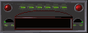
I’m sure that many of you have heard me say that I’m always available for you, whether you’re an ARRL member or not. It’s true, and you can feel free to write or call me anytime. If you have any questions, concerns, or would just like to sit and chat for a while over a cup of coffee or something cold to drink, feel free to call or write me (419) 512-4445 or n8sy@n8sy.com

Ok… I hope that you get on the bands and just go crazy!!! There’s so much to enjoy on the bands, so, get Radio-Active, but above all, regardless of your preferred mode or band, remember the golden rules of our incredible hobby: Have FUN, be respectful and most importantly, be Radio Active!

73, and we’ll see you at the Great Lakes Division booth!

Scott…

Scott Yonally, N8SY
Director - Great Lakes Division
n8sy@n8sy.com

Handbook Give Away – Have you entered yet???
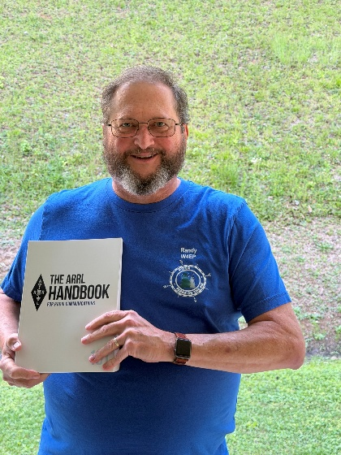
How’s about I give away an ARRL softcover Handbook absolutely FREE !!!

Yes, I’m holding a little contest to "GIVE AWAY" an ARRL softcover Handbook. Why you ask? It’s to get you to check-in to the Great Lakes Division website and take a look around.

Getting signed up is just as simple as filling out a couple of quick questions and you’re entered!!

>> Click Here To Enter <<

Start Planning for ARRL Field Day 2026
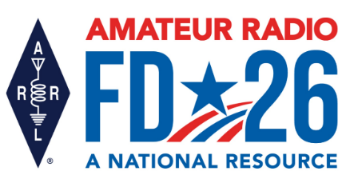
It’s not too early to gear up and get ready for ARRL Field Day! Field Day 2026 takes place June 27 – 28 and will bring together more than 30,000 amateur radio operators for one of the most popular on-the-air events in the US and Canada.

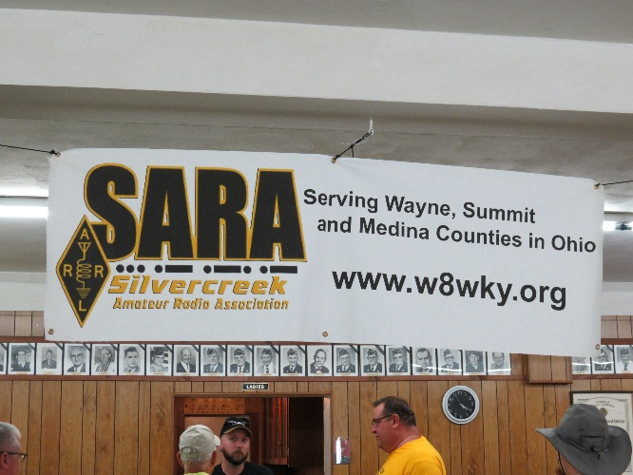
This year’s Field Day theme is “Amateur Radio: A National Resource.” Combined with the ARRL Year of the Club, it provides the perfect opportunity for radio clubs to set up stations in public places to demonstrate ham radio's science, skill, and service to our communities and our nation.

All of the information you need to get started can be found on the Field Day web page, including how to join the ARRL Field Day Facebook Group, where you can share your plans, tips, and tricks for a successful Field Day.

The overall objective for Field Day is to contact as many stations as possible on the 160-, 80-, 40-, 20-,15- and 10-meter HF bands, as well as all bands above 50 MHz, and to learn to operate in less-than-optimal conditions. Many clubs choose to set up camp-style fashion with portable equipment, temporary antennas, and off-grid power sources.

Field Day is open to all amateurs in the areas covered by the ARRL/RAC Field Organizations and countries within IARU Region 2 (North and South America). DX stations residing in other regions may be contacted for credit but are not eligible to submit entries. Each claimed contact must include contemporaneous direct initiation by the operator on both sides of the contact. Initiation of a contact may be either locally or by remote.

Also check out the Field Day site locator page to help find participating stations near you. As an added incentive for anyone participating in ARRL’s yearlong America250 Worked All States (WAS) Award, contacts made with ARRL Affiliated Radio Clubs all year, including during Field Day, will count toward your America250 WAS Affiliated Club Endorsement.

Check out those details at www.arrl.org/america250-was. For more information about ARRL Field Day, visit www.arrl.org/field-day

Oh… and don’t forget to get your Field Day Merchandise at the ARRL Exhibit area in the Tesla Building at Dayton.


New Book Release: Satellite Operating for Amateur Radio

Ever wanted to operate amateur radio satellites but felt intimidated by tracking the “birds” or unsure about the equipment needed? ARRL The National Association for Amateur Radio®'s new book, Satellite Operating for Amateur Radio, is now shipping and shows just how approachable, exciting, and rewarding satellite communication can be.

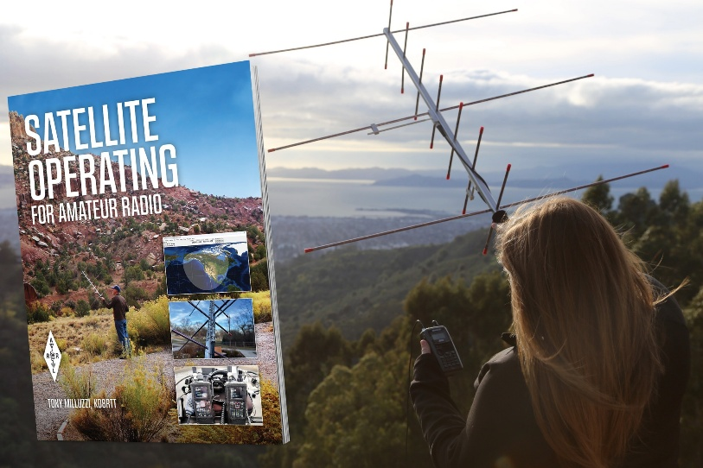
Written by Tony Milluzzi, KD8RTT, the book offers a clear step-by-step path into the world of amateur satellite operation. It begins with the fundamentals of listening to satellite passes and demonstrates how even a basic handheld radio can be enough to get started. From there, readers are guided through making their first satellite contact, with practical tips that build confidence quickly.

“I’ve learned so much from the satellite community, and this book is my way of passing that along to others,” said Milluzzi. “I hope it helps a ham who has always been curious about satellites take those first steps to get on the air.”

Beyond the basics, Satellite Operating for Amateur Radio provides in-depth coverage for more experienced operators. Topics include digital modes such as FT4 and D-STAR®, as well as roving, award-chasing, and advanced operating techniques. The book also explores antenna options, modern tracking tools, and mobile apps, plus ways to engage with the amateur satellite community.

Whether you’re just getting started or building on existing skills, Satellite Operating for Amateur Radio provides the tools and knowledge you need to get on the air and point your antenna toward the sky.

This book pairs perfectly with the ARRL Dual-Band 2 m/70 cm Handheld Yagi Antenna, ideal for making satellite contacts and receiving signals from weather satellites.
Satellite Operating for Amateur Radio is now shipping. Order from the ARRL online store or through an ARRL publication dealer. ARRL Item No. 2363, ISBN: 978-1-62595-236-3, $22.95 ARRL member price, $25.95 retail.

Introducing the QTC App

In the long history of the National Traffic System, traffic handlers have come up with all sorts of clever methods of managing the messages they receive, send, and deliver. Five-by-seven-inch note cards, long rolls of Teletype paper, and ARRL message blanks were once popular; more recently, it's been Windows Notepad documents, spreadsheets, or even a sophisticated purpose-built program such as Lane Kendall’s “Ready to Copy.”

Web browsers have become powerful application platforms recently, and they’ve emerged as the basis for many popular apps. One advantage of these types of apps is that they can run almost anywhere, and don’t need to be installed. With that in mind, the NTS2 team has built the Radiogram Portal and the Radiogram Postcard apps on the browser platform, and now there’s a browser-based message management application available, called QTC.

For traffic handlers, QTC offers the basic functions of filing away radiograms that you send, receive, or deliver, so that you can see a summary list of them and quickly locate a specific message that you’ve handled in the past. It also calculates and presents monthly reports on your traffic-handling activity. It links directly to the Postcard app so that you can quickly send a postal mail confirmation copy of any radiogram that you deliver. The app also has convenience features for looking up mailing addresses and generating message numbers and timestamps.

QTC is a free-of-charge app that runs on any modern web browser, on desktop operating systems such as Windows, MacOS, and Linux. Once you’ve loaded the app once, you can still use most of its functions when you’re offline, such as during an internet service outage; the app keeps a local database of your messages and syncs them automatically with the cloud. This also means you can log in to QTC from any web browser anywhere in the world and have full access to all of your data.

To get started, visit nts2.arrl.org/qtc If you’re not already logged in to NTS2.0, you’ll be prompted for your login name and password. If you’ve never logged in to the NTS2.0 website, you’ll have the opportunity to register (and choose a password). Your call sign will be used as your login name.

To get a sense of what QTC can do, and how to use it, take a moment to read the Help page at nts2.arrl.org/qtc-help For help and support – as well as bug reports and feature requests – there's now a dedicated discussion group; visit groups.io/g/qtc-users -- Jonathan Taylor, K1RFD


YOTA at Hamvention 2026
Are you going to the Dayton Hamvention this year? We hope to see you there! Please be sure to spend some time visiting our booth (#4304) while you’re there. We will be on hand to answer questions about youth activities, and have free stickers for all as well as drawstring backpacks for youth (while supplies last).

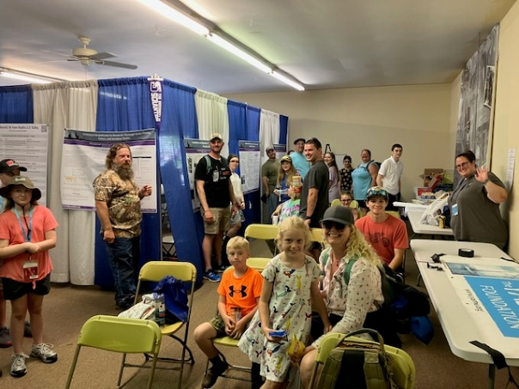
We will also have a free lunch for youth during social hours at noon on both Friday and Saturday in the booth talks area behind the YOTA booth, along with our usual drinks and snacks. All young hams and aspiring siblings are invited to take a break from shopping and forums to connect with all the other young hams at Hamvention!
In the booth talks area behind the YOTA booth, HamSCI will present Gary Mikitin, AF8A giving a booth talk with Q & A entitled "Careers in Engineering: Unlimited Opportunities". If you have questions about becoming an engineer, stop by! ARISS will also have some booth events happening on Friday and Saturday. Please visit the web page for the latest schedule of speakers and topics from HamSCI and ARISS.
Each year, we also post a listing of all the youth activities at Hamvention no matter who sponsors them. You can find that list at https://youthontheair.org/hamvention2026.
Thursday
Contest University – 7 am to 5 pm - Free admission for youth, but you must register in advance.

Go to contestuniversity.com and click on Contact Us. Send a message asking for the youth scholarship and mention YOTA.

Friday
YOTA Youth Social in YOTA Booth, 12 noon - 1 pm
Connect with other young hams and enjoy a free lunch, snacks, drinks, and eyeball

QSOs!ARRL Collegiate Dinner, 6 pm – Dewey's Pizza, 131 Jasper Street, Dayton - see CARP Facebook page - please sign up in advance - Contact Tony KD8RTT or Andy KK4LWR for more information.

Saturday
RCA Youth Forum - 9:15 am to 10:50 am, Room 3
Youth presentations, panel discussion, special guest, and lots of prizes for both youth and adults!

YOTA Youth Social in YOTA Booth, 12 noon - 1 pm

Connect with other young hams and enjoy a free lunch, snacks, drinks, and eyeball QSOs!

- ARRL Youth Rally, 1 to 4 pm, Room 4
The Youth Rally is intended for students who are 11 to 21 years of age. While Hamvention offers free tickets for youth aged 12 through high school, advance registration for the Youth Rally is recommended. The Youth Rally registration fee is $20 and includes a t-shirt (to wear on Saturday), badge, lanyard, and reusable tote bag.
- ARISS Forum - 1:10 - 2:20 pm, Room 2
Celebrating 25 years of amateur radio on the ISS and pioneering new spaceflight opportunities for hams and youth!
- ARRL Collegiate Amateur Radio Program (CARP) Forum - 4 pm, Room 4
- Contest Dinner - 6:30 pm - a limited number of free tickets are available for youth. See contestdinner.com for more details about the event. An IC-7300 will be given away to a youth attendee!

Great Lakes Division Hamfests
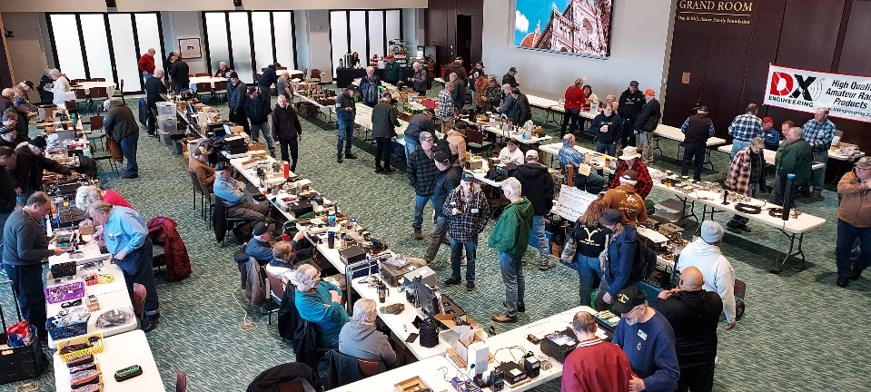
Here in the Great Lakes Division, we have over 50 hamfests a year. So, if you haven’t started planning your hamfest schedule yet, you really need to start now.

Let's fully support all of our hamfests in every way possible. It means success for everyone. Be sure to invite your ARRL Officials as soon as your date is set.

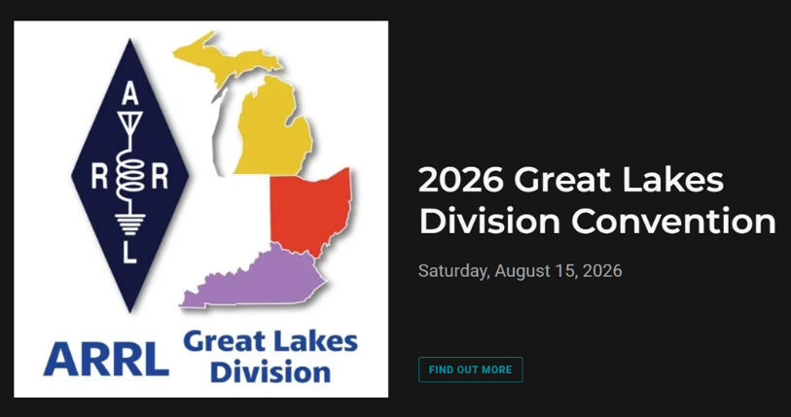

If you are planning on having your hamfest listed in QST please be sure to start your planning well in advance of your Hamfest date, as this allows adequate time for QST Listings. QST announcements require a 3-month lead time.

06/05/2026 - 06/06/2026  LARS 2026 Yooper Hamfest  Location: Newberry, MI  Type: ARRL Hamfest  Sponsor: Luce County Amateur Radio Society  Website: http://w8nby.org  Learn More | 06/06/2026 - FCARC SummerFest  Location: Delta, OH  Type: ARRL Hamfest  Sponsor: Fulton County Amateur Radio Club  Website: https://k8bxq.org/hamfest  Learn More
06/06/2026 - IRA Hamfest  Location: Hudsonville, MI  Type: ARRL Hamfest  Sponsor: Independent Repeater Association  Website: https://w8ira.org/hudsonville-hamfest/  Learn More | 06/20/2026 - Midland Amateur Radio Club Swap  Location: Midland, MI  Type: ARRL Hamfest  Sponsor: Midland Amateur Radio Club Inc  Website: http://www.w8kea.org  Learn More
06/27/2026 - W8ACW-Trunk Sale/Field Day  Location: Grand Blanc, MI  Type: ARRL Hamfest  Sponsor: Genesee County Radio Club Inc  Website: http://w8acw.org  Learn More | 07/11/2026 - Intercity Amateur Radio Club Hamfest  Location: Ontario , OH  Type: ARRL Hamfest  Sponsor: Intercity Amateur Radio Club  Website: http://W8WE.ORG  Learn More
08/01/2026 - 2026 Columbus Ham Fest  Location: Grove City, OH  Type: ARRL Hamfest  Sponsor: Aladdin Shrine Audio Unit  Website: http://www.columbushamfest.com  Learn More | 08/01/2026 - Letcher County Hamfest  Location: Whitesburg, KY  Type: ARRL Hamfest  Sponsor: Letcher County Amateur Radio Club  Website: http://www.lcarcky.com  Learn More
08/15/2026 - Cincinnati Hamfest℠ , ARRL Great Lakes Division Convention  Location: Owensville, OH  Type: ARRL Convention  Sponsor: Milford Amateur Radio Club  Website: https://cincinnatihamfest.org/  Learn More | 08/16/2026 - Warren Hamfest  Location: Cortland, OH  Type: ARRL Hamfest  Sponsor: Warren Amateur Radio Association  Website: http://w8vtd.com/hamfest  Learn More
08/22/2026 - Portsmouth Radio Club 2026 Hamfest  Location: Wheelersburg, OH  Type: ARRL Hamfest  Sponsor: ARRL, Jett Fire Equipment, Shawnee Computer,1776 Guns and Ammo  Website: https://www.portsmouthradioclub.com  Learn More | 09/12/2026 - General Motors ARC Swap Meet  Location: Shelby Township, MI  Type: ARRL Hamfest  Sponsor: General Motors Amateur Radio Club  Website: http://gmarc.org  Learn More

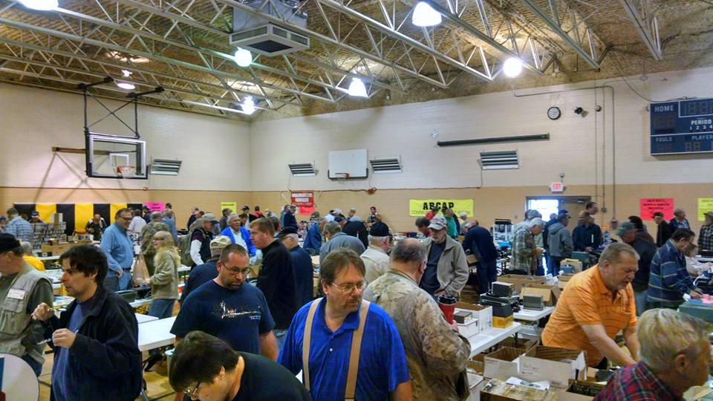
You can always find the latest information about upcoming hamfests on the Great Lakes Division website.
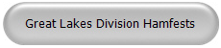

Just click to get the latest hamfest updates.

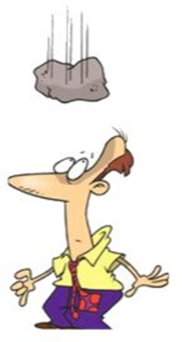
Murphy’s Law…

Law of mental health
If you're feeling good, don't worry, you'll get over it.

The First Myth of Management
It exists.

Rule of Reason
If nobody uses it, there's a reason.

STOP – Right there!!!
We’ve come to the end…

Be Radio-Active --- See Ya’ Soon!

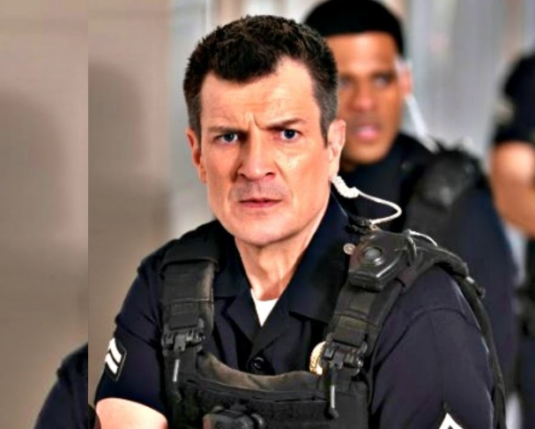

Radio Waves is produced as a look inside of the Great Lakes Division and all that it has to offer. It is our sincerest hope that you have enjoyed this edition and will encourage your friends to be a part of the ARRL and receive the latest news and information about the ARRL and the Great Lakes Division!

The pictures throughout this newsletter are from various newsletters, Facebook posts and/or were sent directly to me in recent weeks. Take a good look at them, you just might be in one of the pictures! “SMILE… you might just be in the Great Lakes Division News!!”

